
June 2022
コンピュータ情報
(kompyu-ta jouhou) : BALITA
Sa Kompyuter, Damdamin Pinagpapala;

PHILIPPINES: USBONG CONTINU​ES TO PROVIDE
COMPUTER SERVICE ASSISTANCE BY SHARING
KNOW-HOW ON MAPARAANG PAGBIBILANG

To eliminate excess steps and inefficient time usage, MARIKINA ORTHOPEDIC SPECIALTY CLINIC (MOSC) requested Usbong's services to automate routine, monotonous tasks and share with unit members know-how on computers.

Here are Key Action Items that we executed in this updates list.
1) Continued to update Knowledge Management System (KMS)
1.1.1) shared: with Public, VALUE of QUICK START-UP;
--> where: START-UP : VEHICLE ENGINE IGNITION
--> observed: during EMERGENCY (ER) situation, START-UP ELAPSED TIME noticeably INCREASES
--> This is due to Unit member shall START via OPEN COMMAND multiple applications together
--> to attempt to decrease WAITING TIME
--> Example: re-starting COMPUTER MACHINES and re-opening applications, e.g. web browsers,
--> after a NO ELECTRICITY POWER incident, CONTINUOUS WAITING TIME for COMPUTATION TO FINISH
--> OUTPUT: WAITING TIME becomes OVER one (1) minute
1.1.2) shared: with Public, technique to SPEED-UP system;
--> Problem: already noticeable DELAY finding PATIENT HISTORY
--> with set TOTAL PATIENT ID count in TRANSACTIONS LIST
--> where: PATIENT ID : 659 TOTAL COUNT
--> where: TRANSACTIONS LIST : 91,478 TOTAL COUNT

--> Technique: create a NEW Identification Number for the SAME PATIENT
--> Example Name:
1) 0 : "BERGSTEIN, AKI"
2) 3543 : "BERGSTEIN, AKIv2"
3) 11682 : "BERGSTEIN, AKIv3"
...

--> add: in PATIENT's LIST, ALL the Identification Numbers of the SAME PATIENT

NOTE (from SYSON, MICHAEL B.):
Previously, we eliminated excess JOIN COMMANDS;
where: JOIN COMMAND : verify the ROWS and COLUMNS of Multiple LISTS

Example: Identify PATIENT's PURCHASED HISTORY using the following:
PATIENT LIST, MEDICINE LIST, and TRANSACTIONS LIST

adds: We can execute SYSTEM SPEED-UP by updating the first PATIENT PAGE viewed to NOT yet include the PURCHASED HISTORY

1.1.2) shared: with Public, technique to auto-generate REPORTS;
--> Example: Monthly Summary Report for each Medical Doctor;
--> opted: to use JAVA COMPUTER LANGUAGE
--> due to using Multiple Computers with variation in Operating System (OS) and Spreadhsheet Tool;
--> where: OS : Microsoft Windows, Linux Ubuntu (LUBUNTU)
--> where: Spreadhsheet Tool : Microsoft Office, LibreOffice Calc

NOTE (from SYSON, MICHAEL B.):
We now have more Machines using the following:
Linux Ubuntu (LUBUNTU) than Microsoft Windows.

observed: select Machines from a previous SUPPLIER were using NON-ACTIVATED Microsoft WINDOWS and OFFICE

OUTPUT#1: Auto-software update from Windows 7 to Windows 10 caused noticeable DELAY in SYSTEM EXECUTION;

OUTPUT#2: Microsoft Office continuously requested to be ACTIVATED
--> observed: this appeared to have NOT caused DELAY
--> RESPONSE by UNIT: simply IGNORE notification

EXECUTED ACTION#1: replaced Installed Software with Linux Ubuntu (LUBUNTU) and LibreOffice Calc

EXECUTED ACTION#2: wrote Computer Instructions using among others:
OS#1: Linux Ubuntu (LUBUNTU):
BASIC Computer Language, Bash Shell COMMAND

OS#2: Microsoft WINDOWS:
Visual BASIC for Applications Computer Language, COMMAND Prompt

observed: minimal TRAINING during execution to shift from OS#2 to OS#1

observed: noticeable SPEED-UP in development for execution
--> via using only ONE (1) Computer Language
--> that executes using a VIRTUAL MACHINE
--> where: VIRTUAL MACHINE executes regardless of OS;

--> where: ACTION to auto-execute by computer uses as INPUT text files
--> where: INPUT text files come from Spreadsheet's Workbooks
--> where: OUTPUT : Web Browser-viewable, Screenshot Photographs,
--> Spreadsheet-readable, et cetera

observed: noticeable SPEED-UP in execution in this context
--> This is instead of using a Web Server
--> where: files can be accessed by multiple computers via Web Browser

--> where: context : does NOT QUICKLY NEED to VIEW and UPDATE files
--> using multiple computers such as with ITEM INVENTORY;

2) Continued with Research & Development (R&D)
2.1) shares: Lessons-learned: ファミ通.com (famitsu.com)
2.1.1) “ジャンプアプリ開発コンテスト2022”のエントリー開始。募集内容は“マンガ創出につながる斬新なアプリ・Webサービス企画、受賞企画には開発資金最大5000万円が提供; last accessed: 20220701; from 20220609;

2022.06.08 23:00
2022-06-08T23:00

KEYPHRASE:
JUMP COMICS APP DEV CONTEST 2022;
MANGA COMICS APP+WEB SERVICE PROJECT
WINNING PROJECT: DEV CAPITAL 50Millon YEN (MAX)
where: 50Millon YEN : 25Millon PHP (approx)

「少年ジャンプ」は、新しい作品創出の基地です。創刊以来50年以上もの間、クリエイターが集まり、成長を促し、読者と共に新作を人気作に導くエコシステムが機能してきました。

SHOUNEN JUMP (COMICS): Simulang pook kung saan inilalabas ang mga bagong LIKHA. Simula nang naglathala, sa loob ng higit sa 50 taon, nagsama ang mga CREATOR (MANLILIKHA), ipinairal ang paglaki nito, kasama ang mga Mambabasa, bumuo ng ECO-SYSTEM upang gabayan ang mga bagong LIKHA na maging tanyag.

keyphrase: increase know-how in among others: drawing techniques, reading&writing
reminder#1: Use of RIFLE requires such know-how to CORRECTLY IDENTIFY and CLASSIFY target object
--> where: IDENTIFY and CLASSIFY : SCIENCE (AGHAM)
--> where: target object : ANIMAL, Teroristang Komunista, et cetera

reminder#2: Teroristang Komunista/MANLOLOKO group misuses wireless broadcasting to attack target
--> where: target with RIFLE is intentionally provoked to ATTACK

NOTE (from SYSON, MICHAEL B.):

In Switzerland, a household may carry RIFLES as part of self-defense;

Self-defense CAN be executed even with EMPTY HANDS
where: EMPTY HANDS : KARATE; 空手; からて
observed: KARATE techniques + WEAPON, e.g. KATANA (日本刀; Japanese Sword), INCREASES STRENGTH

--> paalala#1: Kabilang sa pagtatanggol sa sarili ang pagpatay sa Mananalakay sa kanyang sariling bahay.

where: Mananalakay : MANLOLOKO/budol-budol/carnapper/smuggler/cybercriminal/Teroristang Komunista group

--> paalala#2: WALANG PANANABIK (EXCITEMENT) sa PAGPATAY;

Additional Reminders:
reminder#1: file: incident reports with Police as part of due process;
reminder#2: prepare: to execute own RECOMMENDED ACTIONS;
where: RECOMMENDED ACTION : PUKSAIN -> TERORISTANG KOMUNISTA

Additional Notes (Lessons-learned from ITALIA):
1) Chief Prosecutor against MAFIA (MAGULONG SAMAHAN) killed;
--> OUTPUT: Prosecution CASE continues; MAFIA still NOT ENDED;

--> paalala: Tinuturi ng mga Teroristang Komunista na sila ang "MAFIA/YAKUZA" sa Pinas
--> Teroristang Komunista : MANLOLOKO/budol-budol/carnapper/smuggler/cybercriminal/Teroristang Komunista group

--> Higit na MABILIS at WASTO na PUKSAIN ang mga ito ng Tagapagpatupad ng BATAS, sa halip na idaan sa HUKOM
--> paalala: Habang inaayos pa lamang ang mga ihahain panlaban sa kanila, ginagamitan na TAYO ng mga PANLOLOKONG INGAY at PISIKAL na PANANAKIT sa pamamagitan ng wireless broadcasting technology.

Example#1 Physical Attacks causing Injury to Target:
Target: SYSON, MICHAEL B.

identified: Teroristang Komunista Members as ATTACKERS
1) Ramon Syson, younger brother of father Dr. Pedro Syson
2) Ryan Syson, eldest son Ramon Syson

Both Knees (datetime stamp: 2020-10-15T13:34)
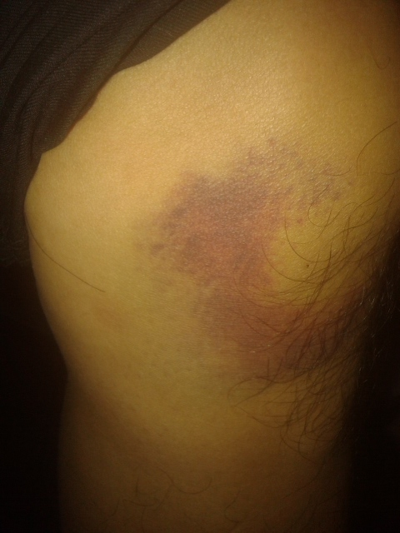  LEFT KNEE | 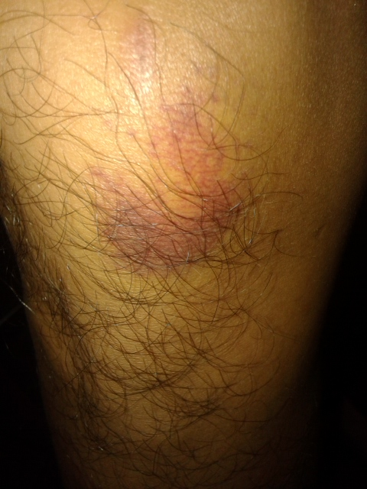  RIGHT KNEE

Example#2 Noise Pollution via RADIO FREQUENCY
previously set to STATIC:
Target: SYSON, MICHAEL B.

identified: Teroristang Komunista Members as ATTACKERS
1) Tyrone Tang, basketball player
2) Keith Haw, friend and classmate of Tyrone Tang

Both are classmates of SYSON, MICHAEL B. @XAVIER SCHOOL, San Juan, Greenhills;

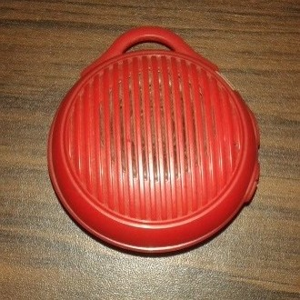

Approx size: 6x6cm

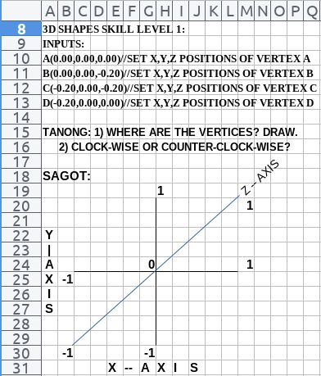

NOW HIRING: COMPUTER SERVICES SALESPERSON
✓Receive half of the revenue from your DIRECT SALE of the service

✓Receive training:
Filipino Language, Sales, Information Technology
Requirements:
1) Curriculum Vitae
2) Portfolio
3) Sulat ng Hangarin
3.1) Ano ang maitutulong mo?
3.2) Bakit mo nais ito?
3.3) Bakit ka karapat-dapat?



EMAIL: APPLY@USBONG.PH

Tanong at Sagot

1) Magkano ang aking kikitain bilang Computer Services Salesperson at Manunulat ng paliwanag sa kompyuter, e.g. Add-on Software?
--> Kung babayaran tayo ng klinik ng 10K pesos bawat buwan, 5K ang sa iyo bilang Computer Services Salesperson.
--> Bilang Manunulat, 4K pesos ang maibibigay sa iyo ng Usbong.
--> Sa kabuuan, 9K pesos ang matatanggap mo bawat buwan.
--> Ang matitirang 10% ng 10K, i.e. 1K pesos, gagamitin ng Usbong sa pag-iipon ng kapital.
--> Gagamitin ito ng Usbong sa paggawa ng mga investment at "float", na ang kahulugan, liquid asset.

2) Paano ako makibabahagi sa tagumpay ng kompanya?
--> Kung wala tayong kikitain mula, halimbawa, sa Computer Automation Service, mauubusan tayo ng kapital na pambayad sa ating lahat. Hindi magtatagal, wala na tayong kompanya.
--> Dahil dito, kailangang maayos ang ating paggawa at pagtuturo sa mga trainee upang tuluy-tuloy ang daloy ng ating kita, habang nagbibigay ng ginhawa sa lipunan.

USBONG I.T. SOLUTIONS
COMPUTER SERVICES

SYSON, MICHAEL B.
FOUNDER

MOBILE: +63929.952.7263
EMAIL: MASARAPMABUHAY@GMAIL.COM

WEBSITE: WWW.USBONG.PH
ADDRESS: #2 E. MANALO (FORMERLY, E. RODRIGUEZ) AVE., STO. NIÑO, MARIKINA CITY, 1820, PHILIPPINES

MAPARAANG PAGBIBILANG
ALGEBRA SKILL LEVEL 1:
INPUTS:
X = 250 //ITEM PRICE
V = 12% //VALUE ADDED TAX (VAT)
Q = ? //ITEM PRICE WITH VAT

TANONG: WHAT IS ITEM PRICE WITH VAT?
SAGOT:

ALGEBRA SKILL LEVEL 2:
INPUTS:
X = ? //ITEM PRICE
V = 12% //VALUE ADDED TAX (VAT)
Q = 364 //ITEM PRICE WITH VAT
TANONG: WHAT IS ITEM PRICE WITHOUT VAT?
SAGOT:

ALGEBRA SKILL LEVEL 3:
INPUTS:
S = 600K //EXCESS STOCK IN WAREHOUSE (JAPAN)
D = 180 //IN USD OF EACH STOCK
L = ? //LOSS

NOTES:
1) USD = UNITED STATES DOLLAR
2) PHP = PHILIPPINE PESO
3) USD1 : PHP54

TANONG#1: WHAT IS THE LOSS IN PHP?
SAGOT:

TANONG#2: WHAT IS THE LOSS IN PHP IF WE SET
USD1 : PHP0.50?
SAGOT:



CAUSE: After investigation, Teroristang Komunista group was verifying via CRIMINAL ACTIONS classified as HARASSMENT/EXTORTION, et cetera to identify among others:

1) LOCATION of smuggled vehicles
2) Police Units who caused DELAY in their smuggling ACTIONS

Paalala) verified: Bureau of Customs (BOC) NEWS
--> 1) @https://customs.gov.ph/boc-destroys-21-smuggled-vehicles/; last accessed: 20220322

| BOC Destroys 21 Smuggled Vehicles
| Posted on June 18, 2021

--

The Bureau of Customs (BOC) led the simultaneous destruction of twenty-one (21) smuggled motor vehicles worth P58.55 million on Friday, June 18, 2021, in Manila and Cagayan de Oro.

--

keyphrase: 58.55Million PHP used for YABANG,
--> instead of increasing know-how in among others: drawing techniques, reading&writing

3) Continued with HEALTH・Security Defense Force
3.1) shares: Lessons-learned from MEDSCAPE.COM
3.1.1) FROM: It's Official. Vitamins Don't Do Much for Health;
last accessed: 20220707; from 20220630

It's Official. Vitamins Don't Do Much for Health

Tinuwid na: Hindi gaanong gumagawa ang mga Bitamina tungo sa Kalusugan

F. Perry Wilson, MD, MSCE

F. Perry Wilson, MD (Manggagamot), MSCE (Master ng Agham sa Paglaganap ukol sa Panggagamot)

Disclosures

Mga pag-amin

June 22, 2022

2022-06-22

Vitamins. If you are like the majority of American adults, you took a vitamin or supplement recently. Over-the-counter sales of these products in this country amount to over $30 billion a year. That's more than the market for statins — and vitamins aren't covered by insurance.

Bitamina; Kung katulad ka ng karamihan ng mga matatandang (adult) Amerikano, kumuha ka ng bitamina o supliment kamakailan. Sa isang taon, higit sa 30USD Bilyon ang benta (SALE) ng mga ito sa over-the-counter (nabibili sa tindahan kahit walang reseta). Higit pa iyan sa Mamimili (market) ng statin (gamot upang magpababa ng TABA, kabilang ang triglyceride (Sa gitna ng TABA) at cholesterol) sa dugo; at hindi saklaw ng insurance (tagapagtanggol sa sakuna) ang bitamina.

For there to be a $30 billion market, there must be some pretty convincing evidence that vitamin supplements work to improve health, right?

Kung may 30USD Bilyong Mamimili, kailangan ng nakapagsasang-ayon na patunay (ebidensya) na tumutulong nga ang mga bitamina bilang supliment upang maiayos ang kalusugan, hindi ba?

Well, in the most thorough meta-analysis to date, researchers from Kaiser-Permanente crunched the numbers from virtually every randomized trial of vitamin supplements in adults to conclude that, basically, they do nothing.

Sa pinakabagong meta-analysis (pagsusuri ng mga Balita ukol sa Balita), pagkatapos gawin ang bilangan ng halos (virtual) bawat isang random na paglilitis ng mga bitaminang supliment, tinapos ng mga tagapagsaliksik mula Kaiser-Permanente na WALANG TULONG ang mga ito.

Notable findings for the harm analysis included evidence that vitamin A use might increase the risk for hip fracture, that vitamin E use might increase the risk for hemorrhagic stroke, and that vitamin C or calcium use might increase the risk for kidney stones.

Kabilang sa mga maisusulat na natuklasan ukol sa pagsusuri ng masamang dulot (ng mga bitamina) ang mga ito: patunay na maaaring pataasin ng bitamina A ang risk (panganib) ng BALE sa Balakang, na maaaring pataasin ng bitamina E ang risk (panganib) ng stroke sa pagdudugo, at maaaring pataasin ng bitamina C o Calcium ang panganib ng bato sa BATO (kidney).

Why are the observational data that show lower vitamin levels linked to worse outcomes so powerful, and the randomized trial data of supplementation so weak? This is classic confounding. Basically, healthier people have higher vitamin levels, and healthier people have less cardiovascular disease and cancer. Vitamin levels are a marker of overall health, not a driver of overall health.

Bakit matinding ipinakikita ng mga Namamasdang Datos na may ugnayan ang mababang nibel ng bitamina sa malubhang kinahinatnan, at mahina naman kapag ginawa ang random na paglilitis ng Datos ng supliment? Nakapagtataka ito. Sa panimula, matataas ang nibel ng bitamina ng mga malulusog na tao, at mababa ang kanilang sakit na may kinalaman sa cardiovascular (Daluyan ng Dugo sa Puso) at cancer. Puna ng Pangkalahatang Kalusugan ang nibel ng bitamina, hindi ito ang nag-uudyok ng Pangkalahatang Kalusugan.

Taking a vitamin, though it is a small act, is nevertheless an act of self-care — a moment that we take for ourselves and ourselves alone — a commitment to try to be healthy.

Bagama't isang maliit na pagkilos ang pagkuha ng bitamina, isa itong pagkilos ng pag-alaga sa sarili; isa itong saglit na tayo lamang at ang sarili lamang natin ang gagawa upang pagpasiyahang subukang maging malusog.

A brief moment of positivity in the morning may not reduce heart attacks or cancer rates, but it may have benefit nonetheless.

Bagama't hindi makapagpapababa ng rate (pangyayari) ng mga pagsalakay sa puso o cancer, may tulong din naman kahit papaano ang isang saglit ng MABUTI (POSITIBO) sa umaga.

F. Perry Wilson, MD, MSCE, is an associate professor of medicine and director of Yale's Clinical and Translational Research Accelerator. His science communication work can be found in the Huffington Post, on NPR, and here on Medscape. He tweets @fperrywilson and hosts a repository of his communication work at www.methodsman.com.

Propesor (Mangangaral) ng Gamot at Direktor (Pinuno) ng Pabilisin ang Panggagamot at Pagsasalin ng Pananaliksik sa YALE: F. Perry Wilson, MD, MSCE; Matatagpuan ang kanyang gawaing hanap-buhay ukol sa science communication (pagpapahayag gamit ang agham) sa Huffington Post, NPR, at dito sa Medscape. Gumagamit siya ng tweet @fperrywilson, at ng repository (lalagyan) ng kanyang gawaing hanap-buhay ukol sa pagpapahayag sa www.methodsman.com.

Sanggunian:
1) GOOGLE SEARCH ENGINE; TRANSLATE
2) https://www.edrdg.org/cgi-bin/wwwjdic/wwwjdic?1F; last accessed: 20220630

Dagdag:
LIFESTYLE CHANGE = Pagbabago ng Pamumuhay

Paalala:
Isalin ang mga pangalan na may kinalaman sa Panggagamot,
--> mula Wikang Ingles tungo sa Wikang Hapon,
--> at mula Wikang Hapon tungo sa Wikang Filipino

3.2) shares: Lessons-learned from ASAHI.COM (NEWSPAPER)
3.1.1) FROM: サイバー攻撃受けた徳島の病院、22日から通常診療 電子カルテ復旧; last accessed: 20220707; from 20220623

サイバー攻撃受けた徳島の病院、22日から通常診療 電子カルテ復旧

Dumanas ng CYBER ATTACK and Pagamutan ng TOKUSHIMA (sa Bansang Hapon), Mula ika-22, balik-karaniwang gamutan na ulit;
Naibalik ang mga DIGITAL CHART;

吉田博行2022年6月21日 19時00分

YOSHIDA, HIROYUKI; 2022-06-21; 19:00

ランサムウェア（身代金ウイルス）によるサイバー攻撃を受けた徳島県鳴門市の医療法人久仁会「鳴門山上病院」は21日、電子カルテなどが復旧したとして、22日から通常診療を再開すると発表した。

Sinalakay ng CYBER ATTACK na RANSOMWARE (VIRUS na maaayos kapalit ng pera), ang "Pagamutan ng NARUTO YAMAGAMI" ng Samahan ng Manggamot ng KUNI, sa Lungsod NARUTO ng TOKUSHIMA-KEN; Nitong ika-21, naibalik ang mga DIGITAL CHART, atbp; Ipinahayag din na muling balik-karaniwan na ang Pagamutan mula ika-22.

19日に受けたサイバー攻撃で、電子カルテにアクセスできなくなっていた。再診患者の受け入れや入院患者の治療に支障はなかったが、20日から新規患者の受け入れを停止していた。

Nitong ika-19, hindi na sila makagawa ng ACCESS sa mga DIGITAL CHART, dahil sa CYBER ATTACK. Tumigil ang pagtanggap ng mga bagong may-sakit mula ika-20, bagama't hindi naman naging baldado ang kanilang pagtanggap ng mga bumabalik na MAY-SAKIT at ang mga ginagamot na ipinasok sa Pagamutan.

病院は被害を受けたシステムの復旧作業を進め、21日に「一部の安全な端末で電子カルテ、院内ネットワーク稼働が可能になる」と発表。22日から新規患者の受け入れを含め、可能な範囲で通常診療を再開するという。

Ipinahayag ng Pagamutan ang pagtuloy sa balik-gawaan ng kanilang sistemang dumanas ng pagtama, at ng ika-21, "Maaari nang pakilusin (maghanap-buhay) ang network sa loob ng Pagamutan, at gamit ang isang bahagi ng ligtas na mga kompyuter, may ACCESS na sa mga DIGITAL CHART". Sinasabing naibalik ang pagbukas sa karaniwang gamutan gamit ang ligtas na bahagi, kabilang na ang paglalagay ng mga bagong may-sakit mula ika-22.

また県によると、病院からは「今のところ個人情報の流出は確認されていない」と報告があったという。県警が、ウイルスの侵入経路などを調べている。（吉田博行）

Dagdag pa, ayon sa pook KEN, sinasabing may report mula sa Pagamutan: "Hindi pa natitiyak kung may dumaloy pailabas ng mga pansariling (pribadong) BALITA sa kasalukuyan." Sinisiyasat na ng Pulis ng pook KEN, ang pinasok na daan ng VIRUS, atbp. (YOSHIDA, HIROYUKI)

