
January 2021
“BUSINESS・COMPANY
EASE PEOPLE”

電波（Electric Wave）: Radio
PHILIPPINES: USBONG CONTINU​ES TO PROVIDE
COMPUTER SERVICE ASSISTANCE BY SHARING
KNOW-HOW ON MAPARAANG PAGBIBILANG

To eliminate excess steps and inefficient time usage, MARIKINA ORTHOPEDIC SPECIALTY CLINIC (MOSC) requested Usbong's services to automate routine, monotonous tasks and share with unit members know-how on computers.

Here are Key Action Items that we executed in this updates list.
1) Continued to update Knowledge Management System (KMS)
1.1) continued: to share know-how on computers and Information Technology (IT) tools
--> This action is for any Unit member to solve problems without the need to wait for the member with the know-how to come.
--> 1.1.1) Problem: Computer Mouse Cursor moves excessively
--> Example: Universal Serial Bus (USB) hub shares electricity among connected devices, thereby causing insufficient electricity for select devices.
--> We add that electric waves, i.e. 電波(dempa)/radio, from wireless devices, e.g. cellular mobile telephones, can cause the problem when the computer mouse uses optical, i.e. light, technology. This is due to we can change light properties of a material using electric waves.
--> Solution: To solve the problem with the computer mouse, put wireless devices farther from where it is located.
--> Additional Recommended Actions:
--> Put to FLIGHT/マナー(mana-) mode, if not Turn OFF, wireless devices when Unit member is sleeping.
--> Those that need to contact the Unit member can write and send, e.g. a Short Messaging Service (SMS) message.
--> This not received message is stored by the network service provider, e.g. PLDT/SMART.
--> The Unit member receives the message after turning ON the wireless device.
NOTE (from SYSON, MICHAEL B.):
We can observe that machines, e.g. vehicles, that use speakers emit excess sound due to select wireless devices.
In fact, each human person has an electric pulse that is also affected by select wireless devices and techniques, e.g. those that are against the law for use by the budol-budol/manloloko/
carnapper/cybercriminal/communist terrorist group to quickly get money. This is why, we remind people to not talk using wireless telephones near people with pace makers.
We add that the Electrocardiogram (EKG) measures electric signals of the heart. We already verified that fish swimming in a river become dizzy and slow-moving due to electric waves that flow from a car battery whose positive and negative ports are each connected by a rod to the river.
With us, human beings, head pain and dizziness leading to death are examples of observable physical injuries caused by the misuse of electric waves by the manloloko group. In addition, a small wireless radio/speaker device whose volume is set to loud can move itself and bump any objects, including humans, nearby. This is after receiving a wireless electric wave signal from a transmitter.
We note that a tower that transmits using antenna/antennae electric waves with sufficient signal strength to reach radio set devices are misused. This manloloko group transmitted such signal to my small wireless radio/speaker, while I was attempting to defend myself from their noise using static sound.

They still continued to transmit electric waves to cause physical injury, while I executed physical exercise, e.g. kata using arnis sticks, 空手(karate) kata, as defense.
This is as recommended by Instructor Meinard Felipe (ECARU, San Roque, Marikina City) in our Basic Life Support, CardioPulmonary Resuscitation training that is certified by the Philippine Heart Association.
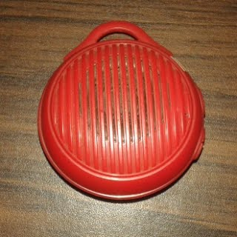
Photograph (RIGHT)
​small wireless radio/speaker
approximate size: 6x6cm
I verified that the recommended actions are not effective against the wireless electric waves from the manloloko group. However, I agree that we need physical exercise and Vitamin C, e.g. from squeezed lemon juice.
Additional Notes:
1) We can make squeezed lemon juice with these steps:
1.1) Use a fork to pierce and scalp the bottom or top outer portion of the lemon.
1.2) Use the fork to pierce to form a hand-drawn asterisk the inner portion of the lemon.
1.3) Squeeze one lemon into a 2L pitcher.
--> At present, a lemon (1/4kg) costs PHP16~20 at the palengke.
1.4) Put 1.5L hot water into the 2L pitcher.
1.5) Put 2L pitcher in the refrigerator.
1.6) Drink half (1/2) to one (1) cup after physical exercise.
2) Vitamin C, e.g. from lemons, increases our immune, i.e. defense, systems. However, we remind Unit members and patients regarding increase in addiction to medicine items, e.g. Vitamin C tablets, pain relievers. This is instead of verifying lifestyle to identify the problem, which such medicine items do not solve.
3) Besides electric waves, there exist sound waves and light waves from wireless broadcasting technology that this manloloko group misuses.
4) We have already requested assistance from among others:
4.1) Law enforcement
4.2) Public Attorney's Office (PAO)
Recommended Action: Puksain ang mga budol-budol/manloloko/
carnapper/cybercriminal/communist terrorist group na gumagamit ng wireless broadcasting technology upang gumawa ng mga panlolokong ingay at pisikal na pananakit.

1.1.2) Problem: Wait List at the Accounting/Cashier Unit
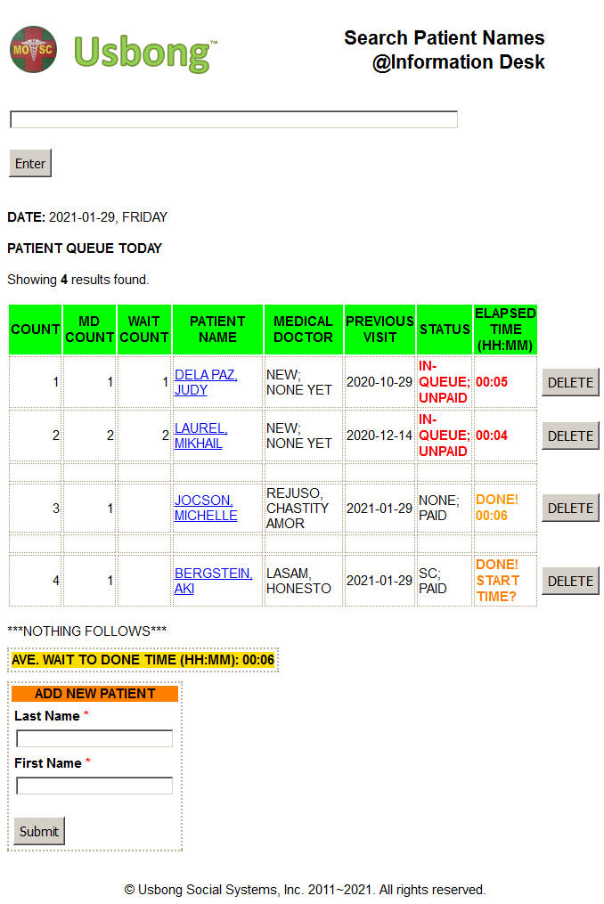
--> Solutions:
--> 1.1.2.1) +added: in patient wait list, Elapsed Time to Done and the Average Wait to Done Time
--> notifies: Unit members via wait list's "DONE! START TIME?" when patient transaction reached Accounting/Cashier Unit, without being added at Info Desk Unit.
--> 1.1.2.2) +updated: instructions so that computer auto-adds in combined transaction notes "MED ONLY", "NON-MED ONLY", "SNACK ONLY", and combinations of these, e.g. "NON-MED, SNACK ONLY".
--> Previously, Unit members had to add by hand these keywords in the notes. Now, the computer auto-identifies based on the number values for the fees, which also include X-ray and Lab fees.
--> 1.1.2.3) +noted: at present, another Unit member provides assistance to quickly eliminate the wait list.
--> Total: more than 2 Unit members work on the cash payment collection at the Accounting/Cashier Unit
--> The Information Desk Unit provides additional Unit members.
--> We use tools, e.g. Tablet Personal Computers (PC) (wireless) and PC (wired). This is to quickly identify the price of items, e.g. medicine and non-medicine.
--> Indeed, we do not quickly eliminate the wait list if the Accounting/Cashier Unit and the patients have to wait for the one (1) person with the know-how to finish.
--> Recommended Action: Continue with sharing know-how, such that Unit members (and even patients) advance to the next level, instead of stagnating in the same skill level for years and years to come.

1.1.3) Problem: Low-level Unit members remain stagnant in skill-level and company income contribution
--> Recommended action: learn whole system
--> where: "whole" = "integer", i.e. integrated

NOTE (from SYSON, MICHAEL B.):
Low-level Unit members receive tasks that do not cause the destruction of the whole system. Low-level = contribution to company income based on know-how/skill-level is low
This is why, as a low-level Unit member, you'll find that you can quickly finish the tasks, e.g. front-end web page development using Hypertext Markup Language (HTML).
We recommend that you use gained time to learn the whole system, i.e. how the parts, e.g. web page in HTML, connect with the system to become whole.
Therefore, from front-end web pages, you can advance to developing back-end computer web servers, e.g. computer databases using Structured Query Language (SQL) technology.
Afterwards, you can advance to be a Unit Chief who is accountable to a Unit with 4 members, including self.
Accountability = if project fails, Unit Chief pays financially for loss.
We add that Unit Chief can become Chief of Unit Chiefs. The Chief of the whole Unit is the member who is accountable for the whole company. We note that advancement to be Chief is measured, i.e. computed, from member's financial investment in company via stocks and company income contribution In addition, advancement is due to necessity, e.g. Former Unit Chief becomes hospitalized due to illness caused by electric wave.
In Osaka, Japan, the following is a known greeting:
儲かりますか。
moukarimasu ka.
Kumikita po ba kayo?
ぼちぼちですよ。
bochi-bochi desu yo.
Unti-unti po.
松下電器 (matsushita denki; PANASONIC) founder, 松下幸之助 (Matsushita, Kounosuke), reminds us that when we start to think about quickly getting money, actions become dirty; People classified to be Mandurugas increases.
Mandurugas = Masama, e.g. budol-budol/manloloko/carnapper/cybercriminal/communist terrorist group;
Reminder: Increase in Tamad causes Increase in Masama.
From observation, a Unit member who intends to continue working with the same company, i.e. lifetime employment, executes the following actions:
1) increasing financial investment in company via stocks
2) increasing company income contribution
If we set the Philippines as the company, this Communist Terrorist group executes the opposite of these actions.
Indeed, "company ease people", i.e. uplift human lives; where Founder Matsushita uses the word, "business", for "company".
Example: We offer computer services assistance to quickly and correctly count the population.
This is instead of inefficiently counting the population by hand.
The speed-up can be from weeks to days.
In addition, we use the population count to compute our income and expenses. If our expenses count is higher than our income, we forecast an increase in Mandurugas to quickly get money.
From Hotta Yoshie, Shiba Ryoutarou, and Miyazaki Hayao's 「時代の風音 (jidai no fuuin; wind sound of the times; Zeitgeist)」, we are reminded that what we only need is money from those who buy our products and services due to quality.
Additional Notes:
1) Wild, J. et. al's "Principles of Accounting" textbook notes that accounting is the life-blood of business.
2) 山本有三 (Yamamoto, Yuuzou)'s「路傍の石」(1935~1937):
--> 方を楽にする = business・company ease people
3) 勇者: 「すべての職業の頂点にたつ者」
--> "Strong person: person who stands at the top point of all work."
--> We reach the highest skill-level and know-how after executing each and all work to the highest degree of training maturity.
--> Example: Cashier person at Accounting/Cashier Unit, Receptionist at Information Desk Unit, Pharmacist, i.e. Item Scholar, at Item Inventory Unit, Janitor at Sanitary and Waste Disposal Unit, et cetera
--> Reference: Enix. (1995). Dragon Quest VI: Usage and Explanation Book/Manual (translated from nihongo by SYSON, MICHAEL B.; Super Family Computer version). Tokyo: Enix Stock Corporation

1.1.4) Problem: text, e.g. numbers, letters, on the Computer Monitor is difficult to read
--> Solution: We can use the zoom tool to make the text larger
--> Additional Note: We remind Unit members to use computer, e.g. Tablet Personal Computer (PC), Mobile Computer, for max time of 30~60mins only; afterwards, execute another action away from Computer Monitor

NOTE (from SYSON, MICHAEL B.):
Previously, I verified using eyeglasses to make text sharper. However, use of eyeglasses causes the eyes of a human person to become adjusted to always use eyeglasses. This is why, instead of eyeglasses, I prefer to use the computer's zoom tool, combined with max time usage of 30~60mins.
I note that electric waves from wireless devices, especially those targeted by the Communist Terrorist/manloloko group, can affect light to make what we see difficult to read, in addition to eye pain. I add that I do not wear excess accessories, e.g. metal earring, anting-anting/scapular necklace. From history, we learn that Journeymen in Germany wear a metal earring for people to identify their classification.
I recommend to wear and use only what we need.

1.2) continued: to share printed Usbong Newsletters to Newspaper Salespersons in the following Barangays:
--> Marikina City: Barangays Sta. Elena, San Roque, and Marikina Heights (new); shared: Unit members at partner Sta. Lucia Health Care Center (SLHCC), Barangay San Isidro, Cainta, Rizal
--> This is in addition to the digital version available at www.usbong.ph; We add that we share questions as review of Maparaang Pagbibilang concepts;
--> The objective of this is to verify if there exist select tasks that we can already request them to execute. This is instead of having only one (1) Unit member do the tasks.

1.3) updated: set of instructions for KMS to display correct counts as output
--> This is due to computer instruction to identify transactions to count the total sold of medicine items was incorrect.
--> learned: that string of letters/numbers/symbols when not yet converted to be classified as "date" is not correctly used by computer as input to identify transactions for conditions other than equals sign, e.g. greater than, i.e. ">"
--> This is despite the sequence is equal, e.g. MM/DD/YYYY to be "01/15/2021"
--> Example: transactions whose transaction date is greater than "01/15/2021"
--> We use the following technologies/tools:
--> 1.3.1) PHP Hypertext Preprocessor Computer Language
--> 1.3.2) CodeIgniter Framework
--> 1.3.3) MySQL Computer Database

NOTE (from SYSON, MICHAEL B.):
We are already updating KMS to connect with the systems used by partner Medical Representatives who visit MOSC.
We learned that they need information pertaining to the number counts of the following:
1) items delivered
2) items remaining
3) items sold
In addition, they prefer the unit of measurement to be box, instead of piece. This action is to solve inefficient time usage by executing the following:
1) eliminate excess workload at our partner clinic
--> Due to the number of patients during select days and time, there is already delay in the following:
--> answering telephone calls, e.g. more than 1 telephone ring
--> receiving payment from patients due to existence of waiting list at the Accounting/Cashier Unit
2) eliminate excess waiting time by Medical Representatives who request for inventory information
Recommended Reading:
1) Information Technology Infrastructure Library (ITIL)
--> Service Level Agreement (SLA); Examples:
--> 1) only 1 telephone ring per call, otherwise penalty
--> 2) answer the question on the telephone within 5mins
--> Note: There is a tendency for the Call Center Agent to hurry the caller to finish.

1.4) updated: set of instructions to speed-up KMS
--> deleted: excess steps, e.g. JOIN commands for computer to access multiple spreadsheet tables in the database
--> Example: ACECLOFENAC (DICLOTOL) 100mg; Cashier Personal Computer (PC); wired network connection
--> view medicine item page command elapsed time (previous): 23, 27, 22, 30seconds
--> view medicine item page command elapsed time (now): 5, 6seconds

NOTE (from SYSON, MICHAEL B.):
We can still speed-up KMS if the computer client is also the computer server. With this, the computer does not anymore need to connect to the computer network router. In its stead, the computer immediately accesses the database.
We verified that the view medicine item page command elapsed time can be as quick as 1, 2seconds. However, for multiple computers, storing a database copy in each computer client shall cause incorrect counts due to synchronization delays. We note that each computer does not only view the counts of the items, but can update the counts by adding and subtracting, i.e. add negative number.
At present, we are using a central computer database, which multiple computer clients access. The problem becomes not with incorrect counts in each accessing computer client, but with the delay caused by having to wait when accessing the computer server using its network address.
Indeed, the task of people classified to be Engineers is to speed-up the system. We add as reminder that speed-up pertains to both quick and correct outputs. In addition, the task of people classified to be Scientists is to identify and classify.
Example: After observing a moving object, you identify it to be an "animal" that is classified to be a "mammal".
Recommended Reading:
1) Firaxis Games and 2K Games' "Sid Meier's Civilization IV" Manual

1.5) updated: KMS to auto-identify and write the year now
--> This is to solve the problem of my having to edit the year every new year. We use the following Languages among others:
--> 1.5.1) PHP Hypertext Preprocessor Computer Language
--> 1.5.2) Java Computer Language

1.6) updated: KMS to auto-generate reports with charts
--> Example: Bar Charts
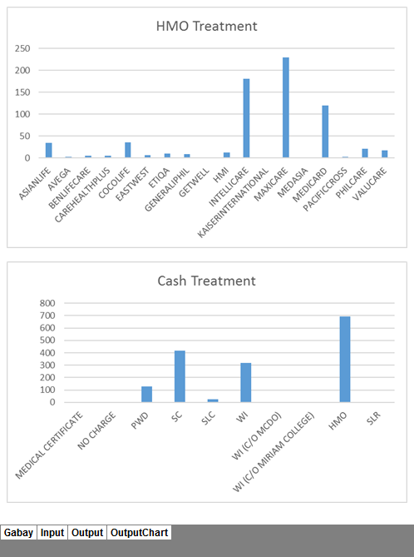
Auto-generated Portion of Sample Output Charts
--> We auto-generate the output charts using Microsoft (MS) EXCEL. it is faster to save the worksheet as .html with the charts as image files than using additional tools and Computer Language.
--> We add the phantom.js tool to save as a whole photograph the output that is viewable on a Computer Web Browser.
--> At present, it is faster to view by a human person this photograph file via network sharing tools, e.g. Viber, Gmail.
--> Reminded: Unit members to use activated software, e.g. Microsoft Office, Microsoft Windows Operating System (OS).
--> As alternative, we recommend what we use: LibreOffice and LUBUNTU 20.04 (LTS) OS.
--> observed: noticeable delay, if not failure to finish execution, in opening and saving MS EXCEL workbook files (size: at least 800KB) using LibreOffice Calc and computers with 32-bit OS system type; At present, we save the worksheet of the MS EXCEL workbook as .csv (comma-separated value) file.
--> This .csv file is what we open and verify with our LibreOffice Calc workbook file.
--> Additional Note: There is still noticeable delay when saving the LibreOffice Calc workbook, albeit the execution finishes.
--> We can still speed-up execution by deleting excess worksheets in the workbook; At present, the file size of our workbook with 2 years of data does not reach 900KB.
--> A 3.5inch high-density diskette can store 1.44MB (max).
--> We add that media files, e.g. photographs, sound, videos, i.e. sequence of photographs with/without sound, cause rapid increase in used file storage size.

1.7) continued: to share significance of Information Technology
--> where: technology, e.g. computers, printers
--> コンピュータ(computer) 情報(information)
--> Recommended action: share information classified to be with Maparaang Pagbibilang, i.e. not emotional/unclear
--> Minecraft: Report Contact Consult
--> Translated from nihongo to English by SYSON, MICHAEL B.
--> Minecraft Playstation(R)3 Edition

Before entering this topic [Rules and Agreement], there is something that I'd like for you to let me be clear. Minecraft is a game where players can make and destroy objects. In the case of playing together with other users (multiplay), you can, together with partners, make objects, destroy objects that your partners made, and your partners can also do the same with yours. Because of this, please do not play together with people who take actions that you do not like. Sometimes, there are people who do things that should not be done. Although it is not something that you like, besides requesting as favor from everyone to take suitable actions, what this company can do is not many. This company depends on reports from everyone who is a user that grasps reflected difference in deeds. In case there are persons who take unsuitable actions, and if there is anyone who reflects difference in the rules, agreements, etc, in case is thought of as not using suitably Minecraft, by all means, please notify this company. This company has prepared a reflected difference report system for those cases. If we receive your report, we shall discuss the necessary corresponding response.
In reporting the problem, please inform us via support@mojang.com using electronic mail with as much detail as possible the user information and list of deeds, etc.

--> Reminder: With computers, there is a tendency to gather information in excess.
--> The solution can be as simple as improving interaction between Unit members, including the patients.
--> Recommended Reading: Jeffrey Liker's "The Toyota Way"

2) Continued with Research & Development (R&D): Automotive
--> 2.1) Usbong CAD (Computer-Aided Design)

NOTE (from SYSON, MICHAEL B.):
The task of people classified to be Artists is to create illusion.
ART = 絵画 (drawing picture) = 幻影 (illusion shadow)
I note that in Satou, Masafumi (Editor)'s Tokyo University English 1981~2005 25years (version 3),
the word, "illusion", is translated in English as "vision".
As with language, Art expresses a simplified, shortened form of an abundant concept.
言語と同じく絵画はより豊かな概念を表している簡略形。
This is due to we know more than we can express in words.
言葉で表しきれないほど多くのことを知っているからである。
Example: Can you describe all you know about your friend, so that another person can quickly identify him in a large crowd?
In addition, the objective of Artists is to execute the following:
1) bring out beauty where it is difficult to bring out
美を見出しにくいところに美を見出すこと
2) bring out order where it is chaos, i.e. disorder
乱れているところに秩序を生み出すこと
Additional Notes:
1) Our concern for nature's beauty is commonly thought of as a sign of our goodness.
自然の美への関心は善良な印であると考えるのが常である。
2) The task of Historians is to strive to impose a kind of rational pattern.
歴史家：ある種の合理的な様式の枠に押し込もうとする
where: rational = logical, Maparaang Pagbibilang
3) "Socrates' philosophy tried to clarify thought by analyzing the meaning of our expressions."
--> Example: why use this word, instead of another?
Recommended Reading:
1) Satou, Masafumi (Editor). (2006). "Difficulty in School Past Questions Series: Tokyo University's English 25years (version 3)". Kyouto: kyougakusha
佐藤雅史（編著). (2006). 難関校過去問シリーズ：東大の英語２５カ年［第3版］. 京都：教学者

--> 2.2) Usbong OpenGL (Graphics Library) and Usbong Engine
--> executed: stress test for computer to auto-draw via 3D grid using tiles as cube
--> verified: increasing 2x window width and height to be 4096
--> verified: increasing 2x grid max row and columns counts to be 40
--> 2.2.1) verified: using the following computer specifications
-->2.2.1.1) Computer #1
//Processor: Genuine Intel(R) CPU T2130 @1.86GHz
//RAM: 3.00GB (2.87 GB usable)
//System type: 32-bit Operating System (OS)
//OS: Windows 7 Ultimate (C) 2009 Service Pack 1
--> 2.2.1.2) Computer #2
//Processor: Intel(R) Celeron(R) CPU N2940 @ 1.83GHz
//RAM: 2.00GB (1.91 GB usable)
//System type: 64-bit Operating System (OS)
//OS: LUBUNTU 20.04 LTS
--> 2.2.2) Results:
--> 2.2.2.1) Computer #1: Noticeable delay in auto-draw
--> 2.2.2.2) Computer #2: No noticeable delay in auto-draw
--> 2.2.3) Solution: in main set of instructions, lower auto-draw delay number to update whole canvas
--> 2.2.4) Additional Notes:
--> 2.2.4.1) lowering auto-draw delay causes smoother, i.e. not skipping, animation sequences
--> 2.2.4.2) verify: adding delay in RobotShip's own movement animation due to noticeably excessively quick
--> 2.2.4.3) Using auto-scaling technique to make all objects smaller did not solve the noticeable delay in auto-draw

--> 2.2.5) OpenGLCanvas: myWindowWidth x myWindowHeight; 6144 x 6144; Grid: iRowCountMax x iColumnCountMax; 30 x 30
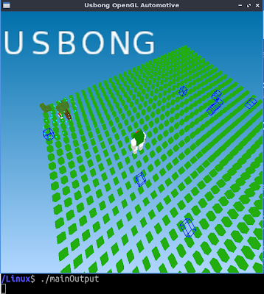

NOTE (from SYSON, MICHAEL B.):
Developing the Usbong Engine with OpenGL reminded me of map makers who also use grids with the x and y coordinate system, e.g. using latitude and longitude, to identify the location of places, e.g. naval ports.
We can learn that it is faster to think about the globe as flat, where those who go beyond the outer edge of one side are transferred to the opposite side, if not fall off.
In addition, from history, we learn that Artists, e.g. Michelangelo, used grids as technique to create Art, e.g. that of the Sistine Chapel.
In my case, I've only extensively used grids when I am assisted by computers; otherwise, I use reference points, e.g. to the right of the center.
This is due to the number of objects with their positions in the grid is more than I prefer to remember. I add that I also prefer not to remember the changing prices of the more than 175 medicine items that our partner MOSC has in the inventory.
It is efficient to use the computer as assistive tool for such tasks. I note here our present problems with item inventory at our partner clinic and our corresponding actions as solution:
1) The names that the Unit members and the computer database use to identify items are not equal.
Example: A Unit member identifies an item with keywords, "Knee Hinge", while for another it is "Knee Brace".
--> Present solution: We receive the item's plastic bag or box with its identified name as keywords. The computer correctly identifies the item due to its keywords are also what we put in the computer database.
2) Select Unit members do not write the size of select items, e.g. wadding sheet, stockinette, that can be cut, such that the whole item in a plastic bag is not always used.
--> Present solution: We clarify the size with the Unit members.

2.2.6) +added: dash command for RobotShip to move x2 faster
--> Pilot notifies RobotShip by pressing directional key x2 to move, with the second press held.

NOTE (from SYSON, MICHAEL B.):
After writing the instructions for the RobotShip to execute the dash action, I am reminded that it is faster to verify variations, e.g. if-then, using the computer, instead of immediately connecting physical material objects, e.g. logic gates to make an integrated circuit. In addition, without assistance from the computer, the output circuits that we can make using physical material objects have less variations.
Therefore, to quickly make a Mecha RobotShip, as physical material object, we can eliminate variations, e.g. rotation movements, which need physical material motors. I note that in 3-Dimensions (3D), we primarily use three (3) rotations, i.e. pitch (x-axis), roll (z-axis), yaw (y-axis). This is albeit a connecting part need not use all three rotations.

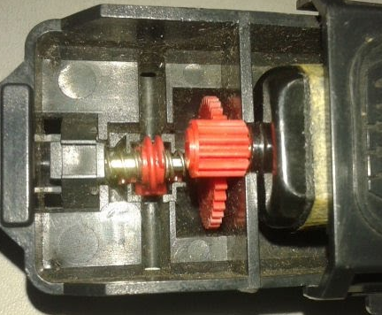
From experience, the remaining problems include among others the following:
1) RobotShip parts as physical material objects, e.g. gears
2) Scale Tool to increase the size of these parts, so that a Pilot can enter/ride the RobotShip
3) Energy to move larger parts
4) Physical injuries during development, especially those due to the Communist Terrorist/manloloko group

--> verified: if dash command instructions causes excess RobotShip movements
--> This is when pressing directional keys to execute rotating movements.
--> At present, the RobotShip executes no excess movements using Linux and Windows machines.

NOTE (from SYSON, MICHAEL B.):
In 「フロントミッション: ガンハザード (Front Mission: Gun Hazard)」 on the Super Family Computer, a technique that I used to destroy the core is to continuously move the RobotShip around it to form a circular motion. This is while firing shotgun bullets.
I note that as with Dragon Quest VI, we first increase our defense by buying armor, before buying weapons using remaining money to increase our offense attacks. To quickly finish the missions, I learned that we can execute the following actions in sequence:
--> 1) Dash towards the target enemy RobotShip.
--> 2) Punch it.
--> 3) Fire the shotgun, which is a spread/three-way directional shot.
However, this technique was not useful in one (1) mission, where I had to use machine gun bullets to hit a flying ship. In addition, I found that the most effective RobotShip companion during missions is Sakata whose RobotShip executes a defensive shield. This is albeit he does not attack at all and his RobotShip's energy eventually becomes used up during long missions.
As we arrive closer to destroying the core, money received by finishing missions increases, such that we can verify weapon variations. Example: mine bomb that pulls enemy RobotShips close to it before it explodes. The technique that I used was to dash towards the target enemy to put the mine bomb, and then dash backwards, while firing shotgun bullets. However, such action was not effective to quickly finish missions due to requiring several additional actions.
Additional References:
1) Front Mission: Gun Hazard's 取扱説明書 (Usage Explanation Book) アクション (ACTION); ミッション (MISSION); ショップ (SHOP)

--> 2.3) Usbong Mecha
--> 2.3.1) verified: techniques, e.g. 2D and 3D printing, to bring the auto-drawn 3D shapes out of the computer monitor
--> i.e. from illusion, i.e. ART, 絵画 (drawing picture), 幻影 (illusion shadow), to material object as product
--> 材料を使って物を作る = use material, make object
--> where: product = 製品 (made item), 成果 (accomplished fruit); Additional Note: メーカー (me-ka-) = maker, i.e. manufacturer
--> learned: we can use an external Universal Serial Bus (USB) keyboard to receive Light Emitting Diode (LED) LED output via Caps Lock key input from Computer Laptop

--> 2.3.2) verified: solutions, e.g. "miniaturization", i.e. make objects smaller, to solve carrying weight problem
--> From physics, i.e. 物理 (object reason), we learn that smaller objects have less heavier weight
--> W = m * a
--> where:
--> W = weight of object due to its mass and gravity
--> m = mass of object
--> a = "acceleration" due to gravity
--> Reference: Dennis, J. (2007). "Pocket idiot's guide to physics". USA: Alpha Books
--> Recommended Reading: Asimov, I. (1987). "Fantastic voyage II: destination brain". New York: Bantam Books.
--> "miniaturization"
3) Continued Training Centre: Security Defense Force
--> 3.1) From Usbong R&D: Automotive:
--> 3.1.1) put tool close to your center position when firing beams as projectiles to quickly and correctly hit targets
--> If you put tool closer to your right side, hitting targets becomes difficult, especially when you also move your position.
--> 3.1.2) use oscillating, i.e. wave movement, with rapid firing of beams as projectiles to increase hits
--> There is a known problem with what we see, such that we do not hit targets.
--> This is even if it appears that we should have hit the targets.
--> 3.2) Question: How to solve unable to open rusted padlock?
--> Answer: Steps:
--> 3.2.1) Clean visible rust using cloth or tissue paper.
--> 3.2.2) Put oil in padlock's open portions, e.g. keyhole, top portion.
--> 3.2.3) Put key to unlock the padlock.
--> 3.2.4) If padlock is still locked using key, repeat to Step 3.2.1).
--> Additional Note: Metal rust can be due to among others: water combined with shampoo and/or soap.
--> Recommendation: For publicly accessible padlocks, e.g. for use with bicycles, use with key as physical material object, instead of those that require entering of Personal Identification Numbers (PIN).

NOTE (from SYSON, MICHAEL B.):
From history we learn that people developed canned food, e.g. sardines, to quickly eat without need to use fire, electricity, etc. I add that I prefer canned food that already includes the can opener, instead of having to use a separate opener. In addition, canned food, as with metal tools, can rust due to water.
Reminder: Care not to eat canned food in excess

4) Continued to update website: WWW.USBONG.PH
--> updated: font size, font style, e.g. bold to be clearer
--> deleted: excess text

5) Continued to share Information on Energy and Health
--> 5.1) observed: select patients buy medicine items, e.g. pain relievers, due to belief that such items solves their health problem
--> reminded: patients to also verify lifestyle, e.g. physical activity.
--> 5.2) reminded: patients to verify medicine item expiration date
--> If already past the expiration date, we recommend not to take such medicine item anymore, unless certain of action.
--> From understanding, medicine items still have weeks after their expiration date, so that patients are not immediately physically injured; reminded: patients to notify us at MOSC if the expiration date is difficult to read due to the small font size, etc
--> We notify the Medical Representatives regarding feedback.
--> 5.3) observed: family members, etc who assist patients with medicine items at times do not yet have sufficient skill-level/know-how; therefore, continuing to share know-how is vital.
--> This is in addition to caring for self.
--> 5.4) observed: at Clinical Unit, due to the number of patients and lower than our recommended skill-level of Unit members, there is an increase in quick, but incorrect, outputs, e.g. blank answers to among others: occupation, body temperature, pulse, weight, in the patient index cards.
--> added: due to the system, which includes training and lifestyle, Medical Doctors eventually forget to care
--> 5.5) clarified: each medicine item has generic name, e.g. paracetamol, and brand name, e.g. Biogesic.
--> Another brand of medicine item with the same generic name, “paracetamol”, can be less expensive.
--> As explained by Unit members, Medical Representatives, and the Philippine Pharmaceutical Directory (PPD) book, there is no big difference between medicine items with varying brands, but have an equal generic name.
--> noted: variations of select medicine items include: can easily be crushed and have only small change in physical effects.

NOW HIRING: COMPUTER SERVICES SALESPERSON
✓Receive half of the revenue from your DIRECT SALE of the service

✓Receive training:
Filipino Language, Sales, Information Technology
Requirements:
1) Curriculum Vitae
2) Portfolio
3) Sulat ng Hangarin
3.1) Ano ang maitutulong mo?
3.2) Bakit mo nais ito?
3.3) Bakit ka karapat-dapat?



EMAIL: APPLY@USBONG.PH

Tanong at Sagot

1) Magkano ang aking kikitain bilang Computer Services Salesperson at Manunulat ng paliwanag sa kompyuter, e.g. Add-on Software?
--> Kung babayaran tayo ng klinik ng 10K pesos bawat buwan, 5K ang sa iyo bilang Computer Services Salesperson.
--> Bilang Manunulat, 4K pesos ang maibibigay sa iyo ng Usbong.
--> Sa kabuuan, 9K pesos ang matatanggap mo bawat buwan.
--> Ang matitirang 10% ng 10K, i.e. 1K pesos, gagamitin ng Usbong sa pag-iipon ng kapital.
--> Gagamitin ito ng Usbong sa paggawa ng mga investment at "float", na ang kahulugan, liquid asset.

2) Paano ako makibabahagi sa tagumpay ng kompanya?
--> Kung wala tayong kikitain mula, halimbawa, sa Computer Automation Service, mauubusan tayo ng kapital na pambayad sa ating lahat. Hindi magtatagal, wala na tayong kompanya.
--> Dahil dito, kailangang maayos ang ating paggawa at pagtuturo sa mga trainee upang tuluy-tuloy ang daloy ng ating kita, habang nagbibigay ng ginhawa sa lipunan.

MAPARAANG PAGBIBILANG
ALGEBRA SKILL LEVEL 1:
INPUTS:
X = 250 //ITEM PRICE
V = 12% //VALUE ADDED TAX (VAT)
Q = ? //ITEM PRICE WITH VAT

TANONG: WHAT IS ITEM PRICE WITH VAT?
SAGOT:

ALGEBRA SKILL LEVEL 2:
INPUTS:
X = ? //ITEM PRICE
V = 12% //VALUE ADDED TAX (VAT)
Q = 364 //ITEM PRICE WITH VAT

TANONG: WHAT IS ITEM PRICE WITHOUT VAT?
SAGOT:

USBONG SOCIAL SYSTEMS, INC.
COMPUTER SERVICES

SYSON, MICHAEL B.
FOUNDER

MOBILE: +63929.952.7263
EMAIL: MASARAPMABUHAY@GMAIL.COM

WEBSITE: WWW.USBONG.PH
ADDRESS: #2 E. MANALO (FORMERLY, E. RODRIGUEZ) AVE., STO. NIÑO, MARIKINA CITY, 1820, PHILIPPINES

