
March 2022
新聞 (xīnwén;
しんぶん(shimbun);
신문 (shinmun))
= Bagong Dinig・Tanong
LAUREL LEAF : LIFE

PHILIPPINES: USBONG CONTINU​ES TO PROVIDE
COMPUTER SERVICE ASSISTANCE BY SHARING
KNOW-HOW ON MAPARAANG PAGBIBILANG

To eliminate excess steps and inefficient time usage, MARIKINA ORTHOPEDIC SPECIALTY CLINIC (MOSC) requested Usbong's services to automate routine, monotonous tasks and share with unit members know-how on computers.

Here are Key Action Items that we executed in this updates list.
1) Continued to update Knowledge Management System (KMS)
1.1) continued: to share know-how on computers and Information Technology (IT) tools
1.1.1) shared: with Public, Usbong Computer Software Automation applied @OFFICE Workplace to auto-generate Weekly Health Maintenance Organization (HMO) Reports

Example Work Output:


Output Design Format based on Template
Template: print-ready (size A4 paper)
Softcopy of Report also auto-generated

Output Notes:
Each Medical Doctor with HMO transaction has a Report,
PLUS Physical Therapy Unit's HMO Report

--> reminder#1: Service Desk Industry: Billion United States Dollar (USD) Industry
--> reminder#2: Business Process Outsourcing (BPO) Industry: Billion USD Industry
--> where: BPO Industry : top private sector employer in the Philippines
NOTE (from SYSON, MICHAEL B.):
The movie and video games industries are also Billion USD Industries. However, from history, we learn that outputs via continuous production do NOT immediately cause: Income > Expenses;

The Family Computer as product generated Income > Expenses to cause a new version, i.e. the Super Family Computer.

However, select add-on hardware and software services, e.g. Family Computer Network System with Satellite Online Service, were SHUTDOWN due to Income < Expenses;

observed: that when investment on expensive equipment, e.g. wireless broadcasting technology, does NOT cause Income > Expenses, equipment is reused for criminal, i.e. illegal, actions, e.g. noise pollution, tax-evasion

reminder: Quarterly Percentage Tax on Amusements, e.g. Karaoke, is @18% of Gross Sales

With Income < Expenses from Sales, and with investment on equipment classified as LOSS, QUICK MONEY to get Return of Investment (RoI) becomes the focus.

松下電器 (matsushita denki; PANASONIC) founder, 松下幸之助 (Matsushita, Kounosuke), reminds us that when we start to think about quickly getting money, actions become dirty; People classified to be Mandurugas increases.

Mandurugas = Masama, e.g. budol-budol/manloloko/carnapper/cybercriminal/communist terrorist group

reminder: Increase in Tamad causes Increase in Masama.

--> continued: with weekly paper transfer
--> observed: action causes Industry need to regularly update delivery system,
--> which includes system parts, e.g. ROADS, PEDESTRIAN LANES;

--> observed: items, e.g. FOOD SUPPLY, also use such delivery system
--> Examples: Fresh Milk; Fruits
--> Reminder: Such physical items for human digestion do NOT yet transfer via computer digital networks

--> reminder: use of computer digital networks causes increased scale;
--> where: scale : DAMAGE via stolen INFORMATION
--> where: INFORMATION classified to be exchanged for MONEY
--> Example: INFORMATION KNOW-HOW of target vehicle's parked location and vehicle's wireless frequency key for carnapping actions
--> INFORMATION stolen via Unauthorized Access to CCTV Camera inside household
--> where: CCTV = Closed-circuit Television (CCTV);


Example: Bubo Bubo Android Application (with Digital Video Recorder (DVR) + CCTV Camera System)

--> observed: target vehicles auto-open and close with Light-Emitting Diode (LED) viewable on CCTV;
--> hears: open-closing sound;
--> adds: IF INFORMATION NOT successfully STOLEN, carnapper/Budol-Budol/Manloloko/Teroristang Komunista group executes NOISE POLLUTION
--> where: NOISE POLLUTION causes DELAYS in system execution @Accounting Unit, e.g. @partner Sta. Lucia Health Care Center (SLHCC)

NOTE (from SYSON, MICHAEL B.):
observed: increased NOISE POLLUTION became noticeable in the Year 2017 continuing to 2018, even to the current Year 2022, with select Teroristang Komunista members identifying themselves due to YABANG and MISTAKE:
Members include among others:

--> 1) SYSON, RAMON (younger brother of DR. SYSON, PEDRO)
--> 2) SYSON, RYAN (son of SYSON, RAMON)
--> 3) SYSON, JOAN (daughter of SYSON, RAMON)
--> 4) HAW, KEITH (Xavier School (XS), San Juan, Greenhills Classmate)
--> 5) TANG, TYRONE (Basketball player, XS, friend of HAW, KEITH)
--> 6) VILLARIN, RAMON (Society of Jesus (SJ); former Ateneo de Manila University President)

--> continued: with observation of identified Teroristang Komunista members' actions
--> reminder: GUILT exists due to continued misuse of wireless broadcasting technology whose NOISE POLLUTION reaches multiple barangays in Marikina City
--> observed: Teroristang Komunista members had LOST ITEMS classified to be exchanged for MONEY;

--> verified: Bureau of Customs (BOC) NEWS
--> 1) @https://customs.gov.ph/boc-destroys-21-smuggled-vehicles/;
last accessed: 20220322
| BOC Destroys 21 Smuggled Vehicles
| Posted on June 18, 2021
--
The Bureau of Customs (BOC) led the simultaneous destruction of twenty-one (21) smuggled motor vehicles worth P58.55 million on Friday, June 18, 2021, in Manila and Cagayan de Oro.
--
--> 2) @https://customs.gov.ph/boc-reports-efforts-against-smuggling-of-agricultural-products/; last accessed: 20220322
| MICP Seizes php 9M Worth of Smuggled Agricultural Products
| Posted on October 15, 2021
--
BOC-IG recorded a total estimated value of 545.06 million worth of seized smuggled agricultural products. In terms of value, the following are the top three commodities: (1) rice amounting to 206.80 million (2) onions amounting to 190.48 million, and (3) garlic amounting to Php 55 million.
--
Actions:
1) file: incident reports with Police;
2) Ignore, if NOT endure, NOISE POLLUTION;
3) clarify: with Family Unit, e.g. Wife, directly and in-person any information/gossip heard, viewed, et cetera;
--> Halimbawa: Kung may narinig kang hindi ayos ukol sa akin, kausapin mo muna ako nang direkta at harap-harapan upang ating LINAWIN ang anumang MALABO.

reminder: SAVED TIME can be used to execute these actions among others:
1) Another work task to speed-up system
2) Rest with own Family Unit

NOTE (from SYSON, MICHAEL B.):
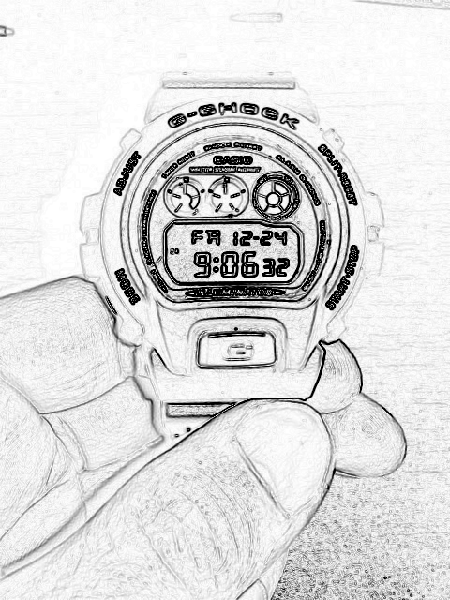
CASIO WRIST WATCH

Purchased Date: 2021-12-14
Cost: PHP5000
ELAPSED TIME: OVER 4 YEARS; @PHP3.42/day (Estimate
based on History)

observed: in トイレ (toire; toilet), when returning CASIO WATCH to LEFT WRIST, hits as reminder self's sternum (胸骨（きょうこつ; chest bone）

--> reminder#1: sternum protects body organs, e.g. physical HEART.
--> reminder#2: Physical PUNCH that hits UP from below sternum causes noticeable physical pain;
--> notes: Person can verify this with even a WEAK PUNCH;

--> remembers: from keyword, "sternum", STERN+NUMBERS
--> where: STERN : STRICT/MAHIGPIT;
--> where: NUMBERS : BILANG
--> notes: When investment causes Financial LOSS in Return of Investment (RoI), select investors shall execute actions classified to be PHYSICAL ATTACKS due to focuses on getting QUICK MONEY;

Example:
ACTIONS, e.g. NOISE POLLUTION, by the Teroristang Komunista group

Recommended Action: verify: before receiving among others: MONEY and GIFTS to CLEARLY identify CAUSE of giving

Reminder: The Facebook Effect (Book Item; Year 2011)
--> where: in select systems, with increasing members,
--> UNCLEAR individual WORK contribution and its payment
--> makes system ineffective and inefficient;

adds: after sufficient investment in corporation, there exists VOTING SYSTEM arriving as printed LETTERS to registered ADDRESS
--> Example: Voting Item: Financial Auditor



NOW HIRING: COMPUTER SERVICES SALESPERSON
✓Receive half of the revenue from your DIRECT SALE of the service

✓Receive training:
Filipino Language, Sales, Information Technology
Requirements:
1) Curriculum Vitae
2) Portfolio
3) Sulat ng Hangarin
3.1) Ano ang maitutulong mo?
3.2) Bakit mo nais ito?
3.3) Bakit ka karapat-dapat?



EMAIL: APPLY@USBONG.PH

Tanong at Sagot

1) Magkano ang aking kikitain bilang Computer Services Salesperson at Manunulat ng paliwanag sa kompyuter, e.g. Add-on Software?
--> Kung babayaran tayo ng klinik ng 10K pesos bawat buwan, 5K ang sa iyo bilang Computer Services Salesperson.
--> Bilang Manunulat, 4K pesos ang maibibigay sa iyo ng Usbong.
--> Sa kabuuan, 9K pesos ang matatanggap mo bawat buwan.
--> Ang matitirang 10% ng 10K, i.e. 1K pesos, gagamitin ng Usbong sa pag-iipon ng kapital.
--> Gagamitin ito ng Usbong sa paggawa ng mga investment at "float", na ang kahulugan, liquid asset.

2) Paano ako makibabahagi sa tagumpay ng kompanya?
--> Kung wala tayong kikitain mula, halimbawa, sa Computer Automation Service, mauubusan tayo ng kapital na pambayad sa ating lahat. Hindi magtatagal, wala na tayong kompanya.
--> Dahil dito, kailangang maayos ang ating paggawa at pagtuturo sa mga trainee upang tuluy-tuloy ang daloy ng ating kita, habang nagbibigay ng ginhawa sa lipunan.

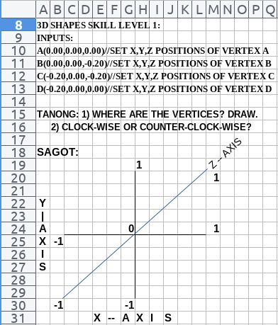

USBONG I.T. SOLUTIONS
COMPUTER SERVICES

SYSON, MICHAEL B.
FOUNDER

MOBILE: +63929.952.7263
EMAIL: MASARAPMABUHAY@GMAIL.COM

WEBSITE: WWW.USBONG.PH
ADDRESS: #2 E. MANALO (FORMERLY, E. RODRIGUEZ) AVE., STO. NIÑO, MARIKINA CITY, 1820, PHILIPPINES

MAPARAANG PAGBIBILANG
ALGEBRA SKILL LEVEL 1:
INPUTS:
X = 250 //ITEM PRICE
V = 12% //VALUE ADDED TAX (VAT)
Q = ? //ITEM PRICE WITH VAT

TANONG: WHAT IS ITEM PRICE WITH VAT?
SAGOT:

ALGEBRA SKILL LEVEL 2:
INPUTS:
X = ? //ITEM PRICE
V = 12% //VALUE ADDED TAX (VAT)
Q = 364 //ITEM PRICE WITH VAT
TANONG: WHAT IS ITEM PRICE WITHOUT VAT?
SAGOT:

ALGEBRA SKILL LEVEL 3:
INPUTS:
S = 600K //EXCESS STOCK IN WAREHOUSE (JAPAN)
D = 180 //IN USD OF EACH STOCK
L = ? //LOSS

NOTES:
1) USD = UNITED STATES DOLLAR
2) PHP = PHILIPPINE PESO
3) USD1 : PHP54

TANONG#1: WHAT IS THE LOSS IN PHP?
SAGOT:

TANONG#2: WHAT IS THE LOSS IN PHP IF WE SET
USD1 : PHP0.50?
SAGOT:

shares: with Philippine Administration, after reaching 18years of old and with Philippine Citizenship, there exists VOTING SYSTEM
--> Example#1: Voting Item: Philippine President (EXECUTION)
--> Example#2: Voting Item: Philippine Senator (LEGISLATION; LAW WRITING)

Additional Note:
1) notes: self wears the CASIO WATCH with the DIGITAL TIME facing myself due to TIME verification FASTER while executing select ACTIONS, e.g. reading printed books

2) remembers: from keyword, トイレ (TOIRE), SHIGESATO ITOI's ほぼ日刊イトイ新聞 with keyword, イトイ (ITOI);

3) shares: PRESIDENT : EXECUTION;
--> CAN his/herself QUICKLY EXECUTE, i.e. destroy, the person classified to be Manloloko/Teroristang Komunista appearing IN FRONT of self, without need for explanation due to already CLEAR in the LAW
--> recommends: IF explains UNABLE to EXECUTE due to existing LAW, be in SENATE to WRITE UPDATES to speed-up EXECUTION,
--> NOT as EXECUTIVE, e.g. PRESIDENT

--> remembers: former Philippine President JOSE P. LAUREL who served during our TIME with the Japanese
--> adds: former Philippine President LAUREL executed SELF-DEFENSE and killed using knife, the person who first attacked him using the LATIGO
--> notes: LAUREL LEAF : LIFE

--> reminder: from History, POISON has been used to cause DEATH, without use of Projectile Tool, e.g. GUN
--> observes: Teroristang Komunista group uses among others:
--> POISON, NOISE POLLUTION
--> recommends: CAUTION due to Teroristang Komunista group KILLS to get QUICK MONEY

--> recommends: verifying ACTIONS of Teroristang Komunista group members to assist in speed-up of identification and classification
--> where: ACTIONS : LIFESTYLE
--> reminder: WORK = HANAP-BUHAY,
--> i.e. unti-unting pagkita ng pera mula sa paggawa

3) Continued with Security Defense Force
3.1) shares: Deutschland System of Pension Insurance:
"The statutory pension insurance is the most important pillar of old-age provisions. Its financing is split: The monthly contributions paid by employees and employers pay the pensions of those currently in retirement. Through their contributions, those insured acquire some rights when they themselves become pensioners. In turn, coming generations provide for these future rents with their contributions (cross-generational contract). In addition, company and private pensions are the second and third pillars of provisions for old age. Under certain conditions these also enjoy government support."
(Hintereder, P. (2010). "FACTS about Germany". Germany: Societäts-Verlag)

3.2) Ear, Nose, Throat (ENT) to Chest near Physical Heart
--> verify: mouth action (put air in mouth; voice-out "pop")
--> chest movement; near physical HEART; ATTACK

--> reminder: budol-budol/manloloko/carnapper/cybercriminal/communist terrorist group misuses wireless broadcasting technology by causing Noise Pollution Attacks to get QUICK MONEY;
--> observed: attacks executed to those who do NOT obey their gawa-gawang RULES;
--> Example gawa-gawang RULES: do NOT file incident reports with Police;

--> verified: Manloloko/Teroristang Komunista group group has been targeting select Unit Members @USBONG HQ, MOSC HQ, SLHCC Unit, St. Vincent General Hospital (SVGH) due to among others:
--> notes: has LOST ITEMS classified as SMUGGLED to be exchanged for QUICK MONEY;
--> reminder: CAUTION due to Manloloko/Teroristang Komunista group kills humans and even pet animals;

--> observed: excess Recorded Noise from Misuse of Harmonica to Intentionally cause Incorrect classification by Dogs and with vehicle status
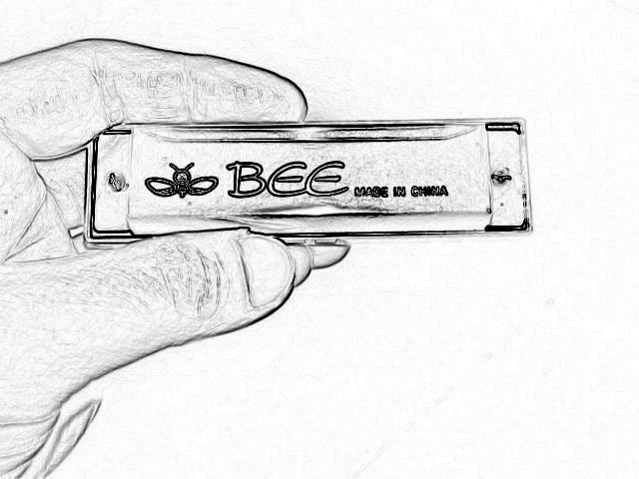

HARMONICA ITEM FROM CHINA

observed: select Teroristang Komunista members migrated from SOUTHERN CHINA;

adds: misuses even religious beings, e.g. 観音 (guanyin; kannon), to make gawa-gawang RULES to get QUICK MONEY

Example gawa-gawang RULES:
Do NOT answer questions for clarification due to among others: SECRET, SURPRISE WEDDING;
IF target still does NOT obey, shall cause stalking, intimidation, harrassment, et cetera; NOISE POLLUTION;

Output: UNCLEAR/MALABO Communication for abuse by the Manloloko group;

observed: Manloloko group ACTION to be as with JIN from Detective Conan Japanese MANGA/Comic series; where: TARGET is tasked by JIN to get MONEY as payment, but learns that even with MONEY, still NOT sufficient; KILLS TARGET
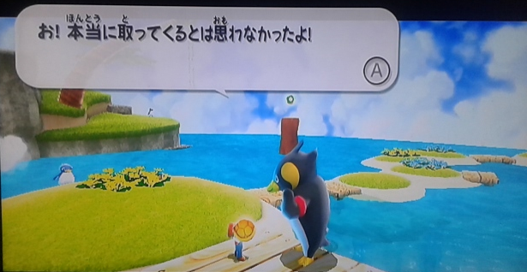
"Hindi ko inisip na kukunin mo't darating ka talaga!"

reminder#1: file: incident reports with Police
reminder#2: no need for excessive optimization/perfectionism with incident reports

observed: if NOT yet killed, NOISE POLLUTION and UNCLEAR/MALABO Communication continue;

3.3) shares: reduced Noise via Ear Plugs
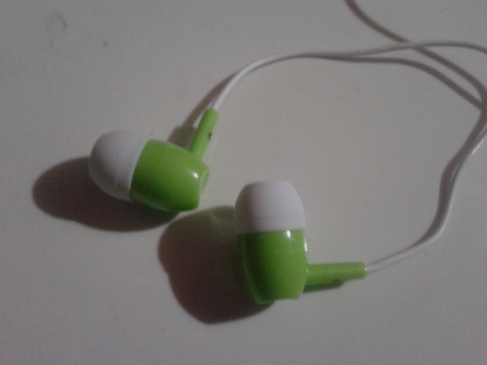

--> adds: however, shall NOT be able to answer telephone Calls @Workplace

--> reminder: lahat na tayo may antenna to receive unsolicited wireless broadcasting;
--> Technology misused to cause NOISE due to NOT Profitable Legally

--> adds: reflected LIGHT from metal part of Stapler causing Erased Effect

--> observed: technique misused to cause NOISE on Object Movement



Lahat na tayo may Antenna na nakasasagap ng unsolicited wireless broadcasting;



