
December 2021
｢合気道｣: aikidou
pinagsamang kaluluwa daan;
｢平安｣: heian
payapa; patag babae may bubong

PHILIPPINES: USBONG CONTINU​ES TO PROVIDE
COMPUTER SERVICE ASSISTANCE BY SHARING
KNOW-HOW ON MAPARAANG PAGBIBILANG

To eliminate excess steps and inefficient time usage, MARIKINA ORTHOPEDIC SPECIALTY CLINIC (MOSC) requested Usbong's services to automate routine, monotonous tasks and share with unit members know-how on computers.

Here are Key Action Items that we executed in this updates list.
1) Continued to update Knowledge Management System (KMS)
1.1) continued: to share know-how on computers and Information Technology (IT) tools
1.1.1) shared: with Public, count total Elapsed Time per Usage before rest
--> Example: verify: if > 1hr in front of computer/television monitor
--> observed: when there exists no set task to execute, Unit member shall watch videos on the Internet
--> observed: This action is equal with verifying news feeds from Social Networking Service (SNS)
--> Recommended Actions:
--> 1) Stop using Internet access when there is NO clear task to execute
--> 2) Turn OFF Internet access by 21:00 MAX

NOTE (from SYSON, MICHAEL B.):
At present, I STOP Computer (and Internet access) use earlier than 21:00, e.g. 20:00. This is due to excess noise from passing vehicles, e.g. Delivery Trucks, causes me to also wake earlier than 05:00.

identified: excess noise to be from wireless signals transmitted by the budol-budol/carnapper/manloloko/cybercriminal/communist terrorist group.
--> excess noise classified to be noise pollution due to vehicles, e.g. Trucks, do NOT ordinarily make such sounds

notified: Barangay Sto. Niño, Office of Public Safety and Security (OPSS)

Additional Note:
1) observed: increase in available Time after stopping use of Internet access

Recommended Action:
received: Time be used with face-to-face interaction with spouse, children...
Example Activities:
--> play musical instruments, physical training, e.g. swimming
--> build house using popsickle sticks (which uses Maparaang Pagbibilang)
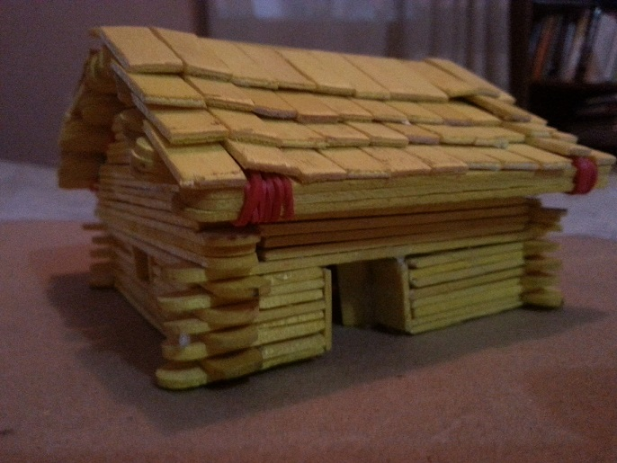

Built Popsickle Stick FINNISH Sauna House with 7yr old Nephew
in the Year 2016

--> practice languages, e.g. nihongo, Deutsche
--> where: nihongo = Japanese language
--> where: Deutsche = German language

shared: with another nephew (now 5yrs old; Year 2021), in school, make friends with those who are learning nihongo and/or Deutsche
--> verified: Filipino citizens who learn such languages also more quickly learn Maparaang Pagbibilang than those who only learn as foreign language English
--> reminder: learning the language includes learning the history
--> Example: History of East and West Germany
--> where: progress became efficient in West Germany than East Germany
--> This is due to clear communication, i.e. MALINAW, hindi MALABO;
--> In addition, statements are based on evidence.
--> After result became clear, the Berlin Wall that separated East and West Germany fell; Germany re-unified in the 90's. By the Year 2000's, majority of the German people became classified to be content, i.e. ginhawa na.

--> The actions of the budol-budol/carnapper/manloloko/cybercriminal/communist terrorist group with their continuous misuse of wireless broadcasting technology to make noise pollution with physical injury cause delays and inefficiency in progress.
--> Recommended Action: Puksain ang mga Teroristang Komunista;
--> No need for negotiation.

Recommended Action:
verify: Deutsche Welle (German Language Wave) Documentary
--> Angela Merkel - Navigating a world in crisis | DW Documentary
"Angela Merkel has been Germany’s Chancellor for 16 years. In that time, she has steered the country through countless international crises, frequently crossing swords with other world leaders."

2) Continued to share know-how regarding Security Defense Force
2.1) Audio Player Transmitter of Frequency Modulator (FM) Radio Wireless Signal
WWW.CDRKING.COM Item
9-in-1 Bluetooth 5.0 adapter+receiver AND transmitter FM Radio Music Player audio adapter for music streaming sound system
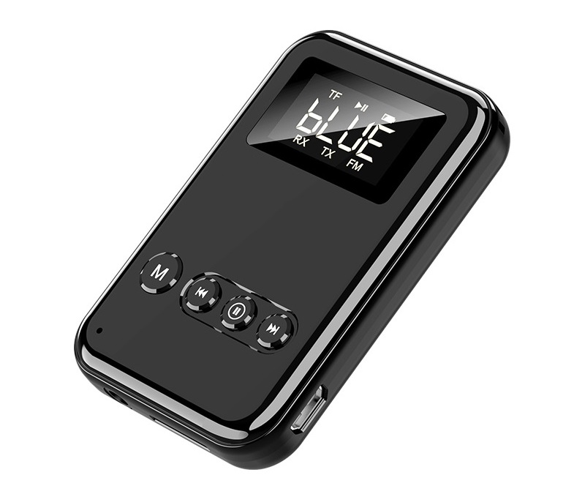
Cost: PHP500~600
Net Weight: 21g; Size: 55 x 21 x 15mm
Frequency: FM 87.5 – 108MHZ
Input: Max DC 5V/2.1A
Battery: Built-in 300mAh Battery
Charging Time: About 1 Hour
Standby Time: About 30 Days

NOTE (from SYSON, MICHAEL B.):
Over 10years ago, Year 2007~2008, I also verified another CDR-KING audio transmitter. However, instead of using Bluetooth technology to connect the transmitter with the Audio player, we used an audio cable and port.

Example Usage: We set the transmitter's frequency to use, e.g. 100. We also set the vehicle radio's receiver frequency to use 100.

With this technique, the vehicle radio shall play the transmitted sound using its speakers. In addition, nearby vehicles who also use the frequency 100 shall receive to play the transmitted sound.

Reminder: Select frequencies are used by broadcasting networks.
Examples: 94.7 Mellow; 100.3 RJ

Using the same frequency shall cause the output sound of the vehicle speaker to include the received audio from the CDR-KING transmitter.

Result: Excess, i.e. Noise, instead of Clear Music.

Additional Notes:
1) learned: audio transmitter item from younger brother in 2007
--> observed: item NOT the usual for me due to used vehicle radio, cassette
--> observed: vehicle Compact Disc (CD) player (if available) malfunctions to destroy inserted CD
--> observed: vehicle air-conditioning machine malfunctions, e.g. loss of freon gas; after incident, vehicle quickly sold
--> noted: observations to be included in pattern of related carnapping, vehicle incidents, et cetera that would continue in the coming years
--> identified: in 10 years, members of the budol-budol/carnapper/manloloko/cybercriminal/communist terrorist group
--> filed: with Law Enforcement, incident reports with identification

2) The transmitter's electric wave as measured by signal strength is NOT as strong as a wireless broadcasting tower's.
--> verified: the budol-budol/carnapper/manloloko/cybercriminal/communist terrorist group to misuse wireless broadcasting towers such that the transmitted signal reaches Brgy. Marikina Heights AND Brgy. Sto. Niño.

Reminder#1: Brgy. Marikina Heights is located at a higher, elevated part of the Marikina Valley; Brgy. Sto. Niño is located at a lower part.
--> executed: walking from Brgy. Sto. Niño to Brgy. Marikina Heights during non-raining Sunday mornings;
--> Walk Elapsed Time: 40mins (one way)
--> Walk Distance: 960meters (one way)

Reminder#2: While at place of residence and workplace in Brgy. Sto. Niño, the budol-budol/manloloko/carnapper/cybercriminal/Teroristang Komunista group transmitted such signal to my CDR-KING mini wireless radio/speaker, while I was attempting to defend myself from their noise using static sound from a supposedly unused radio frequency.

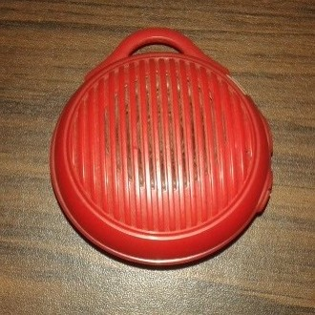

Approx size: 6x6cm

Reminder#3: Android telephone speaker can reach >= 40meters
--> The Teroristang Komunista group continues without permit to misuse:
--> Telephone mic to execute eavesdropping,
--> Telephone speaker to cause noise pollution
--> verified: wired/wireless-tapping executed using telephone network, GLOBE, and Dr. SYSON, Pedro's GLOBE post-paid SIM telephone number.
--> Recommended Actions:
--> 1) Turn OFF telephone and/or Set to Flight mode to disconnect from wireless network
--> 2) notify: spouse, siblings, et cetera to send you a written message via, e.g. Short Messaging Service (SMS) if CALL is NOT received.
--> Telephone network shall send you the written message when you re-connect to wireless network.
--> 3) notify: Law Enforcement

2.2) Action Technique: Shotokan Karate
--> https://www.youtube.com/user/shotokankataman/videos;
--> last accessed: 20211121
--> Heian Shodan - Shotokan Karate
--> Peace Beginner Level
2.2.1) 合気道 (あいきどう；aikidou）
--> (pinagsamang kaluluwa daan)

2.2.2) 平安（へいあん、初段～五段; heian, shodan ~ godan）
--> payapa; patag babae may bubong; simulang nibel ~ ikalimang nibel

2.2.3) 鉄騎初段（てつ＋き＋しょだん; tetsu + ki + shodan）
--> bakal na kabayo malaki maaari simulang nibel

2.2.4) 抜塞大（ぬく＋ふさぐ＋おおきい; nuku + fusagu + ookii）
--> tanggalin baradong malaki

2.2.5) 観空大（みる＋くう・そら＋おおきい;
miru + kuu・sora + ookii）
--> masdan kawalan・kalangitan malaki
・・・
2.3) Paalala#1:
2.3.1) 結局、歴史では、戦争が伸びてると、
kekkyoku, rekishideha, sensou ga nobiru to,
Kinalauanan, sa kasaysayan, sa paghaba ng digmaan,

兵士が疲れるし、供給なども切れる・・・
heishi ga tsukarerushi, kyoukyuu nado mo kireru...
napapagod ang sundalong mag-aaral, napuputol ang bigay na pagsasaluhan (supply)...

敵がわかれば、ターゲットして、
teki ga wakareba, ta-gettoshite,
Kapag alam na ang kalaban, gawing target,

優柔不断をせずに、早めに終わりにすること。
yuujuu fudan wo sezu ni, hayame ni owarini suru koto.
hindi gawin ang walang hintong bait at pag-aakma (flexible), tapusin na habang maaga pa.

わくわくすることなく、仕事としての決断でね。
wakuwaku suru koto naku, shigoto toshite no ketsudan de ne.
hindi gawin nang may excitement; bilang hanap-buhay pagpasiyahan, hinto.

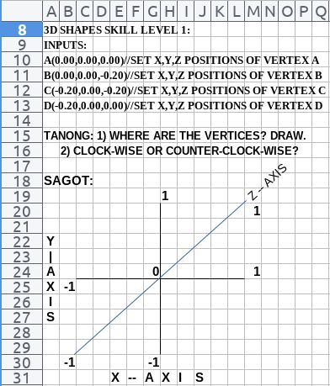

USBONG I.T. SOLUTIONS
COMPUTER SERVICES

SYSON, MICHAEL B.
FOUNDER

MOBILE: +63929.952.7263
EMAIL: MASARAPMABUHAY@GMAIL.COM

WEBSITE: WWW.USBONG.PH
ADDRESS: #2 E. MANALO (FORMERLY, E. RODRIGUEZ) AVE., STO. NIÑO, MARIKINA CITY, 1820, PHILIPPINES

ALGEBRA SKILL LEVEL 3:
INPUTS:
S = 600K //EXCESS STOCK IN WAREHOUSE (JAPAN)
D = 180 //IN USD OF EACH STOCK
L = ? //LOSS

NOTES:
1) USD = UNITED STATES DOLLAR
2) PHP = PHILIPPINE PESO
3) USD1 : PHP54

TANONG#1: WHAT IS THE LOSS IN PHP?
SAGOT:

TANONG#2: WHAT IS THE LOSS IN PHP IF WE SET
USD1 : PHP0.50?
SAGOT:





2.4) Paalala#2:
うまくできることをして、
umaku dekiru koto wo shite,
Gawin ang maiging nagagawa,

意味がわからず、うまくできないことを
imi ga wakarazu, umaku dekinai koto wo
hindi maunawaan ang saysay, hindi maiging magawa,

他にして良い。
hoka ni shite yoi
Sa magagawa ipagawa, ayos.
2.5) budol-budol/manloloko/carnapper/cybercriminal/Teroristang Komunista group
--> Patuloy araw-gabi ang kanilang maling paggamit ng wireless broadcasting technology sa paggawa ng panlolokong ingay at pisikal na pananakit.
--> Kahit ang Nanay-nayan kong Hapon binabastos.

--> Mungkahing mga Aksyon:
2.5.1) Matuto ng Maparaang Pagbibilang.
2.5.2) Gawan ng incident report ang Pulis.
2.5.3) Puksain ang mga Teroristang Komunista.
--> Hindi na kailangang makipag-usap sa mga Manloloko.
--> There is NO COMMUNICATION using Teroristang Komunista's wireless broadcasting technology.
--> In its stead, increased Noise Pollution with Physical Injury
NOTE (from SYSON, MICHAEL B.):
I had to start going to partner Sta. Lucia Health Care Center (SLHCC) due to the CASH and Health Maintenence Organization (HMO) Payments were NOT being received correctly and quickly.

DR. SYSON, PEDRO requested my assistance due to NOBODY else was going to work on it. Without yet my wife's physical presence to assist, I had to shift focus away from our USBONG STORE, USBONG SPECIALTY BOOKSTORE, et cetera.

While working on the task, I learned that the noise pollution from the Teroristang Komunista group continued at SLHCC.

The Accountant who was mainly responsible for working on the task experienced a STROKE on the face, classified to be BELL's PALSY.

Previously, a Medical Doctor (Orthopedic Surgeon) who was part of MOSC also had a STROKE, which caused him to have a MAJOR surgical operation on the head.

The wireless electric, magnetic, sound waves broadcasted by the budol-budol/manloloko/carnapper/cybercriminal/Teroristang Komunista group is NO JOKE.

Additional Note#1: The Medical Doctor trained first at the University of the Philippines Manila as part of INTARMED (INTegrated Liberal–ARts MEDicine).
--> where: INTARMED: intense yet quick Medical Doctor training
--> where: Orthopedic: dagdag na training na may kinalaman sa BUTO, MASEL, at sa mga NAGDIDIKIT sa mga iyon, e.g. JOINT
--> where: Surgeon: keyword: KNIFE
--> Select Readings: https://ronibats.ph/2011/how-i-got-into-intarmed/;
last accessed: 20211225

Additional Note#2: The Teroristang Komunista group has been misusing the Closed-circuit Television (CCTV) Camera inside the household, in particular where the vehicles are located, and even inside MOSC
--> The CCTV Camera exists to supposedly provide security monitor surveillance; It can be accessed using an Android application.
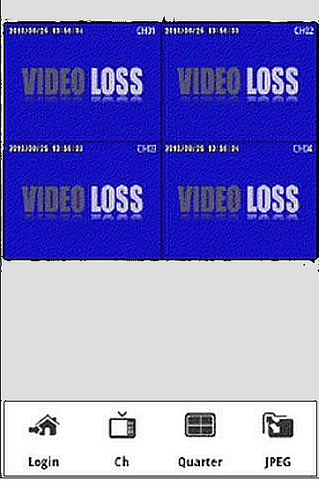
--> Example:

Bubo Bubo Android Application (with Digital Video Recorder (DVR) + CCTV Camera System)

https://m.apkpure.com/bubo-bubo/icatch.video.h264#icatch.video.h264-3;
last accessed: 20211206

--> Executed Actions:
--> notified: DR. SYSON, PEDRO to change the PASSWORD to access the CCTV Camera System, instead of having us with the MOSC Unit continue to endure the attacks, e.g. noise pollution, vehicular theft.
--> reminded: DR. SYSON, PEDRO to file a report with the Police identifying his younger brother, SYSON, RAMON, and his family as members of this Teroristang Komunista group.

Additional Note#3: observed: Teroristang Komunista group has been promulgating their gawa-gawang INDIRECT COMMUNICATION
--> This is executed by causing noise pollution, e.g. grave threats "patayin", AND physical injury (falling to the ground) to those who do NOT obey their Gawa-gawang Patakaran (Rules)

Example Gawa-gawang Patakaran:
1) Do NOT share know-how with People, including the Police.
2) Do NOT file incident reports with Law Enforcement.

--> observed: this is due to the Teroristang Komunista group aims to be the "Law Enforcement" of their own Gawa-gawang Patakaran that is NOT of the community.
--> In addition, while target UNIT is at CHAOS, having UNCLEAR/MALABO Communication, this Manlolokong/Teroristang Komunista group steals vehicles, et cetera to get quick money.

Example#1 Physical Attacks causing Injury to Target:
Target: SYSON, MICHAEL B.
Both Knees (datetime stamp: 2020-10-15T13:34)

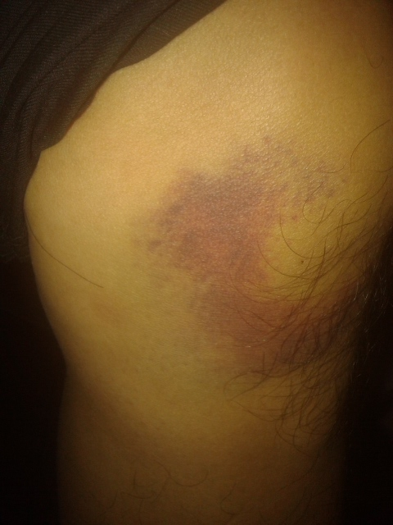  LEFT KNEE | 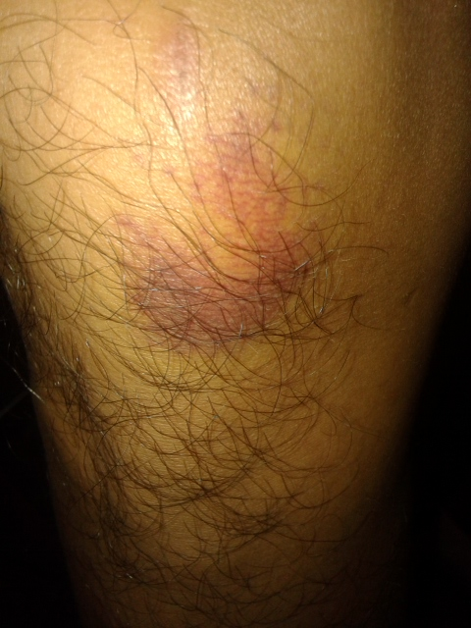  RIGHT KNEE

Reminder: In Physics, we learn that sound carries energy.
That energy hits our eardrums when the sound as wave enters our ears.
A sufficient amount of energy can physically hurt our eardrums.
We know the amount of energy is sufficient because we already feel pain.
This leads to loss of hearing, which further leads to falling to the ground due to being off balance.

Reminder: SYSON, MICHAEL B. continues to endure multiple attacks from this Teroristang Komunista group.
Example#2: index finger hitting electric fan of computer mother board while executing computer repair service, causing noticeable amounts of blood to come out.

observed: Senior Members of this Teroristang Komunista group are dying
--> Teroristang Komunista admits to self to be Manloloko
--> Result: CHAOS (internal and external) leading to CANCER
observed: Senior Citizens have difficulty changing their habits
--> The younger generation shall make mistakes due to YABANG from crimes committed while dependent on Senior Members

Recommended Action: Destroy the younger generation of this Teroristang Komunista group. No need for negotiation.

NOTE (from SYSON, MICHAEL B.):
生き残りながら、がんばって、
ikinokorinagara, gambatte,
Habang natitirang nabubuhay, gawin nang lubos ang magagawa,

この犯罪グループを終わりに致しております。
kono guru-pu wo owarini itashite orimasu.
ang kriminal na samahang ito, wakasin, ginagawa ko po.

ご協力をお願い申し上げます。
gokyouryoku wo onegai moushiagemasu.
Ang inyo pong pinagsamang tulong na lakas, aking may galang na pakiusap.

NOW HIRING: COMPUTER SERVICES SALESPERSON
✓Receive half of the revenue from your DIRECT SALE of the service

✓Receive training:
Filipino Language, Sales, Information Technology
Requirements:
1) Curriculum Vitae
2) Portfolio
3) Sulat ng Hangarin
3.1) Ano ang maitutulong mo?
3.2) Bakit mo nais ito?
3.3) Bakit ka karapat-dapat?



EMAIL: APPLY@USBONG.PH

Tanong at Sagot

1) Magkano ang aking kikitain bilang Computer Services Salesperson at Manunulat ng paliwanag sa kompyuter, e.g. Add-on Software?
--> Kung babayaran tayo ng klinik ng 10K pesos bawat buwan, 5K ang sa iyo bilang Computer Services Salesperson.
--> Bilang Manunulat, 4K pesos ang maibibigay sa iyo ng Usbong.
--> Sa kabuuan, 9K pesos ang matatanggap mo bawat buwan.
--> Ang matitirang 10% ng 10K, i.e. 1K pesos, gagamitin ng Usbong sa pag-iipon ng kapital.
--> Gagamitin ito ng Usbong sa paggawa ng mga investment at "float", na ang kahulugan, liquid asset.

2) Paano ako makibabahagi sa tagumpay ng kompanya?
--> Kung wala tayong kikitain mula, halimbawa, sa Computer Automation Service, mauubusan tayo ng kapital na pambayad sa ating lahat. Hindi magtatagal, wala na tayong kompanya.
--> Dahil dito, kailangang maayos ang ating paggawa at pagtuturo sa mga trainee upang tuluy-tuloy ang daloy ng ating kita, habang nagbibigay ng ginhawa sa lipunan.

MAPARAANG PAGBIBILANG
ALGEBRA SKILL LEVEL 1:
INPUTS:
X = 250 //ITEM PRICE
V = 12% //VALUE ADDED TAX (VAT)
Q = ? //ITEM PRICE WITH VAT

TANONG: WHAT IS ITEM PRICE WITH VAT?
SAGOT:

ALGEBRA SKILL LEVEL 2:
INPUTS:
X = ? //ITEM PRICE
V = 12% //VALUE ADDED TAX (VAT)
Q = 364 //ITEM PRICE WITH VAT
TANONG: WHAT IS ITEM PRICE WITHOUT VAT?
SAGOT:

