
August 2021
↑ KNOW-HOW causes
↑ available PRODUCTS・SERVICES

PHILIPPINES: USBONG CONTINU​ES TO PROVIDE
COMPUTER SERVICE ASSISTANCE BY SHARING
KNOW-HOW ON MAPARAANG PAGBIBILANG

To eliminate excess steps and inefficient time usage, MARIKINA ORTHOPEDIC SPECIALTY CLINIC (MOSC) requested Usbong's services to automate routine, monotonous tasks and share with unit members know-how on computers.

Here are Key Action Items that we executed in this updates list.
1) Continued to update Knowledge Management System (KMS)
1.1.1) shared: answers to questions via www.stackoverflow.com, www.askubuntu.com, et cetera
--> reminder: There exists logical answer to logical question;
--> where: logical = clear, not emotional
--> where: logical questions = mga tanong ukol sa Maparaang Pagbibilang.
--> Example Question: How to execute "Drawing circle with GL_POLYGON, radius out of scale"?
--> Example OUTPUT:
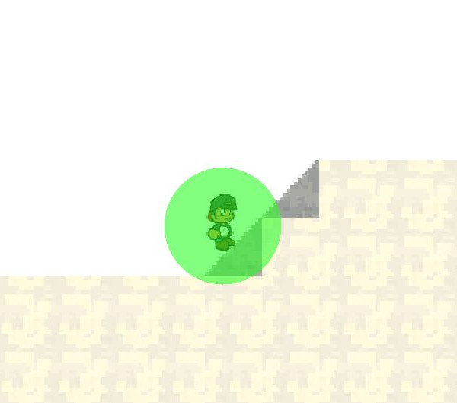

Auto-drawn Circle Shape

--> Example Answer (executed on LUBUNTU (LTS 20.04) machine):
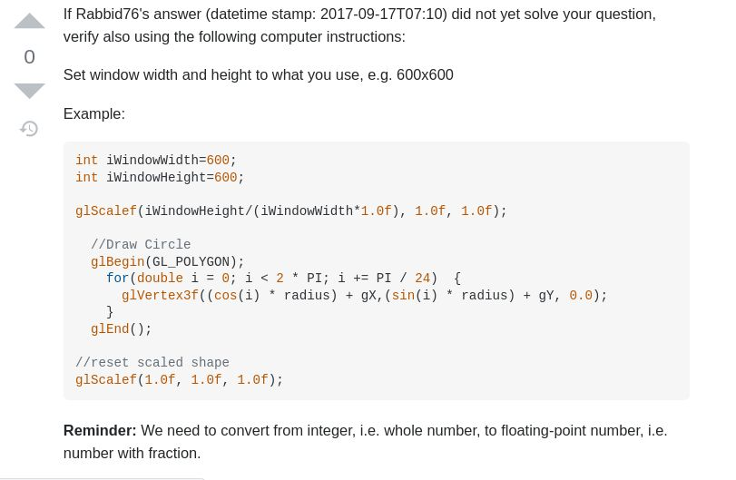
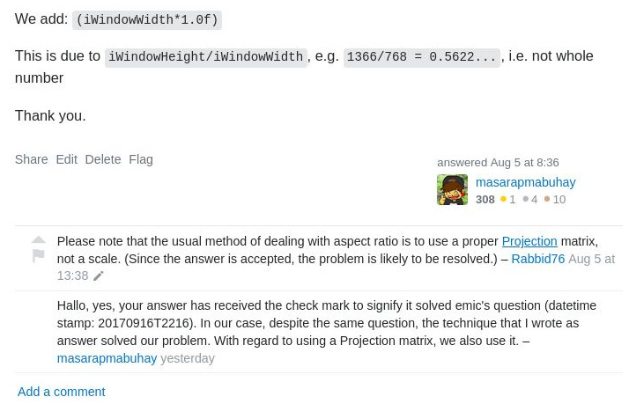
1.1.2) shared: computer instructions to climb diagonal of right triangle tile on www.github.com

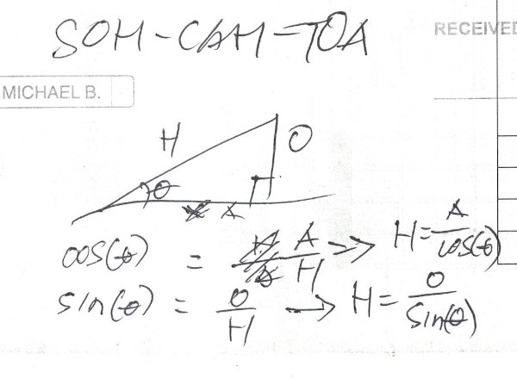
NOTE (from SYSON, MICHAEL B.):
We need to find the correct position in the Hypothenous, i.e. diagonal line of the right triangle. We know the following:

1) right triangle, i.e. has 90degrees angle inside;
--> There exist 3 angle values in a triangle; added total is 180degrees; In this case, the two (2) remaining angle degrees vales: 45 and 45;
--> from 90/2=45;

2) step in X-axis; we set it to be the A, i.e. adjacent side of angle theta
3) step in Y-axis; we set it to be the O, i.e. opposite side of angle theta

Recommended Action: learn: Maparaang Pagbibilang;
Recommended Reference:
learn: http://www.mathisfun.com/sine-cosine-tangent.html
--> last accessed: 20210810

Additional Note:
1) added: gravity in the world
--> Otherwise, Pilot as Unit member shall appear to float when moving in the opposite direction, e.g. in the x-axis;
This is instead of moving down due to gravity.
--> 重力がなかったら、山を登れない。
--> juuryoku ga nakattara, yama wo noborenai.
--> Kung walang bigat+lakas, i.e. gravity, hindi makaaakyat ng bundok.

1.2) added: web page version of select forms, e.g. from Laboratory Unit
--> This action is to assist Unit members who need to find, answer, and print the correct forms.

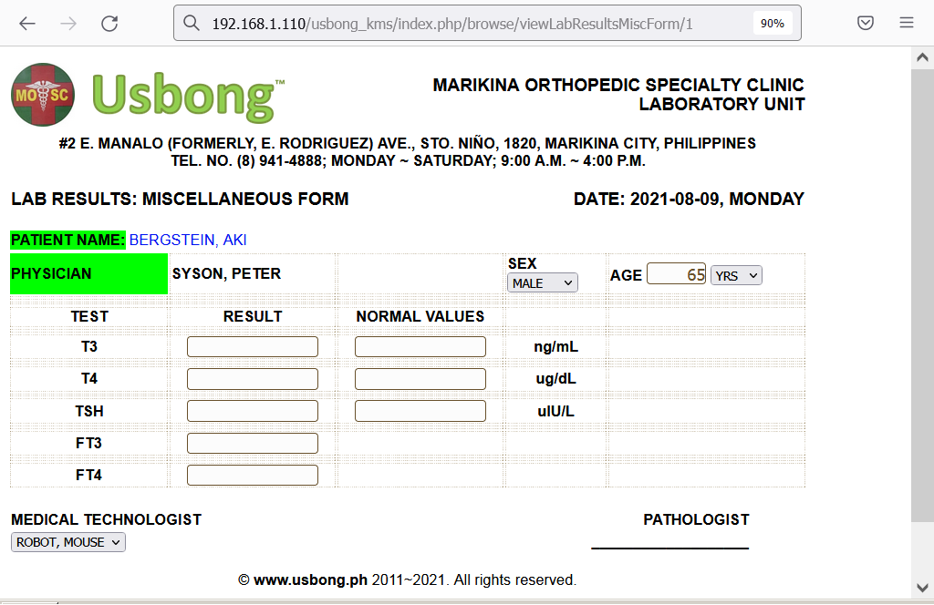
--> added: .csv (Comma Separated Values) template for this form
--> reminder: computer auto-generates the Hypertext Markup Language (HTML) web page
--> Template used as input to identify the positions,
--> when creating the table with columns and rows

NOTE (from SYSON, MICHAEL B.):
Recommended Reading:
Johnson, S. (1998). Who moved my cheese? UK: Vermilion

Johnson writes a story of mice and the value of change to achieve cheese, i.e. wealth.

There exist variations of mice:
1) Those who do NOT change due to already hve cheese; Did NOT want to accept the pattern of decreasing cheese.

2) Those who do NOT change due to FEAR of NOT finding more cheese; Prefers to stay as is, despite the pattern of decreasing cheese.

3) Those who do change to find new cheese; accepts the pattern of decreasing cheese; Executes action despite need for movement.

Additional Notes:
1) observation: Expenses > Income Pattern;
--> Budol-budol/manloloko/carnapper/cybercriminal/communist terrorist group continues to misues wireless broadcasting technology to cause noise pollution and physical injury.
--> Objective: Quick money;
--> Recommended Action: Puksain and Teroristang Komunista;
No need for negotion

2) Increase in Tamad causes Increase in Masama, e.g. Manloloko
--> This is due to as wealth increases, people classified as communist increase.
--> "Communist"/Komunista: Tao na naniniwala na dahil sagana na tayo, hindi na natin kailangang maghanap-buhay.
--> We clarify that a Communist is NOT necessarily evil.
--> Indeed, a Communist may still go to work, albeit believes that it's NOT necessary.
--> The problem occurs when they become Terrorists.
--> "Terrorist"/Terorista: Tao na gumagawa ng panloloko at pisikal na pananakit sa isa at higit pang mga tao.
--> "Communist Terrorist": Tao na naniwala na sagana na siya, kaya lang naubasan gawa ng pagwawaldas; naging Terorista upang mabilis na makakuha ng pera.
--> As the next generation continues, e.g. the family business, the increasing number of members in the household causes the previously sufficient income to become insufficient.
--> Solution: It is vital that each communist・family・company member learn the value of honest work.

2) Continued to share information on Health
--> Security Defense Force: Part 23: BMI: Body Mass Index
= 体格指数 (katawan maramihang turong bilang)

BMI＝体重［kg］/ 身長［m]^2 ≧ 25のもの
where: BMI = Body Mass Index
体重 (taijuu) = katawan bigat
身長 (shinchou) = katawan haba

Example: 80kg / (1.80mm)^2 = 24.69
Reminder: 180cm = 1.80mm
Reminder: 18.5 ≦～＜25 普通体重 (futsuu taijuu; ordinary body weight); Normal Range
2.1) Dagdag na Sanggunian:
http://www.jasso.or.jp/data/magazine/pdf/chart_A.pdf; last accessed: 20210809
日本肥満学会 (nihon himan gakkai)
Japan Society for the Study of Obesity

2.2) Mungkahing Aksyon:
2.2.1) verify: body weight each day; increasing, decreasing, no change?
--> verify: actions to achieve correct body weight for your height
--> example#1: continuous walking of at least 20mins daily.
--> This action reduces body weight by at least 1kg.
--> example#2: choosing NOT to eat meat in the evening.
--> This is after already eating meat during lunch.
--> In its stead, eat fruits, vegetables, even rice.
--> This action also reduces body weight by at least 1kg.
--> example#3: drink milk <1/2 cup every other day (approx).
--> Otherwise, due to not as physically active as growing children, we shall grow excessively big.
3) Continued with Research & Development (R&D)
--> increased know-how causes increased available products・services
--> Example: know-how of computer hardware parts and software instructions

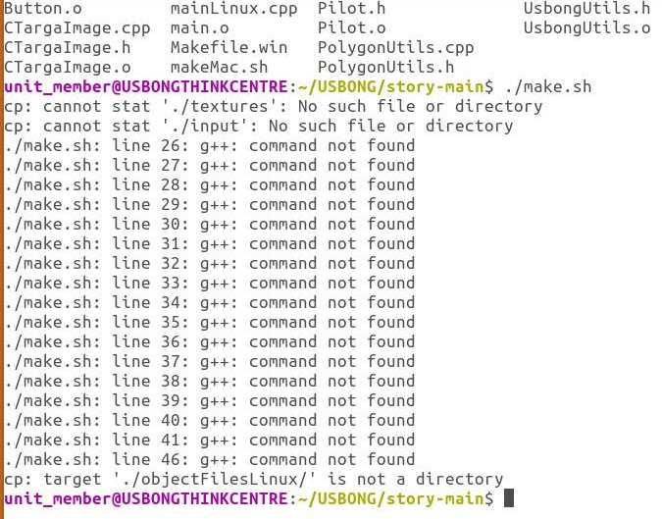

g++ library not yet installed
reminder: library contains reusable sets of instructions

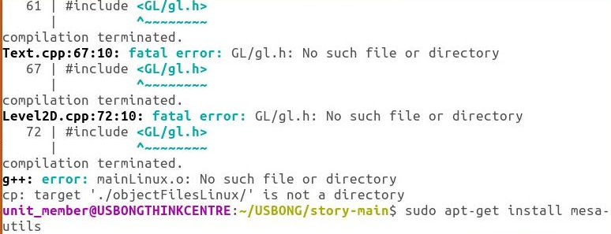
GL not yet installed
where: GL = Graphics Library from OpenGL

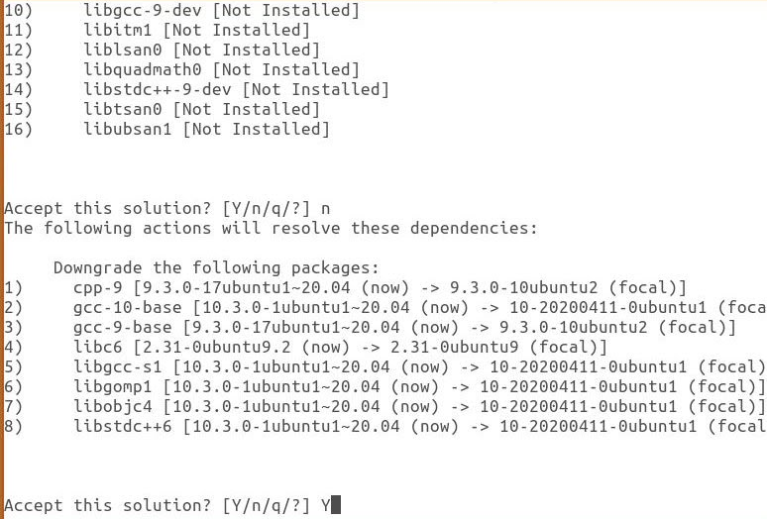
Computer Solution#1: Not to install
Computer Solution#2: Downgrade existing packages to install

--> computer repair skill increased; service via computer repair unlocked
3.1) Example Computer Repaired:
3.1.1) Hardware:

System: 64-bit Operating System (OS)
Processor: Intel(R) Core(TM) i3-4160 CPU @3.60GHz
Memory: 4GB Random Access Memory (RAM)
+Digial Video Disc (DVD) hardware device

--> SATA Harddisk Storage read problem;
--> where: SATA = Serial Advanced Technology Attachment
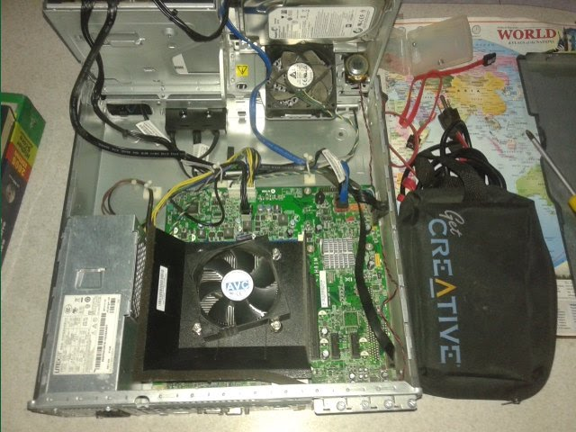

--> verified: replacing SATA cable part (PHP35) to connect to POWER
--> and data transfer unit; reminder: variations in SATA cable part exist;

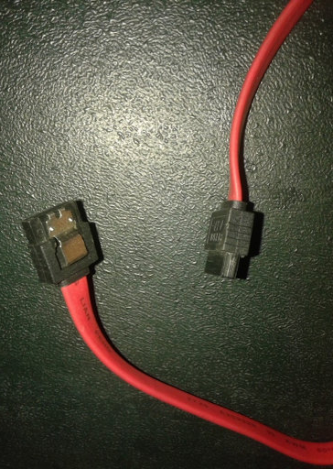 | 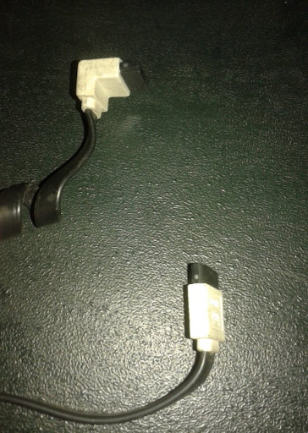
SATA cable head variation#1 | SATA cable head variation#2

--> available physical space still insufficient to cause excess bending of cable to cause read problem
--> replaced: SATA Harddisk Storage with mini version (PHP650; 160GB) used with Laptop computers
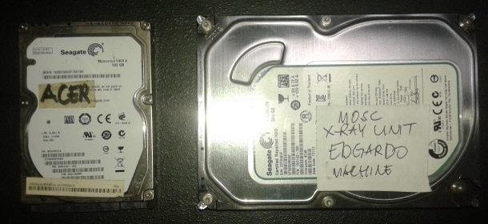
LEFT: SATA HARDDISK (MINI VERSION);
RIGHT: SATA HARDDISK

--> Computer Estimated Cost with SATA Harddisk Storage (250GB): PHP6,000
3.1.2) Software: Basic Input Output System (BIOS) Only
3.1.3) Results:
3.1.3.1) Hardware:
obtained: computer valued at PHP4,000 from <PHP4,000 due to un-repaired
obtained: know-how to execute service repair valued at >PHP685 from PHP0
obtained: computer product valued at >PHP4,685 from <PHP4,000
3.1.3.2) Software:
obtained: LUBUNTU (LTS 20.04) OS; from None
obtained: GNU Image Manipulation Program (GIMP); from None
obtained: LibreOffice Suite, e.g. Calc; from None
obtained: Usbong Pagong; from Usbong Story
3.2) Example Computer Reused:

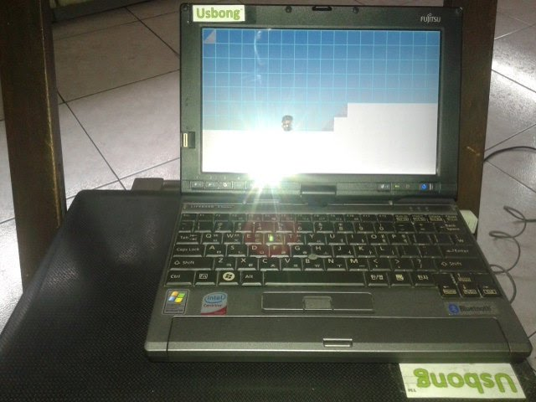
3.2.1) Hardware:
System: 32-bit Operating System (OS)
Processor: Intel(R) Core(TM) Solo CPU U1400 @1.20GHz
Memory: 1GB Random Access Memory (RAM)
Storage: 40GB Harddisk
Computer Purchased Cost: PHP4,000

NOTE (from SYSON, MICHAEL B.):
Computers used at the Cashier Unit need NOT be the fastest.

Even computers with the hardware and software specifications in our example can be reused. In addition, they can execute the following software applications, which our partner clinic, Sta. Lucia Health Care Center (SLHCC), uses.

1) auto-generate Payslip for the Day
2) auto-generate Official Receipt for the Day

The output of these are printed using a dot-matrix printer connected to each computer.

The computers also connect to a computer server at another Unit using a router with a small antenna. The wireless signal is sufficient to reach 30m (approx) distance. The computers form a Local Area Network (LAN).

By removing excess Graphical User Interface (GUI), such that only the Command Prompt Window remains, the computers can quickly send the Payslip reports for re-verification at the other Unit.

3.1.2) Software:
--> Basic Input Output System (BIOS)
--> added: Windows 7 Ultimate Service Pack 1; Year 2009
--> added: Java Virtual Machine (JVM); from None
--> added: Python Library (version 2.7.18); from None
--> added: LibreOffice Suite, e.g. Calc; from None
--> added: Usbong Story; from None
--> added: Usbong Pagong; from Usbong Story

NOTE (from SYSON, MICHAEL B.):
After verification, execution speed by 32-bit computer of OpenGL instructions is noticeably slow.

Reminder: OpenGL contains sets of reusable instructions to execute 3D and 2D computations.

However, due to technique used in OpenGL's instructions, even 2D computations become as noticeably slow, as those of 3D.

To solve this, we used Simple Directmedia Layer (SDL) and SDL Image to speed-up execution of 2D computations, and removed OpenGL.

Output: Usbong Pagong
Your browser does not support the video tag.

Additional Notes:
1) "Command & Conquer: Red Alert" (Year 1996): execution speed noticeably fast
--> even with Windows XP machines (32-bit OS);

2) "Command & Conquer: Tiberian Sun" (Year 1999): execution speed became noticeably slow; from SDL to Non-SDL?
--> observed: NON-SDL and OpenGL NOT anymore noticeably slow with 64-bit Operating Systems

3) There now exists OpenRA: "Open Source real-time strategy game engine for early Westwood games such as Command & Conquer: Red Alert written in C# using SDL and OpenGL. Runs on Windows, Linux, *BSD and Mac OS X."
--> https://github.com/OpenRA/OpenRA; last accessed: 20210821
--> reminder: Open Source = computer instructions are available to the public

4) Continued to share information on Security Defense Force
Part 24: Pera, Batas
4.1) Pera: Money History
--> exchange of items: guitar to exchange with fish
--> fish to exchange with vegetables
--> currency, e.g. Philippine Peso (PHP), speeds-up system
--> no need to find a person who is willing to exchange his fish for your guitar
--> we can quickly exchange the guitar for a set amount of money in PHP currency
--> A set of this set amount we can use in exchange for vegatables, et cetera
--> Reminder: There also exists exchange of service
--> Example: Computer repair service
--> Additional Reminder: What we only need is 金 (money) from those who receive quality products and services from us.
--> observation: a person in-need of money does not create quality products・services.
4.2) Batas: Law Interpretation
--> observation: from American literature, e.g. New York Times, we learn that the law was created to have variations in its interpretation.
--> Ginawa ang batas na nakabatay sa kung paano mo nauunawaan ito.
--> However, due to majority wins, a majority group of people has to interpret it in the same way.

--> Problem: in select systems, only a minority has learned Maparaang Pagbibilang
--> Therefore, the majority can be manipulated to agree in a minority's interpretation

--> Example: A person in-need of money shall accept whatever interpretation to receive money.
--> A person in such need may be a Father of an ill Mother.
--> Reminder: maintenance medicine of a Senior Citizen can cost >= PHP5,000 per month

--> However, after verification, the Teroristang Komunista had been using as weapon wireless broadcasting technology
--> to cause the person to become ill.
--> Cause: Quick Money;
--> Kung kailangan-na-kailangan mo ng pera, maipagagawa niya sa iyo ang nais niya.
--> Therefore, as long as the majority is in-need of money, a minority can manipulate them to accept the interpretation.
--> Reminder: a pie chart can have one (1) majority and several minorities;
--> The Teroristang Komunista is an example minority that has NOT learned Maparaang Pagbibilang

--> observation: in nations, e.g. Japan, France, Germany, Switzerland,
--> people learn to be NOT in-need of money;
--> Example: eating food readily available to the common people;
--> contributing via work to the increase in value of the hometown itself
--> where: hometown is where you live

--> The Teroristang Komunista executes the opposite of these actions,
--> promulgating: Quick Money
--> Mungkahing Aksyon: Puksain ang mga Teroristang Komunista; No need for negotiation

NOW HIRING: COMPUTER SERVICES SALESPERSON
✓Receive half of the revenue from your DIRECT SALE of the service

✓Receive training:
Filipino Language, Sales, Information Technology
Requirements:
1) Curriculum Vitae
2) Portfolio
3) Sulat ng Hangarin
3.1) Ano ang maitutulong mo?
3.2) Bakit mo nais ito?
3.3) Bakit ka karapat-dapat?



EMAIL: APPLY@USBONG.PH

Tanong at Sagot

1) Magkano ang aking kikitain bilang Computer Services Salesperson at Manunulat ng paliwanag sa kompyuter, e.g. Add-on Software?
--> Kung babayaran tayo ng klinik ng 10K pesos bawat buwan, 5K ang sa iyo bilang Computer Services Salesperson.
--> Bilang Manunulat, 4K pesos ang maibibigay sa iyo ng Usbong.
--> Sa kabuuan, 9K pesos ang matatanggap mo bawat buwan.
--> Ang matitirang 10% ng 10K, i.e. 1K pesos, gagamitin ng Usbong sa pag-iipon ng kapital.
--> Gagamitin ito ng Usbong sa paggawa ng mga investment at "float", na ang kahulugan, liquid asset.

2) Paano ako makibabahagi sa tagumpay ng kompanya?
--> Kung wala tayong kikitain mula, halimbawa, sa Computer Automation Service, mauubusan tayo ng kapital na pambayad sa ating lahat. Hindi magtatagal, wala na tayong kompanya.
--> Dahil dito, kailangang maayos ang ating paggawa at pagtuturo sa mga trainee upang tuluy-tuloy ang daloy ng ating kita, habang nagbibigay ng ginhawa sa lipunan.

MAPARAANG PAGBIBILANG
ALGEBRA SKILL LEVEL 1:
INPUTS:
X = 250 //ITEM PRICE
V = 12% //VALUE ADDED TAX (VAT)
Q = ? //ITEM PRICE WITH VAT

TANONG: WHAT IS ITEM PRICE WITH VAT?
SAGOT:

ALGEBRA SKILL LEVEL 2:
INPUTS:
X = ? //ITEM PRICE
V = 12% //VALUE ADDED TAX (VAT)
Q = 364 //ITEM PRICE WITH VAT

TANONG: WHAT IS ITEM PRICE WITHOUT VAT?
SAGOT:

ALGEBRA SKILL LEVEL 3:
INPUTS:
S = 600K //EXCESS STOCK IN WAREHOUSE (JAPAN)
D = 180 //IN USD OF EACH STOCK
L = ? //LOSS

NOTES:
1) USD = UNITED STATES DOLLAR
2) PHP = PHILIPPINE PESO
3) USD1 : PHP54

TANONG#1: WHAT IS THE LOSS IN PHP?
SAGOT:

TANONG#2: WHAT IS THE LOSS IN PHP IF WE SET
USD1 : PHP0.50?
SAGOT:





USBONG
COMPUTER SERVICES

SYSON, MICHAEL B.
FOUNDER

MOBILE: +63929.952.7263
EMAIL: MASARAPMABUHAY@GMAIL.COM

WEBSITE: WWW.USBONG.PH
ADDRESS: #2 E. MANALO (FORMERLY, E. RODRIGUEZ) AVE., STO. NIÑO, MARIKINA CITY, 1820, PHILIPPINES

