
November 2021
｢得点王｣
"tokutenou"
"kumuha ng tuldok (punto) hari";
Computer Simulation Game

PHILIPPINES: USBONG CONTINU​ES TO PROVIDE
COMPUTER SERVICE ASSISTANCE BY SHARING
KNOW-HOW ON MAPARAANG PAGBIBILANG

To eliminate excess steps and inefficient time usage, MARIKINA ORTHOPEDIC SPECIALTY CLINIC (MOSC) requested Usbong's services to automate routine, monotonous tasks and share with unit members know-how on computers.

Here are Key Action Items that we executed in this updates list.
1) Continued to update Knowledge Management System (KMS)
1.1) continued: to share know-how on computers and Information Technology (IT) tools
1.1.1) shared: with Public, goal: execute in 1month work valued by client at >=3months
--> Example (3months): Total Income: PHP90,000 (100%)
--> Total Expenses (Tax, SSS, PhilHealth, Pag-Ibig, et cetera included): PHP30,000 (33.3%)
--> Total Saved: PHP60,000 (66.7%)
--> Note: Total Income (1month) PAYS Total Expenses (3months) @PHP30,000 (33.3%)

NOTE (from SYSON, MICHAEL B.):
It is doable to start at 10% Total Saved money.
Increase this with increasing know-how.

Example: Execute investment in Mutual Funds, e.g. Peso Bonds.
where: Peso Bonds = money lent with interest to Philippine government for Administration to execute public projects
where: public project example = road building to speed-up delivery of products, e.g. fresh milk

Reminder#1: verify: increase in your work years also causes increase in your know-how
Reminder#2: Increase in Total Income causes Increase in Total Expenses
Reminder#3: With those who are already married and have children, Total Saved money decreases.

Recommended Actions:
1) Spouse contributes in family work by increasing income and/or decreasing expenses.

2) Children Count: 2; increase if financially capable after computation
--> learn: Fertility Awareness Method (FAM) of Contraception
--> Female egg and NO-egg counting
--> Example (NO-egg): Count 25 days after 1st Day of Menstruation
--> Executable whether regular or irregular menstrual cycle pattern
--> Reminder: Female egg + Male sperm causes conception

Reference:
2.1) Insel, P., et al. 2008. Core Concepts in Health (10th Ed.). NY: McGraw-Hill


Used Book bought @BookSale, Philippines

3) When child reaches 16yrs old, set household to be as company dormitory.

4) By 18yrs old, allow children to execute skilled work,
--> e.g. computer program writing.

5) By 20yrs old, send children to Japan for >=10months of study abroad.
--> verify: savings pattern results in sufficient money to execute this action.


1.1.2) shared: with Unit members, Telephone Network Prepaid Load Reserve System

We add PHP100 load value from the 1st Prepaid Card to the Unit's mobile telephone.
We use the 2nd Card when we've used up all the 1st Card's load value.
Whenever a Card is used, we immediately replace it by buying a new Card.
Reminder: PLDT/SMART network has fluctuating wireless signal inside partner Sta. Lucia Health Care Center Clinic (SLHCC). Clinic located on basement floor.
GLOBE Prepaid Cards
each with PHP100 load value
Cost: PHP100 each

--> reminded: Unit members to verify Load Usage
--> This is to identify frequency of Card replacement and Total Cost

NOTE (from SYSON, MICHAEL B.):
I, myself, use Prepaid Cards, instead of Postpaid service with my mobile telephone.

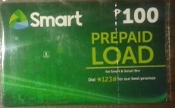

SMART Prepaid Card
with PHP100 load value
Cost: PHP100

Reminder: Postpaid service = Monthly Paid Load
Example: SMART Lite 5GB Internet Usage + Unlimited All networks Calls, Text, Landline Calls @PHP599/Month

With Prepaid Load, 1 SMS text : PHP1
From observation, I replace Prepaid Cards after 1~1.5 Months.

In addition, I do NOT necessarily stop myself from writing Short Messaging Service (SMS) Text and Calling over the network if necessary.

As for the Internet, I already have access @the workplace and place of residence in Marikina City, so there is no need to add excess costs.

I still use my Android telephone, albeit it's technology of over 5years already.
At present, I mainly use the following applications:
1) SMS text system; NOT email system
2) Viber Application (to upload SMS Reports)
3) Dictionaries
--> e.g, Japanese-English Dictionary (JED), Chinese Mandarin (PLECO)
4) Camera (to capture Photographs) & Voice Recorder (to record Sound)
5) Firefox Web Browser (to access Usbong KMS)

Recommended Action:
--> learn: technique to replace telephone's Android Operating System (OS) with a Lightweight version, e.g. LUBUNTU.
--> This action is to recycle slower telephones by executing focused set of tasks, e.g. Electronic Book Readers with Human-Computer interactivity.
--> I previously used the Android as a Kindle eBook Reader.
--> I now find less books to read with know-how that I do NOT yet know.
--> Computer Interactive Games offer added value.
--> Example: スター フォックス６４(Starfox 64; NINTENDO64 system)
--> includes: voice-over of Unit members, instead of only subtitles
--> Reminder: Subtitle text difficult to read during active battle

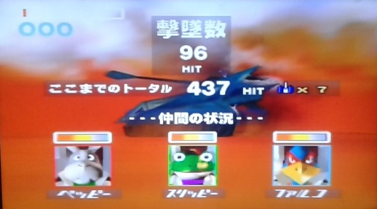

状況により、爆弾をうまく使わないと、進めない。
joukyouNiYoriBakudanWoUmakuTsukawanaitoSusumenai.
Batay sa kalagayan, kapag hindi maiging gamitin ang pasabog na bala, hindi maka-uusad.
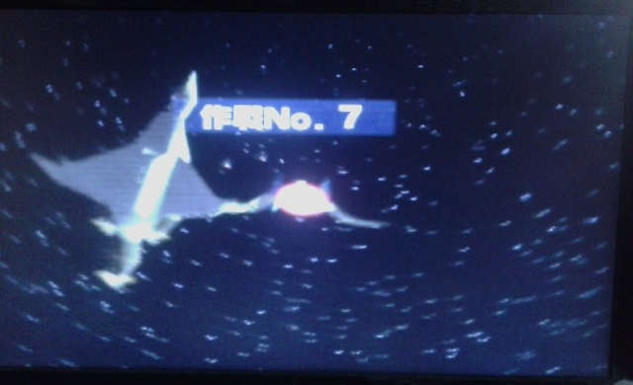

初めて最後のサルを倒せて、旅が50分もかかったけど。
hajimeteSaigoNoSaruTaoseteTabiGa50funMoKakattaKedo
Unang pagkakataong mapataob ang huling Matsing, ang paglalakbay, gumamit pa ng 50hati/minutos nga lang.

1.1.3) shared: with Public, notes on Guidelines and Instructions for Bureau of Internal Revenue (BIR) Form No. 1701Q (January 2018 (ENCS)) Quarterly Income Tax Return for Individuals, Estates and Trusts

Philippines Buwis MAX |  | 日本 税金MAX  (nihon zeikin MAX;  Japan Tax MAX)
1) Tax Rates Effective: 2018-01-01 ~ 2022-12-31  Over 8M, PHP2,410,000 +  35% of the excess over PHP8,000,000 |  | 1) 収入５５％税金  --> shuunyuu 55% zeikin  --> income 55% TAX

2) Tax Rates Effective: 2023-01-01 ~ onwards
Over 8M, PHP2,202,500 +
35% of the excess over PHP8,000,000
3) Stocks via Mutual Funds @BANKS  TAX payment already included  in the received NET income |  | 2) 株２０％税金  --> kabu 20% zeikin  --> stocks 20% TAX

1.1.3.3) Additional Note: Dual Citizenship
--> Example: Philippines + United States of America (U.S.A.), double TAX; NOT recommended by majority of nations
--> With Japan, by 21years old, choose only ONE (1): Japan or Philippines
--> Gabay: SAAN ka umuuwi? KANINO ka umuuwi?
1.1.3.4) References:
1.1.3.4.1) OKAMOTO YOSHIKI CHANNEL: 「日本人がお金持ちになるための４つの方法」
--> "Mamamayan ng Bansang Hapon, 4 na paraan upang magkaroon ng salapi"
--> last accessed: 20211108
1.1.3.4.2) eBIR Form No. 1701Qv2018
1.1.3.5) Recommended Action:
--> verify: Zaide, J. (2004). "Bababa, ba?". Philippines: Academic Publishing Corporation
--> What is the output?
--> Misuse of wireless broadcasting technology by budol-budol/carnapper/manloloko/cybercriminal/communist terrorist group NOT yet in Foreign Service Training?

2) Continued with Research & Development (R&D)
2.1) Usbong Pagong: Unit Movement Direction from RIGHT to LEFT
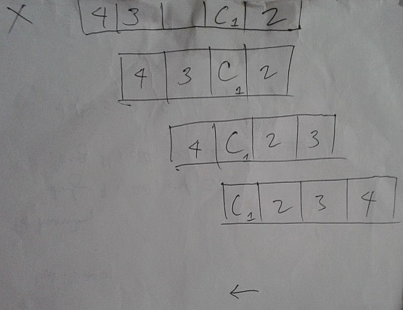
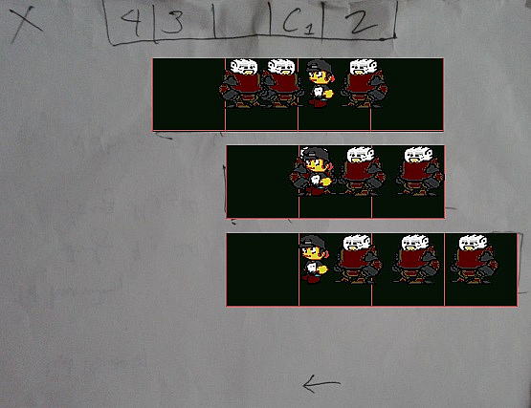
Plan: Hand Written by Human Actual: Executed by Computer

NOTE (from SYSON, MICHAEL B.):
In this case, it is faster to capture the technique by first writing by hand a plan with the intended output.

From the plan, we identify patterns that we can use to write the instructions that the computer can auto-execute repeatedly.

Example Pattern: We move Unit members to the RIGHT of the Unit Chief.
--> After movement, we move the remaining Unit members still on the LEFT of the Unit Chief a step to the right, but still on the LEFT of Unit Chief.

After identifying patterns, we write short notes that we afterward translate into Computer Language, e.g. C/C++.

Example Notes of Execution Steps:
IF current Unit member still to the LEFT of Unit Chief
--> IF current Unit member immediately to the LEFT of Unit Chief
----> move to the RIGHT of Unit Chief based on Unit Identification#
--> ELSE
----> move 1 STEP to the RIGHT, but still LEFT of Unit Chief
ELSE
--> move to the RIGHT of Unit Chief based on Unit Identification#

--> Reminder: CHAOS = Gulo
--> Panlolokong Ingay from the Teroristang Komunita causes CHAOS
--> Increase in Teroristang Komunista : Speed-up of SOCIAL CANCER
--> where: Teroristang Komunista = budol-budol/manloloko/carnapper/cybercriminal/Communist Terrorist group who continues to misuse wireless broadcasting technology to cause noise pollution and physical injury.
--> Reminder: End Result of SOCIAL CANCER = DEATH
--> where: CANCER Cell = Teroristang Komunista・Manloloko
--> Reminder: Human Body : Human Society; Increased Scale
--> Recommended Reading: Lewis Thomas' "The Lives of a Cell"

Recommended Action:
--> 1) Execute Alles klar, i.e. ALL CLEAR, to eliminate CHAOS/Gulo
--> Halimbawa: LINAWIN ang MALABO.
--> 2) Puksain ang mga Teroristang Komunista・Manloloko;
--> No need for negotiation.

Additional Note:
--> 1) To destroy Teroristang Komunista, increase your available Energy.
--> Light & Water create Energy classified to be Nuclear.
--> where: Nuclear Energy = Exponential Energy
--> where: Nuclear : Community・Family・Company

3) Continued to share know-how regarding Security Defense Force
3.1) Deutsche Welle (German Language Wave) Documentary
--> "How a neo-Nazi terror network went undetected in Germany | DW Documentary"
--> "Between 1998 and 2011, a German neo-Nazi terrorist group murdered ten people. They called themselves the National Socialist Underground or NSU, carried out robberies to finance their terrorist cell, and planted bombs to spread terror in Germany."

3.1.1) Select people chose NOT to share information via police incident reports
3.1.2) Select people (from Domestic Intelligence & Ministry of the Interior) blocked access to all further investigations

observed: vehicular incident with criminal evidence, e.g. guns, neo-Nazi DVDs, dead people
--> where: dead people identified to be members of group

Paalala: Gumawa ng incident report sa Tagapagpatupad ng Batas, i.e. Law Enforcement.
--> Ito'y sa halip na tumanggap ng tulong mula sa mga Teroristang Komunista・Manloloko.
--> Mayroon silang sariling gawa-gawang patakaran, na naiiba sa Batas ng Lipunan.
--> Halimbawa: Huwag ibahagi sa nakararami ang know-how ng kanilang pamamaraan, i.e. technique.
--> where: nakararami includes Law Enforcement, e.g. Pulis
--> where: technique = wireless broadcasting technology misused to execute among others:
--> wireless telephone eavesdropping to identify when household members are outside the house for partner thieves to enter and steal items, e.g. vehicle key.
--> notified: Law Enforcement after verifying wireless telephone to be DR. SYSON, PEDRO's
--> wireless telephone connected to GLOBE network; targeted even during international travels
--> destination: Japan (Year 2016)
--> destination: Switzerland (Year 2014)

NOTE (from SYSON, MICHAEL B.):
Sa bansang Hapon, saan tutungo ang mga iligal na namamalagi roon na kailangan ng tulong?

Kapag pumunta sila sa Pulis, hindi sila papayagan pang mamalagi sa bansang Hapon. Kung kaya't, sa halip, tutungo sila sa gawa-gawang samahan na may sariling mga patakaran.

Paalala: Karaniwang ginagawa ang mga iligal na pamamalagi sapagkat nais nilang makakuha ng malaking salapi, kung ihahambing sa halaga, halimbawa, ng Piso sa Pinas.
--> Pinadadala naman nila ito sa kanilang mga kamag-anak na karaniwan ding hindi natututo ng Maparaang Pagbibilang.

--> Mula sa pagsasanay ng Philippine Overseas Employment Agency (POEA) Taong 2008, matututunang hindi tuluyang nakauuwi sa Pinas ang mga Overseas Filipino Workers (OFW) sapagkat parating nauubos ang kanilang ipinadadalang salapi, bagama't may nais silang mag-ipon.

Mungkahing Mga Aksyon:
1) Matuto ng Maparaang Pagbibilang.
2) Gawan ng incident report ang Pulis.
3) Puksain ang mga Teroristang Komunista.
--> Hindi na kailangang makipag-usap sa mga Manloloko.
--> There is NO COMMUNICATION using Teroristang Komunista's wireless broadcasting technology.
--> In its stead, increased Noise Pollution with Physical Injury

4) Continued to share know-how regarding Health
4.1) observed: patients, e.g. Senior Citizens (SC), with increasing variations of Medicine Items have difficulty in correct identification
--> Example: Five (5) variations of Medicine Items to control the following among others:
--> Uric Acid (due to Gout), Blood Flow, Joint Pain, Ostheoarthritis, Calcium deficiency
--> In addition, select set of medicine items taken two (2) times per day.
--> Another set taken only one (1) time after breakfast.
--> Select family members provide assistance, albeit may NOT add care equal with that of the patient.
--> Caregivers may be hired, yet the quality of care may NOT again be equal with that of the patient.
--> This is even if it is already sufficient with the rest of the family members.
--> Cause: Increasing cost; Family members now only waiting for patient to accept death.
--> Result: Speed-up of patient's time of death
--> Recommended Action: verify: own Lifestyle to include among others:
--> 1) Burn excess Fats via Physical Exercise
--> Example: Continuous walking of at least 20mins per day
--> 2) Receive Light from Sunshine
--> 3) Drink clean Water, instead of sugared beverages
--> 4) Interact with people who are aligned with your Spirit, i.e. Kaluluwa;
--> Example: People NOT classified to be Teroristang Komunista・Manloloko.
--> 5) Eat fruits and vegetables; No meat dinner; No need to eat pork
--> 6) Execute work that contributes to community
--> where: work includes among others: cleaning own Toilet, sharing of computer know-how;
--> Results: LESS need for Medicine Items; Strong Community・Family・Company
--> Reminder: Human beings CAN live longer than 100 years old.
4.2) verified: FOOTBALL Sports Match: Spain and Germany
--> 得点王 (tokutenou; kumuha ng tuldok (punto) hari); Computer Simulation Game
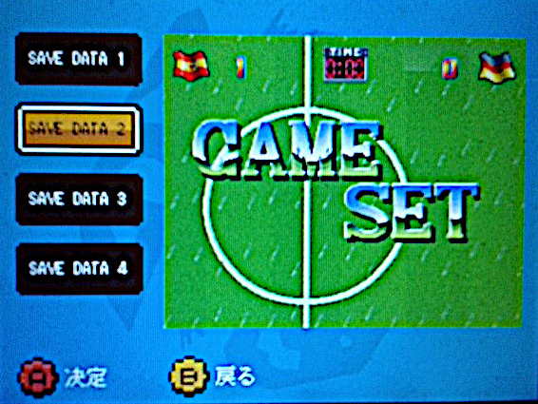

Shin-Nihon Kikaku (SNK) NEO-GEO System
新日本 (shin nihon; Bagong Pinanggalingan ng Araw (Bansang Hapon))
企画 (kikaku; Tinayong Larawan (Plan))
Year 1992
--> Lessons-Learned:
ドイツに勝つには足や体を使い、ボールを取り、
doitsuni katsuniha ashi ya karada wo tsukai, bo-ru wo tori,
Upang manalo sa Aleman, gamitin ang paa, katawan, atbp, kunin ang bola,

ゴールにストレートの攻撃で相手がガードするので、
go-runi sutore-to no kougeki de aite ga ga-do surunode,
Patungong GOAL, sa direktang pagsalakay, dahil gagawa ng GUARD ang katunggali,

仲間との再攻撃がダメならば、
nakama to no saikougeki ga dame naraba,
kapag walang saysay ang muling pagsalakay kasama ang partner,

自分の頭で、ボールをぶつかって行こうと
jibun no atama de, bo-ru wo butsukatte ikou to
gamit ang sariling ulo, tamaan ang bola, sugod! daw
NOW HIRING: COMPUTER SERVICES SALESPERSON
✓Receive half of the revenue from your DIRECT SALE of the service

✓Receive training:
Filipino Language, Sales, Information Technology
Requirements:
1) Curriculum Vitae
2) Portfolio
3) Sulat ng Hangarin
3.1) Ano ang maitutulong mo?
3.2) Bakit mo nais ito?
3.3) Bakit ka karapat-dapat?



EMAIL: APPLY@USBONG.PH

Tanong at Sagot

1) Magkano ang aking kikitain bilang Computer Services Salesperson at Manunulat ng paliwanag sa kompyuter, e.g. Add-on Software?
--> Kung babayaran tayo ng klinik ng 10K pesos bawat buwan, 5K ang sa iyo bilang Computer Services Salesperson.
--> Bilang Manunulat, 4K pesos ang maibibigay sa iyo ng Usbong.
--> Sa kabuuan, 9K pesos ang matatanggap mo bawat buwan.
--> Ang matitirang 10% ng 10K, i.e. 1K pesos, gagamitin ng Usbong sa pag-iipon ng kapital.
--> Gagamitin ito ng Usbong sa paggawa ng mga investment at "float", na ang kahulugan, liquid asset.

2) Paano ako makibabahagi sa tagumpay ng kompanya?
--> Kung wala tayong kikitain mula, halimbawa, sa Computer Automation Service, mauubusan tayo ng kapital na pambayad sa ating lahat. Hindi magtatagal, wala na tayong kompanya.
--> Dahil dito, kailangang maayos ang ating paggawa at pagtuturo sa mga trainee upang tuluy-tuloy ang daloy ng ating kita, habang nagbibigay ng ginhawa sa lipunan.

MAPARAANG PAGBIBILANG
ALGEBRA SKILL LEVEL 1:
INPUTS:
X = 250 //ITEM PRICE
V = 12% //VALUE ADDED TAX (VAT)
Q = ? //ITEM PRICE WITH VAT

TANONG: WHAT IS ITEM PRICE WITH VAT?
SAGOT:

ALGEBRA SKILL LEVEL 2:
INPUTS:
X = ? //ITEM PRICE
V = 12% //VALUE ADDED TAX (VAT)
Q = 364 //ITEM PRICE WITH VAT
TANONG: WHAT IS ITEM PRICE WITHOUT VAT?
SAGOT:

ALGEBRA SKILL LEVEL 3:
INPUTS:
S = 600K //EXCESS STOCK IN WAREHOUSE (JAPAN)
D = 180 //IN USD OF EACH STOCK
L = ? //LOSS

NOTES:
1) USD = UNITED STATES DOLLAR
2) PHP = PHILIPPINE PESO
3) USD1 : PHP54

TANONG#1: WHAT IS THE LOSS IN PHP?
SAGOT:

TANONG#2: WHAT IS THE LOSS IN PHP IF WE SET
USD1 : PHP0.50?
SAGOT:





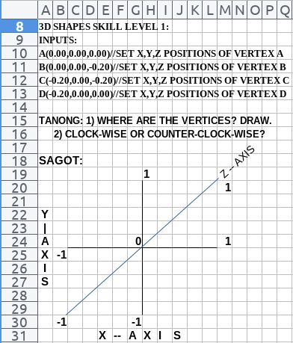

USBONG I.T. SOLUTIONS
COMPUTER SERVICES

SYSON, MICHAEL B.
FOUNDER

MOBILE: +63929.952.7263
EMAIL: MASARAPMABUHAY@GMAIL.COM

WEBSITE: WWW.USBONG.PH
ADDRESS: #2 E. MANALO (FORMERLY, E. RODRIGUEZ) AVE., STO. NIÑO, MARIKINA CITY, 1820, PHILIPPINES

