
June 2021
EXPENSES > INCOME PATTERN
Manloloko as 化け物 (bakemono; naibang bagay)
Solution: Alles klar (All clear)

PHILIPPINES: USBONG CONTINU​ES TO PROVIDE
COMPUTER SERVICE ASSISTANCE BY SHARING
KNOW-HOW ON MAPARAANG PAGBIBILANG

To eliminate excess steps and inefficient time usage, MARIKINA ORTHOPEDIC SPECIALTY CLINIC (MOSC) requested Usbong's services to automate routine, monotonous tasks and share with unit members know-how on computers.

Here are Key Action Items that we executed in this updates list.
1) Continued to update Knowledge Management System (KMS)
--> 1.1) 1.1) continued: to share know-how on computers and Information Technology (IT) tools
--> 1.1.1) LibreOffice Calc
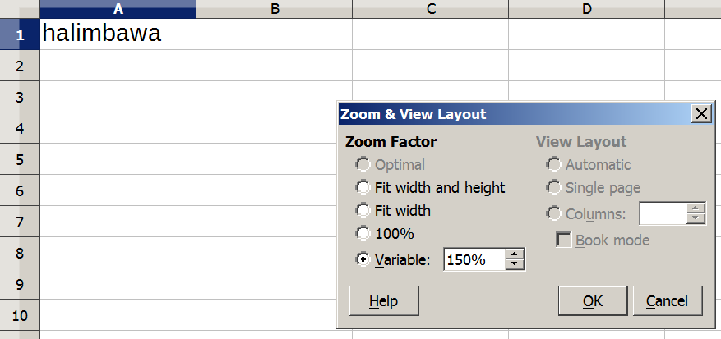
--> observed: select Unit members use Font Size that causes human eyes to be strained
--> Recommended Action: Increase Font Size of text via Zoom tool, e.g. set to 150% size; As for printed text, we can put it closer to our eyes to make text larger.
--> 1.1.2) Cash Register Machine
--> Recommended Action: Speak out-loud entered inputs
--> Examples: "seven times ten"; "isang daan ang bigay, tatlumpo ang sukli"; observed: we use IT Tools, e.g. Cash Register Machines, Computers, to assist us to count; This is due to the 数 (kazu; "number") has increased to make outputs incorrect and slow to finish without machine assistance.
--> In nihongo, kazu, written as 和, signifies "harmony" and "Japan".
--> reminder: Even with machines, Unit member still needs to have know-how to identify the correct inputs, e.g. multiplication operation, 0.20 for 20%; updated: patient and item pages to use "@" symbol to identify fee in the output, e.g. Cart List
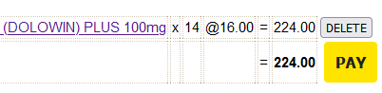
Example: x 14 @16.00
--> This is due to for select transactions, re-entering inputs in Cash Register in the correct sequence is slower.
--> reminder: With Cash Register Machines, e.g. CASIO, we enter quantity first before the fee. Example Sequence: 14 x 16.00
--> updated: in Item pages' Purchased Item History List to include Patient Name; This is due to when executing re-verification to generate the End of Day Report, identifying which Patient purchased the Item has become noticeably slow.
--> reminder: When Cash Register Report and Computer Report not equal, we need to identify the cause.
--> Example Cause #1: Duplicate Input in Computer Database
--> Example Cause #2: Input entered in Cash Register, but not in Computer Database;
--> Problem: In Cash Register, Item not quickly identified due to multiple Items have equal price, e.g. 16.00
--> Brand Names: DOLOWIN PLUS and ZERODOL-P;
--> Equal Generic Name: ACECLOFENAC 100MG + PARACETAMOL 500MG
--> Previously, we used the phpMyAdmin tool.
--> Input Steps Count (Previous): 6
--> Input Step #1: Choose Items List
--> Input Step #2: Search Items List using Item Name keyword to identify Item Identification (ID)
--> Input Step #3: Choose Transactions List
--> Input Step #4: Search Transactions List using Item ID to identify Patient ID of transaction
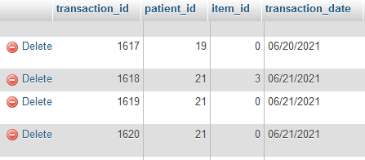
Example Transactions List
phpMyAdmin Tool
--> Input Step #5: Choose Patients List
--> Input Step #6: Search Patients List using Patient ID to identify Patient Name
--> Input Steps Count (Now): 3
--> Input Step #1: Choose Items List
--> Input Step #2: Search Items List using Item Name keyword
--> Input Step #3: Choose Item

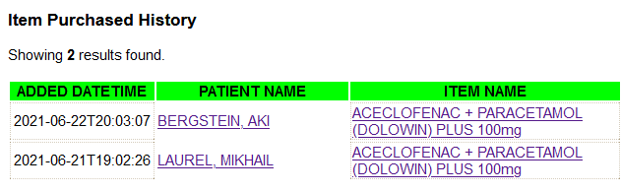
Example View Item Page
Example Item Purchased History List
NOTE (from SYSON, MICHAEL B.):
To identify the correct items in the Cash Register's printed report, we can verify the items that go together.

Reminder: The printed report does not include the Item name and item identification (ID). This is due to after computation, the quantity of item variations is now over 1000.

Example Cash Register Report:
14 x
・19・00 @
03・266・00
10 x
・10・00 @
03・100・00

After verification, the computer database has only 1 item priced @19.00.

PARA + ORPHENADRINECITRATE (PARADRINFORTE) 50/650mg; x 14 @19.00 = 266.00

We use the transactions history list to identify which items it is partnered. This is due to over 10 items are priced @10.00.

Examples:
1) DICLOFENAC SODIUM (CURAFEN) 100mg
2) OFLOXACIN (FLOXA-200) 200mg
3) OMEPRAZOLE (RANZOLE) DELAYED RELEASE CAP 40mg
4) DICLOFENAC NA (SUBSYDE CR) 100mg UPDATED

We learn that the following are written together in the Medical Prescription.
1) PARA + ORPHENADRINECITRATE (PARADRINFORTE) 50/650mg
2) DICLOFENAC NA (SUBSYDE CR) 100mg UPDATED

From this technique, we have generated an answer to solve the identification problem.

Additional Notes:
1) We can also use the Index Card to verify the answer.
--> However, we shall still need to verify each Index Card to identify the Patient Name based on the medicine prescription written on it. After computation, using the Computer was faster to solve the problem.
--> Reminder: Handwritten text adds delay in execution time, in contrast to digital text.

--> 1.1.3) Index Card Template to use with Photocopy Machine
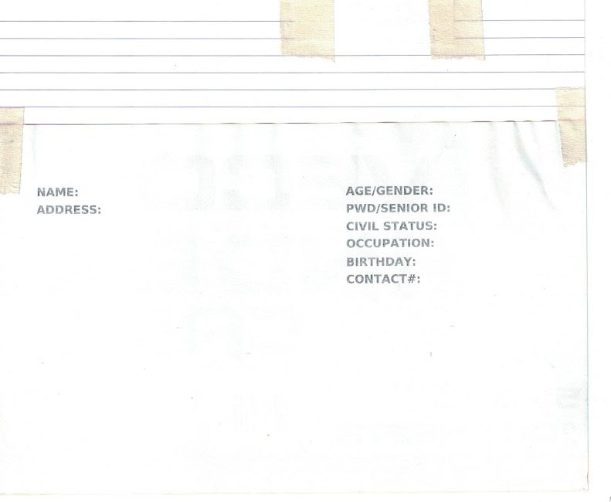
--> shared: with Unit Members @Information Desk Unit to speed-up printing of Index Cards
--> At present, computer @Information Desk is NOT connected to the Photocopy Machine.
--> This action empowers Unit members to generate Index Cards,
--> even without assistance from SYSON, MICHAEL B.
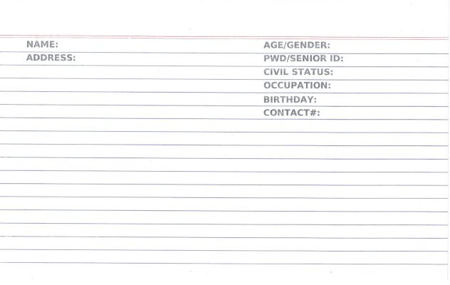
-> 1.1.4) Tablet PC as board to put medicine item boxes
--> This action is after adding medicine items using KMS on the Tablet PC to compute the total fee.
--> At present, the medicine item storage is 3meters from the Cashier Unit.
--> We store temporarily select boxes @the Cashier Unit to quickly receive payment from the next patient.
--> When time is available or when physical usage exceeds available space, we return the boxes to the storage.

2) Continued to update Training Centre: Security Defense Force
2.1) Human Energy and Health: Food
2.1.1) Sharp Knife
--> Reminder: With かぼちゃ (kabocha, i.e. kalabasa), we need sharp knife. With knife, cut outward, not toward self.
--> Use correct knife length.
--> Example: With select parts of Tuna fish, cut using short knife, e.g. blade length < 15cm
--> This is to increase knife maneuverability.
--> reminder: regular ruler length 30cm
--> Tuna fish’s inner part soft, in contrast to outer part
--> Unless double-edged knife, top part of knife blade is not sharp.
--> Press it with palm of hand to cut hard food object, e.g. kalabasa.
--> Flat part of knife blade is not sharp.
--> Press it with palm of hand to crush にんにく (ninniku, i.e. bawang) to quickly remove outer part classified to be its cover.
--> With にんじん (ninjin, i.e. carrot), we can quickly cut it in chunks by using knife to make diagonal slices from the carrot’s tip part, where its root is located, not the top part
--> After verification, cooking kabocha and ninjin with water, kikkoman soy sauce, sugar, using electric stove, can cause kare- taste.
--> If kikkoman soy sauce not available, use in its stead Iodized salt.
--> Additional Note: kikkoman soy sauce includes soy milk with nutrition that exists in fresh milk.
--> However, nutrition quantity sufficient to not cause human person, e.g. classified to be Senior Citizens, to have increased body fat.
--> This is in contrast to daily full cups/glasses of fresh milk, appropriate for growing and physically active children.
--> reminder: With kabocha and ninjin, we use wooden chopstick to pierce the chunks. If difficult to pierce due to not yet soft, add time to cook.
--> reminder: burn, i.e. sunugin, body fat via continuous walking 20mins daily; Increased food consumption, increased walking time;
--> Example: Continuous walking of 40mins;
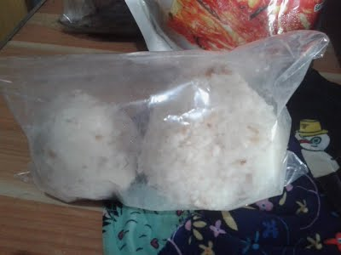
--> observed: jump/skip rope executed continuously x800 daily, not effective to reduce body weight
--> Continuous daily walking effective.
--> Use jump/skip rope exercise to verify if with physical health status, e.g. current body weight, can execute action.
--> Recommended Action: verify: physical therapy exercises
ALGEBRA SKILL LEVEL 3:
INPUTS:
S = 600K //EXCESS STOCK IN WAREHOUSE (JAPAN)
D = 180 //IN USD OF EACH STOCK
L = ? //LOSS

NOTES:
1) USD = UNITED STATES DOLLAR
2) PHP = PHILIPPINE PESO
3) USD1 : PHP54

TANONG#1: WHAT IS THE LOSS IN PHP?
SAGOT:

TANONG#2: WHAT IS THE LOSS IN PHP IF WE SET
USD1 : PHP0.50?
SAGOT:





USBONG
COMPUTER SERVICES

SYSON, MICHAEL B.
FOUNDER

MOBILE: +63929.952.7263
EMAIL: MASARAPMABUHAY@GMAIL.COM

WEBSITE: WWW.USBONG.PH
ADDRESS: #2 E. MANALO (FORMERLY, E. RODRIGUEZ) AVE., STO. NIÑO, MARIKINA CITY, 1820, PHILIPPINES

5.3) 流れ (nagare; daloy (ng salaysay))
--> Kapangyarihang may kinalaman sa 星見の結果 (bituin nakita; pinagtali kinahinatnan nito)
5.3.1) Daloy ng salaysay
--> May naisulat; Isinaaayos ito; Hayaan ang naisulat na; Alam;
5.3.2) Maligaya ang matuklasan ang sagot sa suliranin.
--> May sagot; Alam ng gumawa ng Daigdig;
--> Suliranan: Nawawala; Hindi malaman kung saan tutungo.

Huwag kaligtaan!
Kunin ang piniling bagay na maiisip mong wasto.
Naunawaan mo ha!

Reference: 幻想水滸伝 GENSO SUIKODEN
--> 幻想 ("gensou"; illusion thought)
--> Year 1995 1996 KONAMI; PlayStation the Best version; executed on PlayStation3 Machine

NOW HIRING: COMPUTER SERVICES SALESPERSON
✓Receive half of the revenue from your DIRECT SALE of the service

✓Receive training:
Filipino Language, Sales, Information Technology
Requirements:
1) Curriculum Vitae
2) Portfolio
3) Sulat ng Hangarin
3.1) Ano ang maitutulong mo?
3.2) Bakit mo nais ito?
3.3) Bakit ka karapat-dapat?



EMAIL: APPLY@USBONG.PH

Tanong at Sagot

1) Magkano ang aking kikitain bilang Computer Services Salesperson at Manunulat ng paliwanag sa kompyuter, e.g. Add-on Software?
--> Kung babayaran tayo ng klinik ng 10K pesos bawat buwan, 5K ang sa iyo bilang Computer Services Salesperson.
--> Bilang Manunulat, 4K pesos ang maibibigay sa iyo ng Usbong.
--> Sa kabuuan, 9K pesos ang matatanggap mo bawat buwan.
--> Ang matitirang 10% ng 10K, i.e. 1K pesos, gagamitin ng Usbong sa pag-iipon ng kapital.
--> Gagamitin ito ng Usbong sa paggawa ng mga investment at "float", na ang kahulugan, liquid asset.

2) Paano ako makibabahagi sa tagumpay ng kompanya?
--> Kung wala tayong kikitain mula, halimbawa, sa Computer Automation Service, mauubusan tayo ng kapital na pambayad sa ating lahat. Hindi magtatagal, wala na tayong kompanya.
--> Dahil dito, kailangang maayos ang ating paggawa at pagtuturo sa mga trainee upang tuluy-tuloy ang daloy ng ating kita, habang nagbibigay ng ginhawa sa lipunan.

MAPARAANG PAGBIBILANG
ALGEBRA SKILL LEVEL 1:
INPUTS:
X = 250 //ITEM PRICE
V = 12% //VALUE ADDED TAX (VAT)
Q = ? //ITEM PRICE WITH VAT

TANONG: WHAT IS ITEM PRICE WITH VAT?
SAGOT:

ALGEBRA SKILL LEVEL 2:
INPUTS:
X = ? //ITEM PRICE
V = 12% //VALUE ADDED TAX (VAT)
Q = 364 //ITEM PRICE WITH VAT

TANONG: WHAT IS ITEM PRICE WITHOUT VAT?
SAGOT:

2.1.2) Iodized Salt
--> Iodized salt has taste of the sea.
--> observed: McDonalds french potato fries use increased Iodized salt
--> McDonalds french potato fries classification: snack, not food as meal for morning, noon, and evening
--> reminder: excess = doku, i.e. lason
--> Recommended Action: In its stead, eat onigiri (riceball; lit: grasped hand)
--> With onigiri, we use Iodized salt, if nori (dried seaweed) not available.
--> onigiri technique:
--> 2.2.2.1) After cooking rice, let rice cool first; otherwise, hands shall be burnt
--> 2.2.2.2) Add Iodized salt on rice inside the rice cooker.
--> reminder: select pain relievers classified to be anti-inflammatory cause us to not experience burn
--> Example: Walking for 2 hours without stop, with problematic cushion in inner part of shoes, causes feet to have callos.
--> Pain equal to burning.
--> 2.2.2.3) Wash hands.
--> Keep palm of hands wet.
--> 2.2.2.4) Put Iodized salt on palm of both hands.
--> 2.2.2.5) Put cooked rice on one palm of hand.
--> 2.2.2.6) Use another palm to cup hand.
--> 2.2.2.7) Use both palms of hands to make rice into ball shape.
--> Additional Note: Ball shape can become triangle shape based on palm hands technique.
--> 2.2.2.8) Put finished rice ball inside plastic bag, e.g. ziploc bag.

NOTE (from SYSON, MICHAEL B.):
I eat 김치 (kimchi) from the 500g 대장금 (大長今; Dae Jang Gum) kimchi pack, which costs PHP140.

Paalala: Mula sa kasaysayan, manggagamot si Dae Jang Gum. Ginamit niya ang pagluluto sa panghihilom. Sa bandang dulo ng salaysay ng "Jewel in the Palace", pagkatapos niyang manganak, mahigpit niyang tinuruan ang kanyang anak gamit ang pamalo. Ito ang palabas na ipinakikita sa mga Turista noong dekada ng taong 2000.

Additional Note:
대장금 (大長今; Dae Jang Gum) ang pamagat sa wikang Koreano ng "Jewel in the Palace"

Remember to eat vegetables classified to be green-leafy. 김치 (kimchi) empowers us to quickly eat such vegetables.

This is due to there is no need to execute additional cooking, after storage in refrigerator.

I add kimchi to the cooked rice. In addition, I put the yellow part of raw egg on the cooked rice. The rice shall assist in making the egg warm.

Reminder: We use the yellow part of raw egg when eating nattou, i.e. fermented bean.

Instead of kimchi, we can use raw tomato with Iodized salt. If available, umeboshi is another food item to put.

As for the white part of the raw egg, we reuse it when cooking chicken with soy sauce to create food classified to be oyakodon.

Reminder: Add kikkoman soy sauce, water, and sugar; no need to add oil. Put previously cooked chopped chicken to re-heat. When done, add white part of raw egg. Add another whole raw egg. Use wooden chopsticks to pierce the egg being cooked.
2.2) Machine Energy and Health: Electricity
--> 2.2.1) Computer Sound


--> To increase security defense against noise pollution, we set the Computer Sound to OFF.
--> observed: volume increases to be noise pollution when excess electricity enters machines, e.g. radio.
--> Reminder: machines, e.g. radio, computer, telephone, are connected to the network wired/wireless
--> Electricity enters machines via among others:
--> Electricity as wired enters via the electrical consent outlet.
--> Electricity as wired enters via the Local Area Network (LAN) RJ-45 cable.
--> Electricity as wireless electric wave enters via antenna/antennae.
--> With Computer/Television Monitors, brightness level increases to be excess.
--> Reminder: Machines consume electricity to execute tasks.
--> Increased tasks cause increased electricity consumption.

--> Insufficient electricity causes machine problems, e.g. tasks are not executed correctly.
--> Increased electricity consumption causes increased heat.
--> 2.2.1.1) verified: cellular telephone connected to SMART network to cause head pain wirelessly
--> Wireless pain distance reached: < 1 meter.
--> cellular telephone: National Telecommunications Commission (NTC)-certified Nokia feature phone, i.e. non-Android.
--> Additional Note: This is despite cellular telephone not used in speaking with another person
--> Cellular telephone in Idle state.
--> identified: cellular telephone to be SYSON, MICHAEL's
--> Reminder: Heart Pacemaker devices are caused to not function correctly by cellular telephones that wirelessly transmit and receive data whose size is usable for calls.
--> Reminder: Network Towers are misused by the Teroristang Komunista to cause physical injury.
--> 2.2.1.2) verified: Android telephone connected to GLOBE network to cause breathing problems, e.g. hirap huminga.
--> Reminder: There exists Ear, Nose, and Throat (ENT) connection.
--> Additional Note: Android telephone brought to another country can still cause such problems.
--> Example Country: Switzerland
--> verified: Android telephone registered with GLOBE network
--> identified: Android telephone to be Dr. SYSON, PEDRO's
--> Wireless attack distance reached: 4 meters
--> verified: attack hit SYSON, MICHAEL B. causing breathing and speaking difficulty during his Oral Presentation (Year 2014)
--> Presentation Details: "Usbong: Electronic Health: Using Information and Communication Technologies (ICT) to enhance the Directly Observed Treatment Short-course (DOTS) Compliance Assessment Tool (DCAT) of the Philippine Plan to Control Tuberculosis"
--> Attack Classification: International Criminal Activity
--> Recommended Action: Destroy the budol-budol/manloloko/carnapper/cybercriminal/communist terrorist group who continues to misuse wireless broadcasting technology to cause noise pollution and physical injury.

--> identified: members of this Teroristang Komunista group to include among others: Ryan Syson, the son of Dr. Pedro Syson's younger brother, "tai-ah", i.e. Ramon Syson and Linda Syson; Both parents are also classified to be with this Teroristang Komunista group.
--> verified: broadcasted panlolokong ingay to reach antennae of moving vehicles
--> identified: Keith Haw, with Xavier High School (San Juan, Greenhills) classmate and basketball player, Tyrone Tang, to be with this Teroristang Komunista group.
--> Mungkahing Aksyon: Puksain ang mga Teroristang Komunista.
--> Aksyon: Sulatan din ng incident report ang Tagapagpatupad ng Batas, i.e. Law Enforcement.

3) Updated: Usbong Training Centre: Security Defense Force
--> 3.1) EXPENSES > INCOME PATTERN
--> Attacks by the budol-budol/manloloko/carnapper/cybercriminal/communist terrorist group continue to be a regular pattern.
--> Cause: Quick Money due to EXPENSES > INCOME PATTERN
--> Action: harassment; extortion using wireless broadcasting technology as weapon by causing noise pollution and physical injury
--> verified: ignoring noise pollution leads to physical injury
--> Reminder: Manloloko is 化け物 (bakemono; naibang bagay)
--> Solution: Alles klar (All clear)
--> Lahat malinaw; Malabo ang mga Manloloko na patuloy na gumagawa ng panlolokong ingay at pisikal na pananakit.
--> Therefore, no need for negotiation.
--> Mungkahing Aksyon: Puksain ang mga Teroristang Komunista.
--> Reminder: When system not cleared, excess Manloloko characters appear due to containers still have previous data.
--> where: data is classified to be money
--> In select systems, Garbage Collectors were added to auto-clear previously used containers.

--> 3.2) Sa labanan, tiyakin na ikaw ang mabubuhay.
Ayon sa kasaysayan, ginawa rin ito ng Pinuno ng Gresiya. Noong mga panahong iyon, nahati sa dalawang pangkat ang Gresiya:

Isa ang mga Spartan, i.e. pangkat na nakikipaglaban dahil naniniwala sila na ang pinakamahalagang bagay sa daigdig: glorified death, i.e. mamatay nang lumalaban Isa naman ang mga Athenian, i.e. pangkat na kabaliktaran ng mga Spartan

Sa daloy ng istorya, nahalal bilang Pinuno ang Athenian. Dagdag pa rito, may malakas na daing ang pangkat ng mga Spartan na salakayin ang Italia, na kung saan kakailanganin nilang tumawid ng dagat mula Gresiya.
--> Pupunta si Batman sa Tokyo, Japan upang malutas ang problema/suliranin ukol sa dumaraming namamatay sa iligal na droga, i.e. ipinagbabawal na gamot, na maaaring magpatupad ng anumang nais ng iinom nito, bagama't pagkatapos ng isang araw, mamamatay.
--> Additional Note:
--> Mas nais ko ang kanyang istorya/salaysay, kaysa sa kanyang pagguhit.
--> 5.2.4) 勇者鬥惡龍 (yongzhe dou elong; Brave Person Fight Evil Dragon;ドラゴンクエスト; dragon quest)
--> Chinese version; umiikot; Kapag labis na malakas ang halimaw, e.g. kaya kang mapuksa agad, maghanap ng ibang daan.
--> Gumamit ng 逃跑 (taopao; takas-takbo, i.e. pagtakas) kung kailangan.
--> Habang pataas nang pataas ang iyong nibel, madaragdagan ang iyong kakayanan, e.g. 霍伊米 (huoyimi; ホイミ; hoimi, i.e. panghilom), 拉里霍 (lalihuo; ラリホー; raliho-, i.e. pampatulog ng halimaw).
--> Paalala: Mga gawa-gawang salita ito.
--> Sa bawat pagpuksa ng halimaw, madaragdagan ang iyong salapi.
--> Aakma ang nakukuha mong salapi sa iyong nibel.
--> Kung panay mahihinang halimaw ang iyong ginagapi, i.e. 打倒 (dadao, hampas-taob), kaunti lang na salapi ang iyong makukuha.
--> Ginagamit ang salapi sa pambili ng kalasag, sandata, atbp.
--> Kailangan ng palakas nang palakas na kalasag, atbp upang makapaglakbay nang mas malayo.
--> Paalala: Kailangan mong magapi ang Dragon upang mailigtas ang Prinsesa.

NOTE (from SYSON, MICHAEL B.):
Maaalala ang ドラゴン クエストV: 天空の花嫁 (Dragon Quest V: Heaven Empty’s Flower Wife). Bagama’t sa halip na 40+ oras, sa loob ng 10 oras ako naghahagilap. Sa DQV, pagkalipas ng 40+ oras, isinantabi ko na. Dagdag sa PlayStation 2, Japanese version ng DQV: Maaalala ang maiging pagkagawa ng Zombie mula 2-Dimensional (2D) papuntang 3-Dimensional (3D) object.

Maaalala ang paglipas ng panahon gawa ng himig, salaysay, atbp.

慣れ (nare; sanayan); halimbawa: Mukhang hindi maayos sa simula ang guhit ng mga mamamayan, atbp; Sa bawat pagdalaw mo sa daigdig ng Dragon Quest, masasanay ka rin; hindi naman ganoong kalubha.

preference: Umaakma ang guhit ayon sa suot na gamit, e.g. kalasag.

--> Recommended Reading:
--> ファミリー コンピュータ ドラゴン クエスト 取扱説明書
--> Family Computer Dragon Quest Handling Speak Clear Book
--> https://www.nintendo.co.jp/clvj/manuals/pdf/CLV-P-HBBBJ.pdf; last accessed: 20210611

--> Recommended Reference:
--> ファミリー コンピュータ ドラゴン クエスト イラスト
--> Family Computer Dragon Quest Illustration
--> http://www.dragonquest.jp/roto/s/; last accessed: 20210614
--> Umaakit ang guhit upang tuklasin ang daigdig ng Dragon Quest.
--> Maaalala ang sa クロノ トリガー (Chrono Trigger), na kung saan naroon sina: Chrono, Robo, at Kaeru (FROG).
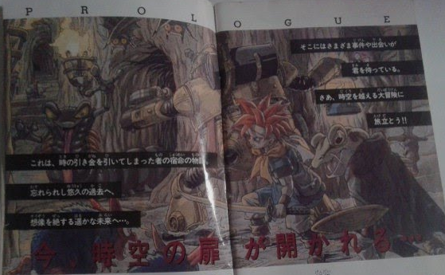

--> Mula sa kasaysayan, naging dalubhasa, i.e. Master, ang mga Hapon sa paggawa ng mga daigdig. Hango ito sa mga aklat ng literatura, i.e. 文学 (bungaku), na may dagdag na interactivity gamit ang Super Family Computer.

--> Recommended Action:
--> verify: Ang Alamat ng Agimat: Anim na Perlas
--> The Legend of Amulet: 6 Pearls
--> JAVA 2 Micro Edition version

--> Donkey Kong's Service Ace Count > Mario's Count
--> サービス エース (Service Ace): Service is not hit to be returned by Opponent; Execution: Donkey Kong's service uses POWER attack with target location can be set to be left or right; If I as Mario incorrectly choose where the target is, I do not hit to return the ball
--> Mario's Smash Ace Count > Donkey Kong's Count
--> スマッシュ エース (Smash Ace): Smash is not hit to be returned by Opponent; Execution: Mario serves using POWER Attack; it is returned by Opponent; I use another POWER Attack to a direction opposite of Opponent to finish; Note: If charge time not sufficient, attack can still be not hit to be returned by Opponent.
5) Updated: Computer Interactive: Lessons Learned
5.1) マリオ ストーリー (Mario Story; for the Nintendo 64): Bully Problem; Tanong: Paano magagapi ang Bully, e.g. Dambuhalang Pagong na naniningil ng ゼニ (zeni), i.e. perang gugugulan ninyo ng oras na maipon, upang makaraan kayo sa daan?
--> Paalala: May gumawa ng incident report sa inyong pangkat (classification: Law Enforcement) ukol sa Bully. Si Charles (考古学者 (koukogakusha; lit: Mag-aaral ng Pinag-ninilayang Luma; Archeologist) na Pagong) ang gumawa ng incident report sa inyo.
--> 5.1.Sagot): Makipaglaban, habang inaalala ang gabay na ito:
--> 5.1.1) Magbilang;
--> Halimbawa: 70 ang health/lakas ng Bully; Gamit ang pamamaraan, maaaring makagawa ang pangkat ninyo ng atake na 8, sa isang turn/palitan ng atake. Ilang palitan ang kakailanganin ninyo upang magapi ang Bully?
--> Mga Paalala: Maaaring bahagyang mabawasan, e.g. -1, ang pinsala ng atake ng Bully kung sa kanyang turn, wasto ninyong magagamit ang Guard Command kapag umatake siya. Kailangan din ninyong hilumin ang inyong pangkat mula sa atake ng Bully.
--> Mas maiging gamitin ninyo ang lakas ng mga kaibigan ninyong Bituin sa paghihilom ng sarili. May badge din na maaaring makapagbigay sa inyo ng kakayanang gumamit ng dalawang item, sa halip na isa lamang sa isang turn/palitan. May item na humihilom, e.g. super kinoko, at gumagawa ng atake, e.g. yuki snowman attack
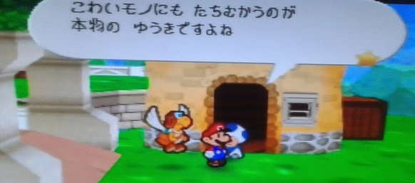
「こわいモノにも たちむかうのが 本物の ゆうきですよね」
kowai mono nimo tachimukau no ga honmono no yuuki desuyone
Tunay na tapang ang nakatayong harapin ang nakatatakot na bagay, 'di ba?

--> Ayon ito sa Nagbabantay na Kinoko na tinutukoy ang mga 化け物 (bakemono; lit: naibang bagay, e.g. Multo).
--> Binabantayan niya ang gate sa Bayan ng Kinoko mula sa mga dumaraan galing o patungo sa Gubat ng Nawawala.
--> Sibat ang hawak niyang sandata.

--> 5.2.Sagot) Gumawa ng Daigdig
--> Gawin ang mga bagay na maayos mong nagagawa.
--> Recommended Readings:
--> 5.2.1) Winston Groom's "Forrest Gump"
--> Life Story: Look up at the stars at night, with the whole sky laid out there, sometimes. Remember it all.
--> "...An then, all of a sudden, I'm forty, fifty, sixty years ole, you know?"
--> The villiage idiot's role in history and literature:
--> "...idiots was not jus useless people, but was put here for a purpose... an the purpose is to make people laugh. At least that is somethin."
--> 人を楽しませる？(hito wo tanoshimaseru?; cause human to enjoy?)
--> Paalala: Mag-ingat na gawing haligi ng buhay ang isang sistema na sa huli pala mali, i.e. baliktad. Isa ito sa mga nagdudulot ng pagkasawi ng ilang tao.
--> Mga Halimbawa:
--> Hindi niya matanggap na kapag patay na ang isang tao, patay na talaga siya. Hindi pupunta ang yumao sa isang lugar, e.g. langit, kung saan makapag-uusap pa kayo, atbp.
--> Hindi niya matanggap na hindi mapupuksa ang mga Teroristang Komunista kung hindi ka gagawa ng aksyon, bago ka patayin sa debate, e.g. aapakan mo ba ang ipis o hindi?
--> 5.2.2) Micromégas ni Voltaire
--> Mababasa rin ang salin nito sa Ingles dito: http://www.gutenberg.org/cache/epub/30123/pg30123.txt;
--> last accessed: 20210401
--> 5.2.3) Kia Asamiya's Batman: Child of Dreams
--> https://www.dccomics.com/graphic-novels/batman-child-of-dreams
--> last accessed: 20210402

Mula sa kanilang nakalap na impormasyon, matindi ang depensa ng mga taga-Italia. Tiyak, mapupuksa silang lahat kapag sumalakay sila. Gayunpaman, upang mapagbigyan ang daing ng mga Spartan, gumawa siya ng COMMAND na salakayin ang Italia.

Subalit, pagdaong ng kanilang mga barko, natuklasan ng mga Spartan na nawawala ang kanilang Pinuno. Natuklasan na lamang nila na iniwan na sila nito. Mababalitaan na napuksa ang mga Spartan gawa ng depensa ng Italia, dagdag pa sa gutom at uhaw na kanilang naranasan.

--> Paalala: Mag-iingat ang mga may pakay na gumawa rin ng ganito, sapagkat ikasasawi niya ito sa panahong matuklasan ng mga kanyang pinagloloko ang kanyang pamamaraan.
--> Mababasa sa kasaysayan na nahuhuli at namamatay rin ang gumagawa ng mga sistema upang ipag-away ang mga pangkat.
--> Ibig sabihin, hindi ito ang pinakaepektibong paraan upang mabuhay nang walang hanggan.
--> Mungkahing Aksyon:
--> tuklasin: Federigo da Montefeltro, Italianong mamumuno na mahilig magbasa. Dahil sa taglay niyang kakayanan, napasusunod niya ang Santo Papa ng Roma at ang mga bansa sa Europa. Gayunpaman, mamatay din siya pagkatapos matuklasan ang kanyang pamamaraan ng paggawa ng sistema upang ipag-away ang mga ito.
4) Continued with Research & Development (R&D)
--> 4.1) Automotive: Usbong CAD (Computer Aided Design)
--> 4.1.1) added: Usbong Text System
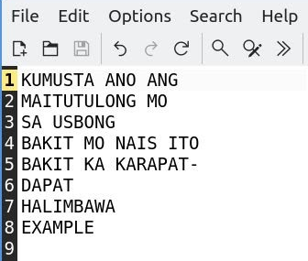
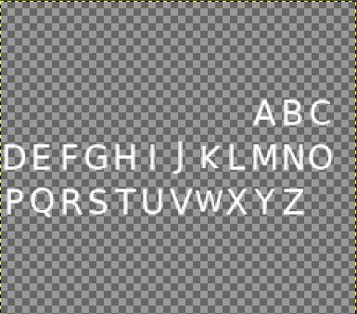

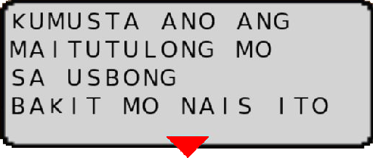

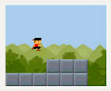
--> verifying: to reuse system to be the output on the Computer Monitor Select key inputs can be removed by reducing available button keys.
--> Android OS: Example Default Output; NOT the Terminal Window
--> During development, e.g. verifying and fixing errors, we add inputs from a keyboard, et cetera.

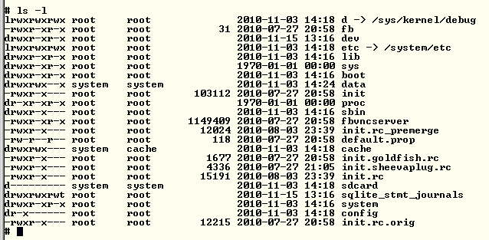
--> verified: system reusable as technique to execute a focused set of actions, e.g. auto-drawing with maps
--> This is due to the use of containers with rows and columns whose values can be set as input.
--> The computer auto-draws the input values as output based on settings,
--> e.g. Font, sequence, tile image identification.
--> reminder: productivity application tools use rows and columns to identify correct location of items
--> Examples: Microsoft EXCEL, LibreOffice Calc, Usbong KMS

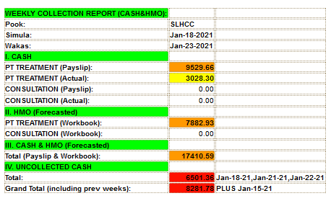
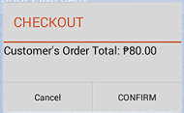
--> observed: computer as tool to assist us in writing the instructions need not be the fastest
--> The following computer specifications can be used to write and execute the instructions:
--> Computer Description: 64 bits
--> System Memory: 2GiB
--> Processor Specification: Intel(R) Celeron(R) CPU N2940 @ 1.83GHz
--> observed: slower computers can be recycled to execute applications generated by faster computers
--> The applications execute a focused set of tasks.
--> reminder: Cash Register Machines use slower p4rocessor specification than Personal Computers (PC)
--> observed: Applications on Android OS need fast computers
--> To recycle slow machines, we eliminate excess instructions by making them focus only on a set of tasks.
--> Example: We remove Android's additional Graphical User Interface (GUI), which executes, while it also executes Applications.

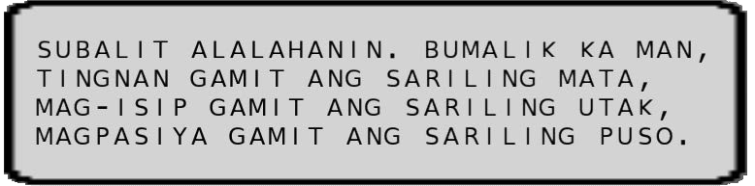
Example Output Full Screen
With Auto-Scale to Make Square Window
Executed on LUBUNTU OS

--> Additional Note:
--> In writing the instructions ourselves, we learn among others:
--> Cause of select outputs opted by Computer Companies
--> Example Output:
--> Addition of Garbage Collector in the JAVA Virtual Machine to auto-clear previously used containers
--> Example Cause:
--> Not clearing the container stored in the Random Access Memory (RAM) causes excess text characters to appear due to still containing previous data. These data were added by the Computer in Memory for use in another set of instructions.
--> Reminder: "Random" need not be so, due to existing pattern; albeit "RAM" is still used
--> Recommended Actions:
--> re-verify: if pattern used by computer is based on clock time
--> re-verify: if technique used to auto-generate monsters, i.e. bakemono, in select computer game dungeons
--> where: bakemono = 化け物 = naibang bagay

NOTE (from SYSON, MICHAEL B.):
From these computer development parts, we can build our own Operating System (OS), i.e. USBONG OS.

After verification, select companies use existing OS, e.g. Linux, Berkeley Software Distribution (BSD), whose computer instructions are publicly available to write their own OS. These OS's are used to execute a focused set of tasks, e.g. mobile computers as electronic book readers, electronic game Read-Only Memory (ROM) readers.

Reminder: an OS can be installed for use inside another OS
Example: We can use FreeBSD on a LUBUNTU OS via Virtual Box.

In addition, after computation, students who learn to make their own systems, e.g. games as hobby, have less in their expenses count. This is in contrast to those who buy the newest and fastest systems, e.g. PlayStation 5, as hobby classified to be entertainment only.
Reminder:
PlayStation 5 Estimated Cost: > PHP 25K
--> Usage as Consumer Only;
--> Software Development Kit (SDK) Additional Cost

Personal Computer (PC) Estimated Cost: PHP 10K
--> Usage as Consumer and Developer
--> Software Tools: open source, i.e. publicly available computer instructions, e.g. LUBUNTU, LibreOffice Calc.

From history, we learn that the cause of the shutdown of companies, e.g. computer games companies, is due to expenses > income, where even stored money becomes insufficient to pay for the increasing expenses.

Example:
Select Computer Games Companies executing development of games exclusive to Sega (Service Games), e.g. for the Sega Saturn system.

株式会社クライマックス (CLIMAX Inc.)
ダークセイバー (Dark Savior); Sega Saturn Exclusive; Year 1996

In addition, select Companies opted to be developer of games exclusive to another Company, e.g. Nintendo; This is instead of for only one of its systems.

Example: Intelligent Systems and Nintendo
--> output: マリオ ストーリー (Mario Story; for the Nintendo 64)

Additional Notes:
1) Camelot Software Planning opted to be exclusive developer to Nintendo.
--> This is after being with SEGA.
--> output: マリオ テニス 64 (Mario Tennis 64; for the Nintendo 64)

2) AlphaDream was exclusive developer to Nintendo until its shutdown.
--> output: マリオ＆ルイージRPG (Mario&Luigi RPG; for the Gameboy Advance)

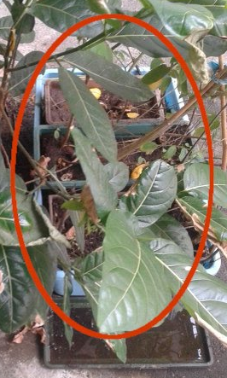

Containers Inside Container
Plants Growing Larger than Container

--> 4.3) Automotive: Usbong Foot
--> reused: instructions in Usbong Volley
--> Usbong Foot Objective as Sport: Pilots hit the ball downward to the centered gray floor plate tiles
--> updated: Computer Artificial Intelligence (AI) to be Human-assistive
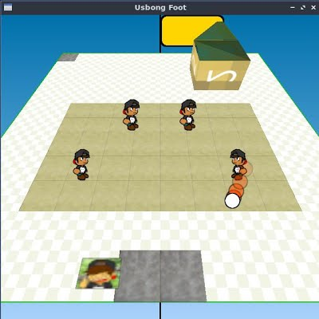
--> At present, Unit members move based on Unit Chief's movements; The 4 Pilots are a Unit. This is instead of 2 Pilots against 2 Pilots in Usbong Volley.

--> TO-DO: -add: Animal to represent Nature who executes defense against the Pilot's attacks to the goal
--> TO-DO: -update: Cap to identify Unit Chief

--> verified: existing Computer AI techniques; example:
マリオテニス６４："FOR ALL PLAYERS HOPING TO TOUCH THE TRUE ENTERTAINMENT"
--> from: CAMELOT (SOFTWARE PLANNING) + NINTENDO
--> Mario Tennis 64; Japanese version; Year 2000
--> verified: I as Mario (classification: ALL-AROUND) can defeat Donkey Kong (classification: POWER) with Computer Difficulty Level set to つよい (tsuyoi; STRONG) i.e. second highest Difficulty Level, and Camera set to NORMAL
--> Highest Difficulty Level: さいきょう (saikyou), i.e. THE MOST STRONG; STRONGEST
--> Count Results:

