
March 2021
CENTRAL NERVE : 中枢神経 (Center Area God Passage)
Network Bandwidth : Electricity Area・Passage
Wireless・Wired
PHILIPPINES: USBONG CONTINU​ES TO PROVIDE
COMPUTER SERVICE ASSISTANCE BY SHARING
KNOW-HOW ON MAPARAANG PAGBIBILANG

To eliminate excess steps and inefficient time usage, MARIKINA ORTHOPEDIC SPECIALTY CLINIC (MOSC) requested Usbong's services to automate routine, monotonous tasks and share with unit members know-how on computers.

Here are Key Action Items that we executed in this updates list.
1) Continued to update Knowledge Management System (KMS)
--> 1.1) updated set of computer instructions @MOSC
--> 1.1.1) removed: the delete button at the Information Desk Patient Wait List page
--> This is due to an increase in delay to finish re-verification of end of day reports.
--> Total Time to Finish: > 50mins; Previously: < 30mins
--> After verification, Unit members at the Information Desk were deleting patient transactions in the list to correct spellings.
--> This is albeit the patient was already classified as paid at the Accounting/Cashier Unit.
--> Unit members at the Cashier Unit had to again add the transactions.
--> This included among others: Consultation, Medicine Item, and Non-medicine Item Fees.
--> 1.1.2) added: in Wait List page count of transactions that are added at the Cashier Unit.
--> This is instead of at the Information Desk Unit when the patient arrives.
--> 1.1.3) verified: Problem: no internet network access due to electricity loss @2021-03-11T12:14 in MOSC HQ, Marikina City
--> re-verified: after electricity returned, local network access to computer servers that are physically present at MOSC HQ remained accessible and continued to work
--> Solution: restart network devices, e.g. routers with small antennae, bridges
--> 1.2) updated: computer instructions @Sta. Lucia Healthcare Center (SLHCC)
--> 1.2.1) Auto-generate Unpaid Health Maintenance Organization (HMO) Summary Report
--> added: auto-write Medical Doctor's complete name in output file
--> Previously, the computer wrote the Medical Doctor's first name in the filename.
--> However, Unit member still had to add the complete name when printing the reports.
NOTE (from SYSON, MICHAEL B.):
The total count for both Consultation and PT Treatment (year 2020) is more than 2300.

Previously, we wrote computer instructions to auto-verify the paid HMO list from SLHCC's Accounting Unit with MOSC's Master List of transactions. In addition, the computer auto-writes as paid and its payment month in the Master List's notes column HMO transactions that are classified to be paid.

However, after re-verification, there exist variations in the paid HMO List from SLHCC. Examples include among others: column sequence, date format, overpaid/underpaid transactions.

We recommend that before writing computer instructions to automate, i.e. automatically execute, tasks, the Unit member as writer verify by doing first the steps that the computer shall execute.

I add that system efficiency becomes noticeable when computers automate routine, monotonous tasks with transactions count of over 1000.

In fact, the computer finishes generating the Unpaid Summary Report in 3seconds (Average).
Execution Elapsed Time in Sequence (seconds): 6,2,2,2

From observation, Unit members with training in Information Technology, which includes among others: computers, engineering, i.e. speed-up system, can identify tasks that computers can automatically execute after being given those tasks for them to execute.

However, automation can only be executed by computers when data are in a format that the computer can use, e.g. digital data.

As with Unit Chiefs who are accountable by paying financially for a failed project, i.e. expenses > income, Unit members who prefer to use IT tools to speed-up execution of their tasks become accountable for usage of their own time.

--> 1.2.2) Auto-generate Short Messaging Service (SMS) Summary Report for the Day
--> added: Consultation transactions counts, e.g. Cash, HMO payments
--> At present, Physical Therapy (PT) transactions do not yet reach 10 during clinic days.
--> This action is to verify Consultation count to be also lesser than before the CORONA VIRUS DISEASE 2019 (COVID-19) pandemic, such that vacant time of Unit members, e.g. Medical Secretaries, has increased.
--> In addition, the counts assist in computing to identify if income > expenses.
--> If income < expenses, it is expected that continuous loss of money shall result to shutdown of Orthopedic and PT Unit operations.
--> 1.3) continued: to share know-how on computers and Information Technology (IT) tools
--> There are two (2) variations of the RJ-45 8pin Cable Wire that we use in a wired network: Straight and Cross
--> where: Straight: used with machines that are NOT of the same classification, e.g. computer and router
--> Cross: used with machines that are of the same classification, e.g. router and router
--> We identify these 2 variations using the sequence of the 8pins.

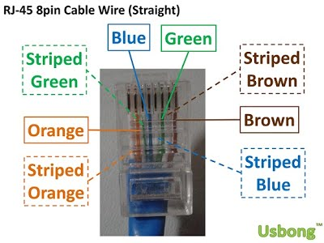
--> Straight: same sequence
--> Example: brown, striped brown...orange, striped orange : brown, striped brown...orange, striped orange
--> Cross: reverse sequence
--> Example: brown, striped brown...orange, striped orange : striped orange, orange...brown, striped brown

NOTE (from SYSON, MICHAEL B.):
We updated the computer network at our partner MOSC using available IT tools. This is to solve the problem of select computers can only send data, but not receive from another computer.

Previously, we used two (2) routers with one connected directly to the Philippine Long Distance Telephone (PLDT) Router.

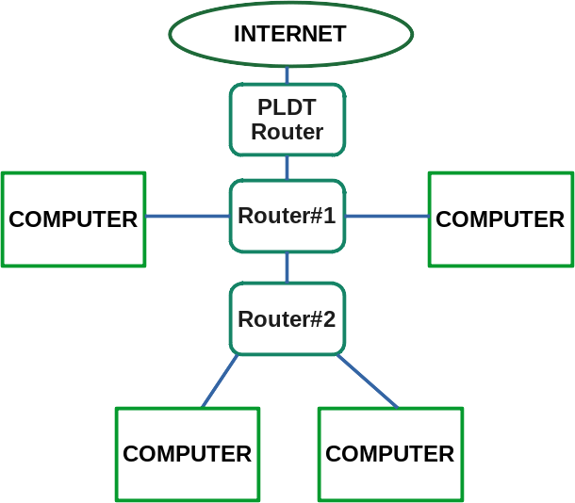

Sample Technical Schematics (Previous)

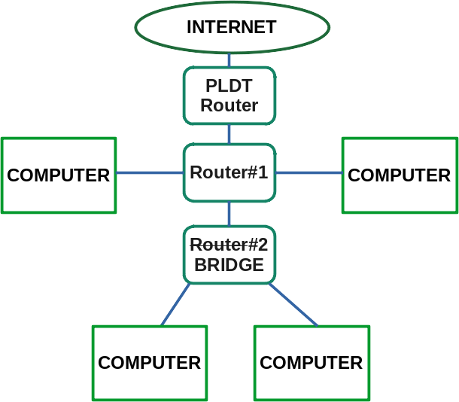

Sample Technical Schematics (Now)

Router#1: connected to PLDT router
Router#2: connected to Router#1

I note that the PLDT Router accepted only one (1) Local Area Network (LAN) wire connected to it.

Select set of computers were connected to Router#1.
Select set of computers were connected to Router#2.

Those that were connected to Router#1 could send data to those computers connected to Router#2.
Those that were connected to Router#2 could NOT send data to those computers connected to Router#1.

Result: CHAT tools, e.g. LAN Messenger, did not function as intended.

Solution: We receive the Internet Protocol (IP) address of all the computers that should function with LAN Messenger from Router#1. We set Router#2 to be classified as BRIDGE.

Additional Notes:
1) BRIDGE = network device that does not create a new set of IP addresses
--> Previously, Router#1 would create a set of addresses, e.g. 192.168.1.1.
--> Router#2 would also create a set of addresses, e.g. 10.11.1.1.

2) Even with the Previous Technical Schematics, computers connected to Router#2 can still access the Internet.
--> Internet = computers connected to the public computer network to be accessible
--> The problem was that the addresses of the computers connected to Router#1 were not accessible to those that were connected to Router#2.
--> Action: re-verify: Sample Technical Schematics (Previous)

Tanong at Sagot

1) Magkano ang aking kikitain bilang Computer Services Salesperson at Manunulat ng paliwanag sa kompyuter, e.g. Add-on Software?
--> Kung babayaran tayo ng klinik ng 10K pesos bawat buwan, 5K ang sa iyo bilang Computer Services Salesperson.
--> Bilang Manunulat, 4K pesos ang maibibigay sa iyo ng Usbong.
--> Sa kabuuan, 9K pesos ang matatanggap mo bawat buwan.
--> Ang matitirang 10% ng 10K, i.e. 1K pesos, gagamitin ng Usbong sa pag-iipon ng kapital.
--> Gagamitin ito ng Usbong sa paggawa ng mga investment at "float", na ang kahulugan, liquid asset.

2) Paano ako makibabahagi sa tagumpay ng kompanya?
--> Kung wala tayong kikitain mula, halimbawa, sa Computer Automation Service, mauubusan tayo ng kapital na pambayad sa ating lahat. Hindi magtatagal, wala na tayong kompanya.
--> Dahil dito, kailangang maayos ang ating paggawa at pagtuturo sa mga trainee upang tuluy-tuloy ang daloy ng ating kita, habang nagbibigay ng ginhawa sa lipunan.

MAPARAANG PAGBIBILANG
ALGEBRA SKILL LEVEL 1:
INPUTS:
X = 250 //ITEM PRICE
V = 12% //VALUE ADDED TAX (VAT)
Q = ? //ITEM PRICE WITH VAT

TANONG: WHAT IS ITEM PRICE WITH VAT?
SAGOT:

ALGEBRA SKILL LEVEL 2:
INPUTS:
X = ? //ITEM PRICE
V = 12% //VALUE ADDED TAX (VAT)
Q = 364 //ITEM PRICE WITH VAT

TANONG: WHAT IS ITEM PRICE WITHOUT VAT?
SAGOT:



USBONG SOCIAL SYSTEMS, INC.
COMPUTER SERVICES

SYSON, MICHAEL B.
FOUNDER

MOBILE: +63929.952.7263
EMAIL: MASARAPMABUHAY@GMAIL.COM

WEBSITE: WWW.USBONG.PH
ADDRESS: #2 E. MANALO (FORMERLY, E. RODRIGUEZ) AVE., STO. NIÑO, MARIKINA CITY, 1820, PHILIPPINES

--> 3.3) YES/NO na dalawang bato
--> Kapag ang isa nakabaliktad at ang isa hindi, YES.
--> Kapag parehong nakabaliktad o pareho ang lapag, NO.
--> Kailangan may isa wala, para may isa na meron.
--> "yin/yang" : dark/light
--> verified: kahit alin ang sagot ng bato, iaakma lang ng Teroristang Komunista ang sagot sa kanilang nais.
--> 3.3.1) Halimbawa: Gagaling ba ako sa aking karamdaman?
--> YES! OK.
--> NO! Magaling na kasi ako.
--> 3.3.2) Kapag iaakma ng Teroristang Komunista
--> Halimbawa: Gagaling ba ako sa aking karamdaman?
--> YES! Gagawan kita ng sakit.
--> NO! Palulubhain ko pa.
--> Dahilan: quick money
--> Aksyon: harrassment; extortion
--> Additional Note:
--> Halintulad ang mga panloloko sa gawa-gawang paliwanag na hindi mo mauunawan ang isang bagay sapagkat hindi ka Indian; hindi mo kailanman matututunan ito, kahit anong aral mo.
--> added: ブシドーブレード (BUSHIDO BLADE) 解説書 (SOLVE TELL, i.e. EXPLANATION, BOOK)
打刀 (うちかたな; uchikata, i.e. hit knife; KATANA)
全体 (WHOLE BODY)：92cm
刃長 (BLADE LENGTH)：69.3cm
反り (REFLECT CUT)：2.1cm
重量 (WEIGHT QUANTITY)：1.5kg

4) Continued to work with among others:
--> PhilHealth, Social Security System (SSS), Securities and Exchange Commision (SEC), Bureau of Internal Revenue (BIR)
--> received: notification to use electronic online system to pay contributions; shared: know-how with banks, e.g. United Coconut Planters Bank (UCPB), Bank of the Philippine Islands (BPI)
--> agreed: mas aayos ang ekonomiya ng Pinas kung matututong magtipid at mag-ipon ang mga Filipino
--> Ito'y sa halip na gumasta nang gumasta.
--> Ituturo mo ba sa iyong anak na gumasta nang gumasta?
--> Maiging may naiipon tayong pera, upang may magamit kapag kinailangan. Halimbawa: Mag-ipon ng hindi bababa sa 10% ng income, i.e. kinikitang pera/salapi mula sa hanap-buhay.

5) continued: to share printed Usbong Newsletters to Salespersons, e.g. Newspapers, Computer Shops, Medical Representatives, and partners, e.g. Sta. Lucia Health Care Center (SLHCC), in the following Barangays:
--> Marikina City: Barangays Sto. Niño, Sta. Elena, San Roque, Kalumpang, and Marikina Heights
--> Cainta, Rizal: Barangay San Isidro
--> Reminder: digital version available at www.usbong.ph
--> This is in addition to the Maparaang Pagbibilang Questions.

NOW HIRING: COMPUTER SERVICES SALESPERSON
✓Receive half of the revenue from your DIRECT SALE of the service

✓Receive training:
Filipino Language, Sales, Information Technology
Requirements:
1) Curriculum Vitae
2) Portfolio
3) Sulat ng Hangarin
3.1) Ano ang maitutulong mo?
3.2) Bakit mo nais ito?
3.3) Bakit ka karapat-dapat?



EMAIL: APPLY@USBONG.PH

--> Only computers with Router#1 can send data to those with Router#2.
--> In the case of the Internet, the addresses are accessible to both computers with Router#1 and Router#2.
--> In addition, the addresses are stored in a list by computers that are also accessible to the public.
--> Routers also store a list of addresses that they set for the computers/machines/devices that are connected to them.

3) Unless set with additional payment, the PLDT Router prevents incoming access to addresses of computers connected to it from computers of the Internet.
--> However, data sent by computers connected to the PLDT Router to the Internet become accessible to the public.
--> Computer Security Companies add encryption technology, e.g. Secure Sockets Layer (SSL), Virtual Private Network (VPN), to execute data encryption, i.e. make data not human understandable without a key to its set lock.
--> This is so that the budol-budol/manloloko/carnapper/cybercriminal/communist terrorist group shall need more time to find information from the data for use with quickly getting money.
--> verified: use of encryption technology, e.g. SSL, is not effective against the communist terrorist group.
--> This is due to among others: web addresses also include information.
--> Example: search keyword "define SSL" using Ubuntu Linux Machine with Google Search Engine
--> Output web address: https://www.google.com/search?channel=fs&client=ubuntu&q=define+ssl;
--> last accessed: 20210312
--> reminder: web addresses with "https" keyword, with the "s" at the end, already use SSL technology

4) The Firefox Computer Web Browser has a Library tool that displays a history list of web addresses.
--> When a Unit member visits a web address, Firefox puts that web address on top of the list.
--> If the web address is already in the list, Firefox moves that web address on top of the list.
--> In addition, this list exists in the computer where Firefox is installed.
--> We add that this tool's technique is reused such that another computer can have a copy of the history list.

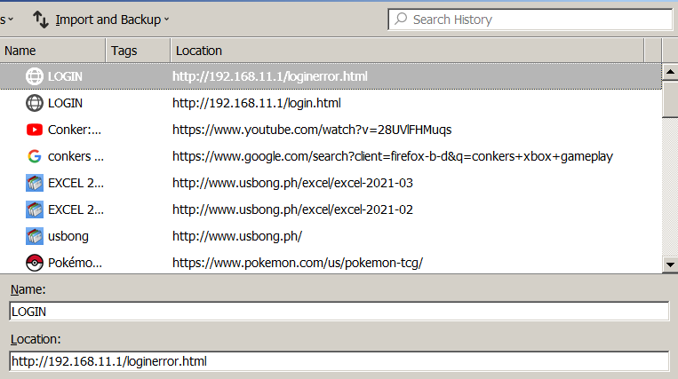
NOTE (from SYSON, MICHAEL B.):
Using Hypertext Markup Language (HTML), we can opt not to include information in the web address.

Example Usage: When we submit a login form, we prefer that the username and password are not included in the web address.

We can execute this action using HTML's POST command, instead of the GET command.

Because we have access to the web page instructions, e.g. which page to load after submitting the login form, we can add instructions to receive the username and password sent using the POST command.

I verified that unauthorized access to web pages via the network is a technique used by the budol-budol/manloloko/carnapper/cybercriminal/communist terrorist group to steal information to quickly get money.

Recommended Action:
1) learn: Usbong Training: Introduction to Writing Pages Using HTML

2) Continued with Research & Development (R&D)
--> 2.1) Automotive: Usbong OpenGL (Graphics Library) and Usbong Engine
--> updated: set of instructions for computer to store in the non-persistent memory storage, i.e. Random Access Memory (RAM), level map values that it read from the .csv (comma-separated values) input file
--> The computer uses this map to identify the positions of the objects to auto-draw.
--> The computer only auto-draws objects that are inside a set range, e.g. row positions 0~60, 21~81.
--> The computer moves the set range after receiving as input keyboard commands from the Unit member.
--> We can replace keyboard commands with another input device, e.g. manibela/steering wheel.

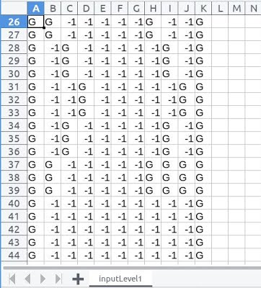

Level Map as .csv input file
where: G = Grass
We can edit this using spreadsheet editors,
e.g. LibreOffice Calc, Microsoft Excel.

--> updated: Usbong Computer-Aided Design
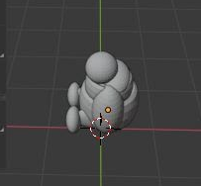
--> added: instructions for computer to use as input .obj files auto-generated using the Blender 3D Tool

--> The output of this action is a file with the set of instructions to auto-draw the object using OpenGL

--> At present, the output file with the set of instructions to auto-draw the Object file is already at 3.6MB
--> where: MB = MegaBytes
--> A 3.5inch high-density diskette can store 1.44MB (max).
--> At present, the file size of our workbook with 2 years of data does not reach 900KB.
--> Reminder: 1MB = 1000Bytes; 1Byte = 8Bits; 1Bit = 1 set of yes OR no, true OR false, 1 OR 0, on OR off

--> added: Usbong Mini to verify auto-drawn Image Texture on flat boards
--> Examples:
--> CAPCOM's Tron Bonne Mini Game: Cannonballs
--> SQUARE ENIX's Octopath Traveler
Recommended Reading:
1) Arthur Clarke's "Rendezvous with Rama"
--> Scientists discover signs of life on an asteroid that is quickly moving towards the Sun.
--> The discovery and its effect reminds me of the discovery of dinosaur fossils and its effect on the population.

--> verified: regrowth of sili plant after most of its leaves were eaten by the caterpillar
--> Recommended Action: verify: that plants still have leaves
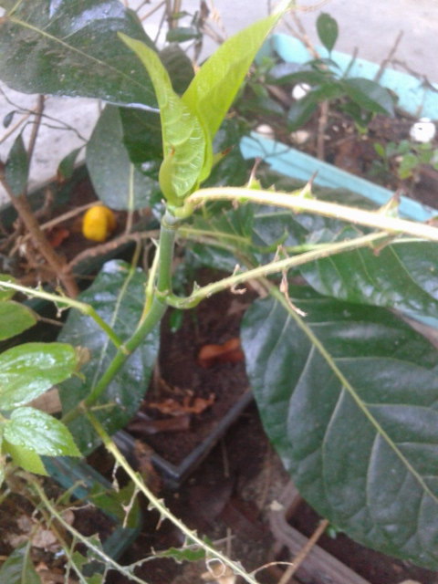
--> This is due to for select plants, e.g. papaya, loss of all leaves cause death to the plant.

Remaining portion of lemon (LEFT) after using juice to make lemon juice

--> verified: arrival of fruit flies

Additional Notes:
1) background blurred in contrast to sili as focused object
--> blurred = malabo = boketeru

2) Objects also become blurry when focused in excess. This know-how is used in Computer Vision to execute robot movement, e.g. before collision with another object. Focused due to object near camera eye.

--> verified: arrival of white ant that is larger than the black ant
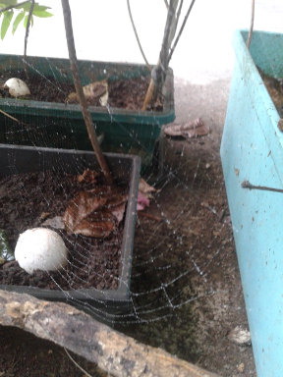
--> observed: that it moves using the tomato stem path that the black ants also use; they do not attack each other
--> observed: white ant to be classified as Termite
--> Action: removed and destroyed Termite

--> verified: arrival of spiders that create new or repair damaged sets of spider webs
each day
--> observed: arrival of mosquitoes
--> Recommended action: verify: action of spider after capturing mosquito to eat; "kiss of death" : suck ball

3) Continued to update Training Centre: Security Defense Force
--> Dagdag na halimbawa ng mga panloloko mula sa grupo ng Teroristang Komunista at ang kanilang "our people's language":
--> 3.1) Hindi maaaring ipaalam sa may-sakit na nagtatanong kung anong araw at oras na ngayon.
--> Halintulad ito sa pagbibigay ng relos o orasan sa may-sakit.
--> verified: may maririnig kang tumutunog-tunog na ingay, e.g. "tick-tock", sa silid ng may-sakit;
--> halimbawa, ang kay 阿媽 (amah, a-ma), i.e. Lola.
--> Mula ito sa wireless broadcasting ng mga Teroristang Komunista, at hindi sa orasan.
--> Hanggang pinaka-itaas na palapag sa silid ng Lola, umaabot ang panlolokong ingay ng mga ito.
--> Gumagawa iyan ng mga sakit na nagdudulot ng paglala ng karamdaman,
--> lalo na kapag hindi ka aakma sa nais ng kanilang grupo.
--> Dahilan: quick money
--> Aksyon: harrassment; extortion
--> 3.2) Hindi ipinagdiriwang ang kaarawan kasama ang mga kamag-anak, kung hindi ika-unang taon pagkatapos ipanganak.
--> Ito'y upang hindi gumasta nang malaki taun-taon.
--> verified: nauubusan pa rin ng pera, kaya kailangan gumawa ng mga panlolokong ingay at pisikal na pananakit.
--> added: Computer Machine Controller in Computer Interactive: Lessons-learned Notes
--> observed: that select items not yet sold in the Philippines in 2008
--> Examples:
--> XBOX360 Universal Service Bus (USB) controller that can be connected to a Computer for use,
--> e.g. with Microsoft XNA Development Kit
--> Nintendo Dual Screen (DS) USB cable to receive electricity after connecting to a Computer
--> This is due to target market was not the Philippines.
--> Recommended Action: verify: target market's preferences, e.g. Magic Trading Cards, create a version that solves the problems, while adding Philippine culture
--> Japanese example: Final Fantasy 6
--> Additional Examples:
--> Mario Kart 64 -> Diddy Kong Racing 64 -> Crash Team Racing
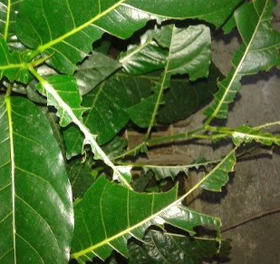
--> 2.3) Energy: Food
--> verified: arrival of new caterpillar (brown, instead of lime green) that ate the leaves of the sili plant
--> observed: parts of sili leaves were being eaten
--> After 7 days, action began to accelerate to be exponential, such that by the 10th day of observation, only sili branches remained for select parts of the sili plant.
NOTE (from SYSON, MICHAEL B.):
The caterpillar appeared bigger than the previous caterpillar that I removed. It was at the back of a sili leaf when I removed it on 2021-03-16 at approximately 13:30.
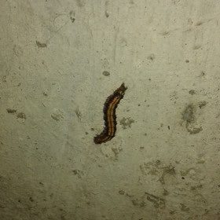
Caterpillar climbing a column
Approximate Size: 0.20 x 1inches

This was during my daily (morning, afternoon, and evening) spraying of water with vinegar to make the leaves moist and with odor, such that the black ants would leave. However, the black ants still remain and have invaded another farther branch of the same tomato plant. This is albeit the speed that they eat the leaves is not as fast as the caterpillar's. I note that during evenings, the black ants do not climb the tomato plant.

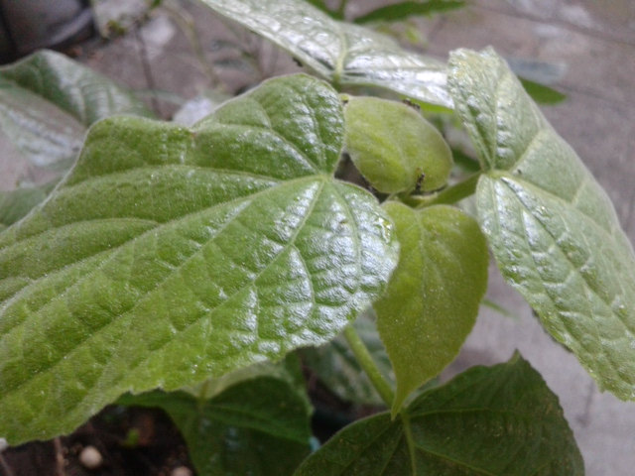
Black ants at top of tallest branch of tomato plant
Egg shell (BOTTOM-LEFT)
You can observe the borders, i.e. silhouette, of the tomato leaves.
They remind me of an auto-drawing technique used with Super Mario Galaxy. I added chicken egg shells on the soil. Sometimes, they contain the remaining unused yellow and white portions after I cooked the eggs. We understand that such portions provide protein. I am re-verifying if they are indeed effective in increasing nutrients in the soil.

In addition, their brightness in contrast to the dark soil makes it faster to identify select parts of the approximately 2 x 1m mini garden.

--> observed: technique also used with background movement in CAPCOM's Street Fighter II': Hyper Fighting
--> added: instructions to auto-execute animation sequences with 3D objects, e.g. Image Texture on flat board
--> used: "modulo" operation to cycle frames
--> we divide a number by another number; output: remainder
--> where: percentage symbol, i.e. "%", = modulo
--> numbers and remainders are integers, i.e. whole numbers
--> if remainder is not whole number, return as output the number before %
--> Examples:
--> 1%4; answer: 1
--> 2%4; answer: 2
--> 4%4; answer 0
--> At present, we use cycling in adding red and white to the object with Image Texture
--> 2.2) updated: Computer Interactive: Lessons-Learned
--> 2.2.1) Street Fighter II': Hyper Fighting
--> attacks do not hit 100%; (due to speed of created world)
--> you winning status, e.g. 90% remaining health strength, can quickly end with you lose
--> 2.2.2) Capcom vs SNK 2: Millionaire Fighting 2001
--> Fighting becomes 勝負 (shoubu; win・lose),
--> e.g. both fighters have low remaining health strength and clock time at less than 3seconds
--> verified: with self as Ryuu (smiling illustrated photograph version; fighting style: K-Groove, i.e. ジャストディフェンス (Just Defense)) that I lost the fight due to verifying the clock and deciding to attack first before computer (set at highest difficulty) as Blanka, with fighting style also K-Groove
--> I as Ryuu had been executing continuously 波動拳（hadouken; wave movement fist）to reduce Computer Blanka's health strength to severity low, i.e. close to zero.
--> However, Computer Blanka's health was still stronger than mine due to I as Ryuu received several hits from Blanka's attacks.
--> Meanwhile, Computer Blanka was still guarding as defense against my 波動拳 attacks.
--> Dhalsim's advice after fighting: excess becomes 毒 (doku; poison, lason)
--> Recommended Action:
--> verify: Intelligent Systems Co., Ltd's TOP MESSAGE
--> https://www.intsys.co.jp/company/message/; last accessed: 20210328
--> 開発支援ツール (development support tool), developer
--> Examples (Representative Works):
--> ファミコンウォーズ (famicom wars; family computer wars; Advance Wars) series,
--> ファイアーエムブレム (faia- emuburemu; Fire Emblem) series,
--> メトロイド (Metroid), et cetera
2.2.3) SQUARE ENIX's Final Fantasy 6 (Japanese version)
--> マジック(majikku) card notes
--> 2.2.3.1) magic:
--> poison increased damage against tyranosaurus
--> reflect sends magic attack to enemy (reflected magic is not reflected again)
--> 幻獣 (genjuu; illusion beast) summon is not reflected
--> reflect from all 4 team members sends magic attack x4
--> 2.2.3.2) items inventory
--> 2.2.3.3) enemy/monster
--> 2.2.3.4) team member character
--> Examples:
Edgar (Machinery): Pinakanais kong isama sa pangkat; Hari ng bansang Figaro. May Castillo na lumulubog at maaaring maglakbay sa ilalim ng buhangin; Gumagawa ng mga non-magic attack gamit ang makina, i.e. machine. Maaalala ang wika ng Chief Ingeniero ng Castillo sa pananalita ng mga taga-Osaka sa bansang Hapon.

Seres (Rune Knight): Mas pipiliin kong isama sa pangkat kaysa kay Tina. May kakayahang humigop ng magic/mahika attack at gawing panghilom ng sarili. Isa siya sa mga ginawang eksperimento ni Kefka gamit ang mga genjuu (illusion beast). Nakaligtas mula sa mga nanamantala, at nagkaroon ng kakayahang mahika. Mapipili ring gumanap sa teatro gawa ng

kamukha ng isang tanyag na aktres ayon sa daloy ng istorya. Malakas.

Kaen (Samurai): Mas pipiliin ko kaysa kay Masshu, bagama't hindi siya kasing lakas ni Edgar o Locke. Naisasama kay Masshu dahil sa daloy ng istorya. Mula siya sa bansang Doma na gawa ng hindi mapuksa ng hukbong sandatahang lakas ng Empire sa tindi ng depensa ng kanilang Castillo, darating si Kefka na maglalagay ng lason, i.e. poison (magic attack), sa tubig na dumadaloy papasok ng bansa. Mapupuksa nito ang mamamayan ng Doma, kabilang ang asawa at anak ni Kaen. Mananatili ang Castillo ng Doma at si Kaen, na magiging kasapi ng inyong pangkat upang gapiin si Kefka. Maaalala ang hugis at gawa ng Castillo ng Doma sa Castillo ng Figaro, bagama't wala na itong mamamayan bukod kay Kaen.

Gasutora (Emperor): Hihikayatin ang inyong pangkat upang magapi si Kefka. Maaalala na tutol ang inyong pangkat sa ginagawa ng Emperor, kasama ni Kefka, na ginagamit ang mga genjuu upang mapalawak ang kanyang empire dahil sa taglay na kapangyarihan/lakas ng mga genjuu. Imumungkahi naman sa inyo ng Emperor na kausapin ninyo ang mga tao sa Castillo. Matutuklasan ninyo na maaari ninyong mahikayat ang mga miyembro ng kanyang Empire na tutol na gawin kayong kasapi sa pamamagitan ng paggapi sa kanila sa labanan. Nakasalalay ang Empire sa lakas.

Settsa- (Gambler): Tanging may kakayahang magpalipad ng barko. Maaalala na pumanaw ang kanyang kaibigan sa gawaing ito. Sa panahon na magugunaw na ang daigdig, kakailanganin ang FALCON, ang barko ng kanyang kaibigan, gawa nang nawasak ang kay Settsa-.

--> 2.2.3.5) Istorya/Salaysay:
Noong mga panahong iyon, pinaniwalaan na tuluyan nang nawala ang mahika/magic/himala sa daigdig. Gayunpaman, nakatuklas ang mga tao ng paraan gamit ang mga makina upang makagawa ng mga malamahikang gawain.
Lingid sa kaalaman ng mga mamamayan, matutuklasan ng Empire na may umiiral pang mahika mula sa mga genjuu (illusion beast) na magagamit sa pagpapalawak pa ng Empire dahil sa taglay nitong kapangyarihan.
Subalit magdudulot ang layuning ito sa pagkawasak ng mga bansa na ayon sa kasunduan, dapat ipagtanggol ng Empire. Gayundin ang magiging ikahihinatnan ng mga tutol na bansa sa kanyang gawaing ito.
Sa kabila nito, may mga tao at nilalang na tutol sa Empire ang bubuo ng pangkat at magkasasama upang pagtulungang gapiin ang Empire.
Additional Note:
1) Sa pook at panahon na magugunaw na ang mundo dahil sa kagagawan ni Kefka, na hinigitan pa ang kapangyarihan ng Emperor, ipaaalam sa iyo ng kompyuter na may magagawa ka pa bago ang katapusan.
--> Halimbawa: May mga magic, item, at team member na kailangan mo rin, bukod pa sa mga kinasanayan mo.
magic, e.g. poison
item, e.g. reflect ring
team member, e.g. Settsa-
Recommended Readings:
1) Baxter, G. and Smith, L. (1995). "Mastering magic cards: an introduction to the art of masterful deck construction". USA: Wordware Publishing Inc.
--> Foreword from "Magic: The Gathering" creator Richard Garfield: pastime with social involvement
--> Richard Garfield, professor of combinatorial mathematics at Whitman College, Walla Walla, Washington
--> History: Magic Cards released in August 1993; patterned after "Cosmic Encounter" from Eon Products and Mayfair Games

2) Lucas, G. (1976). "Star wars". USA: Ballantine Books.
--> Prologue: "But as often happens when wealth and power pass beyond the admirable and attain the awesome, then appear those evil ones who have greed to match."
--> Empire rots from within, albeit may not be visible outside.
--> The cause of the fall of an empire is due to problems at the core.

NOTE (from SYSON, MICHAEL B.):
「ポケモンカードゲーム」: ゲームの進め方・アドバイス.html
"POKEMON CARD GAME": Techniques to Advance in the Game・Advice.html
弱点: Weak Point:
炎の弱点は水
Flame's weak point: Water
水の弱点は雷
Water's weak point: Thunder・Lightning
草の弱点は炎
Grass's weak point: Flame
…
カードゲームの魅力：Card Game's Charm (as strength):
「最初に作ってもらったデッキをずーっと使うより、自分でデッキを改造したり、新しく作ってみたいよね。」
"Instead of continuously using the first built DECK that we received, we agree that we want to re-build the DECK and create anew ourselves."
重要な情報：Important Information:
「この世界にいるトレーナー達と戦って、もし負けてしまっても、自分が損をすることは無いんだ。負けたからといって持っているカードが減らされたり、大事なカードを取られたりすることも無い。相手トレーナーも何度でも対戦してくれるから、負けることを恐れないでどんどん挑戦しよう。」
"It is not our loss if we end up losing after fighting with the trainers of this world. Even if we say we lose, the cards that we have are not reduced, precious cards are not taken from us, etc. Our partner trainers are willing to fight battles with us no matter how many times, so we should quickly and continuously challenge them, without being afraid to lose."
マシン：Machine:
マシンに「デッキの作り方」を記録しておこう。
Let's record in the machine the "Techniques to Build DECKS".
Reference:
1) https://www.nintendo.co.jp/n02/dmg/acxj/page03.html; last accessed: 20210326
--> Translated from nihongo to English by SYSON, MICHAEL B.
Additional Notes:
1) POKEMON = POCKET MONSTERS
2) I remember playing the first Pokemon (red version) back in elementary school on my Gameboy Color. There was a problem with the cartridge's battery, such that the save file gets erased. Still, I continued to play the game until I received the Pokemon badges after defeating all the Pokemon trainers.
--> The Pokemon series continued on, releasing the yellow version, etc. While I did verify these games, I didn't anymore use my time to play them as much as the Pokemon (red).
--> This is with the exception of the Pokemon Trading Card Game, which I classify to be an alternate version that I played on Gameboy Color.
--> This result is due to the following:
--> received: recommendation from older sibling to verify it
--> played: previously the Magic The Gathering Card Game
--> observed: Pokemon series' gameplay remained the same, but with more monsters whose designs are not quite like those from the first.
--> observed: we grew up to begin to play another game, instead of the Pokemon series

