
October 2020
コンピュータ：情報
INTERACTIVE：AUTOMOTIVE

PHILIPPINES: USBONG CONTINUES TO PROVIDE
COMPUTER SERVICE ASSISTANCE BY SHARING
KNOW-HOW ON MAPARAANG PAGBIBILANG

To eliminate excess steps and inefficient time usage, MARIKINA ORTHOPEDIC SPECIALTY CLINIC (MOSC) requested Usbong's services to automate routine, monotonous tasks and share with unit members know-how on computers.

Here are Key Action Items that we executed in this updates list.
1) Updated in partner peripheral Unit Computer Bot's rounding instructions when auto-generating Short Messaging Service (SMS) reports
--> MS EXCEL at the Sta. Lucia Health Care Center (SLHCC) Cashier Unit uses "Banker's Rounding" by default.
--> To quickly solve this, SLHCC ORTHO & PT Unit Computer Bot verified only until the second to the last digit to the right.
--> Example:
--> ORTHO & PT Unit : 535.72
--> Cashier Unit : 535.71
--> If the values are equal, Computer Bot uses Cashier Unit's value.
--> Computer Bot that auto-generates SMS Report now uses "Banker's Rounding".
--> found: instructions guide to execute Banker's Rounding at www.stackoverflow.com.
--> Microsoft Documentation was unclear on technique to execute; less predictable
NOTE (from SYSON, MICHAEL B.):
At the time, it was faster to update instructions at SLHCC Ortho & PT Unit than at the Cashier Unit due to waiting time to receive approval from SLHCC Administration. Previously, I intended not to use Banker's Rounding at all.

Banker's Rounding:
if digitToVerify = even number
AND if digitToVerify <= 5, round down, else round up
if digitToVerify = not even number, round down

You can find the actual set of instructions that we use already available to the public on GitHUB:
Examples:
535.716 --> 535.71; digitToVerify = 1
714.286 --> 714.29; digitToVerify = 8

UsbongUtilsRound(double inputValue, int numOfDecimalPlacesAfterDot)

Example Usage: UsbongUtilsRound(714.286, 2)
Output: 714.29

In addition, I wrote the instructions in the Java Computer Programming Language.
2) Added instructions to automatically compute the week's total unpaid Cash transactions from partner SLHCC Unit
--> In addition, the computer automatically identifies the dates of the unpaid transactions.
--> These actions are due to an increase in the number of unpaid Cash transactions.
--> I note that we do not anymore execute cash collections every day that SLHCC is open.
--> Instead, we use time and money to automate more tasks, e.g. receive reports via Short Messaging Service (SMS) network.
--> After computation, we learned that the number of transactions has decreased by at least 1/4 the total last year.
NOTE (from SYSON, MICHAEL B.):
Estimated Traveling Time from MOSC HQ to SLHCC Unit is 26mins by foot. Estimated Traveling Time from MOSC HQ to SLHCC Unit is 22mins (parking time not included) by vehicle.
From my observation, the primary advantage of a vehicle is to bring items

whose weight is in excess of 5kg and with traveling distance of at least 624meters.
In addition, computed diesel expense per week of two-way travel (Monday~Saturday) is PHP400.
We now use the diesel expense savings to buy the 4 Liters of milk, which we share with Unit members at the MOSC HQ every week.
I note that we buy promo sets of 2 milk cartons to reduce expense by PHP15 per set.
I add that I find value in continuing to invest at least 10% savings in the PESO BOND.
The PESO BOND is used by the Philippine administration to build infrastructure/layer of technology, e.g. roads, to make delivery of information and energy efficient.
Already, we shared that fresh milk as energy offers complete nutrition.
After computation, I learned that the interest rate of the PESO BOND from July until September 2020 is at 7.36% net.
This is despite the performance of other investments via banks is lower at, for example, only 1.75% net.
If you observed that the Philippine administration is inefficient, this is due to majority of the people who vote representatives have not learned Maparaang Pagbibilang.
Given this situation, the banks shall make certain that any investment, e.g. PESO BOND, is profitable.
Recommended Action:
1) Share know-how on Maparaang Pagbibilang
--> Example: As the next generation continues the family business, the increasing number of members in the household causes the previously sufficient income to become insufficient.
--> Therefore, it is vital that each famly member learns the value of honest work.
--> Mula sa Tamad ang Masama.
--> From literature we learn that the family business 삼성 (SAMSUNG) also observed the problem with the succeeding generations squandering wealth.
--> The solution was to reinvest back into the company profits, instead of straight into the pockets of the family members.
--> With this, SAMSUNG was able to expand outward.
3) Updated instructions to automatically verify and compute all Health Maintanence Organization (HMO) payments
--> +Updated: again the set of instructions after 2 years
--> In addition, I observed variations in the format and structure of the MS Excel files that we received from SLHCC.
--> learned: that it is faster to use the text editor tool, notepadqq, in LUBUNTU Operating System (OS), instead of featherpad
--> This is due to featherpad does not add color to text for files classified as Java computer language.
--> Although the "vi (Visual)" editor is also available, I find notepadqq in LUBUNTU faster in executing copy-paste commands.
--> I add that I use notepad++ with Windows OS.
4) Continued to update Knowledge Management System (KMS)
4.1) Added: Value-Added Tax (VAT) button to auto-identify and compute with VAT all non-medicine items in Cart List
--> This action is based on feedback after actual use by Unit members.
--> It is faster to request the computer to automatically add or deduct VAT for each non-medicine item and the total using a button.
--> In addition, the computer identifies the patient classification to be Senior Citizen (SC), Persons with Disabilities (PWD), etc.
--> There is no VAT for transactions with SC and PWD patient classifications.
--> At present, we opted not to remove the +12% VAT checkbox yet.

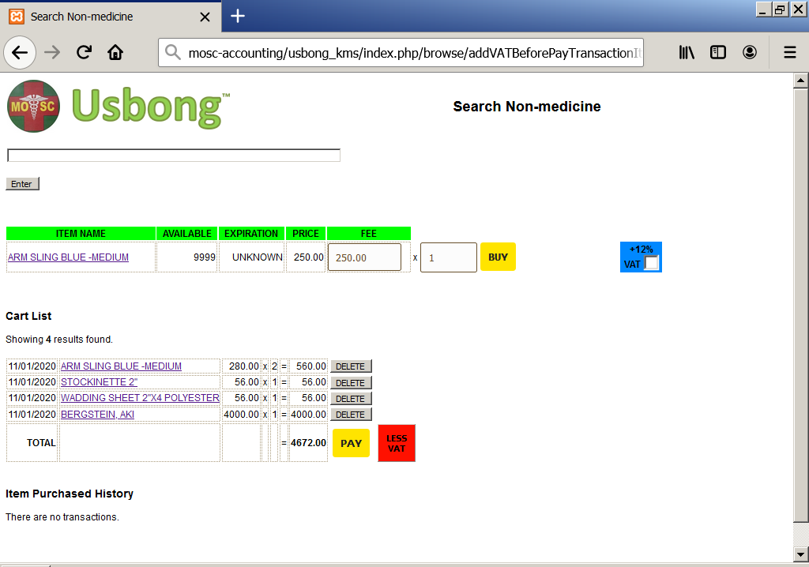
Example Non-medicine page with VAT button
Computer automatically adds or deducts

4.2) Added: instructions for computer to automatically note elapsed waiting time in patients list
--> The objective of this is to eliminate waiting time.
--> In addition, we at the Accounting/Cashier Unit can quickly answer questions from patients who call on the telephone or are already waiting outside the clinic.
--> This action therefore reduces burden at the Information Desk Unit that also provides physical assistance to the Medical Doctors and the patients.
--> I note that with computers, there is a tendency to gather information in excess.
--> The solution can be as simple as improving interaction between Unit members, including the patients.
--> Recommended Reading: Jeffrey Liker's "The Toyota Way"
--> +added: value of Information Technology to efficiently execute: Report, Contact, Consult
--> Recommended Reference: Minecraft (Playstation 3 Edition)

NOTE (from SYSON, MICHAEL B.):
We recommend that the Information Desk Unit already write using the computer the patient names in the wait list. This is instead of writing the names in the pen and paper wait list, and then into the computer.
With this action, we eliminate excess steps.
I note that the technique of writing using pen and paper is still a necessary skill to learn in such a way that a person can quickly remember to use it when the need arises.
In this case, it is equal with riding a bicycle.
Recommended Reading:
1) Mediktor
--> Hospitales: "Reducción de los tiempos de espera y prevención de errores médicos."
--> Telemedicina: "Guía a los pacientes al nivel de atención adecuado."
2) Bullfrog's Theme Hospital Manual
--> Kailangan munang pisikal na pumunta ng may-sakit sa MOSC para gawan ng physical examination, e.g. timbang, Blood Pressure, temperatura.
--> Mayroon kasi na kapag kinamusta sa telepono, ang isinasagot, "OK naman po ako", pero kapag ginawan ng physical examination mukhang nangangayayat/namumutla o labis na mataba.
4.3) Added: automatically taken photographs of wait list with our noon report
--> We still continue to use the PhantomJS tool to automate this browser action.
--> You may also find the documentation with examples on the PhantomJS web page easier to understand if you work with Computer Bots using sets of instructions classified as batch and/or bash shell files.
--> We also already shared to the public the actual sets of instructions that we use via GitHub.
NOTE (from SYSON, MICHAEL B.):
More than 10 years ago, I worked with an Australian citizen who recommended to me the use of Javascript to quickly display changing elapsed time on a web page without the use of the computer browser's reload tool.
I note that the reload tool accesses the computer web server that causes noticeable delay and web page change. With Javascript, the client computer's browser already executes the command.

--> Bilang paglilinaw, halimbawa, handa ka bang pangalagaan habang-buhay ang isang may-sakit na nagpunta sa iyo?
--> Kung hindi, magiging taga-bigay ng agaran at pansamantalang lunas lamang ang iyong tungkulin sa kanya.
--> 8.2) "Dugong Bigay, Dugtong Buhay"
--> +received: among others after donating blood to the Philippine Red Cross at partner SLHCC
--> Previously donated locations include: AMANG and Veterans Memorial Medical Center (VETERANS)
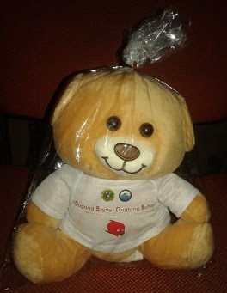
"Dugong Bigay, Dugtong Buhay"
NOTE (from SYSON, MICHAEL B.):
In 2014, I was invited to represent our team at a Tech4Dev conference of the Ecole Polytechnique Fédérale de Lausanne (EPFL) in Switzerland for our work on the following:
"Usbong: Electronic Health: Using Information and Communication Technologies (ICT) to enhance the Directly Observed Treatment Short-course (DOTS) Compliance Assessment Tool (DCAT) of the Philippine Plan to Control Tuberculosis"
I note that Lausanne is located in the French-speaking part of Switzerland.
In addition, there is the Red Cross Headquarters, where I found nearby a statue of Mahatma Gandhi whom we remember as an advocate of Universal Suffrage, i.e. pagpili via pagboto anuman ang paniniwala, natutunan man ang Maparaang Pagbibilang o hindi, atbp.
The design of his face reminds me of a mosquito, fly, or hornet.
Recommended Readings:
1) Firaxis Games and 2K Games' "Sid Meier's Civilization IV" Manual
2) Paramahansa Yogananda's "Autobiography of a Yogi"

Tanong at Sagot

1) Magkano ang aking kikitain bilang Computer Services Salesperson at Manunulat ng paliwanag sa kompyuter, e.g. Add-on Software?
--> Kung babayaran tayo ng klinik ng 10K pesos bawat buwan, 5K ang sa iyo bilang Computer Services Salesperson.
--> Bilang Manunulat, 4K pesos ang maibibigay sa iyo ng Usbong.
--> Sa kabuuan, 9K pesos ang matatanggap mo bawat buwan.
--> Ang matitirang 10% ng 10K, i.e. 1K pesos, gagamitin ng Usbong sa pag-iipon ng kapital.
--> Gagamitin ito ng Usbong sa paggawa ng mga investment at "float", na ang kahulugan, liquid asset.

2) Paano ako makibabahagi sa tagumpay ng kompanya?
--> Kung wala tayong kikitain mula, halimbawa, sa Computer Automation Service, mauubusan tayo ng kapital na pambayad sa ating lahat.
--> Hindi magtatagal, wala na tayong kompanya.
--> Dahil dito, kailangang maayos ang ating paggawa at pagtuturo sa mga trainee upang tuluy-tuloy ang daloy ng ating kita, habang nagbibigay ng ginhawa sa lipunan.

USBONG SOCIAL SYSTEMS, INC.
COMPUTER SERVICES

SYSON, MICHAEL B.
FOUNDER

MOBILE: +63929.952.7263
EMAIL: MASARAPMABUHAY@GMAIL.COM

WEBSITE: WWW.USBONG.PH
ADDRESS: #2 E. MANALO (FORMERLY, E. RODRIGUEZ) AVE., STO. NIÑO, MARIKINA CITY, 1820, PHILIPPINES

7) Continued working with the Marikina City Public Attorney's Office (PAO) regarding the problem with the budol-budol/manloloko/carnapper/communist terrorist/cybercriminal group.
--> I again note that the aforementioned group uses wireless broadcasting technology to cause physical injury.
--> 7.1) Requested: assistance from 'Amang' Rodriguez Memorial Medical Center (AMANG)
--> 7.2) Updated: Usbong Education Training Course: Training Centre: Security Defense Force
--> Tanggapin na likas sa tao ang pakikipaglaban
--> Sa labanan, tiyakin na ikaw ang mabubuhay
--> Mas maiging paniwalaan na kapag patay ka na, talagang patay ka na, i.e. hindi ka pupunta sa isang lugar na kung saan ika'y magiging mas maligaya.
--> Added: Mga Paalala
--> "Communist"/Komunista: Tao na naniniwala na dahil sagana na tayo, hindi na natin kailangang maghanap-buhay.
--> "Terrorist"/Terorista: Tao na gumagawa ng panloloko at pisikal na pananakit sa isa at higit pang mga tao.
--> "Communist Terrorist": Tao na naniwala na sagana na siya, kaya lang naubusan gawa ng pagwawaldas; naging Terorista upang mabilis na makakuha ng pera.
--> Recommended Reading: "THE PRESIDENT’S PENULTIMATE REPORT TO THE PEOPLE 2016-2020"
NOTE (from SYSON, MICHAEL B.):
Every week, I have been doing continuous walking hikes for more than 30minutes each way. This is in addition to the daily walking of at least 20minutes.
The longest that I've done is 2 hours one-way.
Another 2 hours is for the return home.
I was able to reach the San Miguel Corporation Headquarters and Shoe Mart (SM) Megamall in Ortigas, Mandaluyong City from Sto. Niño, Marikina City.
I computed that it would take me at least 3 hours to reach the National Bureau of Investigation (NBI) Headquarters in Taft Ave., Ermita, Manila.
I add that without training and hiking/rubber shoes, I will already be exhausted by the time that I arrive, such that I will have low defense against any attacks from the budol-budol/manloloko/carnapper/
communist terrorist/cybercriminal group.
In addition, I observed that select roads and intersections, e.g. Katipunan Ave. going to Barangay Libis, Quezon City or Barangay Industrial Valley Complex (IVC), Marikina City are a danger to walking persons due to incomplete/missing pedestrian lanes to make a way a la city racing track for fast-moving vehicles.
8) Continued to share publicly available information on Health
--> This action reminds people of what they already know.
--> 8.1) Example:
--> Pagkatapos makausap ng Medical Doctor ang may-sakit ukol sa kanyang nararanasang problema, bibigyan niya ng hatol o diagnosis ang karamdaman.
--> Imumungkahi rin niya ang pinakamaiging aksyon bilang treatment, e.g. gamot, surgical operation, physical therapy, sa kanyang diagnosis.
--> Dagdag pa, kailangang ipaalam ng may-sakit sa kanyang Medical Doctor kung tumatalab o epektibo sa kanya ang gamot, atbp.
--> Maaari kasing kailangan ng mas malakas na gamot, lifestyle change, e.g. masikatan ng araw, at hindi nakakulob sa kuwarto at buong araw tulog hanggang matuluyan nang mamahinga.
--> Mahalaga rin na may physical activity, bagama't kailangang may know-how sa wastong paggawa upang hindi sumakit ang likod, madulas, atbp.
--> Maiging may community, family, o company doctor ang isang lipunan, sapagkat mahalagang may regular na nangangalaga rito.

However, problems during execution can be difficult to identify with Javascript especially by a novice computer writer due to the computer may not output any error message at all.
In fact, the computer may not output any error message even for syntax errors.
Problems with execution are classified as logical errors, in contrast to syntax errors which are classified as compilation errors.
I add that in Javascript, there is no additional compilation required. The computer immediately executes what it understands from the instruction.
In addition, I tend to remember "Javascript" with Sun Microsystems, along with another computer language, i.e. "Java".
Sun Microsystems was acquired by Oracle Corporation in 2010.
4.4) Added: Print-ready Newsletter
--> observed: technique, e.g. layout design, used by Balita in printed newspaper
--> shared: printed Newsletter with among others: Newspaper Salespersons and Unit Members
--> I note that we use recycled paper for these printouts.
--> In addition, we understand that recycled paper can be further recycled.
--> This action is repeated until eventually they are burned to be another source of energy.
NOTE (from SYSON, MICHAEL B.):
We learn from Clarke, Arthur C.'s "3001 The Final Odyssey" that human beings learn to transform their selves into machines that live longer. Afterwards, human beings as machines learn to transform their selves into pure energy.
We note that this pure energy transmits to us messages as a guide.
Scripture from scholars, e.g. those classified as Astro-physicists, share with us that the stars we see at night on planet earth tend to be already dead stars.
However, we still see the light they emitted due to the time it takes for their light energy to travel and reach us.
In addition, present technology already empowers us to send information using optical fibers, which transmit using light energy more quickly than copper wires.
From observation, we learn that majority of the messages/information transmitted using light energy are unusable and can be classified as garbage.
This is why we learn to choose only those that are usable, i.e. assists us in realizing goodness.
In the end, after classifying everything, we learn to accept the truth that there is good and bad.
And we are set free to choose with our actions.
Recommended Actions:
1) Read Scripture, e.g. the Book of Genesis
2) Interact with Filipinos who understand "Aklat ni Mormon"
3) Verify 銀河鉄道999 (Space Galaxy Express 999)
--> Japanese Manga and Animation available
--> The Japanese animation story is an hour and a half film that empowers the viewer to invent all sorts of branching stories from the realm of possibility created in the world; however, at some point, the viewer has to stop. And the story is transformed into a distant memory.
4.5) Updated: set of instructions for Computer Bot to automatically access and save the database storage from one machine to another
--> learned: that we can reduce elapsed time from 240seconds (4mins) to 22seconds
--> This is by executing the "mount" command to enable access to the source folder in the "mnt" directory.
--> I note that the machines are connected to the computer network.
NOTE (from SYSON, MICHAEL B.):
I also verified if we can use the "mount" command to speed-up the scanning with our partner clinic's Samsung SCX-4521F machine (Printer and Scanner).
However, although the Samsung machine is connected to the computer via Universal Serial Bus (USB) cable, the "mount" command fails due to requiring a storage from the Samsung machine to put into the computer.

Meanwhile, I continued to share scanner and printer know-how, e.g. ink cartridge replacement, and information regarding the status of available machines, e.g. Brother DCP-165C, that our Unit member has.
I add that ink cartridge replacement requires a shift from 2-Dimensional (2D) to 3D way of seeing and thinking, i.e. counting.
Indeed, if only a minority is brilliant, i.e. thinks/counts via Maparaang Pagbibilang, we do not expect the people's administration to be efficient and effective to bring ginhawa to the people.
Recommended Action:
1) If you have been getting your hair cut by another person for 30 or more years, already attempt to cut the hair of your own head.
--> You can verify your 2D to 3D way of seeing and thinking as you cut your own hair while looking at yourself in the mirror.
--> Previously, I thought that a person needs another person to have his/her hair cut if the hairstyle is not going to be bald.
--> As it turns out, this action is doable by even only one (1) person.
--> However, the person still has to be careful when making the cut using the scissors to not hurt his/her fingers.
--> I recommend using a razor for shaving and the small scissors used in cutting nose hair.
5) Added more examples on Image Processing Automation to automatically draw shapes
--> +added: release example to draw shapes with texture for use in displaying text in a set font
--> +added: release example to receive keyboard inputs to move a robot ship and shoot beams
--> The key input mechanism from Sierra and Kuju's "Geometry Wars" offered an intuitive example.
--> The Nintendo Dual Screen (DS) has directional keys for movement; Another set of keys are for shooting beams up, down, left, and right.
--> At present, the robot ship is an auto-drawn red square.
--> The beam is an auto-drawn yellow square whose size is 1/10th of the robot ship; The asteroid is an auto-drawn blue square whose size is 10x that of the robot ship.
--> +added: release example to auto-detect collision between beam and asteroid
--> +added: release example to auto-draw explosion of asteroid after being hit by a beam
--> The computer auto-draws blue-green squares that circle the x and y coordinate positions of the asteroid after collision.
--> The computer auto-moves outward the blue-green squares that circle the hit asteroid.
--> In addition, we can still rotate the grid to be isometric in view.
NOTE (from SYSON, MICHAEL B.):
Here are select Math, i.e. Maparaang Pagbibilang, concepts to effectively write instructions for the computer to automatically draw shapes:
1) Algebra, i.e. use of containers whose value inside may vary
2) Coordinate System to identify positions in the x, y, and z-axes
3) 2D Shapes, e.g. square, circle
4) 3D Shapes, e.g. cube, sphere
5) Trigonometry, i.e. identify positions using angles and distances of shapes, e.g. in particular, triangles
I was classified a "slow" learner in English and Math in elementary school.
I learned Maparaang Pagbibilang faster after learning to use the computer. This is due to the computer assisting me visually what is happening with the numbers.
Example:
An update in the positions causes a shape to move in which direction?
Recommended Web Service:
1) https://www.mathsisfun.com/sine-cosine-tangent.html
6) Continued with Research & Development (R&D)
--> 6.1) Automotive
--> +added: Image Processing Automation to draw shapes in Automotive folder
--> +added: release example to draw robot ship as cube instead of square
--> I set the computer to not fill any color on any face of the cube.
--> +added: release example to draw grid using a cube as guide
--> +added: release example to rotate the field of view 360 degrees
--> We can move the field of view forward, backward, and sideways left or right.
--> The computer automatically draws the 3D shapes in their correct positions; I note that the computer still draws the asteroids, beams, and explosions on a portion of the cubic grid, i.e. grid as cube.
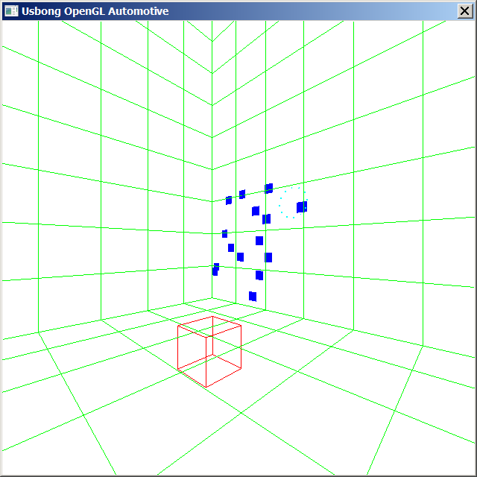
Image Processing Automation
Auto-drawn by a Windows Machine
NOTE (from SYSON, MICHAEL B.):
The technique as set of instructions for the computer to execute is classifed to already be more than 20 years, albeit still used even years after.
I verified it using the following:
1) 1993: id's Doom 1
--> Included in id, Zenimax Media Inc., and Bethesda's Doom 3 (BFG Edition)
--> Playstation 3
2) 1993~1994: "NAMCOT"/NAMCO's サイバースレッド (Cybersled)
--> Playstation 1
3) 2015: 2K and gearbox's Borderlands 2 (Game of the Year Edition)
--> Playstation 3

I add that the it took 24~25 years for Japan with Germany sharing information with each other to make Zero Jet Fighters.

Singapore took the same amount of years to grow from low-skilled laborers to high value-adding skilled, knowledge workers by applying information.

We the Philippines took also the same amount of years to receive approval to execute building a train system in the island of Mindanao.
Therefore, it will take less years for any nation with access to information to execute.
Recommended Reading:
1) David Shippy and Mickie Phipps' "The Race for a New Game Machine"
--> Xbox 360 and Playstation 3 launched 2005~2006.
--> 6.2) コンピュータ（computer） Interactive
--> +added: Lessons learned from select Computer Games
--> 6.2.1) CAPCOM: Capsule Computer
--> Street Fighter IV: Ryuu and Ken Rival Battle
--> Computer identifies if you as Ryuu execute actions intended by the developer, i.e., use 波動拳（hadouken）, and then 昇竜拳（shouryuuken）when opponent jumps towards you
--> Ken executes actions for you to realize what else you can do
--> You maintain to use the way, i.e. the developer's intended actions; Computer identifies it; Computer plays Classic Street Fighter II battle tune as background music
--> During battle, what Ken says encourages you; not "trash talk"
--> Additional Note: After battles, you as Ken give defeated opponent encouragement, i.e. optimistic view
--> 6.2.2) SONY Computer Entertainment Europe and Guerrilla
--> KillZone 2; Choose role as Ingeniero (Engineer); Elite mode;
--> Less death count of being killed; Repair robots; Add robots; Use available/repaired stationary machine-guns; Use technique in any map; however, certain maps no available stationary machine-guns
--> Recommended Reading: Winston Groom's "Forrest Gump"
NOW HIRING: COMPUTER SERVICES SALESPERSON
✓Receive half of the revenue from your DIRECT SALE of the service

✓Receive training:
Filipino Language, Sales, Information Technology
Requirements:
1) Curriculum Vitae
2) Portfolio
3) Sulat ng Hangarin
3.1) Ano ang maitutulong mo?
3.2) Bakit mo nais ito?
3.3) Bakit ka karapat-dapat?



EMAIL: APPLY@USBONG.PH

