
July 2022

手術 (しゅじゅつ; shujutsu) :
Paraan ng Kamay (SURGERY)

PHILIPPINES: USBONG CONTINU​ES TO PROVIDE
COMPUTER SERVICE ASSISTANCE BY SHARING
KNOW-HOW ON MAPARAANG PAGBIBILANG

To eliminate excess steps and inefficient time usage, MARIKINA ORTHOPEDIC SPECIALTY CLINIC (MOSC) requested Usbong's services to automate routine, monotonous tasks and share with unit members know-how on computers.

Here are Key Action Items that we executed in this updates list.
1) Continued to update Knowledge Management System (KMS)
1.1) continued: to share know-how on computers and Information Technology (IT) tools
1.1.1) shared: with Public, VALUE of multiple Computer Servers
--> observed: recent NO ELECTRICITY POWER incident near SCHOOL BUILDING CONSTRUCTION
--> in Barangay Sto. Niño, Marikina City caused WAITING TIME
--> for ELECTRICITY to RETURN to be OVER one (1) HOUR.
--> Previously, in 5mins (APPROX), ELECTRICITY POWER returns for Computer Servers to auto-start;
--> added: partner MOSC, has POWER GENERATOR using FUEL
--> to cause select appliances, e.g. Light Emitting Diode (LED) LAMPS, local router, to function;
--> added: however, desktop computers to be set to OFF;

NOTE (from SYSON, MICHAEL B.):
verified: using Uninterruptible Power Supply (UPS) devices;
however, opted NOT to use due to among others:
1) STORED ELECTRICITY POWER decreased
--> from 5mins to zero seconds with CONTINUED USE;
--> UPS device remained connected to electrical outlet to refill electricity

Current ACTION:
1) using: recycled LENOVO IdeaPad with BATTERY as Computer Server
--> where: IdeaPad classified to be Laptop Personal Computer (PC)
--> observed: execution of Computer Web Browser, e.g. Mozilla Firefox, to have noticeable DELAY

OUTPUT: opted: to USE Tablet PC for Web Browser ACTIONS,
while using recycled LENOVO Laptop Computer as Server
during NO ELECTRICITY POWER incidents

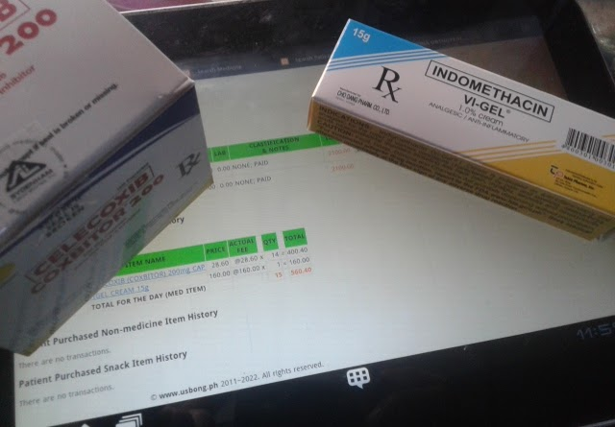
Example Tablet PC on BATTERY Power

Additional Notes:
1) installed: in LENOVO IdeaPad, the following Web Server Tools:
1.1) Apache Web Server
1.2) MySQL
1.3) phpMyAdmin Tools

--> observed: XAMPP did NOT install successfully, in contrast with another Linux Ubuntu Computer Server

--> ACTION: wrote: in a file, List of Install Commands for Auto-execution
--> where: classification: NON-XAMPP Web Server

2) observed: in LENOVO IdeaPad, applications that I wrote in the following Computer Languages execute WITHOUT noticeable DELAY:

2.1) C/C++ COMPUTER LANGUAGE
2.2) JAVA COMPUTER LANGUAGE

--> observed: noticeable DELAY due to the following:

1) increase in computation tasks
--> Example: COMMANDS with 3-Dimensional Graphics techniques, e.g. floating-point numbers/fractions, for drawing the resizable DISPLAY

2) decrease in available memory storage
--> Example: Spreadsheet with multiple worksheets with ROW and COLUMN counts whose Total FILE SIZE is 724KB

Recommended Action: use: MACHINES with the following:
1) faster microcomputers (processors);
2) higher memory storage (Random-Access Memory (RAM));

continued: with AUTOMATIC transferring as copies Database files
--> from MAIN Computer Server to available Multiple Computer Servers
--> where: Computer Server : combination of Operating Systems (OS),
--> e.g. Linux Ubuntu, Windows 7;
--> where: Database files : Saved Work
--> Example Computer Instructions written in Bash Shell

--> reminder: When MAIN Computer Server malfunctions due to LOSS of ELECTRICITY POWER, this ACTION empowers UNIT to QUICKLY use another Computer Server with the copy of the Database files to UPDATE INVENTORY, et cetera
1.1.2) shared: with Public, DECREASE in TAX by next year, JANUARY 2023 onwards

eBIR Form No. 1701Qv2018

TABLE 1 - Tax Rates (effective January 1, 2018 to December 31, 2022)

If Taxable Income is: | Tax Due is:
Not over P250,000 | 0%
Over P250,000 but not over P400,000 | 20% of the excess over P250,000
Over P400,000 but not over P800,000 | P30,000 + 25% of the excess over P400,000
Over P800,000 but not over P2,000,000 | P130,000 + 30% of the excess over P800,000
Over P2,000,000 but not over P8,000,000 | P490,000 + 32% of the excess over P2,000,000
Over P8,000,000 | P2,410,000 + 35% of the excess over P8,000,000

TABLE 2 - Tax Rates (effective January 1, 2023 and onwards)

If Taxable Income is: | Tax Due is:
Not over P250,000 | 0%
Over P250,000 but not over P400,000 | 15% of the excess over P250,000
Over P400,000 but not over P800,000 | 22,500 + 20% of the excess over P400,000
Over P800,000 but not over P2,000,000 | 102,500 + 25% of the excess over P800,000
Over P2,000,000 but not over P8,000,000 | 402,500 + 30% of the excess over P2,000,000
Over P8,000,000 | P2,202,500 + 35% of the excess over P8,000,000

REMINDER: SINGLE PROPRIETOR: BIR FORM 1701

1st Quarter | 15-APR
2nd Quarter | 15-AUG
3rd Quarter | 15-NOV
Annual | 15-APR (Following Year)

REFERENCE: Offline eBIR Forms Package (version 7.9.2.1)

2) shares: Lessons-learned from ASAHI.COM (NEWSPAPER)

2.1) FROM: 潰瘍性大腸炎の治療に「ミニ臓器」 患者本人の細胞から作出 世界初;
last accessed: 20220708

潰瘍性大腸炎の治療に「ミニ臓器」 患者本人の細胞から作出 世界初

Una sa Daigdig: MINI LALAGYAN ng LAMAN;
Binuo mula sa CELL (Binalutan ng Manipis) ng May-sakit
sa panglulunas ng Nasusunog na Pakiramdam
ng Malaking Bahagi ng Tiyan (LARGE INTESTINE)
na may Sakit sa Pagpisa (ULCER)

有料会員記事

Sulatin sa nagbabayad na kasapi

野口憲太2022年7月8日 7時00分

NOGUCHI, KENTA; 2022-07-08T07:00

東京医科歯科大学は7日、大腸の粘膜に炎症が起こる難病「潰瘍（かいよう）性大腸炎」の患者1人に対して、患者本人から採取した細胞を増やして腸の「ミニ臓器（腸上皮オルガノイド）」を作り、患部に移植したと発表した。この大腸炎に限らず、治療のためにオルガノイドを患者に移植したのは、世界で初めてという。

Sa ika-7 araw, ipinahayag ng Malaking Paaralan (Pamantasan) ng TOKYO sa Maparaang Panggagamot kabilang ang Ngipin, na nailipat sa May-sakit ang binuong MINI LALAGYAN ng LAMAN (Balat ng Tiyan na ORGANOID) mula sa pagdagdag ng ginagamit niyang CELL, upang bigyang-lunas ang "Sunog sa Malaking Bahagi ng Tiyan na may Sakit sa Pagpisa (ULCER)"
Una sa daigdig; inilipat sa May-sakit ang ORGANOID upang bigyang-lunas hindi lamang ang Nasusunog na Pakiramdam sa Malaking Bahagi ng Tiyan.

潰瘍性大腸炎は、大腸の粘膜で慢性的な炎症が起きる難病で、腹痛や下痢、血便などの症状が続く。

Sunog sa Malaking Bahagi ng Tiyan na may Sakit sa Pagpisa (ULCER): Mahirap na sakit na nagaganap dulot ng Mabagal na Nasusunog na Pakiramdam, sa Malagkit na Takip (MEMBRANE) ng Malaking Bahagi ng Tiyan (LARGE INTESTINE); Tuluy-tuloy na karamdaman na may dugo sa dumi, pagtatae, pananakit ng tiyan, atbp

NOW HIRING: COMPUTER SERVICES SALESPERSON
✓Receive half of the revenue from your DIRECT SALE of the service

✓Receive training:
Filipino Language, Sales, Information Technology
Requirements:
1) Curriculum Vitae
2) Portfolio
3) Sulat ng Hangarin
3.1) Ano ang maitutulong mo?
3.2) Bakit mo nais ito?
3.3) Bakit ka karapat-dapat?



EMAIL: APPLY@USBONG.PH

Tanong at Sagot

1) Magkano ang aking kikitain bilang Computer Services Salesperson at Manunulat ng paliwanag sa kompyuter, e.g. Add-on Software?
--> Kung babayaran tayo ng klinik ng 10K pesos bawat buwan, 5K ang sa iyo bilang Computer Services Salesperson.
--> Bilang Manunulat, 4K pesos ang maibibigay sa iyo ng Usbong.
--> Sa kabuuan, 9K pesos ang matatanggap mo bawat buwan.
--> Ang matitirang 10% ng 10K, i.e. 1K pesos, gagamitin ng Usbong sa pag-iipon ng kapital.
--> Gagamitin ito ng Usbong sa paggawa ng mga investment at "float", na ang kahulugan, liquid asset.

2) Paano ako makibabahagi sa tagumpay ng kompanya?
--> Kung wala tayong kikitain mula, halimbawa, sa Computer Automation Service, mauubusan tayo ng kapital na pambayad sa ating lahat. Hindi magtatagal, wala na tayong kompanya.
--> Dahil dito, kailangang maayos ang ating paggawa at pagtuturo sa mga trainee upang tuluy-tuloy ang daloy ng ating kita, habang nagbibigay ng ginhawa sa lipunan.

ALGEBRA SKILL LEVEL 3:
INPUTS:
S = 600K //EXCESS STOCK IN WAREHOUSE (JAPAN)
D = 180 //IN USD OF EACH STOCK
L = ? //LOSS

NOTES:
1) USD = UNITED STATES DOLLAR
2) PHP = PHILIPPINE PESO
3) USD1 : PHP54

TANONG#1: WHAT IS THE LOSS IN PHP?
SAGOT:

TANONG#2: WHAT IS THE LOSS IN PHP IF WE SET
USD1 : PHP0.50?
SAGOT:



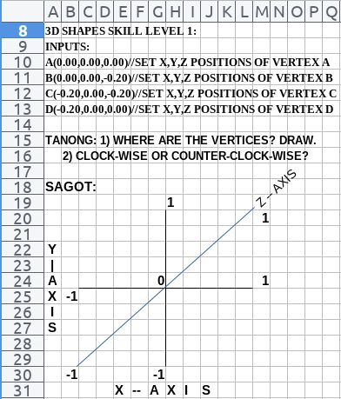

国内には22万人の患者がいると推計される。薬で炎症を抑える治療が一般的だが、傷ついた粘膜が治らないと、大腸を摘出する手術が必要になる場合もある。

Sa loob ng Kaharian, nasusukat na may 220K ang May-sakit nito. Bagama't karaniwan ang paggamit ng GAMOT upang malunasan ito sa pamamagitan ng pangangasiwa (CONTROL) ng Nasusunog na Pakiramdam, kapag hindi nalunasan ang nasugatang Malagkit na Takip, nangyayari rin ang pangangailangang ilabas ang Malaking Bahagi ng Tiyan gamit ang Paraan ng Kamay (SURGERY).

東京医科歯科大の臨床研究チ…

Ang pangkat ng mananaliksik ng TOKYO sa Maparaang Panggagamot kabilang ang Ngipin...

この記事は有料会員記事です。残り362文字有料会員になると続きをお読みいただけます。

Sa nagbabayad na kasapi ang sulating ito. May natitira pang 362titik. Kapag naging nagbabayad na kasapi na po kayo, maaari niyo na pong mabasa ang kasunod.

Sanggunian:
GOOGLE SEARCH ENGINE; TRANSLATE
Japanese-English Dictrionary (JED) Android Application
PLECO Chinese-English Dictionary Android Application
3) SECURITY DEFENSE FORCE
--> 3.1) NOISE POLLUTION from MANLOLOKO/budol-budol/carnapper/smuggler/cybercriminal/Teroristang Komunista group
--> reminder: carnapper executes among others: BUKAS KOTSE CRIMINAL ACTIONS

--> Cybercriminal/Teroristang Komunista group continues
--> Example#1: wireless broadcasting of IDEAS on how to improve OUTPUTs, e.g. in computer programming;
--> observed: IDEAS appear to be among others: JARGON, obvious, came from another who appeared to have know-how, but were NOT verified by his/herself;
--> OUTPUT: INCORRECT;
--> classification: NOISE POLLUTION

--> Example#2: continuous broadcasting of "panaginip"
--> by Manloloko group to cause RE-ACTION, e.g. regrets;
--> SOLUTION#1: classify: as NOISE POLLUTION;
--> where: NO NEED to use available TIME to identify significance, et cetera
--> SOLUTION#2: file: incident reports with Law Enforcement, e.g. Police
--> 3.2) FRATERNITY: Question & Answer for CLARIFICATION

Q&A#1) Please teach me about fraternities, sororities, New People's Army (NPA), and Communist Party of the Philippines (CPP).
What have you encountered?

1) classifies: Those that execute harm, e.g. NOISE POLLUTION, PHYSICAL INJURIES, are with the Manloloko/Teroristang Komunista group;
reminder#1: smuggler/carnapper classified with the Manloloko/Teroristang Komunista group
reminder#2: Teroristang Komunista/MANLOLOKO group misuses wireless broadcasting to attack target

Example#1 Physical Attacks causing Injury to Target:
Target: SYSON, MICHAEL B.

identified: Teroristang Komunista Members as ATTACKERS
1) Ramon Syson, younger brother of father Dr. Pedro Syson
2) Ryan Syson, eldest son of Ramon Syson

Both Knees (datetime stamp: 2020-10-15T13:34)
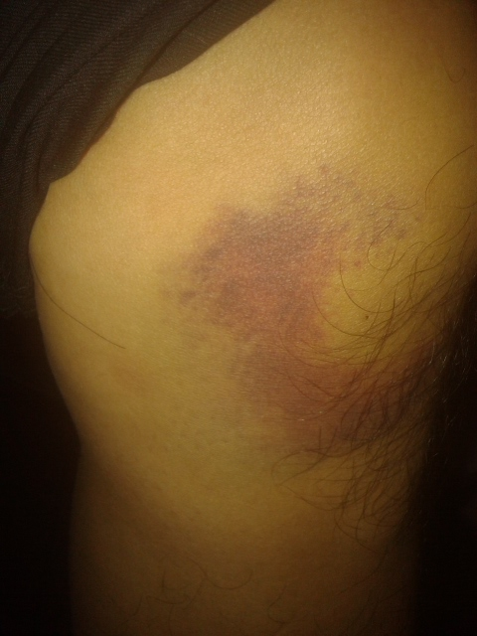  LEFT KNEE | 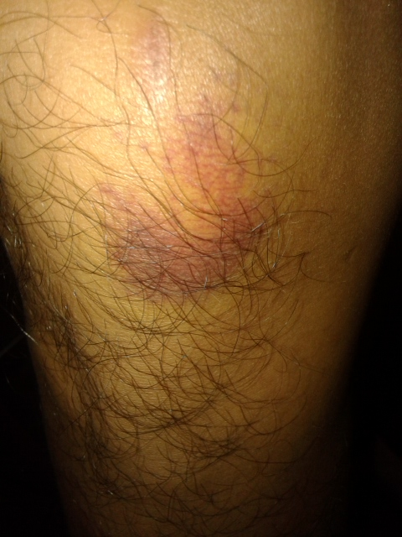  RIGHT KNEE

Example#2 Noise Pollution via RADIO FREQUENCY
previously set to STATIC:
Target: SYSON, MICHAEL B.

identified: Teroristang Komunista Members as ATTACKERS
1) Tyrone Tang, basketball player
2) Keith Haw, friend and classmate of Tyrone Tang

Both are classmates of SYSON, MICHAEL B. @XAVIER SCHOOL, San Juan, Greenhills;



Approx size: 6x6cm

CAUSE: After investigation, Teroristang Komunista group was verifying via CRIMINAL ACTIONS classified as HARASSMENT/EXTORTION, et cetera to identify among others:

1) LOCATION of smuggled vehicles
2) Police Units who caused DELAY in their smuggling ACTIONS

Paalala) verified: Bureau of Customs (BOC) NEWS
--> 1) @https://customs.gov.ph/boc-destroys-21-smuggled-vehicles/; last accessed: 20220322

| BOC Destroys 21 Smuggled Vehicles
| Posted on June 18, 2021

--

The Bureau of Customs (BOC) led the simultaneous destruction of twenty-one (21) smuggled motor vehicles worth P58.55 million on Friday, June 18, 2021, in Manila and Cagayan de Oro.

--

keyphrase: 58.55Million PHP used for YABANG,
2) Use of Greek letters, e.g. Alpha, Epsilon, due to based on American School System, e.g. Harvard;
--> where: American School System has VOTING systems;
--> Therefore, after VOTING, the PRESIDENT of the GROUP is the Unit Chief;
--> adds: SCHOOLS measure performance via GRADES;
--> Because Fraternities/Sororities are SCHOOL-based, GRADES are used for identification;
--> Example: which student is part of a GROUP during graduation;
--> FAILURE in SCHOOL : DROP-OUT classification

--> notes: MANLOLOKO group adds "MYSTERY", causing INCORRECT IDEAS
--> where: INCORRECT IDEAS cause FEAR, DESIRE, et cetera;
--> where: may accept PANLOLOKO to CORRECT via INFORMATION the INCORRECT IDEAS;

Q&A#2) Have you been invited before?

During my visits as student to University of the Philippines (UP): Diliman・Manila, Asian Institute of Management (AIM), et cetera;

observed: NOISE POLLUTION about Fraternity/Sorority groups;

--> Example: "Epsilon group is FRIENDS with ALL";
--> notes: increase in excess USE of TIME to think of significance
--> ACTION: classify: as NOISE POLLUTION

remembers: @Medical City Hospital, Ortigas, Pasig City, meeting female students who introduced themselves as part of SORORITY who work on Mental Health;

reminder: Those that execute NOISE POLLUTION
with PHYSICAL HARM are with the MANLOLOKO group;
Recommended ACTIONS:
1) file: incident reports with Police;
--> Puksain ang mga Teroristang Komunista.
2) ignore, if NOT endure: NOISE POLLUTION;
3) clarify: with Family Unit, e.g. Wife, directly and in-person
--> any information/gossip heard, viewed, et cetera;
--> Halimbawa: Kung may narinig kang hindi ayos ukol sa akin, kausapin mo muna ako nang direkta at harap-harapan upang ating LINAWIN ang anumang MALABO.
Keyphrase:
PHYSICAL INJURY, MURDER;
Additional Reference:
1) Marikina City Ordinance Enacting the Noise Control Regulations (ORDINANCE No. 100 Series of 2010)

USBONG I.T. SOLUTIONS
COMPUTER SERVICES

SYSON, MICHAEL B.
FOUNDER

MOBILE: +63929.952.7263
EMAIL: MASARAPMABUHAY@GMAIL.COM

WEBSITE: WWW.USBONG.PH
ADDRESS: #2 E. MANALO (FORMERLY, E. RODRIGUEZ) AVE., STO. NIÑO, MARIKINA CITY, 1820, PHILIPPINES

MAPARAANG PAGBIBILANG
ALGEBRA SKILL LEVEL 1:
INPUTS:
X = 250 //ITEM PRICE
V = 12% //VALUE ADDED TAX (VAT)
Q = ? //ITEM PRICE WITH VAT

TANONG: WHAT IS ITEM PRICE WITH VAT?
SAGOT:

ALGEBRA SKILL LEVEL 2:
INPUTS:
X = ? //ITEM PRICE
V = 12% //VALUE ADDED TAX (VAT)
Q = 364 //ITEM PRICE WITH VAT
TANONG: WHAT IS ITEM PRICE WITHOUT VAT?
SAGOT:

