
February 2022
防衛大学校 (bouei daigakkou; Defense Force University)
Past Examinations; Reminder:
"Ipaubaya ang aking katawan sa Panginoon."

PHILIPPINES: USBONG CONTINU​ES TO PROVIDE
COMPUTER SERVICE ASSISTANCE BY SHARING
KNOW-HOW ON MAPARAANG PAGBIBILANG

To eliminate excess steps and inefficient time usage, MARIKINA ORTHOPEDIC SPECIALTY CLINIC (MOSC) requested Usbong's services to automate routine, monotonous tasks and share with unit members know-how on computers.

Here are Key Action Items that we executed in this updates list.
1) Continued to update Knowledge Management System (KMS)
1.1) continued: to share know-how on computers and Information Technology (IT) tools
1.1.1) shared: with Public, lessons learned from Bureau of Internal Revenue (BIR): Regional District Office 45 (RDO45), Brgy. Sto. Niño, Marikina City
--> Quarterly Percentage Tax (Form 2551): CAN be set to Tax Rate 1.0% if classified to be Person exempt from Value-Added Tax (PT010) under Sec. 109 (BB) (Sec. 116)
--> where: VAT required for GROSS SALES >PHP3 Million
--> offline software tool from BIR: eBIR (version: 7.9.2)
--> added: due to Bayanihan Act as One
--> effective (expected): until June 2022
--> received: information after visiting BIR:RDO45 for Annual Certificate of Registration
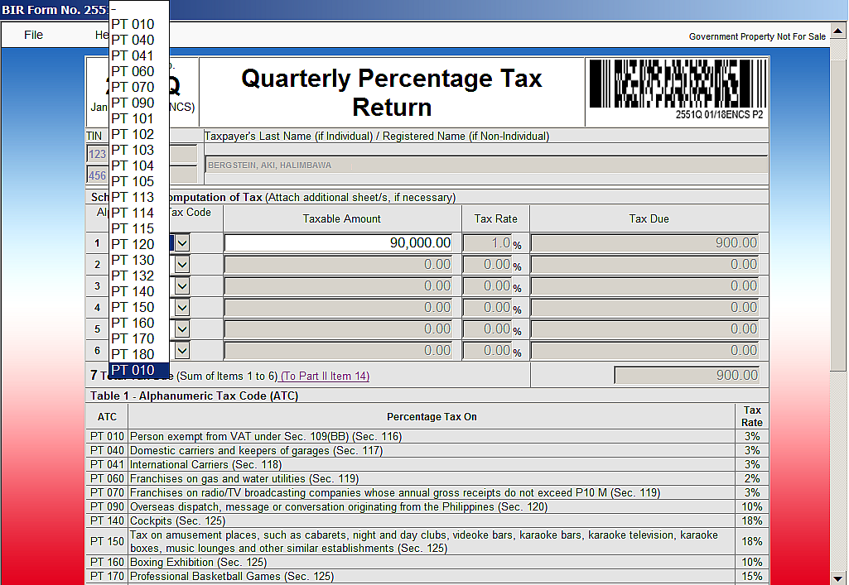
BIR Form 2551: Quarterly Percentage Tax Return

--> Instead of filing Quarterly Percentage Tax Returns AND Graduated Income Tax Returns, a person can opt to file Income Tax Returns set to the 8% Income Tax Rate of Gross Sales in excess of PHP250,000;
--> reminder: we immediately pay the 8% Income Tax as soon as our Gross Sales are over PHP250,000
--> With this action, we CAN eliminate work TIME used for excess report filings.
--> reminder: paying @banks costs at least 2hours of work TIME;
--> References:
--> received: explanation @BIR RDO45, Brgy. Sto. Niño, Marikina City
--> https://www.bir.gov.ph/index.php/tax-information/income-tax.html; last accessed: 20220218
1.1.2) shared: with Public, regular security updates of Computers used at partner Units
--> increased: network security by removing connection to the Internet
--> where: Internet classified to add excess connections to the local Unit's network;
--> reminder: Internet: public network of Computer Database Storages
--> added: Internet connectivity to execute regular security updates;

Step#1 update: Virus and spyware definitions
Step#2 execute: Computer Storage Scan

observed: LESS NEED to add Anti-virus Software with the following actions:
1) executing: Non-pirated Software
2) visiting: websites with NO PIRATED, i.e. illegal, software for download;
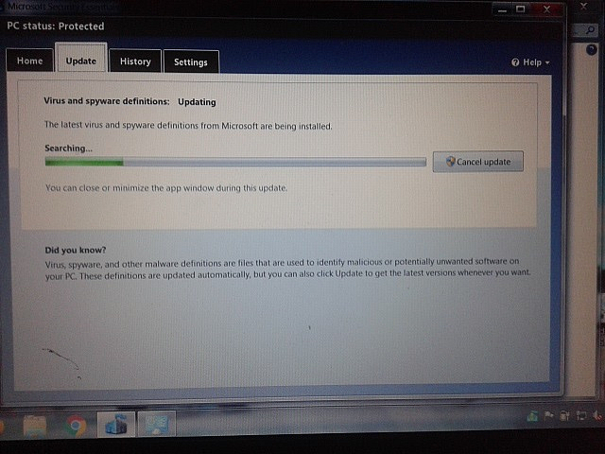
NOTE (from SYSON, MICHAEL B.):
This observation is based on my actually putting AIR to vehicle Tires @Petron Energy Station.

Reference#1: Petron Logo from Receipts;

Reference#2: 防衛大学校 (bouei daigakkou; Defense Force University) Past Examinations;
Reminder: "Ipaubaya ang aking katawan sa Panginoon."

Petron Energy Stations sell Petron Value Cards @PHP100, where amount inside Card is also @PHP100;

reminder: @select grocery stores, Value Cards purchased @PHP100 contain PHP0;

Value inside Card increases with increasing fuel added to vehicle.

Example: 2021-12-28;
Paid Amount: PHP200 = 3.74L (FUEL) @PHP53.50;
Received: Points valued @PHP5.23

reminder: Points in Value Card CAN be used to pay for services, e.g. FUEL;

Additional Note:
1) In the Year 2008, in Tokyo, Japan, I was able to use the Electronics Discount Store's Value Card points to receive a WACOM Tablet set@10,000yen (PHP5,000; approx) used for digital illustrations;
--> I had previously used the Value Card to mainly buy an electronic dictionary @10,000yen (PHP5,000; approx) in Year 2004~2005, Osaka, Japan;

Example Electronics Discount Stores in Japan:
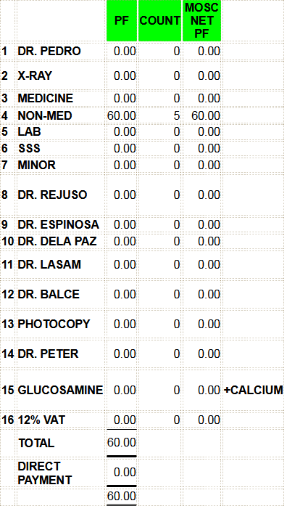
1) BIC Camera 2) YODOBASHI Camera

1.1.3) updated: auto-generated Summary Report from Computer to verify with Cash Register Report
--> added: DIRECT PAYMENT and updated Grand Total computations;
--> where: DIRECT PAYMENT : payment received via Bank Transfer, et cetera

1.1.4) shared: with Public, COMPOUND notes
--> where: COMPOUND: income from interest is returned to the current invested amount
--> result: increased total income;
--> Example:
--> where: A2 = INPUT AMOUNT; B2 = INTEREST RATE
--> equation (NON-COMPOUND): =A2+(A2*B2*0.01)*5
--> equation (COMPOUND): =A2*((1+B2*0.01)^5)

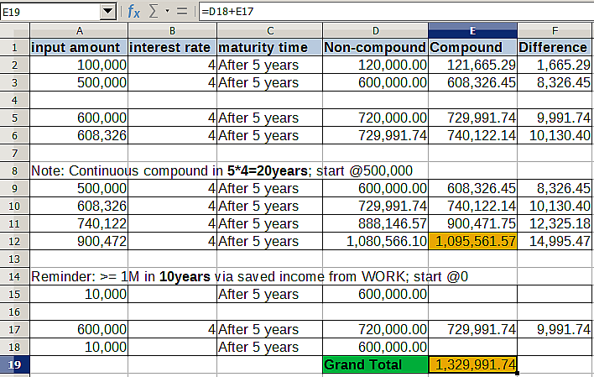
--> reminder: new vehicle cost now >= PHP400,000
--> The budol-budol/carnapper/manloloko/cybercriminal/communist terrorist group illegally shortens TIME to obtain such vehicle via among others:

--> 1) carnapping, i.e. theft
--> 2) replacement of parts to be defective
--> 3) noise pollution

--> output#1: promulgation of QUICK MONEY, instead of WORK
--> where: WORK = unti-unting pagkita ng pera mula sa hanap-buhay
--> output#2: increase in vehicle incidents, e.g. excess vehicle collision;
--> output#3: increase in patients @Hospitals and Clinics to further cause increase in excess workload;
--> output#4: increase in insurance expenses due to excess vehicle and health claims, to cause insurance company to close with brankrupt classification;

--> Recommended Action via Law Enforcement: Mula sa mga output dahil sa kanilang pinagloloko, maiging puntahan na sa kanilang Tirahan at puksain.

NOTE (from SYSON, MICHAEL B.):
In the Year 2005 (School Year: 2005~2006), I was driving the household's Mitsubishi Adventure vehicle (Manual Transmission) with two (2) Japanese Exchange Students to Little Tokyo, in Pasay Road, Makati City.

At the bridge, as we were about to go down from the upward slope, the clutch of the gear box malfunctioned. Shift of gears to increase or decrease max acceleration became NOT executable;

At the time, I heard the sound of the words, "engine break", coming from a person using wireless broadcasting technology as used by the Teroristang Komunista group. After verification, I identify the person to be Xavier School classmate during High School, in San Juan, Greenhills, Keith Haw, who due to YABANG and mistake, still continues to misuse wireless broadcasting technology to cause noise pollution with physical injury.

Reminder#1: Keith Haw is friends with classmate and basketball player, Tyrone Tang; I classify Tyrone Tang to be with the Teroristang Komunista group;
Reminder#2: Teroristang Komunista group also includes among others:
2.1) Ramon Syson, younger brother of father Dr. Pedro Syson
2.2) Ryan Syson, eldest son Ramon Syson



NOW HIRING: COMPUTER SERVICES SALESPERSON
✓Receive half of the revenue from your DIRECT SALE of the service

✓Receive training:
Filipino Language, Sales, Information Technology
Requirements:
1) Curriculum Vitae
2) Portfolio
3) Sulat ng Hangarin
3.1) Ano ang maitutulong mo?
3.2) Bakit mo nais ito?
3.3) Bakit ka karapat-dapat?



EMAIL: APPLY@USBONG.PH

Tanong at Sagot

1) Magkano ang aking kikitain bilang Computer Services Salesperson at Manunulat ng paliwanag sa kompyuter, e.g. Add-on Software?
--> Kung babayaran tayo ng klinik ng 10K pesos bawat buwan, 5K ang sa iyo bilang Computer Services Salesperson.
--> Bilang Manunulat, 4K pesos ang maibibigay sa iyo ng Usbong.
--> Sa kabuuan, 9K pesos ang matatanggap mo bawat buwan.
--> Ang matitirang 10% ng 10K, i.e. 1K pesos, gagamitin ng Usbong sa pag-iipon ng kapital.
--> Gagamitin ito ng Usbong sa paggawa ng mga investment at "float", na ang kahulugan, liquid asset.

2) Paano ako makibabahagi sa tagumpay ng kompanya?
--> Kung wala tayong kikitain mula, halimbawa, sa Computer Automation Service, mauubusan tayo ng kapital na pambayad sa ating lahat. Hindi magtatagal, wala na tayong kompanya.
--> Dahil dito, kailangang maayos ang ating paggawa at pagtuturo sa mga trainee upang tuluy-tuloy ang daloy ng ating kita, habang nagbibigay ng ginhawa sa lipunan.

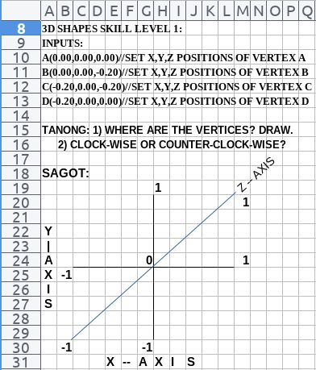

USBONG I.T. SOLUTIONS
COMPUTER SERVICES

SYSON, MICHAEL B.
FOUNDER

MOBILE: +63929.952.7263
EMAIL: MASARAPMABUHAY@GMAIL.COM

WEBSITE: WWW.USBONG.PH
ADDRESS: #2 E. MANALO (FORMERLY, E. RODRIGUEZ) AVE., STO. NIÑO, MARIKINA CITY, 1820, PHILIPPINES

MAPARAANG PAGBIBILANG
ALGEBRA SKILL LEVEL 1:
INPUTS:
X = 250 //ITEM PRICE
V = 12% //VALUE ADDED TAX (VAT)
Q = ? //ITEM PRICE WITH VAT

TANONG: WHAT IS ITEM PRICE WITH VAT?
SAGOT:

ALGEBRA SKILL LEVEL 2:
INPUTS:
X = ? //ITEM PRICE
V = 12% //VALUE ADDED TAX (VAT)
Q = 364 //ITEM PRICE WITH VAT
TANONG: WHAT IS ITEM PRICE WITHOUT VAT?
SAGOT:

ALGEBRA SKILL LEVEL 3:
INPUTS:
S = 600K //EXCESS STOCK IN WAREHOUSE (JAPAN)
D = 180 //IN USD OF EACH STOCK
L = ? //LOSS

NOTES:
1) USD = UNITED STATES DOLLAR
2) PHP = PHILIPPINE PESO
3) USD1 : PHP54

TANONG#1: WHAT IS THE LOSS IN PHP?
SAGOT:

TANONG#2: WHAT IS THE LOSS IN PHP IF WE SET
USD1 : PHP0.50?
SAGOT:

Despite the clutch problem, I was able to park the vehicle in front of Little Tokyo, Makati City. I did NOT observe noticeable physical wounds with the two (2) Japanese exchange students. I did NOT also receive any such notifications from them.

However, due to the Mitsubishi Adventure vehicle could NOT yet be driven HOME to Marikina City, we rode with another male Filipino student back.

Reminder#3: Increase in identification of Teroristang Komunista group members speeds-up system for Law Enforcement to destroy it.
Reminder#4: verified: filing law suit case against Teroristang Komunista group members is ineffective due to shall be attacked during process execution, which include among others: paperwork.

observed: system efficiency achieved via Law Enforcement executing quick action with assistance from people who file incident reports that include Teroristang Komunista group member identification, et cetera;

Teroristang Komunista keywords:
QUICK MONEY via among others: carnapping, smuggling

1.1.4) shared: with Public, adding used items, e.g. telephones, and parts
--> This action is to decrease Expenses and increase know-how.

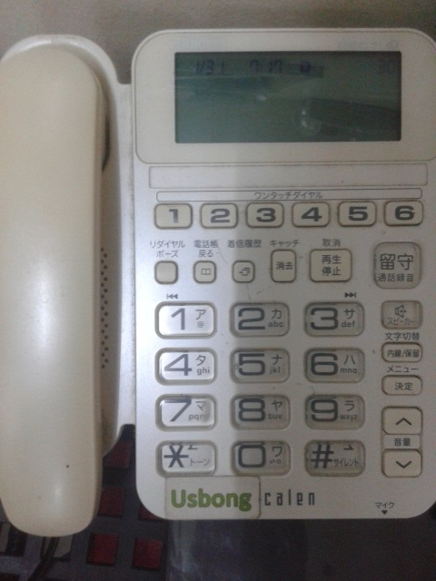

Increased Obsevable addingnihongo Alphabet Writings @Workplace

NOTE (from SYSON, MICHAEL B.):
I note that regular viewing of nihongo alphabets causes curiosity to learn more;

This know-how is also reused with advertising using media, e.g. television, such that viewer eventually buys product for verification after regular viewing;

observed: seeing a person regularly in-person or on social media, e.g. Facebook (FB), Instagram, shall cause increase in curiosity to learn more, e.g. the person's LIKES.

reminder: There exists decrease in work productivity and speed-up of usage of available TIME using web services, e.g. FB.

observed: even @Philippine Long Distance Telephone (PLDT) Corporation, FB, is NOT permitted during WORK TIME;

Recommended Actions:
1) classify: already FB to be "Entertainment", instead of COMMUNICATION TOOL for non-trivial cases such as for Consultation @Public Hospitals

2) stop: active computer and mobile telephone use by 21:00 (MAX); Use gained TIME to rest with own Family Unit

reminder: COMMUNICATION TOOLS, e.g.Telephones, Electronic MAILS, have CALLER/SENDER and target RECEIVER;

observed: the budol-budol/carnapper/manloloko/cybercriminal/
communist terrorist group broadcasts NOISE POLLUTION without first identifying CALLER and RECEIVER; In addition, wireless LINE is CUT even before further clarification can be executed;

Example: REGULAR NOISE POLLUTION with identified keywords, e.g. "BOBO", "TANGA", "TANGINA", to signify among others: "STUPID";

reminder: voice recording and manipulation techniques as used @KARAOKE are reused by Manloloko group

reminder: Quarterly Percentage Tax on AMUSEMENT PLACES, e.g. KARAOKE: 18% of Quarterly SALES INCOME

observed: NOISE reaches HOME and WORKPLACE @#2 E. Manalo Ave., Barangay Sto. Niño, 1820, Marikina City

observed: Members of Manloloko group causing NOISE POLLUTION can be identified due to their YABANG and MISTAKES, albeit still faster to execute identification when Members CLEARLY identify themselves as the CALLER and their target RECEIVERS.

Action Items: filed: incident reports with Police identifying members;
--> Endure, if NOT ignored;
--> observed: continuous noise pollution targetted @ME among others, due to: GAWA-GAWANG PATAKARAN
Examples: do NOT report to POLICE, NEED FOR QUICK MONEY
where: QUICK MONEY: ACTION via carnapping, smuggling, et cetera;
NEW vehicle cost now >= PHP400,000

reminder: “ANG WALANG PAKI TAONG TUMUTULONG SA TERORISTA”; ANTI-TERRORISM PARTNERSHIP

https://www.keishicho.metro.tokyo.jp/kurashi/heion/antep_mpd.html; last accessed: 20211021
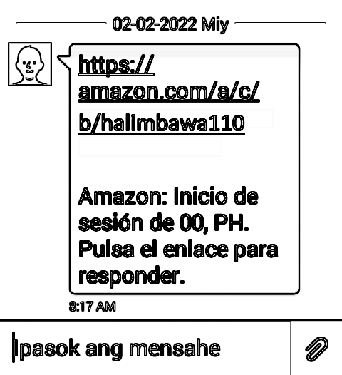

Sign-in notification from Amazon Web Service (AWS)

--> use: of another language, e.g. español, 日本語 (nihongo, i.e. Japanese Language), increases to a certain extent security defense against attacks from the Communist Terrorist, i.e. Teroristang Komunista, group in the Philippines;

--> This is due to Teroristang Komunista group members' children, as based on school performance, begin to become dependent on CHEATING via wireless broadcasting technology to get QUICK MONEY;

--> observed: children of this Manloloko group already have difficulty speaking their "people's language", i.e. "liannanoue", i.e. 福建話 (hokkienoue) of Southern China;
--> observed: speaking, listening, reading, and writing skill levels, if such exist at all, are only at ELEMENTARY level (max);
--> observed: even with language training @Private Schools, e.g. Xavier School, San Juan, Greenhills, for children with Chinese ancestry, the output know-how of CHINESE MANDARIN is still also at ELEMENTARY level (max), despite supposedly thirteen (13) years (approx) of training;

--> However, select people who were previously classified to be "SLOW" advance faster due to learned correct techniques. Such action causes ENVY to Teroristang Komunista group who makes them their targets of attacks.

NOTE (from SYSON, MICHAEL B.):
observed: in the Year 2011 (approx), Tools, e.g. WireShark, CAN be misused to get sign-in passwords to accounts on Web Services, e.g. Facebook (FB).

To increase security defense against unauthorized access, SMS text message notifications were added by Web Service companies.
Additional Notes:
1) caution: when connecting to a network @public places, e.g. airports, due to a computer with the WireShark tool may also be connected to the same network to receive without your permit account passwords, et cetera;

2) reminder: With unauthorized access to accounts, information, e.g. bank transactions (vehicle payments), investments, photographs (of visited countries), family members, friends, become available for misuse.

The objective is to identify if there exists QUICK MONEY to be stolen via among others: carnapping

reminder: after finishing to pay tuition @private schools, target Family Unit begins to receive excess MONEY to buy among others: NEW VEHICLES

An attack is executed to cause CHAOS, i.e. GULO, to target via regular, unsolicited wireless broadcasting, while the Manlolokong/Teroristang Komunista group steals the vehicles, et cetera;

Example: Based on the photographs online, a STORY is created to cause target person, family members, and friends to NEED to keep a SECRET due to a SURRISE WEDDING executed to be as a MOVIE with expensive wireless broadcasting technology equipment for production.

Output: UNCLEAR/MALABO Communication for abuse by Manloloko group

observed: such pattern to be misused on me among others since the Year 2011, and earlier...
observed: even while as a working student in the Year 2004, there was also already such NOISE POLLUTION

observed: even after finally marrying, the new Family Unit does NOT COMMUNICATE with the Family members as ordinary people do;
instead, continuous misuse of INDIRECT COMMUNICATION

observed: this to be due to regular misuse of wireless broadcasting technology, e.g. transmitters and receivers, to cause CHAOS when any member does NOT obey the Manloloko group's gawa-gawang patakaran

Actions:
1) file: incident reports with Police;
2) Ignore, if NOT endure, NOISE POLLUTION;
3) clarify: with Family Unit, e.g. Wife, directly and in-person any information/gossip heard, viewed, et cetera;
--> Halimbawa: Kung may narinig kang hindi ayos ukol sa akin, kausapin mo muna ako nang direkta at harap-harapan upang ating LINAWIN ang anumang MALABO.



