
May 2021
PAINT EQUATION & PIXEL PATTERN
ZEITGEIST (Time Spirit) :
時代の風音 (jidai no fuuin; Wind Sound of the Times)

PHILIPPINES: USBONG CONTINU​ES TO PROVIDE
COMPUTER SERVICE ASSISTANCE BY SHARING
KNOW-HOW ON MAPARAANG PAGBIBILANG

To eliminate excess steps and inefficient time usage, MARIKINA ORTHOPEDIC SPECIALTY CLINIC (MOSC) requested Usbong's services to automate routine, monotonous tasks and share with unit members know-how on computers.

Here are Key Action Items that we executed in this updates list.
1) Continued to update Knowledge Management System (KMS)
--> 1.1) verified: instructions to upload Index Cards as Image Files
Example: Index Card Image File Upload Tool

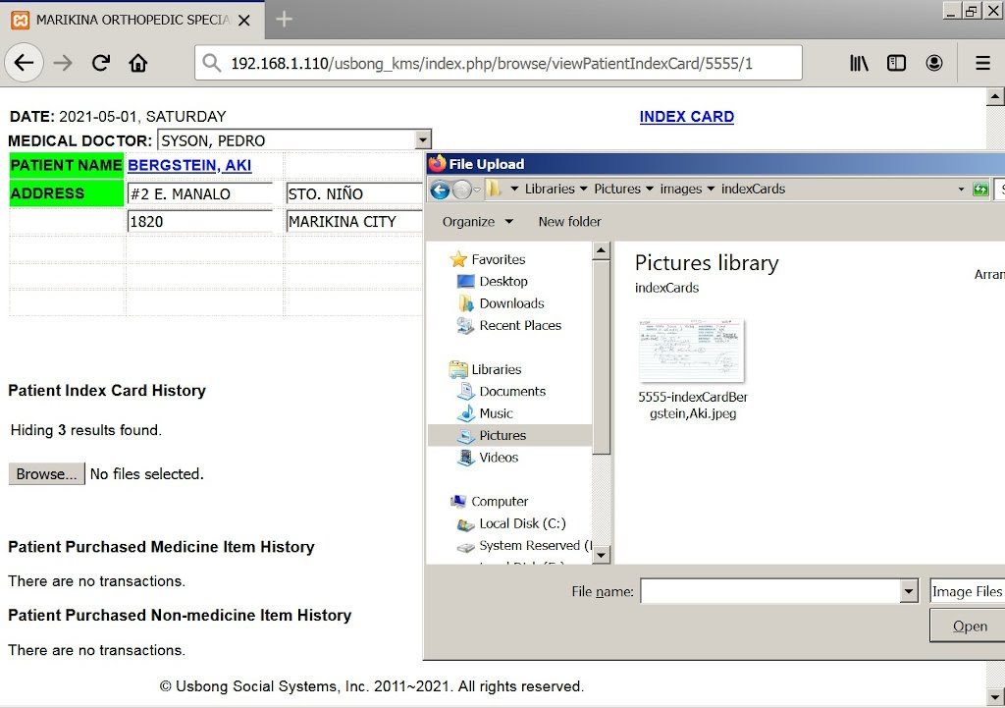
NOTE (from SYSON, MICHAEL B.):
We have been using the KMS's Store Image Command to quickly transfer images from a computer, e.g. mobile telephone, to another.

In addition, the Computer Server automatically stores the image file's storage LOCATION in the MySQL (Structured Query Language) Database (DB). We note that we do not store the image file in the DB to eliminate excess file storage space consumption.

To execute these actions, we use among others:
Apache Web Server
Hypertext Markup Language (HTML)
PHP Hypertext Preprocessor (PHP) + CodeIgniter Framework (version 2)
MySQL: Structured Query Language

Reminder: For select devices, computers do not quickly identify them after connecting via Universal Series Bus (USB) cable.

Example: Samsung Duos Mobile Telephone requires installation of "Samsung Kies" for a Microsoft Windows Computer to identify it.

--> 1.2) updated: set of instructions to prevent multiple button clicks, e.g. to execute the add transaction
--> Previously, the Computer Server already prevented multiple additions of patients in the same Cart List.
--> However, a Unit member using a Computer Client can quickly press/click the add patient button multiple times to cause the Server to accept the additions. This is due to the time it takes for the Server to verify if a patient already exists in the List.
--> learned: we need to add instructions for the Computer Client to automatically set the button to disabled
--> When the Client auto-reloads the page, the button is reset to enabled.
--> Reminder: We use Javascript to execute Client Commands.
--> HTML container values set using PHP Commands are only updated after the Server finishes execution.

--> 1.3) continued: to share know-how on computers and Information Technology (IT) tools

--> Examples:
--> 1.3.1) writing answers to questions and voting effective answers @www.stackoverflow.com
--> 1.3.2) IT ASIA: Information, Technology, and Society in Asia
--> Recommended Actions:
--> 1.3.2.1) learn: nihongo, albeit select courses are in the English language
--> 1.3.2.2) verify: map to include countries classified to be part of Asia
--> Maparaang Pagbibilang via Information Technology is vital to make Society in Asia strong

--> Recommended Reading: Hayao Miyazaki, Shiba Ryoutaro, at Hotta Yoshie sa 「時代の風音 (jidai no fuuin; wind sound of the times; Zeitgeist)」
--> Kung nais sumalakay ang isang pangkat ng mga Indian sa isa pang pangkat sa India, maiging alam nila ang bilang, i.e. ilan ang kanilang kalabang pangkat.
--> Kung may 500 sundalo ang kanilang kalaban, magdala na sila ng 600 sundalo.
--> Kung may kakayanang magpadala ng Airstrike ang kanilang kalaban, maiging magsama sila ng mga Anti-aircraft vehicle.

NOTE (from SYSON, MICHAEL B.):
Noong mga panahong iyon, upang mabuo ang bansang Hapon, kinailangang wasakin ni Nobunaga, Oda ang umiiral na sistema. Upang magawa ito, kinailangan niya ng mga sundalo at mamumuno, i.e. Unit Chief, sa pagsalakay sa mga lumalaban na pangkat.

Paalala: Hindi susunod ang mga pangkat sa mahina, i.e. hindi malakas.

Upang makabuo naman siya ng Unit ng mga sundalo at Chief nito, nagsimula siyang gumawa ng sistema na tinatawag na “COMMISSION”. Dito ibinibigay ni Oda ang kalahati ng kanilang makakamit na kita mula sa pagsalakay. Si Toyotomi, Hideyoshi ang naging huwaran ng pagkaepektibo ng panibagong sistema.

Paalala: Sa panahong ngayon, ang sistema ng “SALARY” ang umiiral. Dito may kaukulang bayad na natatanggap ang manggagawa buwan-buwan mayroon mang kita ang kompanya o wala.

Nagtiwala si Oda kay Hideyoshi dahil naunawaan niya ang nais nito. Nang palaki na nang palaki ang kailangang ibigay ni Oda kay Hideyoshi gawa ng matagumpay nitong pagsalakay sa mga lumalabang pangkat, tumugon si Hideyoshi kay Oda na nais niyang maghanda sila ng isang taong pagkain ng mga Sundalo upang salakayin ang sunod, e.g. Kyuushuu, Korea.

Ayon sa aklat ng kasaysayan, si Tokugawa, Ieyasu ang magpapanatili ng sistemang binuo sa pamumuno nina Nobunaga, Oda at Toyotomi, Hideyoshi.

Mungkahing Aksyon:
--> USBONG: Tanong at Sagot

Recommended Reading:
1) takakawa, k. (1993). shin suji michi gakushuu 19: nihon no rekishi (society: year 6). Toukyou: Sanma-ku

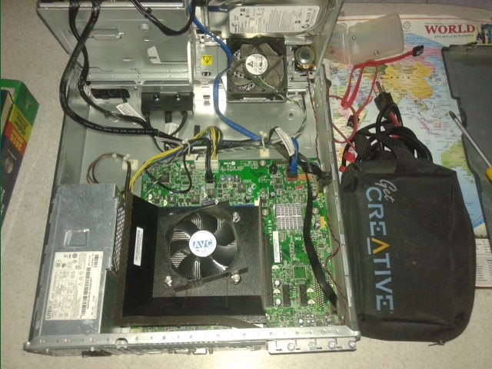
--> 1.4) continued: to provide computer service assistance via computer parts repair and replacement

--> reminded: Unit members to clean area due to insects, e.g. ipis/cockroaches, enter the computer box to cause problems, e.g. hardware reading failure
--> Ipis size can be 4cm; Ipis egg size 2cm
--> In addition, loose SATA cable connection can cause hardware reading failure; where: SATA = Serial Advanced Technology Attachment
NOTE (from SYSON, MICHAEL B.):
The budol-budol/carnapper/manloloko/cybercriminal/Communist Terrorist group continues to misuse wireless broadcasting technology to cause noise and physical injury.

Effect: While executing computer repair, such noise can cause among others: physical movement problems, e.g. excess movement to make hands drop and hit objects, e.g. computer fan.

Reminder: The computer fan's blades are sufficiently sharp, especially when spinning, to cut finger skin and cause blood to come out.

I experienced this result after again being targeted by this Teroristang Komunista group. In my more than 10 years of working with computers, this was the first incident of my finger hitting the computer fan.

Reminder: We unplug the electrical socket from the outlet consent to eliminate physical injury.

The noise from the Teroristing Komunista can also cause problems in memory, e.g. remembering.

Reminder: wireless broadcasting technology is used as weapon to cause dizziness, et cetera, equal with the effects of illegal drugs, e.g. taima, marijuana

Modus Operandi: Target person is caused to leave object, e.g. cash, mobile telephone, on a table. Teroristang Komunista picks the object to be classified as stolen.

Cause: Quick money; especially because stolen money by Teroristang Komunista group has become insufficient due to their increasing members who marry and have children.

Executed Action among others:
1) Filed written incident report to provide assistance to Law Enforcement

Recommended Action: Puksain ang mga Teroristang Komunista

Additional Note:
1) Software/computers/machines do not intentionally cause us physical injuries. The problem is with people classified to be Teroristang Komunista who intentionally misuse technology by causing us physical injuries to quickly get money.

--> 1.5) updated: set of instructions to auto-generate Monthly Summary Report of Daily Patient Count. This is in addition to the Monthly Report from partner Sta. Lucia Health Care Center (SLHCC) Unit.
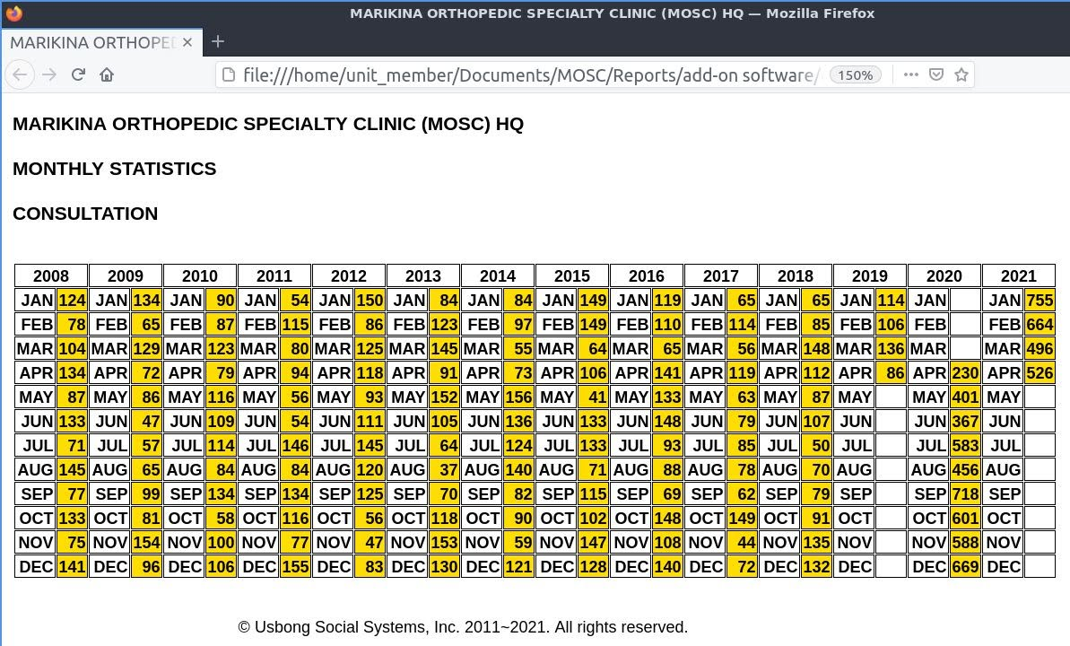
EXAMPLE MOSC REPORT

--> observed: increase in patient count in the year 2020 and 2021
--> This is due to increase in Medical Doctors in the morning and increase in patients in the afternoon. In select months from 2019 to 2020, patient count via data entered in Computer Database stopped.
--> This is due to among others:
--> Trained Unit member left to work in the Kingdom of Saudi Arabia.
--> received: request to focus on partner SLHCC Unit to verify cause of payment delays This is for both Cash and Health Maintenance Organization (HMO) payments.

--> learned: after providing assistance and working on the tasks, e.g. those executed by SLHCC's Accounting Unit, that there exist attacks to Unit members by the budol-budol/car-napper/manloloko/cybercriminal/Communist Terrorist group who misuse wireless broadcasting technology.
--> The effect of such attacks is equal with that of illegal drugs for use with the central nerve.
--> Examples of such illegal drugs: taima, marijuana
--> Examples of Effect: excitement, dizziness, illusion

--> Reminder: At partner SLHCC Unit, patient count decreased by at least 25%. This is due to decrease in Medical Doctors for Consultation and patients opting not to come for Physical Therapy (PT) Treatment.
--> Example Cause: to eliminate infection from CORONA VIRUS 2019 (COVID-19)

--> 1.6) updated: @partner Sta. Lucia Health Care Center (SLHCC) Unit, set of instructions in workbooks to auto-generate Payslip and Official Receipt Reports: This is due to select Medical Doctors from May 2021 use an increased Tax Withheld value, i.e. 10%: Previously, it was 5%.
--> ORTHO & PT Unit Member notifies via Local Unit Telephone the Cashier @Cashier Unit to already auto-generate Payslip Report due to no more Cash payments from patients for the day.
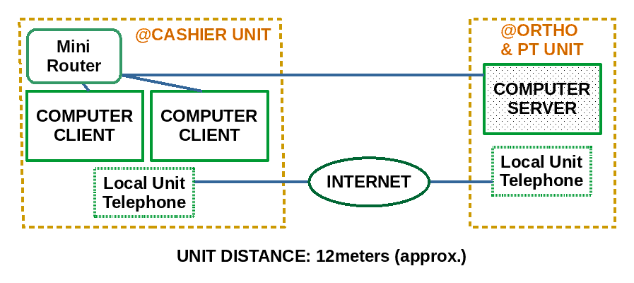
EXAMPLE TECHNICAL SCHEMATICS (HARDWARE)

--> Computer Client @Cashier Unit auto-sends the Payslip Report with the transaction details. This is received by the Computer Server @ORTHO & PT Unit. We use a Mini Router with one (1) small antenna to wirelessly connect the computers in a local network.
--> Example: Router Machine from https://www.linksys.com/ph/

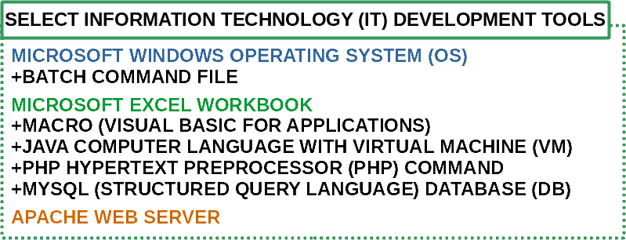
--> We use additional IT tools to automatically transfer data from the Microsoft EXCEL workbook stored in a Computer Client @Cashier Unit to the Computer Server @ORTHO & PT Unit.
--> We add Macros, i.e. set of instructions, that we wrote using the Visual Basic for Applications (VBA) Computer Language to save data as Tab-delimited .txt files in the file system storage of the Microsoft Windows Operating System. In addition, our Macros include execution of Batch Command Files.

--> Reminder: Batch Command Files are identified and executed by Computer Machines that use the Microsoft Windows OS. With Linux, e.g. LUBUNTU 20.04LTS, an alternative to the Microsoft Windows OS, we use Bash Shell Command Files.

--> The Batch Command Files contain instructions to notify the Java Virtual Machine (VM) to execute a set of instructions to automatically use as input the Tab-delimited .txt files into a packet that we can send to another Computer that is also connected to the network.
--> The .txt files contain the Payslip transaction data from the Microsoft EXCEL workbook.
--> Example Destination: Computer @ORTHO & PT Unit
--> The Java Computer Language empowers us to use existing libraries, which contain sets of instructions available to the public, to execute Web Network Commands, e.g. those written in the PHP Computer Language. With this action, we do not anymore need to open a Computer Web Browser, thereby eliminating excess steps and making execution faster.
--> Additional Note: We can opt to use Computer Web Browsers, instead of executing the tasks using Microsoft EXCEL workbooks. With this action, we shall exchange the use of MS EXCEL workbooks with Web Browsers. At present, however, our partner clinic prefers to use MS EXCEL workbooks.
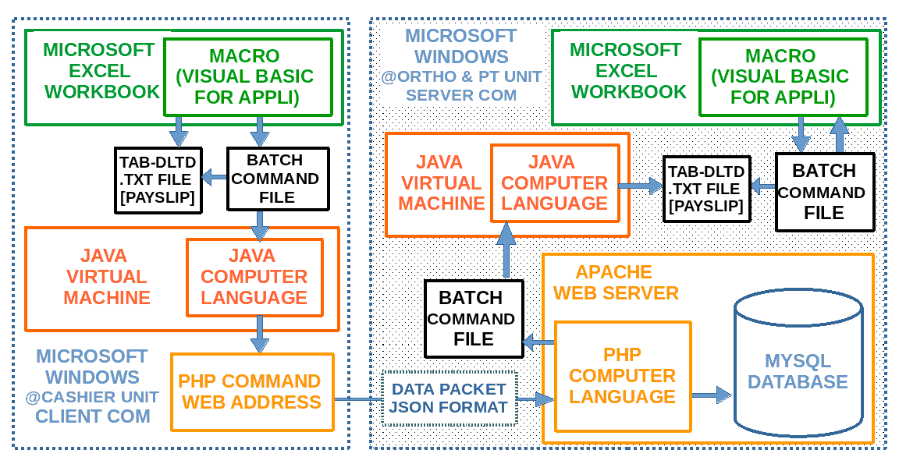
EXAMPLE TECHNICAL SCHEMATICS (SOFTWARE)

--> The Computer that receives the packet auto-stores its data in its Database (DB) in the Structured Query Language (SQL) and as a Tab-delimited .txt file in a list stored inside a folder in the OS. The packet and the stored data in MySQL DB adhere to the JSON format.

{\"i0\":[123456,\"BERGSTEIN, AKI\",\"PT\",\"1000\",\"562.50\"],\"iTotal\":1,\"payslip_type_id\":2,\"cashierPerson\":\"SYSON, MICHAEL B.\"}

Example Payslip Report Content in JSON Format
DATETIME stamp auto-added by Computer Server

--> In addition, using the PHP Computer Language, we can add and execute MYSQL Commands to interact with the DB and Batch Command Files to interact with the OS.

--> Additional Note: We still store data in the DB, not only to use as a history list, but also to prepare when we execute system upgrade, which includes rank up of Unit members' skill level, by using Web Browsers.

--> Unit Members @ORTHO & PT Unit can now notify the Microsoft Excel Workbook via a Macro to auto-generate the Payslip Report, including auto-computing the expected Amount Paid and Professional Fee.
--> Reminder: Correct Health Maintenance Organization (HMO) Fees and Cash Discounts, e.g. for Senior Citizens, are auto-computed.

--> The Macro opens and reads the day's packet stored as a Tab-delimited .txt file in a folder in the OS.

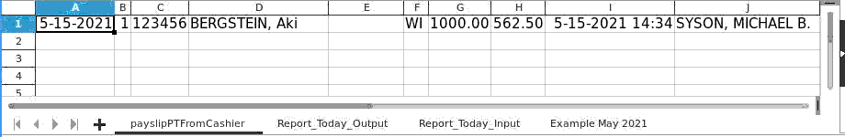
Example Payslip Transaction Data From Cashier Unit
Auto-generated @ORTHO & PT Unit
Workbook File Opened Using LibreOffice Calc,
An alternative Spreadsheet to MS EXCEL

--> The Macro uses the data to auto-correct the Payslip Report @ORTHO & PT Unit; It includes notes, e.g. corrections if select transactions are not equal with that @Cashier Unit.

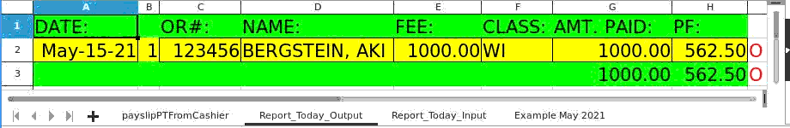
Example Report Today Output
Auto-generated @ORTHO & PT Unit
Workbook File Opened Using Libreoffice Calc,
An alternative Spreadsheet to MS EXCEL

--> In addition, the computer server includes in the auto-generation a Tab-delimited .txt file with the transactions data for the Month.
--> The computer stores this .txt file in a folder.
--> Data in this file is equal with data in the Month's worksheet.
--> We create and store a .txt file for each month for both Consultation and PT Treatment transactions. We use this file with Report Generation, e.g. for Monthly Summary Report, HMO Billing Report.
--> We added the Consultation Count in the SMS Report to assist us in computing if our expenses is more than our income. If so, it is expected that continuous financial loss shall cause the Unit to shutdown.
--> In addition, after verification, the number of patients coming for Physical Therapy (PT) @partner SLHCC has decreased by more than 25%. Previously, we achieved PT patient count of at least ten (10) each day.

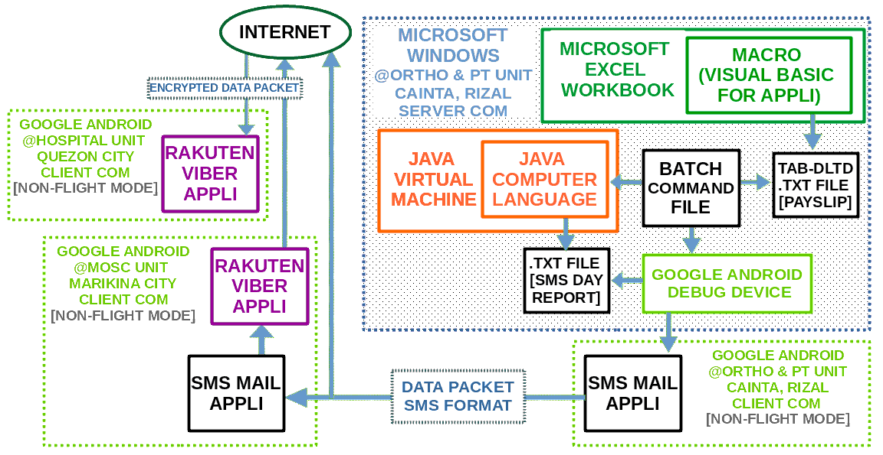
EXAMPLE TECHNICAL SCHEMATICS
WITH SMS REPORT (SOFTWARE)

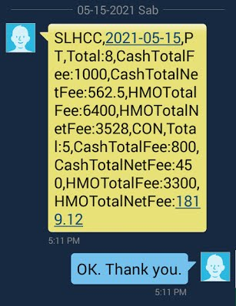
After re-verification, select patients opted to go to a PT Unit that is nearer to where they live. Example: PT Unit @St. Vincent General Hospital (SVGH), Marikina City.

Reminder: To eliminate infection from the CORONA VIRUS 2019 (COVID-19), cities in the Philippines executed Community Quarantine actions. Therefore, patients who do NOT need to travel, e.g. to visit a hospital/clinic, were recommended to stay at home.

Recommended Action: Unit members use vacant time to learn Maparaang Pagbibilang via Information Technology
Example SMS Report Today Output
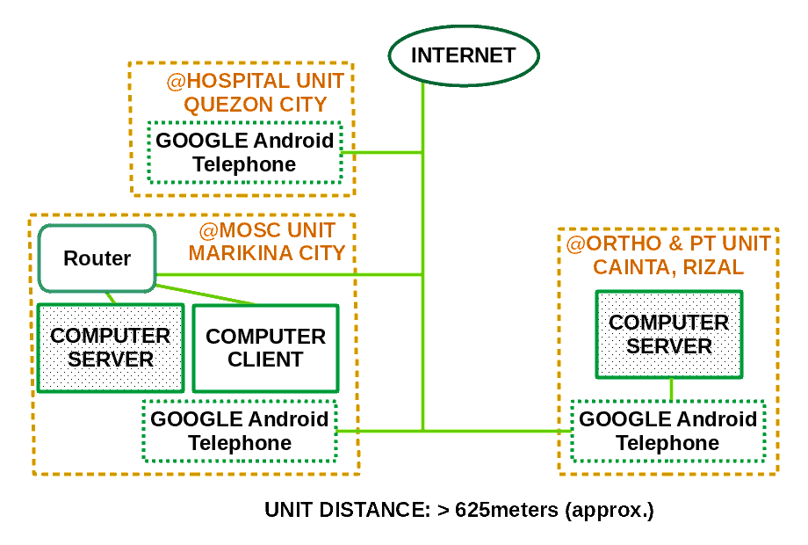
EXAMPLE TECHNICAL SCHEMATICS
WITH SMS REPORT (HARDWARE)

2) Continued with Research & Development (R&D)
--> Usbong: Reduce, Reuse, Recycle
--> verified: techniques to reuse available machines, e.g. television (TV) sets The objective is to connect them to the Computer Server via LAN (Wireless・Wired): where: LAN = Local Area Network
--> Example Usage: View Patient Wait List on the TV set

--> 2.1) verified: adding PlayStation Portable (PSP) to TV set
--> learned: PSP's Computer Web Browser Technology accepts only select HTML Commands; Web Services, e.g. YouTube, do NOT execute
--> Therefore, we shall need to update the Computer Server instructions
--> This is so that files are displayed correctly on the TV set + PSP.
--> 2.2) verified: adding Android box to TV set
--> learned: we can add input devices, e.g. computer keyboard & mouse, XBOX360 Controller
--> Web Services, e.g. YouTube, do execute
--> Cost: Android box x1 @PHP1,000
--> Technical Specifications:
Android Operating System (OS) version: 11.1
Memory Storage: 8GB + 128GB
Central Processing Unit (CPU): 64-bit 4 Cores
Input Voltage Requirement: 12V
Wireless Fidelity (WiFi): 2.4G/5G
Wired RJ-45 Cable Port Count: 1
Universal Serial Bus (USB) Port Count: 3
High Definition Multimedia Interface (HDMI) to TV Port Count: 1
Physical Box Size (approximate): 15 x 15 x 2.5cm

--> 2.2) Automotive: Usbong CAD (Computer Aided Design)
--> 2.2.1) added: Usbong Paint Equation Tool (with Pixel Pattern)

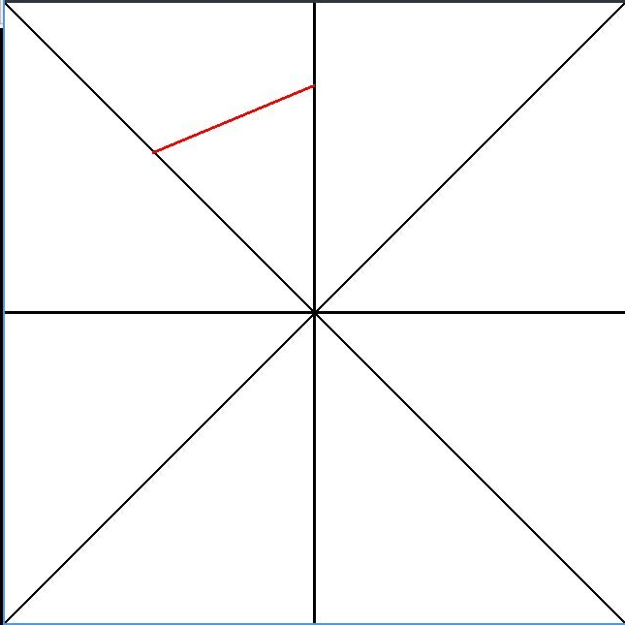
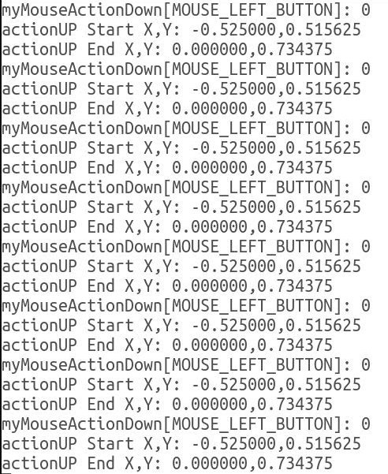

--> added: "undo" Command using the "z" key of the keyboard
--> This is due to after verification, the "undo" Command speeds-up the system. In the Usbong Paint Equation, the Command deletes from the history list the newest line added. We can use this Command until there are no more remaining lines in the history list.

NOTE (from SYSON, MICHAEL B.):
In high school and college, I learned to use the Macromedia Director 6, i.e. "Flash", albeit already unsupported by Adobe Systems, Inc. since 2021-01-12). My team and I created an animation story with a Role Playing auto-combat system as a College Filipino project.

While our classmates were submitting Compact Disks (CDs), we were able to put the output file in a 3.5inch high-density diskette with 1.44MB storage (max).

This was due to I drew the story's characters and objects using lines, shapes, et cetera that the computer automatically converted into a format that it can use to auto-draw using equations. This is instead of Image Files, e.g. those in .jpeg formats.

--> PLUS: Usbong Pixel Pattern Tool
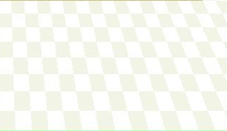
--> We can speed-up the system by using this tool to add pixel patterns on shapes, e.g. square quads. We reuse the pixel pattern on each Tile that we set in the input .csv (Comma-Separated Values) file.
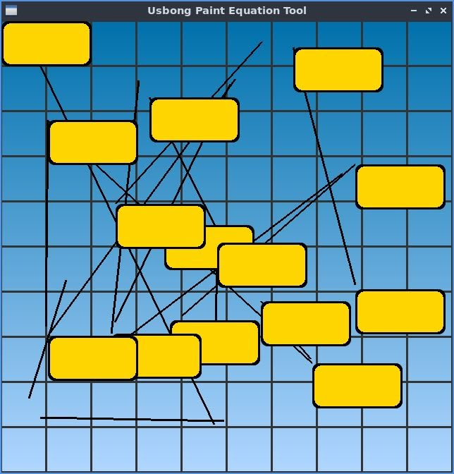
--> Usbong Menu System
--> We reuse the set of instructions for the Usbong Paint Equation (with Pixel Pattern) Tool.
--> Grid with Size: 10x10 Tile; Press a location in the grid to add a Button; Instructions to Auto-draw Lines still Exist

NOTE (from SYSON, MICHAEL B.):
We can use the Usbong Menu System to create applications for use with, e.g. Automated Teller Machine (ATM), Automated Selling Machine, i.e. Vendo.

I observed that select ATM's already use Java with the Java Virtual Machine (JVM). In this case, we use C/C++ with OpenGL to increase our available know-how as sets of computer instructions.

I already previously used Java with JVM with such tasks that execute on Microsoft Windows Machines, Android Mobile Telephones, et cetera.
Example: USBONG on Android

In addition, I have used C# with Microsoft Visual Basic to quickly add buttons that execute actions as triggered events after receiving a button pressed input. I note that I only verified such set of instructions to execute on Windows Machines.

In the year 2008, in Japan, I observed that Touch-capable Machines with such Menu System were being used to assist customers in purchasing items, e.g. Internet Connectivity Access @Manga Kissaten (Coffee Shop). I was able to quickly use such machines due to Japanese computer games systems that I used also had such menu systems.

Example: Nintendo Dual Screen (DS) Lite
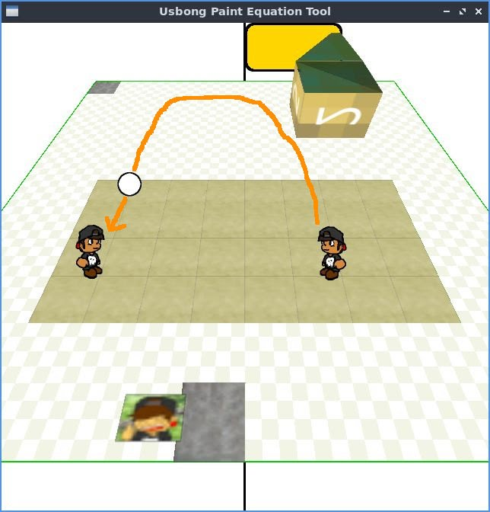
--> 2.2.2) added: Usbong Volley
With Ball Velocity: Acceleration and De-acceleration; due to Gravity and Collision with Pilots

--> added: Computer Artificial Intelligence (AI) to be Human-assistive: At present, the Computer executes vertical movement exactly with Unit Member as Pilot moves.
--> With horizontal movement, Computer moves in the exact direction as the Unit member;
--> therefore, when Unit member moves forward horizontally in the x-axis, Computer moves backward.
--> Usbong Volley Present Objective as Sport: Pilots alternately hit the ball before it hits the ground.

--> verified: Namco's Klonoa Beach Volleyball for the PlayStation system
--> observed: horizontal view can be used to solve the problem with select Sports that cause Player movement to be difficult to execute by a human person
--> Example: In Mario Tennis 64, being at the Top part of the Tennis Court adds movement difficulty.
--> However, because two (2) human Players share one (1) Television Screen, we can make the system fair by causing the Players to interchange between Top and Bottom parts of the Tennis Court.
--> Now, with Multiple Computer Monitor Screens, both Players can be at the Bottom part.
--> observed: even with a horizontal view, combining height to make certain angles, makes hitting flying objects difficult
--> Example: With Mario Story 64, floating blocks can be difficult to hit using the Mario JUMP command.
--> Recommended Actions:
--> verify: Publisher (Japan): http://www.starsign.co.jp/
item_switch_Volley.html last accessed; 20210520
--> verify: Developer (Barcelona): https://www.unfinishedpixel.com/; last accessed: 20210520

NOTE (from SYSON, MICHAEL B.):
While writing the computer instructions to develop the Usbong Volley, I was reminded that instead of Command#1, we can use Command#2. Execution time appears to be equal. In addition, after verification, when we have reached the maximum Command#1 that we can use, we can use Command#2 in its stead.
Reminder: Usage beyond Maximum causes auto-draw output problems.

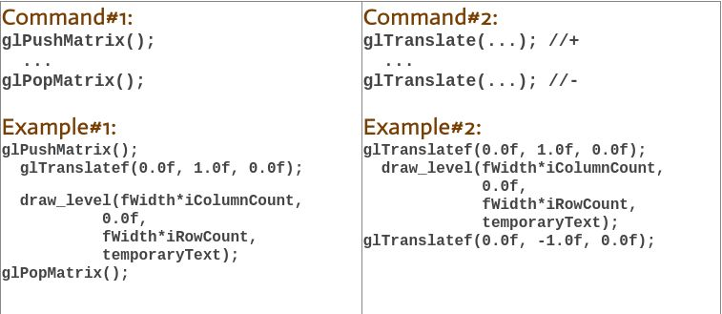
Reminder: The instructions notify the Computer to add to the level position a 1.0f in the y-axis, i.e. vertical.
--> where: f = floating-point number; used when digits after the dot are needed by the computer to make select computations
--> Example: 5.0/2.0 = 2.5
--> If we use whole numbers, i.e. no digit after the dot, this is an example output:
--> Example: 5/2 = 2
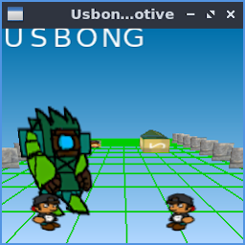
--> 2.3) Automotive: Usbong Network
Window Size (width x height): 256x256pixels
Color Level: 24 bits (R8, G8, B8)
File Size as .BMP (Bitmap) Image Format: 196730 B, i.e. 192.1 KB

--> 2.4) Energy and Health: Food
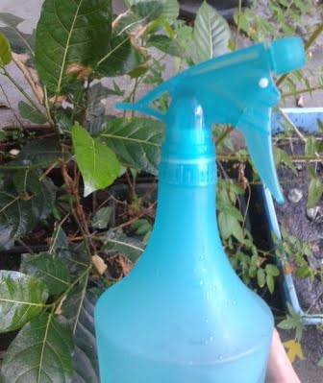
--> verified: water + vinegar spray mechanism
--> After setting spray output to be center focus, instead of spread, target hit distance can reach 3meters.
--> verified: tomato plant leaf to be heart shape
--> 2.5) Security Defense Force
--> verified: German Luger weapon tool mechanism to be rapid fire
--> reminder: Put tool close to your center position when firing projectiles to quickly and correctly hit targets
--> If you put tool closer to, e.g. your right side, hitting targets becomes difficult, especially when you also move your position.
--> There is a known problem with what we see, such that we do not hit targets. This is even if it appears that we should have hit the targets.
--> With machine-guns, rapid firing with stationary rotating movement to cause oscillating, i.e. wave movement, of projectiles increases hits.
--> If you are already hitting the target, no need to add excess wave movement. This is due to tool mechanism's precision, i.e. rapid fire causes projectiles to consistently hit set location.

NOTE (from SYSON, MICHAEL B.):
We learn that 三上 真司 (Mikami, Shinji; CAPCOM バイオハザード BIOHAZARD Producer) shares the objective of creating a world system for us to experience being stuck there and approaching death.

We have the option to choose to execute one of these two (2):
1) wait to be killed by the virus, i.e. virus-infected zombie
2) fight before we die

He adds that such experience is similar to the preference of select people to not drink Lager Beer. It is either we choose to experience it or not.

Reminders:
German Luger weapon tool
German Lager Beer

Additional Note:
1) We classify "Producer" to be "Unit Chief" due to if project fails, , i.e. expenses > income, Producer is accountable to pay financially for the failed project.

Reference:
三並達也 (Ed). (1997). "BIO HAZARD: The True Story Behind BIO HAZARD". OSAKA: CAPCOM

3) Updated: Usbong Training
--> 3.1) Training Centre: Security Defense Force
--> 3.2.1): Halimbawang Ingay
--> Patuloy na panlolokong ingay (at pisikal na pananakit) gamit ang wireless broadcasting technology ng mga budol-budol/manloloko/carnapper/cybercriminal/Teroristang Komunista
--> 3.2.1.1) ingaySaGateMulaWirelessBroadcastingTechNgMgaTeroristangKomunista.m4a (20210514T2017)
--> @00:07 (MM:SS), kulang ba sa langis ang gate? Hindi.
--> Bakit tumutunog ang gate nang ganyan kapag binubuksan?
--> Teroristang Komunista (gawa ng yabang): "Mafia", "Yakuza"
--> Mungkahing Aksyon: Puksain ang mga Teroristang Komunista.
--> Dagdag: Tao man o Hayop, e.g. bantay na aso sa bahay, pinapatay gamit ang wireless broadcasting technology na may epekto ng sa iligal na droga, e.g. taima, marijuana.

--> Sanhi: Quick Money gawa ng pag-aasawa at pag-aanak nang kulang ang ninanakaw.
--> Aksyon: Sulatan din ng incident report ang Tagapagpatupad ng Batas, i.e. Law Enforcement.
--> 10.2) noteLabisNaIngayMulaSaWirelessBroadcastingTechNgMgaTeroristangKomunista.m4a (20210523T0914)
--> @00:19 (MM:SS), labis na gawa-gawang tunog mula sa sasakyan
--> @00:31 (MM:SS), dagdag na tunog ng tahol ng aso (gawa ng may nakita/narinig)
--> @00:32 (MM:SS), sinasabayan ng panlolokong ingay ang nagsasalita upang magulo ang madirinig
--> Paalala: Sa pagdudulot ng paghirap sa paghinga, may ugnayan ang mga ito: Ear, Nose, Throat (ENT)
--> Mungkahing Aksyon: Puksain ang mga Teroristang Komunista.
--> Sanhi: Quick Money gawa ng pag-aasawa at pag-aanak nang kulang ang ninanakaw.
--> Aksyon: Sulatan din ng incident report ang Tagapagpatupad ng Batas, i.e. Law Enforcement.
--> 3.2.2) Continued misuse of wireless broadcasting technology

--> We note that a tower that transmits using antenna/antennae electric waves with sufficient signal strength to reach radio set devices are misused.
--> This budol-budol/manloloko/carnapper/cybercriminal/
Teroristang Komunista group transmitted such signal to my small wireless radio/speaker, while I was attempting to defend myself from their noise using static sound.
--> Software/computers/machines do not intentionally cause us physical injuries.
--> The problem is with people classified to be Teroristang Komunista who intentionally misuse technology by causing us physical injuries to quickly get money.
--> Mungkahing Aksyon: Puksain ang mga Teroristang Komunista.
--> Sanhi: Quick Money gawa ng pag-aasawa at pag-aanak nang kulang ang ninanakaw.
--> Aksyon: Sulatan din ng incident report ang Tagapagpatupad ng Batas, i.e. Law Enforcement.
Additional Note:
--> Even Television set devices receive panlolokong signal from this Teroristang Komunista group who misuse transmitter towers, et cetera.
--> verified: broadcasted BS, i.e. panlolokong, content that replaces regular broadcasting on Channel 7 (GMA 7) by including Ninoy Aquino still alive and on the Senate.
--> identified: members of this Teroristang Komunista group to include among others:
--> Ryan Syson, the son of Dr. Pedro Syson's younger brother, "tai-ah", i.e. Ramon Syson and Linda Syson
--> Both parents are also classified to be with this Teroristang Komunista group.
--> verified: broadcasted panlolokong ingay to reach antennae of moving vehicles
--> identified: Keith Haw, with Xavier High School (San Juan, Greenhills) classmate and basketball player, Tyrone Tang, to be with this Teroristang Komunista group.
--> Mungkahing Aksyon: Puksain ang mga Teroristang Komunista.
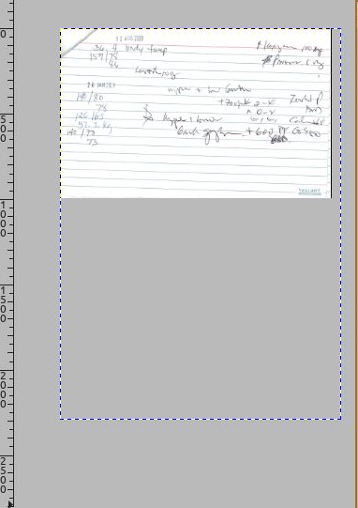
--> Aksyon: Sulatan din ng incident report ang Tagapagpatupad ng Batas, i.e. Law Enforcement.
--> 3.2) Introduction to Image Processing Automation (with GNU Image Manipulation Program (GIMP))
--> added: instructions in Scheme Computer Language to automatically resize the canvas width and height
--> Input files include scanned images of index cards used @partner MOSC

NOTE (from SYSON, MICHAEL B.):
GIMP can receive as input instructions written in the Scheme Computer Language to automatically execute Image Processing.

Example Usage: Resize Canvas using a set width and height

Additional Notes:
1) The Scheme Computer Language uses syntax where a Command is inside a set of parentheses. Inside, we put at the left-most the function, e.g. addition operation.

Example#1:
> (+ 3 5)
Output: 8

Example#2:
> (* 4 6)
Output: 24

2) At present, the functions that we have used with Image Processing include among others:
--> 2.1) Functions as Commands to get items in a List container
--> Reminder: A List container in Scheme has a head and a tail
--> where: head = first item in the List; tail = rest of the items in the List
--> We use these functions to get the items :
--> head : car
--> tail : cdr

--> Example Create List: (1 2 3)
> (set! list '(1 2 3))
Output: (1 2 3)

> (car list)
Output: 1
> (cdr list)
Output: (2 3)

--> 2.2) Functions as Commands to get items in a Vector container
--> Reminder: Vectors are Containers with a number sign, i.e. #, before the set of parentheses
--> Command: (vector-ref v 0)
--> where: v = vector object

--> Example#1:
> (vector-ref #(1 2) 0)
Output: 1
--> Example#2:
> (vector-ref #(1 2) 1)
Output: 2

--> 2.3) Functions as pre-added GIMP Commands to get items in a GIMP Image List container
--> Example#1:
> (gimp-image-list)
--> output: (1 #(1))

--> Example#2:
> (car(gimp-image-list))
--> output: 1

NOW HIRING: COMPUTER SERVICES SALESPERSON
✓Receive half of the revenue from your DIRECT SALE of the service

✓Receive training:
Filipino Language, Sales, Information Technology
Requirements:
1) Curriculum Vitae
2) Portfolio
3) Sulat ng Hangarin
3.1) Ano ang maitutulong mo?
3.2) Bakit mo nais ito?
3.3) Bakit ka karapat-dapat?



EMAIL: APPLY@USBONG.PH

Tanong at Sagot

1) Magkano ang aking kikitain bilang Computer Services Salesperson at Manunulat ng paliwanag sa kompyuter, e.g. Add-on Software?
--> Kung babayaran tayo ng klinik ng 10K pesos bawat buwan, 5K ang sa iyo bilang Computer Services Salesperson.
--> Bilang Manunulat, 4K pesos ang maibibigay sa iyo ng Usbong.
--> Sa kabuuan, 9K pesos ang matatanggap mo bawat buwan.
--> Ang matitirang 10% ng 10K, i.e. 1K pesos, gagamitin ng Usbong sa pag-iipon ng kapital.
--> Gagamitin ito ng Usbong sa paggawa ng mga investment at "float", na ang kahulugan, liquid asset.

2) Paano ako makibabahagi sa tagumpay ng kompanya?
--> Kung wala tayong kikitain mula, halimbawa, sa Computer Automation Service, mauubusan tayo ng kapital na pambayad sa ating lahat. Hindi magtatagal, wala na tayong kompanya.
--> Dahil dito, kailangang maayos ang ating paggawa at pagtuturo sa mga trainee upang tuluy-tuloy ang daloy ng ating kita, habang nagbibigay ng ginhawa sa lipunan.

MAPARAANG PAGBIBILANG
ALGEBRA SKILL LEVEL 1:
INPUTS:
X = 250 //ITEM PRICE
V = 12% //VALUE ADDED TAX (VAT)
Q = ? //ITEM PRICE WITH VAT

TANONG: WHAT IS ITEM PRICE WITH VAT?
SAGOT:

ALGEBRA SKILL LEVEL 2:
INPUTS:
X = ? //ITEM PRICE
V = 12% //VALUE ADDED TAX (VAT)
Q = 364 //ITEM PRICE WITH VAT

TANONG: WHAT IS ITEM PRICE WITHOUT VAT?
SAGOT:

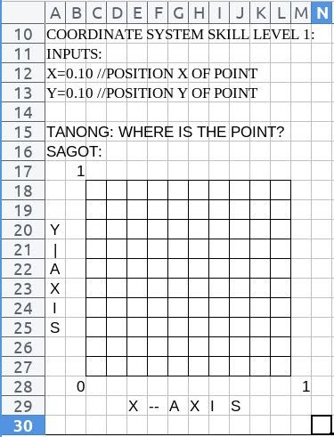

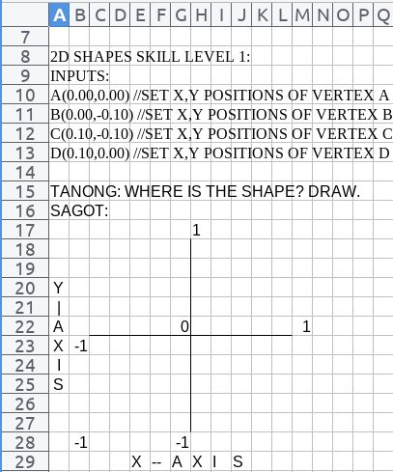

USBONG SOCIAL SYSTEMS, INC.
COMPUTER SERVICES

SYSON, MICHAEL B.
FOUNDER

MOBILE: +63929.952.7263
EMAIL: MASARAPMABUHAY@GMAIL.COM

WEBSITE: WWW.USBONG.PH
ADDRESS: #2 E. MANALO (FORMERLY, E. RODRIGUEZ) AVE., STO. NIÑO, MARIKINA CITY, 1820, PHILIPPINES

