
November 2020
COMMUNITY・FAMILY
・COMPANY DOCTOR = VITAL

血液（Blood Liquid）・大脳生理（Big Brain Grow Reason）
・精神（Spirit God）
PHILIPPINES: USBONG CONTINUES TO PROVIDE
COMPUTER SERVICE ASSISTANCE BY SHARING
KNOW-HOW ON MAPARAANG PAGBIBILANG

To eliminate excess steps and inefficient time usage, MARIKINA ORTHOPEDIC SPECIALTY CLINIC (MOSC) requested Usbong's services to automate routine, monotonous tasks and share with unit members know-how on computers.

Here are Key Action Items that we executed in this updates list.
1) Continued to update Knowledge Management System (KMS)
1.1) added: in Non-medicine Item Page, Value-Added Tax (VAT) cell with auto-computed value
--> +added: cell with auto-computed value of discount for patients classified as SC/PWD
--> where: SC = Senior Citizens (SC); PWD = Persons with Disabilities
--> These actions assist Unit members with Official Receipts.
--> In addition, these are based on feedback after actual use by Unit members.
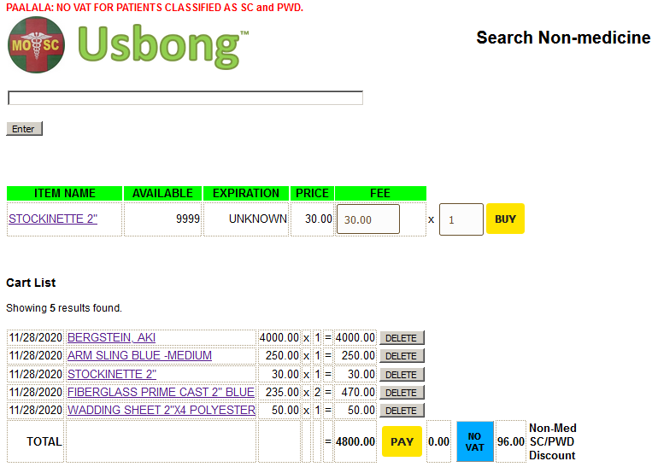
1.2) added: in system snack items
--> This action is to solve problems with computer auto-generated report does not include snack count and income, in contrast to Cash Register report.
--> In addition, we note that entering of patient transactions to computer database is at times executed after noon.
--> This occurs when paying patients increased to form a wait list.
--> Recommended Action from Unit Member: Receive assistance to process an increased number of paying patients
--> We add that the computer auto-generates the unified and non-unified snack reports.
--> where: non-unified = time-based list; unified = list that combines items whose item identifications are equal
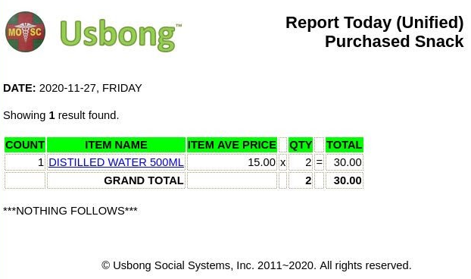
1.3) added: system notifies Cashier Unit member if patient name is not included in the Cart List
--> This action is to solve the problem of no patient name in the auto-generated Official Receipts (OR) Reports

--> Recommended Action: Reuse tool as part of point card system
--> This action identifies patients who buy from MOSC, their place of residence, also in Barangay STO. NIÑO, Marikina City, etc?
--> Community・Family・Company Doctor = VITAL
1.4) updated: system to fix auto-computed total fee and count report problem when the same patient has already paid and comes back to buy another set of items/services
1.5) updated: system to set maximum execution time for any request to be 300seconds
--> I note that this is due to the size of our database now requires maximum execution time to be more than 30seconds.
--> Problem already occurs with command: viewReportMedicineUnified.php
--> In addition, we can reduce the main database size by making smaller database sub-sets from it.
--> These sub-sets contain transactions that are less often used, e.g. those from a previous year.
1.6) continued: to share printed Usbong Newsletters to Salespersons in Barangays Sta. Elena and San Roque
+observed that due to Typhoons, e.g. Ulysses, select roads become muddy and slippery
--> We can still walk, albeit with caution, from Barangay Sto. Niño to Sta. Elena and San Roque.
--> +observed: E. Manalo Ave., Sto. Niño, in front of USBONG HQ and MOSC HQ Building (Postal Number: 1820)
--> Water level of the flood did not become so high that we had to move items to higher ground.
--> Water level became lower by 17:00 after the Typhoon hit Marikina City.
--> +verified: Newspaper Salespersons in Barangays Concepcion Uno and Dos, Marikina City
--> Barangay Concepcion Uno: Near the Puregold Supermarket and McDonalds Fastfood Restaurant, the Newspaper Salesperson does not yet sell "Balita".
--> Barangay Concepcion Dos: I did not yet find Newspaper Salespersons even near a Bakery.
--> We can establish partnerships to build points where people can get the printed Usbong Newsletter.
--> This is in addition to the digital version.
--> By sharing know-how and information, we can increase the skill level of the population in the barangay, the city, the main island of Luzon, the whole Philippines, the Asian continent, the whole world, the beyond, and outer space.
--> Recommended Reading: Enix. (1995). Dragon Quest VI: Usage and Explanation Book/Manual (translated from nihongo by SYSON, MICHAEL B.; Super Family Computer version). Tokyo: Enix Stock Corporation
NOTE (from SYSON, MICHAEL B.):
I add the following things that we can learn from the Book/Manual:
1) Pagdating mo sa isang lipunan, una mo munang puntahan ang simbahan. Pagkatapos, kausapin mo ang mga mamamayan upang malaman kung ano ang kanilang kailangan.
2) Kapag makikipag-usap sa tao, lumapit sa kanya at harapang kausapin.
3) Mahalaga ang Manual o Aklat ng Paggamit at Paliwanag upang malaman ang ginagawa ng mga ito:
3.1) 呪文（jumon; binibitiwang salita mula sa nakasulat; sumpa）
3.2) 特技（tokugi; bukod-tanging kakayanan）
--> Sa madalas na paggamit, unti-unti mong maaalala ang ginagawa ng mga ito.
--> Kahit nasa nihongo, may mga gawa-gawang banyagang pangalan.
--> Halimbawa: ホイミhoimi, スクルトsukuruto, マヌーサmanu-sa, ルカナンrukanan, リレミトriremito, ルーラru-ra
--> Maaaring ihalintulad ito sa pag-alala ng pangalan at ginagawa ng mga gamot.
4) Mapanganib na kapag sinasabi mong "Kaya ko pang magpatuloy!"
--> Kapag nakikipaglaban nang halos hindi na makakaya, habang hindi mo naiisip, makatatagpo kayo ng malakas na kalaban, at lahat kayo patay.
--> +observed: that the computer notes your elapsed playing time
--> After 30 minutes in a dungeon, the computer automatically generates a strong monster.
--> This monster destroys your whole team.
--> Therefore, each dungeon is played twice.
--> Return to the nearest town and write your progress.
--> Go back again to the dungeon after resting.
2) Requested: PhilHealth via email that the Total Amount Due in the auto-computed PhilHealth Statement of Premium Account (SPA) Form already be rounded to become whole numbers, i.e. integers.

--> This is so that when we pay our contributions in cash, the totals and the received change are exact, i.e. no excess or missing amount, even the centavos.
Example:
Total Amount Due: 818.78 -> 819
Employer Share: 409.39 -> 409.50
Employee Share: 409.39 -> 409.50
--> I note that we have already written a request to Bangko Sentral ng Pilipinas (BSP) to eliminate the centavo coins.
--> The Bureau of Internal Revenue (BIR) already executes this, albeit still only in select BIR forms.
--> Action: Count combinations of 0.01, 0.05, 0.10 centavo coins until you reach 1.00
--> We humans counting by hand these combinations of centavo coins causes inefficient usage of time.
--> We would rather use available time to do other things, especially when we reach our 60’s.
3) Added training course on Introduction to Computer Networks
--> The sets of instructions are already available to the public from the Open Source Community.
--> We at USBONG updated the sets to execute on LUBUNTU machines.
--> We shall verify adding Windows machines.
--> We note that the sets use the Berkeley Software Distribution (BSD) sockets.
--> These are available with Linux and UNIX-like machines.
--> In addition, we use the C Computer Programming Language.

NOTE (from SYSON, MICHAEL B.):
More than 10 years ago, I used Windows sockets (Winsock) to connect computers in a network. Equal with BSD sockets, I set a server-client computer network.
I experienced difficulty causing what is displayed on one computer to be exactly equal with that of the other.
I verified and failed using both the following:
1) Transmission Control Protocol (TCP)/Internet Protocol (IP)
2) User Datagram Protocol (UDP)
1.1) TCP/IP: send data packets with verification that packets are correctly received; slower than UDP, but prevents data loss
2.1) UDP: send data packets without additional verification that packets are correctly received; faster than TCP/IP, but data loss occurs
As it turns out, it was a known problem with networked computer games that aim for real-time gameplay, e.g. multiplayer first-person shooters, in contrast to turn-based, e.g. chess, go.
However, because each person is not necessarily verifying what is displayed in another person's computer monitor, the computer game engine is not stressed to display exact positions on multiple computer monitors.
In 2006, the New Super Mario Bros. for the Nintendo Dual Screen (DS) with its 2-Dimensional (2D) gameplay showed that exact positions can be displayed on multiple DS systems. Using wireless communication technology, the distance can be as far as 65feet, with the systems facing each other as directly as possible.

I have yet to write the computer instructions to successfully execute this. I note that I also encountered the problem in 2004 when I attempted to
synchronize wirelessly in real-time 2D graphics on mobile devices using the Java computer programming language and BlueTooth Technology.
I think that we can already use audio-visual technology to send visual information, e.g. as continuous screenshot images, instead of individual positions and other data of the shapes with which we interact.
I add that in the summer of 2004, I learned as the editor of our team's documentary video on Political Dynasties in the Philippines that Flash Video technology can noticeably reduce the file size of analog video. From history, we learn that such technology was used by YouTube, which registered in 2005.
YouTube was acquired by Google in 2006.
Recommended Reading: New Super Mario Bros. Instruction Booklet
4) Added training courses on Introduction to Maparaang Pagbibilang
--> 3.1) Algebra, i.e. use of containers whose value inside may vary
--> 3.2) Coordinate System to identify positions in the x, y, and z-axes
--> 3.3) 2D Shapes, e.g. square, triangle
--> 3.4) 3D Shapes, e.g. cube
--> 3.5) Trigonometry, i.e. identify positions using angles and distances of shapes, e.g. in particular, triangles
--> Nagdudulot ito ng mga problema sa ating pakiramdam.
--> Dahil dito, maiging alamin bukod sa pag-inom ng gamot, kung ano ang maiging paraan ng paglunas, e.g. lifestyle change to increase physical activity, eat nutritious food, e.g. vegetables, whose total weight you can carry using a basket
--> Reminder: avoid eating pork/swine and food made from animals/insects, e.g. rats, cockroaches, that eat dirt
--> We add that with this action, we learn to identify and classify what we eat.

NOTE (from SYSON, MICHAEL B.):
Maiging nasisikatan ng araw at hindi nakakulob sa kuwarto. Mayroon kasing mga may-sakit na nakahiga na lamang sa kama hanggang tuluyan nang mamahinga.

Bagama't hindi natin mapipilit ang mga may nais nang mamahinga, kailangan ang physical activity ng mga taong may nais pang patuloy na mabuhay.
働く (hataraku in nihongo) = work; maghanap-buhay
Left Chinese character 人 = person
Right Chinese character 動 = move, i.e. "bigat lakas" = gravity

Research from Ishihara Clinic notes the following select corresponding policies for Cancer.
I've translated the text from nihongo to English.

1) Concentrating on harmonizing, e.g. Japanese, food that warms the body, make certain to eat small servings to fill 60~70% of stomach.

2) Promote Natural Killer (NK) cells to work in destroying Cancerous cells using these activities: karaoke, immerse in hobby, speak with people who are aligned with your spirit, etc, warm body, make yourself feel better.

3) Starting with God, nature, siblings to surrounding people and things, live bringing a grateful mind. This is not at all a Spirit God discussion; in the same way as feeling well living・working, you get to encourage the NK cells, the kind of white blood cells that work to destroy Cancer cells.

Recommended Reading: Ishihara, Yuumi's 老化は「体の乾燥」が原因だった! 内臓、皮膚、頭脳…全身が若返る食べ方・暮らし方

NOW HIRING: COMPUTER SERVICES SALESPERSON
✓Receive half of the revenue from your DIRECT SALE of the service

✓Receive training:
Filipino Language, Sales, Information Technology
Requirements:
1) Curriculum Vitae
2) Portfolio
3) Sulat ng Hangarin
3.1) Ano ang maitutulong mo?
3.2) Bakit mo nais ito?
3.3) Bakit ka karapat-dapat?



EMAIL: APPLY@USBONG.PH

Tanong at Sagot

1) Magkano ang aking kikitain bilang Computer Services Salesperson at Manunulat ng paliwanag sa kompyuter, e.g. Add-on Software?
--> Kung babayaran tayo ng klinik ng 10K pesos bawat buwan, 5K ang sa iyo bilang Computer Services Salesperson.
--> Bilang Manunulat, 4K pesos ang maibibigay sa iyo ng Usbong.
--> Sa kabuuan, 9K pesos ang matatanggap mo bawat buwan.
--> Ang matitirang 10% ng 10K, i.e. 1K pesos, gagamitin ng Usbong sa pag-iipon ng kapital.
--> Gagamitin ito ng Usbong sa paggawa ng mga investment at "float", na ang kahulugan, liquid asset.

2) Paano ako makibabahagi sa tagumpay ng kompanya?
--> Kung wala tayong kikitain mula, halimbawa, sa Computer Automation Service, mauubusan tayo ng kapital na pambayad sa ating lahat.
--> Hindi magtatagal, wala na tayong kompanya.
--> Dahil dito, kailangang maayos ang ating paggawa at pagtuturo sa mga trainee upang tuluy-tuloy ang daloy ng ating kita, habang nagbibigay ng ginhawa sa lipunan.

USBONG SOCIAL SYSTEMS, INC.
COMPUTER SERVICES

SYSON, MICHAEL B.
FOUNDER

MOBILE: +63929.952.7263
EMAIL: MASARAPMABUHAY@GMAIL.COM

WEBSITE: WWW.USBONG.PH
ADDRESS: #2 E. MANALO (FORMERLY, E. RODRIGUEZ) AVE., STO. NIÑO, MARIKINA CITY, 1820, PHILIPPINES

・同一バンドの車がありますと混信してしまいますので、2台以上の車で遊ぶときは違うバンドの車同士で遊んでください。また、バンドの違う車同士でも接近しすぎると電波が干渉する恐れがあります（故障ではありません）。車の距離を離して遊んでください。
・When there is another vehicle using the same band, conflicting signals end up, so when there are more than 2 vehicular machines, please play with vehicles together using different bands. In addition, even if vehicles together are using different bands, when they become near, there is a tendency for an electric wave negotiation to occur (not an accident). Please play after yielding vehicle distance.
8.2) Added: Image Processing Automation in R&D folder
--> This is to advance in know-how from the Usbong Education Training Course
--> verified: existing Filipinos that work with 3-Dimensional (3D) Technology
--> Example: Filipinos at Secret6 and RanidaGames

NOTE (from SYSON, MICHAEL B.):
I observed that there is less focus by Filipinos in building an engine that can auto-draw objects. In its stead, priority is given to receiving and doing outsourced work where the task is to draw objects by hand.
While there already exist tools, e.g. Unreal Engine and Unity Engine, I note that we Filipinos can also learn to build engines via Maparaang Pagbibilang.

Example: Usbong Engine
By using tools, e.g. Open Graphics Library (OpenGL), that are already
available to the public, we can quickly port, i.e. translate, a set of instructions that execute on a Windows Machine to a Linux machine in 34mins.

8.3) Added: references materials
--> shared: with Unit members that using computers, we already have the tools to build an engine
--> Recommended Action: share know-how on Maparaang Pagbibilang

NOTE (from SYSON, MICHAEL B.):
When I was in elementary school, I often looked at the images from the Lego Brochures. Even today, I still find Lego sets expensive. Because of this, I would tend to attempt to create a version of what I saw using the available Lego pieces and tools that I have.

9) Shared Information via among others: available used books, brochures, computers, printers
--> Example: Villanueva, Rene (Anvil Publishing, Inc.)'s "Mahiwagang Ibong Adarna At Iba Pang Dulang Pang-Elementary"
--> +added: paper marks to identify pages to emphasize:
--> "Mahiwagang Ibong Adarna" page49; "Ang Gamugamong Naakit sa Liwanag" page33
--> This action pertains to the company system where the older sibling shares with younger sibling.
--> Example: Instead of the younger sibling buying a new set of school books, he can receive the set that his older sibling used.
--> At USBONG, we also repair among other Information Technology (IT) tools: computers, scanners, and printers
--> Any Unit member who has sufficient know-how and is willing to make time to fix available tools can use them.
--> In addition, when an office or workplace upgrades their machines, we can buy those used items.
--> We then transfer the items that we had been using to Unit members who request for their use.
10) Shared Information on Energy and Health
--> +reminded: Unit members and patients who visit MOSC the value of physical activity
--> Select medicine items are not effective without accompanying physical activity.
--> recommended: 20mins of continuous walking everyday;
--> however, those that eat more also need to increase their physical activity
--> Example: skip ropes x800; if going from 1~800 is too challenging, begin first with smaller sets, e.g. set of 200 x4
--> In addition, correct technique prevents among others: back pain and slipping on the floor.
--> Ang ating dugo ang nagdadala ng pagkain, i.e. energy, sa mga cell ng ating katawan.
--> Kapag umiinom tayo ng gamot, lalo na ang mga may kailangan ng receta, may sumasamang lason, i.e. toxic, sa dugo.
--> Ang ating liver ang pangunahing naglilinis nito.
--> Kaya lang, kapag labis-labis ang pag-inom ng gamot, hindi na makakayanang linisin ng liver ang lason.
--> shared: with Unit members questions as review of each Maparaang Pagbibilang concept
--> We classify the difficulty of all skills to be Middle ~ High School level.
--> Unit members who can answer the questions correctly need not do additional questions as a form of repetitive exercise.
--> We note that Unit members are reminded to write the names of the people they worked with after finishing each question.
--> In addition, by identifying each Unit member's present skill level, we can request Unit members to assist in Computer Service Automation based on their level.
--> We learned that the list of concepts, e.g. Algebra, can be used with computers using any computer language.
--> Indeed, the purpose of computers is "to compute".
--> The objective of which is for us to receive as output: Information.
--> However, from observation, those who have already received an introductory training on Maparaang Pagbibilang do not necessarily advance to learning Computer Languages.
--> This tendency is due to the training system.
--> Computers become noticeably useful when the number of transactions that the trainees count exceed 1000 per year.
--> Action: Count the global population size; Select reports share that it already exceeds 6 Billion.

NOTE (from SYSON, MICHAEL B.):
This action of identifying the skill level of Unit members creates a system where we can increase our income by increasing know-how. This is instead of stagnating in skill level and income as the years progress.

We add that increased skill level leads to advancement of position to become Unit Chief.

Unit Chiefs are accountable to Unit members.
Unit Chiefs can become Chiefs of Unit Chiefs.

Due to accountability, Unit members tend to prefer not to become Unit Chiefs.
Accountability = if project fails, Unit Chief pays financially for loss.

However, Unit members learn to advance in position due to necessity.
Example: Former Unit Chief becomes hospitalized due to illness caused by heat wave;
After computation, you are the next in-command to be Unit Chief.

Recommended Reading: Abegglen, J., et al. (1985). "Kaisha: the Japanese corporation". USA: Basic Books, Inc.

5) Added Case Study on Nippon Telegraph and Telephone (NTT) corporation
--> We emphasize mathematical optimization promotes communication.
--> Example Problem: SONY PlayStation Hardware Sales Forecast overly optimistic;
--> Result (1997): Warehouse (Japan): Excess Stock X 500~600K @USD180 each; Loss: USD108M
--> Solution: Hardware Expansion via Software Profit
--> Software Profit via Repeat Production using Compact Disc (CD) technology
--> PlayStation Sales Results: 1.78 price elasticity
--> where value <1 = necessity, i.e. people buy with less and less regard for price
--> Example (at present): insulin medicine
--> Philippine Context Action: Ayusin via Maparaang Pagbibilang ang sistema sa Pinas upang may 1.78 price elasticity ang PlayStation sa "general public"
--> Reference: Asakura Reiji's "Revolutionaries at Sony".

NOTE (from SYSON, MICHAEL B.):
P = 1/((A/B)^2)
where:
P = Price Elasticity
A = New Price
B = Previous Price
Halimbawa: Year 2020: Filipino family bumibili ng Playstation 4 console + Minecraft Dungeons @PHP10K

What should the PREV PRICE's be to achieve PHP10,000?
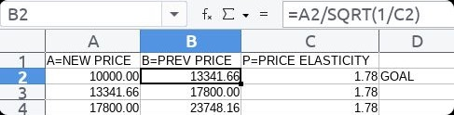

What should the NEW PRICE's be if we start at PHP17,999?
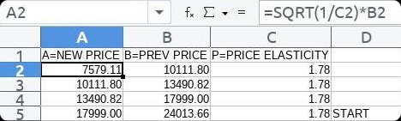
6) Continued to work with the Sta. Lucia Health Care Center (SLHCC)'s Accounting Unit
--> This is with regard to remaining uncollected Cash and unpaid Health Maintenance Organization (HMO) transactions
--> +observed: increased elaped time in identifying uncollected cash payments from previous weeks
--> Previously, unpaid cash was for the week only.
--> Action: -add: auto-identify previous weeks to reduce elapsed time
--> We note that elapsed time of going to SLHCC Unit every Monday~Saturday is still longer.
--> This is due to Traveling Time (26mins x2) and Waiting Time (at least 60mins).
--> +updated: set of instructions to auto-verify paid HMO transactions
--> +updated: set of instructions to auto-generate unpaid HMO Summary Reports
--> Example: Unpaid HMO transactions (2019)
--> The delay is due to among others:
--> 6.1) Select HMO Offices were closed during the CORONA VIRUS 2019 (COVID-19) Quarantine Lock-down
--> 6.2) Select Unit members were attacked by the budol-budol/manloloko/carnapper/communist terrorist/cybercriminal group, who still even now continues to use wireless broadcasting technology to cause physical injury,
--> e.g. cough, ear and throat itch leading to pain, breathing/cardiac problems;
--> reminder: Ear, Nose, and Throat (ENT) are connected
--> We emphasize 6.2) due to the additional stress that it creates, thereby causing select Unit members to do the following:
--> 6.2.1) opt to rest, 6.2.2) undergo therapy, and 6.2.3) eventually resign
--> Unfinished work is then carried by remaining Unit members in addition to their present workload.

7) Updated Training Centre: Security Defense Force to include Introduction to Self-Defense Parts 1 and 2
--> Mungkahing mga Aksyon:
--> 7.1) Puksain ang mga budol-budol/manloloko/carnapper/communist terrorist/cybercriminal group na gumagamit ng wireless broadcasting technology upang gumawa ng mga panlolokong ingay at pisikal na pananakit.
--> 7.1.1) Halimbawa ng Panloloko:
--> May nakikita kang mga larawan/imahe o may naririnig kang mga bulung-bulong ukol sa mga yumaong kilala o mga anghel/demonyo na sinusundo ka na.
--> Paalala:
--> Hindi ito tulad ng iyong radyo o television na madali mong maisasara kung nais mo gamit, halimbawa, ng POWER OFF button nito.
--> 7.1.2) Halimbawa ng Pisikal na Pananakit:
--> Gamit ang baterya ng sasakyan, pasadahan mo ng kuryente ang isda sa ilog. Makikita mo na mahihilo ito at madaling kunin gawa ng hindi na ito mabilis na makalangoy upang makaiwas.
--> Kapag direkta mo namang tinusok at pinasadahan ng kuryente mula sa baterya ng sasakyan ang palaka, makikita mong manginginig ito.
--> Paalala:
--> Alalahanin na maaaring dumaloy ang kuryente sa hangin, i.e. wireless.
--> 7.2)「お悩み12：どこでも誰でも簡単にできるストレス解消法」
--> "Iyong Alinlangan#12: Simpleng paraan ng paglabas ng istres: Saan man, kahit sino"
--> Translated from nihongo to Filipino by SYSON, MICHAEL B.
--> Ito'y kapag nakararanas ka ng istres dahil ang pakiramdam mo, wala ka nang kontrol sa mga nangyayari.
--> 7.2.1) Gumawa ng Prediction
--> Kung alam mo na ang mangyayari, hindi ka na kailangang mag-alinlangan.

--> Kung hindi mo alam kung ano ang mangyayari, dahil mulat ka sa iyong nararamdaman, maisasaayos mo ito.
--> 7.2.2) Maglakad
--> Move your left foot, say out-loud "left"
--> Move your right foot, say out-loud "right"
--> 7.2.3) Huminga
--> Breathe slowly; Exhale slowly
--> 7.3) Sanggunian:
--> 7.3.1) Marikina City Ordinance Enacting the Noise Control Regulations (ORDINANCE No. 100 Series of 2010)
--> 7.3.2) Fujitsu Group Total Life. (2008). Information Magazine: プラスワン（Plus 1） (No. 74, Summer 2008). Japan: Fujitsu Health Insurance Group et al.

8) Continued with Research & Development (R&D): Automotive
--> recommended: max traveling time (to workplace): 1 hour
--> recommended: max traveling time (return home): 1 hour
8.1) Verified: with TOMICA distributor ToysRUs Philippines regarding availability of BitChar-G 二カド電池 (Ni-Cd Battery)
--> learned: at present, not available
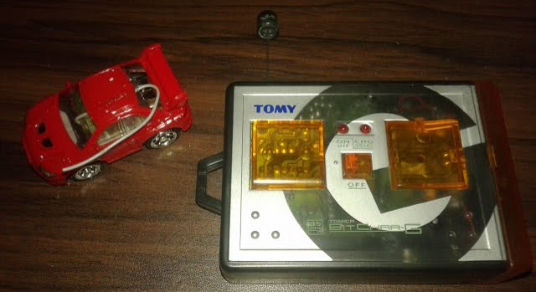
Radio Control (RC) machine

NOTE (from SYSON, MICHAEL B.):
Here are select points from the RC Machine Manual's TROUBLE SHOOTING section.
I've translated the text from nihongo to English.

取り扱い説明書：トラブルシューティング
Usage Explanation Book (Manual): TROUBLE SHOOTING
1) | 症状 | Symptom Condition
2) | 原因 | Cause
3) | 対策 | Corresponding Policy

1.1) 症状 | 走行しない  Does not move
1.2) 原因 | 電波が届いていない  Electric wave does not reach
1.3) 対策 | ・送信機と車の距離は送信機のアンテナと車のアンテナを完全に伸ばして約2.5ｍです。条件によっては、送信距離が短くなる場合があります。  ・Distance between signal transmitter and vehicle is 2.5m after completely extending the antenna of transmitter and vehicle. Based on conditions, there are cases when the transmit signal distance becomes shorter.

2.1) 症状 | うまく操作できない  Cannot successfully control
2.2) 原因 | 周波数が同じであっても、組み合わせによっては、車が走行しない場合があります。  Even if band wave range number is the same, after synchronizing, there are cases when the vehicle does not move
2.3) 対策 | ・ビットチャージで遊ぶ際は、必ずパッケージに同梱されていた送信機と車の組み合わせで遊んでください。  ・When playing with BitChar-G, please be certain to play with the signal transmitter and vehicle that came together inside the package.

3.1) 症状 | 勝手に動く  Moves by itself
3.2) 原因 | 同一バンドの車で遊んでいませんか？  Are you playing with another vehicle using the same band?
3.3) 対策 | ・他の電波を発生する機器が近くにありますと、混信する可能性があります。場所を変えるか、他の機器の電波を切って遊んでください。  ・When another electric wave emitting device is near, there is a possibility of conflicting signals. Please play after changing venue, or cutting the electric wave from the other device.

