
April 2021
Rosso = Pula

忍 (shinobi; "sword/knife mind") :
しんぼう (shimbou; bear to execute patience)

PHILIPPINES: USBONG CONTINU​ES TO PROVIDE
COMPUTER SERVICE ASSISTANCE BY SHARING
KNOW-HOW ON MAPARAANG PAGBIBILANG

To eliminate excess steps and inefficient time usage, MARIKINA ORTHOPEDIC SPECIALTY CLINIC (MOSC) requested Usbong's services to automate routine, monotonous tasks and share with unit members know-how on computers.

Here are Key Action Items that we executed in this updates list.
1) Continued to update Knowledge Management System (KMS)
--> 1.1) continued: to share know-how on computers and Information Technology (IT) tools
--> The computer's Internet Protocol (IP) address is automatically changed by the Router, i.e. network device that creates the address to give to the computers connected to it. This is unless we notify the Router via the computer to set our preferred IP address. If not, the IP address given by the Router to the computer can change again after, e.g. turning off the computer via the shutdown command and turning it on using the POWER button the next day.
--> Reminder: We use the IP address to access computers, e.g. those classified to be Computer Servers. If the IP address changes, we shall not be able to access those computers using another computer via the network. In addition, we can add security locks, such that only select files are available for access, e.g. web server pages. This action of auto-changing the IP address is also executed by the Philippine Long Distance Telephone (PLDT) Company with its PLDT Router. The PLDT Router's own public IP address is not static, i.e. changes, unless set with additional payment. Therefore, the budol-budol/manloloko/carnapper/cybercriminal/
communist terrorist group shall need to verify the new public IP address every time it changes. IT Tools, e.g. DynDNS (now with Oracle Corporation), exist to assist in automatically updating the public IP address of the Computer Server that is set with it. This is so that Computer Clients can continue to access the Computer Server even if its public IP address changes.

Example: Web Page File stored inside Computer Server;
File viewed by Computer Client using Web Browser
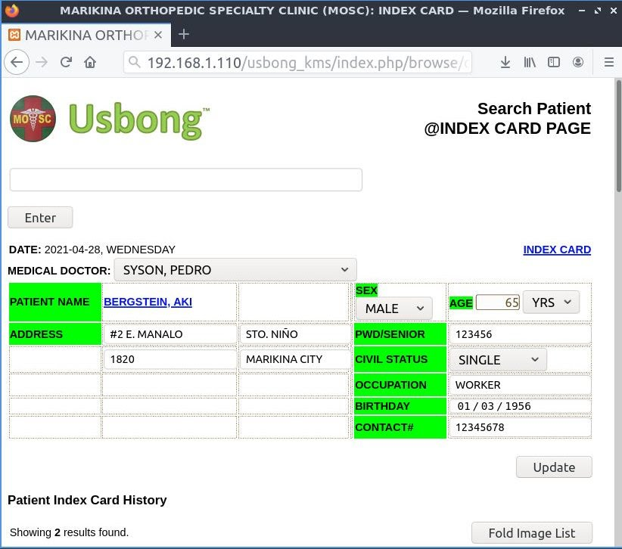
Sample Patient Index Card Web Page File
--> Reminder: The date and time that the Router changes the IP address is based on the instructions set on the Router. Without access to that set of instructions, it became faster to use the DynDNS tool. The DynDNS tool empowered people to set a new IP address that is static. Computer Clients who intend to access the Computer Server use that static IP address.
--> The Computer Server regularly sends a notification using an installed application from the DynDNS tool to DynDNS's own publicly accessible Web Server. The notification contains information regarding Computer Server's Router IP address.
--> Reminder: Router's tasks include among others: automatically setting Computer Server's IP address. Any change in the Computer Server's Router IP address is updated by the DynDNS tool on its Web Server.
--> Therefore, the DynDNS Web Server has information on the following:
--> 1.1.1) Router's public non-static IP address
--> 1.1.2) Router's preferred public static IP address

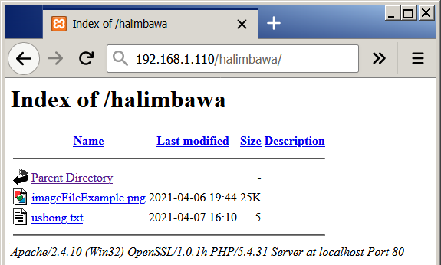
Sample Files List inside "halimbawa" folder
Stored Inside Computer Server
--> Reminder: Router assists Computer Clients who intend to access the Computer Server by opening the network route and transferring data to the correct destination. However, after re-verification, this DynDNS technique that we previously used with our partner MOSC, is not anymore successfully, unless we pay additional fee to PLDT to update the PLDT Router settings.

NOTE (from SYSON, MICHAEL B.):
If multiple Computer Servers are connected to the Router and we use only one (1) public static IP address, we shall need to add a port number to identify the Computer Server requested by the Computer Clients. Therefore, the Computer Clients shall need the public static IP address from the DynDNS Tool and the Computer Server's port number. The Router receives these information from the requesting Computer Clients to successfully connect them to the Computer Server.
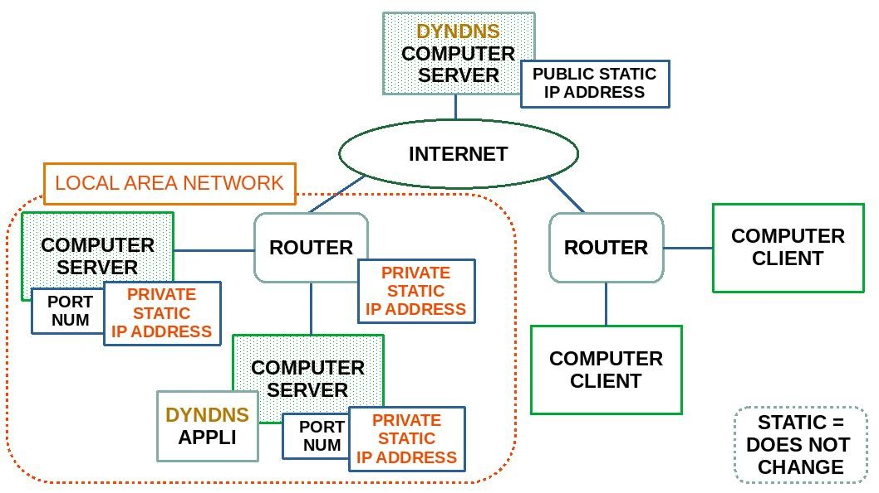
Reminder: The Computer Servers with the Router in the following part of the Schematics also have their own Private Static IP address via Local Area Network (LAN). In addition, LAN can be wired, wireless, or both. We use the same Port Numbers as with the Public Static IP Address.

2) Continued with Research & Development (R&D)
--> 2.1) Automotive: Usbong CAD (Computer Aided Design)
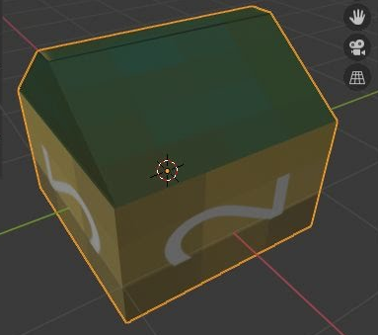
--> +verified: Blender3D Tool to assist in creating 3D object with image textures; shared: in Usbong CAD notes as reminder of the following:
--> Reminder: Set Computer Monitor Resolution to higher than 800x600 resolution
--> This is due to select options, e.g. in horizontal bar for Layout, Modeling, etc, in Blender3D are not visible.
--> verified: options, et cetera visible using the following:
--> Resolution: 1366x768
--> Added Delay: > 7 days

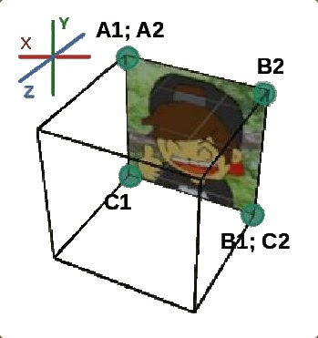
--> 2.2) Automotive: Usbong OpenGL (Graphics Library) and Usbong Engine; updated: set of instructions for computer to automatically translate 3D object instructions exported as output from the Blender3D Tool to OpenGL language
--> We use the translated instructions with the Usbong Engine. The Usbong Engine assists in empowering us to execute these actions among others:
--> verify objects, e.g. for use before manufacturing into physical material object
--> interact with objects, e.g. for use as simulation before physical action
--> receive information as another form/shape of literature (文学bungaku; written study)

Explanation: OpenGL Instructions
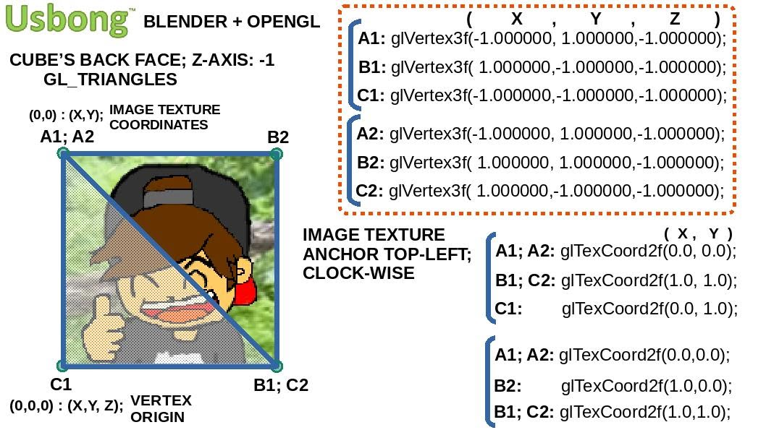
NOTE (from SYSON, MICHAEL B.):
We can observe that select lines are jagged. This is due to after computation, the computer opts to set a number value for outputs whose value is classified to be irrational, e.g. does not end.

Examples:
1) 10/3=3.33333...
2) π, i.e. pi; 3.14...
--> ratio of circle's circumference to its diameter
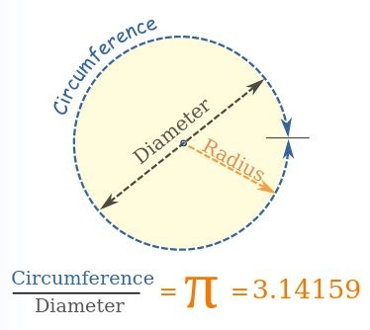
Otherwise, if we instruct the computer to continue to compute, the computer shall use up all its available resources, but shall still not finish.

As with circles, we can choose to accept the computer's auto-drawn shape due to it is already sufficient in the set system.

From literature, e.g. Clarke, Arthur C.'s "3001 The Final Odyssey", we learn that cybercriminals developed computer viruses to cause the computer to identify that a computation shall finish in a set acceptable time, albeit in fact shall not.

Reference: 1) https://www.mathsisfun.com/definitions/pi.html; last accessed: 20210416

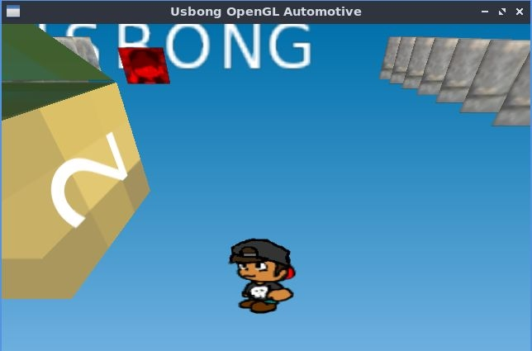
--> We can reuse the same image texture file to make the object face right from facing left. If not, we shall need to add an image for each; thereby increasing file size and memory storage usage. Instead of this, we can opt to write instructions for the computer to auto-flip an image. In addition, it is faster to identify the location of the texture coordinates using folding paper. Reminder: We set vertex positions of each triangle clock-wise.
--> updated: set of instructions to execute in Usbong Mini system
--> updated: instructions for Unit member to execute using inputs from keyboard movements, e.g. move up, down, left, right.
--> Camera and Image objects also move accordingly.
--> With Usbong Mini, we create a world system to store information which Unit members can receive by interacting with the objects, e.g. people, inside the world.
--> Reminder: 文学(bungaku; literature, i.e. written text), is also a form of system to receive information.
--> 2.3) Automotive: Usbong Network
--> updated: instructions for multiple computers to send and receive image files; This is in addition to text messages.

NOTE (from SYSON, MICHAEL B.):
As a reminder, We already use this image file transfer action with KMS using PHP Hypertext Preprocessor (PHP) Computer Language. We also previously wrote instructions in the Java Computer Language with the Android Operating System (OS).

Libraries, i.e. files that contain computer instructions, exist to make usage faster. However, for select applications, computer execution is faster by using the C/C++ Computer Language. This is due to the following among others:
1) PHP instructions is an additional layer to the C/C++ Computer Language. This makes Web development and computer execution faster, albeit not necessarily for applications that do not need to execute on a Web Browser. In addition, we shall need to add a Web Server, e.g. Apache.

2) Select computers do not execute the Android OS and the Java Virtual Machine (JVM); therefore, we shall still need to execute additional steps, e.g. downloading and installing the libraries. Reminder: JVM is an additional technology layer to execute Java computer instructions.

To make development and execution faster, e.g. with applications that continuously transfer image files, we eliminate excess steps, which include among others: additional libraries and technology layers, et cetera.

--> verified: output image file to be incorrect when sent using technique to send text files; With Bitmap (BMP) image files, we can add in the technique the use of its image header
--> This is to identify the following among others: image file size (in Bytes), width and height. We can verify the read data in Hexadecimal, instead of as String of characters. This is due to the printed output on the Computer Monitor is not quickly verifiable by human persons.
--> Reminder: Decimal : each digit has 10 values, i.e. 0~9;
--> Example: 3
--> Hexadecimal: each digit has 16 values, i.e. 0~9, a~f; we add "0x" to classify digit to be Hexadecimal
--> Example: 0x42
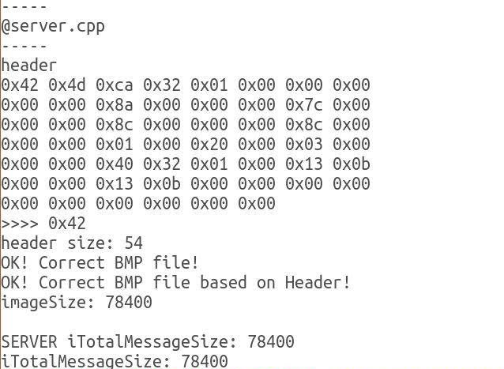
Server Output: Computer Notes
--> Additional Notes:
--> We set the "ADDRESS_IP" value to be the computer to connect to from this computer;
--> With only (1) computer machine, we can verify data transfer by setting "127.0.0.1", i.e. local computer, to be the IP address for BOTH the sender and receiver computers.
--> Reminder: sender = client; receiver = server
--> Example with two (2) computer machines:
--> Receiving computer's IP Address: 192.168.1.110
--> Sending computer's IP Address: 192.168.1.50
--> We as Client send image file to receiving computer, i.e. Server, at address 192.168.1.110.
--> We also update the receiving computer's "ADDRESS_IP" to be the sender's IP address, 192.168.1.50.
NOTE (from SYSON, MICHAEL B.):
At present, we verified that we can send BMP image files whose width and height are set to be 140x140pixels and 256x256pixels. In addition, color level is set to be 24bits with RGB (8,8,8). We do not add the Alpha channel, i.e. for transparent pixels.

However, the output file size is not yet exact as the input image. This is albeit the difference after viewing the image file is not noticeable.

Example "imageSample.bmp" image file sizes (140x140pixels):
input: 78,538Bytes
output: 78,400Bytes
sent data only: 78,400Bytes

If we intend to send a screenshot as a photograph image of a Computer Monitor, the following are the file sizes:
Example image screenshot (1024x736pixels):
Set to 24bits: 2.2MB
Set to 16bits: 1.4MB

Example image screenshot (256x256pixels):
Set to 24bits: 192KB
Set to 16bits: 128KB

Recommended Actions:
1) verify: sending and receiving continuous image screenshot photographs. This is to execute animating images, e.g. as videos.
--> add: object movement based on Unit member inputs,
--> e.g. multiplayer New Super Mario Bros. on the Nintendo Dual Screen (DS) Lite with its 2-Dimensional gameplay using 2006 technology
--> We can also opt to execute multiplayer 3-Dimensional gameplay,
--> e.g. Konami's ポイッターズ ポイント (poitta-zu pointo; "Poy Poy") released in the year 1997 on the Sony PlayStation, where Unit members throw objects at each other. Objects include among others: rocks, wood, rockets Throwing technique can be updated based on glove.
2) verify: image compression techniques
--> e.g. those used with .jpg, .png image files
--> Reminder: We can also use Math equations to reduce image size in exchange for computer processor usage.
--> Example: y = 0.5x + 2
--> Reminder: We need at least two (2) points to make a line.
--> Point#1: (2,3); Point#2: (8,6);
--> where: (x,y)


Reference: https://www.mathsisfun.com/algebra/line-equation-2points.html; last accessed: 20210428

3) verify: sending and receiving sound, in addition to image files
--> 2.4) Automotive: Usbong Sound
--> added: audio files in .m4a format
--> audio length < 60seconds
--> used: musical instruments, e.g. guitar and electronic piano
NOTE (from SYSON, MICHAEL B.):
1) Mga Hakbang:
1.1) Makinig ng mga tugtugin.
1.2) Subukang gayahin ang tugtugin.
1.3) Gumawa ng iyong tugtugin gamit ang mga bahagi mula sa mga natutunan.

Mungkahing Aksyon: Matutong pakinggan kung tunog mula robot o kompyuter na hindi pa pulido ang paliwang sa paraan ng pagtugtog.
Paalala: Siyasatin ang tunog sa karaoke, i.e. kaya nitong magpatunog ng mga ito: Tunog na mula sa hindi pulido ang paliwanag sa robot o kompyuter; Tunog na awtomatikong isinasaayos gamit ang auto-tuner

Kahit ang pagtugtog, ginagawan ng panlolokong ingay at pisikal na pananakit ng mga budol-budol/carnapper/manloloko/cybercriminal/
communist terrorist group.

2) Piano
2.1) Isanay ang lahat ng mga daliri na mapindot nang wasto ang mga piano key; Mungkahing Aksyon:
--> Gamitin ito: Suzuki Piano School - Volume 1 (New International Edition); Kahit ang Volume 1 lang muna; Pagkatapos, subukan mo nang tugtugin ang mga nais mong tugtugin, e.g. Disney Hits Easy Piano (Music Sheet); If we hold on together (from "Land Before Time"); Broadway Musical; Japanese animation games, e.g. Magic Knight Rayearth ゆずれない願い(yuzurenai negai; hindi bumibigay na hiling); Lupang Hinirang
2.2) Matutong bumasa ng mga nota
2.2.1) Mas malaki ang sulat ng nota mas maigi
Halimbawa: はじめてのひさしぶりの大人のピアノ（スタジオジブリ); hajimete no hisashiburi no otona no piano (stajio jiburi); una sa matagal nang pangmatandang piano (Studio Ghibli)
Mahalaga ang kakayahang magbasa, gawa ng hindi mo rin maaalala ang pagtugtog sa wastong nota, lalo na kung hindi mo rin regular na tinutugtog.

2.3) Sa simula pasadahan muna gamit ang kanang kamay ang nota kahit may maling piano key
2.4) Unti-unting ayusin ang mga bahagi na may maling tunog
2.5) Unti-unting idagdag ang sa kaliwang kamay
Paalala: Karaniwang mula sa key na tinutugtog gamit ang kanang kamay nakikilala ang kanta, gawa ng doon sumasabay ang pagbigkas ng titik, i.e. lyric. Gayunpaman, matutuklusan mong mahalaga rin ang tunog mula sa kaliwang kamay.

Mungkahing Aksyon: Pakinggan lamang ang bahagi na tinutugtog ng kaliwang kamay, atbp na nasa likod ng kumakanta. May Bass, Drums, atbp. Halimbawa: 「おやすみなさい (oyasuminasai; mahibing na pagtulog)」ni AIKO (ALBUM: 「秋 そばにいるよ (sa taglagas, nasa tabi mo ako!)」)

2.6) Maaaring matuklasan ang nais ng gumawa ng tugtugin, sa pamamagitan ng pagtugtog nito. Mga Halimbawa:
2.6.1) Super Mario Bros. sa piano, halintulad sa tumatalon, i.e. JUMP, ang pagtugtog.
2.6.2) Legend of Zelda sa piano, halintulad sa sumasakay ng kabayo; Maaalala ang sa Indiana Jones.
2.6.3) 日の丸の旗 (hi no maru no hata; watawat ng bilog ng araw)：
--> Maaalala ang mga bata; at ang pagsulat ng pagbigkas.
Halimbawa: 勢 （いきほひ ikihohi to be いきおいikioi now; signifies: energy/vitality, bagama't agad kong naaalala ang "impulse", hal: impulse buying, nitong kahulugan)
--> 2.5) Computer Interactive: Lessons-learned
--> 2.5.1) Samurai Spirits IV SPECIAL: サムライスピリッツ天草降臨 (Langit Damo Bumaba Pansamantala)
--> SNK Neo Geo Mini version
--> verified: can finish all matches using only one (1) coin in 14:35:03,
--> where Minutes:Seconds:Milliseconds
--> Difficulty set to highest; No setting for Capacity
--> Beginning matches, e.g. first two (2) Computer Characters, are for verifying action control
--> use: technique to defeat Jubei for all matches
--> learn: 忍 (shinobi; literally: sword/knife mind; to signify: 我慢 (gaman; literally: I-slow) and しんぼう (shinbou; pagbigkas: shimbou, gamit ang "m"), i.e. bear to execute patience
--> This is due to person tends to not stick with technique when it appears technique not effective against opponent; Example: Time is zero at Time minus 10 seconds: defeated Jubei's fist : bato, i.e. ishi; intention
--> Reminder: Hanzo and Jubei find each other at the start;
--> Both are pulled to the Evil Spirit coming from the mountain Castle in Kyuushuu Island. Hanzo arrives to learn that Jubei has already defeated the Evil Spirit. However, Jubei is still seeking a Strong person.
--> Hanzo and Jubei fight.
NOTE (from SYSON, MICHAEL B.):
半蔵 (Hanzo; half inside; kalahati laman-sa-loob)
--> 臓 with 月 (tsuki; buwan): used with 内臓 (naizou; inside-body), e.g. 心臓 (shinzou; physical heart), 肝臓 (kanzou; liver; atay)
--> Hanzo (修羅(shura)；剣豪(kengou); middle level version)'s sword hilt (柄；つか; tsuka), murasaki (violet : poison/lason)

十兵衛 (Jubei; ten soldiers clean; sampung sundalo malinis)
--> 二刀 (nitou; 2 Swords/Knives)
Hanzo attacks using combinations of weak and medium slashes to be quick are not effective against Jubei; Jubei's Swords' reach farther due to length and technique. Jubei's strong slash higher damage than Hanzo's several combinations of weak and medium slashes

Note: We use Hanzo's strong slash when opponent attacks, e.g. strong slash, that requires recovery time

Execute Hanzo's bouncing fireball, Jubei executes jumping slash that can reach Hanzo; damage exchanged lower for Hanzo.

verified: execute weak attack to deal damage first at start, execute bouncing fireball continuously; Jubei may also attack at the same time as Hanzo's weak attack to cause swords to hit but no damage to both Characters.

Note: my execution of bouncing fireballs not yet perfect due to created world's input system; expected: Computer Jubei shall move closer to Hanzo, due to his Swords reach at a set length.

verified: I as Hanzo can defeat Computer Jubei, albeit requires several attempts; In addition, Hanzo does not kill Computer Jubei; We use 時間切れ (jikangire, Time Cut; Time has reached zero)

observed: requires several movement actions, e.g. tumbling (double back command), jumping on walls; Jubei runs towards you with 「いくぞ！(iku zo!; literally: pupunta/susugod na'ko!; heto na'ko!)」, albeit does not always execute attack, i.e. dashing forward cut with rising cut. Bagama't Kompyuter ang ating katunggali, hango na rin ito sa pagiging katunggali ang developer na gumawa ng paliwanag at nagturo sa Kompyuter.
--> 2.5.2) Dragon Quest VI (Japanese version)
--> open world, i.e. hindi dumadaloy ang istorya/salaysay sa isang daan lamang; Sa pagdalaw mo sa daigdig nito, maiging pumunta muna sa Simbahan at pagkatapos kausapin ang mga tao upang malaman kung ano ang kanilang kailangan.
--> Hindi mo kailangang mamalagi sa daigdig; kung hindi mo na nais magpatuloy, maaari kang huminto.
--> Paalala: Sa matagal na hindi mo pagbabalik, kinalaunan nawawala/nabubura rin ang mga naisulat sa aklat sa Simbahan, bagama't may tumatagal na isa. Ibabahagi sa iyo ng kompyuter kapag nabura: お気の毒 (oki no doku; lason po sa iyong enerhiya/espiritu/kaluluwa)
--> Pagkapili mo ng aklat ng inyong paglalakbay, ibabalik kayo ng kompyuter sa Simbahan kung saan isinulat ang aklat.
--> 2.5.2.1) Kailangan maibalik ang nawawalang Hari ng kaharian ng Reidokku.
--> Ayon sa mga tao, naglakbay siya upang gapiin ang tinaguriang pinakamalakas na Halimaw, "Mudo-", na nais sakupin ang lahat. Mula sa inyong pagsisiyasat, kakailanganin niyo ang Salamin ni Ra- upang mailigtas ang Hari. Kapag nalampasan ninyo ang mga pagsubok upang makuha ang Salamin ni Ra-, kakailanganin naman ninyong kalabanin ang Halimaw. Pagkatapos ninyong magapi ito, kailangan naman ninyo sunod na ilabas at ipakita ang Salamin ni Ra- sa harapan nito. Dito mamumulat ang Halimaw na siya pala ang Hari. Pag-uwi ninyo, makakausap na ninyo sa Castillo ng Reidokku ang nagmumuning Hari na nakatingin nang malayo palabas. Aaminin niya sa inyo na hirap siyang makapaniwala na siya ang naging Halimaw.
--> 2.5.2.2) Kailangang malutas bakit wala nang bumabalik pagsakay ng barko patungong Bansa/Kaharian ng Ligaya, i.e. "Langit"
--> Ayon sa mga tao, may dumarating na barko sa kanilang bayan. Pagkatapos, kailangan lamang na sumakay sa barko ang sinumang may nais na iwan ang kanilang kasalukuyang buhay upang pumunta sa Kaharian ng Ligaya. Hindi kailangang bumili ng ticket bilang bayad sa pagsakay. Kapag sinubukan ng inyong pangkat na sumakay sa barko, matutuklasan ninyo na mayroong isang katerbang pagkain at inumin sa loob nito. Maliligaya ang mga sumakay ng barko.
--> Magigising kayo na sinisipa ng demonyo, i.e. uri ng halimaw.
--> Dadalhin niya kayo sa kanilang panginoon.
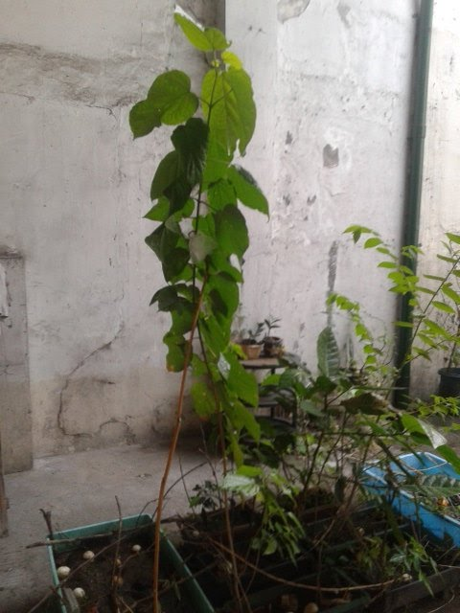
--> Pagpasok niyo sa kanyang Castillo, madirinig niyong may sinisigawan ng "BOBO". Matutuklasan ninyo na wala nang buhay ang mga kasama niyong sumakay sa barko. Jamiras (na mukhang baliw na agila) ang pangalan ng panginoon ng mga demonyo. Kilala rin niya si Mudo-, na nabalitaan niyang nagapi kamakailan. Gawa nito, maaari na si Jamiras na palawakin pa ang kanyang sakop. Makikita niya na buhay pa ang dugo ng inyong pangkat. Kakalabanin niyo siya at maaaring umabot ng tatlong beses bago niyo matutunan ang paraan upang tuluyan siyang magapi. Mas mahirap na katunggali si Jamiras kaysa kay Mudo-. Maaari ring makatulong ang Tubig na nagbibigay-buhay mula sa bayan ng Amo-ru. Maaalala na isang paglalakbay din ang pagpunta sa bayan ng Amo-ru. Uuwi ang mga kaluluwa ng mga kasama ninyong sumakay sa barko, atbp sa kanilang mga katawan. Kapag kinausap ninyo ang mga tao na iyon, ibabahagi nila sa inyo na nanaginip sila ng bangungot, i.e. hindi kaaya-ayang panaginip.

--> 2.6) Energy and Health:
--> 2.6.1) Food
--> verified: tomato branch with the black ants has grown to have height of approximately 160cm.

--> added: another pre-used, i.e. previously used, container (0.5 x 1.0 x 0.5m; width x length x height) with 10kg of loam soil (RIGHT; skyblue)

--> verified: pinya without skin, leaves on top, and chopped bottom part do not regrow; added: seeds, e.g. papaya, watermelon.

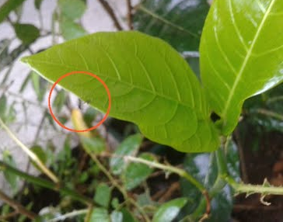
--> verified: arrival of black ant with wings on a new leaf of the sili plant; classified: winged ant to be queen ant

--> continued: to verify growth of new leaves after loss caused by caterpillar and arrival of queen ant
--> reminder: select plants, e.g. papaya, die after loss of all leaves
--> continued: to spray water with vinegar every day, Morning, Afternoon, and Evening: At present, speed of eating parts of leaves not yet as fast as the caterpillar's.
--> Recommended Reading:
--> 藤田 紘一郎（fujita kouichirou）'s 寄生虫と人との共生
--> kiseichuu to hito to no kyousei
--> where: 寄生虫 (kiseichuu; literal: drop-by + bear, i.e. borne to live, + insect) = parasite
--> Parasite and Person and their Living Together
--> shares: Teacher Fujita ate a parasite, "kiyomiCHAN", to verify its positive effect on human health. Parasite classified to be サナダムシ (sanadamushi), i.e. tapeworm. At the time, people refused to eat the parasite for the research experiment.
--> learned: Teacher Fujita's physical health weakened due to the parasite.
--> However, kiyomiCHAN learned that if Teacher Fujita, its host, died, she, the parasite, shall also die. Teacher Fujita's physical health became stronger. His weight decreased due to kiyomiCHAN ate the excess.
--> People began to request to be given the parasite to eat as well. Teacher Fujita shared that the parasite came from Indonesia. The parasite lived in the river where dirt, i.e. tae, dumi, from the people transfer. He adds that children played in the river, albeit do not become ill. Recommends: Japan to re-verify cleanliness system This is to empower the Minority to execute actions to learn new information and share with all.
--> Reminder: Majority prefers not to execute those actions due to existing created/updated system; Information = new if learned as a surprise
NOTE (from SYSON, MICHAEL B.):
Kapag matagal nang hindi nalilinis ang bahay, kabilang ang silid, toilet, atbp nito, darami ang mga kuyagot, alikabok, dumi, atbp na nagdudulot ng hindi malinis at maaliwalas na pakiramdam sa mga taong naninirahan doon.

Gayundun ang sa ating dugo. Kapag marami at samu't sari na ang ating mga iniinom na gamot, hindi malilinis ng ating pangunahing taga-linis, i.e. liver/atay, ang lason sa dugo. Gawa nito, pati ang mga pagkain na dumaraan sa dugo para sa ating mga cell magiging marumi.

Pinaaalala sa atin nina Hayao Miyazaki, Shiba Ryoutaro, at Hotta Yoshie sa 「時代の風音 (jidai no fuuin; wind sound of the times; Zeitgeist)」 na nakabatay ang halaga ng bahay sa oras na ibinigay natin sa pag-aalaga nito.

Halintulad ito ng paalala ng Alamid sa "Le Petit Prince" ni Antoine de Saint-Exupéry ukol sa halamang rosa ng Munting Prinsipe. Maaalala na mahalaga para sa Munting Prinsipe ang halamang rosa, dahil siya ang nag-alaga nito. Dagdag pa rito, bagama't mayroong isang katerbang halamang rosas sa daigdig, hindi ng mga ito kasing-halaga ng halamang rosa na inalagaan ng Munting Prinsipe.

«On ne peut pas mourir pour vous [les roses].»
Hindi kayang mamatay ang isa, e.g. ako, para sa inyo [isang katerbang halamang rosas].
One, e.g. myself, cannot die for you [the roses].

Additional Recommended Readings:
1) Rosemary Sutcliff's "Sword at Sunset"
--> Author's Note: "I have kept the theme, which seems to me to be implicit in the story, of the Sacred King, the Leader whose divine right, ultimately, is to die for the life of the people."
--> Mungkahing Aksyon (sa mga hindi pa nauunawaan kung paano tayo *iniligtas* ni Hesu Kristo): Magsimba ka.

2) Lydia Gonzales-Garcia's "Mga Pangulo ng Pilipinas"
--> "Ang kalayaan ay maaari lamang makamit ng mga taong handang ipagkaloob ang buhay o kayamanan."
--> Maaalala na kahit ang mga pangulo, e.g. Ferdinand Marcos, ginamitan ng mga wireless broadcasting technology nang matuklasan ito ng mga Teroristang Komunista.
--> Recommended Action: verify: Ferdinand Marcos' "The New Philippine Republic: A Third World Approach to Democracy" [AKLAT]

3) John Ford's "The Dragon Waiting"
--> Paalala: Kahit ang Hari ng Inglatera, maaaring ibagsak o ilagay sa kanyang posisyon ng iilan lamang, i.e. kaunti/Minority, na mga nilalang.
--> Halimbawa: Isang pangkat, i.e. Unit, na may apat na miyembro;
--> Halimbawang miyembro nito: German Todesmann as Knight Doctor; Malakas; Ginagawa niya ang mga bagay na hindi nais gawin ng iba, e.g. pagpuksa sa mga Tamad.
--> where: Tamad = Masama, e.g. Teroristang Komunista
--> Ito'y upang mailagay sa posisiyon ang pinili ng kanilang pangkat na maging Hari, i.e. Richard.
--> "Mehr Arbeit für die Todesmann"
--> Dagdag na hanap-buhay para sa *Patay-na-Lalake*
--> where: Todes = patay/deceased; Mann = Lalake; Todesmann : "Vampire"
--> Dagdag na paalala: Kailangan ding mag-ingat ang batang nag-aakalang masusunod ang kanyang mga utos gawa ng kanyang maling pag-aakalang ipinanganak siyang Hari nila.
--> Mungkahing Aksyon: Maghanap-buhay, i.e. unti-unting pagkita ng pera/salapi; Paalala: Kabilang sa hanap-buhay ang pagiging mag-aaral, i.e. student
4) Miyazaki, Hayao's Manga/Comic Book, 「雑想ノート(zassou no-to; various thoughts, i.e. "Daydream", note) : No. 9」
--> Matutuklasan natin ang nangyari sa labanan ng Hapon at Inglatera ayon sa mga Hapon.
--> Maaalala na nagsulat si Winston Churchill ng Inglatera ng salaysay sa kanyang aklat na "The Hinge of Fate". Ukol ito sa mga nangyayari noong digmaan, kabilang ang kanilang pagkikipaglaban sa mga Hapon.
--> namasdan: sa labanan sa dagat sa Timog-Silangang Asiya, patungong Hilagang Africa, maaaring magapi ang barko ng hukbong pandagat ng mga taga-Inglatera, gamit ang isang Unit na may tatlong (3) miyembrong sakay ang Zero Jet Fighter Machine, i.e. "Meat Ball (肉ダンゴnikudango = 日の丸hi no maru)" , ng Hapon.
--> Paalala: Sakop ng Inglatera ang India, Egypt, at Timog Africa.
--> Mababasa sa salaysay ni Winston Churchill na hindi maaaring maliitin ang lakas ng hukbong panlipad ng bansang Hapon. Ibig sabihin, kahit isang malakas na Unit, maaari nang sumagisag sa buong bansang Hapon.
--> Paalala: Sa Japanese Animation, "Porco Rosso", ni Miyazaki, Hayao, binuo ng buong lipunan sa isang barangay ng Italia ang sasakyang panlipad ni Porco. Maaari ring lumapag ito sa dagat.
Notes:
1) Translated "Le Petit Prince" quotation from French
--> to Filipino and English by SYSON, MICHAEL B.
2) Translated "The Dragon Waiting" quotation from German
--> to Filipino by SYSON, MICHAEL B.


--> 2.6.1) Cleanliness
--> 2.6.1.1) verified: use of dental floss item to eliminate excess problems with human teeth; Food items, e.g. hard beef, can get stuck between our teeth to cause tinga. If not removed, person shall experience teeth and gum pain. Recommended Action: Use dental floss combined with brushing of teeth 3x per day after eating meals, i.e. morning, afternoon, evening
--> verified: local product Hapee to be a more inexpensive alternative to Colgate toothpaste
--> 2.6.1.2) verified: use of dental item, "Explorer", to remove hard Food dirt that got stuck. Food dirt that gets stuck near teeth and gum can become hard plaque if not quickly removed. Such dirt is caused by among others: regularly drinking coffee, tea, and eating bread. In addition, we can reuse its hook to clean the coffee/tea stains.
--> Paalala: Sungkitin ang dumi mula sa ngipin at hindi ang gum upang hindi ito dumugo.
--> Explorer dental item available at Medical and Dental Supplies Stores.
--> Execute action for self due to if for another person with service fee, permission, i.e. permit, is necessary.
--> verified: these actions reduced need to visit the Dentist from 2x per year to only 1x per year; Reminder: We regularly visit the Dentist to request assistance to clean our teeth; This is due to select parts of teeth are faster to clean by another person.

--> 2.6.1.3) verified: use of nose hair scissors and disposable razor items to eliminate excess head hair
--> Recommended Steps:
--> 2.6.1.3.1) Use nose hair scissors to cut the excess hair near the ears, such that no hair touches the ears
--> 2.6.1.3.2) Use nose hair scissors to cut the excess at the back of head
--> You can move the excess hair to your right to be cut first.
--> You can then move the remaining hair to your left to be cut next.
--> Execute these actions moving from bottom of head to the top.
--> Reminder: Excess : Use your fingers to make hand scissors, cut hair that extend beyond your fingers
--> 2.6.1.3.3) Use nose hair scissors to cut the excess at the front of head
--> Move the front hair, i.e. bangs, downward.
--> Use nose hair scissors to cut upward, such that the front hair are not aligned straight horizontally.
--> Move the portion of hair to the side that you prefer, e.g. right to left, still cut upward the excess.
--> 2.6.1.3.4) Use disposable razor to cut excess hair at the back of head.
--> Additional Notes:
--> You can also opt to not cut the patilya hair, i.e. near the ear;
--> Reminder: You shall need to regularly twist both the patilya hairs if they are not yet sufficiently long.
--> If not all executed correctly, e.g. front hair still aligned straight, your hairstyle shall be that of the Beatles.
--> With these actions, we expect to cut hair 1x per month.
--> Execute action for self due to if for another person with service fee, permission, i.e. permit, is necessary.
3) Continued to work with among others: PhilHealth, Social Security System (SSS), Securities and Exchange Commission (SEC), Bureau of Internal Revenue (BIR)
--> received: reply to work with Law Enforcement via incident reports, et cetera regarding the noise and physical injury caused by the budol-budol/manloloko/carnapper/cybercriminal/communist terrorist group who continue to misuse wireless broadcasting technology.
--> This is due to such criminal attacks are classified to be with Law Enforcement. In addition, the Communist Terrorist group executes attacks whose effects are classified to be with iligal na droga, e.g. 大麻 taima, i.e. "big hemp weed", as manufactured product, e.g. marijuana.
--> Effect: attacks central nerve, i.e. 神経 (God Passage), to cause excitement, dizziness, illusion, etc.
--> Dahilan: quick money; Actions: harassment, extortion
--> We add that while such attacks continue, we do not expect that our computations, e.g. BIR filings, shall be regularly correct and on-time.
--> Recommended Action: Puksain ang mga Teroristang Komunista
4) continued: to share printed Usbong Newsletters to Salespersons, e.g. Newspapers, Computer Shops, Medical Representatives, and partners, e.g. Sta. Lucia Health Care Center (SLHCC), in the following Barangays:
--> Marikina City: Barangays Sto. Niño, Sta. Elena, San Roque, Kalumpang, and Marikina Heights
--> Cainta, Rizal: Barangay San Isidro
--> Reminder: digital version available at www.usbong.ph
--> This is in addition to the Maparaang Pagbibilang Questions.
--> Select questions are included in the newsletter.
--> Example: those regarding Value-Added Tax (VAT) (Level 1 and 2) and the map (Level 1)
--> verified: Balita newspaper tabloid not yet available
--> This is albeit partner newspapers, e.g. Manila Bulletin, are available.
--> verifying: select newspaper tabloids, e.g. Bulgar
--> observed: writers include among others: children of previous government administration representatives
--> Select children at present are also administration representatives
--> verifying: written Filipino and content to be not problematic
--> This is in contrast to interview text of Showbiz characters who use English as Filipino verbs, i.e. pandiwa
--> Recommended Action: update: administration system to reduce if not eliminate need of children of previous representatives to also be representatives; Examples:
--> add: computer automation in system to eliminate excess steps
--> add: emphasis on Maparaang Pagbibilang
--> add: Puksain ang mga Teroristang Komunista
NOTE (from SYSON, MICHAEL B.):
I continue to verify available printed computer magazines/books with the keyword "Game", e.g. GameFan, Gamers' Republic, Game Players, Ultra Game Players, GamePro, Games Master Philippines, that are stored in the household. I add the Electronic Gaming Monthly that uses the keyword "Gaming".

Most of these are used magazines printed in the 90's onward and were sold at BookSale. In addition, most if not all are already out-of-print. From these, I verify the cause of their going out-of-print, in addition to the history of the computers/machines/software that they wrote as literature.
Reminder: 歴史家の役割はある種の合理的な様式の枠に押し込もうとすること。
The task of Historians is to strive to impose a kind of rational pattern.
where: rational = logical, Maparaang Pagbibilang
Example #1: We verify the paper material that they used to print the photographs and the text. Select paper materials remind me of those used by the Economist. We at USBONG also print newsletters, albeit we use recycled newspapers (480pieces; legal size; PHP133 @Office Warehouse) to reduce cost.
Example #2: In EGM^2 (June 1995; Vol 1, Issue 12), Chief Editor Ed Semrad wrote his answers to the question on why the cost of the new systems, i.e. Sega Saturn, Sony PlayStation, and Nintendo Ultra 64 was still not identified. I add that I agree that a price range, instead of the exact dollar amount, causes dissatisfaction.
1) Element of Surprise
1.1) Public Relations (PR): If everybody knew, no need to go to the trade show.
1.2) Members classified as Master in Business Administration (MBA)
at Strategic Planning Unit: If price announced too early, competitor will lower price. Example: Sega of Japan vs Sony of Japan
2) Package not yet known
--> Example: Sega Saturn + Virtua Fighter
3) Yen/Dollar Rate
--> Currency Fluctuations: "Having the yen drop from 100 to the dollar to 80 to the dollar is like taking a 20 percent pay cut."
--> Reminder: Systems made in Japan
4) Uncertainty to reduce Criticism
--> No editorials about excessively high cost.
Additional Notes:
1) The following websites continue to still be accessible:
--> I first visited them over 15 years ago.
1.1) Gamasutra: The Art & Business of Making Games
--> https://www.gamasutra.com/; last accessed: 20210403
--> I have yet to find a game review with grade/score in their news articles.
1.2) Famitsu (nihongo)
--> https://www.famitsu.com/; last accessed: 20210403
--> Gamasutra also adds news in Japan from Famitsu.
2) The Weekly Shounen Jump Manga/Comics uses a combination of these:
--> 2.1) glossy paper with text in colored ink
--> 2.2) recycled paper with select pages in non-gray colors with text in dark colored ink; I note the One Piece part as the front manga has 10 pages. The Manga adds Computer Games news, e.g. Nintendo Dual Screen (DS).
--> I observed that GameFan also attempted to make itself into a Comic Book, at double the price, but more than double the size of Comic Books, e.g. those from Marvel Comics.
--> However, this action did not persist in the year 2000's.
--> At present, year 2021, the Weekly Shounen Jump Manga/Comics' price is at Yen290, i.e. approximately PHP145 from 290/2.
--> This is an increase from the PHP125, in the year 2008.
--> PHP20, was added after re-verifying 12 years later.
3) Games Master Philippines was sold new at PHP100.
--> It was less expensive than even the used magazines from the United States of America (USA). However, I did not find anymore Magazines after the year 2006.
--> Recommended Actions:
--> verify: Gamasutra: The Art & Business of Making Games
--> add: Japanese news with nihongo and explanation
--> add: lessons learned, instead of game review grades/scores
--> add: computer developers as writers to news articles
--> apply: in the Philippine context
5) Continued to update Training Centre: Security Defense Force
--> Reminder: We define poverty as the denial or absence of human rights, e.g. security of person against attacks from the budol-budol/manloloko/
carnapper/cybercriminal/communist terrorist group.
--> 5.1) Recommended Readings:
5.1.1) United Nations' Universal Declaration of Human Rights
5.1.2) Marikina City Ordinance Enacting the Noise Control Regulations (ORDINANCE No. 100 Series of 2010); Please refer to the City Ordinance document for the complete Noise Control Regulations.
ARTICLE IV.
PROHIBITED ACTS

Section 4 -- The following shall constitute as prohibited acts punishable under this Ordinance:
(a) Operation or Sound Reproduction Devices -- No person shall operate or use or cause to operate any sound reproduction device for any of the following purposes:

2. To create unnecessary noise, except when the noise is a result of the operation or use of any claxon or air horn installed in a motor vehicle to signal imminent danger.

(p) Unnecessary Noise means any excessive or unusually loud sound, or any sound which either annoys, disturbs, injures endangers the comfort, repose, health, peace, or safety of a person, or which causes injury to plant or animal life, or damage to property or business.

WHEREAS, noise pollution or unabated noise is considered a public nuisance disturbing not only the auditory nerves, but even the emotional and psychological well-being of persons;

WHEREAS, it is a right of every human being to have a peaceful environment and to have a good night's sleep.
--> 5.2) Additional Notes:
--> 5.2.1) Mungkahing Aksyon: Puksain ang mga Teroristang Komunista.
--> 5.2.2) マリオストーリー（Mario Story; Nintendo 64 version）
--> Aksyon: Gawan ng Report ang Insidente sa Law Enforcement upang siyasatin; Isinalin mula nihongo sa Filipino ni SYSON, MICHAEL B.
--> 「おとなりの家から ドタバタと」
--> Mula sa bahay ng kapitbahay may "DOTABATA" na
--> 「うるさい 物音が」
--> maingay na tunog ng bagay
--> 「きこえるようになったのよ」
--> ang maaari nang marinig!
--> Paalala: Mayroon ding wave mula sa electric light, dagdag pa sa sound wave. Ingay rin ito kapag labag sa batas, e.g. labis.

NOW HIRING: COMPUTER SERVICES SALESPERSON
✓Receive half of the revenue from your DIRECT SALE of the service

✓Receive training:
Filipino Language, Sales, Information Technology
Requirements:
1) Curriculum Vitae
2) Portfolio
3) Sulat ng Hangarin
3.1) Ano ang maitutulong mo?
3.2) Bakit mo nais ito?
3.3) Bakit ka karapat-dapat?



EMAIL: APPLY@USBONG.PH

Tanong at Sagot

1) Magkano ang aking kikitain bilang Computer Services Salesperson at Manunulat ng paliwanag sa kompyuter, e.g. Add-on Software?
--> Kung babayaran tayo ng klinik ng 10K pesos bawat buwan, 5K ang sa iyo bilang Computer Services Salesperson.
--> Bilang Manunulat, 4K pesos ang maibibigay sa iyo ng Usbong.
--> Sa kabuuan, 9K pesos ang matatanggap mo bawat buwan.
--> Ang matitirang 10% ng 10K, i.e. 1K pesos, gagamitin ng Usbong sa pag-iipon ng kapital.
--> Gagamitin ito ng Usbong sa paggawa ng mga investment at "float", na ang kahulugan, liquid asset.

2) Paano ako makibabahagi sa tagumpay ng kompanya?
--> Kung wala tayong kikitain mula, halimbawa, sa Computer Automation Service, mauubusan tayo ng kapital na pambayad sa ating lahat. Hindi magtatagal, wala na tayong kompanya.
--> Dahil dito, kailangang maayos ang ating paggawa at pagtuturo sa mga trainee upang tuluy-tuloy ang daloy ng ating kita, habang nagbibigay ng ginhawa sa lipunan.

MAPARAANG PAGBIBILANG
ALGEBRA SKILL LEVEL 1:
INPUTS:
X = 250 //ITEM PRICE
V = 12% //VALUE ADDED TAX (VAT)
Q = ? //ITEM PRICE WITH VAT

TANONG: WHAT IS ITEM PRICE WITH VAT?
SAGOT:

ALGEBRA SKILL LEVEL 2:
INPUTS:
X = ? //ITEM PRICE
V = 12% //VALUE ADDED TAX (VAT)
Q = 364 //ITEM PRICE WITH VAT

TANONG: WHAT IS ITEM PRICE WITHOUT VAT?
SAGOT:

USBONG SOCIAL SYSTEMS, INC.
COMPUTER SERVICES

SYSON, MICHAEL B.
FOUNDER

MOBILE: +63929.952.7263
EMAIL: MASARAPMABUHAY@GMAIL.COM

WEBSITE: WWW.USBONG.PH
ADDRESS: #2 E. MANALO (FORMERLY, E. RODRIGUEZ) AVE., STO. NIÑO, MARIKINA CITY, 1820, PHILIPPINES

