
May 2022
メモリー (memori-) : LALAGYAN ng ALAALA

PHILIPPINES: USBONG CONTINU​ES TO PROVIDE
COMPUTER SERVICE ASSISTANCE BY SHARING
KNOW-HOW ON MAPARAANG PAGBIBILANG

To eliminate excess steps and inefficient time usage, MARIKINA ORTHOPEDIC SPECIALTY CLINIC (MOSC) requested Usbong's services to automate routine, monotonous tasks and share with unit members know-how on computers.

Here are Key Action Items that we executed in this updates list.
1) Continued to update Knowledge Management System (KMS)
1.1) continued: to share know-how on computers and Information Technology (IT) tools
1.1.1) reminded: Public, to classify all DIGITAL INFORMATION set to PRIVATE to be PUBLIC
--> where: DIGITAL INFORMATION : text, photographs, videos, sound

--> objective: increase Security Defense against the MANLOLOKO/budol-budol/
carnapper/smuggler/cybercriminal/Teroristang Komunista group

--> observed: stolen information misused by the MANLOLOKO
--> to cause stalking, intimidation, harrassment, et cetera; NOISE POLLUTION;

--> MANLOLOKO's objective: QUICK MONEY via causing TARGET to obey their gawa-gawang RULES
--> where: gawa-gawang RULES is NOT of the community
--> where: misuses even religious beings, e.g. 観音 (guanyin; kannon)
--> with: gawa-gawang EXPLANATION that is supposedly NOT learnable by Filipino citizens

Examples of gawa-gawang RULES:
--> Example#1: Do NOT file incident reports with Police;
--> Example#2: Do NOT answer questions for clarification
due to among others: SECRET, SURPRISE WEDDING;
--> observed: CLARIFICATION shall show MANLOLOKO group's INCORRECT ACTIONS
--> where: INCORRECT ACTIONS : ILLEGAL, e.g. smuggling, carnapping, human trafficking, murder

--> Output#1: UNCLEAR/MALABO Communication for abuse by the MANLOLOKO group;
--> Output#2: DELAYS in system execution @Accounting Unit,
--> e.g. @partner Sta. Lucia Health Care Center (SLHCC), MOSC

NOTE (from SYSON, MICHAEL B.):
Question: How does the MANLOLOKO group steal DIGITAL INFORMATION that is set to be PRIVATE?

DIGITAL INFORMATION stored in a computer, e.g. outside the Philippines, may pass through networks whose security settings are NOT secure.

reminder#1: electronic mail services, e.g. GMAIL, may store the electronic letters of a country, e.g. the Philippines, in another country, e.g. Singapore

reminder#2: GMAIL classified with CLOUD-based SERVICES

The MANLOLOKO group connects to a PUBLIC and/or PRIVATE-accessible network to steal using tools, e.g. WIRESHARK, DIGITAL INFORMATION;

Example of STOLEN DIGITAL INFORMATION:
1) visited website addresses
2) passwords
3) text messages

This is even if website as service is encrypted via HTTPS
where: HTTPS = Hypertext Transfer Protocol Secure

reminder#3: Multiple network nodes CAN be created using Multiple routers

Example:
router#1 CAN be set to be accessible using PRIVATE passwords
router#2 CAN be set to be accessible to be PUBLIC without password
router#1 and router#2 are CONNECTED to each other;
DIGITAL INFORMATION from router#1 are stolen using router#2;

where: router#2 can be located in the Philippines or another country

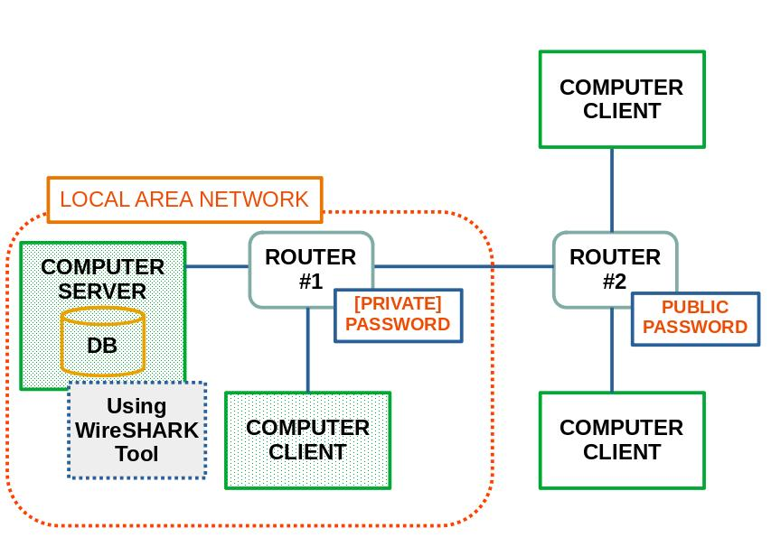
installed: WIRESHARK on Computer Server as DEFENSE

Computer Server's Internet Protocol (IP) Address: @192.168.1.10
Computer Client's IP Address: @192.168.1.40

Computer Client requests from Computer Server the following file located in its directory system:
website address: /usbong_kms/index.php/report/viewWebAddressList

WIRESHARK identifies the requesting source IP Address.

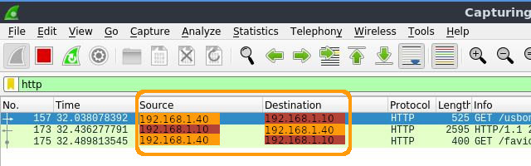

Requested File as Website Address:
/usbong_kms/index.php/report/viewWebAddressList

Manloloko misuses WIRESHARK to steal INFORMATION to execute network abuse classified to be ATTACKS;

Example ATTACKS: NOISE POLLUTION, i.e. PANLOLOKONG INGAY
Example OUTPUT: DELAY in service execution

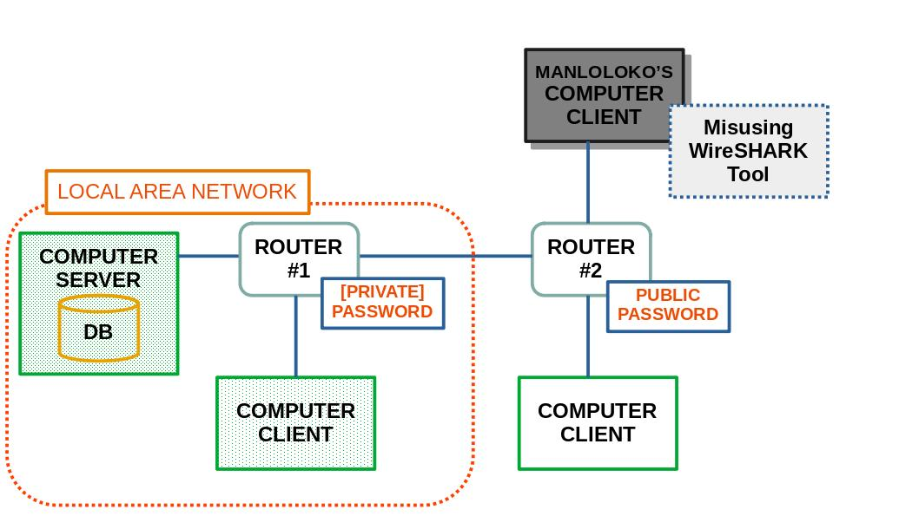
identify: IP Addresses from captured network traffic LIST

where: Computer Client requests for Google Web Service;
Computer Client located inside Local Area Network;
Google Web Service located outside;

--> use: ipinfo.io to assist in identifying among others:
1) physical location
2) contact information

Example Address List in Sequence:
1) 142.250.66.99 : Google LLC, U.S.A.
--> 1600 Amphitheatre Parkway, Mountain View, CA, U.S.A.

2) 122.2.215.143 : Philippine Long Distance Telephone Company
--> Taguig, Metro Manila, Philippines

3) 142.251.85.103 : Google LLC, Singapore
--> Singapore, Singapore

"To report abuse and illegal activity":
1) https://www.google.com/contact/
2) abuse@pldt.net
3) network-abuse@google.com

Recommended Actions:
1) file: incident reports with Police;
2) Ignore, if NOT endure, NOISE POLLUTION;
3) clarify: with Family Unit, e.g. Wife, directly and in-person
--> any information/gossip heard, viewed, et cetera;
--> Halimbawa: Kung may narinig kang hindi ayos ukol sa akin, kausapin mo muna ako nang direkta at harap-harapan upang ating LINAWIN ang anumang MALABO.

--> 1.1.2) continued: to share know-how in 日本語 (にほんご; nihongo)
--> Usbong SCHOOL: https://github.com/usbong/school/
--> Japanese Language Proficiency Test (JLPT): https://www.jlpt.jp/

JLPT LEVEL: N5~N4; where: N1 highest @HIGHSCHOOL level
1) Sectional Pass Mark: >= 31.6%
1.1) Language Knowledge: (Vocabulary/Grammar）・Reading
38/120 = 0.316;
31.6%
1.2) Listening
19/60 = 0.316;
31.6%
2) Total PASS Mark: >= 50.0%
90/180 = 0.5;
50.0%

NOTE (from SYSON, MICHAEL B.):

Recommended Actions:
1) verify: Sample Examinations as practice before Actual Examination
--> observed: Listening Part to appear to be excessively QUICK due to student has LESS audio material to repeatedly listen as practice
where: audio material : @same/similar LEVEL as Examination
2) verify: Examination Rules to receive: PASS
--> observed: with select examinations, question items' difficulty level NOT in increasing sequence, PASS Mark >= 70%
ACTION: finish: questions that CAN be QUICKLY answered CORRECTLY;
--> This is instead of using available TIME to answer more difficult questions valued @SAME POINTS
3) verify: VALUE to receive PASS in Examination
Example OUTPUT: increase in RANK
--> reminder: No need to use available TIME and MONEY to take Examination
--> where: VALUE classified to be LOST

2) Continued with Research & Development (R&D)
2.1) shares: Lessons-learned: asahi.com (朝日新聞DIGITAL; asahi shimbun digital)
--> note: KEYPHRASE technique as with TELEGRAM/SMS (SHORT MESSAGING SERVICE) MESSAGE
--> Translation from 日本語 (にほんご; nihongo) to English by SYSON, MICHAEL B.

2.1.1) （社説）ゲノム情報 差別防ぐルール作りを;
last accessed: 20220602; from 20220516

2022年5月16日 5時00分
2022-05-16T05:00

３年前に作られた「全ゲノム解析等実行計画」に基づき、がんと難病の患者を対象に、ＤＮＡの遺伝情報（ゲノム）を網羅的に解析する作業が進む。

...保険や雇用分野での差別的な取り扱いを、法律で明確に禁じている国もある。

ところが日本にはそうした規定はない。わずかに個人情報保護法によって、ゲノム情報の取得にあたっては本人の同意が必要とされているくらいだ。

海外の例も参考にしながら具体的な検討を行う場を速やかに設けるよう求める。

ゲノム医療のあり方について人々の考えや意識を探る調査を継続して行い、ていねいな説明を通じて、社会の合意形成を図ることも必要だ。

keyphrase: GENOME INFORMATION;
--> requires: person's AGREEMENT to obtain INFORMATION in JAPAN;
--> In INSURANCE, EMPLOYMENT FIELDS DISCRIMINATION TREATMENT, NOT YET in JAPAN,
--> CLEARLY PROHIBITED in LAW @SELECT COUNTRIES

2.1.2) 半導体工場、国内で巨額投資続々 政府は経済安保観点からも支援; last accessed: 20220602; from 20220516

土居新平2022年5月16日 5時00分
Doi Shinpei; 2022-05-16T05:00

スマートフォンや家電、自動車などあらゆる製品に使われる半導体は世界的に不足しており、争奪戦が激しい。 企業は巨額の投資をし、政府は経済安全保障の観点からも補助金を出して、生産力を高めようとしている。

東芝が約4割の株式を持つ半導体大手のキオクシアホールディングスは、北上工場（岩手県北上市）に新たな製造棟を建てる。建屋面積は約3万1千平方メートル。総事業費は1兆円規模とされ来春にも完成する。生産するのはスマホなどに使う記憶用半導体「NAND（ナンド）型フラッシュメモリー」だ。

キオクシアは世界最大級のメモリー工場である四日市工場（三重県四日市市）で新たな製造棟を4月に完成させた。秋にも稼働する。こちらも総事業費は1兆円規模。北上工場の分を合わせ、米半導体大手のウエスタンデジタル（WD）と共同で負担する見通しだ。

政府は半導体産業を支援する…

keyphrase: 半導体工場 (half-guided body engineering area; TRANSISTOR FACTORY) in JAPAN;
--> TOSHIBA; IWATE PREFECTURE; MIE PREFECTURE; MEMORY, e.g. NAND FLASH MEMORY;

NOTE (from SYSON, MICHAEL B.):
ASAHI Newspaper Observations:

1) observed: correction in spelling during QUICK SMS Reporting for select words, e.g. MIE PREFERECTURE
--> "PREFERECTURE" with the excess "ER", should be "PREFECTURE"

emphasis: VALUE of UNIT's EDITOR to re-verify quickly translated sentences' grammar, sentence structure, significance, et cetera.

2) observed: problems in JAPANESE SOCIETY due to among others:
2.1) young people executing CHAOTIC behavior
2.2) people with NO WORK
2.3) senior people with errors in MONEY

ACTION:
2A.1) STRICT with newly elected politicians, e.g. Prime Minister KISHIDA,
2A.2) sharing that problem WORSE in Foreign Countries;
where: increased DEATH COUNT due to FIRE during WINTER

3) Continued with Security Defense Force
3.1) shares: ULTRASOUND TECHNIQUE
3.1.1) FROM: ULTRASOUND THERAPY
website address: https://www.sciencedirect.com/topics/medicine-and-dentistry/ultrasound-therapy; last accessed: 20220530

--> observed: pattern IF tool/technique NOT effective to increase INCOME LEGALLY, shall be MISUSED by MANLOLOKO group to execute ACTIONS classified to be ILLEGAL,
e.g. intimidation, harassment to get QUICK MONEY;

where: harass: "cause trouble or any mental, economical or any other damage [1]"

MANLOLOKO : MANLOLOKO/budol-budol/carnapper/smuggler/
cybercriminal/Teroristang Komunista group

keyphrase:
unsolicited physical stimulation,
wireless physical attacks,
mobile telephone (tech since Year 2008 and earlier)

emphasis:
"...sound waves at very high frequencies (0.5-5 MHz) to produce mechanical vibration within the tissues."
"Physical therapies"
Lindsay M. Bearne PhD MSc MCSP, Michael V. Hurley PhD MCSP,
in Rheumatology, 2010 ULTRASOUND THERAPY

"In the management of rheumatic diseases, ultrasound therapy (US) is commonly used as an adjunctive therapy for its proposed effects on inflammation as well as for pain relief. It uses sound waves at very high frequencies (0.5-5 MHz) to produce mechanical vibration within the tissues. If applied in high doses absorption of US results in heating, which decreases pain and fluid viscosity, increases metabolic rate and blood flow (thermal effects) (Nussbaum 1997). At lower doses of US or following pulsed US non thermal, mechanical effects such as stable cavitation (formation of gas bubbles in tissues), standing waves (reflected waves superimposed on incident waves) and acoustic streaming (fluid movement which exerts pressure changes on a cell) occur (Maxwell 1992) which cause membrane distortion, increased permeability, increased nutrient transfer and facilitation of tissue repair (Mortimer & Dyson 1988). When applied to acutely inflamed tissues it encourages the inflammatory process to progress to the proliferation stage (Watson 2000).

Whilst there is evidence to support the physiological effects of US in laboratory or animal studies, (Mortimer & Dyson 1988) evidence for its clinical effectiveness in people with rheumatic conditions is limited (Brosseau et al 2004, Zhang et al 2007) and it is only recommended for those with arthritis of the hand (Casimiro et al 2002, Welch et al 2001). Moreover, a recent review concludes US may only be effective for people with carpal tunnel syndrome and those with calcific tendonitis of the shoulder (Roberston & Baker 2001) despite being a frequently used electrophysical modality in musculoskeletal conditions (Kitchen & Partridge 1996)."

Additional Reading:
[1] Notes on Prohibitions In using the Nintendo Account Service

USBONG I.T. SOLUTIONS
COMPUTER SERVICES

SYSON, MICHAEL B.
FOUNDER

MOBILE: +63929.952.7263
EMAIL: MASARAPMABUHAY@GMAIL.COM

WEBSITE: WWW.USBONG.PH
ADDRESS: #2 E. MANALO (FORMERLY, E. RODRIGUEZ) AVE., STO. NIÑO, MARIKINA CITY, 1820, PHILIPPINES

MAPARAANG PAGBIBILANG
ALGEBRA SKILL LEVEL 1:
INPUTS:
X = 250 //ITEM PRICE
V = 12% //VALUE ADDED TAX (VAT)
Q = ? //ITEM PRICE WITH VAT

TANONG: WHAT IS ITEM PRICE WITH VAT?
SAGOT:

ALGEBRA SKILL LEVEL 2:
INPUTS:
X = ? //ITEM PRICE
V = 12% //VALUE ADDED TAX (VAT)
Q = 364 //ITEM PRICE WITH VAT
TANONG: WHAT IS ITEM PRICE WITHOUT VAT?
SAGOT:

ALGEBRA SKILL LEVEL 3:
INPUTS:
S = 600K //EXCESS STOCK IN WAREHOUSE (JAPAN)
D = 180 //IN USD OF EACH STOCK
L = ? //LOSS

NOTES:
1) USD = UNITED STATES DOLLAR
2) PHP = PHILIPPINE PESO
3) USD1 : PHP54

TANONG#1: WHAT IS THE LOSS IN PHP?
SAGOT:

TANONG#2: WHAT IS THE LOSS IN PHP IF WE SET
USD1 : PHP0.50?
SAGOT:





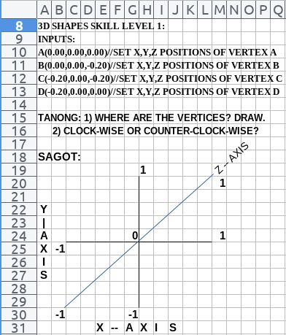

NOW HIRING: COMPUTER SERVICES SALESPERSON
✓Receive half of the revenue from your DIRECT SALE of the service

✓Receive training:
Filipino Language, Sales, Information Technology
Requirements:
1) Curriculum Vitae
2) Portfolio
3) Sulat ng Hangarin
3.1) Ano ang maitutulong mo?
3.2) Bakit mo nais ito?
3.3) Bakit ka karapat-dapat?



EMAIL: APPLY@USBONG.PH

Tanong at Sagot

1) Magkano ang aking kikitain bilang Computer Services Salesperson at Manunulat ng paliwanag sa kompyuter, e.g. Add-on Software?
--> Kung babayaran tayo ng klinik ng 10K pesos bawat buwan, 5K ang sa iyo bilang Computer Services Salesperson.
--> Bilang Manunulat, 4K pesos ang maibibigay sa iyo ng Usbong.
--> Sa kabuuan, 9K pesos ang matatanggap mo bawat buwan.
--> Ang matitirang 10% ng 10K, i.e. 1K pesos, gagamitin ng Usbong sa pag-iipon ng kapital.
--> Gagamitin ito ng Usbong sa paggawa ng mga investment at "float", na ang kahulugan, liquid asset.

2) Paano ako makibabahagi sa tagumpay ng kompanya?
--> Kung wala tayong kikitain mula, halimbawa, sa Computer Automation Service, mauubusan tayo ng kapital na pambayad sa ating lahat. Hindi magtatagal, wala na tayong kompanya.
--> Dahil dito, kailangang maayos ang ating paggawa at pagtuturo sa mga trainee upang tuluy-tuloy ang daloy ng ating kita, habang nagbibigay ng ginhawa sa lipunan.

