
July 2021
EXPENSES > INCOME PATTERN
たいまつ (松明; taimatsu;
kahoy liwanag)
Kahoy na may apoy upang magbigay liwanag

PHILIPPINES: USBONG CONTINU​ES TO PROVIDE
COMPUTER SERVICE ASSISTANCE BY SHARING
KNOW-HOW ON MAPARAANG PAGBIBILANG

To eliminate excess steps and inefficient time usage, MARIKINA ORTHOPEDIC SPECIALTY CLINIC (MOSC) requested Usbong's services to automate routine, monotonous tasks and share with unit members know-how on computers.

Here are Key Action Items that we executed in this updates list.
1) Continued to update Knowledge Management System (KMS)
--> 1.1) continued: to share know-how on computers and Information Technology (IT) tools
--> 1.1.1) adds to development time
//1) identifying correct positions due to there exist pixel and vertex positions
--> Reminders: We use vertex position to identify 3-Dimensional (3D) position; We use pixel position to identify 2-Dimensional (2D) position

NOTE (from SYSON, MICHAEL B.):
We can also use the vertex position to identify the 2D position. If the set of instructions already uses pixel positions, we can use a tool to auto-convert the pixel position to vertex position.

Example:
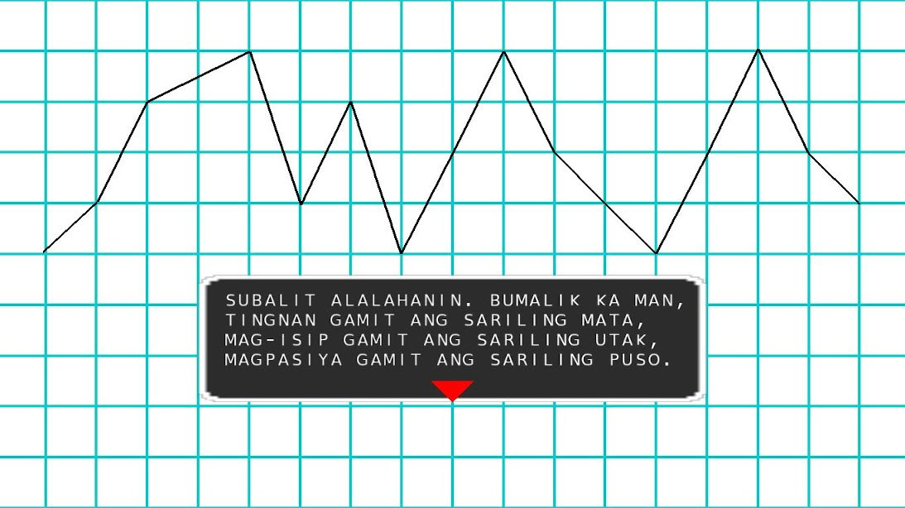
Example Computer Instructions from UsbongUtils
//note: vertex point origin 0,0,0 at center
//note: pixel point origin 0,0 at top-left
float UsbongUtils::autoConvertFromPixelToVertexPointX(int iPointX)
{
float fHalfWindowWidth=fMaxWindowWidth/2;
float fHalfWindowHeight=fMaxWindowHeight/2;

if (iPointX<fHalfWindowWidth) {
//note: use of parenthesis
return (fHalfWindowWidth-iPointX)/fHalfWindowWidth*(-1);
}
else if (iPointX==0) {
return 0;
}
else {
return (iPointX-fHalfWindowWidth)/fHalfWindowWidth;
}
}

float UsbongUtils::autoConvertFromPixelToVertexPointY(int iPointY)
{
float fHalfWindowWidth=fMaxWindowWidth/2;
float fHalfWindowHeight=fMaxWindowHeight/2;

if (iPointY<=fHalfWindowHeight) {
return (fHalfWindowHeight-iPointY)/fHalfWindowHeight;
}
else if (iPointY==0) {
return 0;
}
else {
//note: use of parenthesis
return (iPointY-fHalfWindowHeight)/fHalfWindowHeight*(-1);
}
}

From history in the Years 1994 1995, we learn that the PlayStation Team in the United States of America (USA) began to only accept submissions for review electronic game Read-Only Memory (ROM) applications that use 3D technology. Those that did not were rejected for publication.

Despite this, the PlayStation Team in Japan still accepted applications that were classified to use non-3D technology. Because of this, select games were accessible in Japan, but not in the USA.

After computation, development companies whose assets only used 2D technology via pixel positions needed to increase their skill level and know-how, especially if their target market is the USA.

From observation, when the PlayStation 2 system arrived in the Year 2000, the quantity of applications began to decrease. It is clear that 3D technology added to development cost.

However, development companies outside Japan, e.g. Europe, became noticeable.
Example: Guerrilla Games (Headquarters: Amsterdam, Netherlands‎)

Meanwhile, Japanese companies at the time worked to solve the problem of increasing development costs. They created groups, e.g. Entertainment Software Publishing (ESP), Game Designers Network (GDNET), to share know-how and financial capital.

Due to they did not intend to create a USA group, they shared information, so that people there can also create such a group themselves.

The idea is that if people replicated the social system, then it is proof that it is correct.

Reminder: The computer games industry is a Billion United States Dollar (USD) industry. However, when expenses > income, actions become dirty to get quick money.

Output: Low quality products/services

Examples of noticeable errors in execution:
1) excess loading times of objects from Read-only Memory to Random Access Memory (RAM)
2) slow 3D animation movement due to excess computation requests

By the Year 2000's, we learn that ESP and GDNET became part of the BANDAI NAMCO group.

Additional Note:
1) Previously, BANDAI and NAMCO were not classified to be one group. In addition, after verification, in the Year 2021, they have business operations in Malaysia, Southeast Asia.

Reference:
1) Halverson, D. 1996. Gamefan: next generation video game magazine (Vol. 4, Issue 12, Dec. 1996). USA: Metropolis Publications, Inc.
--> "Special K's Japan Now!: Exclusive Gamefan Interview with ESP -- the creators of GD NET"

//2) identifying axis origin from where to add
//3) identifying object anchor to which steps are added
//identified delays shall add computation time during movement in galaxy
//speed-up via machine tool, e.g. RobotShip, assists Human Pilot

//note: reminded: difficulty in Math, i.e. Maparaang Pagbibilang,
//due to no quick feedback; example: no quick output using select inputs
//computer as machine tool assists in speed-up of output

//4) identifying correct Window Width and Height values due to variations in machine
//After computation, it is faster for machine manufacturers to auto-verify correct display outputs
//using own machine's Window Width and Height inputs
//question: Is this Microsoft's strategy?
//At present, USBONG verifies display output using available manufactured machines

//5) identifying correct inputs, e.g. rotation angle and axis, for use with 3D techniques, e.g. translate, rotate, scale,
//adds to development time, due to display output verification;
//fast computers speed-up development time
NOTE (from SYSON, MICHAEL B.):
We can identify patterns in the instructions to execute 3D techniques, e.g. scale, via the Open Graphics Library (OpenGL).

Example: Multiple Scale Commands = Multiplication Commands

variation#1:  glScalef(0.06f, 0.06f, 1.0f);  glScalef(0.55f, 0.55f, 1.0f); | variation#2:  glScalef(0.06f*0.55f, 0.06f*0.55f, 1.0f);

This is without yet verifying the actual computer instructions in OpenGL.

Reminder: OpenGL computer instructions are publicly available

--> 1.1.2) shared: answer to question via www.stackoverflow.com
--> reminder: There exists logical answer to logical question; where logical = clear, not emotional
--> where: logical questions = mga tanong ukol sa Maparaang Pagbibilang.
--> Example Question: How to execute "opening a window that has no title bar with win32"?
Example Answer (executed on Windows 7 machine):
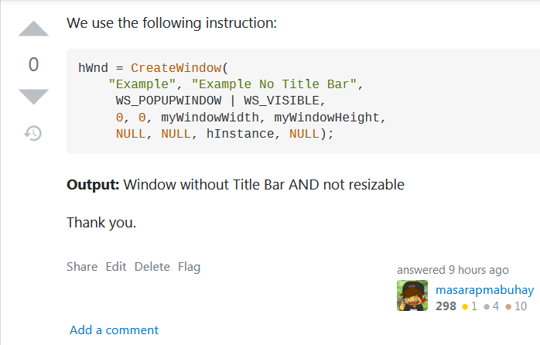

NOTE (from SYSON, MICHAEL B.):
With questions that are NOT logical, I admit that I do not know what the correct answer is.

--> 1.1.3) shared: action steps to auto-generate the Acknowledgment Form for Printing; Previously, we wrote the answers by hand.
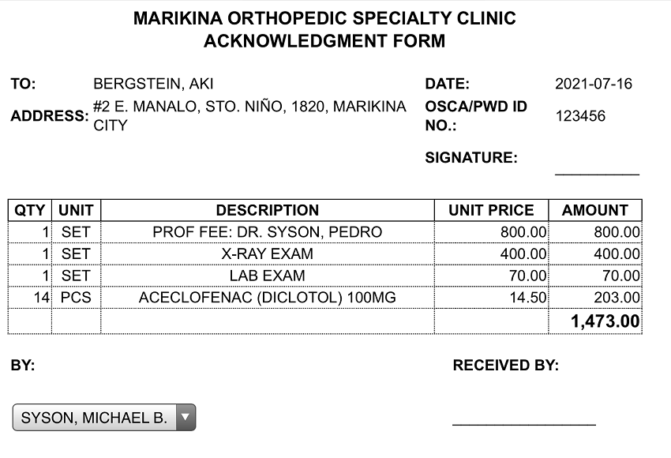
--> The Apple iPad Table Personal Computer (PC) auto-connects to the set Printer. Both the Tablet PC and the Printer are connected to the Computer Network; Reminder: There exist wired and wireless connections.



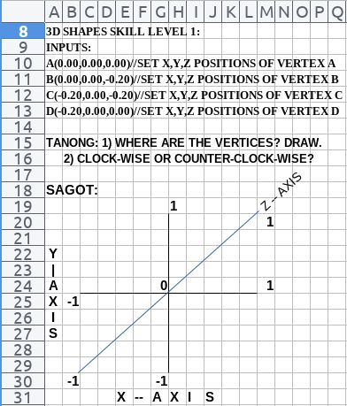

USBONG
COMPUTER SERVICES

SYSON, MICHAEL B.
FOUNDER

MOBILE: +63929.952.7263
EMAIL: MASARAPMABUHAY@GMAIL.COM

WEBSITE: WWW.USBONG.PH
ADDRESS: #2 E. MANALO (FORMERLY, E. RODRIGUEZ) AVE., STO. NIÑO, MARIKINA CITY, 1820, PHILIPPINES

MAPARAANG PAGBIBILANG
ALGEBRA SKILL LEVEL 1:
INPUTS:
X = 250 //ITEM PRICE
V = 12% //VALUE ADDED TAX (VAT)
Q = ? //ITEM PRICE WITH VAT

TANONG: WHAT IS ITEM PRICE WITH VAT?
SAGOT:

ALGEBRA SKILL LEVEL 2:
INPUTS:
X = ? //ITEM PRICE
V = 12% //VALUE ADDED TAX (VAT)
Q = 364 //ITEM PRICE WITH VAT

TANONG: WHAT IS ITEM PRICE WITHOUT VAT?
SAGOT:

ALGEBRA SKILL LEVEL 3:
INPUTS:
S = 600K //EXCESS STOCK IN WAREHOUSE (JAPAN)
D = 180 //IN USD OF EACH STOCK
L = ? //LOSS

NOTES:
1) USD = UNITED STATES DOLLAR
2) PHP = PHILIPPINE PESO
3) USD1 : PHP54

TANONG#1: WHAT IS THE LOSS IN PHP?
SAGOT:

TANONG#2: WHAT IS THE LOSS IN PHP IF WE SET
USD1 : PHP0.50?
SAGOT:



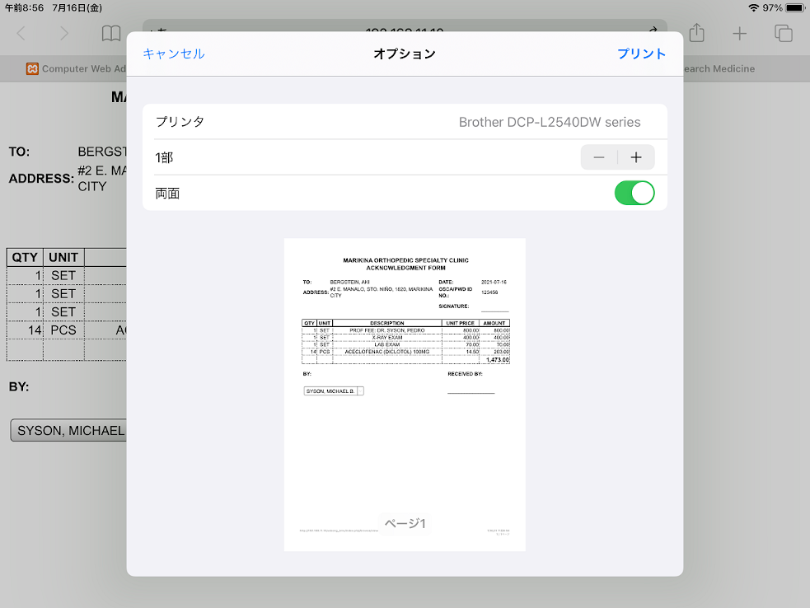
NOTE (from SYSON, MICHAEL B.):
With the Apple iPad PC, we set the Language to be nihongo. We encourage Unit members to learn languages, e.g. nihongo. This is due to after verification, problems in the Philippines are caused by incorrect beliefs.

Examples:
1) Religion not set to be "N/A", i.e. "Not Applicable"
2) Maparaang Pagbibilang is NOT valued.

Reminder: Beliefs are classified to be with Culture. Culture CAN be changed.

Recommended Actions:
1) re-verify: Kasaysayan ng Pilipinas
2) learn: nihongo
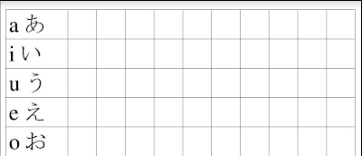
Example Japanese Alphabet: hiragana Practice Sheet

--> 1.2) updated: computers instructions @Sta. Lucia Health Care Center (SLHCC) Unit; This action is due to received request from MOSC Unit Chief, Dr. SYSON, PEDRO A.
--> 1.2.1) updated: in add-on software, computers instructions to add in SMS Report Total Counts, instead of Fees.

SLHCC,2021-07-10,PT,Total:3,iCashTotalTransactionCount:2,
iHMOTotalTransactionCount:1,CON,Total:6,iCashTotalTransactionCount:2,
iHMOTotalTransactionCount:4
Example Auto-generated SMS Report (Now)

SLHCC,2021-07-10,PT,Total:3,CashTotalFee:1071.42,CashTotalNetFee:675,HMOTotalFee:800,
HMOTotalNetFee:441,CON,Total:6,CashTotalFee:1142.86,CashTotalNetFee:720,HMOTotalFee:2100,
HMOTotalNetFee:1157.62
Example Auto-generated SMS Report (Previous)

--> 1.2.2) updated: in Master workbook, computers instructions to add in Summary Report for the Week, Total Counts,
--> i.e. Cash, HMO, and Grand Total (Both Cash and HMO)
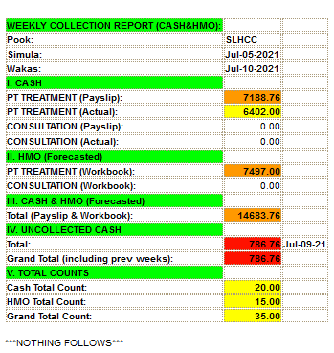
Auto-generated Summary Report for the Week
Added V. TOTAL COUNTS
NOTE (from SYSON, MICHAEL B.):
After verification, I first wrote the Macros, i.e. set of instructions, to auto-generate the Weekly Collection Report with our partner Unit @SLHCC on 2019-12-26.

In addition, we last updated the instructions on 2020-12-06.
Our newest update has the date: 2021-07-11.

From this, we learn that the computer instructions did not need additional updates for 7months and 5days (approx) after the last update.

We used the saved time to execute additional tasks to speed-up the system.

Reminder: Zeit ist Geld; Time is Gold.

--> 1.2.3) updated: in add-on software, computers instructions to auto-generate the Unpaid HMO Summary Report
--> where: HMO = Health Maintenance Organization
--> The input files of each Month of the Year are from the Master List workbook.
--> File Format: .csv (Comma-Separated Values)
--> Previously, the HMO Total Count included the Sta. Lucia Cares (SLC) transactions count. This is albeit the SLC transactions also had its list with the Total Count. This action is to make clear the Total HMO Count.

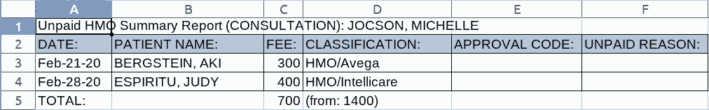
Halimbawa: Auto-generated Unpaid HMO Summary Report
With re-verification and update by Human Unit Member

--> 1.3) updated: computer instructions to speed-up KMS
--> verified: available instructions to identify which set causes speed-up in system
--> Computer languages:
--> PHP Hypertext Preprocessor (PHP) (with CodeIgniter Web Framework Version 2)
--> MySQL (Structured Query Language)
--> Objective:
$this->db->select('t1.patient_name, t1.patient_id, t2.transaction_id, t2.transaction_date, t2.fee, t2.transaction_type_name, t2.treatment_type_name, t2.treatment_diagnosis, t2.notes, t2.medical_doctor_id');
--> where: db = Database
--> 2 tables (with row and column): Patient and Transaction
--> Patient Table Count: >7,800rows, 15columns;
--> Transaction Table Count: >40,000rows, 23columns
pamahalaan. Nang papalapit na sa katapusan, maaalalang kakausapin ni Toshizou ng shinsengumi ang kanyang mga kasamahan sa pangkat.
Toshizou: Kung sino ang may mas mahalaga pang bagay upang ikabuhay, umuwi na! Ang mga wala na, sumama kayo sa'kin!
Susugod si Toshizou ng shinsengumi sa kanang pakpak ng sandatahang lakas ng pamahalaan.
Pamahalaan: Ano ang pangalan mo?
Toshizou: Pangalawa sa pangkat ng shinsengumi, 土方歳三 (Hijikata, Toshizou)!
Pamahalaan: Isasantabi mo na ba ang iyong sandata?
Toshizou: Hindi!
Pakikilusin ni Toshizou ang kanyang kabayo upang sugurin ang kanang pakpak.
Madirinig ang pagputok ng baril.
Patay.
Tutumba si Toshizou.
Maaalala ang pag-ulan sa silangan.
Masarap.
Paalala: Hindi nais ng karaniwang tao ang maging Bayani.
Namamatay ang Bayani... sa bagay na mas mahalaga pa kaysa kanyang buhay.
Paalala: Ang patay, talagang patay.
Gayunpaman, maaari nating tingalain ang Bayani bilang paalala sa kakayanan ng tao.

NOW HIRING: COMPUTER SERVICES SALESPERSON
✓Receive half of the revenue from your DIRECT SALE of the service

✓Receive training:
Filipino Language, Sales, Information Technology
Requirements:
1) Curriculum Vitae
2) Portfolio
3) Sulat ng Hangarin
3.1) Ano ang maitutulong mo?
3.2) Bakit mo nais ito?
3.3) Bakit ka karapat-dapat?



EMAIL: APPLY@USBONG.PH

Tanong at Sagot

1) Magkano ang aking kikitain bilang Computer Services Salesperson at Manunulat ng paliwanag sa kompyuter, e.g. Add-on Software?
--> Kung babayaran tayo ng klinik ng 10K pesos bawat buwan, 5K ang sa iyo bilang Computer Services Salesperson.
--> Bilang Manunulat, 4K pesos ang maibibigay sa iyo ng Usbong.
--> Sa kabuuan, 9K pesos ang matatanggap mo bawat buwan.
--> Ang matitirang 10% ng 10K, i.e. 1K pesos, gagamitin ng Usbong sa pag-iipon ng kapital.
--> Gagamitin ito ng Usbong sa paggawa ng mga investment at "float", na ang kahulugan, liquid asset.

2) Paano ako makibabahagi sa tagumpay ng kompanya?
--> Kung wala tayong kikitain mula, halimbawa, sa Computer Automation Service, mauubusan tayo ng kapital na pambayad sa ating lahat. Hindi magtatagal, wala na tayong kompanya.
--> Dahil dito, kailangang maayos ang ating paggawa at pagtuturo sa mga trainee upang tuluy-tuloy ang daloy ng ating kita, habang nagbibigay ng ginhawa sa lipunan.

Reminder: wireless broadcasting technology is used as weapon to cause dizziness, et cetera, equal with the effects of illegal drugs, e.g. taima, marijuana

4.1.2) Example Incorrect Beliefs:
4.1.2.1) Maparaang Pagbibilang is NOT valued
4.1.2.2) Religion NOT set to be "N/A", i.e. "Not Applicable"

Reminder: Beliefs are classified to be with Culture. Culture CAN be changed.

4.1.3) Recommended Actions:
4.1.3.1) re-verify: Kasaysayan ng Pilipinas
4.1.3.2) learn: nihongo
4.1.3.3) learn: Maparaang Pagbibilang

//column
fTx = 0.0f+0.0625f*(myUsbongUtils->autoIdentifyColumnInputInLevelMapContainer(sTileId));

//texture y-axis; start from bottom; anchor
//CAPCOM's GHOSTS'N GOBLINS? (Arcade, Family Computer; Year 1985)

//May tattoo ng puso ang braso ng mga Dambuhalang Goblin. Umaaligid-aligid sila sa loob ng Gusali;
//paalala: Goblin = uri ng halimaw; bakemono, i.e. naibang bagay; Maaaring dalawang set ng pagsalakay upang mapuksa ang Dambuhalang Goblin.

//May tapang din ang pagtalon mula sa itaas na palapag upang magbalik at sumalakay muli; Ito'y sa halip na harapin ang halimaw, at tanggapin nang nakikipaglaban ang tiyak na kamatayan.

//paalala: ang patay, patay na.

//16.0f due to tile x16 to be height max
//0.0625f*16.0f=1.0f

//row
fTy = 1.0f-0.0625f*(myUsbongUtils->autoIdentifyRowInputInLevelMapContainer(sTileId));

4.1.4) Mungakahing Babasahin:
--> 4.1.3.1) Miyazaki, Hayao's Manga/Comic Book, 「雑想ノート(zassou no-to; various thoughts,
--> i.e. "Daydream", note) : No. 9」
--> 4.1.3.2) 司馬遼太郎's「燃えよ剣」
--> Shiba, Ryoutarou's "moeyo ken",
i.e. nasusunog patalim
Ukol ang aklat sa mga nangyari patungo sa alam nating wakas.

Dekada 50 ng taong 1800, may nagaganap na malaking pagbabago dulot ng pagdating ng armada, i.e. barkong pandigma, ng Amerka. Sa pamumuno ni Commodore Matthew Perry, ginamit nila ang kanilang mga kanyon upang mapilitang buksan ng mga Hapon ang kanilang bansa sa mga banyaga pagkatapos ng mahigit 300 daang taon.
Maaalala na pinananatili ang kapayapaan sa bansa sa tulong ng mga shinsengumi. Pangkat sila na nagpapatupad ng mga patakaran, i.e. regulasyon, batay sa mga nakalap na balita. Sa kalusugan, ito ang tungkulin ng endocrine system ng ating katawan; keyword: "regulate". Halimbawa nito ang sa labis na pagtibok ng puso.
Paalala: daigdig ang ating katawan; daigdig ang bansa.
Ngunit gawa ng lakas ng mga banyaga gamit ang kanilang mga sandatang kanyon, napagpasiyahan ng mga namumunong Hapon sa pamahalaan, i.e. administration, na kailangan nang ayusin ang kasalukuyang sistema upang mas maiging magagawa ang pagpapatupad ng mga patakaran. Maaalala na gamit ng mga shinsengumi bilang sandata ang katana, i.e. patalim. Sa panibagong sistema, papalitan ang mga shinsengumi sapagkat kailangan nang isantabi ang mga katana. Ito'y upang pag-aralan ang mga banyagang sandata, e.g. kanyon, upang gawing bahagi ng lakas ng Hapon.
Gayunpaman, ilan sa mga shinsengumi ang tutol sa pansasantabi ng kanilang katana. Magkakaroon tuloy ng labanan sa pagitan ng pangkat ng mga shinsengumi at ng

--> Combined using JOIN Command
--> reminder: increase in JOIN Command causes increase in execution time to finish
--> Examples (by verification sequence):
--> 1)
$this->db->group_by('t2.added_datetime_stamp');

--> 2) Faster to execute than #1, albeit added_datetime_stamp NOT newest
$this->db->group_by('t1.patient_id');

--> 3) Noticeably equal with #1
$this->db->order_by('t2.added_datetime_stamp', 'DESC');
$this->db->limit(1);

--> 4) Fastest to execute with added_datetime_stamp newest
$this->db->where('added_datetime_stamp = (SELECT MAX(t.added_datetime_stamp) FROM transaction as t WHERE t.patient_id='.$iPatientId.')',NULL,FALSE);

NOTE (from SYSON, MICHAEL B.):
In all the instructions, we set the patient_id using this Command:

$this->db->where('t1.patient_id =', $iPatientId);

After computation, when the total transactions count with the set patient id, i.e. identification, is over 10,000, computer instruction #1 causes computer to noticeably LOAD without finish.

After verification, we need to execute computer restart to solve the problem. If computer is classified to be the Computer Server, Computer Clients do not receive the requested data, e.g. last patient visit.

Reminder: Computer Server executing on Windows 7 machine can restart in 60secs. However, without detection and Command to restart, service operation is stopped.

2) Continued with Research & Development (R&D)
--> 2.1) Food and Energy
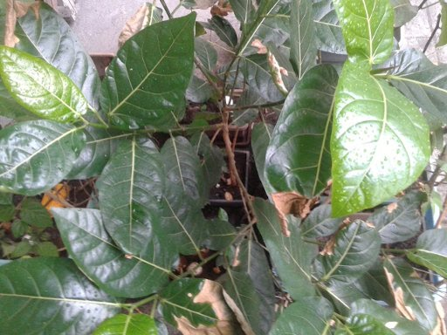  Sili Leaf Shape | 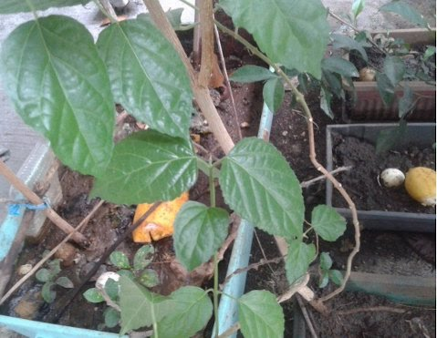  Tomato Leaf Shape

--> 2.2) Usbong Automotive Computer-Aided Design (CAD): Map System
--> added: instructions to auto-compute the width and height of each rectangle tile of grid; This is based on the computer's actual screen/monitor's window width and height.

  Auto-executed on Windows 7 machine; 1024 x 768 |   Auto-executed on macOS machine;  1280 x 800

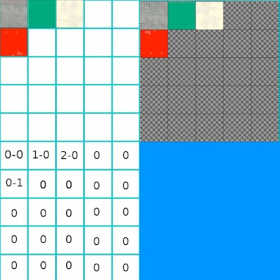
NOTE (from SYSON, MICHAEL B.):
We can identify the position of objects in a map using rows and columns of a grid. We start the count at 0. Example: 0-1, i.e. Row 0, Column 1;
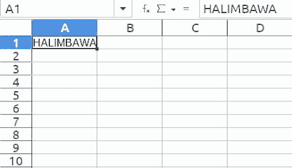
--> In spreadsheet tools, e.g. Microsoft Excel, LibreOffice Calc, this position is A1.

TOP: LibreOffice Calc; Spreadsheet Tool
LEFT: Usbong CAD; Texture Map System Tool

We use this same technique to identify the image texture of the rectangle tile to put in the map.

Reminder: The image texture can have transparent parts to create shapes that are not rectangle.

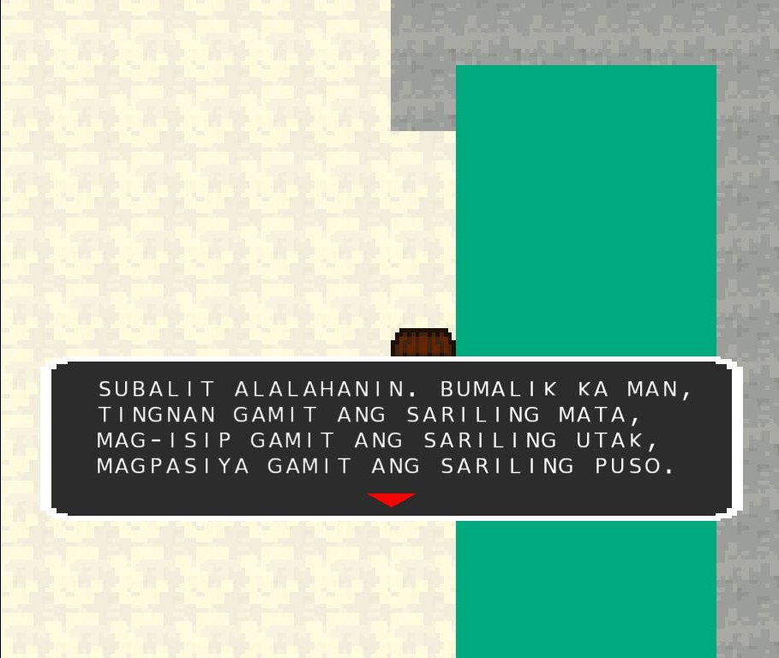

--> 2.3) Usbong Story
--> After verification, the total file size of the Usbong documentation on GitHUB is already >183MB.
--> +added: new repository to decrease wait time to finish download of updated version.
--> updated: instructions for computer to receive Input Commands for Unit Chief inside World to execute actions, e.g. movement.
--> updated: instructions for Unit Chief to interact with objects, e.g. tile walls to stop Unit Chief from moving forward.

3) Continued to share information on Health

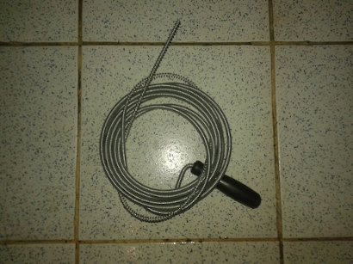

TOP: Cleaned Lababo; TOP-RIGHT: Pipe Clean Metal Wire 3m @PHP140
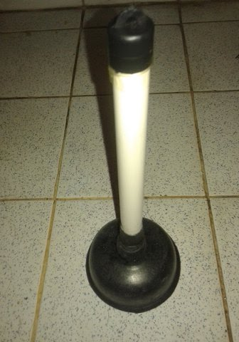
RIGHT: Pump 30cm (approx) @PHP35

3.1) Clean Toilet: Execution Steps
--> 3.1.1) observed: water did not anymore enter the lababo hole to cause a pool to form
--> 3.1.2) used: a long object (size 10cm; approx) to verify if an object was clogging the pipe
--> 3.1.3) observed: small water bubbles to come out due to air could enter the pipe,
--> albeit not sufficient to drain the water pool
--> 3.1.4) used: pump to cause additional air to enter the hole
--> reminder: the pump is put on the hole to create a vacuum; we execute multiple suck movement before removing the pump on the hold
--> output: not effective; small water bubbles did not anymore come out
--> 3.1.5) used: Pipe Clean Metal Wire (size 3meters) to remove clog
--> reminder: we put metal wire into the hole until the wire does not anymore enter; we use multiple counter-clock-wise movement; we remove the wire to verify if wire caught clogging objects; we clean the wire; repeat to put metal wire into the hole
--> 3.1.6) used: again Pump to cause additional air to enter the hole
--> 3.1.7) verified: water entered the lababo hole to drain the water pool

NOTE (from SYSON, MICHAEL B.):
I opted not to first remove the bottom pipes of the Lababo. This is due to when I previously removed and returned the pipes to fix water leaks, I needed additional time. This additional time included among others: buying the pipe parts replacement and fixing new water leak problems.

Indeed, to solve problems, it is vital that we have the know-how to quickly verify which tool and technique to execute, so that the output goal is correct.

3.1) Reduced Body Weight

NOTE (from SYSON, MICHAEL B.):
After verification, we can reduce body weight from at least 1kg by choosing NOT to eat meat in the evening. This is after already eating meat during lunch.

Reminders:
After computation, 5kg of rice is sufficient for 1 & 1/2 months (approx) for 1 person.
We can opt to eat meat only once each day.

In its stead, we eat the following:
vegetables, rice, fruits

Example vegetables:
김치 (kimchi), pechay, kalabasa, i.e. かぼちゃ (kabocha), carrot,
だいこん (daikon), ampalaya, bawang
Example fruits: kamatis, papaya, pinya, saging na saba

Reminder: Boiled vegetables retain more nutrition than those that were cooked stir-fried.

In addition, we can eat raw egg that we mix with newly cooked rice.

We can remove the yellow part of the egg from its white part.
The white part, we can put and mix in the boiling soup with the vegetables.

Alternatively, we can mix the yellow and white part inside the bowl.
This is instead of eating the white part as is.

We put the newly cooked rice on top of the mixed egg.
We can add Iodized salt.

Reminder: We still recommend continuous walking of at least 20mins daily. This action also reduces body weight by at least 1kg.

In the morning, we can eat the following:
set#1: bread, cheese, ketchup, fruits
set#2: vegetables, rice, fruits

Additional Notes:
Cheese Quantity: x1pc from Eden Singles (square shape) set of 10; Net Weight: 208g
Ketchup Details: Heinz Tomato Ketchup Bottle 300g

Reminder: We can drink milk <1/2 cup every other day (approx).
--> Otherwise, due to not as physically active as growing children, we shall grow excessively big.

Recommended Actions:
1) verify: body weight each day; increasing, decreasing, no change?
--> verify: actions to achieve correct body weight for your height

4) Continued to update Training Centre: Security Defense Force
4.1) Wika: We encourage Unit members to learn languages, e.g. nihongo. This is due to after verification, problems in the Philippines are caused by INCORRECT beliefs.

4.1.1) Example Problem: Budol-budol/manloloko/carnapper/cybercriminal/communist terrorist group who continues to misuse wireless broadcasting technology to cause noise pollution and physical injury.
--> Objective: Quick money
--> Recommended Action: Puksain; No need for negotiation

