Attachment 5 Daily Pattern Development for the Estimation of Daily Flows and Weir Spills in CalSim II

# Objective

CalSim II modeling has been updated with revised daily flow patterns for the United States Bureau of Reclamation (Reclamation). This improvement to CalSim II has been incorporated into the Benchmark modeling. Daily flow estimates were improved to more accurately assess spills into the Sutter and Yolo Bypasses. CalSim II’s representation of daily flows have been improved by accounting for more historic data at more locations along the Sacramento River between Red Bluff and Freeport. In addition, the simulation of daily variance for periods without historical records has been refined. Previous iterations of CalSim II match daily patterns of months with historic records to months without historic records based on similar unimpaired total Delta inflow. However, this matching method has been improved by accounting for more river locations (along the Sacramento River, Sutter Bypass, Feather River, and American River), similar water year types, and more extensive period of records extending into 2020. Finally, new post-processing tools have been developed to verify the accuracy of CalSim II’s daily flows.

# Methodology

### Data Assembly and Input Development

An historical dataset for all rivers and tributaries contributing to the Sacramento River upstream of the Fremont Weir and Sacramento Weir was assembled to develop daily flow patterns at each location. Daily patterns were observed for the Sacramento River, Yuba River, Bear River, Feather River, Sutter Bypass, and American River. Only data later than WY 1964 were collected since gage records and operations data were sparse before that. Table 5‑1 includes the source and availability of all the gages that were collected for this effort.

Table 5‑1. Available Historical Gage Records

|  |  |  |
| --- | --- | --- |
| Location | Gage | Period Available |
| Yuba River near Grass Valley | USGS 11417500 | 10/1/1964 – 9/30/2019 |
| Yuba River near Smartville | CDEC (YRS) | 12/1/1996 – 5/14/2020 |
| Yuba River at Parks Bar Ridge | CDEC (YPB) | 2/1/2011 – 5/14/2020 |
| Yuba River near Marysville | USGS 11421000 | 10/1/1964 – 5/14/2020 |
| Bear River near Wheatland | USGS 11424000 | 10/1/1964 – 5/14/2020 |
| Feather River at Oroville | USGS 11407000 | 10/1/1964 – 9/30/2019 |
| Thermalito Release to Feather River | USGS 11406920 | 11/16/1997 – 09/30/2019 |
| Feather River near Gridley | USGS 11407150 | 10/1/1964 – 9/30/1998 |
| Feather River above Boyd’s Landing | CDEC (FSB) | 12/23/2010 – 5/14/2020 |
| Feather River near Nicolaus | USGS 11425000 | 10/1/1964 – 9/29/1984 |
| American River at Fair Oaks | USGS 11446500 | 10/1/1964 – 5/14/2020 |
| Sacramento River at Knights Landing | USGS 11391000 | 10/1/1964 – 4/29/1981 |
| Fremont Weir Spill (USGS) | USGS 11391021 | 10/1/1964 – 9/29/1975 |
| Fremont Weir Spill (CDEC) | CDEC (FRE) | 5/18/1984 – 5/14/2020 |
| Sacramento River at Verona | USGS 11425500 | 10/1/1964 – 5/14/2020 |
| Sacramento River Weir Spill | USGS 11426000 | 10/1/1964 – 10/1/2019 |
| Sacramento River at Freeport | USGS 11447650 | 10/1/1964 – 9/30/2015 |

In addition, simulated results from USRDOM modeling were used to develop daily flows for the following parameters:

* Sacramento River flow above Fremont Weir
* Sutter Bypass outflow (inflow to the Sacramento River)
* Ord Ferry spill
* Moulton Weir spill
* Tisdale Weir spill
* Colusa Weir spill
* Sacramento River flow at Wilkins Slough

Daily patterns were computed for each of the parameters collected from the historical observations and USRDOM outputs listed above using Equations (5‑1) and (5‑2).

An adjustment factor is calculated based on observed (or simulated by USRDOM) monthly averages (ratio of daily flow to monthly average flow):

|  |  |
| --- | --- |
|  | (5‑1) |

Daily flows are then computed by multiplying the monthly flow simulated by CalSim II with the corresponding adjustment factor:

|  |  |
| --- | --- |
|  | (5‑2) |

In the end, four daily pattern timeseries were selected as CalSim II inputs and used to compute daily flows at the following locations:

1. Sacramento River flow above Ord Ferry – Regulated flow ()
   1. Daily pattern based on USRDOM simulation (from WY 1964 – 2003)
      1. Regulated flow is taken as the sum of Sacramento River flow at Keswick, Clear Creek flow, and Stony Creek flow
   2. Applied to CalSim II arc C116
2. Sacramento River flow above Ord Ferry – Unregulated flow ()
   1. Daily pattern based on USRDOM simulation (from WY 1964 – 2003)
      1. Unregulated flow includes all other tributary flows simulated by USRDOM upstream of Ord Ferry. See Section 3.1.
   2. Applied to CalSim arc C116
3. Feather River flow at confluence of Sacramento River ()
   1. Daily pattern based on historical records (from WY 1968 – 2003) (Feather at Nicholas, Feather below Thermalito, Yuba River at Marysville, and Bear River near Wheatland)
      1. Feather River daily patterns exclude historic information prior to the regulation of Lake Oroville.
   2. Applied to CalSim II arc C223
4. American River flow at confluence of Sacramento River ()
   1. Daily pattern based on historical records (from WY 1965 – 2003) (American River at Fair Oaks)
   2. Applied to CalSim II arc C303

## Daily Pattern Mapping

Daily flow variability was created for two periods: pre-development and post-development of major dams or reservoirs in the river basins (Table 5‑2). For the post-development period (10/1/1964 – 9/30/2003), CalSim II daily flow patterns were generated by disaggregating CalSim II monthly outputs based on daily observation data using the following equation:

|  |  |
| --- | --- |
|  | (5‑3) |

where, is the daily CalSim II flow, is the simulated monthly CalSim II flow, is the daily observation flow, and is the monthly average observation flow.

Table 5‑2. List of reservoirs in the basin and their inception years

|  |  |  |
| --- | --- | --- |
| Reservoir | River | Year of Inception |
| Shasta | Sacramento River | 1944 |
| Folsom | American River | 1955 |
| Oroville | Feather River | 1967 |
| New Bullards Bar Reservoir | Yuba River | 1969 |

For the pre-development period or when observation data was unavailable, each month was assigned the daily pattern of the month from the post-development period with the most similar average monthly flow. Then, the daily pattern of that matched month was used to disaggregate monthly CalSim II flow. For February, if the pre-development period included 28 days and its matched month in the post-development period included 29 days, then the flow from February 29th in the post-development period was excluded from the calculation of the daily patterns. On the other hand, if the pre-development period included 29 days and its matched month in the post-development period only had 28 days, then the flow from February 28th in the post-development period was duplicated and used to determine daily patterns for a 29-day month. An example of the calculated daily flow ratios for the Feather River near Nicolaus station is shown in Figure 5‑2. Figures 5‑4 to Figure 5‑6 illustrate examples of daily simulated CalSim II flow at the Sacramento River at Verona station, and spills at Fremont and Sacramento weirs in WY 1998.

**Evaluation of Daily Pattern Mapping Methods**

The “No_WYT_match” lines in Figure 5‑2, Figure 5‑4, Figure 5‑5, and Figure 5‑6 show river flows estimated using the daily pattern matching method described above, in which months from the pre-development period are matched with months from the post-development period based on total monthly flow volume, regardless of water year type or any other factors.

In addition to the total flow criteria, a few more criteria were tested to find the matching month for simulated CalSim II monthly flow in the pre-development period, which are outlined below:

* **Use_threshold method**: Visually-defined thresholds were established from daily anomaly plots for each month that separated wetter (Wet - W and Above normal – AN) and drier years (Below normal - BN, Dry - D and Critical – C). An example for the American River at Fair Oaks station is shown below (Figure 5‑1, Figure 5‑2, Use_threshold line). In December, if monthly CalSim II flow was smaller than 5,000 cfs, the daily pattern matching only accounted for drier years to determine the month with the most similar average monthly flow in the observation records and vice versa.

|  |
| --- |
|  |
| Figure 5‑1. Observed daily over monthly flow anomaly  for the American River at Fair Oaks station. Points are color-coded based on WYT. |

* **With_WYT_match method**: Only years assigned the same WYT with the simulated CalSim flow were considered to determine the month with the most similar streamflow in the post-development observation records (Figure 5‑2, With_WYT_match line).

|  |
| --- |
|  |
| Figure 5‑2. Daily flow ratio generated using five different methods (a) plotted together with observation flow (b) for the WY 1956 at Feather River near Nicolaus station. No_WYT_match: matching monthly flow regardless of WYT; Use_threshold: matching monthly flow based on a given threshold; With_WYT_match: matching flow based on both the total monthly flow and the same WYT; Water_balance: routing daily generated flows from tributaries; Water_balance_hybrid: same as Water_balance but only applied outside of the available observation data (from WY 1968 to 1984). |

* **Special case for the Feather River Basin**: Since the Feather River near Nicolaus had only 16 usable years of observations in the post-development period (WY 1968 to 1984) for monthly flow matching, two additional methods (Water balance and Water balance hybrid) were developed. These methods made use of all three major upstream gages with longer observation records (Thermalito Afterbay, Yuba River near Marysville and Bear River near Wheatland) to generate daily flow pattern (Figure 5‑2).
  + Water balance method: the daily flows for three upstream gages mentioned above were developed using either the without-WYT (Water_balance_noWYT) or with-WYT (Water_balance) matching methods. These flows are subsequently routed downstream to the Feather River near Nicolaus station based on the water travel time published by DWR in 2016[1] (Figure 5‑3). An example of the result for WY 1956 is shown in Figure 5‑2 (Water_balance_noWYT and Water_balance lines). This method did not use any observation data at the Feather River near Nicolaus station.
  + Hybrid water balance method: this method used the available observation data (WY 1968 to 1984) at the Feather River near Nicolaus station to generate daily pattern based on Eq. (2‑3). For the years outside of the period, from WY 1968 to 1984, the Water balance method above was applied (see the Water_balance_hybrid_noWYT and Water_balance_hybrid lines in Figure 5‑2).

|  |
| --- |
|  |
| Figure 5‑3. Water Travel Times (in hours) between gage stations or reference points (GEI Consultants, 2016). |

|  |
| --- |
|  |
| Figure 5‑4. Daily simulated CalSim II flows using different daily pattern generation methods compared to observed flow (black dots) in the Sacramento River at Verona station in WY 1998. |

|  |
| --- |
|  |
| Figure 5‑5. Daily simulated CalSim II spills using different daily pattern generation methods compared to observed spills (black dots) at Fremont weir in WY 1998. |

|  |
| --- |
|  |
| Figure 5‑6. Daily simulated CalSim II spills using different daily pattern generation methods compared to observed spills (black dots) at Sacramento weir in WY 1998. |

Based on this analysis, the “No_WYT_match” daily pattern mapping method resulted in the best fit with respect to daily historic flow patterns in the Upper Sacramento River. In the Feather River Basin, the “Water_balance_ noWYT” method was chosen to develop the daily patterns.

# CalSim II Code Update

The daily patterns for the Sacramento River upstream of Ord Ferry, Feather River, and American River are included in “weir_steps_dailyops.wresl” and used to estimate daily flows and weir spills. A list of all daily flow estimates is shown in Table 5‑3. All calculations included in this section assume units of cubic feet per second (cfs).

Table 5‑3. CalSim II Parameters used to Estimate Daily Weir Spills.

|  |  |  |  |
| --- | --- | --- | --- |
| **Parameter** | **CalSim II Arc** | **Computation Method** | **Formula** |
| Regulated flow upstream of Ord Ferry |  | Daily patterns from USRDOM |  |
| Unregulated flow upstream of Ord Ferry |  | Daily patterns from USRDOM |  |
| Sacramento River flow above Ord Ferry |  | Daily patterns from USRDOM (regulated and unregulated flows) |  |
| Ord Ferry spill |  | Rating curve | See Section 3.2 |
| Sacramento River flow below Ord Ferry |  | Mass balance |  |
| Change in flow between Ord Ferry and Moulton Weir |  | Mass balance, using daily pattern of Sacramento River flow above Ord Ferry |  |
| Sacramento River flow above Moulton Weir |  | Mass Balance |  |
| Moulton Weir spill |  | Rating curve | See Section 3.2 |
| Sacramento River flow upstream of Colusa Weir |  | Mass balance |  |
| Colusa Weir spill |  | Rating curve | See Section 3.2 |
| Sacramento River flow upstream of Tisdale Weir |  | Mass balance |  |
| Tisdale Weir spill |  | Rating curve (with and without notch) | See Section 3.3 |
| Sacramento River flow downstream of Tisdale Weir |  | Mass balance |  |
| Sacramento River flow upstream of Fremont Weir |  | Mass balance |  |
| Sutter Bypass flow upstream of Sacramento River confluence |  | Mass balance | See Section 3.4 |
| Feather River flow upstream of Sacramento River confluence |  | Daily patterns of historic records |  |
| Total flow rating at Fremont Weir |  | Mass balance |  |
| Fremont Weir spill |  | Rating curve (with and without notch) |  |
| Sacramento River flow at Verona |  | Mass balance |  |
| American River flow upstream of Sacramento River confluence |  | Daily patterns of historic records |  |
| Total flow rating at Sacramento Weir |  | Mass balance | See Section 3.7 |
| Sacramento Weir spill |  | Rating curve | See Section 3.7 |

Formula definitions:

Day of the month

Number of days in the month

Indicates the value of a parameter from the previous cycle of the CalSim II simulation

Daily pattern factor for regulated flows on day i of the month

Daily pattern factor for unregulated flows on day i of the month

Daily pattern factor for Feather River flows on day i of the month

Daily pattern factor for Feather River flows on day i of the month

Some of the parameters listed in Table 5‑3 are described in more detail in the following sections.

## Regulated and Unregulated Flow Upstream of Ord Ferry

Daily patterns for regulated and unregulated flow upstream of Ord Ferry were determined using a USRDOM simulation of historic conditions for WY 1922 – 2003. The following USRDOM outputs were considered regulated flows: Sacramento River flow at Keswick, Clear Creek flow, and Stony Creek flow. All other flows upstream of Ord Ferry were considered unregulated sources of inflow. Table 5‑4 and Table 5‑5 show all regulated and unregulated flows considered in USRDOM and used to develop daily patterns upstream of Ord Ferry.

Table 5‑4. Regulated Flows Upstream of Ord Ferry in USRDOM.

|  |  |
| --- | --- |
| **Regulated Flow** | **USRDOM Output** |
| Sacramento River flow downstream of Keswick Dam | 200-KESWICKDAM |
| Clear Creek flow downstream of Whiskeytown | 230-CLRCKBLWWS |
| Stony Creek inflow to the Sacramento River | 142-STONYCKINF |

Table 5‑5. Unregulated Flows Upstream of Ord Ferry in USRDOM.

|  |  |
| --- | --- |
| **Unregulated Flow** | **USRDOM Output** |
| Cow Creek inflow to the Sacramento River | 190-COWCKINF |
| Cottonwood Creek inflow to the Sacramento River | 186-COTTONWDIN |
| Battle Creek inflow to the Sacramento River | 185-BATTLECKIN |
| Paynes Creek inflow to the Sacramento River | 180-PAYNESCKIN |
| Redbank Creek inflow to the Sacramento River | REDBANK_CK_AT_GAGE |
| Antelope Creek inflow to the Sacramento River | 170-ANTELOPEIN |
| Mill Creek inflow to the Sacramento River | 165-MILLCKINF |
| Elder Creek inflow to the Sacramento River | ELDER_CK_AT_GAGE |
| Thomes Creek inflow to the Sacramento River | 162-THOMESCKIN |
| Deer Creek inflow to the Sacramento River | 160-DEERCKINF |
| Big Chico Creek inflow to the Sacramento River | 145-BIGCHICOIN |

The regulated and unregulated daily patterns were applied to monthly CalSim II outputs for the Sacramento River at Keswick, Clear Creek, and Stony Creek. An upper limit of regulated flow was established for each CalSim II parameter – 15,000 cfs for Sacramento River flow at Keswick, 500 cfs for Clear Creek flow, and 2,000 cfs for Stony Creek flow. All flows exceeding these upper limits were classified as unregulated flows. Moreover, the regulated daily pattern factors are applied to the portion of flows below the defined upper thresholds and the unregulated daily pattern factors are applied to the portion of flows above the defined upper thresholds.

## Ord Ferry, Moulton Weir, and Colusa Weir Spill

The Ord Ferry, Moulton Weir, and Colusa Weir spill rating curves are shown in Figure 5‑7, Figure 5‑8, and Figure 5‑9. Sacramento River flow is assumed at the location of each weir. These curves were developed in the Sacramento and San Joaquin River Basins Comprehensive Study (California Reclamation Board and Corps, 2002) and is used in USRDOM and CalSim II modeling.

Sacramento River flow at Ord Ferry () is computed using daily patterns of regulated and unregulated flows simulated by USRDOM, as computed by the Equation (5‑4).

|  |  |
| --- | --- |
|  | (5‑4) |

Where:

Regulated Sacramento River flow at Ord Ferry on day i of the month

Unregulated Sacramento River flow at Ord Ferry on day i of the month

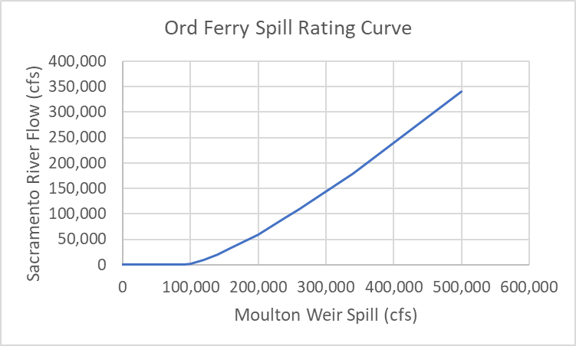

Figure 5‑7. Ord Ferry Spill Rating Curve used in CalSim II and USRDOM modeling.

Sacramento River flow at Moulton Weir () is estimated by adding the flow downstream of Ord Ferry to the change in flow between Ord Ferry and Moulton Weir (). The change in flow between Ord Ferry and Moulton Weir is computed by taking the difference between the CalSim II monthly average estimates of flow upstream and downstream of Moulton Weir, C117 and C123. Both parameters are converted to daily timesteps by using the daily pattern ratios developed for flows in the upper Sacramento River as simulated by USRDOM.

|  |  |
| --- | --- |
|  | (5‑5) |

Where:

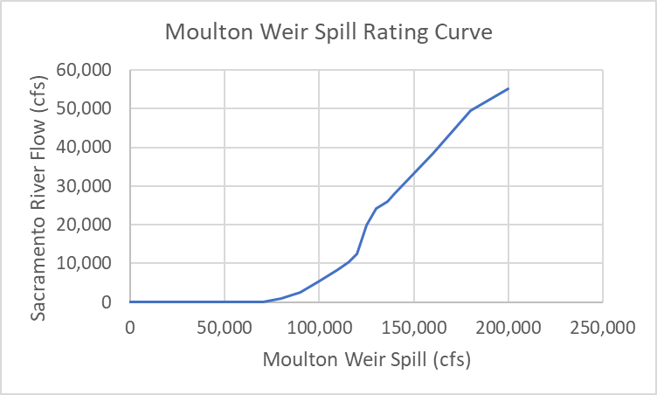

Figure 5‑8. Moulton Weir Spill Rating Curve used in CalSim II and USRDOM modeling.

The Colusa Weir is situated downstream of the Moulton Weir. Accordingly, the flow upstream of the Colusa Weir () is estimated using the following mass balance calculation:

|  |  |
| --- | --- |
|  | (5‑6) |

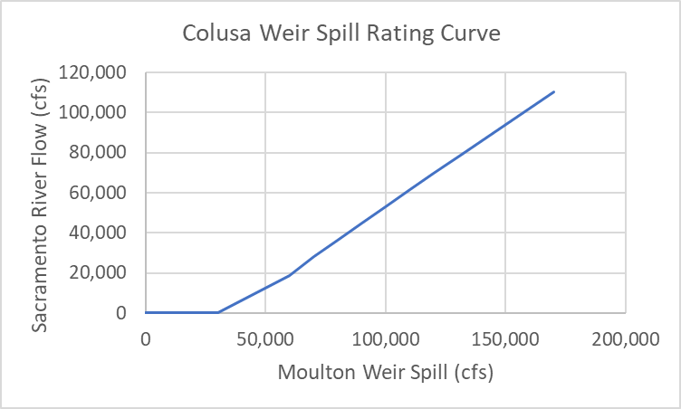

Figure 5‑9. Colusa Weir Spill Rating Curve used in CalSim II and USRDOM modeling.

## Tisdale Weir Spill

Tisdale Weir spill is estimated based on daily Sacramento River flow () using the rating curve shown in Figure 5‑10. The “without notch” curve was developed in the Sacramento and San Joaquin River Basins Comprehensive Study (California Reclamation Board and Corps, 2002) and is used in CalSim II and USRDOM modeling. The “with notch” curve is consistent with the Tisdale Weir Project included in the Sacramento River Voluntary Settlement Agreement (MBK, 2019), which assumes the notch to operate from December 1st through March 15th each year. Although Tisdale Weir notch operations are included in the CalSim II code, they are turned off and not used to determine Tisdale Weir spills in Benchmark models.

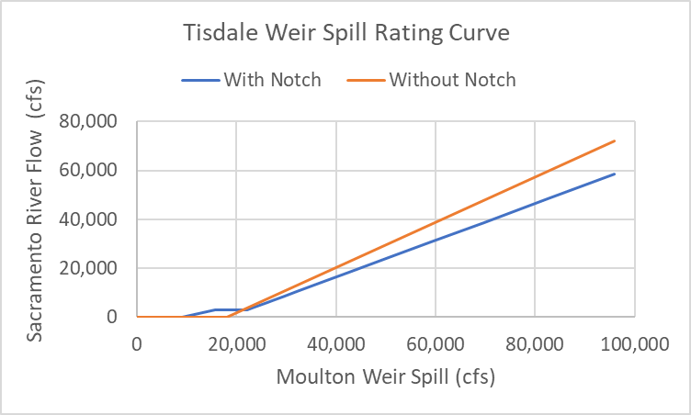

Figure 5‑10. Tisdale Weir Spill Rating Curves in CalSim II modeling.

## Sutter Bypass Flow

The Sutter Bypass flow is estimated based on daily weir spills and monthly flows that are converted to daily flows using regulated daily patterns.

|  |  |
| --- | --- |
|  | (5‑7) |

Where:

Average monthly flow at Butte Slough

Average monthly flow for the Sutter National Wildlife Refuge

Average monthly return flows into the Sutter Bypass

daily pattern of regulated flows at Keswick, Clear Creek, and Stony Creek (based on USRDOM)

## Fremont Weir Spill

The Sacramento River flow at the Fremont Weir is denoted , where “i” represents the day of the month. This flow is computed as shown in Equation (5-8).

|  |  |
| --- | --- |
|  | (5‑8) |

Where:

Fremont Weir spill is estimated based on daily Sacramento River flow () using the rating curve shown in Figure 5‑11. It is assumed that the proposed Fremont Weir notch will be operated from November 1st through April 31st. Without the notch, CalSim II assumes that Fremont Weir spills when flow in the river () exceeds 50,500 cfs. With the notch, spills are assumed when flow in the river exceeds 12,532 cfs. The rating curves used to estimate spills over the weir, with and without the notch, are shown in Figure 5‑11. These assumptions are consistent with those used for ROC on LTO analysis (2019). In CalSim II, Fremont weir spills are denoted as when the notch is operating and as when the notch is not operating.

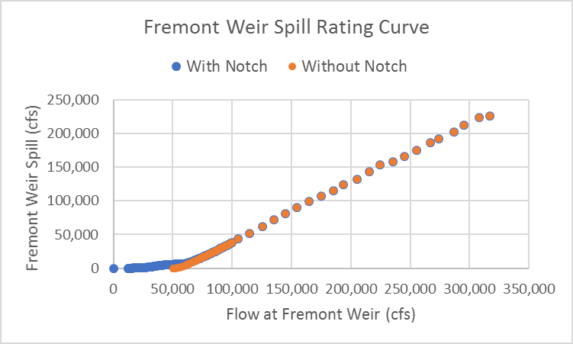

Figure 5‑11. Fremont Weir Spill Rating Curves in CalSim II and USRDOM modeling.

## Sacramento River flow at Verona

For verification purposes, daily Sacramento River flow at Verona is computed using CalSim’s daily pattern parameters, averaged on a monthly basis, and compared to CalSim’s monthly output for Sacramento River flow at Verona, C160. The daily estimation of Verona flow is calculated using Equation (5-9).

|  |  |
| --- | --- |
|  | (5‑9) |

Where:

## Sacramento Weir Spill

Daily Sacramento Weir spills () are estimated based on Sacramento River overflow, as defined by Qsac165amr303 in Equation (5-10). In CalSim II, the Sacramento Weir is located at node 166, which has 5 monthly arcs that feed into or out of it. CalSim II does not have a daily parameter that corresponds directly to C165, which is the Sacramento River flow contribution to Node 166. Additionally, CalSim II does not have daily computations for the inflow and outflows between the Sacramento Weir and Verona (i.e., D163, D165, D165A). As a result, CalSim II estimates the daily Sacramento River flow contribution to Node 166 by taking the difference between the monthly Sacramento River flow at the Sacramento Weir (C165_prv) and the average daily-computed Sacramento River flow at Verona (qsac160_prv) of the previous cycle. This provides an estimate of the net inflow and outflow between Node 162 and Node 165 on a daily time-step.

|  |  |
| --- | --- |
|  | (5‑10) |

Where:

The confluence of the Sacramento River and American River is just downstream of the Sacramento Weir. When the American River flow is high, it often contributes to the overflow at the Weir. As the proportion of American River flow that contributes to weir spills correlates to flow rate, an analysis of this correlation led to the following rules that govern the American River contribution to Sacramento Weir spills:

1. If :
2. If :
3. If :
4. If :

The rating curve used to estimate spills over the Sacramento Weir is shown in Figure 5‑12. Spill begins when river flow () exceeds 60,220 cfs.

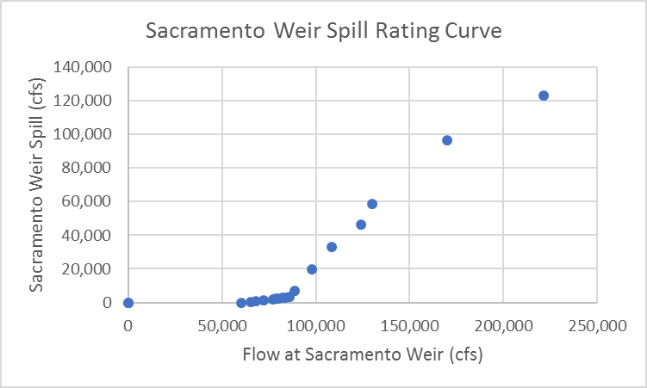

Figure 5‑12. Sacramento Weir Spill Rating Curve in CalSim II.

# Results

Results of the Benchmark 011721 HIST CalSim II model were used to evaluate the effectiveness of the daily pattern logic in simulating Sacramento River flow and weir spills. Daily outputs from the model were compared against historic records from USGS. Table 5‑6 includes the parameters and periods used in this analysis.

Table 5‑6. Parameters and Dates used for Daily Pattern Verification.

|  |  |  |  |
| --- | --- | --- | --- |
| **Parameter** | **Historic Record ID** | **CalSim II Daily Output** | **Period of Record** |
| Fremont Weir Spill |  | USGS 11391021 | 01/01/1947 – 09/29/1975 |
| Sacramento River Flow at Verona |  | USGS 11425500 | 10/1/1964 – 9/30/2003 |
| Sacramento Wier Spill |  | USGS 11426000 | 09/30/1943 – 09/30/2003 |

Table 5‑7 through Table 5‑9 compare average annual weir spills into the Yolo Bypass simulated by CalSim II and recorded by USGS gages for the complete period of record classified based on Water Year Type (WYT). These tables are presented to provide a sense of the differences between the Benchmark 011721 HIST simulation and historic records. Often, the monthly CalSim II outputs do not match with monthly average historic data. Consequently, the effectiveness of the CalSim II daily pattern logic should be measured by evaluating sub-monthly trends in flow levels rather than total flow volumes.

Table 5‑7. Fremont Weir Spill Average Annuals – Historic vs CalSim II.

|  |  |  |  |  |
| --- | --- | --- | --- | --- |
|  | Fremont Weir Spill (average) (cfs) (WY 1947-1975) | |  |  |
| WYT | Historic (USGS) | CalSim II (Benchmark 011721 HIST 011221) | Difference (cfs) | Difference (%) |
| Long-term | 2,809 | 2,448 | 361 | 13% |
| Wet | 5,755 | 5,062 | 693 | 12% |
| Above Normal | 1,947 | 1,566 | 380 | 20% |
| Below Normal | 453 | 403 | 50 | 11% |
| Dry | 131 | 100 | 32 | 24% |
| Critically Dry | 0 | 0 | 0 | N/A |

Table 5‑8. Sacramento River Flow at Verona Average Annuals - Historic vs CalSim II.

|  |  |  |  |  |
| --- | --- | --- | --- | --- |
|  | Sacramento River flow at Verona (average) (cfs) (WY 1964-2003) | |  |  |
|  | Historic (USGS) | CalSim II (Benchmark 011721 HIST 011221) | Difference (cfs) | Difference (%) |
| Long-term | 20,471 | 19,290 | 1,182 | 6% |
| Wet | 28,117 | 26,151 | 1,966 | 7% |
| Above Normal | 22,389 | 21,401 | 988 | 4% |
| Below Normal | 15,637 | 15,416 | 221 | 1% |
| Dry | 13,950 | 13,204 | 747 | 5% |
| Critically Dry | 10,645 | 10,105 | 540 | 5% |

Table 5‑9. Sacramento Weir Spill Average Annuals – Historic vs CalSim II.

|  |  |  |  |  |
| --- | --- | --- | --- | --- |
|  | Sacramento Weir Spill (average) (cfs) (WY 1944-2003) | |  |  |
| WYT | Historic (USGS) | CalSim II (Benchmark 011721 HIST 011221) | Difference (cfs) | Difference (%) |
| Long-term | 223 | 182 | 41 | 18% |
| Wet | 558 | 450 | 108 | 19% |
| Above Normal | 179 | 148 | 31 | 17% |
| Below Normal | 7 | 13 | -6 | -90% |
| Dry | 0 | 1 | -1 | -338% |
| Critically Dry | 0 | 0 | 0 | N/A |

A post-processing tool was developed to compare historic records with the CalSim II outputs (the “Daily Patterns CalSim Verification” spreadsheet). For Benchmark 011721 HIST, the tool shows that modeled flow and weir spills trend closely with historic data. Figure 5‑13 through Figure 5‑15 show the Fremont Weir spill, Sacramento River flow at Verona, and Sacramento Weir spill in WY 1970 from December through April. In general, the sub-monthly trends in flow increases and decreases between simulated and observed data are relatively consistent. For example, all the Fremont Weir spills in December are allocated towards the end of the month. Additionally, there are two distinguished spikes in Fremont Weir and Sacramento Weir spills in the second half of January. Typically, differences in flow volumes are caused by discrepancies in monthly average estimates, which cannot be completely addressed by daily pattern factors. Limitations are further discussed in Section 5.

Figure 5‑16 through Figure 5‑18 show Sacramento River flow and weir spills for WY 1965. These figures also include 7-day averages to compare the weekly flow trends between the CalSim II simulation and historic records. For the most part, the CalSim II simulation closely matches the historic flow trends. In December, for example, the simulated and historic Sacramento Weir spills peak within one day of each other. Additionally, although the volume of Fremont Weir spill differs between CalSim II and historic records, the rate of change in 7-day average spill is often consistent between the two datasets.

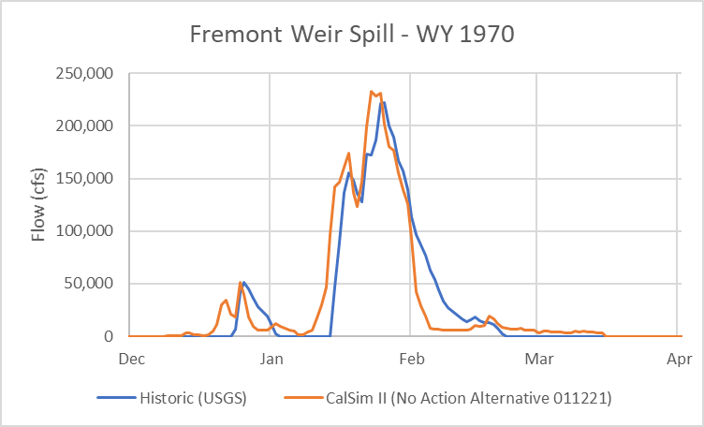

Figure 5‑13.Fremont Weir Spill in WY 1970 - Historic vs CalSim II.

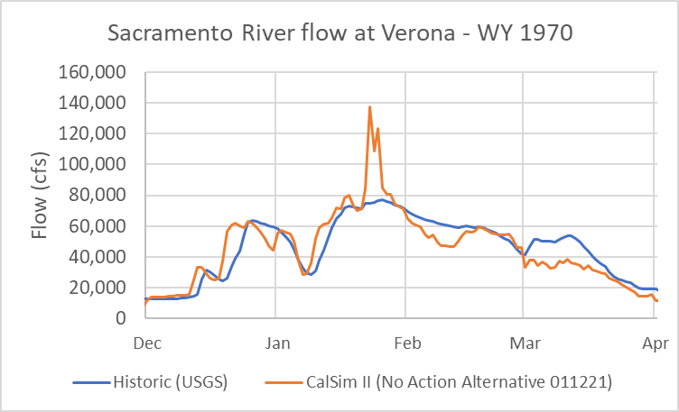

Figure 5‑14. Sacramento River Flow at Verona in WY 1970 - Historic vs CalSim II.

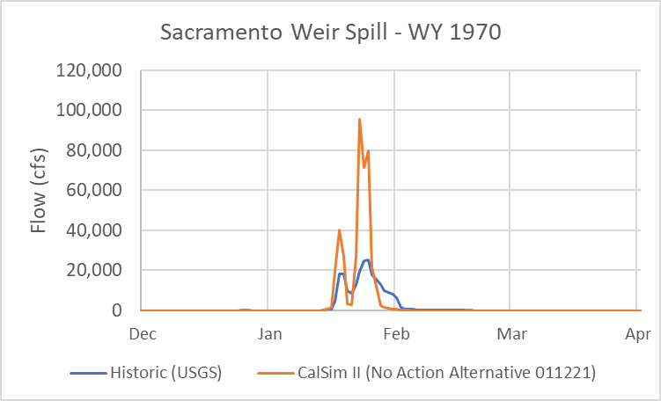

Figure 5‑15. Sacramento Weir Spill in WY 1970 - Historic vs CalSim II.

Figure 5‑16. Fremont Weir Spill in WY 1965 - Historic vs CalSim II (Benchmark 011721 HIST 011221).

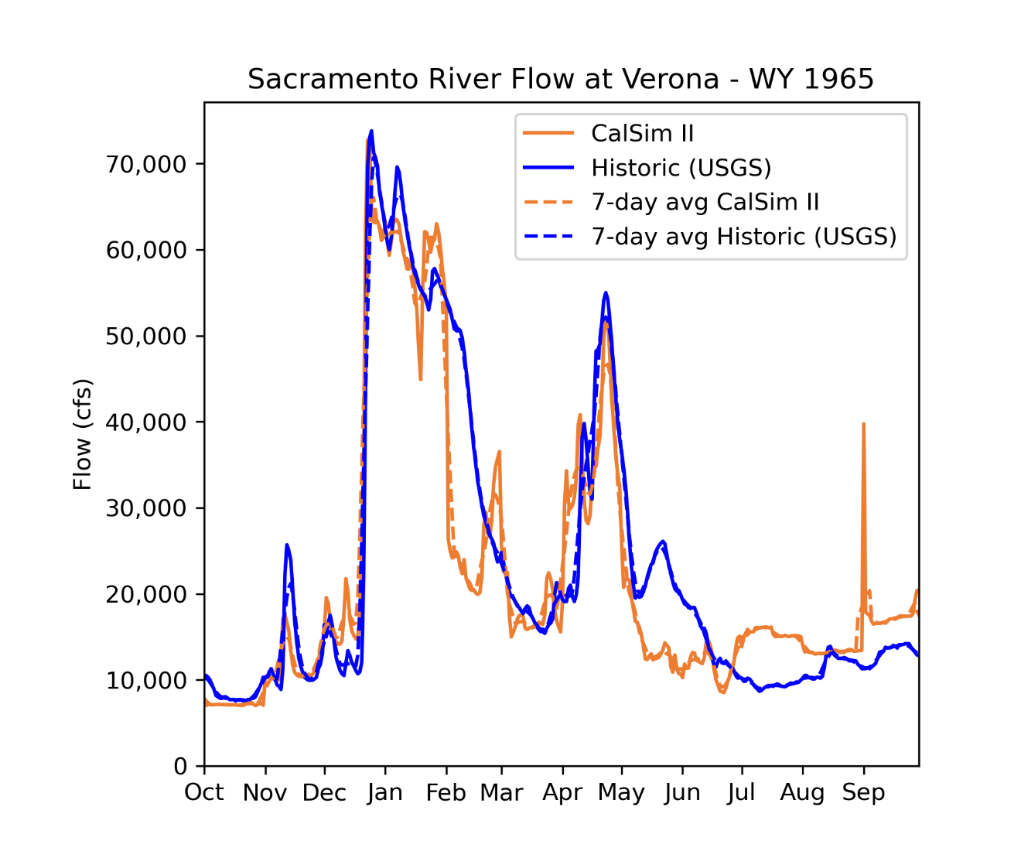

Figure 5‑17. Sacramento River Flow at Verona in WY 1965 - Historic vs CalSim II (Benchmark 011721 HIST 0111221).

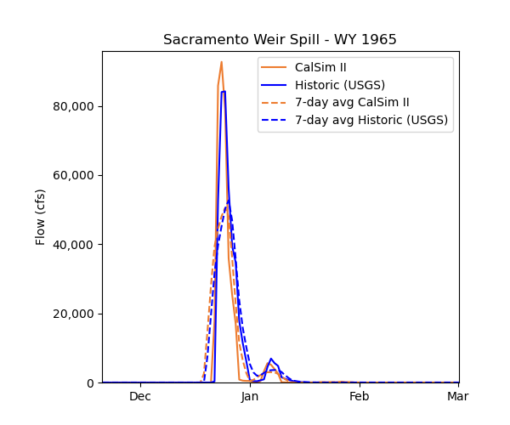

Figure 5‑18. Sacramento Weir Spill in WY 1965 - Historic vs CalSim II (Benchmark 011721 HIST 011221).

# Limitations

Daily patterns were developed for four parameters: (1) regulated Sacramento River flow above Ord Ferry, (2) unregulated Sacramento River flow above Ord Ferry, (3) American River flow at Sacramento River confluence, and (4) Feather River flow at the Sacramento River confluence. All other daily flow estimates are computed through mass balance calculations. Daily flow and weir spill estimates could be improved with more daily pattern inputs. However, doing so would require an increase in the availability of flow data.

The accuracy of daily flow estimates is limited by the accuracy of corresponding monthly flow estimates. If the monthly average volume of flow simulated by CalSim II differs from the monthly average historic flow, then the daily volume of simulated flow will also differ from historic records. The daily pattern factors cannot improve the accuracy of CalSim’s average monthly estimates. Instead, the daily pattern factors serve to improve the daily shifts in flow throughout each month. The effectiveness of the daily pattern logic should be evaluated by comparing the day-to-day fluctuations in flows throughout each month.

# References Cited

California Department of Water Resources. Water Travel Times. 2016. Available: https://cdec.water.ca.gov/reportapp/javareports?name=water_travel_time_2016.pdf. Accessed: 2020.

California Reclamation Board and Corps. 2002. Sacramento and San Joaquin River Basins Comprehensive Study.

CDEC: California Data Exchange Center. 2021. CA. Available: https://cdec.water.ca.gov/. Accessed: 2021.

GEI Consultants. Water Travel Times Schematic. January 2016. Available: https://cdec.water.ca.gov/reportapp/javareports?name=water_travel_time_2016.pdf. Accessed: 2020.

MBK Engineers. 2019. *Technical Memorandum on Revised Tisdale Weir Notch Assumptions.* October 21, 2019.

USGS: U.S. Geological Survey. 2021. Available: https://www.usgs.gov/. Accessed: 2021.

1. https://cdec.water.ca.gov/reportapp/javareports?name=water_travel_time_2016.pdf