KROM Documentation

2019 Proposed Action

October 30, 2020

CADSWES: Neumann, Frischmeyer, Zagona

# Introduction

This report documents the Klamath RiverWare Operations Model (KROM) that represents the 2019 Proposed Action (2019 PA). This RiverWare model can be used to operate the system and reproduces the results of the Excel-based tool referred to as the **PA Calculator**. Throughout the report, the reader should be able to trace the data and computations from the PA Calculator into the KROM.

This document contains the following sections:

* Model: Description of the model layout, objects, physical processes, and data sources
* Operating Policy: Conceptual overview of the RiverWare rules that represent the 2019 PA operating policy
* Outputs: Description of the various ways to view results from the KROM
* Workflow and User’s Guide: Description of the steps the operator performs using the KROM that matches the workflow performed using the PA Calculator

# The Model

This section describes the run time range, model layout, the objects and methods used, and the data specified on the objects.

## Run Time Range

Like the PA Calculator, the KROM has a daily timestep that corresponds with the frequency of KBAO’s operating decisions for the Klamath River and Klamath Project.

The model always starts on October 1, of the previous year and finishes on February 28/29 of the subsequent year. Thus if we are operating the system in the summer of 2020, the model runs from October 1, 2019 to February 28, 2021.

KROM has sufficient time period of observed data and forecasted values so that decisions can be made appropriately and the overall trends can be seen in the results. The model contains a scalar slot called the **Operation Start Timestep** that tracks the date at which data is moved forward from observed to forecasted. It can be thought of as the day at which the system is being operated, often the current day. It could also be a previous day if the system has to be re-operated due to missing data, holidays, etc. Before the operation start timestep, the data and computations are in the “**observed period**” (after-the-fact computations). After the operations start timestep, the computations are in the forecast or “**predictive period**.” For a given operations start timestep date, for example, 7/4/2020, previous timesteps, 10/1/2019 to 7/3/2020, are driven by observed data. Future timesteps, 7/4/2020 to 2/28/2021, are predictive and driven with forecast data. As the operations start timestep progress through time, observed data replace forecast data. With this concept, the model always starts on the same timestep, but by modifying the operation start timestep, the operator can define the forecast calculation period.

## Model Layout

The workspace layout is a spatial representation of the Klamath River Basin’s physical features. Important river reaches, reservoirs, and irrigation canals are represented as objects on the workspace. Each object houses data in structures called “slots” while physical process are represented through solution and user selectable methods, such as flow routing, reservoir storage, and canal diversions. Figure 1. shows the workspace and the objects.

1. Workspace of the KROM, above the Lake Ewauna Gain object

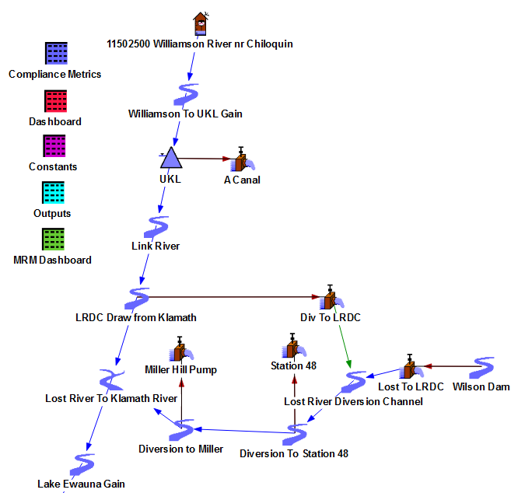

1. Workspace of the KROM, below the Lake Ewauna Gain object

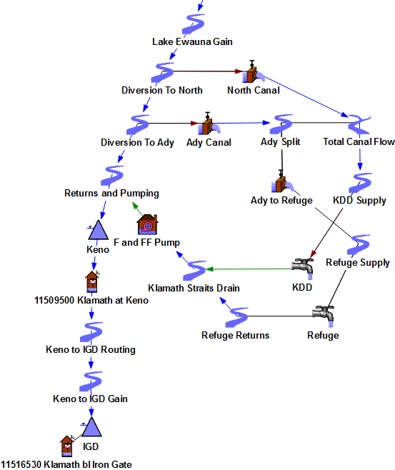

The headwaters of the model start at the Williamson River since it is the most upstream location with data in the PA Calculator. From the Williamson River, the layout represents locations on or directly adjacent to the Klamath River until Iron Gate Dam (IGD) where the most downstream releases are assigned. The Klamath River below IGD is not modeled as decisions in the KROM are based on meeting flows out of IGD.

In reality, the system is much more physically intricate than the layout shown. The modeled layout is simple to run operations rather than comprehensively model every process. The simplified representations of these sections are discussed next.

### Lost River Diversion Channel

The Lost River Diversion Channel (LRDC) system encompasses the section of the workspace that starts as the flows diverted from the Lost River at Wilson Dam and ends at the canal’s flow into the Klamath River. Additionally, it includes the transfer from the Klamath River to the LRDC. The flows from the Lost River to the LRDC are either input or forecasted. Sections upstream or downstream from Wilson Dam are not modeled.

### Klamath Project

The Klamath Project covers the network of canals, pumps, and water users on the workspace that make up the basin’s agricultural and refuge lands. These lands are classified into two regions, Area 1 and Area 2. Area 1 represents the Klamath Irrigation District (KID) and Tulelake Irrigation District (TID) including A Canal, Station 48, and Miller Hill Pump supply with diversions. Area 2 represents the Refuge and Klamath Drainage District (KDD) that North and Ady Canal supply with diversions. F/FF Pump returns runoff flow back to the Klamath River. Secondary reaches and diversion objects are represented in Area 2 to split flows between the two water users.

### PacifiCorp projects

The facilities managed by PacifiCorp include the stretch of objects on the Klamath River that start at Keno Dam, continue through both a lag and gain reach, and end at IGD. The gains and lag represent the lumped local inflows and losses between the reservoirs and total travel time between the workspace’s headwaters and tailwaters respectively. In addition to Keno Dam and IGD, PacifiCorp also manages two reservoirs between called JC Boyle and Copco 1 and another hydropower facility at Copco 2. These are excluded those from the model since PacifiCorp does not provide the logic nor data to solve for them.

## Objects and Methods

The physical features in the Klamath River Basin are represented by the following types of objects on the workspace: Storage Reservoir, Reach, Diversion Object, Water User, Confluence, Data Object, Inline Pump and Stream Gage. Each object represents physical processes and contains physical data that the model uses to route flows, as part of operating policies, and forecast hydrology.

### Storage Reservoirs

The Storage Reservoirs represent reservoirs with a release and spillways. Since Reclamation does not manage the basin’s hydropower operations, which is done by PacifiCorp, all the reservoirs are modeled as Storage Reservoirs. IGD’s energy production is also excluded. The reservoir’s storage is a function of the pool elevation, which the model determines with the Elevation Volume Table. In the PA Calculator, that table is available for UKL. For Keno and IGD, tables were provided by Reclamation from previous modeling studies[1]. On the Storage Reservoir, the total Outflow is composed of Spill and Release. In many models, Release represents a low flow control structure, while Spill represents either controlled gates or uncontrolled spillway crests. In this model, the Release represents the entire outflow; spill remains zero. Thus, the “Spill” method is set to “None”. Additionally, UKL directly supplies a diversion canal. Its “Diversion from Reservoir” method is set to “Available Flow Based Diversion”.

### Reaches

A Reach represents a section of the river that routes water downstream. In addition to downstream passage, reaches may have accretions (called Local Inflows in RiverWare), diversions, and sometimes lag the flow. Each process is described further:

* **Diversions:** The “Diversion from Reach” method is set to “Available Flow Based Diversion”, which creates a diversion slot that links to the adjacent Diversion Object. The LRDC Draw from Klamath, Diversion to Miller, Diversion to Station 48, Diversion to Ady, and Diversion to North are Reaches with this configuration.
* **Accretions:** If the accretion comes as an influx from the surrounding area, the “Local Inflow and Solution Direction” is set to “Specify Local Inflow, Solve Outflow” or “Solve Local Inflow”. This creates a slot to set or solve the hydrologic gain. The Reaches with “Gain” in their name use this method. If the accretion comes as a return flow from a pump, the Reach’s return flow slot is linked to the outflow slot of the pump, and set no method. The Returns and Pumping reach has this configuration.
* **Lag:** While incremental in reality, the model represents lag as a single lag on the Keno to IGD Lag object. For this Reach, the “Routing” method is set to “Time Lag”. The time lag duration is 3 days, which is taken from the PA Calculator, and is set on the lag time slot.

### Diversion Objects

A Diversion Object represents the physical structure that diverts water from a reach or reservoir. In the Klamath Basin, this is either a canal or pump, which transports water to the irrigation districts and/or refuge lands. The Diversion Object’s diversion slot links to the adjacent reach’s or reservoir’s diversion slot. As for the irrigation district and/or refuge lands, its diversion slot links to the Diversion Object’s outflow slot. The Diversion Object’s methods are as follows:

* “Diversion Object Solution Direction” category: “Solve for Outflow” method
* “Diversion Request” category: “Input Diversion Request” method
* “Available Flow” category: “Available Flow Diversion” method

### Water Users

A Water User represents irrigation districts or refuge lands along the Klamath River. On the Water User, the solution equations represent the diversion of water, depletion (consumption) and return flow of unused water. The return flow is not modeled since there is no explicit logic that computes it in the PA Calculator. Rather, the PA Calculator assumes that the return flow contributes some unknown portion to the accretion. The model includes the return flow for Area 2’s Water Users, KDD, since it can estimate the return flow proportions with algebra between the objects’ known physical processes. The algebra works because two canals divert water from the river and one pump returns it back. As for Area 1, the canals divert water, but lack the location where water returns back to the river. Thus, there are no Water Users in Area 1. The methods on the Water Users are as follows:

* “Diversion and Depletion Request” category: “Input Request” method
* “Return Flow” category: “Fraction Return Flow” method
* “Fraction Return Flow Input” category: “Input Fraction” method

### Inline Pumps

An Inline Pump is RiverWare’s representation of a pumping station. The “Inline Pump Solution Direction” category uses the “Solve Downstream” method, which prevents looping errors. No energy consumption or head is modeled in this model.

### Confluences

A Confluence represents a flow junction with two inflows and one outflow. The “Confluence Solution Direction” category is uses the “Solve Downstream Only” method to prevent looping errors.

### Stream Gages

A stream gage represents a point in the system where a gage collects data. Gage names include the USGS gage number.

### Data Objects

A Data Object is an object that holds user-defined data in the model. In this model, data is stored on a Data Object if it applies to multiple objects or is not location specific (i.e. climate scenarios and dates respectively). These objects have no methods and do not solve.. The Dashboard data objects holds slots that hold per run settings and account supply values. The Compliance Metrics data objects hold post processed slots, which are discussed near the end of the report.

## Data

Specified data and operating policy drives the model. The model imports data through a variety of methods. Operators have the option to manually enter data through scripts, SCT’s, or the slot viewer. Otherwise, the model automates the import process with the Data Management Interface (DMI), which links directly to the Excel workbook serving as a database. Also, data can be modified between runs to alter the input data. The run, as defined by the operator, varies by timestep, management decisions, and/or climate conditions. The frequency that data changes depends on the type. We define the types of data as follows: Per Run Settings, Observed Hydrology, and Hydrology Tables.

Note, in this text, we use the RiverWare notation Object.Slot. This indicates that the slot, a data variable, is on that particular object.

### Per Run Settings

Per Run Settings are those settings that the operator may change before each model run. They consist of adjustment factors and seasonal supplies for forecasts, switches for climate scenarios, exceedance percentages for table lookups, contribution percentages for accretions to Iron Gate Dam, and operation dates. Many of the settings vary by their period of application. Some apply for a week, others for a month, and some for an entire season. The operator has access to change that period along with their value. Table 1. shows the inventory of the slots.

1. Objects and their slots that represent the Per Run Settings.

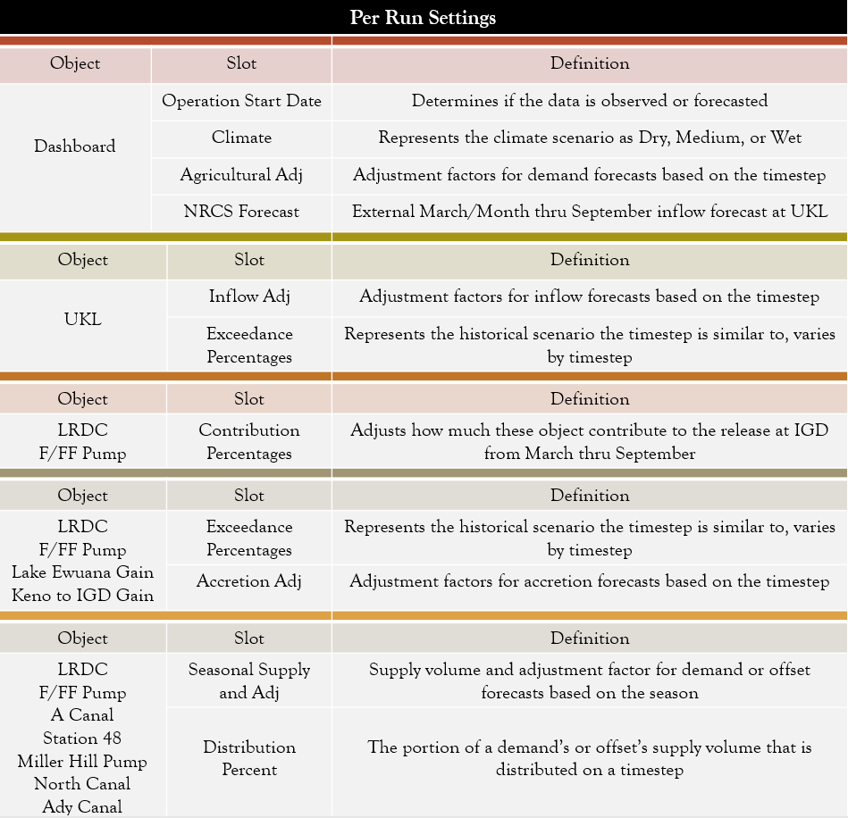

In the model, these settings are stored typically as scalars or tables. If the slot is location specific, such as the seasonal volume adjustment factor for Ady Canal, that data is stored on the object itself (i.e. Ady Canal.Season Adj). Otherwise, data that applies to multiple locations are stored on data objects, such as the climate scenario switch (i.e. Dashboard.Climate).

Scripts and system control table (SCT) sheets provide access for the operator to view and edit the Per Run Settings.

### Observed Hydrology

The observed hydrology are the flow and other values that have been measured throughout the basin from the run start date until the operation start timestep. The operation start timestep can be thought of as the day at which the system is being operated, often the current day. It could also be a previous day if the system has to be re-operated due to missing data, holidays, etc. The operation start timestep is used to determine whether the data is in after-the-fact mode (observed hydrology) or is in a forecast mode. Thus, if either the run start or operation start timestep changes, so must the hydrology data in the model. Observed hydrology takes the form of accretions to or diversion from the Klamath River, inflows at Upper Klamath Lake (UKL), releases at Iron Gate Dam, external volumetric forecasts for the season, or etc. Reclamation stores this data in an external file or database. Figure 4 shows the inventory of the Observed Hydrology slots.

1. Slots that represent the Observed Hydrology.

|  |  |  |
| --- | --- | --- |
| Type of Data | Slot Name | Notes |
| Inflows | 11502500 Williamson River nr Chiloquin.Gage Inflow |  |
| Reservoir Elevation | UKL.Pool Elevation |  |
| Accretions | Lost River Diversion Channel. Inflow |  |
| F and FF Pump.Inflow |  |
| Keno to IGD.Local Inflow | This represents the PacifiCorp accretions. |
| Diversions | A Canal.Diversion Request |  |
| Station 48.Diversion Request |  |
| Miller Hill Pump.Diversion Request |  |
| Ady Canal.Diversion Request |  |
| North Canal.Diversion Request |  |
| Ady to Refuge.Diversion Request | The portion of the Ady Canal that goes to the refuge. |
| Releases | UKL.Link River | Releases from UKL to Link River |
| UKL.Keno Power Canal.Outflow | Power releases. The UKL.Outflow is the sum of Link River and Keno Power Canal |
| 11509500 Klamath at Keno.Gage Inflow | This represents the total release from Keno |
| 11516530 Klamath bl Iron Gate.Gage Inflow | This represents the total Outflow from IGD |
| Miscellaneous | Miller Hill Pump.Spill |  |
| Dashboard.Sukraw Well | Total pumping from the Sukraw Wells. |

These slots are time series since the measurements occur over the run period. The model imports the data from an external database (Excel file) with a DMI.

### Hydrology Tables

Hydrology tables store data for several forecast and release computations. Hydrology tables remain constant through a year and are only updated occasionally. Tables range from datasets for the minimum/maximum releases at the major reservoirs, flood control pool elevations, daily forecasts at multiple locations, and UKL trajectory correction factors. Figure 5 shows the inventory of Hydrology Tables’ slots.

1. Objects and slots that represent the Hydrology Tables. EP is short for Exceedance Percentages, the values in the parenthesis show the exact ones used.

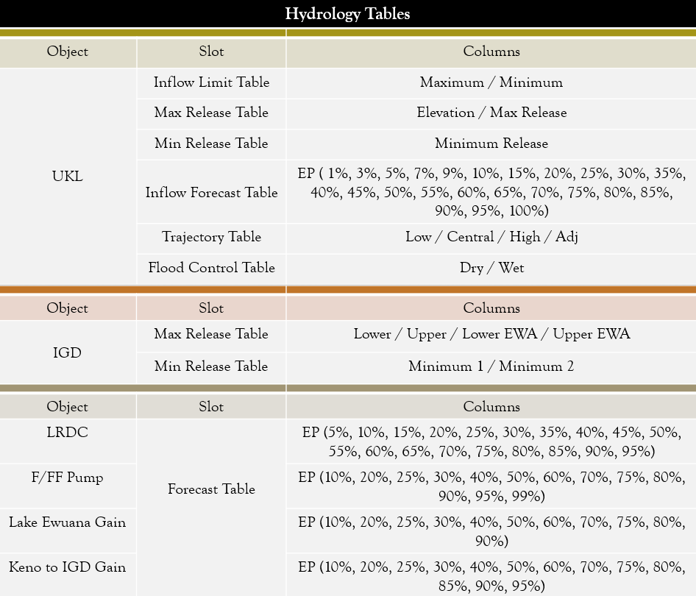

Most Hydrology Tables are periodic table slots since the rows vary by date or month. The exception is UKL’s maximum release table, which is elevation based. Since these don’t change frequently, the operator can access the object to get to the relevant table (i.e. the Iron Gate Dam Maximum Release Table is on the Iron Gate Dam object.) No data objects are required since the tables are all location dependent.

# Operating Policy

This section describes the operating policy that is modeled in the KROM 2019 Proposed Action. The description is conceptual in this section, but detailed documentation and descriptions of individual rules can be found in a separate appendix “KROM_RuleAndFunctionDocumentation.html”.

For the KROM, the main goal of the operating policy is to determine the flows from Upper Klamath Lake and Iron Gate Dam necessary to satisfy the Biological Opinion (BiOp) requirements for flows in the river. The secondary goal is to provide information to the operator on how the remainder of the season or year may play out due to the forecasted hydrology, demands, and accretions. The operating policy or rules can be split into two components, pre-simulation or initialization rules that happen once at the start of the run, and simulation computations or rulebased simulation rules that happen within each timestep.

## Pre-Simulation Computations

Pre-simulation computations process the imported data to set up the run. These computations forecast hydrology and demands from the operation start timestep to the run finish timestep. Additionally, they compute the seasonal account supplies from the NRCS inflow forecasts. The model performs the pre-simulation computations with the initialization rules, which execute during the initialization phase that precedes the run. Each initialization rule computes values over a period that varies per pre-simulation computation (i.e. operation start timestep through run finish timestep).

### Hydrological Forecasts

Hydrological forecasts generate accretions and flows for the basin from the operation start timestep to the end of the run. The locations with forecast policies are as follows:

* UKL.Inflow,
* LRDC.Inflow,
* Lake Ewauna.Local Inflow,
* F/FF Pump.Inflow, and
* Keno to Boyle Gain.Local Inflow.

The last four slots are the accretions. Reclamation bases all the forecasts on historical hydrology and uses adjustment factors to tailor it for the operating year’s conditions. A value is forecasted for each timestep from the operation start timestep to the run finish timestep. The operator can view the forecasts from the slot viewer or SCT sheets.

#### UKL Inflow

The inflow forecast at UKL is a two-step process.

1) The policy looks up an inflow from the “UKL.Inflow Forecast Table” with the exceedance percent and date as the parameters.

2) The policy adjusts the lookup value with an adjustment factor based on how far the timestep is past operation start timestep.

The policies manipulate the inflow at UKL to find the 60-day normalized, maximum, and minimum average inflow. Those values are utilized for the UKL Central Tendency Controlled Release policy described on page 13.

#### Accretions

The accretion forecasts, for each location, are a two-step process.

1) If the timestep is less than a week past the operation start timestep, the policy computes the accretion as the average of the past week’s accretion. Otherwise, the policy looks up an accretion from the “River Accretion*.Forecast Table” with the timestep appropriate percent and date as the parameters.

2) The policy adjusts the lookup value (not the average) with an adjustment factor based on how far the timestep is past operation start timestep.

The simulation computations then further manipulate the accretions to determine the agricultural and environmental demands they satisfy. This affects allocations since accretions can supply demands without a withdrawal from the seasonal account volume. Thus, more supply is leftover for other or later demands.

### Demand Forecasts

Demands forecasts are requests; they are only met if the policies allow for it (i.e. reservoirs release enough water). The objects that receive demand forecasts are the diversion objects, which represent the major canals/pumps. They transport water for the agricultural or refuge lands. The policy sets the demands on diversion request slots to ensure that the available flow limits it (See Diversion Object in Object and Methods). In tandem with the demands, the policy also forecasts offsets at the Lost River Diversion Channel and F/FF Pump. On a given timestep, offsets represent the expected flow that demands can utilize other than the release from UKL. They are theoretical and not physically modeled. Thus, the policy sets them on custom series slots. Offsets only serve to estimate the demands that the project supply does not have to allocate for. Demands and offsets are forecasted for each timestep from the operation start timestep to the run finish timestep. In the computation, the recent demands or offsets have no direct effect on the future values. However, if the operator expects the demands to exceed the account supply based on past use or offsets to decrease based on the precipitation forecasts, they can alter the adjustment factors. This limits future forecasts. From the objects, the operator can view the forecasts with the slot viewer or SCT sheets.

#### Agricultural

The agricultural demand and offset forecasts, for each location, are a two-step process.

1) The policy looks up the supply and adjustment factor from the “Agricultural Object*.Seasonal Supply and Adj” with the date as the parameter.

2) The policy multiplies the following factors: distribution percent, supply, and adjustment factor.

The simulation policies manipulate the agricultural demands and offsets to determine how much UKL releases for agricultural demands on a daily basis. If there's water stress, the operator can alter adjustment factors to limit the supply from UKL.

#### Refuge Lands

The refuge diversion forecasts are a constant distribution from the beginning of December thru the end of February. Over this period, the policy allocates 11,000 acre-ft for the refuge. Thus, on each timestep, the refuge’s diversion request is equivalent to 62 cfs. During the rest of the year, upper management assigns diversion requests based on water availability. These enter the model as inputs and have little foresight (i.e. assigned a few weeks before or reported after the fact). As an alternative diversion source, management can pump water from Tule Irrigation District to the refuge. This is represented as an input local inflow on the Refuge Supply object. The simulation policies manipulate the refuge diversions to approximate the return flows it sends to the Klamath River.

### Account Supplies

Each year, Reclamation assigns UKL’s expected spring through summer supply between two main objectives, agriculture or “Project Supply” and the “Environmental Water Account (EWA)”. Since both are products of the NRCS inflow forecast, which updates monthly from March thru July, they update with the same frequency. The model computes each account available supply on every timestep from the run start date to the run finish timestep. Their slots are found on the Dashboard data object. The model tracks the account’s use and remaining volume on a daily timestep. The SCT sheet that presents their slots includes the Account Supplies as well.

#### UKL Supply

The NRCS inflow forecast, end of February storage, and target storage at the end of the spring/summer contribute to the projected volumetric supply at UKL. The computation is the sum of the inflow forecast and February storage, minus the target storage.

#### Environmental Water Account (EWA)

Along with the UKL Supply, the policy uses the Boat Dance Supply to compute the EWA. The Boat Dance Supply is an allocation for a tribal ceremony that occurs on every odd numbered year. The policy’s computation takes a one-step if/then structure:

If the UKL Supply is greater than 1,035 KAF, the EWA is the UKL Supply minus 350 KAF. Else, the EWA is the sum of the Boat Dance Supply and the maximum of 400 KAF or the output of a second order equation that uses the UKL Supply as the input.

#### Project Supply

Once the EWA is set, the policy allocates the remainder of the UKL Supply for the Project Supply, but it includes a few conditions. The first condition is a reduction factor, the Project Supply Reduction. It is set by the operator if they think UKL’s May thru June inflows are going to be less than the forecast. The EWA experiences no reduction since the policy dictates it has a higher priority. The second condition is a floor allocation, the Project Supply April Lock. This dictates that the Project Supply can be no less than its volume in April. If that volume is unavailable, the storage at UKL is drawn down within limitations, which means the end of season target storage is not met. The policy’s computation is a two-step process.

1) It takes the difference between the UKL Supply and the sum of the EWA, Project Supply Reduction, and 7.436 TAF. The 7.436 TAF represents the estimated ungauged diversions.

2) If the operation start timestep is after April, it takes the maximum of the difference value and the Project Supply April Lock. Else, it assigns the difference value from step one.

## Simulation Computations

As described in Run Time Range section on page 1, the run consists of a 16 month range from Oct 1 to the end of the second February. Based on the operations start timestep, the computations are either an observed period before the operations start timestep or a predictive period after the operations start timestep. The following sections describe how the objects solve during each period.

### Observed Period

During the observed period, the rules execute but have no effect on the simulation objects. Instead the input values drive the solution. In particular, the key objects solve as follows:

* UKL solves for Inflow given Pool Elevation and Outflow. The Inflow propagates upstream.
* Given Williamson River flows at the gage and computed UKL Inflows, the Williamson to UKL Gain reach can solve for Local Inflow.
* All Diversions are specified as inputs and divert the specified amount from the linked source.
* Lake Ewauna Gain.Local Inflow, Keno to IGD Gain.Local Inflow, and F/FF pump flows are specified as inputs.
* Thus, Keno is assumed to be constant elevation and solves for Hydrologic/Local Inflow given Inflow, Outflow and Pool Elevation
* Also, IGD solves for Storage and Pool Elevation given Inflow and Outflow.

### Predictive Period

Throughout the predictive period, after the operation start timestep, the model executes rules that determine the release at UKL and IGD. The objects solve as follows:

* UKL Inflow and all accretions are forecasted. Thus, UKL and IGD can solve for Storage and Pool Elevation given Inflow and Outflow.
* Keno is assumed to be constant elevation and solves for Hydrologic/Local Inflow given Inflow, Outflow and Elevation.
* Diversions are forecasted and divert the specified amount from the linked source.

The remainder of this section and the crux of the model are the rules to determine the UKL and IGD releases. Rules can fire and re-fire on a timestep if their dependencies change due to another policy’s rules. This feature is necessary since the rules often set conflicting values. The policies are as follows, from lowest to highest priority and in order of execution:

* Environmental Release
* Central Tendency Controlled Release
* Ramping and Minimums Release
* Flood Control Release.

Each policy is represented by a Policy Group in the ruleset that contains intermediate calculation and a rule that sets the UKL release and another that sets the IGD release. The policy coordinates these releases since the IGD release relies on the supply that the UKL release provides. Detailed documentation is presented in a separate appendix “KROM_RuleAndFunctionDocumentation.html”. After a rule sets both releases, the model has the necessary information to solve the systems of objects.

The remainder of this section describes the four areas. Again, these are executed in order of lowest priority to highest priority, the same order as listed.

#### Environmental Release

The Environmental Release keeps the river stage at a level that maintains a healthy habitat for the species in the Klamath River. It is critical that enough water is sent from UKL to sustain that stage below IGD. The logic that determines the release to satisfy this criteria is based on season. The early fall/winter logic establishes releases for spawning, the late fall/winter logic fills UKL, the spring logic allocates releases while conserving storage at UKL, and the summer logic distributes the supply that remains until fall.

#### Central Tendency Controlled Release

As a safeguard against excessive pool elevation drawdown at UKL, the Central Tendency Controlled Release rate allows the pool elevation to gradually rise and eventually reach the historical mean. In addition to the reservoir release, the policy imposes limits on the diversion request rates for the Refuge and KDD during the fall/winter season. The reservoir release and diversion request max rates are inversely proportional to the difference between the simulated and central tendency pool elevations (i.e. the larger the difference, the smaller the release or rate.) Logic for reservoir release remains constant from season to season. The diversion request max rate only remains active during the fall/winter season. For both, the central tendency pool elevation fluctuates throughout the year. It is lowest at the beginning of fall and highest during the middle of spring.

#### Ramping and Minimums Release

The ramping policy defines ramping as the gradual release reduction that prevents sharp drops from day to day. The logic and values for the ramping policy remains constant between seasons.

The minimums release policy defines the lowest allowable release that sustains the aquatic habitat. Minimum releases are stored on periodic slots, but can be adjusted by the operator if conditions dictate the minimums need to be raised or lowered. The logic that sets minimum releases remain constant, but the magnitude of the releases fluctuate based on the season.

#### Flood Control Release

The Flood Control Release ensures that UKL’s pool elevation does not overtop its dam. Commonly, the Flood Control Release persists for a brief period of around 4 to 15 days, which gradually decreases the pool elevation until it is under the flood control threshold elevation. The logic for flood control remains the same, but the curve values shift with the seasons. Additionally, the manager has the option to alter the flood curve that this policy implements. The options for flood curves are based on the NRCS forecast, and the operator chooses between the two options, wet or dry. The operator can change between curves from January thru March. After March, the curve is locked in.

# Outputs

The results or outputs of a run are stored in slot values, typically series slots. Operators use outputs to evaluate their management decisions. Additionally, they relay outputs to stakeholders, who use the information to plan for water availability in the coming season. Commonly, these slots are post processed into plots and metric values including period minimums or seasonal cumulative values. If the outputs surpass or violate a threshold, the operator can deem their management decisions inadequate. Threshold slots are located on the same object as the associated output slot. Many output slots are shown on an SCT sheet making it easier for the operator to evaluate a run.

Post processing results make the outputs easier to comprehend. The following sections describe three types of post processed outputs as follows:

* Cumulative Account Use
* Plots
* Compliance metrics
* Model Reports

## Cumulative Account Use

The Cumulative Account Use represents the total volume an account distributes across a set period. Operators track it to evaluate the extent that objectives are supplied (i.e. the degree of over or under allocation). There are four accounts that the operator tracks usage, which are the following: EWA, Project Supply, KDD Fall/Winter, and Refuge Fall/Winter. Of these, the EWA is the only account that is actively tracked within a timestep, in terms of the cumulative use. For the others, rules track the cumulative use on a daily timestep, at the end of the run. Since the allocations occur as releases from UKL, the rule converts the flow to volume and sums them over the period of interest. Table 4. shows the slots output for each account. The slots for the Cumulative Account Use appear on the same object as their Account Supply. Alternatively, they are found on the SCT sheet that presents the Account Supplies.

1. Slots that make up the Cumulative Account Use outputs.

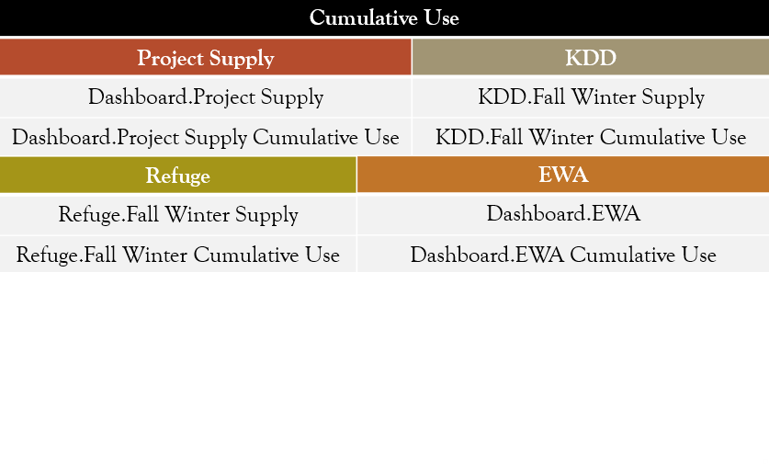

## Plots

Operators use Plots to visualize the pool elevation at UKL and release at IGD, Examples are shown in Figure 3. and Figure 4. , respectively. Each has time on the x-axis, which spans the entire water year. In addition, the operator can zoom in on the UKL pool elevation plot to see more detail such as the month of February as this month is important since it tracks how UKL fills before the agricultural diversions begin in the spring. The operator can view as well as edit the plots from the plotting feature.

See View Results: Run Range on page 27 for more information on the available plots.

1. Sample UKL elevation plot

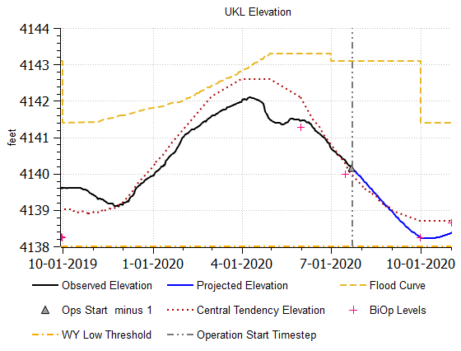

1. Sample IGD Flows plot

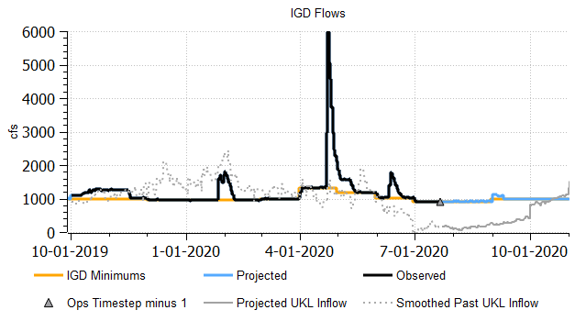

## Compliance Metrics

Compliance Metrics are policy defined criteria that a model run satisfies to be considered acceptable. If the model run fails to meet any of these criteria, the operator must alter their management decisions so that the compliance metrics are met. The model computes each compliance metric in a “Scalar slot with Expression”; each metric represents a single value. These slots are kept on one data object for convenient access. Additionally, they are presented on multiple output canvas. Figure 5. shows a sample of the compliance metric output canvas.

See View Results: Key Metrics on page 26 for more information on the available Output Canvas.

1. Sample Metric Output Canvas

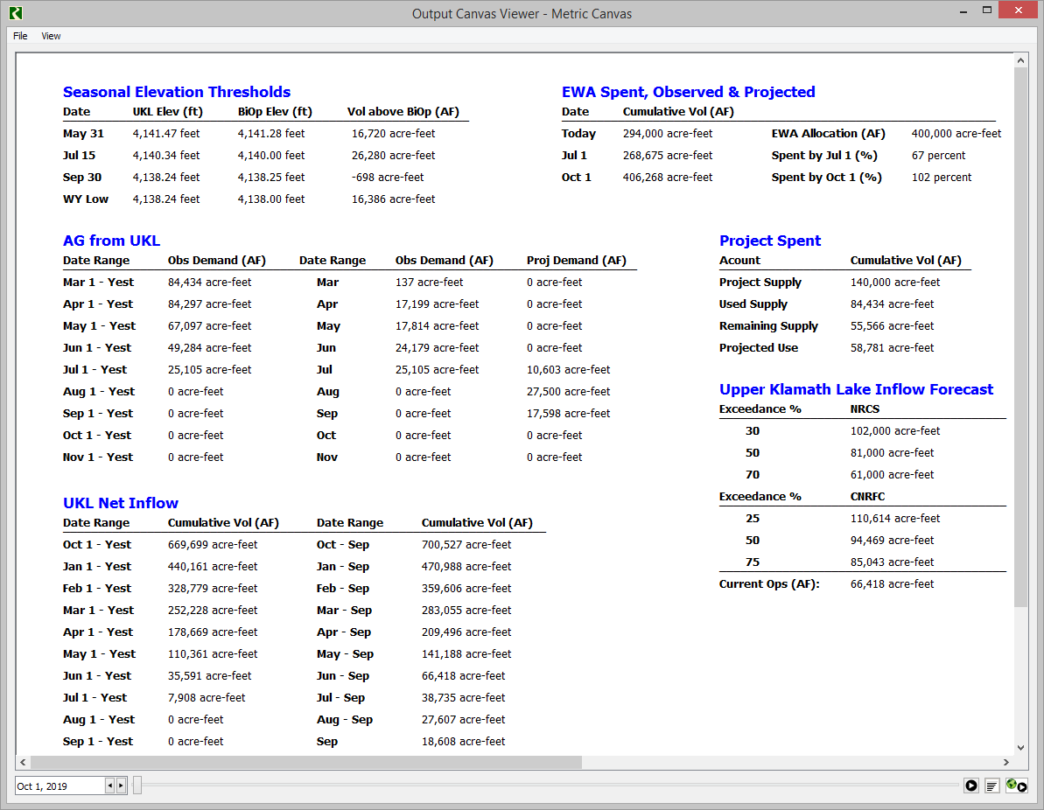

## Model Report

For the stakeholders, Reclamation sends out the model run projections in a RiverWare Model Report. The Model Report is a flexible output tailored in content and format by the model developer.

See “5) Generate Reports and Output Products” on page 33 for more information on the available Model Reports. With collaboration from the operator, additional reports can be developed that include the plots, charts, and tabular data that they want to communicate to the stakeholders and accompany those outputs with definitions and analyses (E.g. what is the EWA and how did affect this year’s operations?).

1. Sample USBR Daily Numbers Model Report output HTML file shown in a web browser

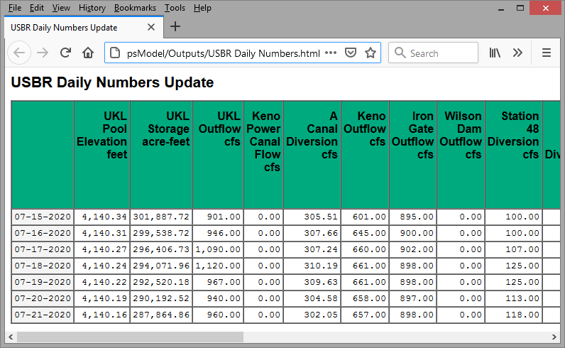

# Workflow and User’s Guide

This section describes the workflow for Reclamation’s Klamath Basin Area Office (KBAO) using the Klamath RiverWare Operations Model (KROM). The chapter is structured by the actions or steps the operator performs and the tools and utilities in RiverWare or externally that are used. We include a description and operator usage guide for both. As an overview, the operator performs the following order of procedures:

1. Acquire, review, and archive the data from external sources
2. Run setup scripts and assign settings and manual inputs in the KROM
3. Generate the official Iron Gate releases and projections based on observed and projected hydrology, respectively
4. Ensure modeled conditions are consistent with forecasts and results satisfy BiOp compliance metrics
5. Repeat steps 2-4 with different inputs/settings if either requirement is not satisfied
6. Prepare and run alternative hydrologic and demand scenarios
7. Generate reports and output products to deliver to stakeholders
8. Archive the model and data

Before opening RiverWare, the KLAMATH_OPS environment variable should be set to the KROM folder containing the models, database, SCTs, and other folders. There are many places in the KROM where files paths are specified and the use of these environment variables allows portability of the models among computers. Search the internet for setting environment variables for more information on how to set these variables.

The following sections describe the use of the following RiverWare utilities. We’ll give a brief overview here, more information can be found in the RiverWare help:

* RiverWare Scripts: scripts automate manual actions the operator performs on a consistent basis. A script has the flexibility to load rulesets, set scalar slots, execute DMI’s, and perform many other actions. Scripts automate actions that the operator would otherwise need to perform before each run.
* DMIs: The RiverWare Data Management Interface DMI automates import and export of data from any external database. In KROM, the DMIs connect to Excel files.
* SCTs: The System Control Table (SCT) is a useful and efficient tool to present and organize multiple slots with which the operator commonly interacts.
* Output Canvas: the Output Canvas provides spatially distributed information on a timestep by timestep basis. Also, it can be used to show a custom table of a data.
* Plots: The operator differentiates between variables based on the line/marker style or color. The plot’s key is present on the bottom panel of the window. If the operator wants to temporarily remove a line or marker, they click the legend item once. To add it back, they click it again. The operator opens the Plot Pages from the Output Manager after the completion of a run and select the plot by name.

## 1) Acquire, Review, and Archive Data

The “Daily Data Import WY 2020” workbook pulls data from the USGS and Hydromet systems. This is also the spreadsheet into which the operator inputs reported values. Additionally, the “Daily Data Import WY 2020 (Backup)” is the working Excel database used for quality assurance and archiving the hydrology and demands. This maintains the workflow for data acquisition and review when using the KROM to run operations as previously using the PA Calculator. Thus, the operator will continue to prepare data and override missing or incorrect data with these two workbooks.

To facilitate the import of data to the KROM, the Backup workbook now has another worksheet called KROM_Export with data in the format required by the RiverWare Data Management Interface (DMI). A comparison of the new and old connections are shown in figure 1 and the new connection discussed.

1. **1)** The existing file/tool connections that are used in KBAO’s daily operations. **2)** The file/tool connection alternative for transferring data to the KROM.

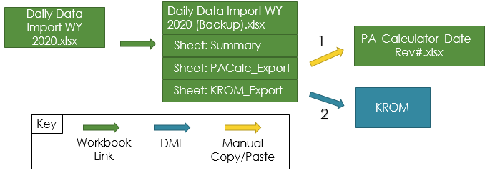

**Daily Data Import WY 2020 (Backup).xlsx -> KROM**

The “KROM_Export” sheet in the “Daily Data Import WY 2020 (Backup)” workbook formats the data for the DMI. Similar to the “PACalc_Export” sheet, it references the “Final” columns in the “Summary” sheet. The “Final” column contains the variable data that has been quality assured (QA) by the operator. Each column header in the “KROM_Export” sheet matches a slot in the KROM.

## 2) Prepare the Model for Today’s Use

After reviewing and archiving the data in the Excel workbooks, the operator opens RiverWare and loads the KROM from yesterday.The model contains both the global function set (GFS), which is necessary as it is referenced by other policy sets, and the ruleset that carries out the operation policy.

The model is configured to automatically run a script “Open SCT and Scroll” that does the following:

* **Open SCT:** This opens the SCT that the operator will use to set manual inputs. It opens **KlamathOps2019PA.sct,** the System Control Table that contains the slots with manual input requirements. The series slots are organized by operating objective, whereas, the scalar, periodic, and table slots are organized by slot name (i.e. slots of the same name are grouped, such as “Distribution Percent” table slots on the diversion objects).
* **Global Scroll:** Set all time dependent windows to the current operations start timestep, often yesterday.

Next, the operator must prepare yesterday’s KROM for today’s use, the operator performs the following steps:

1. Execute the Script to Prepare for Operations:
   1. Clear Previous Run’s Hydrology
   2. Setup Timestep Parameters
   3. Import New Hydrology
2. Enter new setup data required for the run:
   1. Set Series Slots
   2. Set Scalar Slots
   3. Set Table and Periodic Slots

These steps are described in the following subsections. When complete, the model is ready for the initial run.

### Execute the script to Prepare for Operations

Run the script **Prepare Single Operations Run.** This script automates tasks that the operator would otherwise manually perform when operating the model. Each individual task this script performs corresponds to a script action. Some actions ask for the operator’s input and others require no interaction to set up. This script is likely only run once per operations day. The subsections correspond to areas of the script.

#### Setup Timestep Parameter

This section of the Prepare for Operations script contains the action that sets the Operation Start Timestep.

The script executes the **Set Scalar Slot Value** action which sets the Operation Start Timestep. If no date is entered, today will be used. Otherwise enter the date to use.

#### Clear Previous Run’s Hydrology

This section of the Prepare for Operations script includes the actions that clear the input hydrology that was used in previous runs. This is necessary as the Operations Start Timestep could be moved earlier in time for re-running a date. The following three actions are used to clear the values in the slots listed in Table 5.

**Clear DMI Values:** This clears the values imported by the last activation of Observed Hydrology DMI.

**Set Series Slot Values:** This clears the values set by initialization rules with a Z flag. It does this by setting the values to “NaN”. There will be multiple of these actions, which are differentiated by type of hydrology. See table 2 for a breakdown of the slots.

**Set Series Slot Flags**: This sets the flags on the slots to Output so they can be cleared the next run.

1. Slots cleared from previous runs.

|  |
| --- |
| Slot Name |
| Keno.Storage |
| UKL.Storage |
| 11502500 Williamson River nr Chiloquin.Gage Inflow |
| UKL.Pool Elevation |
| Lost River Diversion Channel. Inflow |
| F and FF Pump.Inflow |
| Keno to IGD.Local Inflow |
| A Canal.Diversion Request |
| Station 48.Diversion Request |
| Miller Hill Pump.Diversion Request |
| Ady Canal.Diversion Request |
| North Canal.Diversion Request |
| Ady to Refuge.Diversion Request |
| Ady Canal.to Ag |
| UKL.Link River |
| UKL.Keno Power Canal.Outflow |
| 11509500 Klamath at Keno.Gage Inflow |
| 11516530 Klamath bl Iron Gate.Gage Inflow |
| Miller Hill Pump.Spill |
| Dashboard.Sukraw Well |

#### Import data from the Backup sheet

This section of the script has the action that imports basin hydrology based on the timestep parameters. The Execute DMI action executes the “Input Hydrology” DMI which imports data from the Backup Excel sheet. The DMI is configured to import the following slot values:

1. Slots imported

|  |
| --- |
| Slot Name |
| 11502500 Williamson River nr Chiloquin.Gage Inflow |
| UKL.Pool Elevation |
| Lost River Diversion Channel. Inflow |
| F and FF Pump.Inflow |
| Keno to IGD.Local Inflow |
| A Canal.Diversion Request |
| Station 48.Diversion Request |
| Miller Hill Pump.Diversion Request |
| Ady Canal.Diversion Request |
| North Canal.Diversion Request |
| Ady to Refuge.Diversion Request |
| Ady Canal.to Ag |
| UKL.Link River |
| UKL.Keno Power Canal.Outflow |
| 11509500 Klamath at Keno.Gage Inflow |
| 11516530 Klamath bl Iron Gate.Gage Inflow |
| Miller Hill Pump.Spill |
| Dashboard.Sukraw Well |

For most slots, the DMI imports values in the range of three timesteps prior to the Start Timestep until the timestep prior to the operation start timestep. There are a few exceptions. The UKL Inflow is pulled starting at 60 timesteps prior to the Operation Start Date. The Keno to IGD Accretion is pulled until the timestep that no data is available.

### Enter New Setup Data Required for the Run

Next, the operator will likely need to specify some data manually. For manual inputs, it can be tedious to open multiple slots from the objects. The System Control Table (SCT) is a useful and efficient tool to present and organize multiple slots that the operator commonly interacts. The SCT present the slots that require daily or per run manual inputs from the operator.

The **KlamathOps2019PA.sct** presents an organized view of the slots requiring manual inputs from the operator. The top-level of organization is done by slot type. Separate tabs contain either the series, scalar, or other slots. The next level of organization varies. The series slots are grouped by operational objective, which are labeled on the slot dividers. Whereas, the scalar, periodic, and table slots are organized by naming conventions. The operator inputs values for multiple purposes. Series slots are generally overrides or reported values from collaborating agencies. Thus, the operator enters values based on availability of information. The scalar, periodic, and table slots are typically the adjustment factors or dates that control hydrologic or demand forecasts. The operator sets values that produce seasonal volumes they expect to occur. Each subsection is broken down by the top-level organization method, slot type.

#### Set Series Slots

Edit the following slots as desired on the Per Run Settings worksheet tab of the SCT:

* UKL.Ag Override: sets overrides when the forecasted values fail to match up with expected demands/hydrology in the basin based on recent field observations. Thus, they are usually set in the range of a week or two after the operation start timestep.
* Keno to IGD Gain.Accretion Override
* Lost River Diversion Channel.Accretion Override
* UKL.Inflow Exceedance: make the model forecast UKL inflows consistent with the NRCS Inflow Forecast. They input a value for each month.
* Dashboard.Pacificorp Borrow: sets the PAC Balance or Flow Requirements from reports from PacifiCorp and Fish and Wildlife Services (FWS), respectively. Reports are commonly available in this range.
* Dashboard.Pacificorp Payback
* Dashboard.May June Augment
* Dashboard.Flex Release
* IGD.Flood Accounting Switch
* UKL.Flood Accounting Switch: activate when you want the UKL Credit account to accrue the portion of release assigned for flooding. This is done when the operator expects flooding, which spans from a week to a few months out depending on the year’s hydrology.
* Refuge Supply.Local Inflow: This represents the reported pumping from the Tule Irrigation District. The operator inputs these in the observed period since KBAO gets their reports after the pumping has occurred.

#### Set Scalar Slots

Edit the following slots on the Scalar Slots tab of the SCT:

1. Scalar Slots to consider setting

|  |  |
| --- | --- |
| **Initial Value Slots** | **Logic Switches** |
| UKL.Initial Credit | F and FF Pump.Average Switch |
| UKL.Initial Difference Ratio | Lake Ewuana Gain.Average Switch |
|  | Lost River Diversion Channel.Average Switch |
|  | Keno to IGD Gain.Average Switch |

The following items are notes on this process:

* The Initial Value Slots use the previous timestep’s value in the current timestep’s computation. Typically, the operator sets these values to zero. The Initial Value Slots may be changed if it is part of the scenario's parameters. Otherwise, the operator leaves them as is for subsequent runs.
* The Logic Switches turn on or off the moving average logic in the Accretion Forecasts initialization rule. By default, these are left on. The purpose of the moving average logic is to smooth the transition from observed to projected accretions. If the values computed by the smoothing fail to match what the operator expects to see in the field, they turn off the moving average logic with the Logic Switch.

#### Set Periodic and Table Slots

The operator will edit the following slots on the Other Slots tab of the SCT:

1. Periodic and Table Slots to consider modifying

|  |  |  |
| --- | --- | --- |
| **Demand Forecasts** | **Accretion Forecasts** | **Other** |
| A Canal.Seasonal Supply and Adj | F and FF Pump.Exceedance and Adj | Dashboard.Climate |
| Station 48.Seasonal Supply and Adj | Lost River Diversion Channel.Exceedance and Adj | UKL.Inflow Adj |
| Miller Hill Pump.Seasonal Supply and Adj | Lake Ewuana Gain.Exceedance and Adj | F and FF Pump.Contribution Percent |
| Ady Canal.Seasonal Supply and Adj | Keno to IGD Gain.Exceedance and Adj | Lost River Diversion Channel.Contribution Percent |
| North Canal.Seasonal Supply and Adj |  | Dashboard.NRCS Forecast Table |
| F and FF Pump.Seasonal Supply and Adj |  | Dashboard.Supply Considerations |
| Lost River Diversion Channel.Seasonal Supply and Adj |  |  |
| Dashboard.Agricultural Adj |  |  |

The following items are notes on this process:

* Demand Forecasts have two tiers for adjustments. The first tier adjusts canals or offsets individually, which are available in the Seasonal Supply and Adj slots. The operator sets the seasonal volume to distribute in the first column and the adjustment to the distribution volume in the second. The second tier adjusts the distribution from UKL for all canals, which is available in the Dashboard’s Agricultural Adj slot. The operator sets the adjustment in the first column and the last date of application in the second column. By default, there are six rows for six adjustments and dates. The operator considers historical demands, current hydrology, and their own judgement to set these slots.
* Accretion Forecasts only have local adjustments, which are available in the Exceedance and Adj slots. The operator sets the exceedance percent in the first column, adjustment factor in the second column, and duration in the third column. These are set for short and long periods, which are also the names of the rows. Additionally, there is a row named default. For this row, the operator only sets the exceedance percent. The operator considers historical accretions, current hydrology, and their own judgement to set these slots.
* The operator sets Dashboard’s Climate slot to either “Dry” or “Wet” for each month in the run period. For January through September, they choose the condition based on the NRCS Inflow Forecast. For November thru December, the operator uses personal judgement based on recent observations and other available forecasts.
* UKL’s Inflow Adjustment slot has two columns, one for the adjustment factor and the other for the duration. The operator sets these for five periods, which are specified by the row names. The NRCS Inflow Forecast, recent hydrology, and personal judgement are factors the operator considers to set these values.
* The operator sets the Contribution Percent from F/FF Pump and LRDC for each month from March thru November. Based on expected water availability and demands, the operator selects fractions that represent the portion of the accretions will reach IGD from the two locations.
* The operator sets the columns in NRCS Forecast Table and Supply Considerations slots based on the availability of forecast products from the NRCS. The NRCS release forecasts from January thru June, usually on a bi-monthly basis. Each forecast is input to a separate row. For each forecast the operator inputs, they also input the date and other column values in the same row. The operator uses personal judgement based on the forecasts or recent hydrology to determine the other inputs. No rows should have empty values. Thus, the operator can delete or add rows with Delete or Append Rows respectively. The column values the operator needs to input are as follows in Table 9. :

1. Columns and values to input in the NRCS Forecast Table and Supply Considerations slots

|  |  |
| --- | --- |
| **NRCS Forecast Table** | **Supply Considerations** |
| Iron Gate Target Date | Iron Gate Target Date |
| End of Feb Elevation | Boat Dance Supply |
| NRCS Inflow Forecast | EWA Augment |
| Forecast Adj | Project Supply Reduction |
|  | Ungaged Diversions |
|  | April Lock Switch |
|  | April Lock Limit |

## 3) Operate and Plan for Season based on Observations and Projections, Respectively

To run the model for daily operations and seasonal planning, perform the following steps:

1. Run the KROM
2. View results: key dates and periods
3. View results: run range
4. Record results or run the next iteration

The current setup uses an iterative approach; the operator may perform the steps multiple times before assigning the official operational and planning results. We describe these steps in the next subsections.

As an alternative to running these iterative steps manually, we also propose an approach using Iterative Multiple Run Management (MRM) that automates the iteration. This is described in “Alternative: Run the KROM with MRM” on page 30.

Once complete, the official results are set and alternative scenario analysis can be performed.

The following sections describe the process:

### Run the KROM

Upon opening the Run Control Panel, click the start button and the run proceeds. Alternatively, use the start run button on the SCT to make a run.

### View Results: Key Metrics

One way to see the important results of a run is through a table of metrics. In the KROM, the metrics are stored in user-defined expression slots and other types of slots and displayed on an Output Canvas.

The **Metric Canvas** Output Canvas presents a summary of the model’s observed and projected results in the form of cumulative volumes or a specific date’s value. The operator views these results in tables that mimic those on the “UKL_SurfaceElevation_Chart” sheet in the PA Calculator. Result tables available to the operator are as follows:

* Seasonal Elevation Thresholds
* EWA Spent, Observed and Projected
* AG from UKL
* Project Spent
* Upper Klamath Lake Inflow Forecast
* UKL Net Inflow

1. Sample Metric Output Canvas



After a run is completed, open the Output Manager from the Utilities menu from the workspace. From the listed outputs, select the Metric Canvas and click Generate to create the Output Canvas. Here is a brief summary for each here.

* Seasonal Elevation Thresholds: Confirm the UKL pool elevation for each date exceeds the BiOp specified pool elevation. Also evaluate if the volume above the BiOp is sufficient enough.
* EWA Spent, Observed and Projected: Validate the EWA spent by July exceeds 61% and EWA by October 1 exceeds 95%. The corresponding volume for the percentage spent by that date is shown and evaluated as well.
* AG from UKL: Perform a strictly judgement based assessment of the values in this table. Check if the timing of distribution matches expectations or follows recent observations.
* Project Spent: Track the used and remaining Project Supply in this table. Use it to validate that distribution does not exceed the seasonal allocation for agriculture.
* Upper Klamath Lake Inflow Forecast: This table shows the most recent NRCS and CNRFC Inflow Forecast the operator input to the model. Compare the Current Ops inflow volume to determine what inflow scenario their settings produced.
* UKL Net Inflow: The operator analyzes the timing of observed and projected inflows in this table. Based on external forecasts and recent observations, check if too much or too little supply enters UKL for a given period.

Additional metrics are stored in the Compliance Metrics Canvas. This shows the key compliance metrics, values, and constraints.

**Compliance Metrics Canvas**:

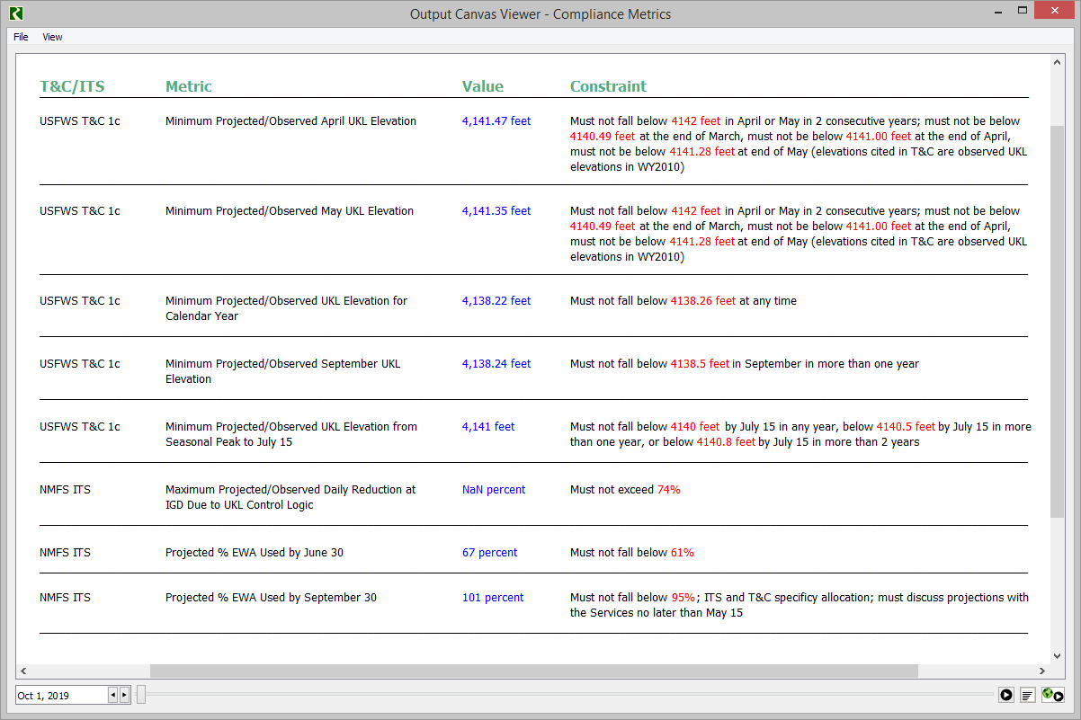

### View Results: Run Range

Another way to view run results is through a plot that shows the time series data over the year. The **UKL Surface Elevation** plot presents a visual representation of the UKL Pool Elevation over the run period. View the observed and projected pool elevations, which the plot distinguishes with separate lines. In addition, the plot shows the operator the following threshold and trend lines/markers for comparison:

* Flood Curve
* Central Tendency Elevation
* WY Low Threshold
* BiOp Levels
* Yesterday’s Elevation

1. Sample UKL Elevation plot



First, check that the projected elevation does not exceed the Flood Curve or fall below the BiOp level. If either are violated, settings need to be adjusted. Next, Compare with the Central Tendency. The operator deems the trajectory suitable based on their own judgement and expected hydrology.

The **UKL Ag Demand** plot presents a visual representation of the UKL Agricultural Demand over the run period. It includes lines and markers that split demands into Observed, Projected, and Yesterday’s Ag Demands for the operator.

1. Sample Ag Demands plot

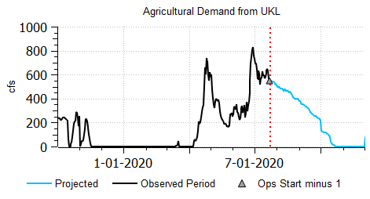

Analyze the projected demands based on judgement and in respect to the recent observed demands. There are no thresholds that the demands need to exceed or stay below. Rather, the operator is concerned about how to balance deliveries to agriculture while distributing supply to other objectives.

The **IGD Flows** plot shows the IGD outflow over the year including the minimum values and UKL smoothed inflows for comparison.

1. Sample IGD Flows plot



### Record Results or Run Next Iteration

If the operator is satisfied with the summarized hydrology and demands in the Output Canvas or projected trajectory of demands and elevation in the Plot Page, they record the official results or move on to running alternative scenarios. Otherwise, the operator will perform another run with altered settings until satisfied with the results.

### Alternative: Run the KROM with MRM

As described above, the operations process is often iterative with many trials of different inputs. Although this can be done manually, the KROM also automates this process using Iterative Multiple Run Management configuration.

The “Run trials of different settings” configuration uses Iterative mode and is designed to automate the process of iterating through multiple runs, each with different settings, until a suitable configuration is found. Defines a suitable configuration of settings of the following slots:

1. UKL Inflow Adjustments produce forecasted seasonal inflows that match with the NRCS Inflow Forecast
2. UKL Agricultural Adjustments produce the forecasted diversions supplied by UKL that match with the Project Supply
3. Accretion Exceedance Percentages and Adjustment Factors produce forecasted accretions that match with expected hydrology

For the configuration of multiple runs with different adjustments/settings, specify the sets of values to try since they likely have a good idea of what adjustments/settings create certain hydrological conditions. Specify in slots, accessible from an SCT, the following:

* The number of runs to make in the MRM Dashboard.Number of Runs to Make.
* Values for each adjustment factor on integer indexes slots. A sample is shown. Each row represents a run to make. In this example, there are 5 rows so 5 sets of setting values.

1. Sample integer indexed slot where MRM settings are specified, one row per run

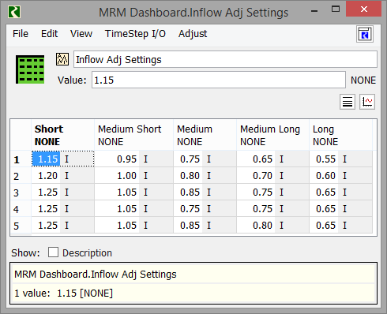

Once the runs are finished, there are certain outputs the operator will want to view. As above, the results will be presented in a table where each row represents the values of one run. See Figure 13. These results can be shown on the same or a different SCT.

1. Sample Integer Index Slot showing a metric for 5 MRM runs.

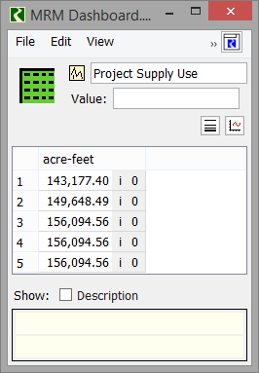

The key metrics are the following:

* Cumulative UKL Inflow: For each iteration, how does the cumulative volume progresses over the season? Check that the cumulative Mar-Sep volume is similar to the NRCS Inflow Volume for the same period
* Project Supply: For each iteration, see how the Project Supply is distributed over the seasons and check that the cumulative distribution is similar to the total Project Supply allocation.
* Compliance Metrics: For each iteration, check if all the compliance metric minimum conditions are met. Metrics include UKL pool elevation and EWA use requirements at various points through the water year.

After analyzing the iterative run outputs and choosing the desired adjustments/settings configuration. The operator will run that setup in a single run to compute the official release at Iron Gate Dam and the hydrological forecasts they will report. To do this, open the script named “Choose desired MRM Run # and Start next Single Run” and choose the desired run to use. Then execute the script. It transfers the values to the single run slots and starts a run.

1. Script dashboard for choosing the desired MRM

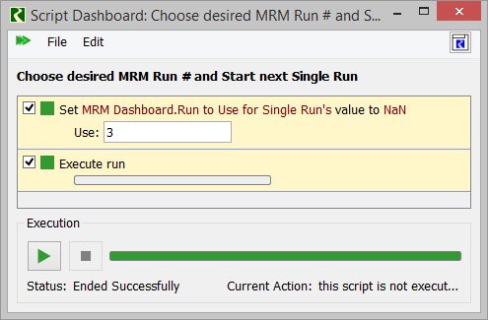

1. After running this MRM configurations and then choosing a single run using the above script, the model may have different input data than before the MRM. If you select this as the official run, then likely you will want to save the model. There is currently no way to go back to the single run setting you had before the MRM.

## 4) Run Scenarios to Analyze Possibilities

With the chosen adjustments/settings in the configuration run, the operator may want to run other scenarios that utilize previous year’s hydrology to see what would occur under different conditions. A second iterative configuration allows this option.

The **Run historical hydrology scenarios** MRM configuration uses Iterative mode. It is designed to run scenarios with various alternative physical inputs. The two types of alternative input configurations that this MRM uses are as follows:

1. Historical UKL Inflows instead of UKL Inflow Forecast logic: Commonly, the historical years the operator selects are similar to the current year’s conditions. It may be any year from 1981 through the present.
2. Historical accretions instead of Accretion Forecast logic: In the PA Calculator, the operator only has the capability to import hydrology from 2014 through the present.

The key to running these scenarios is selectively shutting off certain forecasting logic and utilizing the correct historical hydrology instead. The rules use one or more switches to accomplish this goal. For example, a switch is a slot value of zero or one, set by an Iterative MRM rule and accessed by a function. Thus, if the switch is active, the respective initialization rule for forecasting will not execute and alternative rules will instead reference the historical hydrology that is coordinated to the switch value. The initialization rules will copy the selected year’s data to the simulation slots, accounting for leap years as necessary. Like in the MRM configuration to run alternative configurations, a table of input values represents runs to make. Then the user can create and run as many scenarios as desired using the desired years and/or settings. In addition, after the runs are finished, the operator will want to see the same outputs as from the Configure Settings MRM runs. These are presented on integer indexed series slots and shown on an SCT.

There is an additional MRM configuration, the **Run with and without Agricultural Deliveries,** where agricultural diversions are set to zero. Therefore, the Project Supply remains as UKL storage. The operator uses this to estimate the portion of storage UKL holds for agricultural demands throughout the rest of the year.

1. After running either of these MRM configurations to look at alternative scenarios (“Run historical hydrology” or “Run with and without Agricultural Deliveries”), you should NOT save the model as the official model. The original input data has been affected.

## 5) Generate Reports and Output Products

The operator will still use many of the existing Excel-based reports and output products. Commonly, these tools serve a dual purpose:

* Generate reports and output products for stakeholders.
* Serve as an archive for the recorded history of select hydrology and demands.

Since the outputs are based solely on historical hydrology, they do not require data from the modeling tool. This is reflected by the tools linking cells to the Daily Data Import WY 2020 workbook rather than the PA Calculator. The workbooks are as follows including the corresponding tasks or type of data reported:

1. Klamath Project Deliveries and Demands_Rev#.xlsx: Report the basin’s cumulative agricultural deliveries for various periods
2. Daily UKL net Inflow Cumulative Year#.xlsx: Report UKL’s cumulative inflow compared to previous years in the recorded history
3. Daily UKL net inflow LOESS all WY: Report UKL’s smoothed daily inflow compared to previous years in the recorded history
4. UKL_WY20##-Year#_wormtrails.xlsx : Report UKL’s daily pool elevation compared to the previous ten years

Preserving the use of these four workbooks maintains most of the operator’s reporting workflow.

As an exception, the workbook that produces the “Hydrology” outputs described in the KBAO Operation Workflow report does not serve as an archive. Rather, it only produces a report of the past week’s hydrology to stakeholders. This is replicated in the KROM with the Model Report feature, which is discussed in the following subsection.

To communicate basin conditions to stakeholders, the operator will send a report of the past week’s hydrology at select locations to stakeholders. The **USBR Daily Numbers** model report displays the basin’s hydrology over the past week in a tabular HTML format. The range of the past week is determined by the Operation Start Timestep. For example, if the Operation Start Date is July 22, 2020, the range of data goes from July 15 through July 21 of 2020. The operator accesses and generates the Model Report from the Output Manager. The reported slots correspond to the hydrological variables in the USBR Daily tab of the KlamathOps2019PA SCT.

After a run is completed, the operator opens the Output Manager from the Utilities menu from the workspace. From the listed outputs, they will select the UBSR Daily Numbers and click Generate to create the Model Report. In doing so, the HTML Model Report is saved to the folder of outputs, and can be sent to the stakeholders.

1. Sample USBR Daily Numbers Model Report output HTML file shown in a web browser



## 6) Archive the Model

The operator will save the new KROM model file with outputs each day to document the exact conditions and operating decisions used to assign releases and plan for the season. They will do this immediately after the run that sets the official operations and seasonal planning results. Using a “KROM_YYYYMMDD_V#” naming convention, the model will be saved to the KROM Model Archive folder. For example, if the model is run on August 3, 2020, they will save the model as “KROM_20200903_V1”. The “V” in the naming convention stands for Version. If the operator makes a significant change to the logic, features, outputs, or model layout, they will document it in the Model Info and update the version number. The operator opens the Model Info from the File menu from the workspace.

1. Klamath RiverWare Operations Model developed from September 1, 2018 through December 31, 2019 for CADSWES’s Cooperative Agreement with Reclamation (R18AC00088).