Pisces Software Program
A tool for more efficiently analyzing hydrology model time series data for users from novices to modelers

What Is The Problem?
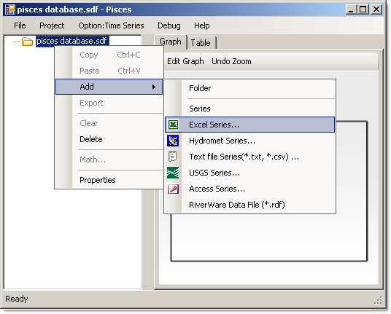
In water resource management projects and studies, it is often necessary to manage and analyze large amounts of hydrology data. This includes time series output data from numerical modeling tools that are used to analyze multiple scenarios or alternatives. There is typically a need to organize, compare or evaluate the data, and use the output data for presentations. This can be difficult even with a relatively small number of scenarios or alternatives.

Some hydrology models have output management features, but their use is limited to those trained to operate these models. Alternatively, output data are input into speadsheet or database tools for comparison, evaluation, and presentation purposes. This can be a cumbersome and labor-intensive process that also requires specialized computer skills.

What Is The Solution?
Reclamation’s Pacific Northwest Regional Office has developed an easy-to-use computer program called Pisces that processes time series data. It does not require special computer skills or modeling experience to operate. Pisces accepts output data from common hydrologic models and offers users immediate, simultaneous, and independent data access and the ability to easily graph any portion of the time series data. It provides convenient access to time series model results and the ability to easily compare many different scenarios or alternatives. Pisces has specialized features that allow users to analyze and compare any combination of scenarios/alternatives. For example, a biologist can evaluate the difference in impacts to fish habitat (flows, temperatures, etc.) between multiple dam release scenarios for a specific river reach. In some cases, over one hundred sets of model output data are input to Pisces for evaluation.

Pisces is currently configured to work with output data from MODSIM, and RiverWare hydrologic computer models. It has a scenario selector unique to Pisces that converts massive amounts of output data into a summary form for each time series by scenario/alternative. Pisces can also be used to organize, graph and analyze observed natural resource time series data. It is configured to accept Reclamation’s Hydromet and AgriMet river and weather conditions data, U.S. Geological Survey’s National Water Information System (NWIS) data, and other data can be entered as text files or as Microsoft Access and Excel files.

Who Can Benefit?
Pisces is most commonly used by participants and stakeholders in water resources planning projects and studies. This includes water and natural resource managers, hydrologists, engineers, biologists, irrigation district staff, and various others. It can also be used by anyone needing to manage and/or analyze any type of time series data sets.

Where Have We Applied This Solution?
Pisces has been used extensively by study team members and others involved with Reclamation-sponsored studies and planning efforts on the Columbia, Rio Grande and Snake Rivers. It is also used frequently by Reclamation staff and others for managing Hydromet and AgriMet data.

Future Development Plans
Since its inception in 2001, the software has been modified slightly as needed for specific project needs. It is expected that the software will continue to evolve as needed by particular users for their projects.

More Information
The software, user manual, and video demonstrations can be downloaded at:

http://www.usbr.gov/pn/hydromet/pisces

Contact Information
Karl Tarbet, Pacific Northwest Regional Office
208-378-5272, ktarbet@usbr.gov

Collaborators
Reclamation’s Science and Technology and Grand Coulee River Bank Stability Programs, Pacific Northwest Regional Office, and Snake River,Yakima, Albuquerque and Ephrata Area Offices.

