Source discovery takes as input a webpage URL and tries to learn the description of the service (if any) that a form on that page provides. It learns how to invoke the form and describes the type of data that is returned when the form is invoked.

The following figure gives describes the various modules used for this purpose and the data flow between them. It also lists the package/library for each module.
URL
Config\DomainConfig.xml

domain descriptions
static data samples
Database configuration for samples
\lib\autowrap.41.jars\fetchautowrap-41.jar
Jmatlab\logreg.dll
edu.isi.sourceDiscovery.logreg
com.fetch.naturallanguage.formextractor
Input Sets,
Sample values for inputs
edu.isi.sourceDiscovery.config
1.
Fetch:
Form Extraction
List <Form>
2.
Anon: logReg
Form Classification
Data\classifier\model.mat
Data\classifier\index.dat
3. Get input sets and expected outputs for the domain
Domain Name
Perform for each sample value
List<WebPage>
5. Fetch:
Autowrap
(Extract data from pages)
edu.isi.sourceDiscovery.formInvocation.FormInvoker
Extracted data as Nested tables
edu.isi.sourceDiscovery.SourceDiscovery
Lib\semanticMapper.jar
4. Invoke Form with the inputs
edu.isi.sourceDiscovery.autowrap.AutowrapInterface
List<List<String>>
8. Check if output label match at least X% of expected domain outputs
7. Semantic Labeler: Label the data columns
6. AutoWrapInterface: Flatten the results from Autowrap
Class to invoke : edu.isi.sourceDiscovery.Main

- Form Extraction
This piece of code is in package com.fetch.naturallanguage.formextractor and was provided by Fetch. It provides the feature to extract list of forms on a web page. The code originally provided by Fetch and has some bug fixes and functionality added by me.

Consider this source (http://www.flytecomm.com/cgi-bin/trackflight) that gives flight tracking information:
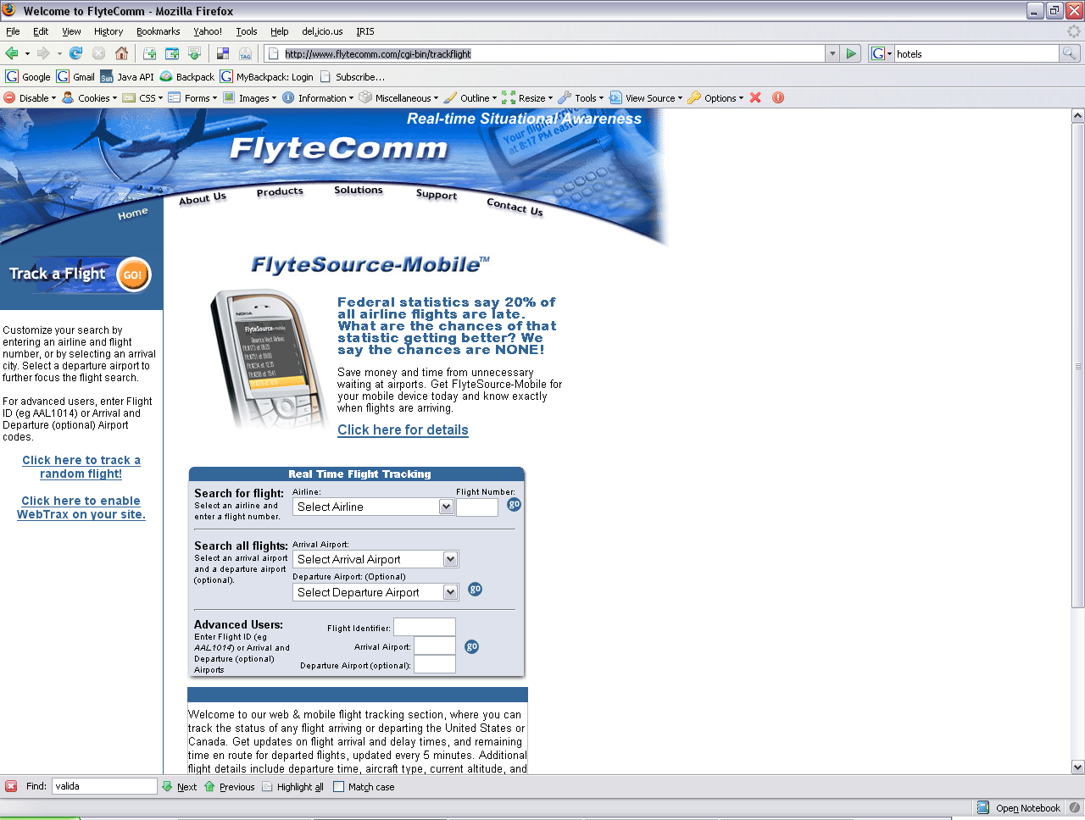
We would get back the title of the page (Welcome to FlyteComm), and that this page contains three forms. For each form, we can get all the text that is present in the form (like: Search for flight: Select an airline and enter flight number…), the names of all fields (textboxes, hidden fields, radio buttons, submit button, select boxes) and their values if any. (default values for text boxes. Text and values for select options / combobox)

- Form Classification
Form classification is down by the LogReg caller developed by Anon. The classifier is written in Matlab. To call the classifier from Java, I used the JMatlab package. The logreg matlab code was exported by Anon as a dll, and placed in Jmatlab folder (Jmatlab\logreg.dll). The edu.isi.sourceDiscovery.logreg.LogRegCaller extends a JMatlab class to specifically call this dll. This dll takes as input the matlab model (data\classifier\modelmat), file containg indexes of features (data\classifier\index.dat) and the input file containing the features found in the source we are classifying.
edu.isi.sourceDiscovery.logreg.FormElementTranslator translates the Form data into a format required by logReg. It uses PortStemmer to stem the words and uses data\classifier\index.dat to get the indexes of the keywords that then get stored in a file that is used as an input to logreg. Logreg generates two output files that give the probability of the form to belong to one of the domains. LogRegCaller reads these files to return the index of the domain with the highest probability.

Consider one of the forms from the web-page. It is shown below:
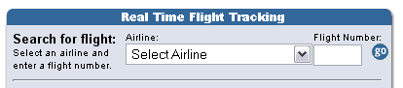

For each form, we give the title of the page, and all the form data to the classifier, which is all the text displayed on the form and all the values for the fields of the form.

In this case, the input to the classifier would be the title=”Welcome to FlyteComm” and form text=” Search for flight: Select an airline and enter a flight number. Airline: not found Airline: --- Popular Airlines --- Select Airline Xtra Airways Japan Airlines Aeromar Monarch Airlines USA 3000 Coastal Air Transport Bradley Air Service Air Alliance Jet Airways Eagle Canyon Airlines Asiana Airlines Merlin Express Yugoslov Airlines Skyway Airlines Rover Airways Intl Empire Airlines Allegiant Air Frontier Flying Service Biman Bangladesh Airlines Belair Eastwind Airlines Continental Express Skagway Air Service Condor Flugdienst APA Intl Air American Airlines National Airlines Canadian Forces Aloha Airlines Big Sky Airlines Air Alma Avia Air SN Brussels Airlines Royal Air Maroc South African Airways Aerolineas Argentinas Kalitta Flying Service Caribair Royal Nepal Airlines Singapore Airlines Kelowna Flightcraft Island Air Pan American … ”

- Inputs & Outputs of Domain
The domains are described in the XML document config/DomainConfig.xml. Its schema is described in config/configuration.dtd
Each domain can have a set of input sets (which include one or more inputs) and produces one or more outputs. (The model capture all the common elements of the sources within the domain) For example, to check flight status in flight domain, the domain can have two input sets, one containing two inputs – airline and flight number; and the other input set containing from and to airports. The outputs of the domain can be marked as required. In the configuration file, for each domain, we can also specify the percentage of the outputs that should match, to mark the source as one that belongs to the domain.
After the form gets classified into a domain, we read the input sets for the domain from this configuration file and also get the sample values for the inputs from this file. With these two, we can invoke the form.
The sample values for each input data type can be statically given within the XML file, or can be loaded from a database, whose jdbc settings are then provided in the configuration file. All database samples can be loaded at startup time, or lazyLoad can be used to load the samples only on demand.

Below is how the inputs are defined in the XML file for flight domain
<inputs>
<inputSet sampleConfiguration="flightSamples">
<input name="airline" /><input name="flightNumber" />
</inputSet>
<inputSet sampleConfiguration="flightSamples">
<input name="airlineCode" /><input name="flightNumber" />
</inputSet>
<inputSet sampleConfiguration="flightSamples">
<input name="fromAirport" />
<input name="toAirport" /></inputSet>
</inputs>
Let flightSamples contain the following samples:
Airline airlinecode flightNumber fromAirport toAirport
"Alaska Airlines" "ASA" "102" "FAI" "ANC"
"American Airlines" "AAL" "332" "DFW" "MIA"
"Northwest Airlines" "NWA" "1126" "MKE" "DTW"

The flytecomm form has two fields – airline and fnum
We then generate all possible invocations of the source, using different input sets, and different order of inputs within the inputs sets, i.e:

1) Airline=Alaska Airlines, fnum=102 ;using sample 1, inputSet1, ordering=1
2) Airline=102, fnum=Alaska Airline ;using sample 1, inputSet1, ordering=2
3) Airline=ASA, fnum=102 ;using sample 1, inputSet2, ordering=1
4) Airline=102, fnum=ASA ;using sample 1, inputSet2, ordering=2
5) Airline=FAI, fnum=ANC ;using sample 1, inputSet3, ordering=1
6) Airline=ANC, fnum=FAI ;using sample 1, inputSet3, ordering=2
..and so on for the rest of the samples.

- Invoking Forms
edu.isi.sourceDiscovery.formInvocation.FormInvoker implements the code to invoke a Form Action URL using GET and POST methods. It takes as input the names and values for the form fields and returns back the page returned by the server

For the above flyteComm example, we each inputset, ordering, we would invoke the page giving the sample values and pass the resulting pages to autowrap.

- Autowrap
After invoking the form multiple times for each sample, we call Fetch’s Autowrap code from an interface edu.isi.sourceDiscovery.autowrap.AutowrapInterface. Fetch’s code is imported as a jar file.

- Getting Flattened Results from Autowrap
Autowrap returns back results as nested tables. edu.isi.sourceDiscovery.autowrap.AutowrapInterface contains code to flatten these results. It contains two methods that flatten data in two ways. getFlattenedResult() works best if there are list expected in the output. However, if the source returns back data is format like this
If the page contains data like this:
Temperature 80 F
Sky Clear
Humidity 10%
getFlattenedResults would give back 80 F, Clear, 10% as one column.
For such cases, getFlattenedResultsOneRowPerPage() should be used, it would return 80 F, Clear, 10% as three different columns. In the code right now, I am calling getFlattenedResultsOneRowPerPage for all cases as we need to just identify that the semantic type is present as any of the outputs.
all the data extracted from the pages is in a single table. For pages that return lists, example:
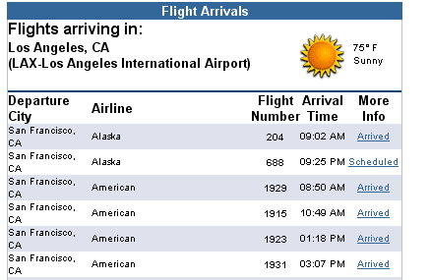
Which gives all flights flying between two airports, let there be 3 invocations of this source: LAX->SFO,
FAI->ANC and DFW->MIA
We would get back the following flat data:

Los Angeles, CA | LAX-Los Angeles International Airport | 75 | Sunny | San Francisco, CA | Alaska | 204 | 09:02 AM | Arrived | San Francisco, CA | Alaska | 688 | 09:25 PM | Scheduled | ….
Fairbanks, AK | FAI-Fairbanks International Airport |  |  | Anchorage, AK | Alaska | 133 | 12:55 AM | Scheduled | Anchorage, AK | Empire Airlines | 8663 | 11:05 AM | Arrived
Dallas, TX | DFW-Dallas International Airport | 92 | Sunny | Miami, FL | American | 495 | 08:44 AM | Arrived | Miami, FL | American | 1773 | 09:36 AM | Arrived
As seen above, the data is a list gets exploded as columns in the table. However, each column contains uniform information that can be labeled well by the Semantic Labeler.

- Semantic Labeler
I exported the semantic mapper code from CALO project as a jar which exists in the lib folder. Complex types semantic mapper is being used to label the examples. As the number of columns can be very large, I have turned off Meta labeling by setting ComplexTypeSemanticLabeler._USE_META_LABELER = false

- Generating the Source Model
After running the semantic labeler on the columns, we can verify that the outputs from the labeler match atleast X% of the optional domain outputs and has all the required domain outputs. Once this is done, the model of the source is constructed and stored in edu.isi.sourceDiscovery.SourceModel. This gives the semantic types of the inputs of the form/source, and the semantic types of the domain outputs that were found in the source.

For this flyteComm source, the first form when invoked with the following inputs:

airline=ASA, fnum=102 ;using sample 1, inputSet2, ordering=1
airline=AAl, fnum=332 ;using sample 2, inputSet2, ordering=1
airline=NWA, fnum=1126 ;using sample 3, inputSet2, ordering=1
returns back data which has fields belonging to the flight domain.

Inputset1 does not return back enough data that belongs to flight domain, as the site required airline code as an input and not really the airline name. By ensuring that the outputs that belong to the domain are more than the inputs that we provide, we come to know of successful invocations, as a successful invocation would return back more outputs that belong to the domain. An unsuccessful invocation might just return back the inputs saying it could not understand the inputs etc

The following is the Source Model that gets generated:
Source: http://www.flytecomm.com/cgi-bin/trackflight Domain: flight
Form: detail_select
formMethod: METHOD_POST
formActionURL: http://www.flytecomm.com/cgi-bin/trackflight
Inputs:
fnum : PR-FlightNumber
airline : PR-AirlineCode
Domain Outputs:
column 0 : CT-Flight:1.0
column 51 : PR-FlightStatus:12.0
column 1 : PR-City:3.0
column 5 : PR-Airport-IataCode:22.0
column 6 : CT-Airport:5.6575313
column 8 : PR-FlightGateNumber:10.0
column 13 : CT-DateTime:19.0

It gives the name of the source, the form that was invoked, the names of the input fields and their corresponding semantic types, and the output columns that got labeled into fields belonging to the flight domain. It gives the column of the output, the name of the semantic type of the column and the score (of semantic labeling, which is an indicator of strength of the alignment of example with the semantic type) of the semantic label.

- edu.isi.sourceDiscovery.SourceDiscovery contains the workflow that ties all the pieces together. The method modelSource(URL, domain) implements the entire workflow. IF domain is specified, it would invoke the form only if the form classifier classified the form as one belonging to the domain.
initialize(..) method contain various parameters that configure the code.

/*
* @param configurationFilename - The name of the domain and samples
configutaion file (.XML file)
* @param numExamplePages - The number of samples to use for invoking
forms / giving sample pages to autowrap
* @param classsifierModelFilename - Full Path to the model.mat file
required by the log reg classfier
* @param classifierIndexFilename - Full Path to the index.dat file
required by the log reg classfier
* @param semanticLabelerModelFilename - Full Path to the patterns file
required by the semantic labeler
* @param semanticLabelerNumberOfPredictions - Number of predictions that
the semantic labeler should generate
* @param log - Stream for logging all steps that are performed
* @param verboseLevel - Level of logging. Use 0 for none, 1 for normal,
2 for extensive
*/
public void initialize(String configurationFilename, int numExamplePages,
String classsifierModelFilename,
String classifierIndexFilename,
String semanticLabelerModelFilename,
int semanticLabelerNumberOfPredictions,
PrintStream log,
int verboseLevel)

Limitations of Source Discovery
SourceDiscovery should be able to find sources similar to the seed source (that is specified in the domain configuration file)

The current limitations are:
- The source should have a simple model, in which there is a form that takes in one or more inputs, then submits the form and gets back the results page. Navigation is not possible.
- The way to submit the form should be simple. If the form is calling some javascript to set some of the form inputs and then submits the form, it would not work.
- This version of Autowrap code is splitting decimal parts of numbers into two data columns. For example, latitude 33.35678 would be required as two columns 33 and 35678. Because of this, recognition of floating points would not work. To fix this, for each column that gets extracted, we add another column to the flattened data, which contains all the data till a space.

Adding a new domain to the source
To add a new domain to the source, the following changes would be required
- Add the domain to the DomainConfig.xml file. The file current contains the following domains:
  - Flight
  - Weather
  - Geospatial
  - Hotel
  - Directory
- If samples for the inputs are not already present, add samples to the samples section in the DomainConfig.xml file

- The classifier would need to be re-trained to recognize the domain. For doing this, in the data\classifier\domain.txt file, add the training examples. The examples are given in this format:
l{<name of the domain}ti{<title of the page>}tx{<text in the form>}
Then execute java class edu.isi.sourceDiscovery.logreg.LogRegTrainer.
This generates the new matlab model file (model.mat) and index.dat

If the classifier is not working well for a particular domain, add more examples in domain.txt and repeat step 3.

Getting results from Delicious
Generic code to get back results from Fetch Agent is present in package edu.isi.sourceDiscovery.agent.
DeliciousWrapper is a class that calls the FetchAgent “delicious” at "caloserve2.esd.sri.com" (It has been removed from there actually). The current “delicious” Fetch wrapper is extracting first 3 pages of search results from delicious.
The actual wrapper is included with the source code in the wrapper\ folder and can be deployed at any server, and then the name of the server can be changed in the DeliciousWrapper class. In the class, one also needs to specify the name of the data schema that would contain the search result. DeliciousWrapper class can then invoke the fetch agent, get back the XML and return list of tuples.

For example:
List<Object> results = edu.isi.sourceDiscovery.agent.DeliciousWrapper.getSearchResults("weather +rss +feeds");

would give back list of URLs of the results when weaher + rss +feeds is typed in the search box. It returns just the URL of the pages (no tag information)

If more, or less search results are desired, the filter needs to be set appropriately in the Fetch Agent.

In the way DeliciousWrapper is implemented, any other Fetch Agent can be built using EzBuilder to extract tags, or any other desired information, and that wrapper can be invoked from the java code.

