Name: USC ID#:

I hereby affirm that all the answers below are my own. I have neither searched online nor taken assistance from any external entity.

Student Signature Above

EE105 – Spring 2025

Midterm

Time Limit: 2 hours

Max Points: 125

|  |  |
| --- | --- |
|  |  |
|  |  |
|  |  |
|  |  |

Total number of pages is 12 (including this page). Put your name on every page where noted

# Section A (25 points)

**Question 1 (25 points)**

Given the circuit diagram below with labeled nodes **N1, N2,**…**N6**. Determine the following:

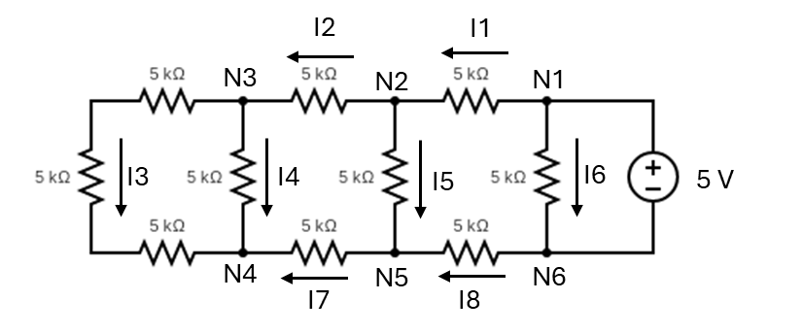

1. (6 pts) What is the equivalent resistance of this network of resistors?
2. (6 pts) Identify the nodes and the loops in the circuit. Then write the KVL and KCL equations for each node and loop. Use the directions of the currents as marked.
3. (6 pts) What are the voltages **VN1, VN2, VN3, VN4, VN5,** and **VN6** at the respective nodes? Assume the negative terminal of the voltage source is grounded.
4. (7 pts) What are the currents labeled **I1** through **I8**?

# Question 2 (10 points)

Given the circuit with nodes **A, B, C,** and **D** as shown. Calculate the following **VAB, IAB,** and **ICD**.

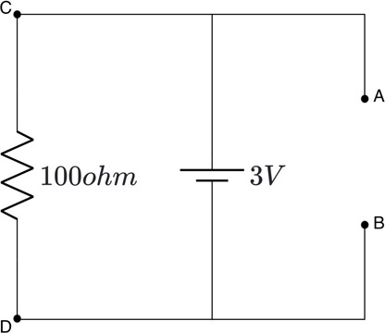

**Question 3 (15 points)**

Given the circuit with six resistors connected to a **3V** voltage source as shown. Find voltages across the resistors (**VA, VB, VC, VD, VE,** and **VF**) and current through resistors (**IA, IB, IC, ID, IE,** and **IF**).

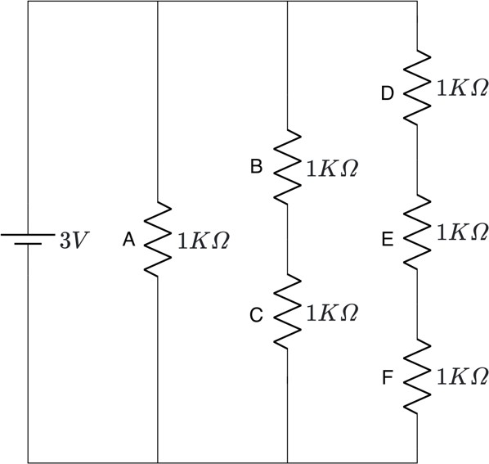

**Question 4 (15 points)**

An LED is connected to a 1V voltage source in series with a 100-ohm resistor, as shown below. Assume it has a quantum efficiency of 20% and emits red light, which is 630 nm.

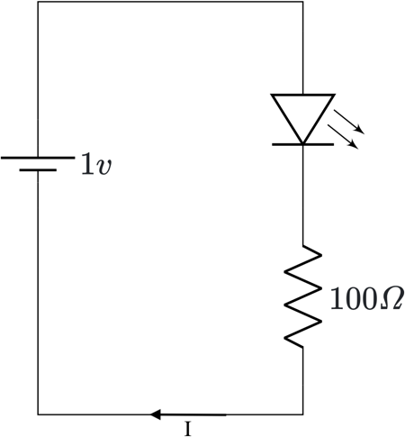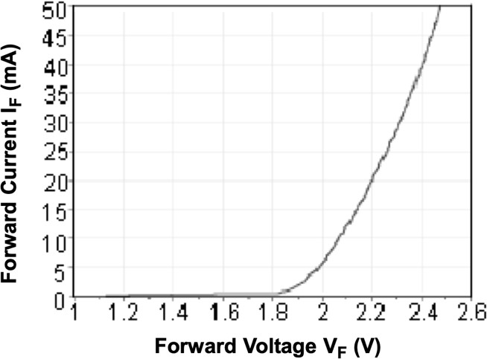

1. Using the provided LED characteristic curve, determine the value of I (the current through the LED) with the 1 V source.
2. If I wanted 5 mA to flow through this circuit, what voltage would I need to set the voltage source to? Assume that you can now change the voltage source value from 1 V to whatever value you want.
3. How much optical power would be emitted from the LED when 5 mA of current is flowing through the circuit?

**Constants:**

$$h=6.626 ×{10}^{-34} J.s$$

$$c=3.8×{10}^{8} m/s$$

$$e=1.6×{10}^{-19} C$$

# Question 5 (10 points)

The diagrams below show two different configurations of photodiodes.

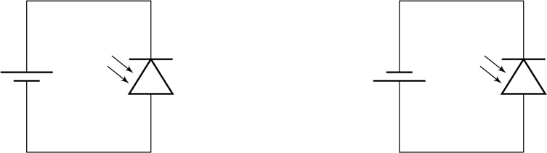

1. Identify which configuration is more effective for capturing light. Explain the reason for your choice.
2. If I gave you a volt meter and a resistor and asked you to measure the current flowing through the photodiode, how would you do that? Draw a circuit diagram and then explain what you would do. Use equations if necessary.

**Question 6 (10 points)**

The circuit below includes a thermistor. Solve the equation for RT (thermistor resistance). The solution should be expressed as a function of Vout.

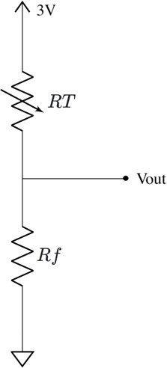

# Question 7 (20 points)

An operational amplifier (Op-Amp) is connected with resistors as shown below. Derive the expression for the output voltage (Vout) in terms of the input voltage (Va and Vb). Follow the steps below

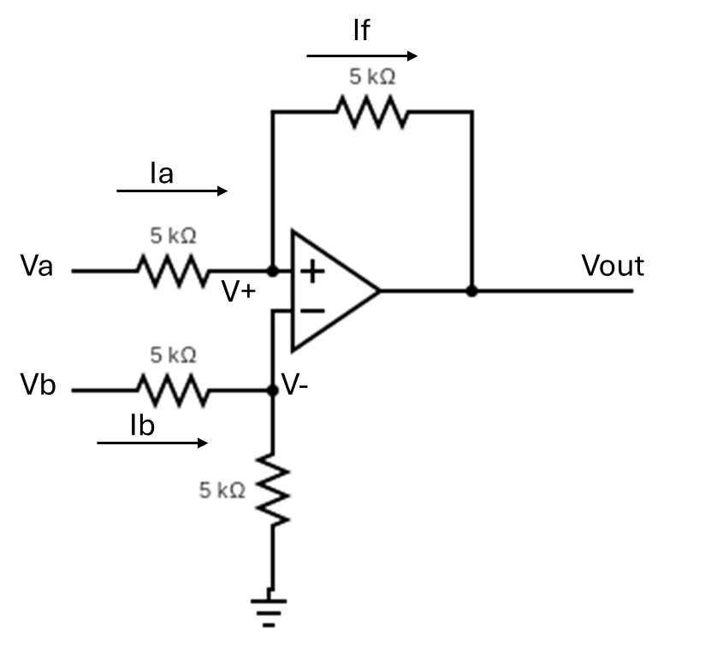

1. Find V- and Ib in terms of Vb.
2. Find Ia and If. Make sure to pay attention to the direction I have drawn the current when choosing how to find Ia and If.
3. Find Vout in terms of Va and Vb.
4. What mathematical function or functions is this circuit implementing on the input voltages Va and Vb?

# Question 8 (20 points)

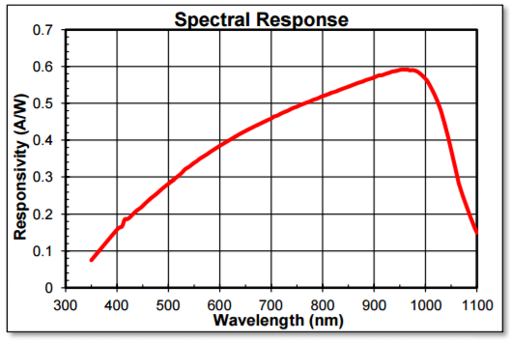Imagine you have a green LED (emission wavelength = 532 nm), and a silicon photodetector with a responsivity as shown below.

Your LED has a diode I-V curve as shown below. Assume a quantum efficiency of current to photon generation of 43%. For the purposes of the questions below, assume 100% of the emitted light falls on the photodetector.

1. (10 points ) Design an LED driver circuit using a tunable voltage source, a 100 Ohm resistor, and the LED. By tuning the voltage source in this circuit, you should be able to control the current in the LED. What is the minimum and maximum voltage you will need the tunable voltage source to output if you want to be able to control the current in the LED between 0 mA and 10 mA? Solve the diode equation and be precise with the voltage required.
2. (10 points) Now use op-amps, ONLY 100 ohm resistors (any number of them), and the photodetector to build a readout circuit. Assume the output of this detection circuit goes to an analog-to-digital converter (ADC), and this analog-to-digital converter can accept a maximum signal of 10 V and a minimum signal of 0 V. In order for us to maximize the use of this (ADC) we want to create a photodetector readout circuit that outputs 10 V when we are flowing max current through our LED (i.e. 10 mA). Design an amplifier circuit that outputs 10V at max LED brightness (i.e. when flowing max current through the LED).

**Constants:**

$$T=300 K$$

$$Is=1{×10}^{-21}A$$

$$K=1.38{×10}^{-23} J/K$$

$$c=3.8×{10}^{8} m/s$$

$$e=1.6×{10}^{-19} C$$

$$n=2$$