**Homework Assignment 1 (9/17, before class)**

**Instructions:** Answer the following questions based on the circuits and concepts discussed in class. Be sure to show all work where applicable.

**Problem 1:** Describe the function of the touchpad used in class. What are the sensor and processing components involved?

**Problem 2:** Define the following electrical quantities and their units, Draw their corresponding circuit symbols.

* + Voltage
  + Current
  + Resistance
  + Capacitance
  + Inductance

**Problem 3:** Analyze the following circuits and calculate the voltage and current across and . ,, , =?

**Problem 4:** Given the circuit below, calculate the voltage and current across the R1, R2, R3 and R4:

* + ,, , , , , , .
  + What is the value of the $I_{C}$?

**Problem 5:**

1. In the given circuit, calculate the voltage values at each node ( $S_{1}$ to $S_{9})$, and the current through each branch ( $I_{1}$ to $I_{12}$) using python.

1. If

calculate the voltage values at each node ( to , and the current through each branch ( to ) using python.

1. What is the difference between the circuit in a) and b). Which one should you use for the touchpad application and why?

**Problem 6:** Derive the equation for $V_{x}- V_{y}$ ​.

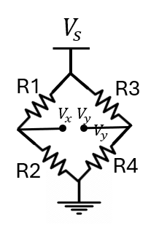

**Problem 7:** Consider a cylindrical resistance of length l=10 cm, radius r=1 mm, and resistance of R=0.54mΩ. Pick the resistivity of the cylindrical resistance from below.

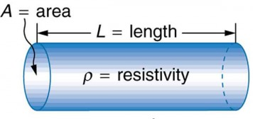

a) 1.7× ${10}^{-5}Ωm$

b) 1.7× ${10}^{-6} Ωm$

c) 1.7× ${10}^{-8} Ωm$

d) 5.4× ${10}^{-9}Ωm$

**Problem 8:** By what factor does the resistance of a rectangular block change if you double each dimension of the block?

* + a) 1
  + b) 2
  + c) $\frac{1}{2}$
  + d) $\frac{1}{4}$

**Problem 9:** Given the circuit below, calculate the voltage values of ,,  *, , .*

Please submit your answers by the due date. Ensure all your work is clearly presented.