EE105: Introduction to Electrical Engineering

Module 1 Circuit Analysis

Objective:
In this lab, we will systematically analyze the circuits in Module 1 by applying Kirchhoff's Current Law and Ohm's Voltage Law. We will assign variables to voltages at each node and currents through each resistor, then formulate KCL and Ohm's law as a linear system of equations. Then, we will solve this system using Python's symbolic computation toolbox to obtain exact solutions.

Kirchhoff's Current Law (KCL): The algebraic sum of all currents entering and leaving a node (junction) in a circuit equals zero.

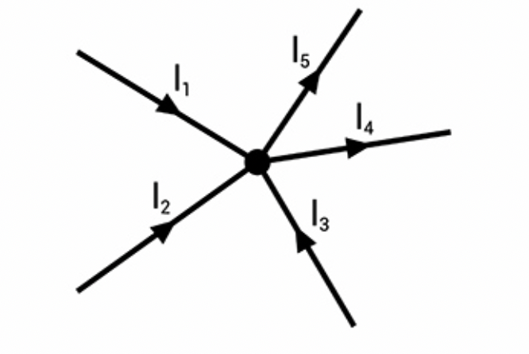
I₁ + I₂ + I₃ = I₄ + I₅

Ohm’s Voltage Law: The voltage across a resistor is directly proportional to the current flowing through it.

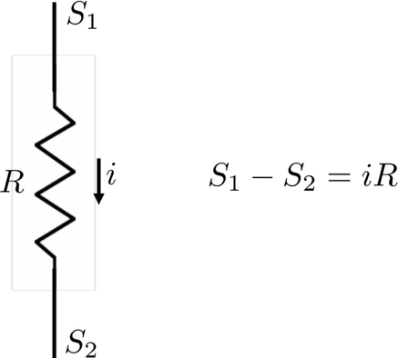

Analysis of Networks on Module 1:

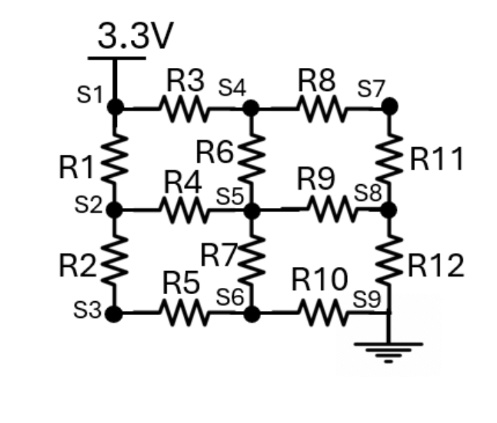
Checkpoint1: Write Kirchhoff's Current Law (KCL) equations
it = i1 + i3
…

Checkpoint2: Ohm's Law (Voltage) equations
i1 × r1 = s1 - s2
…

Checkpoint3: Solve these equations using SymPy
from sympy import symbols, Eq, solve

# Define the variables
i1, i2, i3, i4, i5, i6, i7, i8, i9, i10, i11, i12, it = symbols(
'i1 i2 i3 i4 i5 i6 i7 i8 i9 i10 i11 i12 it'
)
s1, s2, s3, s4, s5, s6, s7, s8, s9 = symbols('s1 s2 s3 s4 s5 s6 s7 s8 s9')

# assign resistance values
# TODO
# r1, ..., = ...

# Define the equations
# TODO:
# equations = [
# Eq(it, i1 + i3),
# ....
# ]

# Substitute s1 = 3.3, s9 = 0
substitutions = {s1: 3.3, s9: 0}

# Solve the system of equations
solution = solve(equations, (i1, i2, i3, i4, i5, i6, i7, i8, i9, i10, i11, i12, it, s2, s3, s4, s5, s6, s7, s8))

# Substitute the known values
solution_substituted = {k: v.subs(substitutions) for k, v in solution.items()}
solution_substituted

Additional SymPy Syntax:
Lt(x, y) # equivalent to x < y - Less than
Le(x, y) # equivalent to x <= y - Less than or equal
Gt(x, y) # equivalent to x > y - Greater than
Ge(x, y) # equivalent to x >= y - Greater than or equal
Ne(x, y) # equivalent to x != y - Not equal

Checkpoint4:
