EE105: Introduction to Electrical Engineering
Pulse Oximeter Demo

Objective:
In this lab, we’ll learn about Pulse Oximeters, how they work, and determine SpO₂ and Heart Rate from the oximeter measurements. The goal of this lab is to understand the fundamental principles behind pulse oximetry, a non-invasive method for monitoring a person's blood oxygen saturation (SpO₂) and heart rate. You will collect photoplethysmography (PPG) data and analyze the signal to estimate these vital signs.

By the end of this lab, you should be able to:
- Explain how light absorption can be used to measure biological signals.
- Acquire and visualize real-time data using a microcontroller (Arduino).
- Calculate heart rate and estimate SpO₂ from a raw PPG signal.

Prerequisites:
- Arduino IDE
- Python (3.9+ preferred).
- VS Code or Jupyter Notebook.

Circuit Schematic:

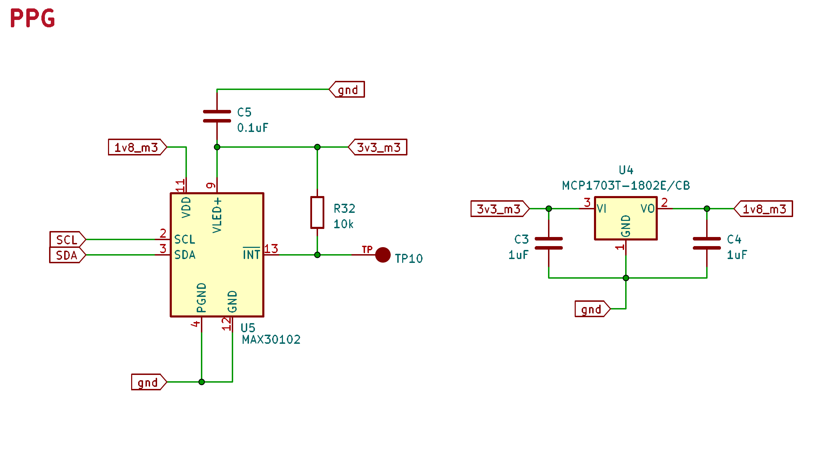
Checkpoint-1: Select Module-3 on your dev board. Open the ppg_module folder. It should contain one folder for Arduino code (devboard_sketch) and another for python tasks (notebook).

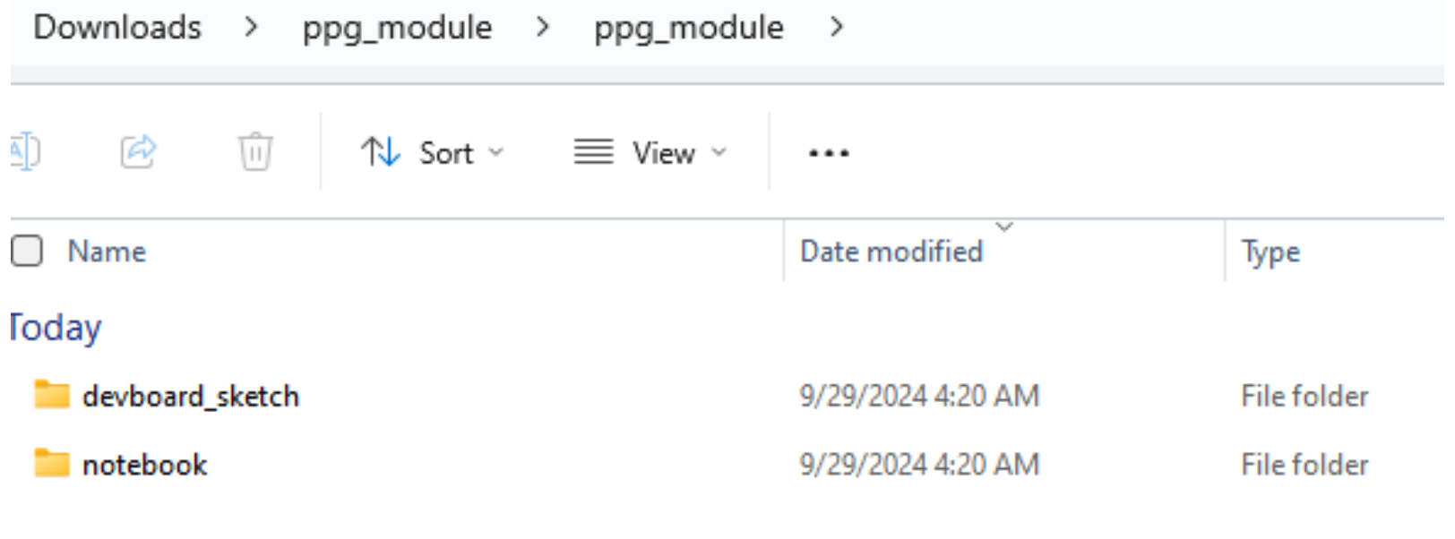

Checkpoint-2: Upload devboard_sketch.ino to your Arduino. Check serial plotter with “m3ppg” command to see whether your ppg sensor is collecting data or not.
Close serial plotter/monitor before moving to next checkpoint.

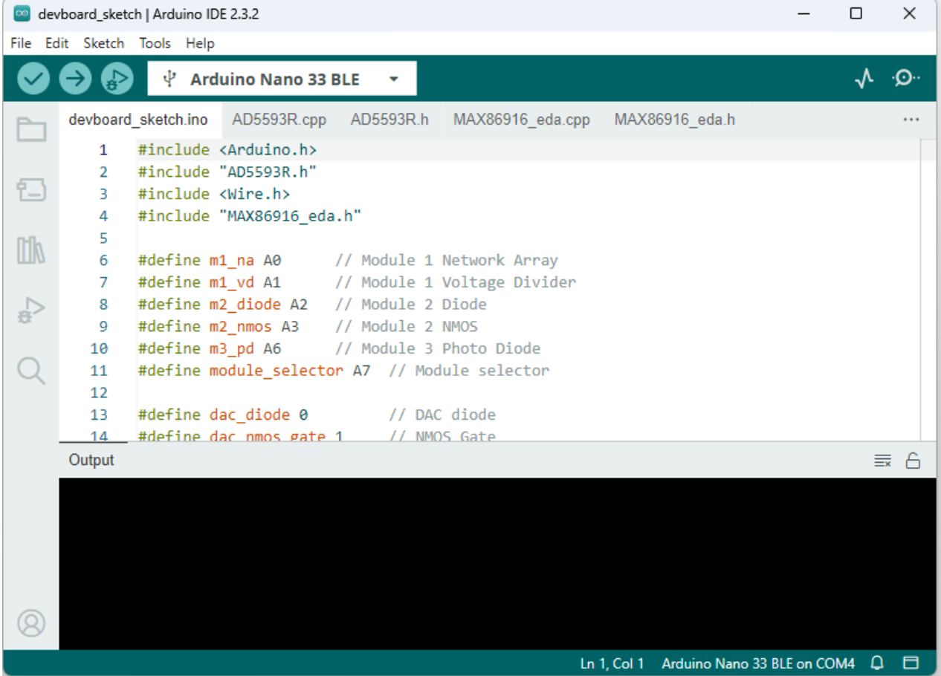
Checkpoint-3: Open python IDLE and open main.py from the Notebook folder.

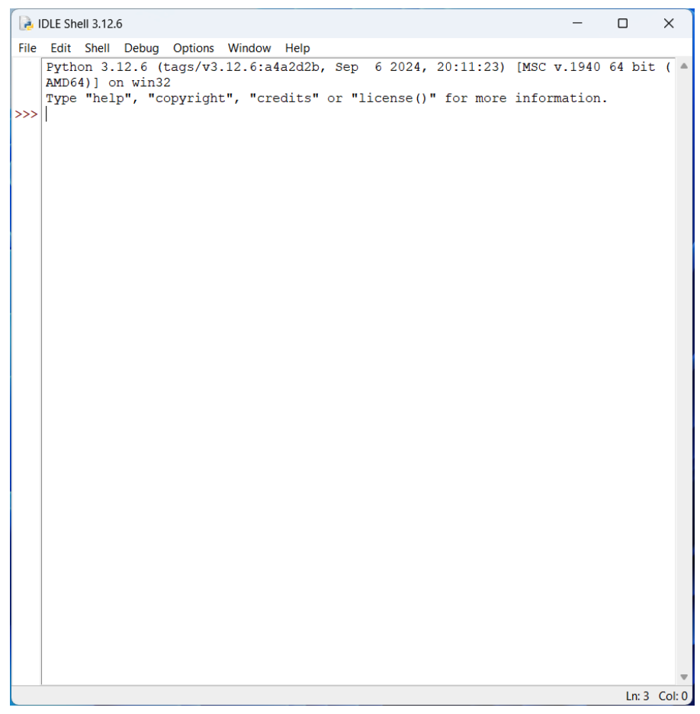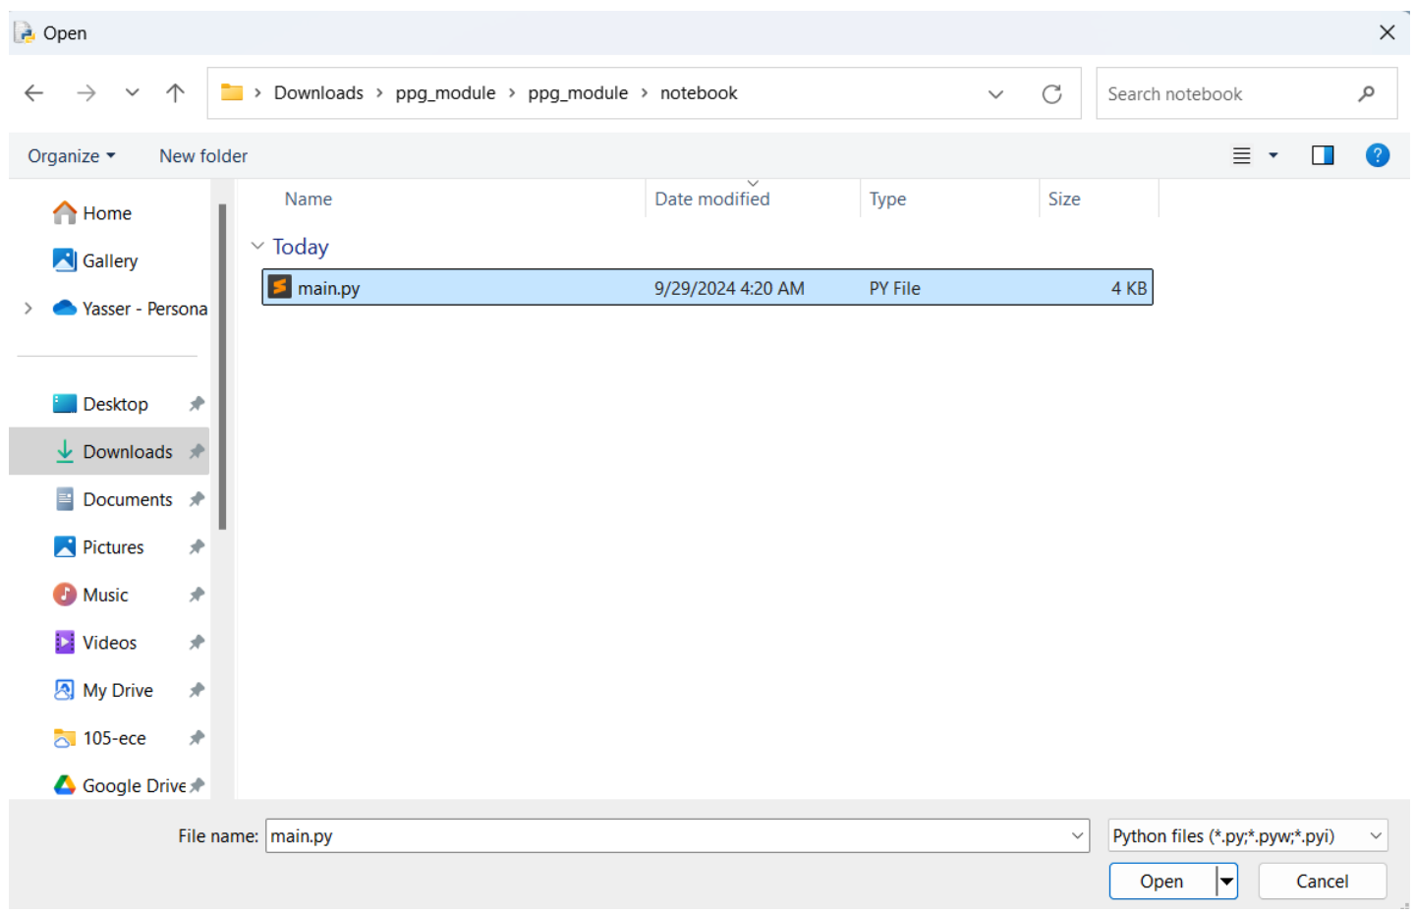

Checkpoint-4: Run main.py module.

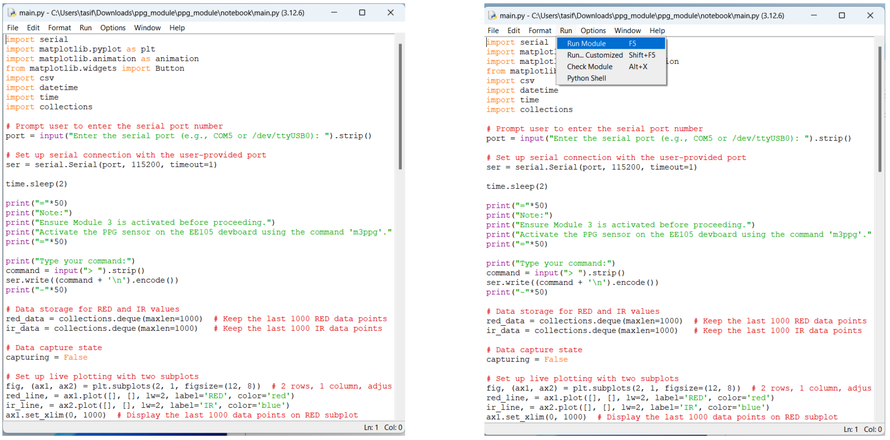

Checkpoint-5: Type in your COM port where your Arduino is connected. Verify the port name from Arduino IDE > tools > port.
If the serial port is correct, you will be asked to type in your command. Use “m3ppg” command to activate the ppg module. This opens a recoding window to capture and save ppg signals.

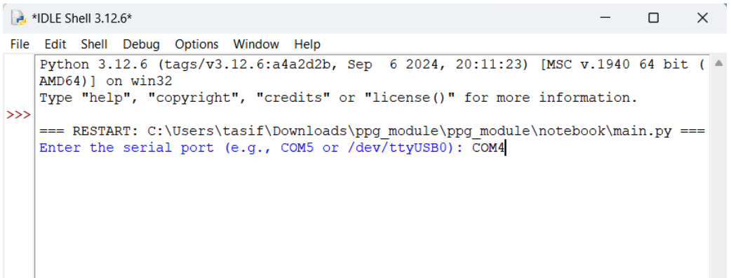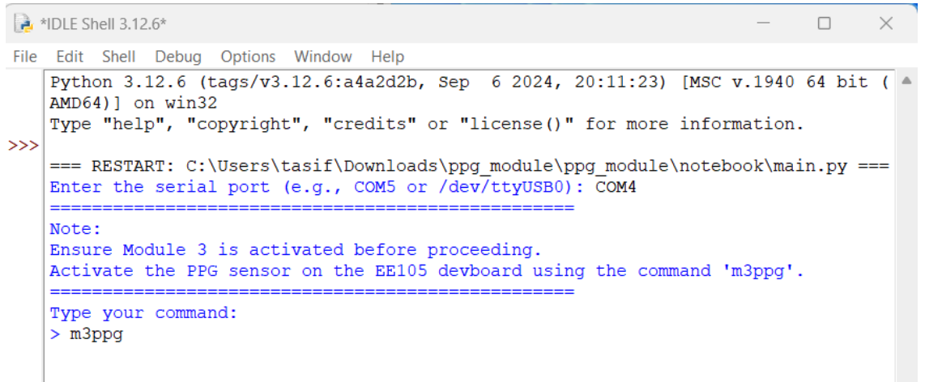
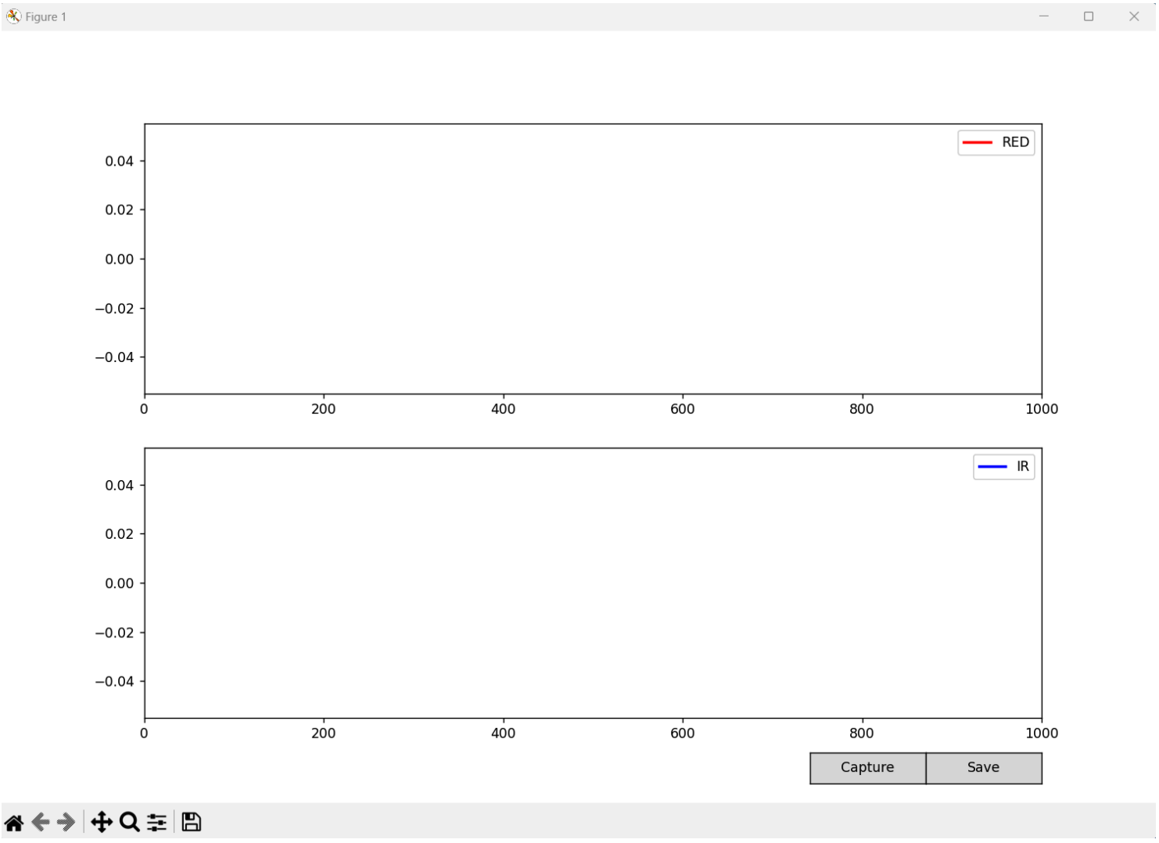

Checkpoint-6: Press capture.

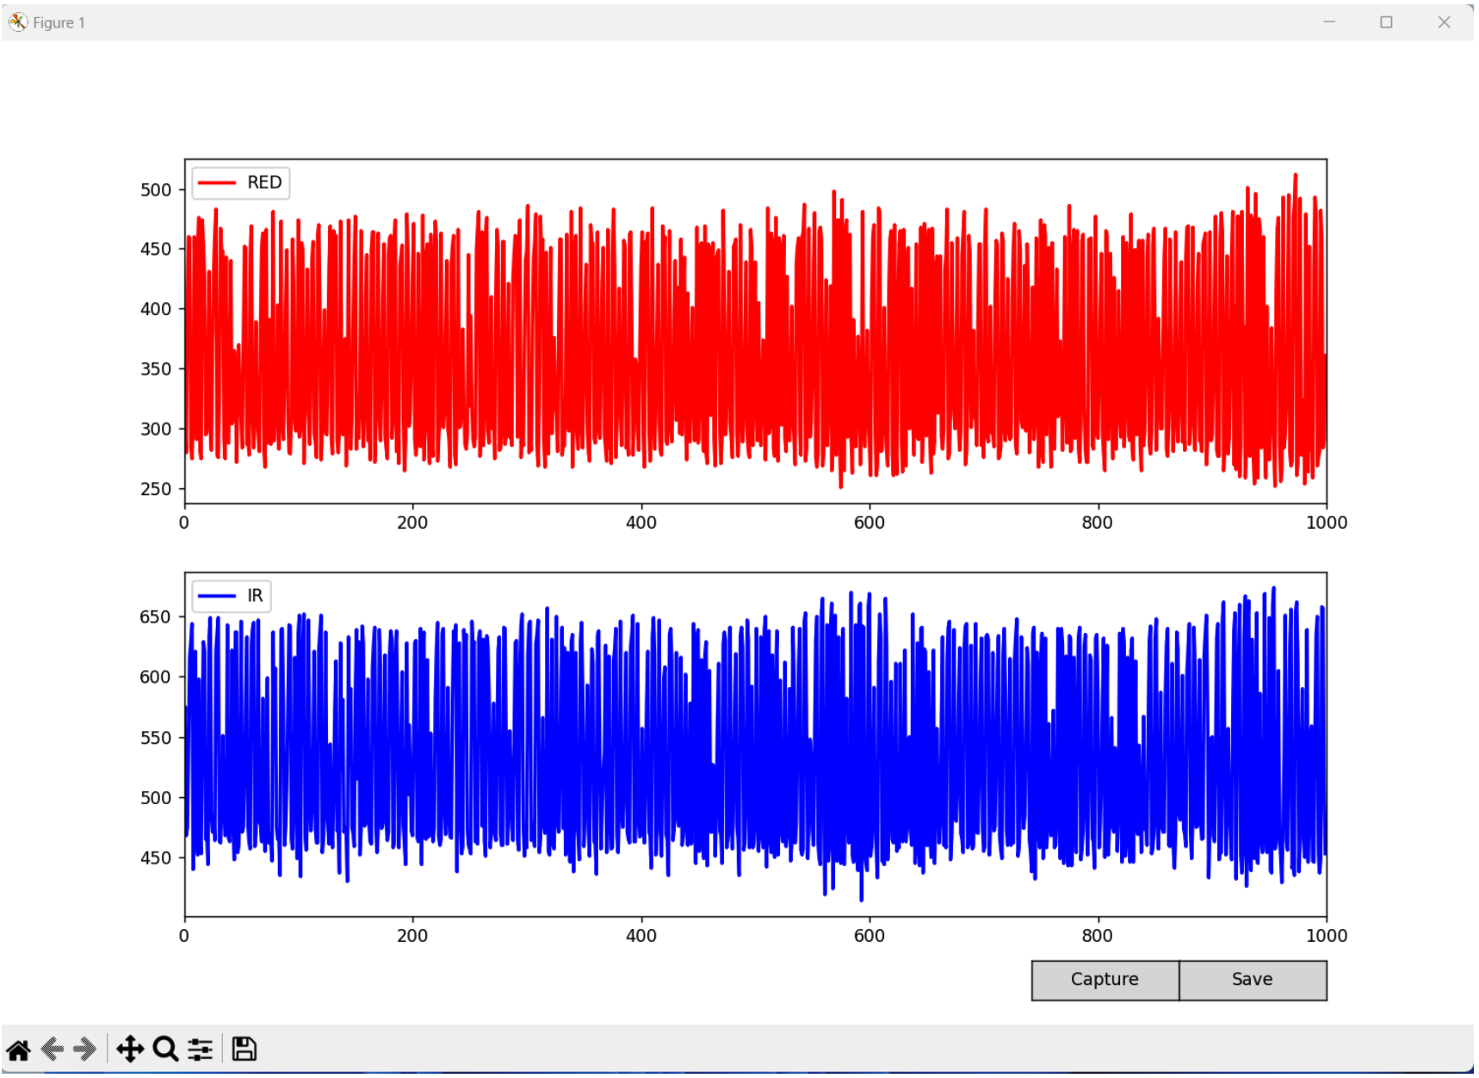

Checkpoint-7: Keep your finger gently on the sensor.

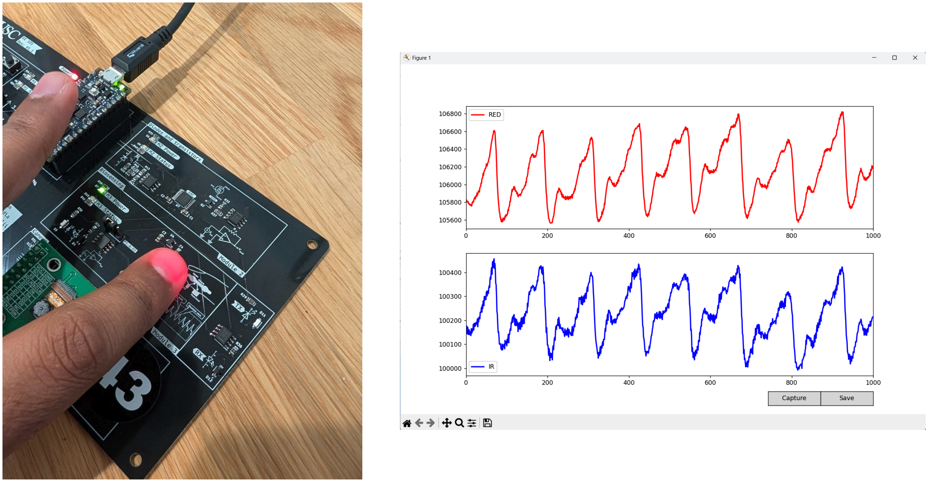

Checkpoint-8: Click save – a new file will be saved in your folder.
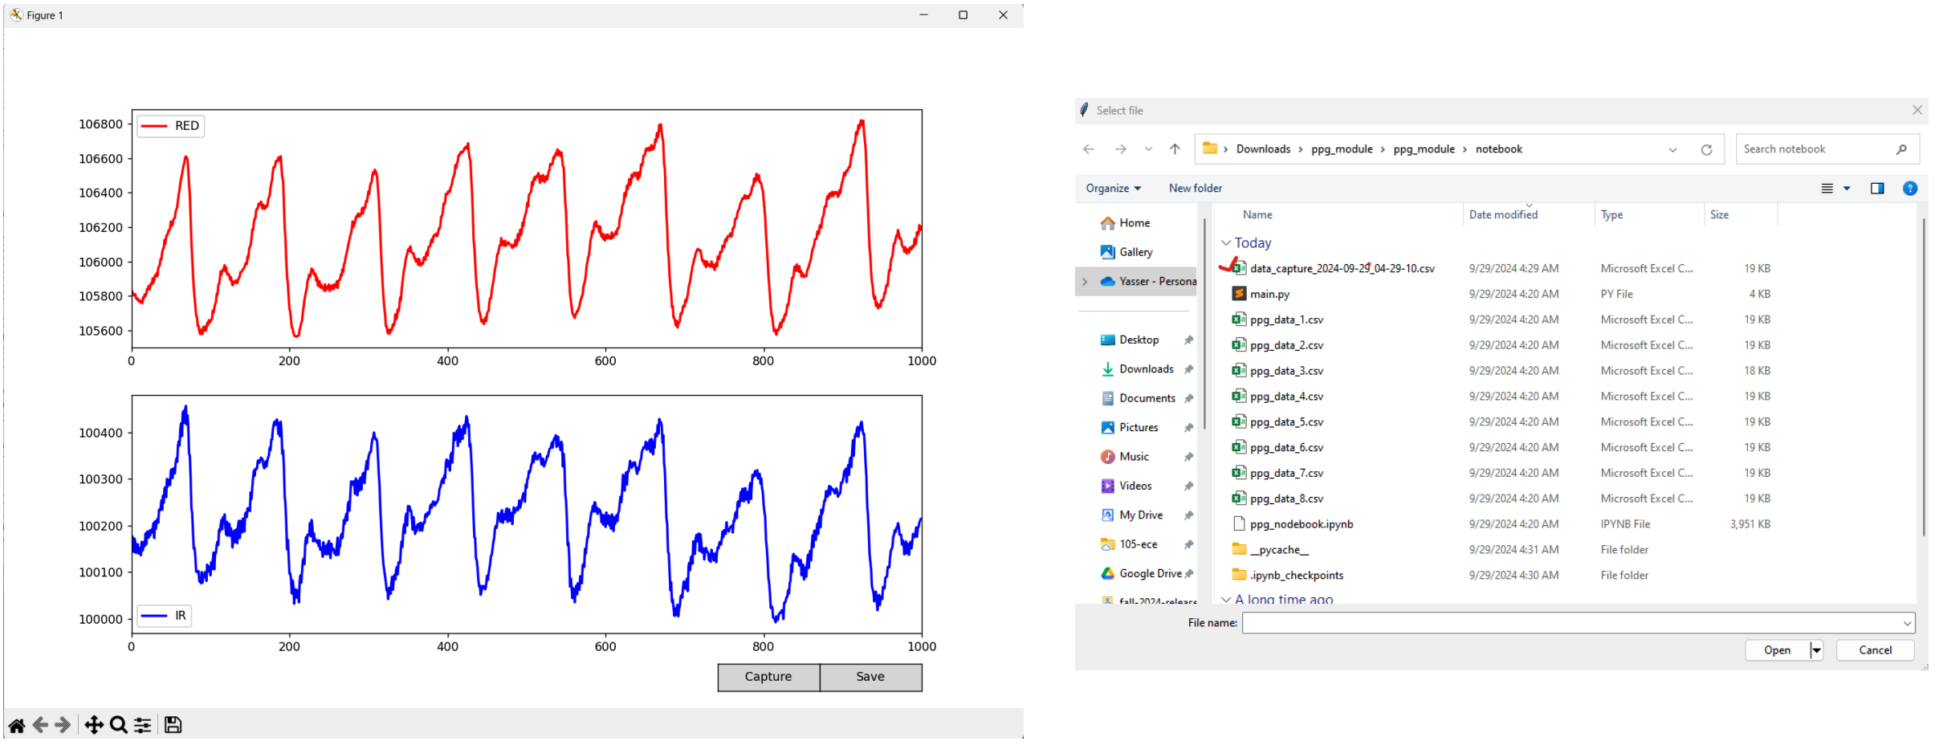

Checkpoint-9: Open ppg_notebook.ipynb file. Select the new .csv file and check the raw data from the file. This file will be used to determine heart rate from your PPG signals.

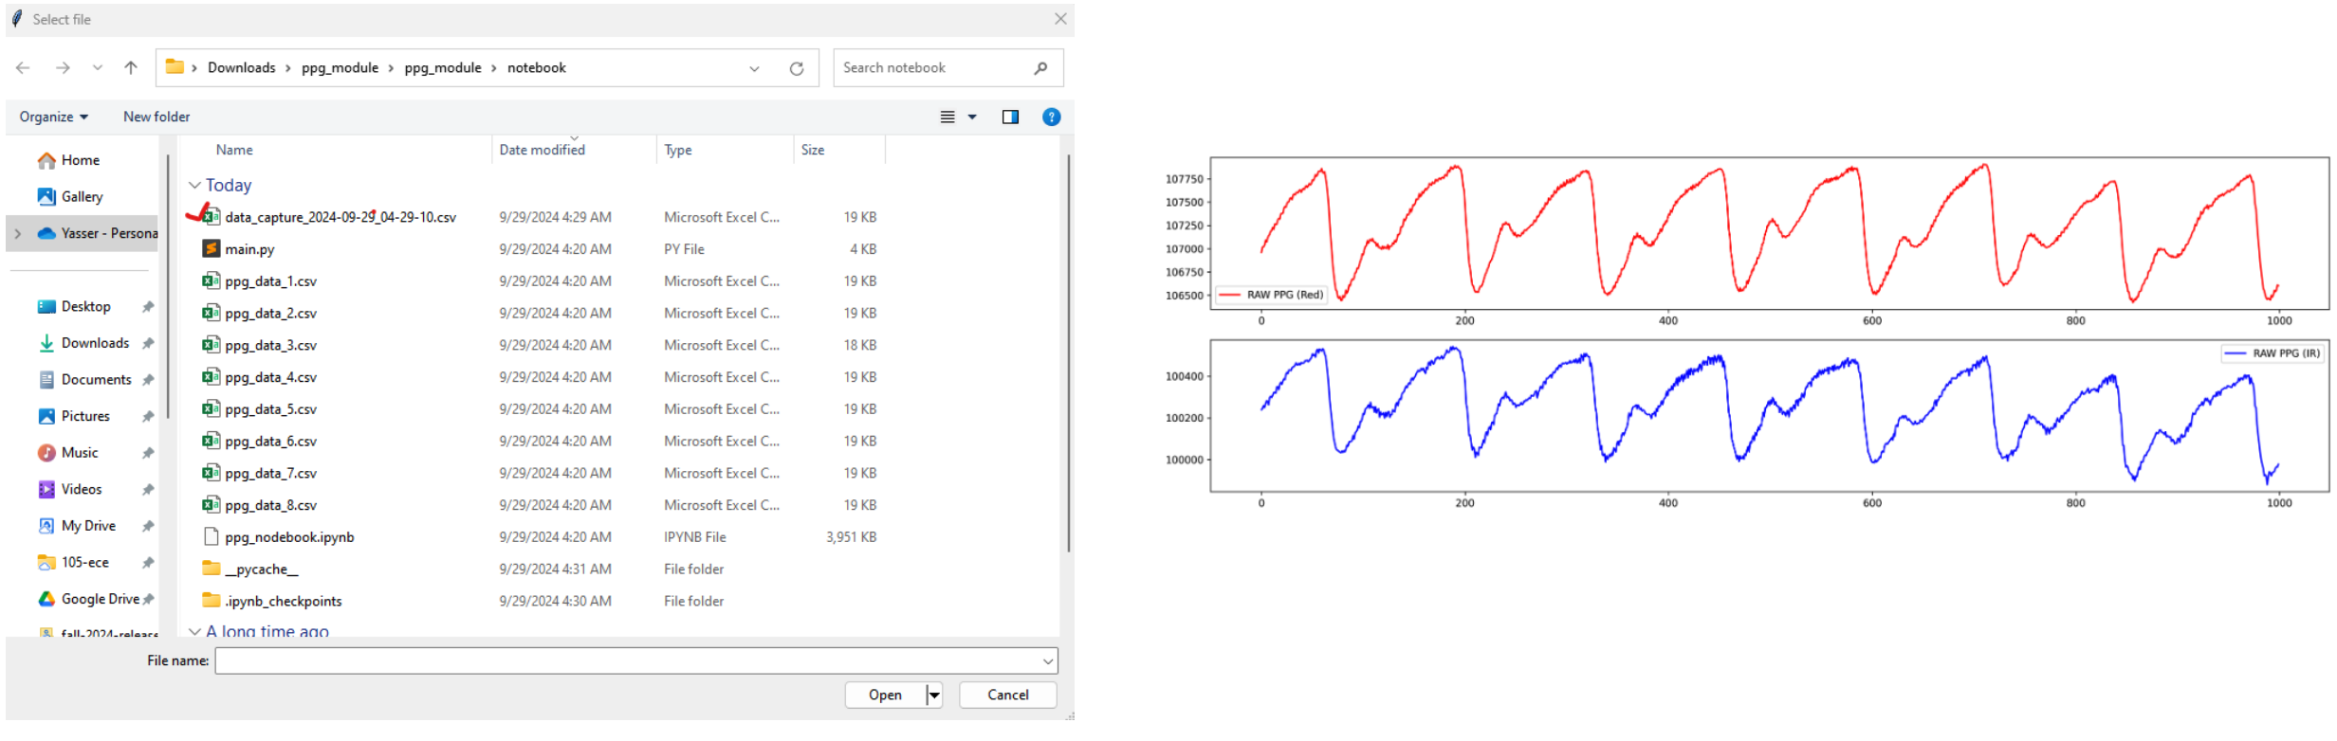

Your PPG signal from the oximeter contains a lot of information mixed together:
- The main, repeating pulse wave caused by your heartbeat.
- Slower changes caused by your breathing.
- High-frequency noise from slight movements or electrical interference.

Checkpoint-10: Removing the high frequency noise from raw data.

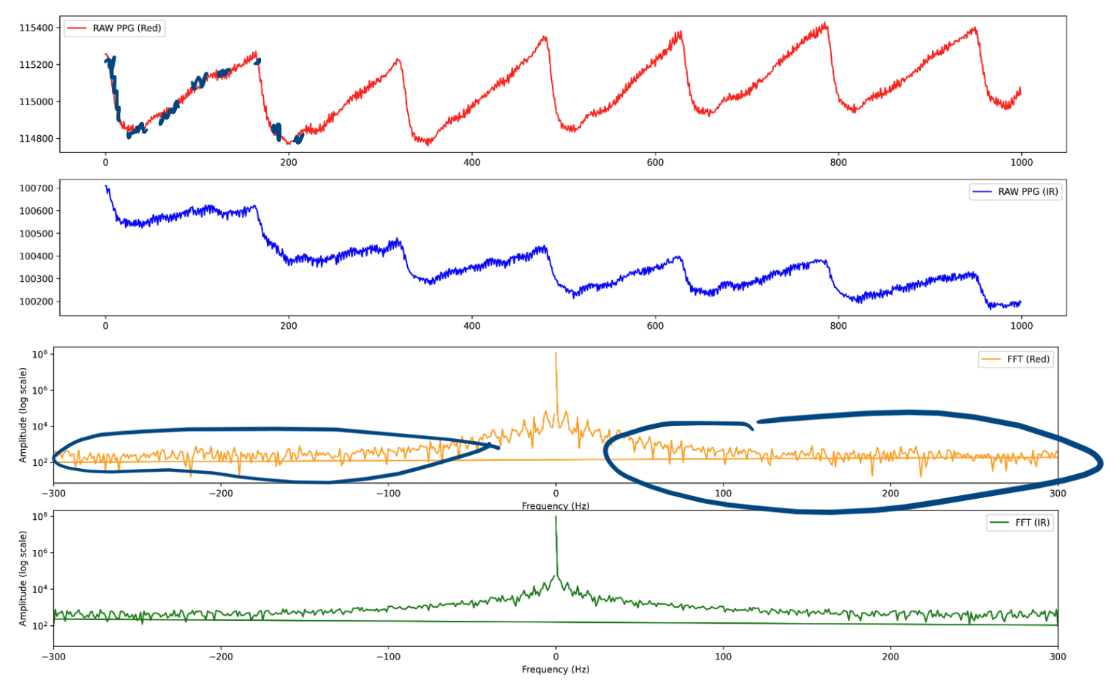

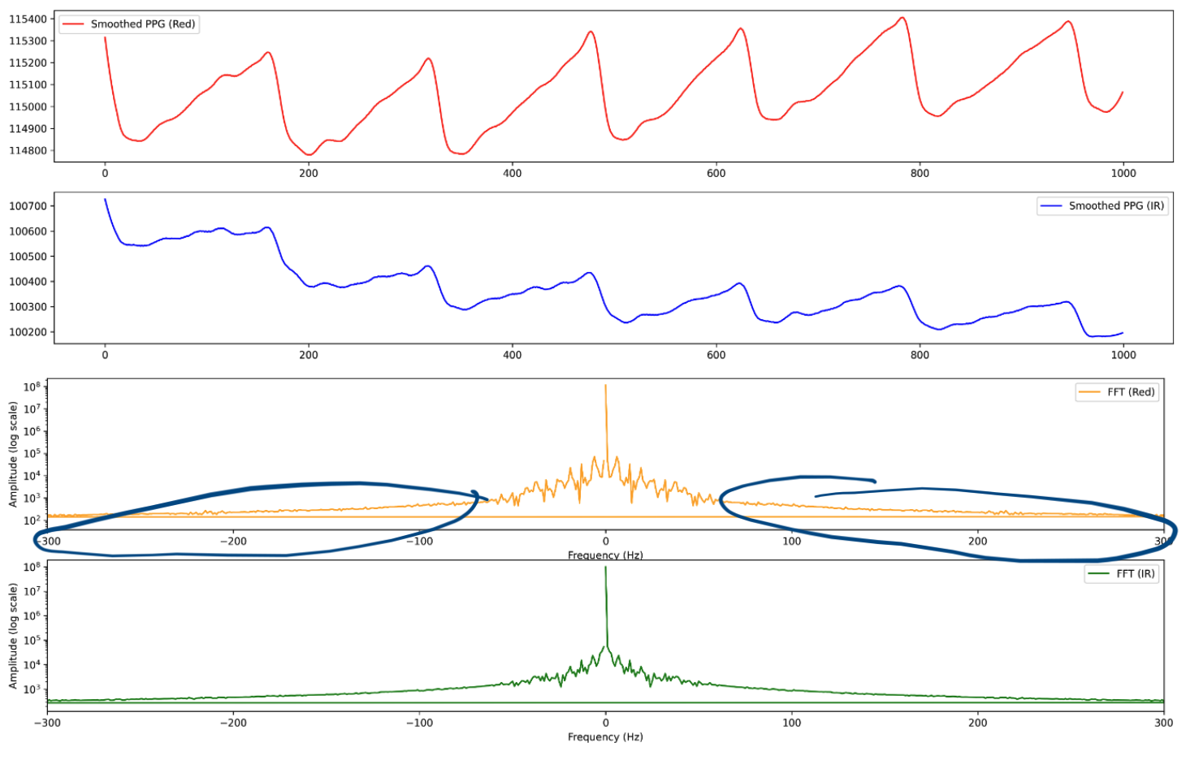

Checkpoint-11: Drift correction.
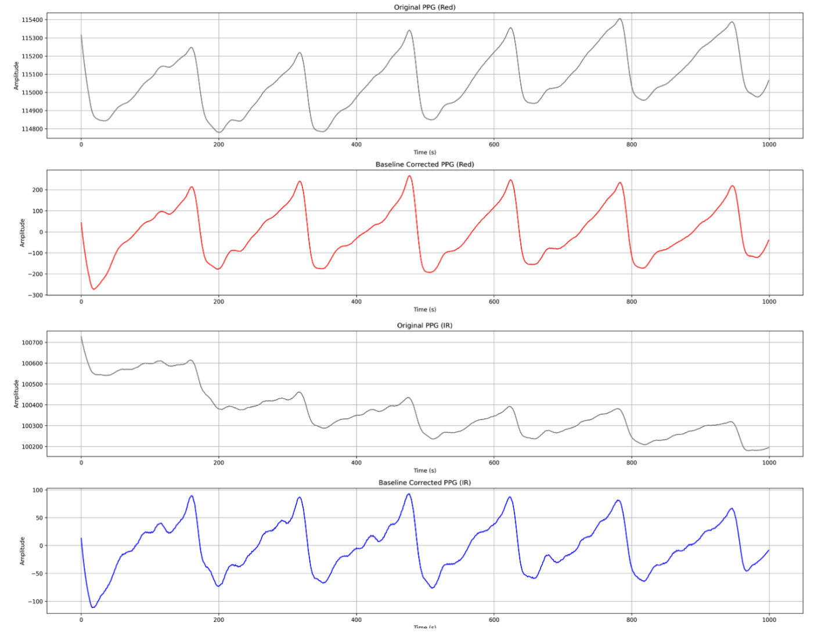

Checkpoint-12: Peak detection.

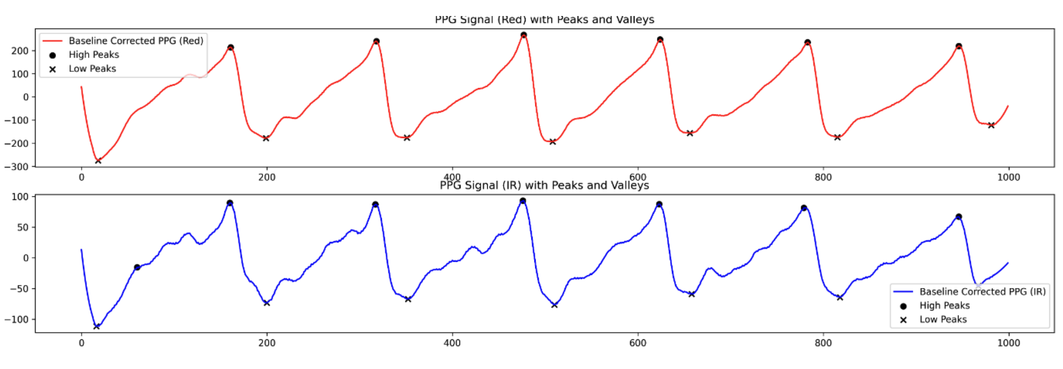

Checkpoint-13: Find heart rate.

By finding the frequency of the peaks, you can directly calculate the heart rate. For example, if the peak is at 1.2 Hz (1.2 cycles per second), your heart rate is:
$$1.2\frac{\text{beats}}{\text{second}}×60\frac{\text{seconds}}{\text{minute}}=72\text{ beats per minute (BPM)}$$

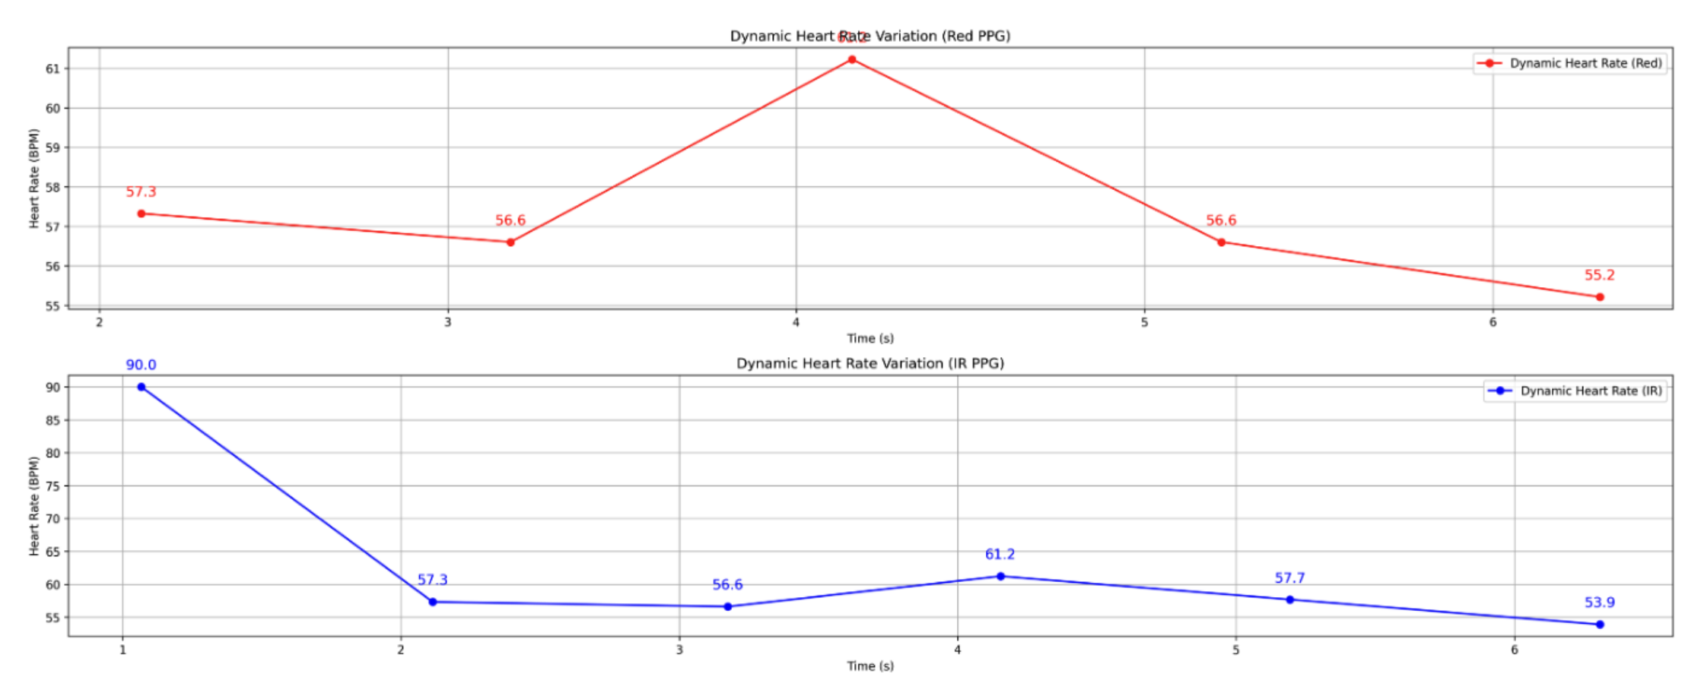

Fourier Transform Basics:
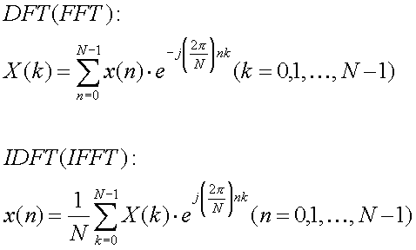
X[k] is the k-th element of the frequency domain representation (FFT). x[n] is the nth element of the time domain signal.
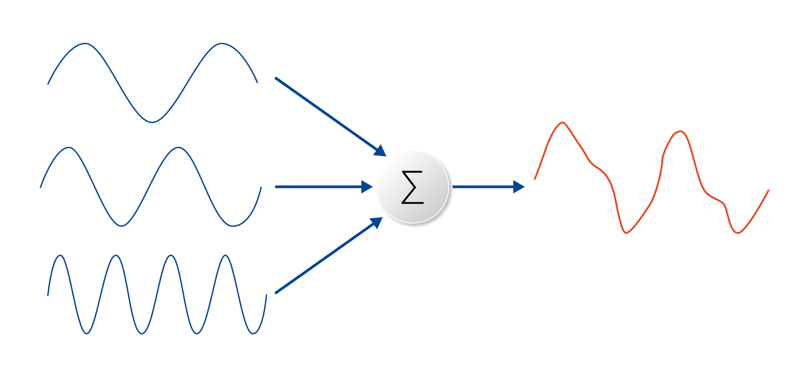
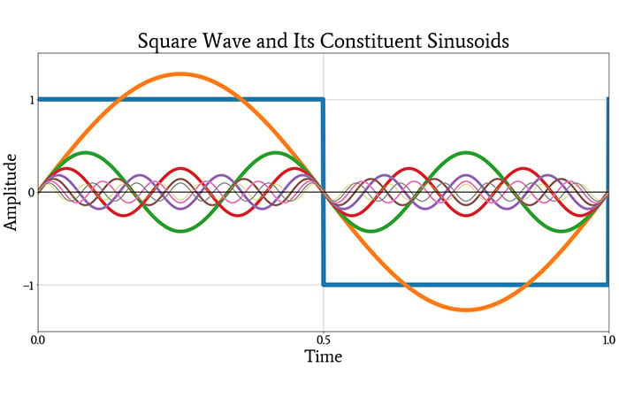

Checkpoint-14: You can also use FFT and a single component to find heart rate.

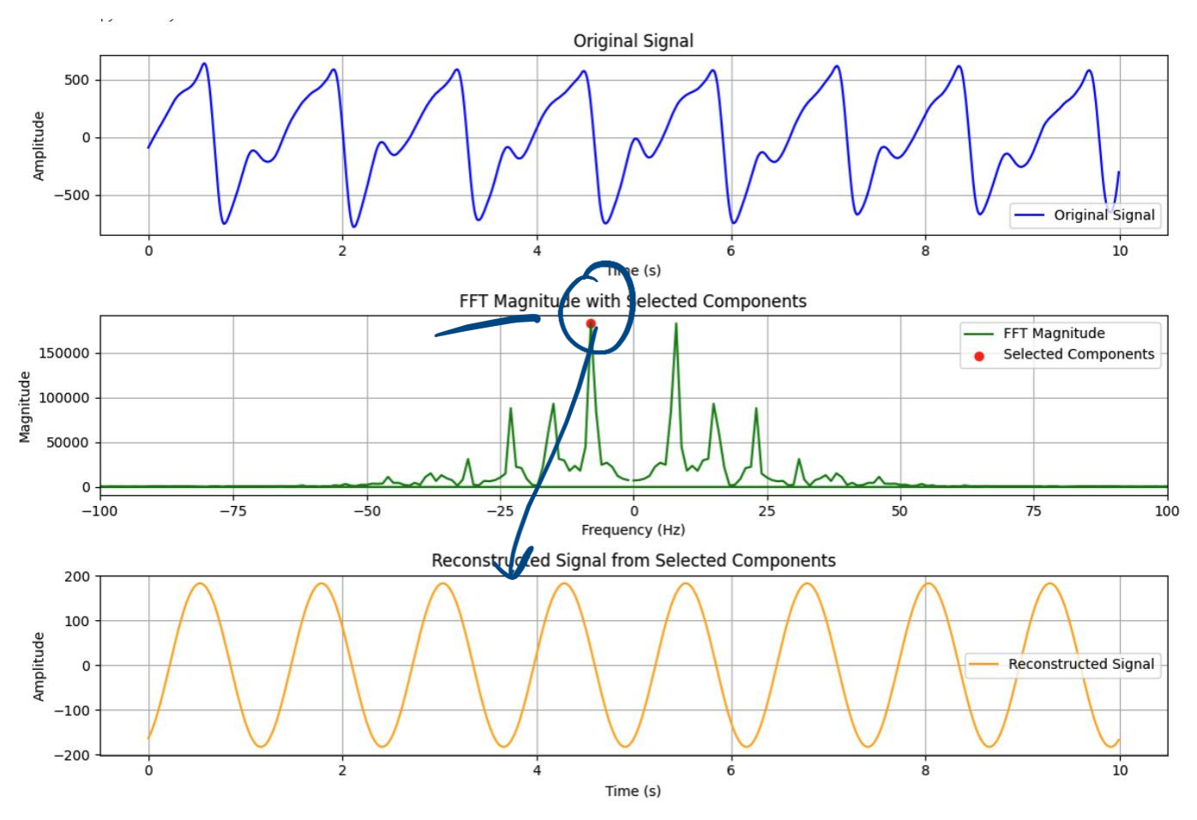

Checkpoint-15: Open spo2_calculations.ipynb file. Run through the file to determine SpO2 from your ppg signals.

The PPG signal has two main components:
- DC Component: The steady, constant part of the signal. It represents the light absorbed by tissues, bone, and non-pulsating blood.
- AC Component: The smaller, pulsating part of the signal that rides on top of the DC component. It's caused by the surge of arterial blood with each heartbeat. The amplitude of the AC component tells us how much light was absorbed by the pulsating blood.

To calculate the $SpO_{2}$ we use the ratio of the AC to DC components for both the red and infrared signals. This "Ratio of Ratios," often called R, is calculated as:

$$R=\frac{AC_{red}/DC_{red}}{AC_{IR}/DC_{IR}}$$

This R value is then used in an empirical formula (calibrated by the manufacturer) to estimate the blood oxygen saturation, $SpO_{2}.$ A common simplified formula looks like this:

$$SpO_{2}\left(\%\right)=110-25⋅R$$
Think about it: If someone has a ROS=0.25, what should be their SpO2 value?

