EE 105 Fall 2025
Homework 4 – upload to grade scope
(Due November 6, before class, late submission will incur 20% points/day penalty)
Instructions: Perform the following tasks based on the circuits and concepts discussed in class. Be sure to show all work where applicable.

- What is the purpose of ADC and DAC in sensor systems?

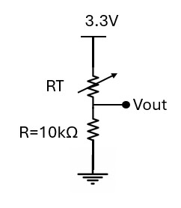

2.

During class we used the following c
o
n
figuration for measuring the skin
temperature
.

I
f
you chan
g
e the

circuit to
:

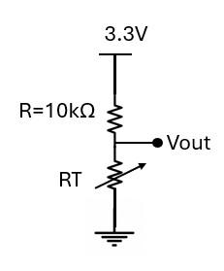
- Write an expression for 𝑅𝑇=𝑓(𝑉𝑜𝑢𝑡)

- Show the Vout plot when you touch the temperature sensor. Explain why Vout is increasing or decreasing? (use your demo board, similar to the lab)

- Calculate the sensitivity of the glucose sensor. (Hint: sensitivity = change in output / change in input)
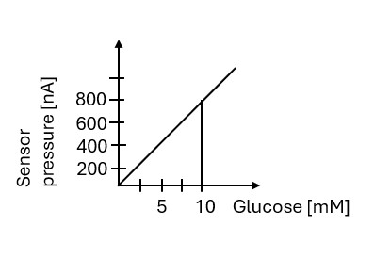

- What is an op amp. Draw an op amp and label each terminal.

- What are the golden rules of an op amp.

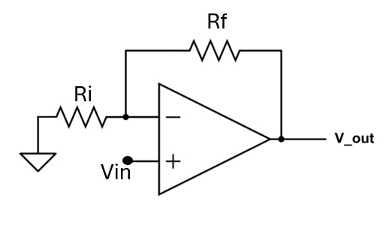
6.

D
erive
𝑉𝑜𝑢𝑡
=

𝑓
(
𝑉
𝑖𝑛
)
.

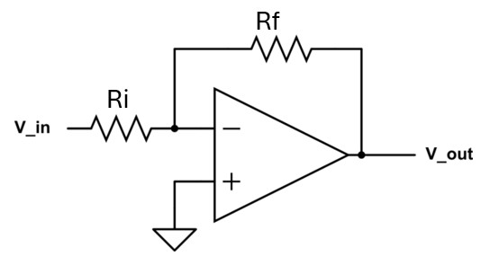
7.

D
erive
𝑉𝑜𝑢𝑡
=

𝑓
(
𝑉
𝑖𝑛
)
.

- What is AFE analog front end?

- Draw the system block diagram of a sensing system. What are the five steps and explain why they are needed.

- Why do we need two different lights in an oximeter?

- Write Beer Lambert’s law and explain each term.

- What are the ac and dc part of an PPG signal. If Rac=20mV and Rdc=625mV, NIRac=20mV, NIRdc=330mV. Calculate SpO2.

- Draw the Fourier component of the signals.
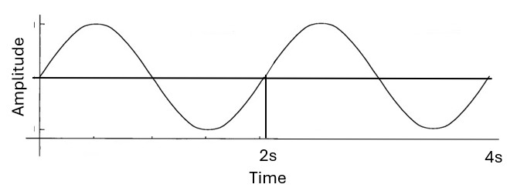

- Draw the output signals. 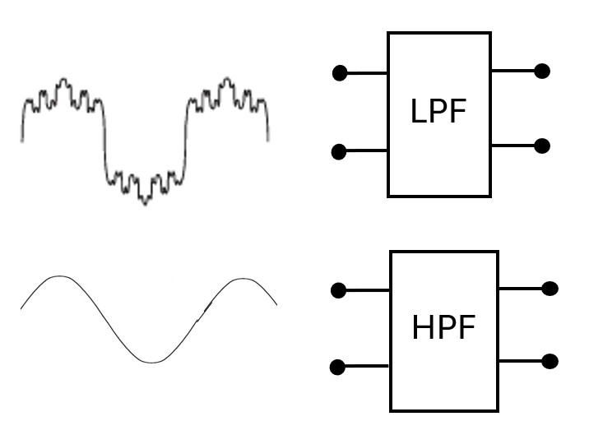

- In what condition oximeter reading will be 0% and 100%.

