EE 105 Fall 2025
Homework 2 – upload to grade scope
(Due September 25, before class, late submission will incur 20% points/day penalty)
Instructions: Perform the following tasks based on the circuits and concepts discussed in class. Be sure to show all work where applicable.

Problem 1: Describe the function of the touchpad used in class. What are the sensor and processing components involved?

Problem 2: Define the following electrical quantities and their units, Draw their corresponding circuit symbols.
  - Voltage
  - Current
  - Resistance
  - Capacitance
  - Inductance

Problem 3: Analyze the following circuits and calculate the voltage and current across $R_{1}$ and $R_{2}$. $V_{R1}$, $I_{R1}$, $V_{R2}$, $I_{R2}$=?
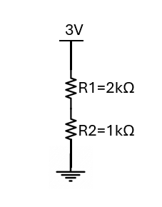

Problem 4: Given the circuit below, calculate the voltage and current across the R1, R2, R3 and R4:
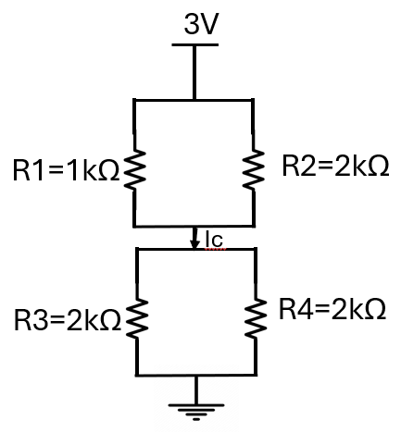
  - $V_{R1}$, $I_{R1}$, $V_{R2}$, $I_{R2}$, $V_{R3}$, $I_{R3}$, $V_{R4}$, $I_{R4}$.
  - What is the value of the $I_{C}$?

Problem 5:
- In the given circuit, calculate the voltage values at each node ($S_{1}$ to $S_{9})$ , and the current through each branch ($I_{1}$ to $I_{12}$) using python.
$$R_{1}=R_{2}=R_{3}=R_{4}=R_{5}=R_{6}=R_{7}=R_{8}=R_{9}=R_{10}=R_{11}=R_{12}=100Ω$$

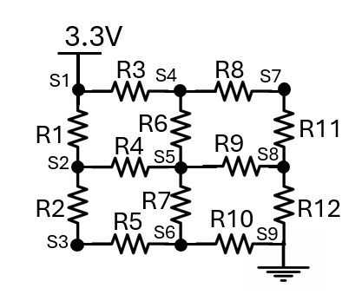

- If
$$R_{1}=R_{2}=R_{6}=R_{7}=R_{11}=R_{12}=100Ω$$
$$R_{3}=R_{4}=R_{5}=R_{8}=R_{9}=R_{10}=50Ω$$
calculate the voltage values at each node ($S_{1}$ to $S_{9})$ , and the current through each branch ($I_{1}$ to $I_{12}$) using python.


- What is the difference between the circuit in a) and b). Which one should you use for the touchpad application and why?

Problem 6: Derive the equation for $V_{x}- V_{y}$​.
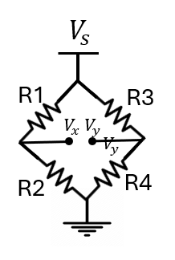

Problem 7: Consider a cylindrical resistance of length l=10 cm, radius r=1 mm, and resistance of R=0.54mΩ. Pick the resistivity of the cylindrical resistance from below.

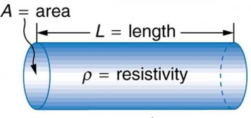
a) 1.7×${10}^{-5}Ωm$
b) 1.7×${10}^{-6} Ωm$
c) 1.7×${10}^{-8} Ωm$
d) 5.4×${10}^{-9}Ωm$

Problem 8: By what factor does the resistance of a rectangular block change if you double each dimension of the block?
  - a) 1
  - b) 2
  - c) $\frac{1}{2}$
  - d) $\frac{1}{4}$

Problem 9: Given the circuit below, calculate the voltage values of $V_{R1}$, $V_{R2}$ , $V_{R3},$ $V_{R4}$, $V_{R5}$, $V_{R6}$.
