Name: ____________________________ USC ID#:___________________

I hereby affirm that all the answers below are my own. I have neither searched online nor taken assistance from any external entity.

____________________
Student Signature Above

EE105 – Fall 2025
Practice Midterm

Time Limit: 2 hours

Total number of pages is 6 (including this page). Put your name on every page where noted

Section A (25 points)

Question 1 (4 points)
Given the circuit diagram with nodes A, B, and C, each connected to either 3V or 6V sources as shown. Determine the voltages V_{A}​, V_{B}​, and V_{C}​ at the respective nodes with respect to the ground.

A
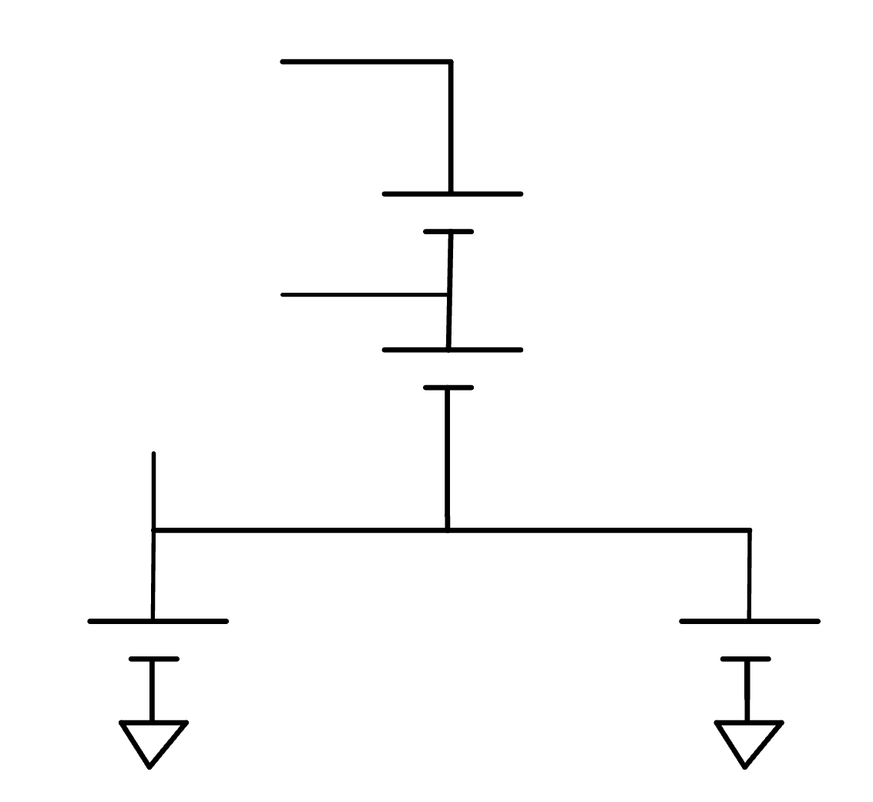
6V
6V
3V
3V
C
B

Question 2 (6 points)
Given the circuit below, determine the current values I1, I2, I3.
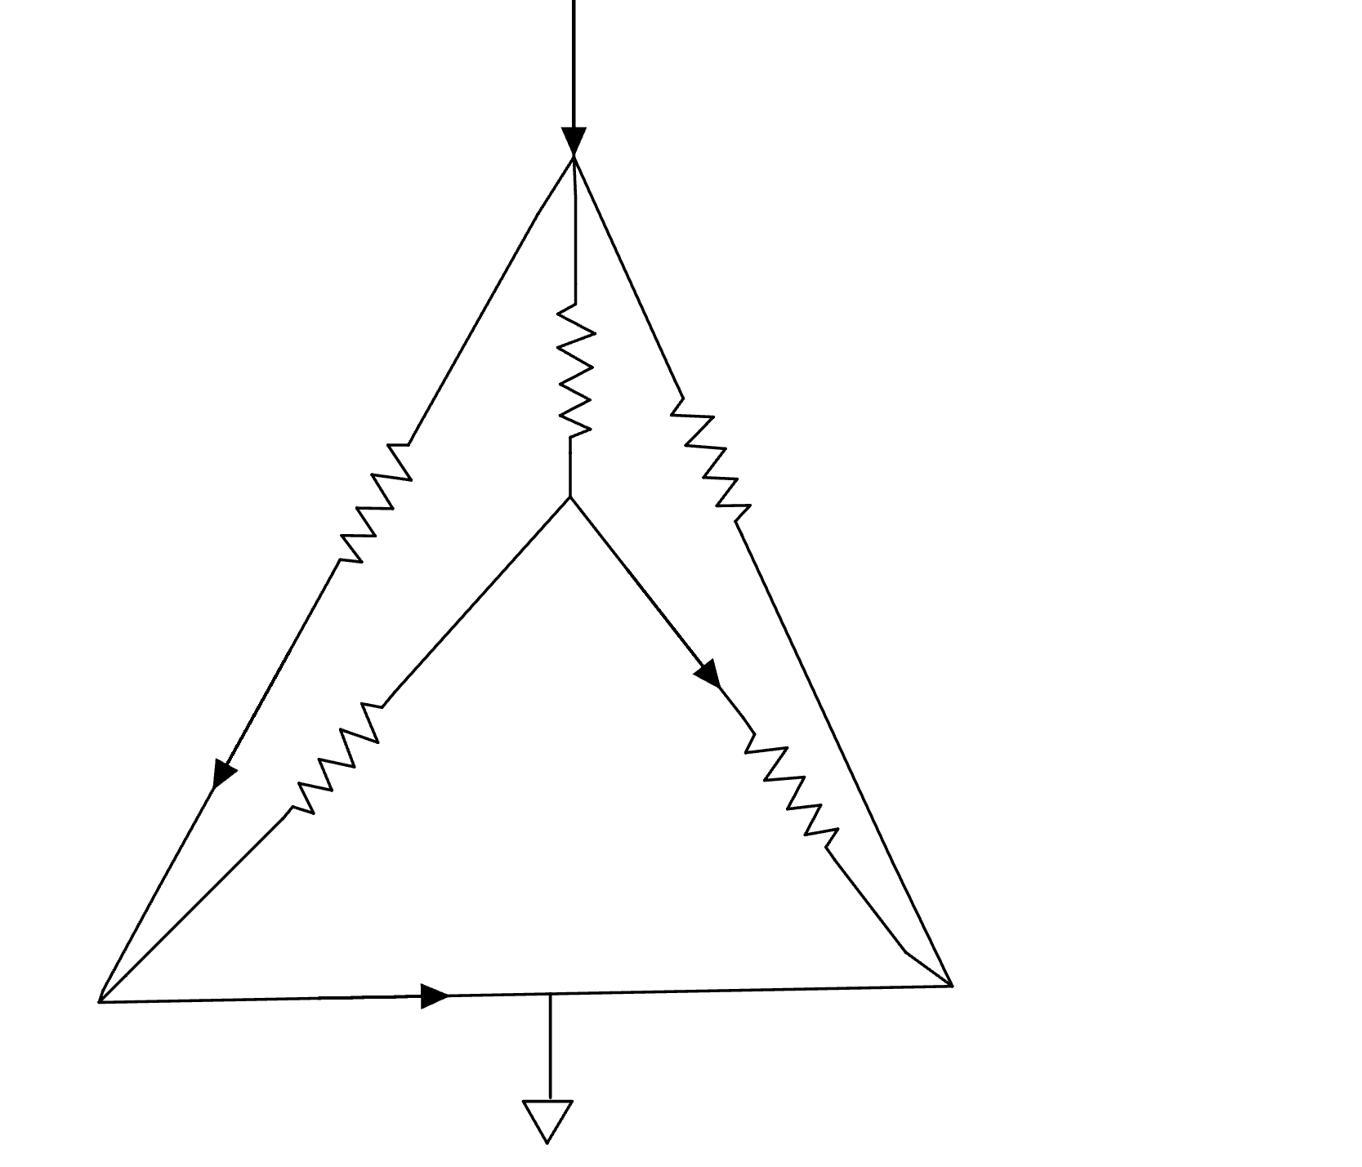
I3
I2
I1
40A
R
R
R
R
R

Question 3(6 points)
Given the circuit with six resistors as shown. Find voltage at node D (V_{D}) and current I1.
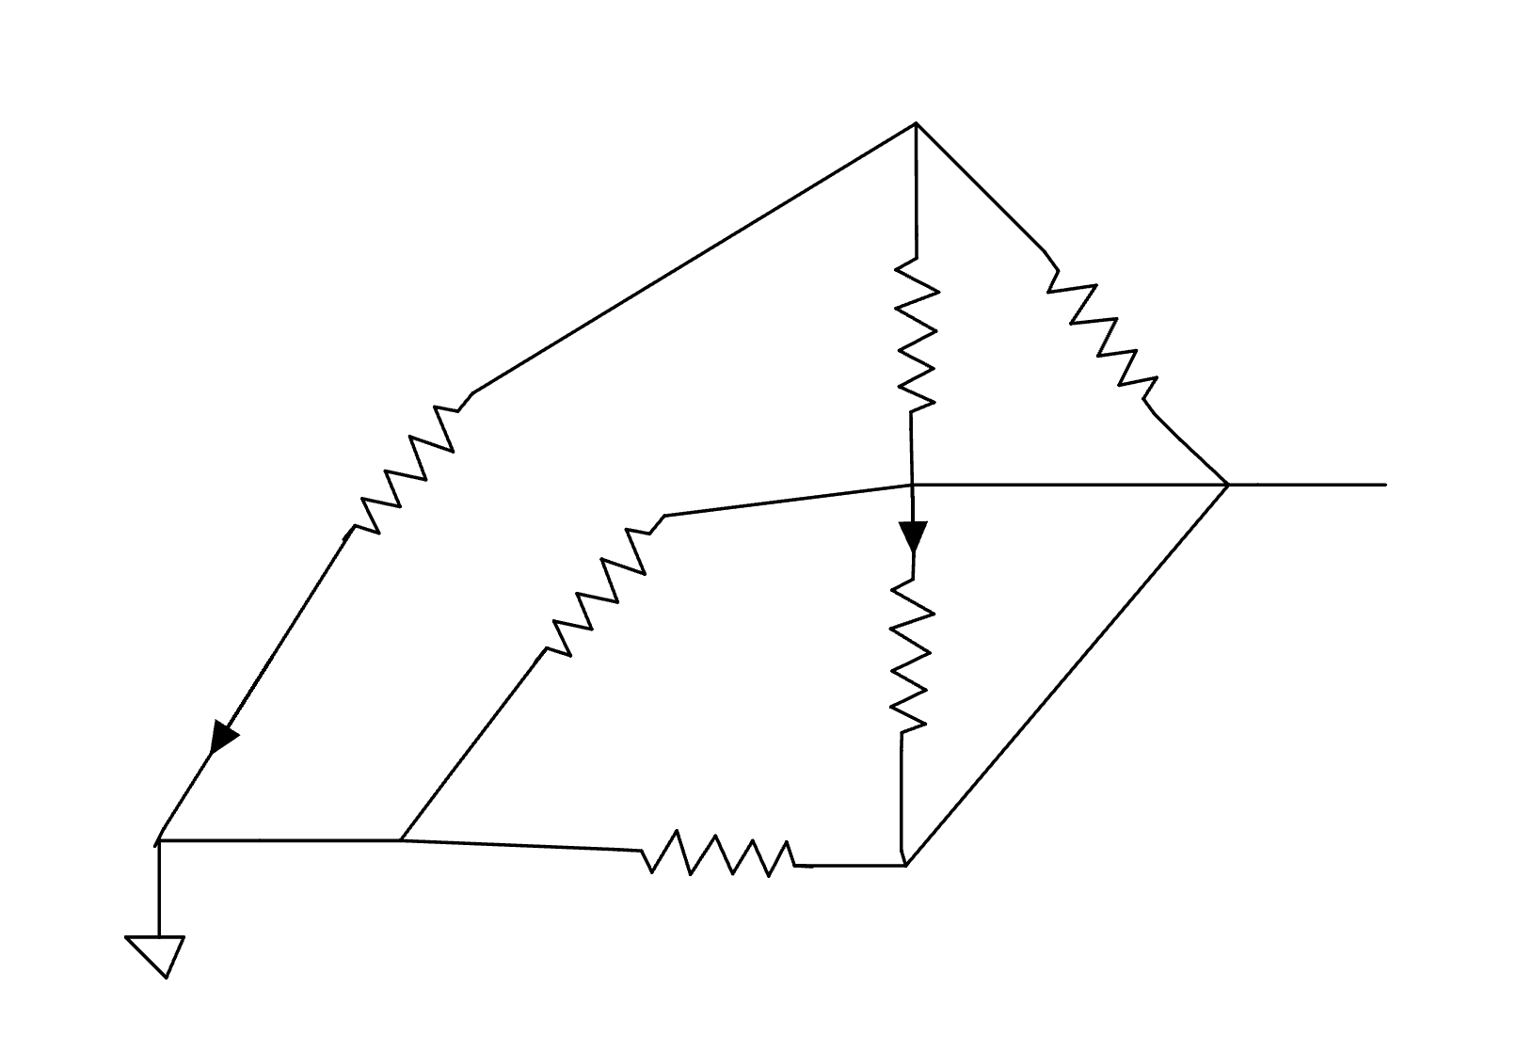
I1
D
2ohm
2ohm
2ohm
1A
3ohm
3ohm
3ohm

Question 4 (6 points)
The voltage at node A with respect ground is 3V and total current going through the circuit is 1mA. Determine resistance value R.

V_{A} = 3V
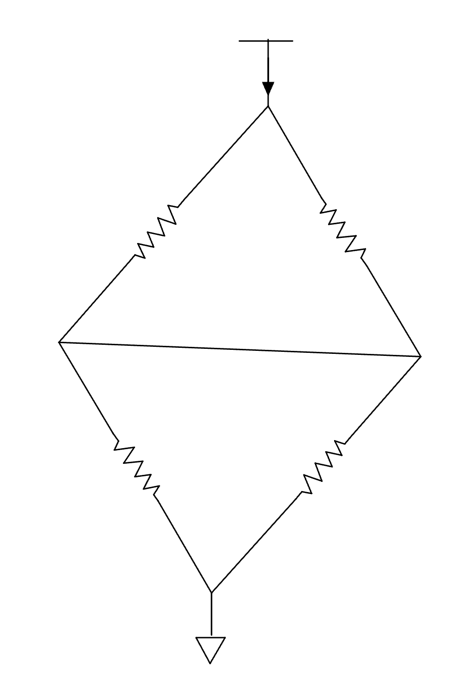
1mA
4R
2R
2R
4R

Question 5 (6 points)

Complete the following python function.

import numpy as np

def create_and_print_evens(num_elements, lower_limit, upper_limit):
"""
Creates a random integer array and then prints its even numbers.

Args:
num_elements: The number of integers to create in the array.
lower_limit: The lowest possible value for the random integers (inclusive).
upper_limit: The highest possible value for the random integers (inclusive).
"""
# Step 1: Create a NumPy array with 'num_elements' random integers
# that are between 'lower_limit' and 'upper_limit'.
# YOUR CODE HERE

# Step 2: Now, loop through the random array you just created.
# If a number is even, print it.
# YOUR CODE HERE

Question 6 (6 points)

Given the three python lists:
a = [1, 2, 3]
b = [-1, 1, 2]
c = a + b

determine the following values:

c =
a[-2:1] =
a[3] =

Question 7 (6 points)

Look at the following code has been uploaded to an Arduino.

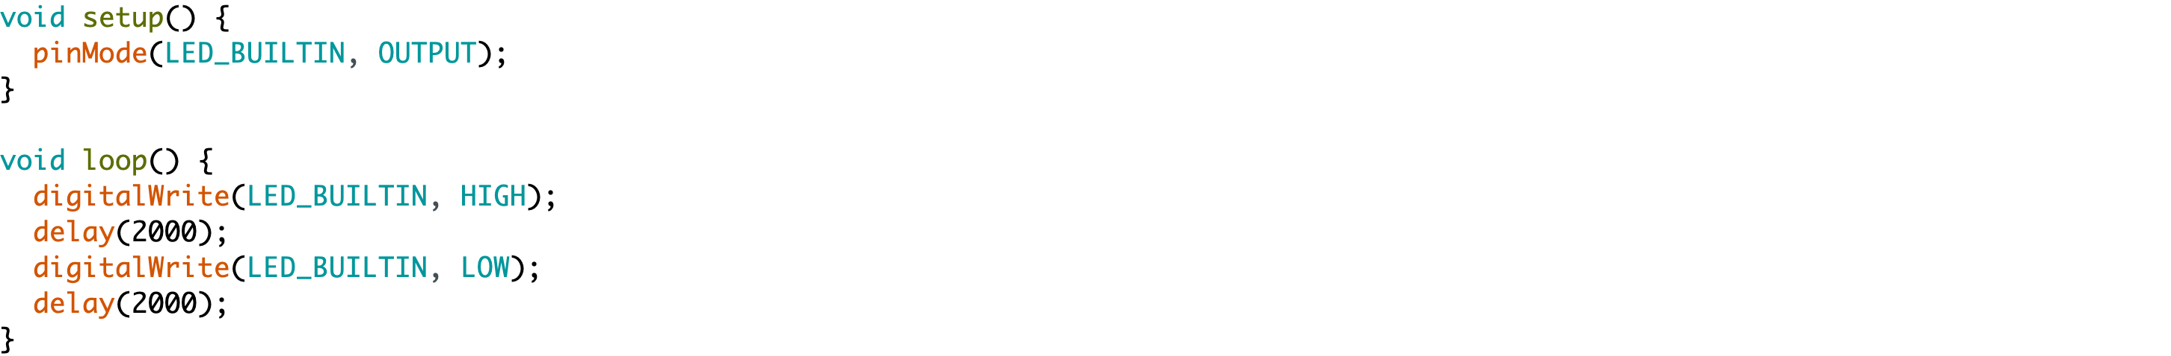

- How many times does the void setup() function run?
- In each cycle, how long does the LED stay ON?
- Explain relationship between delay time and frequency of LED blinking.
- How should you modify the code if the LED blinking frequency needs to be 2Hz?

Question 8 (8 points)

A microcontroller uses a 12-bit ADC with a 5V reference voltage. The ADC outputs digital values in the range 0–4095 (since it is 12-bit).
- What is the range of the raw ADC output?
- Derive the formula for converting the raw ADC output into the corresponding analog voltage.
- Calculate the ADC conversion factor (the multiplier needed to convert the raw ADC value to voltage).
- If the ADC reading is 2175, compute the actual voltage.

Question 9 (6 points)

Draw the CMOS inverter and explain it’s operation to fill up the following table

Vin | Vout
VDD
0

Question 10 (8 points)

Draw the cross section of p-channel and n-channel MOSFETs. Label each layer and terminal. What gate bias will be need to turn on the p-channel and n-channel MOSFETs?

Question 11 (8 points)

Consider an n-channel MOSFET with the following parameters:
- Mobility–oxide product: μC_{ox} = 200 μA/V²
- Width/Length ratio: W/L = 10
- Threshold voltage: V_{T} = 1.0 V
a) For V_{GS} = 2.5 V and V_{DS} = 1.0 V:
i) Determine whether the MOSFET operates in the linear or saturation region.
ii) Calculate the drain current I_{D}.
b) For V_{GS} = 4.0 V and V_{DS} = 5.0 V:
i) Check the region of operation.
ii) Calculate I_{D}.
c) Compare the results from (1) and (2) and briefly explain why ID changes with operating region.

Question 12 (8 points)

Briefly explain what happens at each stage of the following figure. Discuss V_{G}, V_{T} relationship, V_{DS,} and I_{D} values for each of the four stages. Define pinch-off and show how V_{DS,Sat} ​is related to V_{GS} and V_{T}.

