EE 105 Fall 2025
Homework 3 – upload to grade scope
(Due October 2, before class, late submission will incur 20% points/day penalty)
Instructions: Perform the following tasks based on the circuits and concepts discussed in class. Be sure to show all work where applicable.

Problem 1: What are the different types of materials used in electronics? What are their charge carrier densities?

Problem 2: Why is silicon used in electronics?

Problem 3: Draw the atomic models of the p-type and n-type semiconductors.

Problem 4:
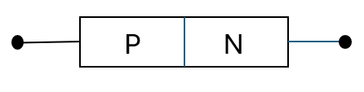
- What is this electronic device?
- Draw the I-V characteristics and explain what the threshold voltage is.

Problem 5: Write the ideal diode equation and explain each quantity in the equation.
- A silicon diode is connected in a circuit with a 5V power supply and a series resistor of 1kΩ. Draw the circuit. The saturation current of the diode is $I_{s}={10}^{-12}A$. Use the diode equation to calculate the current through the diode when the voltage across it is 0.7V.
$$n=1$$
$$\frac{kt}{q}=26mV$$
- Find the voltage across the diode when the current through it is 1mA.

Problem 6: What is a MOSFET? What is a p-channel and n-channel MOSFET? Draw their side view and label each segment.
- A n-channel MOSFET is used in a circuit with a drain resistor RD=1kΩ and a supply voltage VDD=10V. The MOSFET has the following parameters:
$V_{th}$=2V
$\frac{μ_{n}.C_{ox}.Z}{2L}$=$0.5\frac{mA}{V^{2}}$
If 𝑉𝐺𝑆=4V, assuming the MOSFET is in the saturation region, calculate the current and voltage across the resistor.
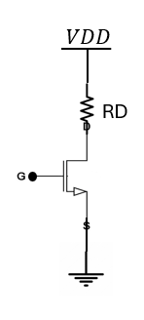

Problem 7: Draw the circuit symbol of p-channel and n-channel MOSFET.

Problem 8:
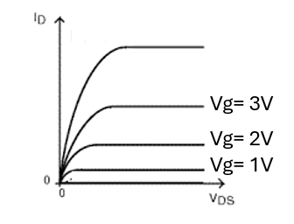
In the shown plot, draw another curve when Vg<Vth. What is the state of the N-channel MOSFET when Vg<Vth?

Problem 9: Fill up the table.
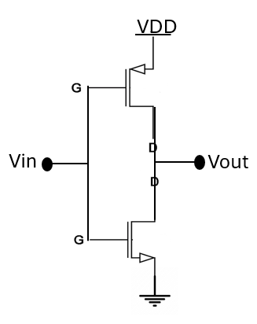
Vin | Vout
0
VDD

- What is this electronic device? Where can you use such a device?

