**ITP 125 – Homework 01 – Introduction to the Command Line**

**Due:**

1 minute before the next class lab

**Submission:**

1. Answer the questions at the end of this file and name the document hw01.docx

You can directly add the screenshots into the word document.

In addition, submit the code for “Your First Program” from Automate the Boring Stuff – Chapter 1. Name the file hw01.py

1. 7zip the file with either 7zip (Windows)/Keka (OSX) and set a password for the decompression. The password should be terminalfu
2. Place the encrypted document into the repo and push to changes GitHub

**Procedure:**

1. Finish the free Codecademy lessons (Unit 01- 03) regarding the command line:

<https://www.codecademy.com/learn/learn-the-command-line>

**or** you can do the following:

<https://learnpythonthehardway.org/book/appendixa.html>

1. Finish the free Codecademy lessons (Unit 01) regarding Git:

<https://www.codecademy.com/learn/learn-git>

**or** you can do the following:

<https://try.github.io/levels/1/challenges/1>

1. Finish the free Codecademy lesson (Unit 02) regarding Python:

<https://www.codecademy.com/learn/python>

and do the following

<https://automatetheboringstuff.com/chapter1/>

**Questions:**

1. Go to the following site:  
     
   <https://www.shortcutfoo.com/app/dojos/command-line>  
     
   How many lessons did you try, and what was your test score of the end of each lesson?
   1. 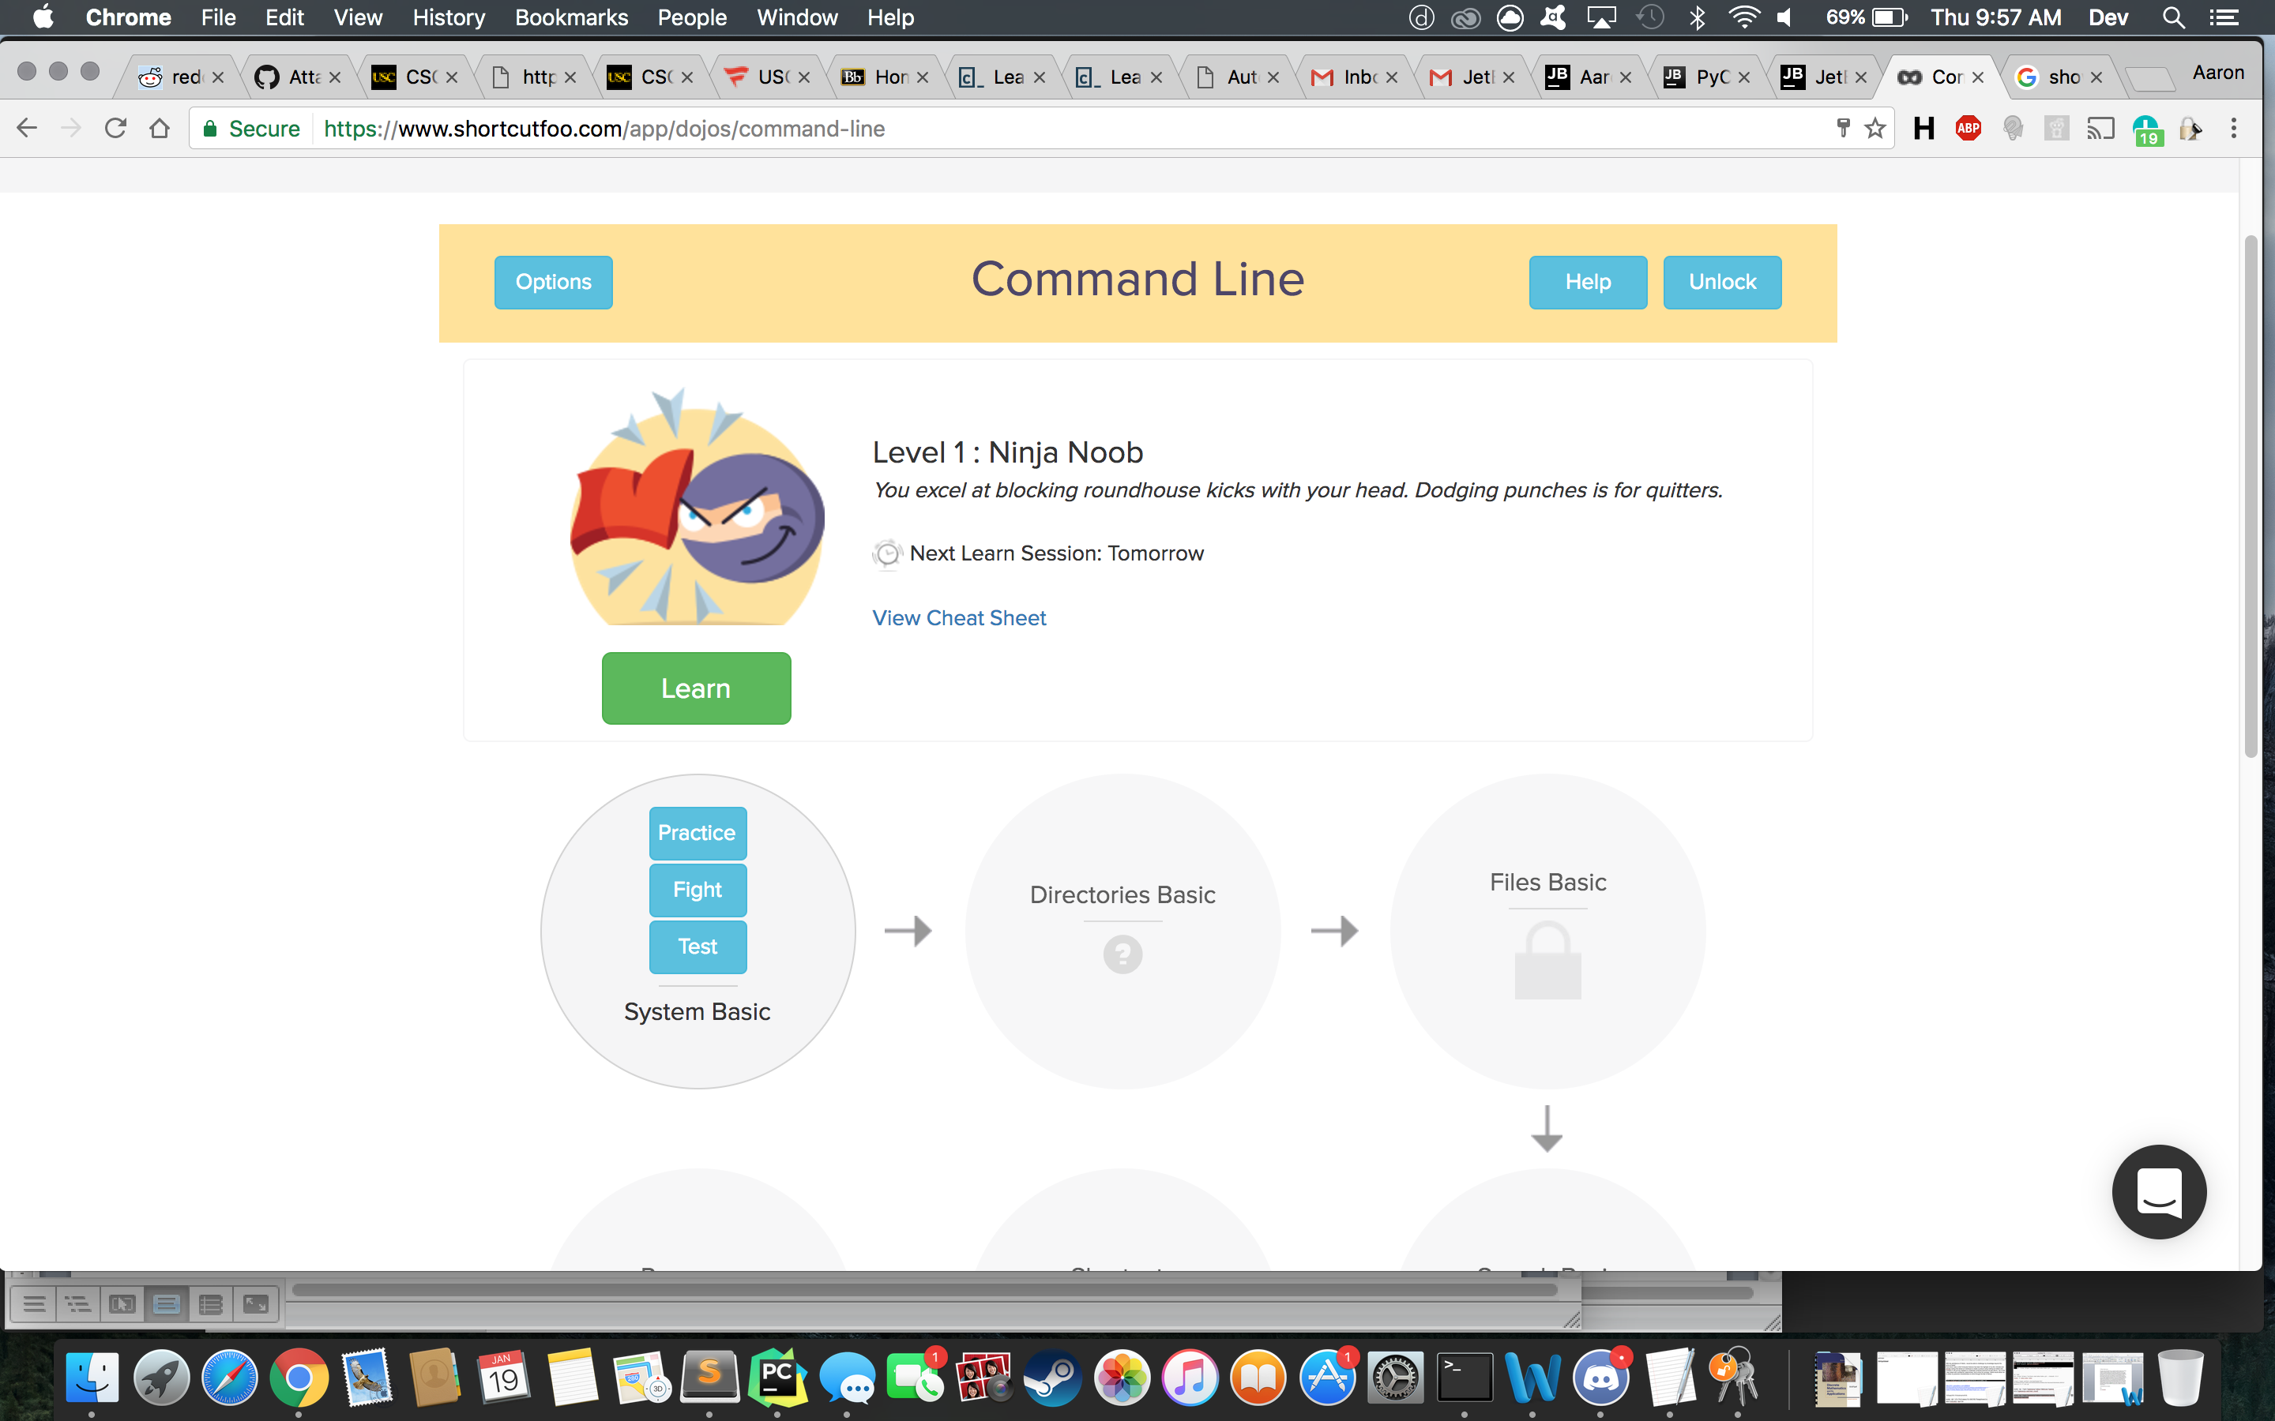
   2. 1 I did one lesson. Here is a screen shot.
2. Did you learn more about the command line from shortcutFoo or Codecademy? Which did you prefer more and why?
   1. I learned more from shortcut foo because it was more interactice
3. Why do you think the instructor is forcing you to learn the command line for the class?
   1. Love it. Absolutely love it.
4. Answer the questions at the end of chapter 1 for “Automate the Boring Stuff”. When you answer the questions, you can create a new section and restart the numbering there.
5. 1. Multiply
   2. String
   3. Floating point
   4. Subtraction
   5. Division
   6. Plus
   7. Int
6. 1. variable
   2. string
7. 1. String
   2. Int
   3. Float’s
8. Expressions are the use of mathematical operators to evaluate numerical value. You cannot use mathematical operations on strings and ints at the same time. But you can do it with floats and ints together.
9. A statement sets a variable = to a value. While an expression is to be evaluated once the program runs
10. 21
11. 1. spamspamspam
    2. error, cannot multiply int to string
12. Variable names cannot begin with #
13. Str(), float(), int()
14. Make 99 into a string using str,, so str(99)

**Resources:**

* [The Command Line Crash Course](http://cli.learncodethehardway.org/book/)