Procedure:

I wasn’t sure what Unit 01-03 entailed, so I just all the whole Command Line lesson.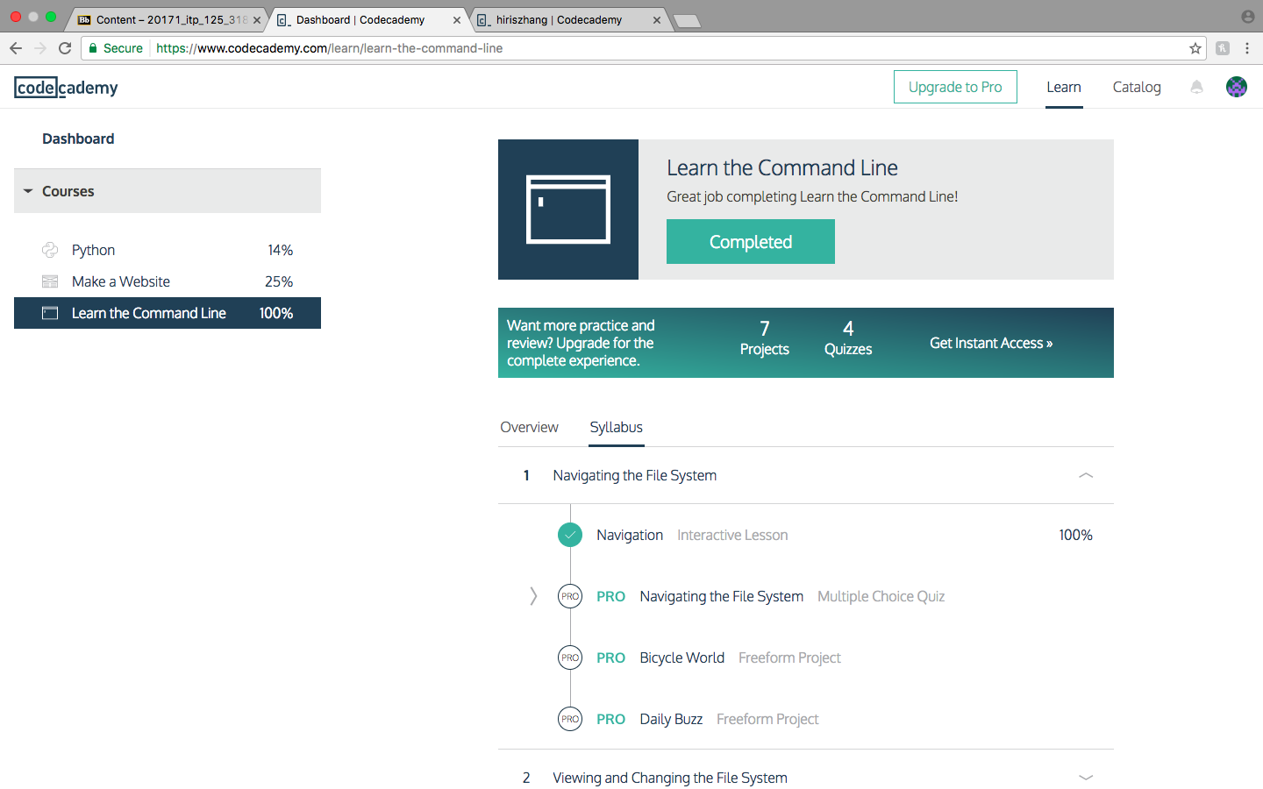

2. I did lessons (unit 01) regarding Git:



3. Screenshot of (Unit 02) regarding Python:

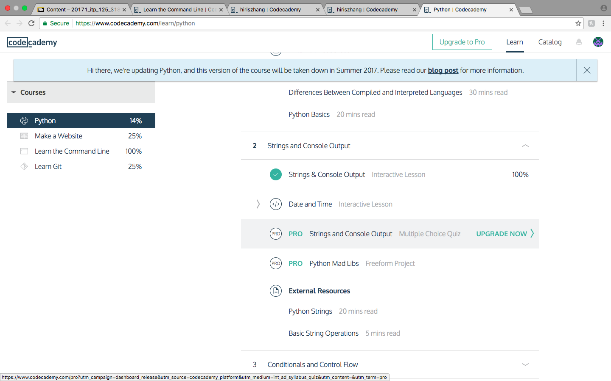

**Questions:**

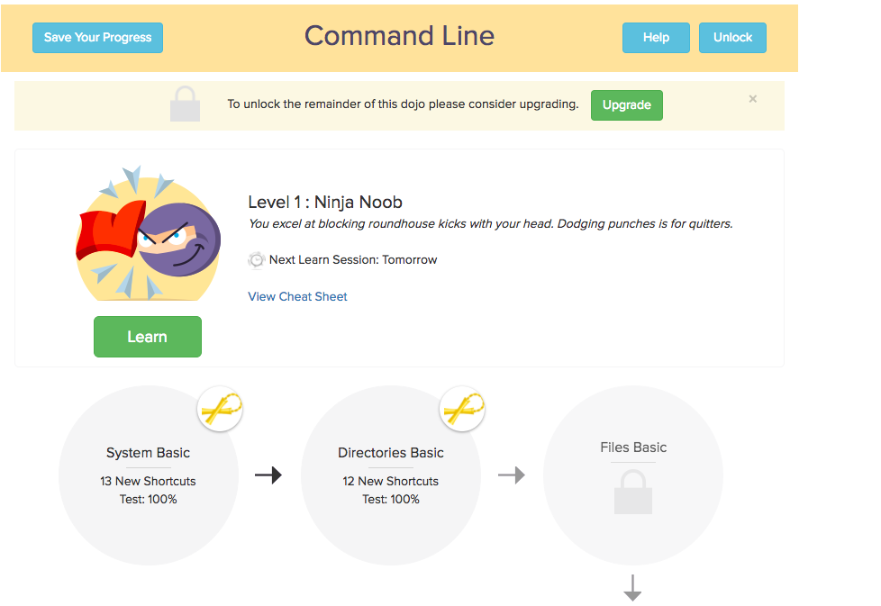

1. 2, 100%

2. I learned more from shortcutFoo because it was more fun, I spent more time working, and the lessons stuck to it to me more. I wanted to get gold belt for all of them, so I would repeat the exercise multiple time, memorizing all the shortcuts, and playing it more like a game than a lesson plan.

3. I think command line is essential to what we’re learning, but because we have limited class time, he wants us to learn these materials on our own so he can spend more time teaching us other stuff.

4. (below)

1. operators = *, ‘hello’, -, /, +,

values= -88.8, 5

2. variable= spam, string= ‘spam’

3. integers, strings, floating-point numbers

4. expressions are made up of values and operators and can always be evaluated. all expressions can be used in any phyton code and also be used as a value

5. a variable makes up an expression, but in an assignment, the variable becomes part of the assignment

6. 21

7. 1000

8. a value is an invalid variable name.

because the variable eggs have a value to it, while 100 is the variable

9. str (), int (), float ()

10. ‘I have eaten’ can only be 1 word, so it should be ‘Ihaveeaten’

and both ‘Ihaveeaten’ and ‘burritos’ should first be assigned a value.