ITP 125 Homework 01

1. 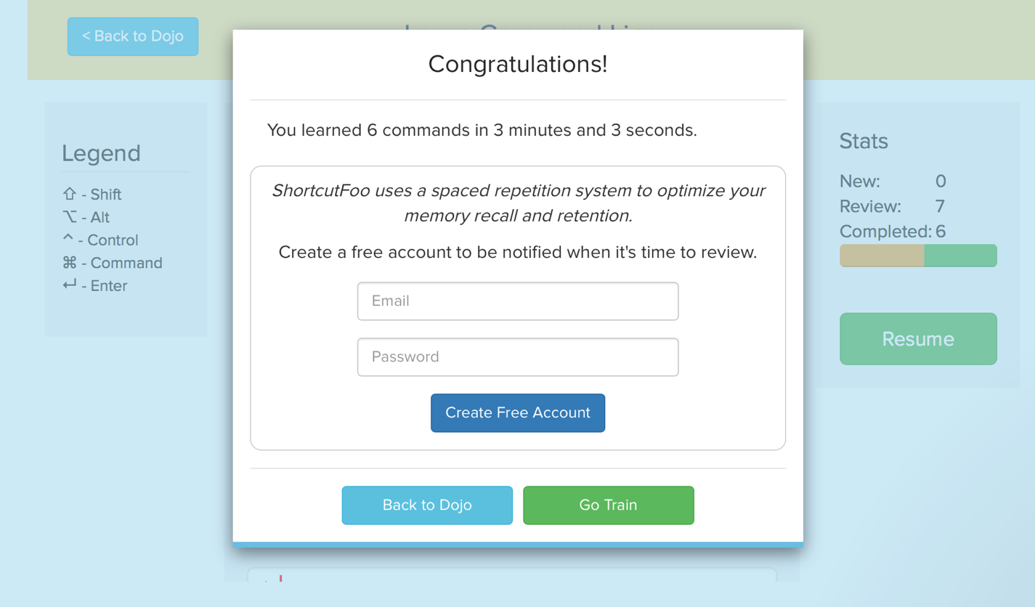I tried one lesson and had to quit after the quiz because its style of instruction is brutal. I learned nothing from just repetitive testing with no explanation at all.
2. Codeacademy introduces new topics and then builds on top of pre-existing knowledge or previous lessons. I don’t even know how shortcutFoo operates but it blows. I prefer Codeacademy because it builds continuously on the previous lessons and explains every step thoroughly.
3. So you understand how your computer operates behind the scenes. Also gives you a greater understanding of how to use a computer. Lastly, even easier when you hack someone?