Mihir Tulpule

ITP 125

HW 1

Homework 1 – CodeAcademy, shortcutFoo, Automate the Boring Stuff Ch.1

1. I completed two of the lessons from the Command Line dojo on shortcutFoo (I was unable to access the remaining quizzes, as I would need to upgrade and pay in order to access said quizzes). I earned 100% on both of the sections I finished (System Basic and Directories Basic.

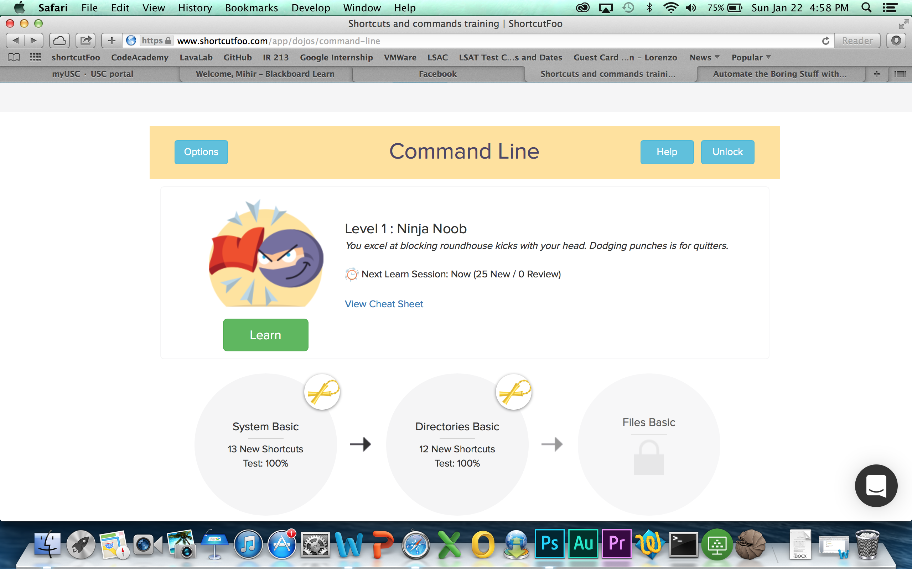

1. Personally, I learned more about the Command Line from CodeAcademy. I preferred CodeAcademy because while shortcutFoo (at least for the sections I completed) largely focused on just teaching me a large number of essential commands, the CodeAcademy lessons were far more structured and taught me Command Line syntax as well. I liked the progression of the CodeAcademy lessons much more in comparison to shortcutFoo’s approach.
2. I think that the instructor is making us learn to use the Command Line because it is foundational to working faster as a programmer/hacker. Rather than utilizing a round-about method (such as point-and-click) to accomplish simple tasks, it is much easier to learn basic commands in Terminal that enable us to complete said tasks with much greater efficiency and precision.
3. Automate the Boring Stuff, Chapter 1

1.

1. \* = operator
2. ‘hello’ = value
3. -88.8 = value
4. – = operator
5. / = operator
6. + = operator
7. 5 = value

2. spam = variable, ‘spam’ = string

3. Three data types are integers, floating-point numbers, and strings.

4. An expression is the most basic type of programming instruction in the designated language. Expressions are made up of values and operators, and they always evaluate/reduce down to a single value.

5. An expression is a section of code that reduces down to a single value, whereas a statement is a line of code that performs an action.

6. After the code runs, the variable bacon will contain the value 21.

7. The two expressions should evaluate to the same end result, which is ‘spamspamspam.’

8. The variable eggs is valid because it fulfills all three constraints (can only be one word, can only use letters/numbers/underscore, and can’t begin with a number). 100 begins with a number and therefore is an invalid variable name.

9. The three functions are str(), int(), and float().

10. The code line would have to read as follows:

print (‘I have eaten’ + str(99) + ‘burritos’)

This is because the + operator can’t add an integer to a string. Thus, the integer 99 will be needed to be run through the str() function in order to convert it into a string value, thus letting Python evaluate the expression.