Zachary Nandapurkar

hw10.docx

1. You can export the data to an XML file in Nessus and then import it into MagicTree via the GUI.
2. Every time I tried to generate the Magic Tree report, it was throwing exceptions with some of the threads. Threads errors really suck, and errors in the run() method probably constitute problems with variables and thread safety. Here is the Nessus report and screenshot of the import in MagicTree.
   1. 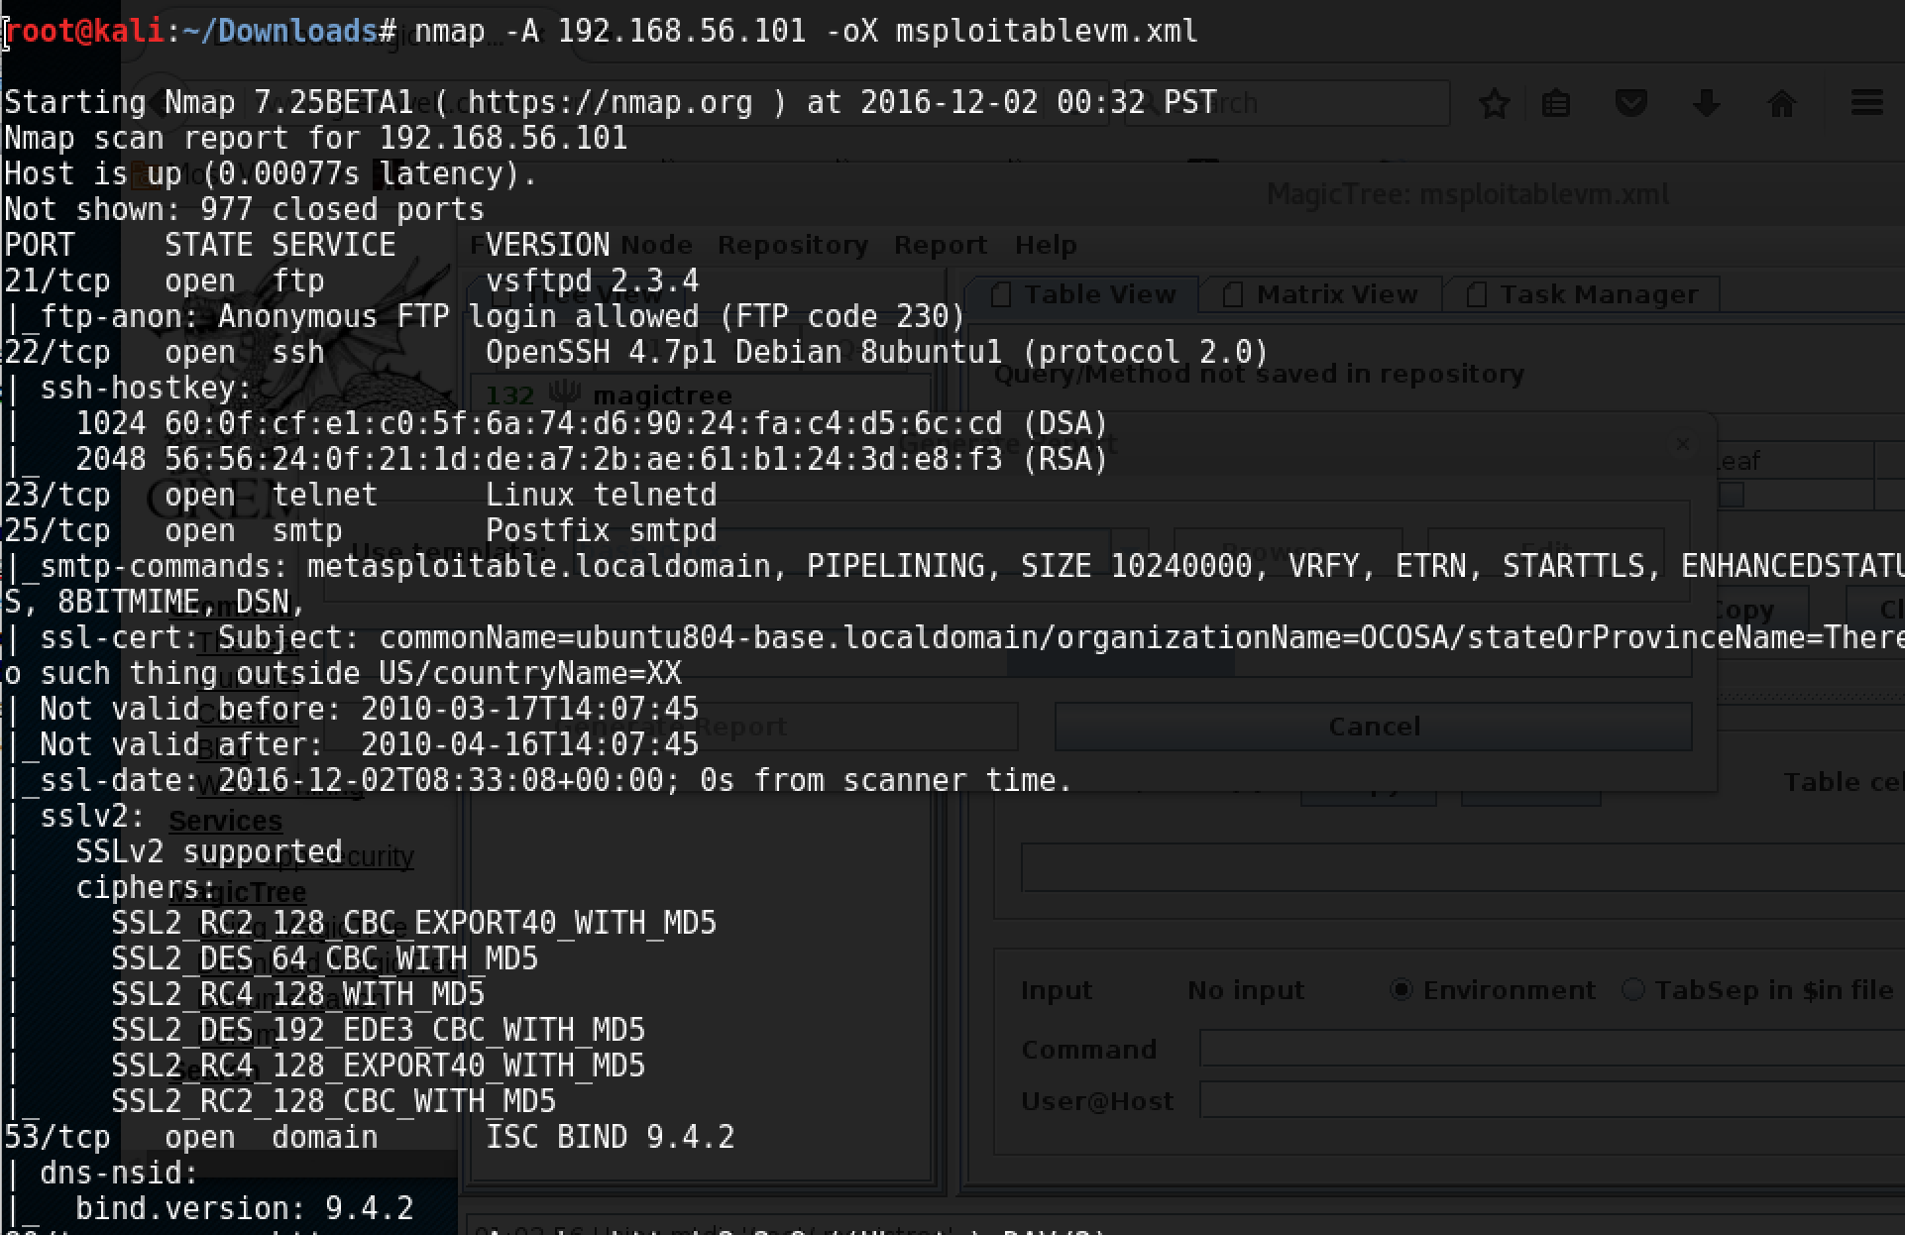
   2. 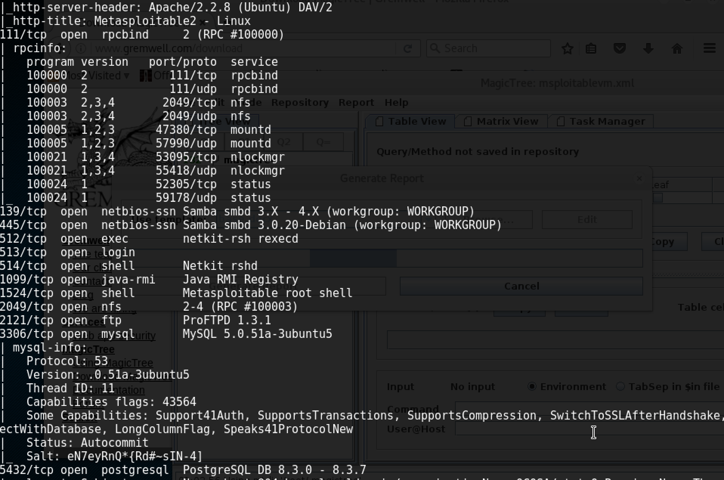
   3. 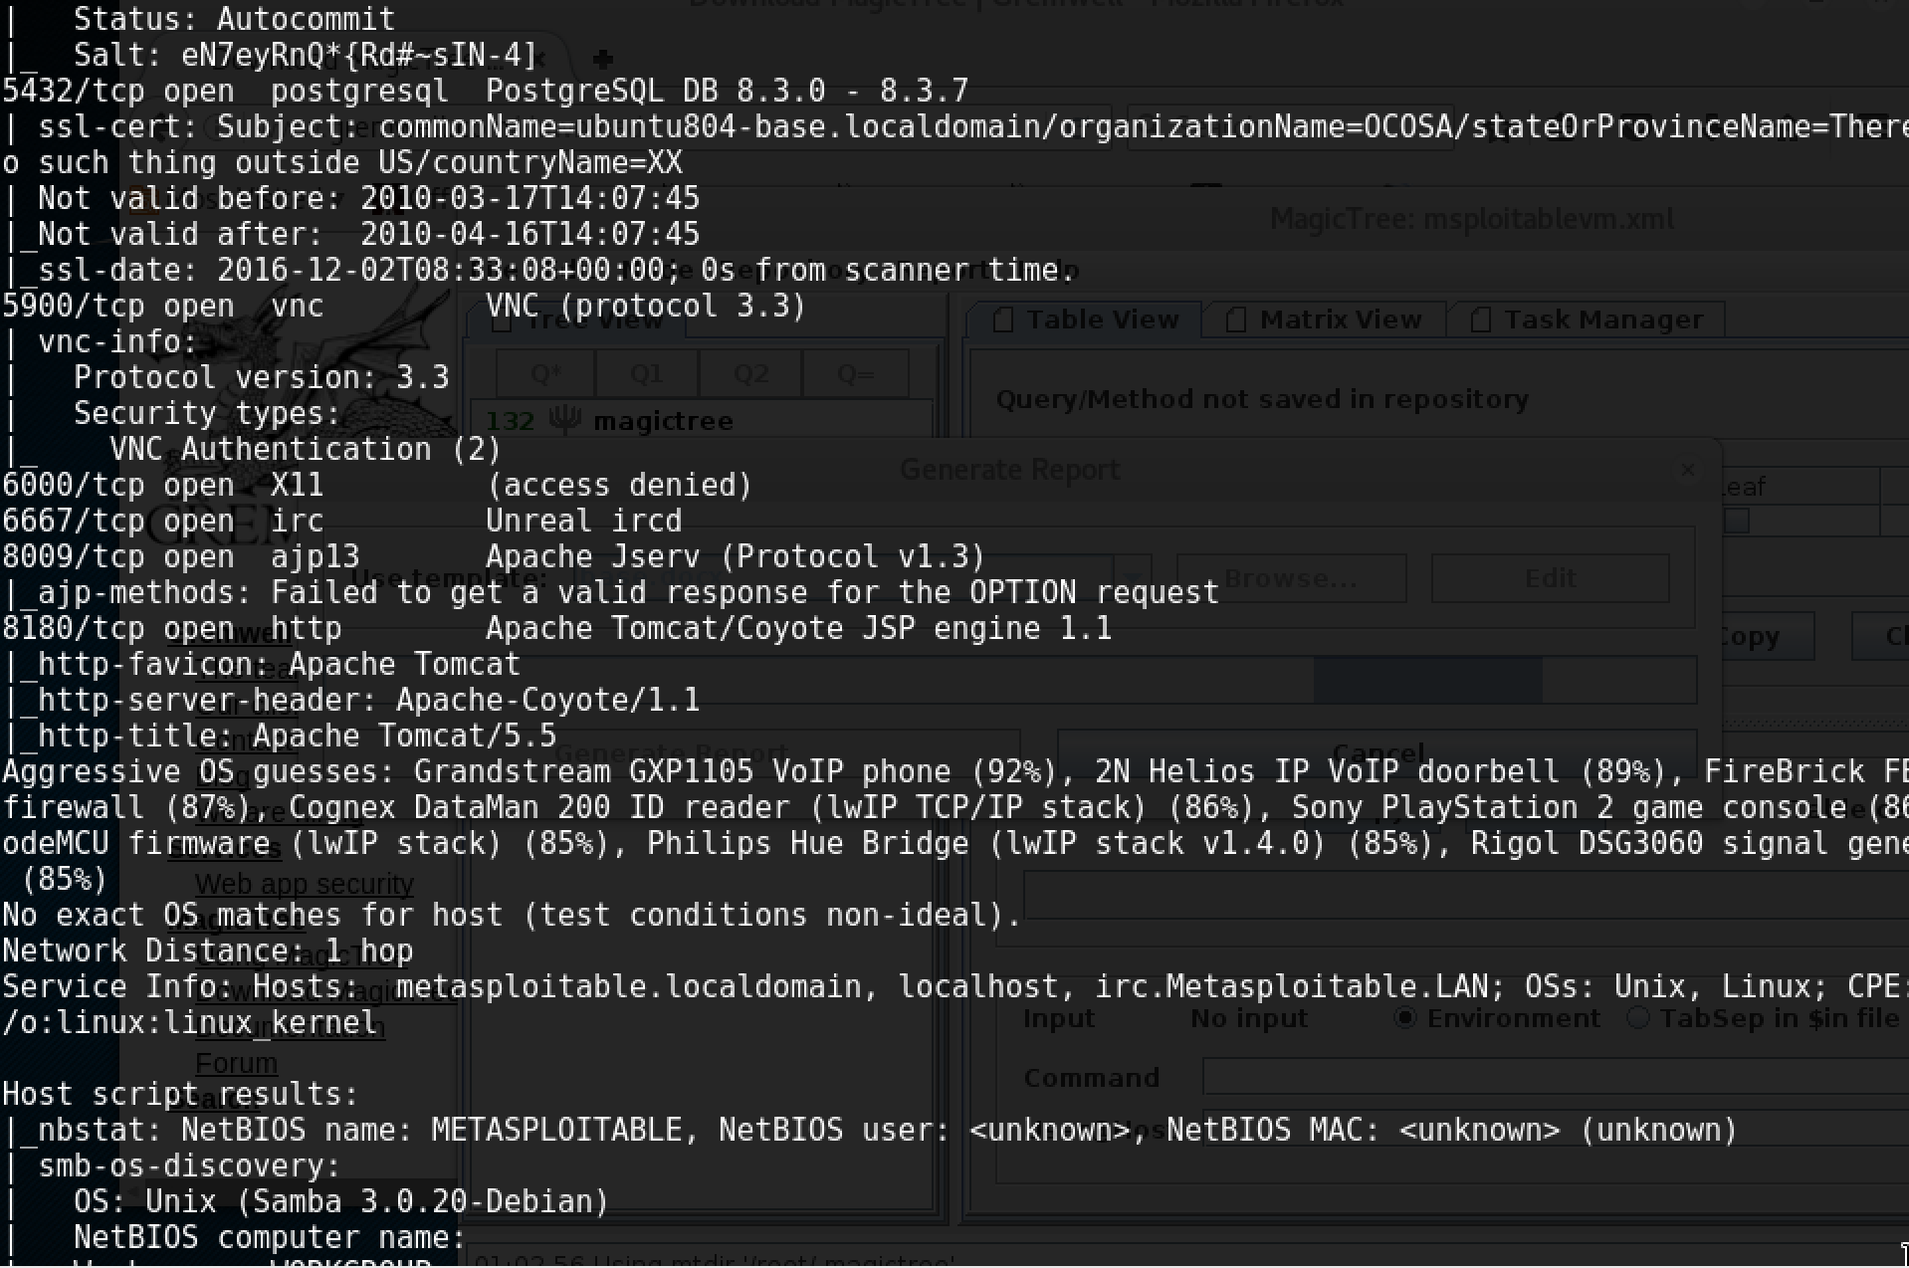
   4. 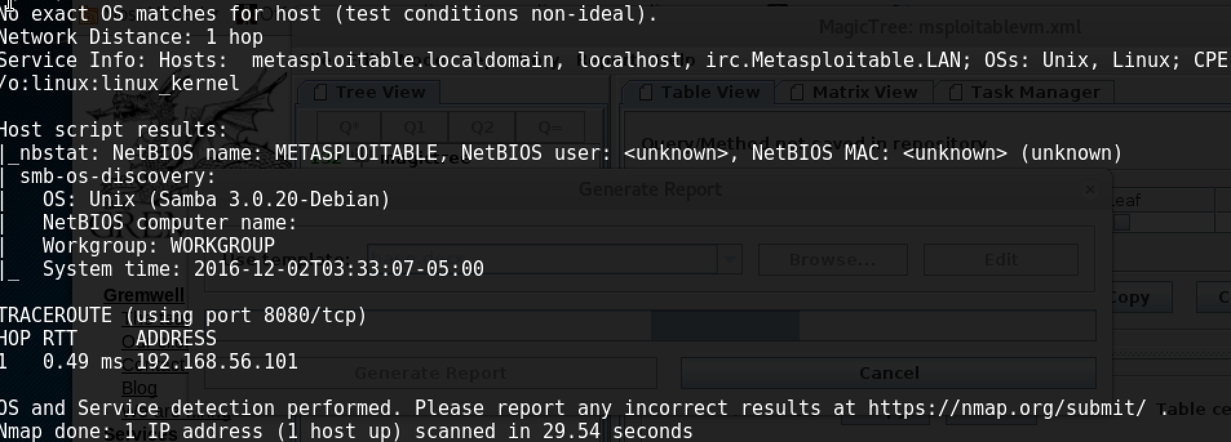
   5. 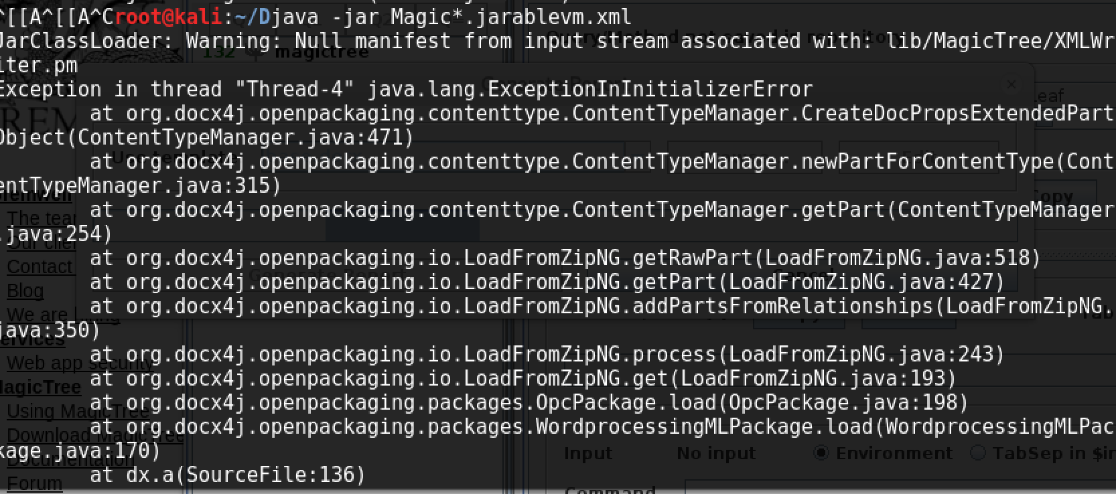
   6. 