Zachary Nandapurkar

Lab 6

1. I did not notice any differences when the firewall was enabled vs disabled. Both showed this result.

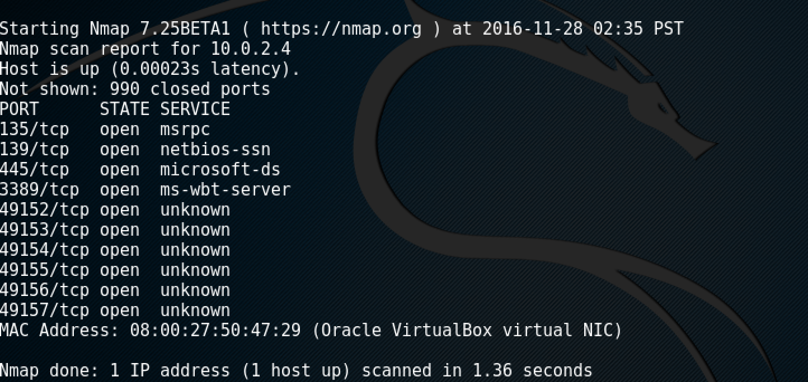

1. Port 135 is used to support a variety of MS services but id not associated with tracert. It's actually The RPC (Remote Procedure Call) Endpoint Mapper and is a fairly crucial service. However, it should be in stealth mode as far as GRC is concerned. Port 139 is for if you are on Windows-based network that is running NetBios, it is open in order to facilitate that protocol. Port 445 provides SMB over TCP. Windows 8 uses both TCP and UDP port 3389 to communicate via Remote Desktop Connection. The 49xxx ports are mostly used by executables like svchost.exe.
2. The service and OS scans both looks correct and accurate to the system.
3. I found that 46 ports were open between 100-200 and specifically port 137. NetBIOS is used by Windows for its file and printer sharing.
4. USC would be able to defeat this through router path tracing.