**ITP 325 – Lab 02 – Kali Setup**

**Due:**

1 minute before the next class lecture

**Submission:**

1. Answer the questions at the end of this file, and name the document lab02.docx
2. Download the instructor’s GPG key from the following location:

<https://sites.google.com/a/usc.edu/chiso/files>

GPG encrypt the *.docx with the instructor’s and your own GPG key.

1. Place the encrypted document into the repo and push to changes GitHub

**Procedure:**

1. Go to Code Academy and do the following lesson:

<https://www.codecademy.com/en/courses/learn-the-command-line>

**Note:** If you want you can create a fake account to just finish the lesson. Before you start this, make sure to go over this lab first.

1. Go download Kali Linux at the following location:

<http://www.kali.org/>

1. Read over the different ways you can install Kali Linux at the following location:

<http://docs.kali.org/category/installation>

1. Choose to install Kali Linux in one of the ways listed below on your laptop, USB, or workstation.

* Bootable USB
* Virtual machine with either VirtualBox or VMware
* Dual Booting

**Questions:**

1. Compare and contrast of the different ways to get Kali Linux running on your own machine. Which one did you choose and why?

Installing Kali Linux through a bootable USB is when you have a USB with Kali Linux installed on it, and every time you plug in the USB you can boot up Kali Linux and store the information on the USB. Using a virtual machine is when you have a virtual computer on which you install Linux on. Dual Booting is when you allocate a certain amount of memory on your hard drive, and when you start up your computer you can choose to boot up Linux. I chose the virtual machine because it is very convenient and easy to boot up, and any problems that I create on Linux will be on a virtual machine and not my computer.

1. When you setup any type of virtual machine there are different network settings that you can apply to the VM. The general types of networking are bridge, NAT, and Host-Only. When thinking about pentesting, compare and contrast the 3 ways of settings up networking for a VM. Which do you think is best for pentesting?

I believe that the Host-Only network is the best for pentesting. A bridged network connects to a networking by using the host computer’s Ethernet adapter. The NAT, otherwise Network Address Translation, connects to the network using the host computer’s IP address. Host-Only creates a network by using a virtual Ethernet adapter between the virtual machine and the host computer. This allows for a network that is contained within the computer, creating an ideal situation for pentesting.

1. In VirtualBox, there are two flavors of NAT. There is just “NAT” and “NAT nework”. What is the difference between the two? Which one is the most similar to NAT within VMware?

<https://www.virtualbox.org/manual/ch06.html#networkingmodes>

<https://www.vmware.com/support/ws3/doc/ws32_network21.html>

1. Prove to the instructor that you completed the Code Academy course. This is an open-ended question, and here is no single right answer. Whatever your proof maybe, make sure to add it into the *.docx.

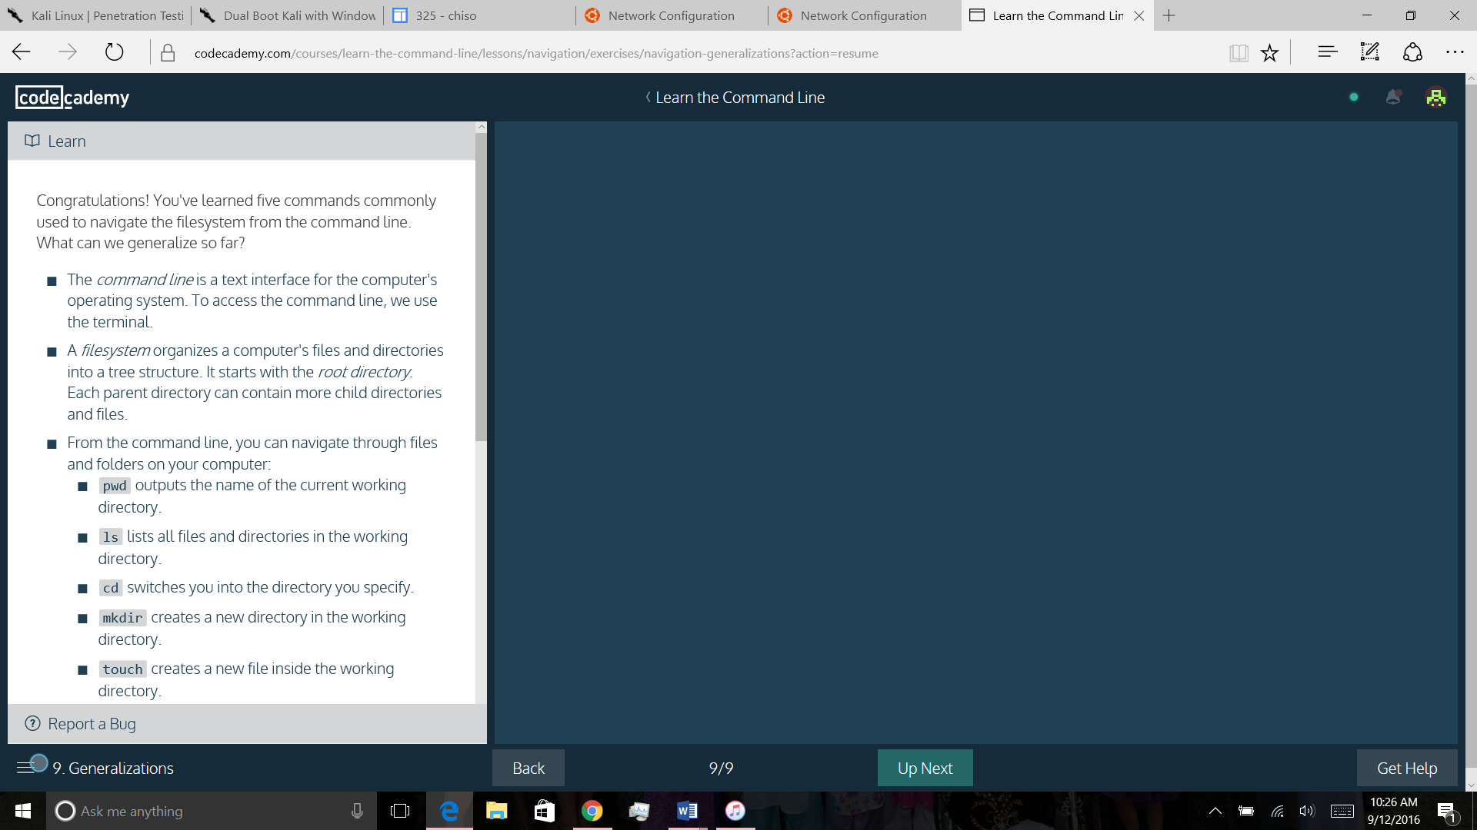

**FAQ:**

1. **Question:** I have no idea what I'm doing.

**Answer:** Before you leave the class make sure you take with the TA, Instructor, or fellow students for help. Do not leave the room before you understand what is going on. You can always use the power of Google/Yahoo/Bing to figure it out.

1. **Question:** How do I prove that I did the course?

**Answer:** That’s up to you to figure out. There are some obvious ways.

1. **Question:** I uploaded the files, but they don’t show up on the website.

**Answer:** Looks like a permission issue again, refer to lab 01 to see how to fix that. You’ll need to SSH into aludra to fix it.

**Video:**

**VirtualBox Kali 2.0 Guest Setup**

Read the description of the video to get an idea on the virtual machine setup.

<http://youtu.be/dDPYrePiG9g>

**Installation of Kali 2.0 on VirtualBox**

Read the description of the video to get an idea on the virtual machine setup.

<https://youtu.be/t2A7w_zAPqY>