**ITP 125 – Homework 01 – Introduction to the Command Line**

**Due:**

1 minute before the next class lab

**Submission:**

1. Answer the questions at the end of this file and name the document hw01.docx

You can directly add the screenshots into the word document.

In addition, submit the code for “Your First Program” from Automate the Boring Stuff – Chapter 1. Name the file hw01.py

1. 7zip the file with either 7zip (Windows)/Keka (OSX) and set a password for the decompression. The password should be terminalfu
2. Place the encrypted document into the repo and push to changes GitHub

**Procedure:**

1. Finish the free Codecademy lessons (Unit 01- 03) regarding the command line:

<https://www.codecademy.com/learn/learn-the-command-line> //done

**or** you can do the following:

<https://learnpythonthehardway.org/book/appendixa.html>

1. Finish the free Codecademy lessons (Unit 01) regarding Git:

<https://www.codecademy.com/learn/learn-git>

**or** you can do the following:

<https://try.github.io/levels/1/challenges/1>

1. Finish the free Codecademy lesson (Unit 02) regarding Python:

<https://www.codecademy.com/learn/python>

and do the following

<https://automatetheboringstuff.com/chapter1/>

**Questions:**

1. Go to the following site:  
     
   <https://www.shortcutfoo.com/app/dojos/command-line>  
     
   How many lessons did you try, and what was your test score of the end of each lesson?  
     
   Prove it with a screenshot.

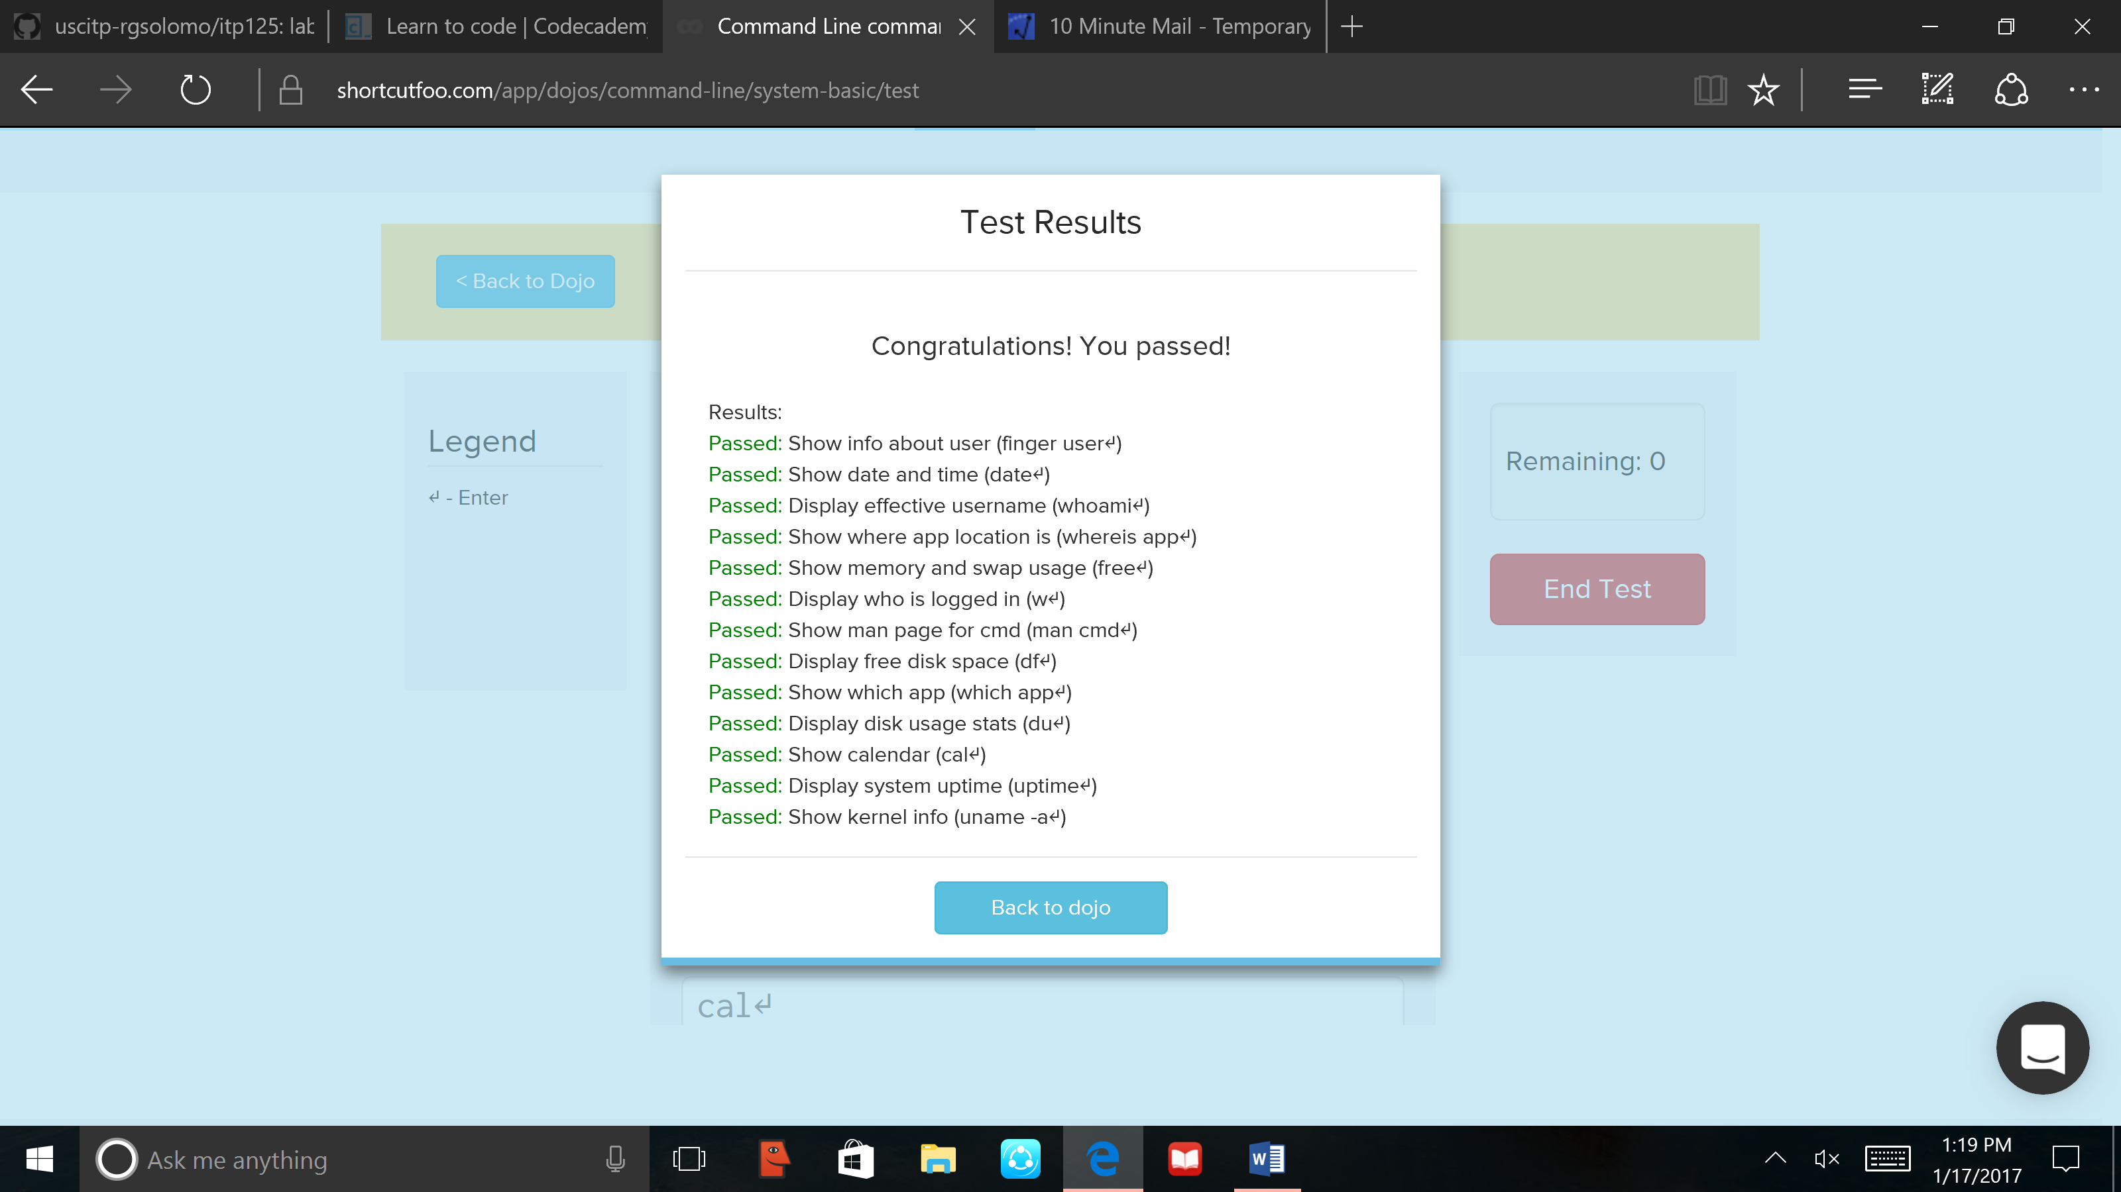

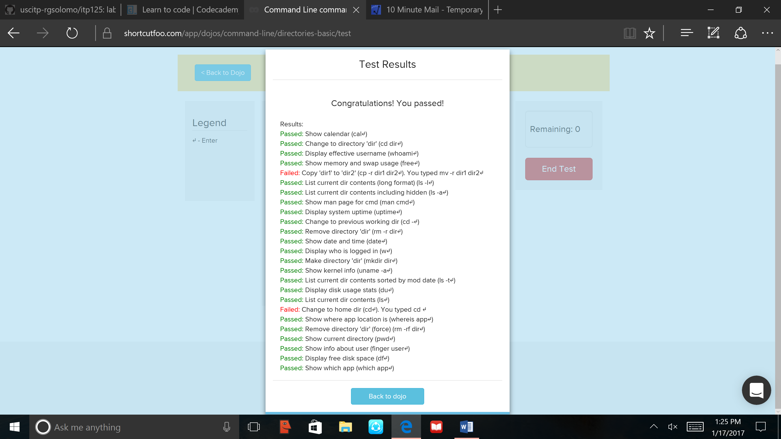

1. Did you learn more about the command line from shortcutFoo or Codecademy? Which did you prefer more and why?

Though I feel as though I learned more terms through shortcutFoo, Codeacademy taught me better how to use them and what exactly they do in the computer, whereas shortcutFoo felt like I was memorizing vocabulary words.

1. Why do you think the instructor is forcing you to learn the command line for the class?

If you want to learn the weaknesses of a system or piece of technology, you need to know exactly how it works. Learning command line helps us do that.

1. Answer the questions at the end of chapter 1 for “Automate the Boring Stuff”. When you answer the questions, you can create a new section and restart the numbering there.

“Automate the Boring Stuff Questions”

1. Operators: + - / *

Values: ‘hello’ , -88.8, 5

1. spam is a variable, and ‘spam’ is a string
2. Data types: integer, string, floating-point number
3. Expressions are made of values and operators, and they evaluate to a single value.
4. This statement assigns a value to a variable, while an expression calculates or evaluates something.
5. It still evaluate to 20, because when 1 was added, the variable bacon still wasn’t changed.
6. The first one will be spamspamspam and the second one will be the same.
7. Variable names cannot be numbers.
8. int, float, and str
9. It will cause an error because when you use plus signs with integers and strings, the compiler thinks that you are trying to add the value. You can fix it by making the number into a string (‘99’ instead of 99).

**Resources:**

* [The Command Line Crash Course](http://cli.learncodethehardway.org/book/)