HW01

1. 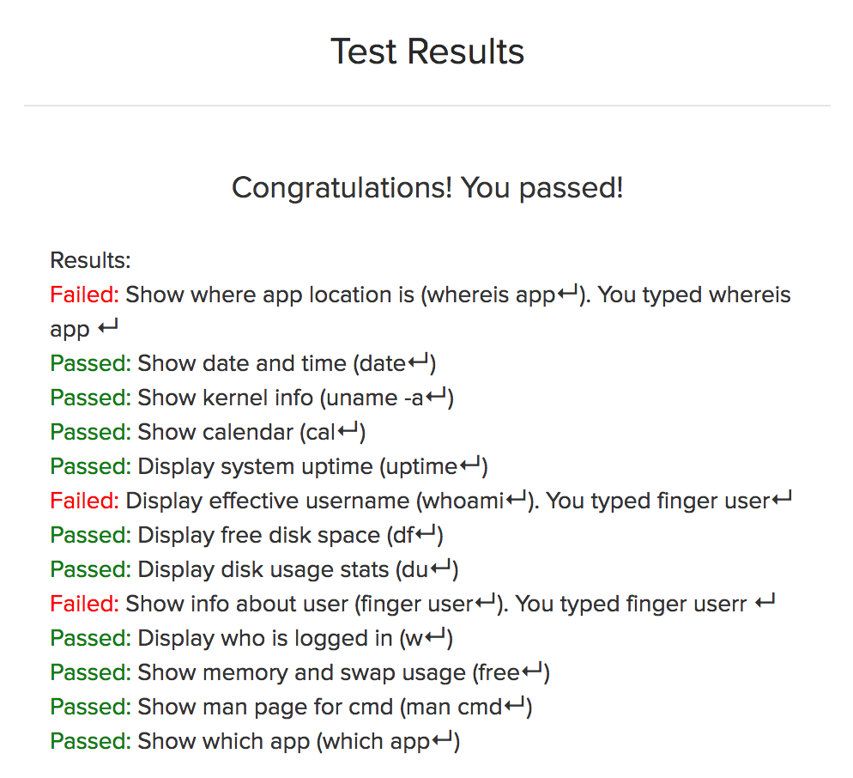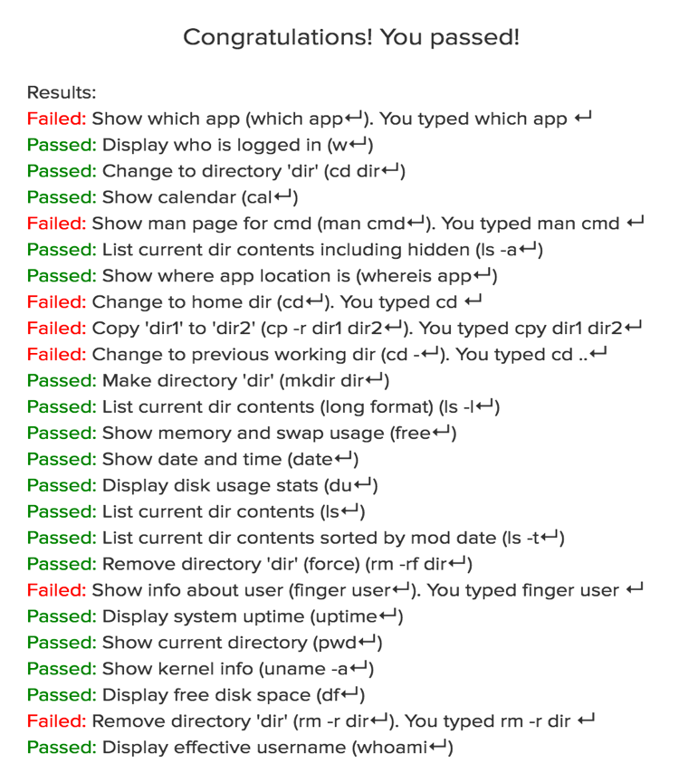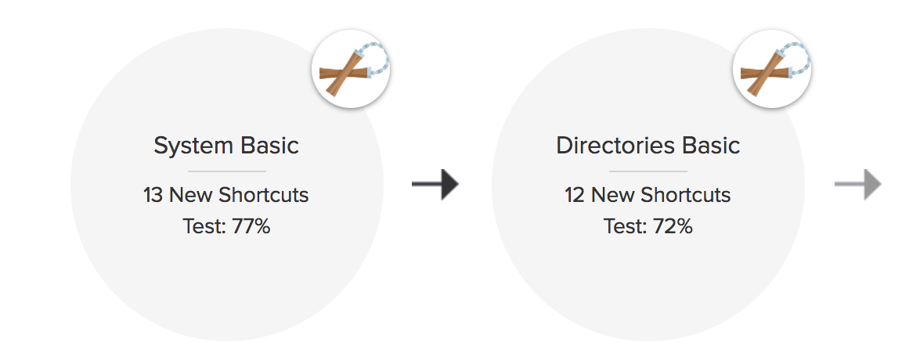Two
2. Code Academy. The learning is simultaneous. It’s not a memory test.
3. Basics of computer networking
4. Automate the Boring Stuff
5. Operators: \* - / +

Values: -88.8, 5, ‘hello’

1. Variable: spam

String: ‘spam’

1. Integers, floating numbers, strings
2. Operators, variables, strings. Reduce to a value.
3. Expression: any line of code that evaluates as a value

Statement: couple lines of code that perform action

1. 21
2. spamspamspam
3. treats 100 like an integer
4. str(), int(), float()
5. ‘I have eaten + str(99) + ‘burritos’