Tanuja Mohan

ITP 125

Homework #1

Questions

1. I tried to do 2 of the lessons (took me a while to keep practicing and going back to taking the te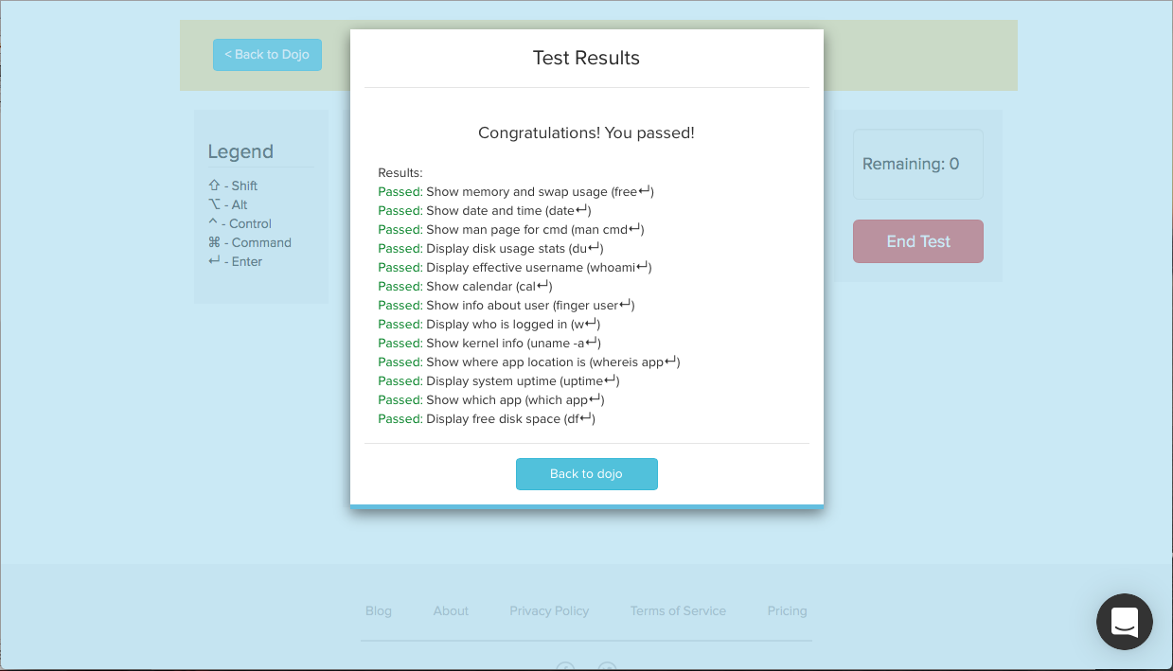st)

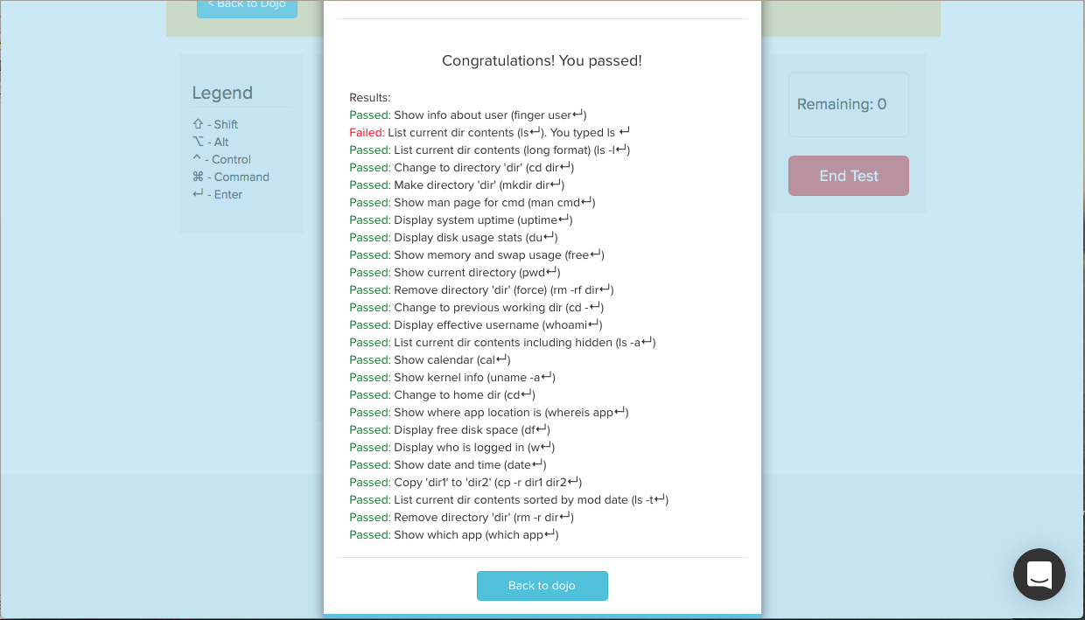

2. I learned more about the command line from Codecademy. This is because I find their course layout more intuitive and broken down into smaller more understandable parts. I’ve used Codecademy before for learning other languages such as Javascript so I feel more comfortable using Codecademy and know that it works in teaching a new language.

3. I believe we are learning command line for this class because it gives the user more access to the files on their computer system. Command line allows us to perform more operations that a UI would not be able to provide us. The command line also helps us understand more how data is organized within a computer and how to search for things that we may not even see on the computer UI itself.

Automate the Boring Stuff Questions

1. Operators: \* , - , / , + Values: ‘hello’ , -88.8 , 5
2. Variable: spam String: ‘spam’
3. 3 Data Types: Integer, Floating-point, and String
4. Expressions are made up of values and operators. All expressions evaluate down to a single value.
5. Difference between an expression a statement: An expression consists of values and operators while a statement consists of a variable name and an equal sign.
6. Bacon contains the value 20 because we never assigned a different value.
7. ‘spam’ + ‘spamspam’ evaluates to “spamspamspam’ and ‘spam’ \* 3 evaluates to ‘spamspamspam’
8. egg is a valid variable name and 100 is invalid because variable names can’t begin with a number.
9. str(), int(), float() functions evaluate to the string, integer, and floating-point forms of the values that you pass into the functions.
10. This expression causes an error because the compiler cannot convert an ‘int’ object to a str implicitly. We can fix it by using the str() function and rewriting the line to be: ‘I have eaten ‘ + str(99) + ‘ burritos.’