1. Go to the following site:  
     
   <https://www.shortcutfoo.com/app/dojos/command-line>  
     
   How many lessons did you try, and what was your test score of the end of each lesson? – **I tried two lessons**  
     
   Prove it with a screenshot.

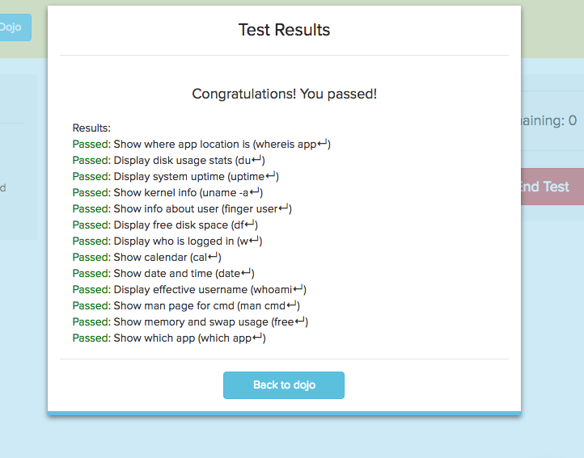

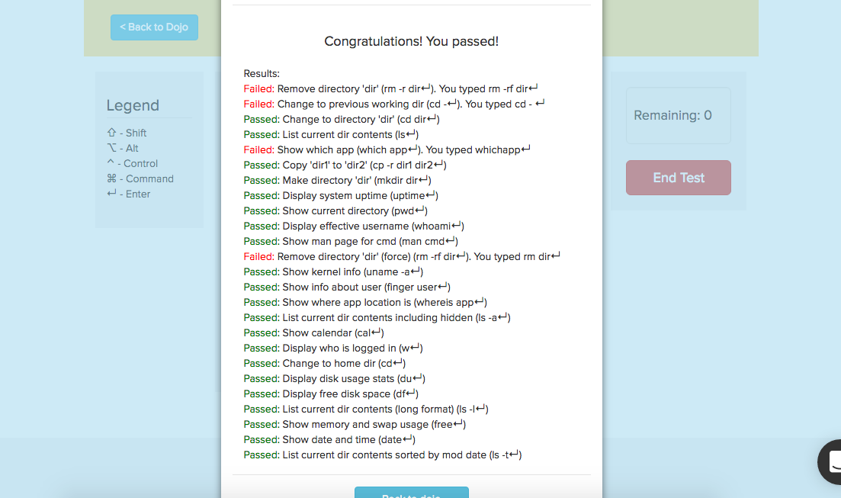

1. Did you learn more about the command line from shortcutFoo or Codecademy? Which did you prefer more and why? – **I learned more about the command line from shortcutFoo. ShortcutFoo is like a flashcard technique of memorizing while codeacademy is applying, yet just to get by and see what it performs that leaning about the command line.**
2. Why do you think the instructor is forcing you to learn the command line for the class? -  **the instructor is forcing us so that without thinking twice or looking at a paper with command lines we can easily apply them. The quicker we know the command line by heart the faster we can start to maneuver around coding.**