John Zeiders

1. 1 12/13 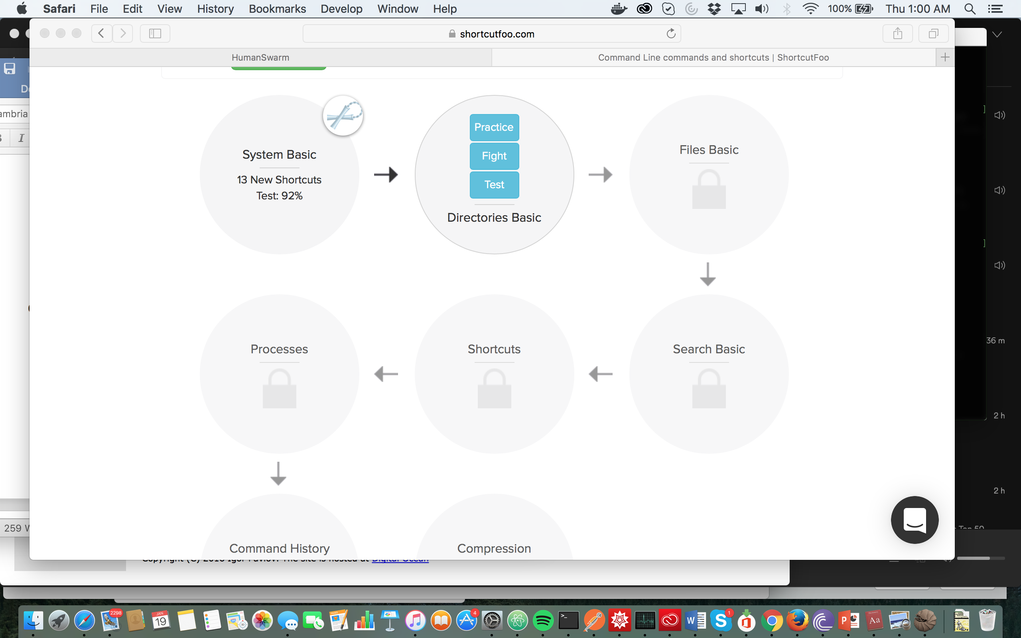
2. I preferred shortcut fu, because I was to memorize quicker. However, code academy did give me a better understanding of what the commands did.
3. Because its magnitudes quicker than using gui’s.

4.

1. operator, value, value, operator, operator, operator, value

2. spam -> var, “spam” -> string

3. int, string, double

4. values combined with operators, they evaluate to a single value.

5. Statements store a value, while expressions simply calculate

6. 20

7.”spamspamspam”

8. leading value cant be a number

9. int(),dbl(),str()

10. The integer can’t be implicitly converted to a string. One solution would be to wrap it in str().