U.S. Committee on the Marine Transportation System
Coordinating Board
Resolution on the adoption of the S-100 Marine Data Framework
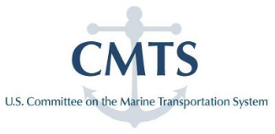
Whereas the U.S. vision for the Future of Navigation (e-Navigation) is to establish a framework that enables the transfer of data between and among ships and shore facilities, and that integrates and transforms that data into decision and action information;
Whereas the use of standards is a recognized method of facilitating such data transfers and harmonization;
Whereas the International Hydrographic Organization’s S-100 Universal Hydrographic Data Model is a stable framework for maritime data and product specifications that can support the wide variety of navigation-related digital data sources, products and customers;
Whereas S-100 is aligned with the broadly accepted International Standards Organization geospatial standards and has been adopted by the International Maritime Organization, International Hydrographic Organization and the International Association of Marine Aids to Navigation and Lighthouse Authorities as the preferred global standard for marine data and navigation products;

Whereas adoption of S-100 aligns U.S. Future of Navigation initiatives with the international community; and

Whereas S-100 provides the lexicon for converting data into meaningful marine safety information for MTS stakeholders;
Therefore, the CMTS Coordinating Board resolves that the IHO’s S-100 Universal Hydrographic Data Model be adopted by CMTS-member agencies as the preferred framework for marine data and product specification, provided such adoption does not supersede or conflict with existing agency data standards requirements.

CMTS e-Navigation Strategic Action Plan; http://www.cmts.gov/downloads/CMTS_e-Navigation_Strategic_Action_Plan_Feb_2012.pdf; February 2012.

