
User Guide
Version 0.6
Last Modified November 30, 2007

Written by
Steven Tyler and Christian Hargraves

Table of Contents
Introduction 4
Intended Audience 4
Assumptions 4
What is Jameleon? 4
Installing Jameleon 5
Writing and Running a Test Script 6
Writing a script using JUnit 6
Running Your First Test Script 7
Using a CSV file 12
Using the Jiffie plug-in 15
Running multiple scripts at once 16
Documenting Test Scripts 17
Writing a custom tag 17
Using the Jameleon GUI to create a custom tag 17
Data-driving Your Tests 23
Environment 23
Organization 24
Application 24
The Context 24
CSV file structure 25
Using CSV Files to Drive Your Test 25
Using a Database to Drive Your Test 26
Advanced Scripting 27
Custom Login Tag 28
Custom Contact Info Tag 29
Custom Validation Tag 30
Properties file 30
CSV file 31
Navigational XML Fragment 31
Test Script 32
Running Scripts via the Command Line with Ant 34
Why the Command Line? 34
What is Ant? 34
The Ant Build File 34
Important Ant Tasks 34
Provided Ant Tasks Explained 34
Intrinsic Problems with Automated Testing 35
How is Jameleon different? 37
Lessons learned 38
Automated daily regression 38
Running a script from the command line 38
Organize your data 38
Plan your script before writing it 39
Use Custom Tags 39
Use XML Fragments 39
Use Xpath for validation 39
Conclusion 40
Appendix A 41
XML Basics 41
Prolog 41
Root Element 41
Multiple Elements 42
Element Attributes 42
XML Formatting 43
Restricting the Structure 43
XML Namespaces 44
XML Fragments 45
Appendix B 47
Glossary 47

Introduction
This document will walk you through the initial configuration of Jameleon. After your environment is configured and Jameleon is setup, we will create a simple test script. Upon writing a successful test script, we will modify our script to include more complex features and explain how to data-drive your script. After reading this document, you should feel comfortable using the JUnit and Jiffie plug-ins for Jameleon to write data-driven tests that are comprised of custom XML tags as well as XML fragments.

Intended Audience
This document is intended for individuals who are interested in automated testing. You do not need to be an expert in Java or XML, but any experience in either of those technologies will be helpful. For readers that are new to XML, you can review the XML Basics in Appendix A.

Assumptions
This document assumes that you have already installed Java 1.4.x or greater and configured the JAVA_HOME environment variable set to the directory where the JDK (not the JRE) is installed. When installing Java under Windows, I like to make sure it is installed in a directory without spaces in it. For example, the default on Java 5 and 6 is to install in C:\Program Files\Java\.... I simply take the Program Files directory out, simplifying the install to C:\Java\...

You you need to add %JAVA_HOME%\bin to your PATH. You can validate that your environment has been configured properly and that you are running an adequate version of Java by issuing the following command at the command line: %JAVA_HOME%\bin\java -version. This will display the version of Java installed. You should also be able to type “javac -version”, getting the version number of the compiler. I like to put %JAVA_HOME%\bin in the path before anything this, assuring that the JRE won't get picked up first.

Troubleshooting your environment is beyond the scope of this document. If you need more information regarding the configuration of your environment for Java, please refer to the sun website at http://java.sun.com

What is Jameleon?
Jameleon is an automated testing framework that manages test execution and reporting. The framework provides the flexibility to use various plug-ins to test widely varying applications such as database, desktop, web and mainframe applications. Each plug-in provides specific functionality to help automate testing. Jameleon will track the test execution and manage the results of the test. It was designed with a focus on integration, regression, functional, and acceptance-level testing. It is not designed to handle performance testing.
Jameleon is modeled closely after the structure of an actual test case. A test case has a goal to test a specific feature of an application. In most cases, to test the desired feature, several other features need to be executed and validated. For example, testing a ‘paste’ feature might require the following steps:
- Start application A
- Open and existing file in application A
- Select the given text and select “Copy” from the “Edit” menu.
- Start application B
- Create a new document in application B
- Paste the text into the new document by selecting “Paste” from the “Edit” menu.
- Validate that the text copied exists in the document opened in Application B.
In the example above, two applications and several steps (features) of each application are used to test the paste feature. In Jameleon, an application is controlled via a session tag. Each session includes functional points that execute features specific to the application. The functional points then get a handle on the application via the session and the session keeps track of the state of the application.
A Jameleon automated script is an XML file that contains tags or keywords that are written in Java. This design allows users with no Java experience to write fully functional test scripts using existing XML tags. Likewise, users who have some Java experience can write a single custom XML tag or keyword to perform the multiple steps required to execute or validate a feature. Other testers can then use the new tag without having to understand the details of the tag.
Jameleon also enforces good documentation. Each XML tag requires a description of the action that is being performed. It also takes advantage of the documentation written in the source code of a Java tag.
Jameleon provides several methods for data-driving your tests. This allows you to use the same set of steps with different values and then validate the results. This approach to automating your tests allows you to get the most out of your time spent writing automated scripts.
Jameleon currently provides several plug-ins. However, this document will focus on the JUnit and Jiffie plug-ins. Here is a list of the provided plug-ins with a brief description:
- JUnit – This plug-in can be used to test at a white box level. All JUnit function tags can be used in conjunction with other plug-ins.
- Jiffie - This plug-in drives Internet Explorer and can therefore only be run on Windows.
- HtmlUnit – This plug-in emulates a browser and has some good JavaScript and XPath support.
- HTTPUnit – This plug-in emulates a browser.
- 3270 (Jagacy) – This plug-in is used to automate mainframe applications.
- JWebUnit – This plug-in is the most basic among the provided plug-ins and currently has no generic tags other than a session tag.
If you wish to use some functionality that Jameleon does not provide, you can write an additional plug-in. The creation of a plug-in is beyond the scope of this document, but you can find more information on this at the Jameleon home page http://jameleon.sourceforge.net/pluginDevelopment.html.

Installing Jameleon
The distribution for Jameleon can be downloaded from SourceForge at http://sourceforge.net/project/showfiles.php?group_id=84246&package_id=157342. This document assumes that you have downloaded the jameleon-test-suite package. This package contains all the common plug-ins for Jameleon as well as some sample scripts.

There is no installation process for Jameleon, per se. All that is required is to simply uncompress the package. This will create a directory structure with a base directory of jameleon-test-suite. The details of the directory structure will be examined throughout this document. The directories that you will be concerned with are:
- scripts - for storing XML scripts
- src\java - for storing custom XML tags
- data - for storing CSV data files to data-drive your tests
- res - for storing properties files

Once Jameleon has been uncompressed, run build.sh or build.bat, depending on your OS. It should complete without any failures. When you begin writing custom tags, running the build file will compile all the java source files for your tags and register them in Jameleon.

Jameleon is now ready for you to start writing scripts. You can launch Jameleon by executing jameleon.bat/sh.

Writing and Running a Test Script
A Jameleon test script is an XML document that contains an XML tag for each piece of functionality that is to be performed in your test case. If you are not familiar with XML, then you may want to read the “XML Basics” section under Appendix A.

The easiest way to understand the components of a test script is by examining an example script. The JUnit plug-in provides a good starting point for our script because it is designed to handle straightforward tests.

Writing a script using JUnit
All Jameleon test scripts must reside within a testcase tag. This tag holds attributes specific to the entire script, such as a namespace definition similar to the following:
<testcase xmlns="jelly:jameleon">

Within the testcase tag, you must also define a session tag. The type of session will depend on the plug-in that you are using. For instance, if you are using the JUnit plug-in, you will use the <ju-session/> tag. If you are using the Jiffie plug-in, you will use the <ie-session/> tag.
The session tag will enclose the core functionality of your script. The plug-ins usually provide tags that will allow you to write a script without creating custom tags. In order to fully understand the components of a script, we will write a simple example script.

The following script uses the JUnit plug-in to compares two values. The following script compares the values in the expected and actual attributes:

<testcase xmlns="jelly:jameleon">
<ju-session>
<ju-assert-equals
functionId="Compare two differing values"
expected="value 1"
actual="value 2"/>
</ju-session>
</testcase>
Notice that we are comparing two different values. It is good practice to write a failing test script and then make it pass. For example, sometimes the script passes because it doesn't test what was intended. Making our test case fail first helps us better define what should be passing and it gives us confidence when it actually begins to succeed.
Save the above code as compareTwoValues.xml in the jameleon-test-suite/scripts directory. The scripts directory is the default location for test scripts and the Jameleon GUI will display all scripts in that directory.

Running Your First Test Script
There are two methods to running your script; through the command line and through the Jameleon GUI. We will cover running scripts in the GUI first.

To launch the Jameleon GUI, run jameleon.bat/sh in the jameleon-test-suite directory. This will display a list of all the test scripts in the scripts directory. Clicking on the script named compareTwoValues.xml will display the steps of the test case in the right pane.
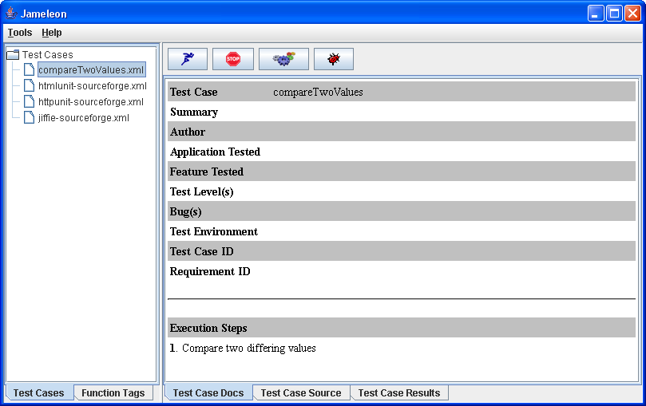
As you can see in the GUI, our test script is missing a lot of information such as a test case summary, author and application tested. We will add those details to our script in a moment. If you see an error that states, “Error on line...” instead of the test case details above, review your script for any typos and ensure that it conforms to XML standards.

Now that your test case details are displayed, you can click the Run Test(s) button that looks like a blue running man. After the test has completed, you will see the results:
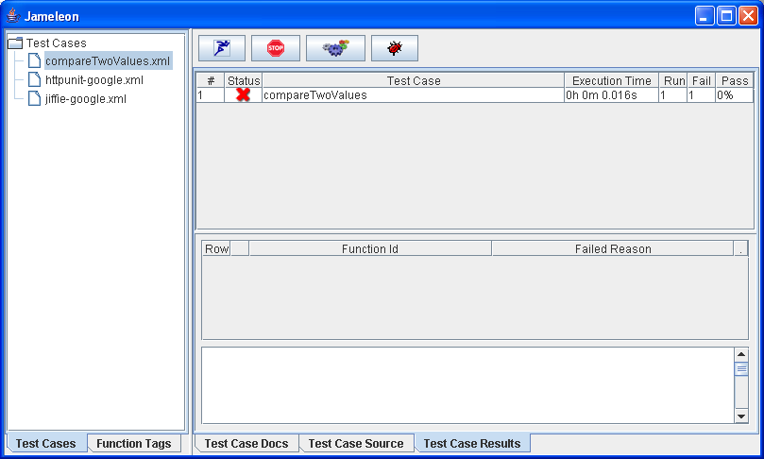
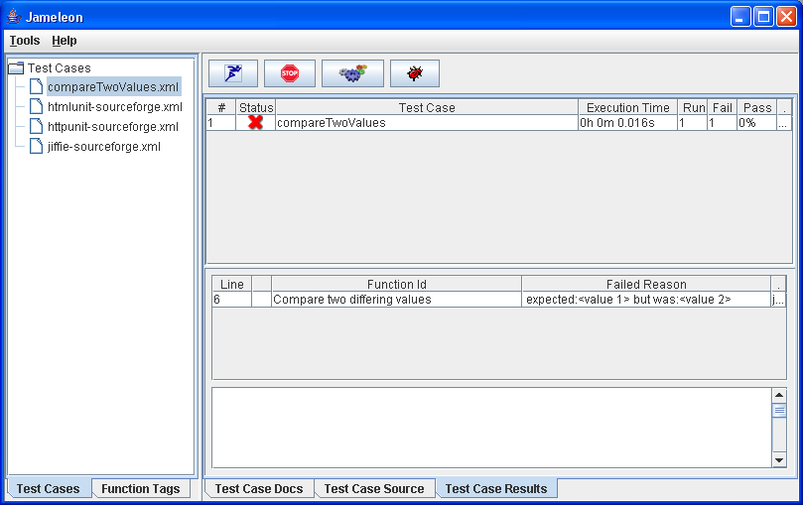
You will also notice that the console window (XTerm or DOS) has tracked the test execution. The following log entries have been output to the console:

Beginning Session: "net.sf.jameleon.plugin.junit.JUnitSessionTag"
BEGIN: Compare two differing values
##################################################################
FAILED: Compare two differing values
##################################################################
Ending Session: "net.sf.jameleon.plugin.junit.JUnitSessionTag"

compareTwoValues FAILED
FunctionId: Compare two differing values
Line #: 6
Error Message: expected:&lt;value 1&gt; but was:&lt;value 2&gt;

The console output lists each functional point that Jameleon encountered prior to the failure. In our case, there is only one functional point, but this can be very useful when trying to figure out what your script is actually doing.

The results tab automatically updates the middle table with failures as the test executes. Since we are only executing one test and it failed, the failure point, and reason are displayed.
The above screen shows us the the Function Id that failed along with the Failed Reason. If that still isn't enough information, you can click on the Failed Reason to see the entire stack trace of the failure:

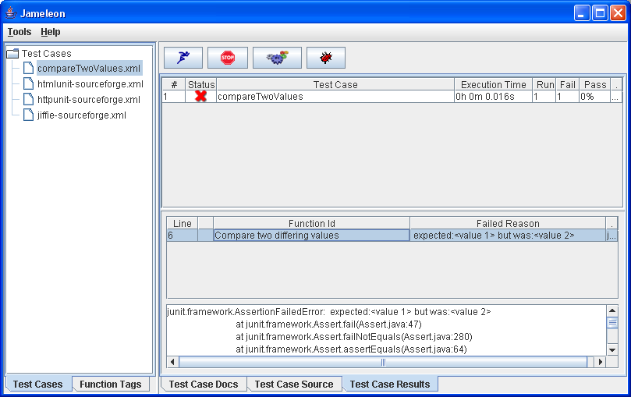
Let's now make our test pass, by changing the expected value to “value 2”. While we are at it, let's add the test case details to our script:

<testcase
xmlns="jelly:jameleon"
xmlns:j="jelly:core"
name="Compare Values">
<test-case-summary>
Validate that two values are equal
</test-case-summary>
<test-case-author>Steven Tyler</test-case-author>
<test-case-level>SMOKE</test-case-level>
<test-case-bug>001</test-case-bug>
<test-case-requirement>REQ001</test-case-requirement>
<functional-point-tested>Feature A</functional-point-tested>
<application-tested>MyTestApplication</application-tested>

<j:set var="interpretedVariable" value="value 2" />
<ju-session>
<ju-assert-equals
functionId="Compare two values"
expected="value 2"
actual="${ interpretedVariable }"/>
</ju-session>
</testcase>

Copy the script above and save it into your compareTwoValues.xml file.

There are several points of interest in our new script.
- We set the name attribute in the testcase tag to Compare Values. The default test case name is the name of script minus the file ending (.xml).
- We added a namespace for the Jelly core functionality with the following line: xmlns:j="jelly:core". This was necessary for us to use the <set/> tag from the Jelly Core Tag Library later in the script.
- We set all the necessary test case details in our script so that it will look nice in the Jameleon GUI. These are more than just nice-to-haves. This test case documentation can be used to figure what the script does at a high level and how it is different from the other scripts. These steps can also be used to perform manual testing of the application. They also come in very handy when trying to debug your script. And best of all, when it comes time to submit your test results to management, you will have all the useful information packaged together by Jameleon in your results.
- We set a variable called interpretedVariable to the value value 2
- We interpreted the actual variable with the line
- actual="${ interpretedVariable }"

Now run this script in the GUI. If you created a new script instead of saving over the existing one, you can refresh the list of scripts that are displayed by double-clicking the TestCases folder.
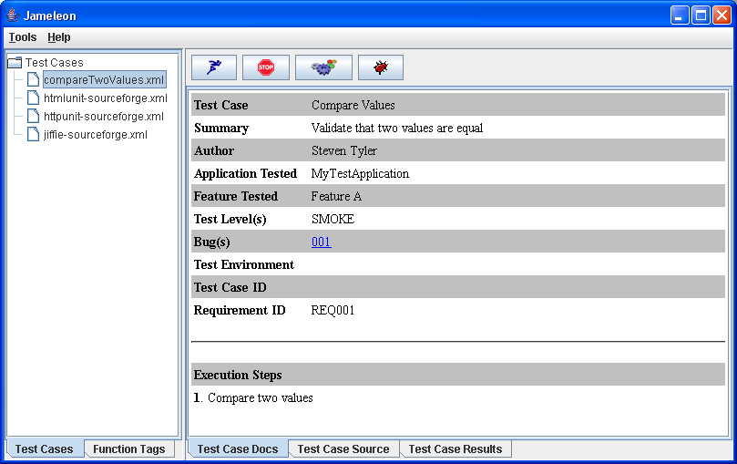

Now our test case looks more like an actual test case!.

After running the test, you are again presented with the results tab. This time, things are different. The Status column shows a successful run and the Test Case column shows a more readable test case name.
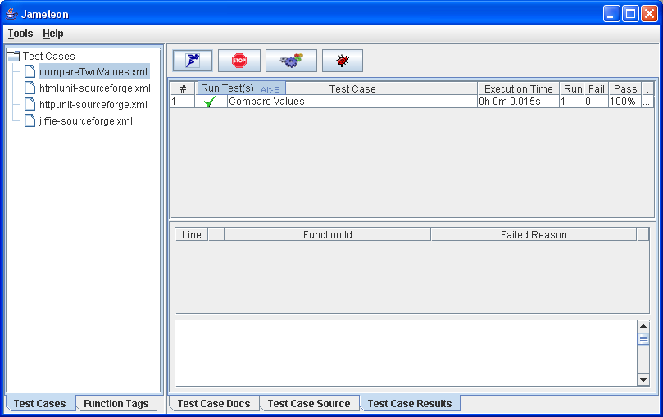

If you examine the console (DOS/xterm) output after running the script, you will see the results as well.

Using a CSV file
Although our new script uses data substitution, we would still have to define a new variable and add another <assert-equals/> tag in the script if we wanted to compare more values. The appropriate way to handle this situation is to use a CSV file to data-drive our script. We will get into all the ways to data-drive a test in the Data-driving Your Tests section. For now, we will discuss using a CSV file.
First, let's create the data file. By looking at our previous script, we know we need two different variables: actualValue and expectedValue. Save the following text into a file named dataDriven.csv in the directory jameleon-test-suite\data. Jameleon will automatically look for a CSV file in the data directory that is the same name as the test case. If the test case's name attribute isn't set, then the name defaults to the file name, minus the file extension.

expectedValue,actualValue
10,10
ten,ten
10,ten
"Hello, how are you?","Hello, how are you?"

When copying the data above into the CSV file, ensure that there are no blank lines after the last line of text. Jameleon will interpret each line as another test scenario, even if the line is blank. Note that comments can be added by beginning the line with #. Also note that the third line in the CSV file should fail.
To use a CSV file to data-drive our test, we only have to make a couple small changes to the script. In the <testcase> tag, add the attribute useCSV=”true” . We no longer need the <set/> tag or the second <assert-equals/> tag and we need to change the variable names to the new names in the CSV file. Also, notice how we added the variables in the functionId. This will greatly help with reproducing the error without digging in to the CSV file. Copy the following script into a file named dataDriven.xml.

<testcase
xmlns="jelly:jameleon"
useCSV="true"
countRow="true">

<test-case-summary>
Use a CSV file to drive a test that compares two values
</test-case-summary>
<test-case-author>Steven Tyler</test-case-author>
<test-case-level>SMOKE</test-case-level>
<test-case-bug>001</test-case-bug>
<test-case-requirement>REQ001</test-case-requirement>
<functional-point-tested>Feature B</functional-point-tested>
<application-tested>MyApplication</application-tested>
<ju-session>
<ju-assert-equals
functionId="Compare '${expectedValue}' and '${actualValue}'"
expected="${expectedValue}"
actual="${actualValue}"/>
</ju-session>
</testcase>

Now that you’ve got your new script and data files setup, it’s time to run them. Select the dataDriven.xml script in the GUI and review the test case details. Notice that there is only one step listed under the Execution Steps. The Test Case Docs tab will list the steps in the test case for only the first row in the data file, thus giving us only one step. However, because we useCSV=”true” in the testcase tag, Jameleon interprets this as a different test case for each row in the CSV file.

Now run the test script. You’ll notice that our script failed, as it is supposed to. Your test results should look like this:
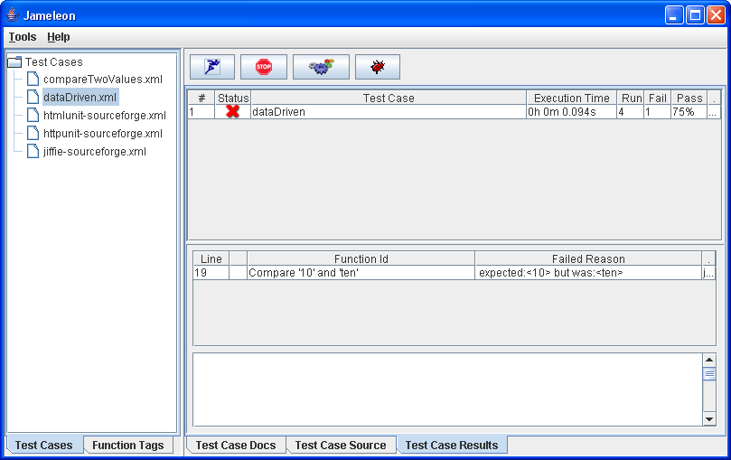
The Line column tells us that the error happened on line #19 of the script. Click the Line column with your mouse and you should see the point of failure in the script.
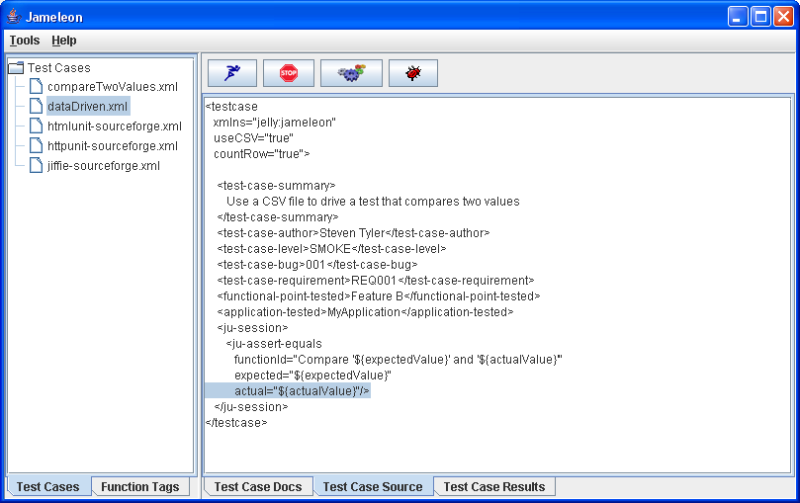

The Function Id column tells us that the failure occurred on the function tag documented as“Compare 10 against ten for equality”. The Failed Reason column tells us that 10 does not equals ten. You can get more information about our test execution by looking at the output to the console:

Begin parsing: ".\data\dataDriven.csv"

key=>value: 'actualValue'=>'10' 'expectedValue'=>'10'

BEGIN executing row number 1
Beginning Session: "net.sf.jameleon.plugin.junit.JUnitSessionTag"
BEGIN: Compare '10' and '10'
SUCCEEDED: Compare '10' and '10'
Ending Session: "net.sf.jameleon.plugin.junit.JUnitSessionTag"

END executing row number 1

key=>value: 'actualValue'=>'ten' 'expectedValue'=>'ten'

BEGIN executing row number 2
Beginning Session: "net.sf.jameleon.plugin.junit.JUnitSessionTag"
BEGIN: Compare 'ten' and 'ten'
SUCCEEDED: Compare 'ten' and 'ten'
Ending Session: "net.sf.jameleon.plugin.junit.JUnitSessionTag"

END executing row number 2

key=>value: 'actualValue'=>'ten' 'expectedValue'=>'10'

BEGIN executing row number 3
Beginning Session: "net.sf.jameleon.plugin.junit.JUnitSessionTag"
BEGIN: Compare '10' and 'ten'
##################################################################
FAILED: Compare '10' and 'ten'
##################################################################

Ending Session: "net.sf.jameleon.plugin.junit.JUnitSessionTag"

END executing row number 3

key=>value: 'actualValue'=>'Hello, how are you?' 'expectedValue'=>'Hello, how ar
e you?'

BEGIN executing row number 4
Beginning Session: "net.sf.jameleon.plugin.junit.JUnitSessionTag"
BEGIN: Compare 'Hello, how are you?' and 'Hello, how are you?'
SUCCEEDED: Compare 'Hello, how are you?' and 'Hello, how are you?'
Ending Session: "net.sf.jameleon.plugin.junit.JUnitSessionTag"
END executing row number 4

End parsing ".\data\dataDriven.csv"
dataDriven FAILED
FunctionId: Compare '10' and 'ten'
Line #: 19
Error Message: expected:&lt;10&gt; but was:&lt;ten&gt;

You can see the values of each of the variables prior to the comparison performed in our test and you can see the row in the CSV file that caused the error. There were three tests that SUCCEEDED and one that FAILED. Also notice that every row was executed regardless the outcome of the previous row. In this case, the fourth row was executed even though the third row failed.

Now that you’ve been introduced to writing a test script with the JUnit plug-in, let's discuss the Jiffie plug-in.

Using the Jiffie plug-in
The Jiffie plug-in enables you to control the Internet Explorer browser under Microsoft Windows. In short, if IE can handle it, you can usually script it. This means that you do not have to worry about JavaScript or keeping track of spawned windows.

If you downloaded the Jameleon test suite package, you already have a script named jiffie-sourceforge.xml. Let’s first examine this script before writing a new one. Here are the contents of the jiffie-sourceforge.xml script:

<testcase xmlns="jelly:jameleon">

<test-case-summary>Tests searching on the sourceforege site</test-case-summary>
<test-case-author>Christian Hargraves</test-case-author>
<test-case-level>ACCEPTANCE</test-case-level>
<functional-point-tested>Jiffie Example</functional-point-tested>

<ie-session baseUrl="http://sourceforge.net" beginSession="true">
<ie-validate functionId="Verify that we are on the sourceforge home page"
title="SourceForge.net: Welcome to SourceForge.net"
textPresent="Open Source Technology Group"/>
<ie-set-text-field functionId="Enter jameleon into the search box."
name="words"
value="jameleon"
form="searchform"/>
<ie-click-button functionId="Click on the 'Google Search' button."
form="searchform"
value="Search"
eventToFire="onclick"
functionDelay="300"/>
<ie-validate functionId="Check that we actually did a search for 'Jameleon' and that we found 'Jameleon'"
title="SourceForge.net: Software Search"
linkPresent="Jameleon"/>
<ie-click-link functionId="Click on the 'Jameleon' link"
link="Jameleon"/>
<ie-validate functionId="Validate that we arrived at the Jameleon SourceForge Page."
title="SourceForge.net: Jameleon"
linkPresent="engrean"/>
<ie-fire-event functionId="Do a mouseover on the 'Project' tab"
htmlElement="li"
eventToFire="onmouseover">
<ie-attribute>
<ie-attribute-name>class</ie-attribute-name>
<ie-attribute-value>begin selected</ie-attribute-value>
</ie-attribute>
</ie-fire-event>
<ie-click-link functionId="Navigate to the Jameleon site by clicking on the 'Home Page' link"
link="Web Site"/>
<ie-validate functionId="Validate that we arrived at the Jameleon SourceForge Page."
title="Jameleon - An Automated Testing Tool - Overview"/>
</ie-session>
</testcase>

The first difference between this script and our previous scripts is the use of the <ie-session/> tag. This instructs Jameleon to use the Jiffie plug-in. One of the attributes for the <ie-session/> tag is the baseUrl, which gives a starting point for your script. If your browser ever opens with a null in the address bar, it’s likely that you have forgotten to set the baseUrl attribute.

The remainder of this script uses tags that are defined within the Jiffie plug-in. All the tags for any plug-in, as well as your own custom tags, can be viewed in the Jameleon GUI. To view them, click on the Function Tags tab in the bottom-left corner of the GUI. This will display the directory structure of tags that Jameleon has recognized. When you click on the tag, you will see a list of all the attributes that are available for that tag.
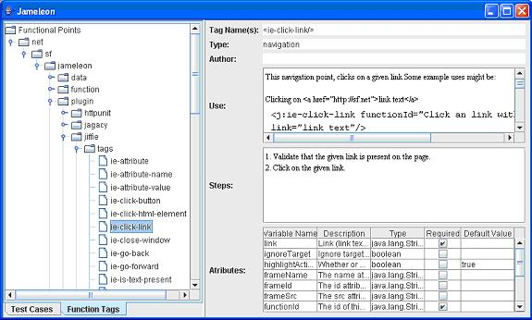

Review each of the tags listed in the jiffie-sourceforge.xml script to become familiar with their functionality. Many of the tags provide some sample xml.

To run this script, click the Test Cases tab again and select the script. Execute the script by clicking on the Execute Script(s) button. A new browser will be spawned and the steps in the script will be executed. A visual aide is added to make observing your script easier. When an action is performed on the page, such as entering text or clicking a link, a box will highlight the element on which an action is being performed.

I will discuss some of the advanced features of using the Jiffie plug-in to automate your tests later in this document. For now, it is enough to understand the structure and how to execute the test script.

Running multiple scripts at once
It would be very tedious if you had to select each script and run it individually. Jameleon allows you to select multiple scripts by holding the ctrl key while selecting the scripts you wish to run. When you have all of the scripts selected, click the Run Test(s) button.

Alternatively, you can use the command line to run all of your scripts by issuing the following command: build test.all. This command will run an Ant task that will execute all test scripts found in the scripts folder. You can also write your own Ant task in the file build.xml to test a specific group of scripts.

Running scripts from a command line is especially useful if you use the XP methodology, which implements automated regression tests. You can use a tool such as CruiseControl (available at cruisecontrol.sourceforge.net) to make this task easier.

Documenting Test Scripts
You may have noticed each tag in the session required an attribute labeled functionId. This attribute enforces the documentation of your test case. The text that is entered as a value for the functionId is displayed in the Jameleon GUI as the Execution Steps.
Sometimes, you may wish to document features that are not complete or as a manual substitute for automation. This can be accomplished by using the <function-doc/> tag. This tag does not perform any action, but still requires either the functionId attribute be set or the body of the tag to have a value. For example, <function-doc>some documentation goes here</function-doc> is perfectly valid.

Writing a custom tag
This section discusses writing a custom tag for the Jiffie plug-in. The concepts covered are applicable to all plug-ins.
Jameleon does not require you to write your own tags, however, there are many benefits to writing a tag (functional point) for each screen or feature in your application. Having a functional point that represents a single feature of the application helps make the script more readable and also helps when creating new scripts. With a pre-defined set of application-specific tags, one can quickly create a test without having to understand the low-level specifics of what it took to automate that specific feature. It turns several steps required to actually automate the feature into one simple step.
Using application-specific tags to test functional areas can save time when a feature in the application changes. If you have several test scripts that test this feature using generic tags, you would need to update each script that tests the modified feature. With custom tags, one can simply change the behavior of the tag to match the changes in the application, benefiting all of the test scripts that use that custom tag.

Using the Jameleon GUI to create a custom tag
The Jameleon GUI provides a wizard to help create your custom tags. Note that currently this feature only works under Windows since it uses Internet Explorer to introspect the HTML. Let’s create our first custom tag that fills out the text field and clicks the Google Search button.

Let’s start by clicking on the Generate Action Point button that looks like several gears. This will spawn the Action Point Generator window. The URL field will be blank. Enter www.google.com and click Go. This will spawn a new browser window that contains www.google.com. Jameleon will parse the web page source and retrieve the recognized objects. In this case, it recognizes the text filed with the name of q.

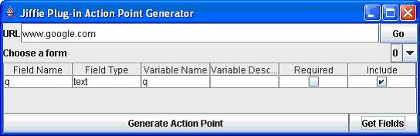

Click the button labeled Generate Action Point. This will spawn the following window:
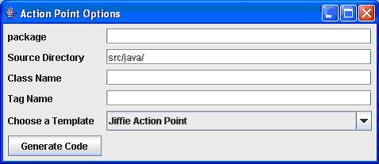

For the sake of this document, enter a package of google. Leave the source directory as is. By default, Jameleon will store these java files in the jameleon-test-suite\src\java directory followed by the package. So, our files will be stored in jameleon-test-suite\src\java\google. Enter a Class Name of GoogleSearchTag and a Tag Name of google-search. Remember that the file that will be created is a Java file and is subject to the restrictions on case. Jameleon tags also must end with Tag or Jameleon will not recognize them. Finally, click the Generate Code button. You can now close all the windows associated with generating the action point.

Now let’s look at the file that was created. Use any text editor to open the file jameleon-test-suite\src\java\google\GoogleSearchTag. It should look like this:

package google;
import net.sf.jameleon.plugin.jiffie.IEFunctionTag;
/**
* DESCRIPTION GOES HERE
* @jameleon.function name="google-search" type="action"
* @jameleon.step Set q text field if value is provided
*/
public class GoogleSearchTag extends IEFunctionTag{
/**
* the form identifier
* @jameleon.attribute default="0"
*/
protected String formIdentifier;
/**
* q
* @jameleon.attribute required="false"
*/
protected String q;
public void testBlock(){
setWorkingForm(formIdentifier);
if ( q != null ){
setTextFieldValue( qFieldName, q);
}
submitWorkingForm();
}
/////////////////////////////////////////////////////////////////////////////////////////////////
// FIELD NAMES ///
// These attributes are used to identify the fields in the form ///
// So they can easily be changed if the form fields ever change ///
////////////////////////////////////////////////////////////////////////////////////////////////
/**
* q's field name
*/
protected String qFieldName = "q";
}

For those of you who are familiar with Java, this should be pretty clear what is happening in this class, but I will point out several key components of this class.

First, this class sets the package where the class exists and imports the IEFunctionTag that is necessary to extend and use the Jiffie plug-in.

Second, comments that contain @Jameleon are interpreted by Jameleon. The comments prior to the class definition are used to summarize the function of the tag and list the steps that the tag performs. The line containing @Jameleon.function sets the name of the tag. This value will be used by our script to reference this class. So, our script will use the <google-search/> tag. Let’s modify the comments so they will accurately describe what our tag will do. The new code should look like this:

/**
* This tag submits search criteria on google.com
* @jameleon.function name="google-search" type="action"
* @jameleon.step Enter the search criteria in the text field
* @jameleon.step Submit the search criteria
*/

These details will now be displayed in the Jameleon GUI when our script uses this tag.

Third, our class extends the IEFunctionTag class. This gives us access to all the functionality in the Jiffie plugin as well as the Jameleon framework. By extending the IEFunctionTag, we can implement the testBlock() method within our class. Any code in this method will get executed when the tag is called. Extending IEFunctionTag gives us
access to all of the methods defined inside IEFunctionTag and FunctionTag. To see which methods are available, simply look at the API docs for the specific plug-in.
Fourth, within our class, we have several variables. These variables are all preceded by a comment block containing the @jameleon.attribute. This allows us to set a default value for the variable or require a script to pass a specific value for our variable. Let’s change the attribute for the q variable to required=”true”.

We also need to add another variable which will hold the value of the submit button we wish to click. Add the following lines to your class:
/**
* The submit button to be clicked
* @jameleon.attribute required="false" default="Google Search"
*/
protected String buttonToClick;

Fifth, the functionality that will be performed when Jameleon calls our class will be enclosed within the testBlock() method. This method should have no return value and must be public. Let’s examine what action is being performed in our testBlock method:

public void testBlock(){
setWorkingForm(formIdentifier);
if ( q != null ){
setTextFieldValue( qFieldName, q);
}
submitWorkingForm();
}
- We set the form on which to operate. The form can be either set by name or by the index, starting with zero. In our case, there is only one form, so the default value of 0 is sufficient.
- Since we made the q variable required, we validate that it is not null. Once that test has passed, we insert the value of q in the text field that is specified by the qFieldName variable.
- The action point generator assumed that there was only one submit button on the page so it added the method call to submitWorkingForm(). This method calls the submit method on the current working form. However, in this case, we have two submit buttons; one with a value of Google Search and another with I’m Feeling Lucky. Since we have multiple submit buttons in our form, we need to use a different method.

We need to replace the submitWorkingForm() with two method calls. First, we need to get the submit button that has a specific value. Once we have the submit button we want, we need to click it. Save your java file after making all the changes that I’ve listed. The new class should look like this:

package google;
import net.sf.jameleon.plugin.jiffie.IEFunctionTag;
/**
* This tag submits search criteria on google.com
* @jameleon.function name="google-search" type="action"
* @jameleon.step Enter the search criteria in the text field
* @jameleon.step Submit the search criteria
*/
public class GoogleSearchTag extends IEFunctionTag{
/**
* the form identifier
* @jameleon.attribute default="0"
*/
protected String formIdentifier;
/**
* The query that will be entered in the search field
* @jameleon.attribute required="true"
*/
protected String q;

/**
* The submit button to be clicked
* @jameleon.attribute required="false" default="Google Search"
*/
protected String buttonToClick;

public void testBlock(){
setWorkingForm(formIdentifier);
if ( q != null ){
setTextFieldValue( qFieldName, q);
}
clickIHTMLElement(getSubmitButtonWithValue(buttonToClick));
}
///////////////////////////////////////////////////////////////////////////////////////////////
// FIELD NAMES ///
// These attributes are used to identify the fields in the form ///
// So they can easily be changed if the form fields ever change ///
/////////////////////////////////////////////////////////////////////////////////////////////
/**
* q's field name
*/
protected String qFieldName = "q";
}

Now it’s time to compile your class and use the new tag in your script. From the command line, navigate to your Jameleon-test-suite folder and run build.bat or build.sh. This will compile all the java files and register them with Jameleon. I recommend running the build file from the command line because if you have any errors during compilation, you will have easy access to them.

If Jameleon was already running while you performed a build, you will need to restart it in order to view your new tag. You can validate that your tag is recognized by Jameleon by running Jameleon.bat and clicking the Function Tags tab in the bottom-left of the GUI. Double-click on the Functional Points folder. You should now see a google folder containing the google-searsh tag. Clicking on the google-search tag will display the details and attributes of the tag.
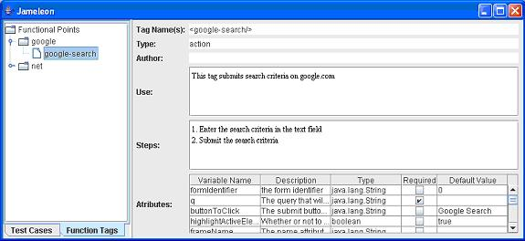

Now that our custom function tag is complete, let’s use it in our script. Let’s use the jiffie-google.xml script as a starting point. Save that script as custom-tag-google.xml. We will then replace the following two tags:
<jm:ie-set-text-field
functionId="Enter jameleon into the search box."
name="q"
value="jameleon"
form="f"/>
<jm:ie-click-button functionId="Click on the 'Google Search' button."
form="0"
value="Google Search"
functionDelay="300"/>

We will substitute them with our new custom tag:
<jm:google-search
functionId="Submit search criteria to google"
q="jameleon"
buttonToClick="Google Search"
functionDelay=”300”/>

Our new script, custom-tag-google.xml, looks like this:

<jm:testcase xmlns:jm="jelly:jameleon">
<jm:test-case-summary>
Loads the Google.com site, and searches for Jameleon
Setting beginSession to true starts IE at the defined baseUrl.
</jm:test-case-summary>
<jm:ie-session baseUrl="http://www.google.com" beginSession="true">
<jm:ie-validate-title
functionId="Verify successful arrival at Google home page."
title="Google"/>
<jm:google-search
functionId="Submit search criteria to google"
q="jameleon"
buttonToClick="Google Search"/>
<jm:ie-validate-title
functionId="Verify that the query for 'jameleon' was made."
title="jameleon - Google Search"/>
<jm:ie-click-link
functionId="Click on the 'Jameleon - An Automated Testing Tool - Overview' link"
link="Jameleon - An Automated Testing Tool - Overview"/>
<jm:ie-validate functionId="Verify we are at the Jameleon home page."
title="Jameleon - An Automated Testing Tool - Overview"
textPresent="Jameleon was designed to test all sorts of applications"/>
</jm:ie-session>
</jm:testcase>

Now execute the custom-tag-google.xml test case. It should function exactly like the jiffie-google.xml test case.

You may now be thinking that you just went through a whole lot of work to write a custom tag to perform an action that can easily be accomplished using two existing tags. Well, you’re right! There’s a trade-off between using a custom tag and an existing tag. In this case, there was only one text field and two submit buttons. If this is the only time that you will access this functionality, it doesn’t make sense for you to write a custom tag. However, a page like google.com is likely to be a starting point for many scripts. If you use existing function tags in all of your scripts, those scripts are now more vulnerable when the application changes. If google.com changes their homepage, however unlikely that is, you would have to edit all of your scripts! However, if you had used a custom tag, you would only need to edit one custom tag to accommodate the changes to google.com.

There is always more than one solution to any given problem so I’ll discuss some of the pros and cons of design decisions in the Test Design Approaches section.

Data-driving Your Tests
Jameleon provides several methods of storing data for your test case. You can store values that do not change across iterations of your test case in a properties file. Store values that change over each iteration in a CSV file or a database. Jameleon uses three concepts to compartmentalize an application; they are environment, organization, and application. These components are used in properties files to help organize the data that your test scripts need.

Environment
The jameleon.conf file is used to hold variables that are global to all applications. Common configuration parameters stored in this file are organization and testEnvironment. If these variables are set, Jameleon will parse other properties files based on the values of those variables. For instance, if testEnvironment=test, then Jameleon will look for a file called test-application.properties. If organization=companyA, then Jameleon will look for data in the jameleon-test-suite\data\companyA directory instead of jameleon-test-suite\data.

Organization
An organization allows a user to test an application that has the same core functionality but may be branded differently for a different customer. For instance, if the field names on a page are named the same across branding, but the title of the page changes, you can set an organization with all the brand-specific information.

An organization is set in a properties file by preceding a variable with the organization name. If you have an application that is branded for companyA and companyB, each brand will have a different homepage title. Since the title of the page is not going to change, it makes sense to store the value in a properties file. You can create an organization for both companies and your entries in the properties files will be:
companyA.homepageTitle=Welcome to company A
companyB.homepageTitle=Welcome to company B

In your script, reference the homepageTitle variable and Jameleon will use the correct value based on the organization you have set.

Application
An application contains data that is, big shock, application-specific. If your application is branded across several different organizations, the data for all brands should exit in the Application.properties file.

The Context
It is important to understand how Jameleon handles the data for your test. Jameleon will compile all the data for a test case into a context. The context contains all data from the properties file for your test as well as any data from your CSV file.

Referencing a variable that is set in the context is easy; just surround the variable with ${}. For instance, if the variable in the context is named firstName, it can be referenced by ${firstName}. There will be many examples of this usage later in this section.

You can create context variables in your script using the Jelly <set/> tag as follows:

<set var="contextVariableName" value="variableValue" />

You can also create a context variable in the testBlock() method a custom function tag by using the setVariable() method as follows:

setVariable("contextVariableName", “variableValue”);

Once these context variables are set, they can be referenced later in your script. Values that are read in from a CSV file have the potential to overwrite values that are set from a properties file. To avoid this potential problem, ensure that all context variables have a unique name. One method of ensuring that the variable names are unique is to add a _c to the end of values stored in a CSV file and a _d to values that are stored in a database.

CSV file structure
A CSV file is a comma-separated list of values. Jameleon uses the first row of a CSV file as a header to define a variable for the column of values below it. Jameleon test scripts can reference the header in the CSV file and the value for the particular row will be returned.

Let’s examine the contents of the CSV file data_driven.csv created earlier:
expectedValue,unusedValue,actualValue
10,,10
ten,null,ten
"Hello, how are you?",,"Hello, how are you?"
10,ignored,ten

The header contains the following variables: expectedValue, unusedValue and actualValue. Jameleon requires that there be a value within each column of data, even if that value is null. The header unusedValue is present only to show that you don’t have to use every variable defined in a header. If your value in a CSV file contains a comma, you must enclose the entire value in quotes. Also remember that values in Jameleon are case sensitive so hello is not equal to Hello.

A word of caution about using Excel to edit your CSV files… Excel is a good tool to determine if you have any missing or extraneous values in your CSV file, but it has a tendency to format your data in unexpected ways. I recommend using a simple text editor or a CSV editor that will not try to manipulate your format.

Using CSV Files to Drive Your Test
There are two ways to use a CSV file to drive your test case. We used the first method already in the script dataDriven.xml. In the <testcase> tag, we set the attribute useCSV=”true”. This approach will execute the entire test case for each line of the CSV file. If you use this approach, a new browser session will be spawned and closed for each row of your CSV file.

You may want to test a scenario that only iterates over a small portion of your script. In this case, you’ll use the <csv/> tag. The <csv/> tag uses the same browser window, depending on where you insert the tag. The <csv/> tag changes the flow of execution in your script. The attributes of the <csv/> tag can be found in the Jameleon GUI in the Function Tag tab.

One thing to keep in mind is that the steps enclosed in the csv block must leave you at that same point that you started from. For instance, if one of the steps submits a form that results in you going to another page, you must include a step to navigate back to the starting point, or your script will fail to work properly.

Let’s convert the script dataDriven.xml to use a <csv/> tag. Open that script in an editor and save it as csvDriven.xml. Remove the following attributes from the <testcase> tag: useCSV=”true” and countRow=”true”. Now we’re ready to enclose the <ju-assert-equals/> tag in <csv/> tags. After the modifications, csvDriven.xml should look like this
<testcase
xmlns:jm="jelly:jameleon"
name="data_driven">
<test-case-summary>
Use a CSV file to drive a test that compares two values
</test-case-summary>
<test-case-author>Steven Tyler</test-case-author>
<test-case-level>SMOKE</test-case-level>
<test-case-bug>001</test-case-bug>
<test-case-requirement>REQ001</test-case-requirement>
<functional-point-tested>Data-driving</functional-point-tested>
<application-tested>Jameleon</application-tested>
<ju-session>
<csv name="data_driven" countRow="true">
<ju-assert-equals
functionId="Compare two values to determine if they are equal"
expected="${expectedValue}"
actual="${actualValue}"/>
</csv>
</ju-session>
</testcase>

There are a few things that need to be pointed out in this script. The opening <csv> tag contains the name attribute. This name is the same name used in the dataDriven.xml file. This means that Jameleon will access the same CSV file for both scripts. This allows you to reuse data files. Remember that you don’t need to use every value listed in a CSV file.

Using a Database to Drive Your Test
Since Jameleon is written in Java, your test scripts can connect to any database that Java supports through JDBC. All you need to do to facilitate this is copy the database driver into the Jameleon-test-suite\lib directory.

Using a database to drive your scenario is similar to using the <csv/> tag. We use the <sql/> tag to enclose tags to iterate over. One key difference between the <sql/> tag and the <csv/> tag is that we typically have more control of the contents of a CSV file. There is often less control over the database.

Here is an example fragment of a script that uses the <sql/> tag to connect to an oracle database:
<sql
jdbcDriver="oracle.jdbc.driver.OracleDriver"
jdbcUrl="jdbc:oracle:thin:@hostname:port:dbInstance"
jdbcUsername="username"
jdbcPassword="password"
countRow="true"
query="select first_name from customers>

<ju-assert-equals
functionId=”Validate that the first name of the customer is ‘Joe’”
expected=”Joe”
actual=”${FIRST_NAME}”

</sql>

This fragment connects to the database with the information provided and executes the query select firstName from customers. Jameleon collects the results and stores it in a list variable named first_name. Depending on the JDBC driver the variable name could end up becoming uppercased (FIRST_NAME as used in the script above). Our script then compares each item in the list to see if it equals the string Joe. You can also use an alias in your select statement to create a more useful name for the variable that will be stored in the context. For example, you could issue the following select statement: SELECT first_name AS customer_first_name FROM CUSTOMERS.

While this scenario isn’t very useful, it demonstrates that you can issue any query on the database and then access the results through a context variable. You can then perform any action with the resulting data.

Another tag that can be used hand-in-hand with the <sql/> tag is the <sql-update/> tag. The <sql-update/> tag can be used to add or delete data in the database to either setup or reset the database for your test. This is an important aspect of scripting with a database, since it is easy for the database to become filled with garbage data that will break your script. This is useful if you have a script that fails due to a valid error. If the script failed before it completed, you can potentially leave garbage data in the database that should be cleaned up. It’s a good habit to enclose <sql-update/> tags in a <precondition/> or <postcondition/> tag to ensure that the statements are executed regardless of the results of the test.

Advanced Scripting
Now that you’ve learned about all the basics of building a script, it’s time to put it all together into one complex script. The following script is designed to demonstrate the flexibility of Jameleon and also give you a reference point when it’s time to write your script.

For this example, I will write a test script to test a requirement for a fictitious Web application. The requirement is that a user will be able to login to a site with an existing username and password. Once they have successfully logged in, they will click on the “Change Contact Info” link and fill out a form to submit their changes. After the changes have been submitted, the page will refresh with the updated contact information that is now stored in the database.

This is a pretty hefty requirement and there are several subtleties to testing this application that I will not pursue. However, there are some clear validation points and design decisions that have to be considered. The user must perform the following acts:

- Access the login page of the site
- Enter valid login credentials and submit the form
- Click on the “Change Contact Info” link
- Fill out a form with all the user’s contact information and submit the form
- Validate the changes are updated on the web page
- Validate that the changes have been pushed to the database

In our script, we want to validate several points along the way to ensure that our script hasn’t encountered a failure. This will avoid any misleading error messages due to an error that wasn’t caught. For the sake of our example script, I will also assume that we will use a CSV file with static content to drive our test. Since the CSV file contains static content, I want to connect to the database prior to the execution of the script to update the values for our user. This will add a level of robustness to the script and ensure that the script doesn’t pass when it should fail (i.e. if you update the database with identical values, you can’t be sure that it really updated).

So, the complete list of test steps is as follows:
- Connect to the database and update the test user’s contact information. (This step should be wrapped in a <precondition/> tag to ensure that your test is run in a properly setup environment)
- Access the login page of the site
- Enter valid login credentials
- Validate that you logged into the site successfully
- Click the “Change Contact Info” link
- Validate that you arrived at the Change Contact Info page
- Fill out the “Change Contact Info” form with values from a CSV file and submit the form
- Validate that the “Change Contact Info” page was refreshed and now reflects the new contact information
- Connect to the database and validate that the changes have been pushed to the database

To write a robust script that covers all the steps listed above, we will use two custom tags and an XML fragment. The tags and fragments will allow us to reuse our code.

Since this application doesn’t exist in reality, I will only focus on the functional areas of the custom tags. If you need more details on the structure of a custom tag, refer to the section Writing a Custom Tag.

Custom Login Tag
The first custom tag will handle the login functionality. A code segment of the login tag will look like this:
package webApp;
import net.sf.jameleon.plugin.jiffie.IEFunctionTag;

/**
* This tag fills out the login form and clicks submit
* @jameleon.function name="webApp-login" type="action"
*/
public class WebAppLoginTag extends IEFunctionTag{
…
public void testBlock(){
setWorkingForm(formIdentifier);
setTextFieldValue (usernameField, username);
setPasswordFieldValue(passwordField, password);
submitWorkingForm();
}
}
Note that we don’t have any variables defined in this code segment, but the names should be intuitive. The key points of this tag are the name, webApp-login, that will be used in our script and the contents of the testBlock() method.

In the testBlock() method, we first set the working form, on which we will operate. We then set the username in a text field and set the password in a password field. Password fields are differentiated from a text field because they mask any text entry. Finally, we submit the form.

Custom Contact Info Tag
For the sake of this example, let’s assume that the “Change Contact Info” form contains the following required fields: firstName, lastName, streetAddress1, streetAddress2, city, state, zip and phoneNumber. Custom tags make forms with a large number of fields much easier to script.

An example testBlock() method of this function tag would look like this:
package webApp;
import net.sf.jameleon.plugin.jiffie.IEFunctionTag;

/**
* This tag fills out the login form and clicks submit
* @jameleon.function name="webApp-change-contact-info" type="action"
*/
public class WebAppChangeContactInfoTag extends IEFunctionTag{
…
public void testBlock(){
setWorkingForm(formIdentifier);

setTextFieldValue(firstNameField, firstName);
setTextFieldValue(lastNameField, lastName);
setTextFieldValue(streetAddressField1, streetAddress1);
setTextFieldValue(streetAddressField2, streetAddress2);
setTextFieldValue(cityField, city);
setTextFieldValue(stateField, state);
setTextFieldValue(zipField, zip);
setTextFieldValue(phoneNumberField, phoneNumber);

clickSubmitButtonWithName(buttonName);
}
}

As in the custom login tag, there are no definitions for the variables that are used in the testBlock() method, but the names should be intuitive. One difference between the login tag and this tag is that we do not use the submitWorkingForm() method. The reason for this is that it’s likely that a form for modifying contact information will likely have a Cancel as well as a Submit button. We can now pass the button to click to the clickSubmitButtonWithName() method. This will give us the flexibility to click Cancel or Submit, depending on our test case needs.

Custom Validation Tag
One of the requirements is that we validate that all of the contact information be displayed after the user submits the form. There are several ways that we can validate that the text exists.

We could use a series of <ie-validate> tags to validate each piece of information (first name, address, etc.) is displayed. This is not the best way because it limits reuse of the code.

We could use Xpath to define the exact location where we expect the updated values to appear. This is the most accurate test, but since this application does not exist, we don’t know the structure of the page.

The approach that we will use for our example is to create a custom validation tag. This will allow us to reuse more code and make our script easier to read. A segment of the validation tag will look like this:

package webApp;
import net.sf.jameleon.plugin.jiffie.IEFunctionTag;

/**
* This tag fills out the login form and clicks submit
* @jameleon.function name="webApp-validate-contact-info" type="validation"
*/
public class WebAppValidateContactInfoTag extends IEFunctionTag{
…
public void testBlock(){
assertTextPresent ( firstName );
assertTextPresent ( lastName );
assertTextPresent ( streetAddress1 );
assertTextPresent ( streetAddress2 );
assertTextPresent ( city );
assertTextPresent ( state );
assertTextPresent ( zip );
assertTextPresent ( phoneNumber );
}
}

This tag will now take the place of eight separate <ie-validate/> tags.

Properties file
Some of the static values for our test case will likely be used by other test cases as well. In order to reduce redundancies in data, the best way to store these values is in a properties file.

For our example, we will define the application “webApp” and create a corresponding properties file named webApp.properties in the res directory. This properties file will contain the following values:
baseUrl=http://www.myAppServer.com/login
jdbcDriver=oracle.jdbc.driver.OracleDriver
jdbcUrl=jdbc:oracle:thin:@hostname:port:dbInstance
jdbcUsername=dbUsername
jdbcPassword=dbPassword

The baseURL value will be used for our Jiffie session. The other lines list the configuration parameters for connecting to the database.

CSV file
Our example script requires several values to populate the forms in our test case. The most common way to store these values is in a CSV file. The CSV file for our script will be named contactInfo.csv in the data directory. The CSV file for our test will contain the following values:

firstName_c,lastName_c,streetAddress1_c,streetAddress2_c,city_c, ...
John,Doe,123 Anonymous St,,New York City, New York

Note that each value in the first row has ‘_c’ appended to it. This will help us differentiate the values that are stored in properties files from values stored in a CSV file.

Navigational XML Fragment
Assume that our Web application has a home page that is displayed after a successful login. On this home page, there are several navigational links, such as “Account Details”, “Order History” and “Change Contact Info”. It’s logical to assume that you would eventually want to test all three of these sections. To test these sections of the site, you may have several test cases that need to navigate to the different links. Using XML fragments allows you to write the code once and reference it in many scripts. For our script we will write an XML fragment that will click the “Change Account Info” link and validate that we arrived at the “Change Account Info” page.

The following code for the XML fragment must be saved in a file named ChangeAccountInfo.xml.fragment in the scripts folder:
<ie-validate
functionId="Validate that the title of the page is webApp Home Page"
link="webApp Home Page"/>
<ie-click-link
functionId="Click the Change Contact Info link"
link="Change Contact Info"/>
<ie-validate
functionId="Validate that the title of the page is Change Contact Info"
title="Change Contact Info"/>

We will use the fragment in the script by placing the following header at the top of the script:
<!DOCTYPE project [
<!ENTITY ChangeAccountInfo SYSTEM " ChangeAccountInfo.xml.fragment">
]>
We then reference it in our script using the following call: &ChangeAccountInfo;

Test Script
Now it’s time to put all the pieces together. The complete script will look like this:

<!DOCTYPE project [
<!ENTITY ChangeAccountInfo SYSTEM " ChangeAccountInfo.xml.fragment">
]>

<testcase xmlns="jelly:jameleon" useCSV=”true”>
<test-case-summary>
Log into the test Web application and change the user’s contact information
</test-case-summary>

<!-- Connect to the database and modify the contact information -->
<ju-session>
<precondition>
<sql-update
jdbcDriver="${jdbcDriver}"
jdbcUrl="${jdbcUrl}"
jdbcUsername="${jdbcUsername}"
jdbcPassword="${jdbcPassword}"
functionId="Connect the database and update the contact information"
sqlUpdateSql="delete from contacts where user=’test’"
/>
</precondition>
</ju-session>

<ie-session application=webApp beginSession="true">
<ie-validate-title
functionId="Verify successful arrival at webApp login page"
title="WebApp Login"/>
<webApp-login
functionId="Login to webApp"
username="${username_c}"
password="${password_c}"
/>

<!-- XML Fragement that clicks the Change Contact Info link -->
&ChangeAccountInfo;

<webApp-change-contact-info
functionId="Fill out the Change Contact Info form and submit it"
firstName="${firstName_c}"
lastName="${lastName_c}"
streetAddress1="${streetAddress1_c}"
streetAddress2="${streetAddress2_c}"
city="${city_c}"
state="${state_c}"
zip="${zip_c}"
phoneNumber="${phoneNumber_c}"
/>
<webApp-validate-contact-info
functionId="Validate that the contact information has been updated on the web page"
firstName="${firstName_c}"
lastName="${lastName_c}"
streetAddress1="${streetAddress1_c}"
streetAddress2="${streetAddress2_c}"
city="${city_c}"
state="${state_c}"
zip="${zip_c}"
phoneNumber="${phoneNumber_c}"
/>
<!—Connect to the database and validate that the contact information has been updated -->
<sql
jdbcDriver="${jdbcDriver}"
jdbcUrl="${jdbcUrl}"
jdbcUsername="${jdbcUsername}"
jdbcPassword="${jdbcPassword}"
query="SELECT FIRSTNAME AS firstName_d
LASTNAME AS lastName_d
STREETADDRESS1 AS streetAddress1_d
STREETADDRESS2 AS streetAddress2_d
CITY AS city_d
STATE AS state_d
ZIP AS zip_d
PHONENUMBER AS phoneNumber_d
FROM CONTACT_INFO
WHERE PHONENUMBER="${phoneNumber_c}">
<webApp-validate-contact-info
functionId="Validate that the contact information
has been updated in the database"
firstName="${firstName_d}"
lastName="${lastName_d}"
streetAddress1="${streetAddress1_d}"
streetAddress2="${streetAddress2_d}"
city="${city_d}"
state="${state_d}"
zip="${zip_d}"
phoneNumber="${phoneNumber_d}"
/>

</sql>
</ie-session>
</testcase>

This test script is not as thorough as it should be, but it shows how to use a number of the principles of automated testing in Jameleon. I want to point out a few points in this script:
- The script uses two sessions, a ju-session (JUnit session) and an ie-session (Jiffie session)
- We are using data from three sources: a CSV file, a properties file and a database.
- We use a <precondition/> tag to ensure that the environment is setup correctly. If this step fails, no other tags will be executed and the test case will fail.
- We reuse the data from the CSV file as well as our custom tag, thus proving the usefulness of compartmentalizing our code.

Running Scripts via the Command Line with Ant

Why the Command Line?
The command line interface makes it easy to run your tests in an automated fashion. This enables you to incorporate your tests into an automated build for regression testing. For example, you can set up a cron job or a build tool to runs your tests every three hours or every night. Some people just prefer to use the command line instead of a GUI. This approach also allows you to see the detailed logging output from your script while it is executing.

What is Ant?
Ant is a feature-rich build tool for Java similar to Make for C/C++. Jameleon uses Ant to build custom tags and to execute Jameleon scripts. Ant has commands just like Make does, except they are defined in an XML file, usually called build.xml, and are called targets. For the sake of this manual, Ant must be run the command line and from the jameleon-test-suite directory.

The Ant Build File
The jameleon-test-suite distribution comes with an example build file that can be used to execute Jameleon scripts right out of the box. To see which targets are available via the provided jameleon-test-suite, open a command prompt and navigate to the jameleon-test-suite directory. Windows users must type build -projecthelp and Unix/Linux users must use ./build.sh -projecthelp. You should see several available build targets and their descriptions. For example, you can call the test.all target by running build test.all from the command line.

Important Ant Tasks
The provided build.xml file comes with several targets. I will only cover a few in this document. For a deeper understanding of Ant, please read the documentation on the Ant Site
- test.all – Executes all scripts ending in .xml that exist in the scripts directory
- test.script -Dscript=**/scriptName.xml – Executes a single script or multiple scripts matching the parameters after -Dscript=. Here are two examples:
  - build test.script -Dscript=**/appname/**/*.xml – executes all scripts nested in the appname folder.
  - buildtest.script -Dscript=dataSubstitution.xml – executes script/dataSubstitution.xml
- test.smoke – Executes all scripts that contain the the following text:
test-case-level>SMOKE

Provided Ant Tasks Explained
- test.smoke – This task is a perfect example for executing test scripts that contain some text. An example uses might be to run all tests developed by “Christian Hargraves” (notice that I didn't put a < in the contains attribute. This would be invalid XML and be solved by putting you variable in the provided) build.properties file.
<target name="test.christians.scripts" description="Run tests authored by Christian">
<run-test contains="test-case-author>Christian Hargraves" script="**/*.xml"/>
</target>
- test.script – This task is a good example for running suites of tests that are contained in a certain directory or all follow a certain naming standard. An example use might be to run all tests against the shopNow application.
<target name="test.shopNow" description="tests shopNow">
<run-test contains="" script="**/shopNow/**/*.xml"/>
</target>
In Ant, the ** means to match any subdirectories. So the above example means that as long as there is a folder named shopNow, then it will execute the script. The following directories would match:

scripts/shopNow/test1.xml
scripts/foo/shopNow/test2.xml
scripts/foo/bar/shopNow/login/validLogin.xml

If the above examples aren't powerful enough for you, review the documentation on Jameleon Ant Tasks on the Jameleon sourceforge.net site. The Test Case Execution Tag section of the page will be the most helpful. If you still don't get your question answered there, feel free to post a question on the user forums.

Intrinsic Problems with Automated Testing
You should now have a good foundation of how to write a test case using Jameleon. Now it’s time to discuss some of the many pitfalls with automated testing and how Jameleon helps to overcome them.
Automated testing does not solve all of the testing needs. In fact, it usually introduces several new problems. While many of these problems may be addressed by being extremely disciplined in an automated testing approach, it is still important to be aware of these problems.

Automated scripts become outdated by frequent changes to the application
Unless scripted by a self-disciplined group of testers who understand object-oriented principles, it is likely that the automated scripts will contain a lot of duplicated code. Imagine having hundreds or even thousands of automated scripts written against a word processor. It is highly likely that those scripts will end up using several features of the word processor just to arrive at the point being tested.

Let's take editing a file as an example. To test the italicizing feature, the application must be started, a file must be opened, text must be selected, the italics button must be pressed and finally the text must be validated as being italicized. This single test includes four actions; not to mention, validating the successful completion of each of the actions required to arrive at the feature to be tested. A change in any of these application features requires changes in the underline test as well as many other tests.

Flexibility and power are often sacrificed for ease of scripting
Many of the available tools have a selling point that they make writing automated tests quick and easy. To do this, they rely on simplified scripting languages. These languages often don't allow access to external resources or publicly developed and supported libraries. The languages can also limit the extent of abstraction and reuse of functionality. At a minimum, they do not encourage good coding practices for maintainability.

The tools lose the complexity of a full language, so organizations can only feasibly test the easier problems. This removes the unique value of automation. Because of the lack of flexibility, it is common to see organizations needing several different tools to test web, desktop and client/server applications. Testers may have to learn many simplified scripting languages, which results in an extended learning curve.
Automated Scripts are Hard to Read and External Docs Get Out of Sync

For both automated and manual testing, test cases document the steps required to validate that the business requirements have been met. Automated scripts are often managed separately from manual test cases.
The nature of applications is that they will change over time. If you have separate repositories for manual and automated test cases, there is a high likelihood that the separate test cases will become out of sync. This leads to a frustrating task of reconciling the manual and automated test cases to determine which test case is accurate.

Too Much Work to Test all Possible Scenarios
In many cases, the data in a test case cannot be easily separated from the actual test script. This requires creating several test scripts to test all scenarios or possibly hard-coding values within your script to test some cases. This results in unwieldy code that is a nightmare to maintain. Ultimately, you may determine that the cost of automating in this fashion is more time consuming and costly than manual testing.

Automated Scripts can be Difficult to Port Between Environments
Many of the automated testing frameworks available don't take the lifecycle of a product into consideration. A product must go through development, alpha testing, beta testing, and performance testing before it reaches the masses. Because of the infeasibility of editing large numbers of scripts, many organizations only run their automated tests against one environment, thus missing opportunities for validation and regression testing as the application advances in the product lifecycle.

Testing Tools Use Proprietary Technologies

Most testing tools require learning a propriety language or technology. This makes it harder to find experienced people, which restrict a company's options in selecting testing tools. The narrow applicability of proprietary technologies may also deter current employees from acquiring a more in-depth knowledge of the tool.

How is Jameleon different?

Jameleon Takes a More Object-Oriented Approach to Testing Applications
Jameleon separates applications into components, such as an HTML page or an operation on a database. The steps to test a component are implemented in a Java class that can be referenced in a Jameleon script by an XML tag. These tags can then be tied together to create a test case. Now when a feature in the application changes, you only need to edit the Java class to match the new functionality of the application. Any script that references the XML tag for your component will use the new functionality without any editing in the script.

Jameleon Supports Scripting at Different Levels of Complexity
Jameleon is an engine, not a specific solution, so the same architecture and scripting language can be used for almost any testing problem. Jameleon offers a macro language to make scripting easier, but it is designed from the beginning with the assumption that the macro language will be extended to meet each organization's specific testing needs. Because Jameleon is written to open standards such as Java and XML, it gives test script developers full control by its ability to interface with code written in any language. The automated scripts themselves are simply a series of keywords that represent complete actions or "functional points" which are, in fact, components that are often custom-written for the application. Currently, Jameleon comes with plug-ins that offer ready-made functional points for Java, web applications and mainframes; but it is architected to be extensible to permit the community to add support for other technologies.

Test cases and test scripts are the same
Because a test case is simply a set of organized features, Jameleon requires that only the features need be documented. The test case's documentation is therefore generated by the order of the features' documentation. The documentation and the scripts can then be generated simply by selecting the order of functions to be executed. Now if a feature's documentation changes, all of the test cases that include that feature get the documented changes automatically.

No Environment Information in the Automated Tests
In Jameleon, test scripts and environments are separate entities. Jameleon allows for a test script to be run against different environments without any changes to the test script itself. After registering an application and the environment(s) it will be run in, you simply change the properties of the application to point to the new environment.

Data-Driven Tests

Jameleon allows test-scripts to be data-driven from any external data source. Currently, there is support for CSV (Comma Separated Values) and JDBC (Java Database Connectivity). This allows one feature to be tested by one script, but with multiple values being passed for each row in the data file. A test can then be defined as one execution for each row of the data source or as one execution for all rows of the data source.

Jameleon uses common technologies

In Jameleon, the features are coded in Java and they are tied together in a test script using XML. These technologies can be learned just about anywhere and are open-standards that many companies adhere to.

Lessons learned
There are many lessons to be learned from successful and failed projects. Here are a few that stand out:

Automated daily regression
This just helps keep you honest. If your scripts run without any human intervention, there is no way that you can rationalize that your input isn’t hurting anything. The key here is to get the script working well enough that when the script fails, you believe that it’s a real error. Don’t ignore failures; they’re either a failure in your script, environment or the application under test. In any case they need to be fixed!

Running a script from the command line
To help in the daily-automation process, you can run all your test scripts from the command line in a batch mode. You can perform this by running the following command in the jameleon-test-suite directory: build test.all. You can perform a more specific subset of tests by creating your own Ant task in your build file.

Organize your data
When you data-drive your tests, you want to minimize redundancies in the values that are stored. One way to do this is to use the properties files to extract frequently used data from your CSV files or SQL queries. However, moving values from the CSV or SQL queries into the properties files can cause some confusion. It may be difficult to locate the source of the variable that is being used. To help with this, make sure you name your variables appropriately. For example, begin all variables that come from CSV files with a “c_”, from properties with a “p_” and from sql queries with a “s_”. This helps reduce debugging time.

Also take into account the user audience. If the user is a non-technical business user, then it’s okay to place all of your data in a CSV file and simply tell the user to add/edit/delete rows from the CSV file to create a new test case.

Using an applications.properties file will also help you organize the data logically. If you test one application in a multi-branded environment, use an organization to store brand-specific variables. When you make the decision to data-drive your tests, consider the volatility of the data. For example, if the data is likely to change, consider mining the necessary values from a database. If the data does not change between different test cases (titles, error messages, form field names), put that data in a properties file. If you are simply testing different scenarios and the data isn’t expected to change, use a CSV file. Avoid complex solutions to separating your data. Separating data from your scripts can also create more maintenance.

Plan your script before writing it
Any testing tool documentation will preach that you need to use good software testing practices when implementing your automation strategy. The major principle is that you need to state your test case goals prior to writing any code.

Use Custom Tags
The design approach of using custom tags is centered on the concept that applications will always change. They may rarely change or change in ways that do not drastically affect your existing tests. To mitigate the affects of these changes, you should use custom tags to handle all the actions on a page.

Unlike google.com’s search form, the application that you’re testing will almost definitely change. When you design your automated test, you have to weigh the costs of creating a custom tag vs. using the existing tags. There are pros and cons to each side of the argument.

Use XML Fragments
XML fragments enable the reuse of xml code in your scripts. This approach augments the use of custom tags. For instance, if you have several scripts that login to your application and then perform a number of actions to get to a page that you are testing, you can write custom tags for each of those pages. Then you can write a fragment that will call each of those tags. The result is that you have reduced the number of tags in your script as well as avoided duplicate code and reduced the points of failure to one. That’s a pretty good return on your invested time.

If you’re unfamiliar with XML fragments, review the XML Basics section at the end of this document.

Use Xpath for validation
If you are testing a web page and you need to validate that some text appears on the page, you can use the <ie-is-text-present/> tag. However, this tag is not very accurate. It will parse the entire contents of the source file. As a result, it makes it difficult to guarantee that specific text appeared where you wanted it to appear.

The solution to this problem is to use Xpath. The <ie-validate-xpath/> tag implements Xpath to locate a value that you are searching for. Through an Xpath statement, you can specify exactly where an element appears within the HTML source.

The Jiffie plug-in also allows you to use Xpath statements within your custom tag. This can be very useful in some scenarios. One example is if your application generates and displays a uniquely generated username or password that you need to use later in your script. You can write a custom tag using Xpath to locate that element and set it in a context variable.

An Xpath tutorial is beyond the scope of this document, but there is a good tutorial at: http://www.w3schools.com/xpath/default.asp.

Conclusion
I hope that you found the information in this document helpful. If you didn’t, please let me know so I can keep it updated and useful.

If you have not found the information that you needed, please visit the user forums for Jameleon at http://sourceforge.net/forum/?group_id=84246

If you still don’t find what you’re looking for, please post a question to the appropriate forum. You will often get a response to your question within a day or two.

Appendix A

XML Basics
This document introduces some basic XML principles and is for those that don't fully know XML. Most of these principles are required to use the macro language. For a more detailed understanding, visit the W3C XML site..

Prolog
Every XML document should start with:
<?xml version="1.0"?>
This states the document type is XML and it uses version 1.0 of the w3c recommendation. This is not required to run Jameleon scripts and in most cases can be excluded.

Root Element
XML is used to represent a nested or tree structure. The basic rule of XML is that a valid XML document must have ONLY one "root" element. A root element is simply an element that starts the document. Just as everything is supposed to have a beginning and end, a valid XML document has one too. An element is an alpha-numeric set of characters surrounded by < and >.
For example:
<?xml version="1.0"?>
<START>
Is a valid element. However, in order for the above to become a valid XML document, it must have an ending element.
<?xml version="1.0"?>
<START>
</START>
is a valid XML document! In this example, <START> is the opening root tag, </START> is the closing root tag and everthing in between is considered owned by <START>
The above example can also be rewritten like this:
<START/>
As may be guessed, the "/" symbol at the end of an element means that this element does not have any children. A "/" at the end of the element ( before the > symbol ) represents the closing of the same opening element. Closing an element is done by the "first opened, last closed" rule.

Multiple Elements
Now let's look at a bit more of a complex XML document that has nested elements.
<testcase>
<name>ExampleTestCase</name>
<httpunit-session>
<some-function-point/>
</httpunit-session>
</testcase>
This example has an opening <testcase> element which contains a <name> and an <httpunit-session> element which in turn contains a <some-function-point> element which does not contain anything so it closes itself. The <httpunit-session> then closes itselft, followed by a closing of the root element or the <testcase> element. Notice how the <name> element contains some arbitrary text. This is giving the test case the name "ExampleTestCase".
The above example represents a hierarchical structure, as do all XML documents. The biggest difference between a simple hierarchical diagram and an XML document is that most hierarchical diagrams don't show where the parent-child relationship ends. It is assumed visually by indentation or some other means. On the other hand, a well formatted XML document will normally include indentations for easy reading, but it is not a requirement so it requires an end tag for every open tag.
In the above example, it can be said that there is a testcase and the testcase is made up of a name and an httpunit-session. The session, in turn, is made up of some-function-point. It is that simple!
The text between element tags must not have <, >, or & inside them. If it is required that these characters be in the text, then the text must look something like:
<?xml version="1.0"?>
<testcase>
<name>
<![CDATA[Some text with some < invalid > characaters in it.&]]>
</name>
<httpunit-session>
<some-function-point/>
</httpunit-session>
</testcase>

Element Attributes
An Element Attribute is a more restrictive way to describe something. In the above example, we used a <test-case> that has a name, and a session. While a session is somewhat complex and would be very difficult to turn into a set of characters, the <name> is simply a set of characters. In this case, it would be appropriate to put it into the <test-case> tag as an attribute:

<?xml version="1.0"?>
<testcase name="ExampleTestCase">
<httpunit-session application="sourceforge">
<some-function-point
functionId="A function point that does something"/>
</httpunit-session>
</testcase>
Notice how "name" was brought into the <test-case> element. Now, the test case's attributes are defined inside the test-case element and the test-case's subelements can now all be represented as objects. Also notice that now both the <httpunit-session> and <some-function-point> elements both have attributes describing something simple about them.
The drawback to using an element attribute is that an attribute can have none of the invalid characters mentioned above. The CDATA marker cannot be used as an attribute's value.This obviously restricts the value of the attribute much more than that of an element's value.

XML Formatting
An XML document does not need to be well-formatted to well-formed. The above example can also be written like:
<?xml version="1.0"?>
<testcase name="ExampleTestCase">
<httpunit-session application="sourceforge">
<some-function-point
functionId="A function point that does something"/>
</httpunit-session>
</tes-case>

<?xml version="1.0"?>
<testcase name="ExampleTestCase">
<httpunit-session application="sourceforge">
<some-function-point
functionId="A function point that does something"/>
</httpunit-session>
</testcase>
In other words, XML doesn't care about "white space" (spaces, tabs, and blank lines). However, it is much easier to read when using "white space".

Restricting the Structure
XML also allows a document to be validated against a predefined structure. There are currently two types of definition documents, Document Type Definition (DTD) and XML Schema. Basically, both of these document definitions accomplish the same thing, but in different ways. Without a DTD, an XML document's structure is not restricted except by the syntax rule mentioned earlier.
The original reason for the creation of XML was to store data in an implementation-independent format. In other words, being able to store the data in one language like C++ and then being able to read it in through different language like Java was a requirement of XML.
Normally, this would mean different implementations for parsing the document at the software level. Thus the idea of a DTD was introduced and a couple of years later XML schema was introduced.
This puts the validation in the hands of the XML parser instead of the software that reads or writes the XML. In other words, using a DTD to restrict the structure of XML while trying to write some unsupported element would cause an error and XML could not be written to. Now data can be written in a standard format and a generic parser can be used to read and write this data without need to implement an in-house parser.
For more information on DTD's, click here. For more information on XML schemas, click here.
Jameleon does not restrict the structure of the XML since the XML is used as a scripting language and the idea of creating function points on the fly would require the DTD to be specific for each customer. However, Jameleon does use this idea to know how to handle custom function points.

XML Namespaces
Since it is likely that two seemingly independent XML documents that describe different things could actually be used together to describe more complex data, the chance of the element names of each document type being the same is pretty high.
For example, let's say there is a trucking company that uses an XML document to describe it's shipping orders. This document would more than likely contain an element that describes the contents, size, and weight of the cargo it is shipping. It would also, more than likely describe the entity shipping and receiving the package. Now let's say there is a farmer that sells fruit. This farmer uses the before-mentioned trucking company to send his fruit across the country and he uses XML to describe his customers, products, and orders.
Now let's say the two companies decide to use the same mechanism to share information. It is more than likely that the two different XML data-types above would use some of the same structure to describe their customers, packages, and products. And if they didn't, the data would mean very similar things and would likely become difficult to understand if the two put together. The farmer would want to keep his own data description and the trucking company would also want to keep their data description since they are working with several companies that ship various products. Wouldn't it be nice if their two data definitions could be included in the same XML document yet remain independent?
XML provides a solution to this dilemma through namespaces. A namespace is basically the idea of defining a document's definition of elements as all starting with a different sequence of characters than it normal would. However, the XML parser is smart enough to give the software the same data structure it is expecting. For example, if we had a simple DTD that defined one single element as <element/> and set a namespace for that DTD to be "jmln", then that element would now be expressed in the document as <jmln:element/>, but by the time it got to application that reads the XML in, it would only get <element/>. that DTD,
Below is an example of how Jameleon uses namespaces:
<j:jelly xmlns:qa="jelly:jameleon" xmlns:j="jelly:core">
As might be guessed, the "xmlns" stands for XML Namespace. This above element imports two different xml document definitions. One for "jelly:core" (defined by xmlns:j="jelly:core") and one for "jelly:jameleon" (defined by "xmlns:qa="jelly:jameleon"). The import of "jelly:core" states that all elements described in "jelly:core" must start with "j". The import of "jelly:jameleon" states that all elements described in jelly:jameleon must start with "qa".
Notice the : after xmlns. This is the part that states what all elements of the type used after the = must begin with. Normally Jameleon would use the XML element, <test-case>. However, the namespace definition of jelly:jameleon, requires all Jameleon-based elements to begin with "qa". So <test-case> turns into <qa:test-case>.
The value of the xmlns:qa is the location of the definition of the document. In this case, "jelly:jameleon" is the location of the structure definition. A namespace may be defined in any element. However, the namespace will only be valid for children of that element. In other words:
<testcase xmlns="jelly:jameleon">
Will also work. Because jelly:core is not defined, only Jameleon-specific tags can be used directly under this tag. However, if the child element declared the jelly:core namespace, it could be used for that element and all children of that element. For most cases, using the above example for Jameleon will get the job done and it keeps the test cases simpler and easier to read.

XML Fragments
An XML fragment is considered an XML document that doesn't have a root element or even if it does, that root may become a child of another element. The idea of including existing XML into another document is very flexible and can be used as a workaround for having a set of the same data in many XML documents.
Including an XML fragment in another XML document is actually quite simple. First, the document that is going to be imported, must be defined and given a name. This definition of this document must be included after the prolog and before the root element of the XML document. Second, the name is used to include that xml fragment in the document wherever desired (as long as it stays a valid XML after the import).
For example:
<httpunit-session application="sourceforge">
<some-function-point functionId="A function point that does something"/>
</httpunit-session>
is saved to the file some.xml.fragment.
<!DOCTYPE project [
<!ENTITY fragToInclude SYSTEM "some.xml.fragment">
]>
<testcase xmlns="jelly:jameleon" name="ExampleTestCase">
&fragToInclude;
</testcase>
In this file, "some.xml.fragment" is given the name "fragToInclude" at the top of the file. The & followed by the name or fragToInclude followed by a ; or just &fragToInclude; is used as the actual "import here" statement.
Once the XML is parsed, the document is brought together to look like:
<testcase xmlns="jelly:jameleon">
<httpunit-session application="sourceforge">
<some-function-point
functionId="A function point that does something"/>
</httpunit-session>
</testcase>
Jameleon does not require the use of fragments, but it is recommended for test cases that test the same functionality but in different ways. Getting to the state where the functionality can be tested is most of the work and the grouping of the function points that get to that point can be put into a fragment for inclusion into the actual test cases.

Appendix B

Glossary

XML Fragment – An autonomous segment of xml that is stored in a separate file. A fragment can be used to segment your code for reusability

Functional Point – This is java class that represents one functional concept of the software being tested. This is also referred to as the custom tag and can generated from the Jameleon GUI action point generator, then modified to test a functional point.

Properties file – These files contain properties for Jameleon and the test scripts. They are stored in the /res directory in the Jameleon root directory.

JUnit – This plug-in can be used to test at a white box level. All JUnit function tags can be used in conjunction with other plug-ins.

Jiffie - This plug-in drives Internet Explorer and can therefore only be run on Windows.

HTTPUnit – This plug-in emulates any browser.

3270 (Jagacy) – This plug-in is used to automate mainframe applications.

JWebUnit – This plugin is the most basic among the provided plug-ins and currently has no generic tags other than a session tag.

Jelly – An open source project that is used by Jameleon and allows XML to be executable

Context – Stores variables during the execution of a test case. Variables can be set in the context to store data that is useful to multiple custom tags.

Application – An application in Jameleon maps to an application under test. An application can be defined in the properties file to hold static variables for an application like the base URL.

Action point – An action point is a tag within the script that performs some action, e.g. submit a form.

Validation point – A validation point is a tag within the script that performs a validation, e.g. asserting that two values are equal.

Navigation point – A navigation point is a tag within the script that neither validates any values nor performs an action but navigates the application to a new point, e.g. using the browser’s navigation controls.

XML – A markup language that is a subset of SGML used to describe data.

CSV file – A Comma Separated Value file. Data is organized in columns of data that are separated by commas. This file format is commonly used to data-drive your script.

Session – A session is the means of grouping together functional points of a single application. The session keeps state and tracks variables of all the functional points grouped in a single session.

Test Cases – A test case contains one or more Sessions. For example, maybe you want to test the delete user action point in the admin interface of an application that allows customers to login. A valid test might be to:

Action Point – An action point can be thought of as the act of doing. Let's take search for example. Usually search only has two UI elements to it, a text box where the search term(s) are entered and a search button that submits the search term(s). The action point doesn't necessarily care about the search results. It only cares that the search page was loaded correctly, the search term was inserted and the search button was clicked. In other words, a action point doesn't validate what happened after the action occurred, it only performs the action.

Validation Point – A validation point verifies the outcome of the action point. Usually an action has several possible outcomes. For example, login might behave differently depending on whether the username and password are correct, incorrect, too long, too short or just non-existent. The action point is the act of logging in and the validation point verifies the outcome when using valid, invalid, too long, too short or just non-existent usernames and passwords.

Navigation points – Navigation points traverse to the action point or the validation point so it can be executed.

Scripting Engine – While the functional points are written in Java, the test cases are written in an XML scripting language. Seemingly unrelated functional points can be tied together in one or more sessions with minimal effort with the scripting language. A tester with a limited programming background can develop the functional points and a tester with no programming knowledge can then group those functional points into a test case.

Data Engine – Testing a functional point is not as simple as just running one test against it. Usually a functional point has rules and boundaries that define failures and successes. With Jameleon, test cases can be data-driven. For each row of data, the test case is executed once and it isn't successful unless each row of data passes. For example, testing a "change email" functional point can't be done with one test. A valid email address adheres to several restrictions. For example, it can't have spaces, quotes, colons, etc in it. The only way to test the "change email" functional point, would be to run the same test case multiple times, each time with a different email address that has a different invalid character in it. Jameleon does this without requiring the script to be changed in any way. In fact, a test case can be run by using a data file or by defining a single set of variables right in the test case itself.

Organization – Sometimes the same application exists in multiple Organizations. The application deployed to different organizations has the same functionality, except the application is customized for each organization. For example, a company may own several sites that sell different products. The same application or shopping cart exists on each of those sites, but the customer discounts are different. The only major differences are simply the look and feel and the products sold on the sites.
Environment – Most medium to large sized organizations have many environments their applications run in. Usually, an Organization will have a sand box or development environment, a testing environment, possibly a staging environment and obviously, a production environment. Except for a few differences, the applications work the same in each environment. A web application, for example, would probably have different host names where the application can be accessed. The data the application uses might be different. Usually, however, the functionality is the same. Jameleon takes these subtle differences into account and allows a test case to be run in many different environments without changing one line of code.

Results – Jameleon is an object-oriented automation-testing tool that does not have many of the weaknesses that are inherent in automated testing. The learning curve is small and maintenance is minimal because Jameleon is separated up into different layers that can be learned by people of different skill sets. Separating applications up into features, allows testing at any level, simply by passing in different data for the same test. And because Jameleon is based on Java and XML, there is no need to learn a proprietary technology.
Jameleon is just the beginning of a more advanced tool that will be used to generate the test scripts and test case documentation based on the grouping order of the functional points. In this tool, when a functional point's script or documentation is updated, the test case documentation will also automatically see the changes.

