Real-World Operational Assessment Data (ROAD) of Physical Road Elements for ADS Readiness:
Pavement Marking Analysis Plan

Report No. FHWA-HRT-26-XXX Month Day, Year



FOREWORD
Text here.
John Harding
Director, Office of Safety and Operations
Research and Development
NOTICE
This document is disseminated under the sponsorship of the U.S. Department of Transportation (USDOT) in the interest of information exchange. The U.S. Government assumes no liability for the use of the information contained in this document.
NON-BINDING CONTENTS
Except for the statutes and regulations cited, the contents of this document do not have the force and effect of law and are not meant to bind the States or the public in any way. This document is intended only to provide information regarding existing requirements under the law or agency policies.
QUALITY ASSURANCE STATEMENT
The Federal Highway Administration (FHWA) provides high-quality information to serve Government, industry, and the public in a manner that promotes public understanding. Standards and policies are used to ensure and maximize the quality, objectivity, utility, and integrity of its information. FHWA periodically reviews quality issues and adjusts its programs and processes to ensure continuous quality improvement.
DISCLAIMER FOR PRODUCT NAMES AND MANUFACTURERS
The U.S. Government does not endorse products or manufacturers. Trademarks or manufacturers’ names appear in this document only because they are considered essential to the objective of the document. They are included for informational purposes only and are not intended to reflect a preference, approval, or endorsement of any one product or entity.
Recommended citation: Federal Highway Administration, Real-World Operational Assessment Data (ROAD) of Physical Road Elements for Automated Driving Systems (ADS) Readiness (Washington, DC: 2026) https://doi.org/XXXXXXXXX.

TECHNICAL REPORT DOCUMENTATION PAGE
1. Report No.  FHWA-HRT-26-XXX | 2. Government Accession No. |  |  |  | 3. Recipient’s Catalog No.
4. Title and Subtitle  Real-World Operational Assessment Data (ROAD) of Physical Road Elements for ADS Readiness: Pavement Marking Analysis Plan |  |  |  |  | 5. Report Date  TBD
 |  |  |  |  | 6. Performing Organization Code
7. Author(s)  Saeid Soleimaniamiri (ORCID: 0000-0002-0139-8319), Gaurav R. Bagwe (ORCID: XXXX-XXXX-XXXX-XXXX), Ed Leslie (ORCID: 0000-0002-1711-2661), Walter During (ORCID: XXXX-XXXX-XXXX-XXXX) |  |  |  |  | 8. Performing Organization Report No.
9. Performing Organization Name and Address |  |  |  |  | 10. 10. Work Unit No. (TRAIS)
Leidos Inc.  11251 Roger Bacon Drive  Reston, VA 20190 |  |  |  |  | 11. Contract or Grant No.  693JJ321D000010 / 693JJ325F00203N
12. Sponsoring Agency Name and Address  U.S. Department of Transportation  Federal Highway Administration  1200 New Jersey Avenue, SE  Washington, DC 20590 |  |  |  |  | 13. Type of Report and Period Covered  Technical Report; October 2025 – May 2026
14. Sponsoring Agency Code
HRSO-40
15. Supplementary Notes
The Federal TOCOR for this project is Walter During.
16. Abstract
[abstract should be 150–300 words]
17. Key Words  Automated driving system (ADS), sensor, camera, lidar, computer vision, roadway imagery, infrastructure |  |  |  | 18. Distribution Statement  No restrictions. This document is available to the public through the National Technical Information Service, Springfield, VA 22161.  https://www.ntis.gov
19. Security Classif. (of this report)  Unclassified |  |  | 20. Security Classif. (of this page)  Unclassified |  |  | 21. No. of Pages  TBD | 22. Price  n/a
Form DOT F 1700.7 (8-72) Reproduction of completed page authorized.

TABLE OF CONTENTS
Chapter 1. Introduction 1
Background 1
Summary of Previous Phase Findings 1
Roadway Elements Relevant to ADS Readiness 2
Infrastructure Attributes Used for Evaluation 4
Operational Scenarios Relevant to ADS Performance 5
Objectives 6
Approach Overview 7
Intended Audience 7
Document Structure 8
Chapter 2. Pilot Image Sources and Pilot Dataset Preparation 10
Overview of Public Data Sources and Candidate Image Sources 10
Role of Public Imagery in Pavement Marking Analysis 10
Relevant Public Data Source Groups from the Earlier Dataset Inventory 11
Downselected Candidate Image Sources for Pavement-Marking Analysis 13
Scenario- and Condition-Based Image Screening 15
Screening Categories for Pavement Marking Analysis 15
Candidate Dataset Coverage by Screening Group 18
Pilot Image Set Assembly and Image-Level Tracking 21
Summary of Dataset Suitability and Limitations 22
Chapter 3. Reference Image Processor Identification and Assessment 24
Overview of Lane Detection and Segmentation Approaches 24
Candidate Image Processing Models 25
Model Evaluation Approach 27
Evaluation Subset and Output Standardization 27
Core Evaluation Metrics 28
Aggregation and Selection Considerations 29
Preliminary Model Comparison and Reference Processor Selection 29
Summary and Implications for Pilot Analysis 37
Chapter 4. Pavement Marking Evaluation Methodology 38
Purpose and Scope of the Pilot Analysis 38
End-to-End Pilot Analysis Workflow 38
Pilot Image Set Preparation 40
Reference Processor Application and Output Standardization 41
Evaluation and Reporting Framework 42
Metrics for Pavement-Marking Assessment and Analytical Measures 43
Image- and Annotation-Based Pavement Marking Indicators 45
Detection Performance Indicators 48
Cross-Factor and Condition-Based Analysis 51
Analysis Grouping, Comparison, and Interpretation Approach 59
Chapter Summary 60
Chapter 5 – Pilot Analysis Execution and Results 62
Pilot Analysis Design 62
Implementation of the Analysis Pipeline 62
Detection Outputs and Analysis Results 62
Observed Patterns and Failure Cases 62
Chapter 6 – Insights, Limitations, and Implications for Future Work 63
Key Findings from the Pilot Analysis 63
Limitations of the Analysis 63
Lessons Learned 63
Implications for Future Data Collection and Analysis 63
References 1

LIST OF FIGURES

Figure 1. Illustration. ADS-infrastructure integration ecosystem. 2
Figure 2. Illustration. Scenario- and condition-based image screening groups for pavement marking analysis. 16
Figure 3. Diagram. Mean metric profile (IoU, F1 Score, Precision, and Recall) for each candidate model, averaged across the four datasets (dataset-normalized). A larger enclosed area indicates stronger overall performance. 33
Figure 4. Diagram. Per-dataset comparison of IoU, F1 Score, Precision, and Recall for each candidate model across BDD100K-Lane, CULane, CurveLanes, and TuSimple. Error bars denote per-image standard deviation. 34
Figure 5. Diagram. Distribution of per-image F1 scores by model and dataset (box = interquartile range, center line = median, diamond = mean; outliers hidden). 35
Figure 6. Diagram. Precision-recall trade-off by model and dataset (dotted contours indicate constant-F1 (iso-F1) lines. Points toward the upper right indicate better joint precision and recall). 36
Figure 7. Diagram. End-to-end pilot analysis workflow. 39
Figure 8. Diagram. Pilot image set preparation workflow. 40
Figure 9. Diagram. Reference processor application and output standardization workflow. 41
Figure 10. Diagram. Evaluation and reporting framework for the pavement marking pilot analysis. 43
Figure 11. Diagram. Relationships among image- and annotation-based pavement marking indicators, detection performance indicators, and cross-factor and condition-based 54
Figure 12. Diagram. Relationships among pavement marking indicators, detection performance indicators, cross-factor measures, and exploratory integrated assessment outputs. 59

LIST OF TABLES
Table 1. Roadway elements relevant to ADS readiness. 3
Table 2. Infrastructure attributes used to evaluate roadway elements. 4
Table 3. Operational scenarios relevant to ADS performance. 5
Table 4. Public and publicly accessible data-source groups from the earlier inventory and their relevance to pavement-marking analysis. 12
Table 5. Downselected candidate image sources for pavement-marking analysis. 14
Table 6. Scenario- and condition-based image screening categories for pavement marking analysis. 18
Table 7. Candidate dataset coverage by screening group. 20
Table 8. Suitability and limitations of public imagery for pavement marking analysis. 22
Table 9. Overview of classical and deep learning-based approaches relevant to pavement marking analysis. 25
Table 10. Candidate image processing models considered for initial comparison. 26
Table 11. Core metrics for initial model comparison. 28
Table 12. Segmentation core metrics (mask IoU / F1 / Precision / Recall) for YOLOPX, HybridNets, SCNN and CLRerNet across four benchmark datasets. 30
Table 13. Cross-dataset summary statistics (mean IoU / F1 / Precision / Recall and cross-dataset consistency) for four models (YOLOPX, HybridNets, CLRerNet, SCNN). 32
Table 14. Summary of metric groups for pavement-marking assessment and their intended use. 44
Table 15. Image- and annotation-based pavement marking indicators. 46
Table 16. Detection performance indicators. 49
Table 17. Cross-factor and condition-based analytical measures. 52
Table 18. Exploratory integrated assessment outputs. 56

LIST OF ABBREVIATIONS
ADAS advanced driver assistance systems
ADS automated driving systems
ARNOLD All Road Network of Linear Referenced Data
AV automated vehicle
AV automated vehicle
DOT department of transportation
FHWA Federal Highway Administration
FP false positive
FN false negative
HD high-definition
HPMS Highway Performance Monitoring System
IOO infrastructure owner-operators
IoU Intersection over Union
LiDAR light detection and ranging;
MIRE Model Inventory of Roadway Elements
NBI/BIM National Bridge Inventory/Bridge Information Modeling
NCHRP National Cooperative Highway Research Program
NDS Naturalistic Driving Study
OSM OpenStreetMap
RID Roadway Information Database
ROAD Real-World Operational Assessment Data
SCNN Spatial Convolutional Neural Network
SHRP 2 Second Strategic Highway Research Program
TP true positive
UTC University Transportation Center

Chapter 1. Introduction
This chapter introduces the purpose and scope of the pavement marking pilot analysis for the project entitled, “Real-World Operational Assessment Data (ROAD) of Physical Road Elements for Automated Driving Systems (ADS) Readiness” (ROAD Readiness). It summarizes the project background, relevant findings from previous research phases, the study objectives, the overall approach, the intended audience, and the organization of the report.

Background
Understanding how roadway infrastructure affects the performance of ADS is an important priority for the Federal Highway Administration (FHWA). As ADS technologies continue to evolve, transportation agencies need better insight into how physical roadway elements, such as pavement surfaces, pavement markings, cross-section and geometry, traffic signals, traffic signs, lighting systems, and roadway structures, affect the ability of ADS-equipped vehicles to perceive and navigate the roadway environment. This understanding can help infrastructure owner-operators (IOOs) make informed decisions about infrastructure design, maintenance, and data management practices that support ADS deployment.
FHWA has supported several research initiatives focused on the relationship between roadway infrastructure and ADS performance. The previous phase of this research, which focused on “Road Features for Automated Driving Systems Readiness Framework, Inventory, and Condition Assessment Development,” considered how specific roadway elements and operational scenarios may affect ADS perception and navigation (Soleimaniamiri et al., in publication). As part of that project, a series of technical memoranda documented a structured taxonomy of roadway elements, relevant infrastructure attributes, priority operational scenarios, and assessment approaches to support evaluation of infrastructure readiness for ADS operation.
This project builds on these earlier efforts by further examining the relationship between roadway infrastructure and ADS performance and by identifying data sources and analysis methods that can support infrastructure-focused ADS readiness assessments. A previous phase of this project reviewed past and ongoing studies related to ADS and advanced driver assistance systems (ADAS), identified datasets that capture roadway elements relevant to ADS operation, and compiled a directory of publicly and privately available datasets for preliminary assessment.
This report builds on that dataset review by analyzing selected, publicly available imagery datasets to better understand how pavement markings appear in real-world roadway environments and what infrastructure-related information can reasonably be extracted from these data. The analysis is intended to evaluate the potential of existing imagery datasets to support pavement-marking assessment and inform future data collection and analysis activities related to ADS readiness.

Summary of Previous Phase Findings
The previous phase of this research established the analytical foundation for evaluating roadway infrastructure readiness for ADS. That work identified physical roadway elements, infrastructure attributes, operational scenarios, and assessment approaches that can influence ADS perception, localization, planning, and control. These findings are carried forward in this report to support the pavement marking pilot analysis.
Figure 1 summarizes the relationship between the previous phase outcomes and the broader ADS-infrastructure integration ecosystem. The previous phase produced a roadway element taxonomy, priority operational scenarios, and assessment tools. These outcomes support IOO applications, FHWA and national coordination needs, and future research directions related to ADS readiness.
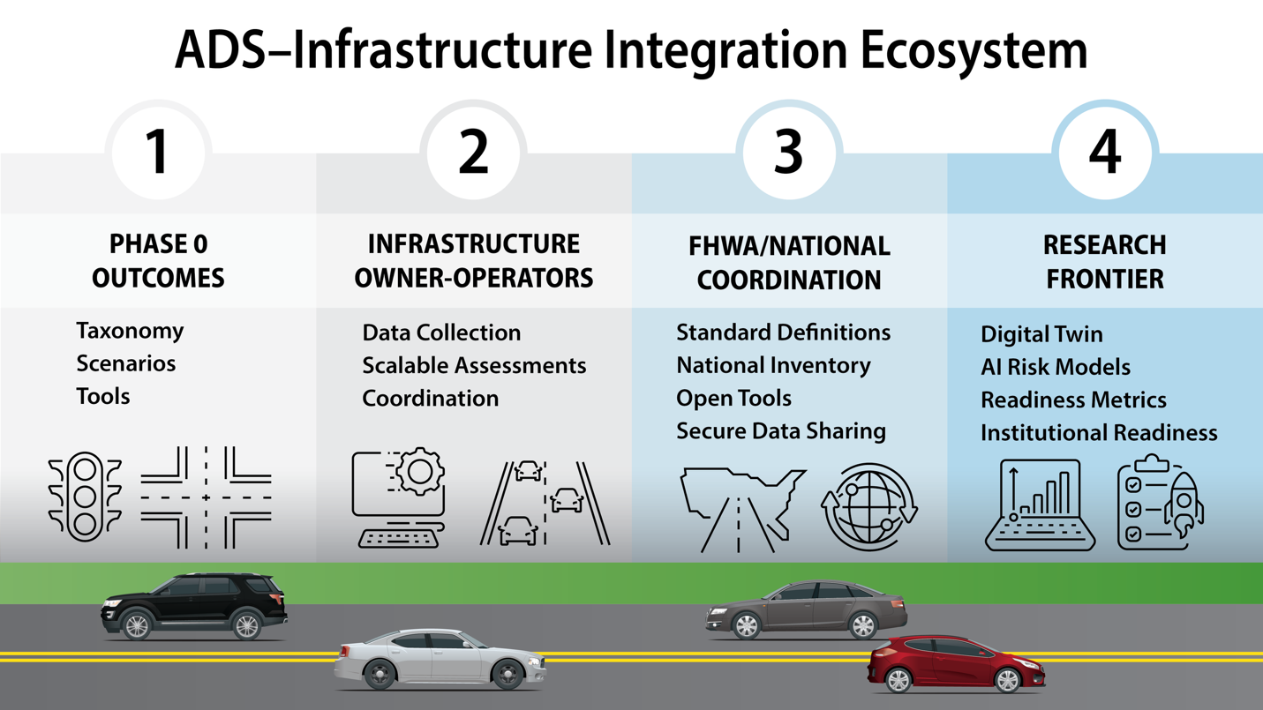
Source: FHWA.
AI = artificial intelligence.
Figure 1. Illustration. ADS-infrastructure integration ecosystem.

Roadway Elements Relevant to ADS Readiness
The previous phase organized roadway infrastructure into seven physical roadway elements that may influence ADS operation:
- Pavement surfaces.
- Pavement markings.
- Cross-section and geometry.
- Traffic signals.
- Traffic signs.
- Lighting systems.
- Roadway structures.
These elements represent physical infrastructure features that ADS-equipped vehicles may need to perceive, interpret, or account for when operating in the roadway environment.
Table 1 summarizes the seven roadway elements and their relevance to ADS readiness. The table is intended to provide a concise reference for the roadway element framework used throughout this report.
Table 1. Roadway elements relevant to ADS readiness.
Roadway Element | Definition or Scope | Relevance to Automated Driving Systems (ADS) Readiness
Pavement surfaces | Travel surfaces used by vehicles and other roadway users, including paved and unpaved surfaces. | Surface condition can affect vehicle control, ride quality, sensor noise, and the ability to detect surface features used for perception or localization.
Pavement markings | Surface-applied traffic control devices, including lane lines, edge lines, crosswalks, arrows, stop bars, and other markings. | Markings support lane-level perception, lane keeping, path interpretation, and identification of travel lanes, turning movements, and pedestrian crossings.
Cross-section and geometry | Physical roadway layout and geometric features, including lane width, shoulders, medians, curves, grades, ramps, and auxiliary lanes. | Geometry affects path planning, lane positioning, sight distance, merge behavior, and the complexity of roadway navigation.
Traffic signals | Power-operated traffic control devices used to assign right-of-way and direct traffic movements. | Signal visibility, placement, phasing, and operating condition affect ADS interpretation of right-of-way and movement permissions.
Traffic signs | Traffic control devices that communicate regulatory, warning, guide, construction, school zone, service, or incident-related information. | Sign visibility, placement, condition, and message clarity affect ADS understanding of speed limits, restrictions, warnings, routing, and roadway rules.
Lighting systems | Infrastructure intended to illuminate the roadway environment during nighttime or low-light conditions. | Lighting affects camera-based perception, visibility of roadway elements, object detection, and consistency of nighttime ADS performance.
Roadway structures | Bridges, tunnels, overpasses, gantries, culverts, retaining walls, and similar infrastructure. | Structures can affect localization, line of sight, clearance, lane availability, sensor performance, and operational constraints.

Although all seven roadway elements are relevant to ADS readiness, this report applies the framework to pavement markings. Pavement markings were selected for the pilot analysis because they are visible in roadway imagery and are relevant to lane-level perception, lane tracking, and path interpretation.

Infrastructure Attributes Used for Evaluation
The previous phase also identified four infrastructure attributes for evaluating roadway elements:
- Presence
- Location
- Design.
- Status.
These attributes provide a consistent way to describe the information that is available about a roadway element and how that information may be relevant to ADS operation.
Table 2 summarizes the four attributes and explains how they apply to pavement markings in this pilot analysis.
Table 2. Infrastructure attributes used to evaluate roadway elements.
Attribute | General Meaning | Application to Pavement Markings
Presence | Whether the roadway element exists and is available within the roadway environment. | Whether lane lines, edge lines, crosswalks, arrows, stop bars, or other pavement markings are visible in the imagery.
Location | Where the roadway element is positioned relative to the roadway, lanes, travel path, or surrounding infrastructure. | Whether markings can be associated with lane boundaries, travel lanes, intersections, merges, ramps, or other visible roadway contexts.
Design | The physical or operational characteristics of the element, such as type, configuration, pattern, dimensions, or placement. | Whether marking type, pattern, layout, continuity, and configuration can be interpreted from the image.
Status | The current condition or operational state of the element. | Whether markings appear faded, missing, obscured, temporary, inconsistent, or otherwise difficult to detect from the available imagery.

These attributes are useful for this report because they distinguish between different types of information that may or may not be available from public imagery. For example, an image may show that a lane line is present, but may not provide enough information to measure retroreflectivity or confirm whether the marking meets design standards. Similarly, an image may show faded or missing markings, but may not provide sufficient context to determine whether the condition is temporary, recurring, or representative of the broader roadway segment.

Operational Scenarios Relevant to ADS Performance
The previous phase also identified operational scenarios where roadway infrastructure may be especially important for ADS performance. These scenarios are important because ADS operation depends not only on individual roadway elements, but also on how those elements interact within specific roadway contexts. For example, pavement markings may be easier to interpret on a straight roadway segment than at an intersection, work zone, or complex merge area where markings, signs, geometry, and other road users interact.
Table 3 summarizes the operational scenarios carried forward from the previous phase and explains their relevance to the pavement marking pilot analysis.
Table 3. Operational scenarios relevant to ADS performance.
Operational Scenario | Why the Scenario Is Relevant to Automated Driving Systems | Relevance to Pavement Marking Analysis
Intersections | Intersections include multiple movements, changing right-of-way, vulnerable road users, traffic control devices, and complex lane configurations. | Markings such as stop bars, turn arrows, lane lines, crosswalks, and guide lines can support path interpretation and movement decisions.
Roundabouts | Roundabouts entail continuous navigation through curved geometry, yield-controlled entries, and circulating traffic. | Lane markings, yield lines, crosswalks, and splitter island markings can affect lane positioning and entry/exit interpretation.
Ramps and merges | Ramps and merge areas include speed differentials, lane transitions, acceleration and deceleration lanes, and changing geometry. | Lane lines, gore markings, edge lines, and merge-area markings can support lane tracking and path planning.
At-grade rail crossings | At-grade rail crossings combine roadway, rail, warning devices, and traffic control elements in a safety-critical setting. | Stop lines, crossing markings, lane lines, and related pavement markings can support recognition of the crossing area and stopping location.
Tolling stations | Tolling areas may include lane assignment, channelization, gantries, booths, and transitions between open-road and controlled-lane environments. | Lane-use markings, channelization markings, and lane boundary markings can affect navigation through tolling areas.
Work zones | Work zones often include temporary, changing, or nonstandard traffic control and roadway configurations. | Temporary markings, removed or covered markings, conflicting markings, and channelization can create challenges for lane detection and path interpretation.
Managed lanes | Managed lanes include special-use lanes, access restrictions, lane separation, and variable operational rules. | Lane markings, buffer markings, access markings, and pavement symbols can indicate lane use and access points.
Rural or isolated roadways | Rural roads may have limited markings, inconsistent shoulders, lower lighting, and fewer supporting traffic control devices. | Edge lines, centerlines, shoulder markings, and missing or faded markings can strongly affect lane-level interpretation in rural or isolated roadway contexts.

These scenarios provide a useful framework for reviewing public imagery datasets and interpreting pilot analysis results. The pilot analysis does not attempt to evaluate every scenario in equal detail. Instead, it uses the scenario framework to determine whether selected datasets include roadway contexts that are relevant to ADS operation and to identify where public imagery may be insufficient for infrastructure readiness assessment.
Together, the roadway elements, infrastructure attributes, and operational scenarios from the previous phase provide the foundation for this report. The pavement-marking pilot analysis applies this foundation to one roadway element in order to evaluate the usefulness and limitations of publicly available imagery (hereafter referred to as public imagery data) for infrastructure-focused ADS readiness assessment.

Objectives
The objective of this study is to evaluate whether publicly available roadway imagery, combined with reference image processing methods, can support infrastructure-focused analysis of pavement markings relevant to ADS and ADAS readiness. The study builds on the previous dataset review by examining selected image datasets in more detail and assessing what pavement marking information can reasonably be observed, extracted, and interpreted from these data.
This study focuses on pavement markings because they provide important information for lane-level perception, lane tracking, lateral positioning, and path interpretation in ADS and ADAS technologies (Mihalj et al., 2022). Pavement markings also provide a practical focus for a pilot analysis because they can be observed in roadway imagery across varied roadway and visual conditions.
This analysis is not intended to replicate proprietary ADS or ADAS perception functions or directly assess how a specific ADS-equipped vehicle would process roadway imagery. Rather, it uses reference image processing methods to evaluate what pavement marking information can be derived from publicly available imagery and how that information may support infrastructure-focused assessments by FHWA, IOOs, and other transportation stakeholders.
The specific objectives of this effort include the following:
- Identify and evaluate publicly available imagery datasets that contain roadway scenes with visible pavement markings.
- Select and apply a reference image processing approach capable of detecting or tracking lane markings within roadway imagery.
- Develop an evaluation approach for assessing pavement marking visibility, continuity, layout, and condition-related characteristics that can be observed from imagery.
- Assess pavement markings captured within the selected datasets across different marking types, roadway contexts, and visible conditions.
- Evaluate the strengths and limitations of publicly available imagery for analyzing pavement markings relevant to ADS and ADAS readiness.
- Conduct a pilot analysis to demonstrate how publicly available imagery and reference image processing methods can support pavement-marking assessments in real-world roadway environments.
The results of this study will inform further FHWA research on the feasibility and value of using public imagery data to analyze pavement markings and assess their implications for ADS readiness.

Approach Overview
This study uses selected public roadway imagery and reference image processing methods to examine how pavement markings can be observed, processed, and compared across different roadway and visual conditions. The approach is designed to assess the potential value and limitations of existing imagery datasets for infrastructure-focused pavement marking analysis.
The study begins by identifying candidate public and publicly accessible image sources and screening sampled images based on roadway scenario, roadway context, pavement marking type or configuration, observed marking visibility, and lighting or weather condition. The screening process supports assembly of a pilot image set that includes variation in roadway and image conditions while documenting gaps in available dataset coverage.
The selected pilot images are organized in a common image-level structure that retains source information, available reference annotations, metadata, and screening group tags. Selected reference image processors are then applied to the prepared images. Where feasible, processor outputs and available reference annotations are converted into compatible lane-level representations to support consistent comparison across datasets and processors.
The pilot analysis combines quantitative evaluation, where compatible reference annotations are available, with visual review and qualitative documentation of processor outputs. The analysis examines pavement marking visibility, continuity, detectability, and related image-based characteristics across the selected image sources and screening groups. The study uses the results to identify observed patterns, limitations, and areas where additional imagery, field measurements, or controlled testing may be needed.
…

Intended Audience
The intended audience for this document includes the following:
- FHWA program managers and researchers involved in ADS-related research and infrastructure-readiness efforts.
- IOOs responsible for the design, operation, maintenance, and data management of roadway infrastructure that may support ADS deployment.
- Researchers and analysts studying the relationship between roadway infrastructure characteristics and ADS perception, localization, and navigation.
- ADS and ADAS technology developers, including vehicle manufacturers and technology providers, interested in how roadway features such as pavement markings appear in real-world imagery datasets.
- Other transportation stakeholders involved in evaluating infrastructure readiness, identifying data needs, or supporting future research related to ADS.

Document Structure
The following provides an overview of the organization of this report:
- Chapter 1. Introduction—Presents the project background, previous-phase findings, study objectives, overall approach, intended audience, and report organization.
- Chapter 2. Pilot Image Sources and Pilot Dataset Preparation—Describes the public and publicly accessible image sources considered for the pilot analysis, the candidate image sources carried forward for review, the scenario- and condition-based screening approach, and the suitability and limitations of the available imagery.
- Chapter 3. Reference Image Processor Identification and Assessment—Summarizes relevant lane detection and segmentation approaches, describes the candidate image processing models, defines the model evaluation approach, and presents the preliminary comparison and reference processor selection.
- Chapter 4. Pavement Marking Evaluation Methodology—Describes the end-to-end pilot workflow, including pilot image set preparation, reference processor application, output standardization, evaluation and reporting, metrics for pavement-marking assessment, and the approach for grouping, comparing, and interpreting results.
- Chapter 5. Pilot Analysis Execution and Results—Describes implementation of the pilot analysis and presents the resulting processor outputs, quantitative and qualitative findings, observed patterns, and documented limitations.
- Chapter 6. Insights, Limitations, and Implications for Future Work—Summarizes the key findings, discusses limitations of the pilot analysis and available public imagery, and identifies implications for future data collection, analysis, and research.

Chapter 2. Pilot Image Sources and Pilot Dataset Preparation
This chapter describes the public and publicly accessible image sources considered for the pavement marking pilot analysis and documents the approach used to screen and organize imagery for review. The chapter builds on the earlier dataset inventory, which identified image-based and sensor-derived datasets that may support infrastructure-focused analysis of pavement markings (Novat et al., forthcoming).
While the earlier inventory considered a broad range of data sources, this chapter focuses on roadway-facing imagery that can be used to observe and evaluate visible pavement markings. The chapter summarizes the candidate image sources, describes the scenario- and condition-based screening approach, and identifies the suitability and limitations of these sources for the pilot analysis.

Overview of Public Data Sources and Candidate Image Sources
Building on the earlier dataset inventory, this section summarizes the data source groups most relevant to the pavement marking pilot analysis and identifies the subset of image-based sources carried forward for further review. Emphasis is placed on sources that provide roadway-facing imagery, annotations related to pavement marking, or supporting context useful for image-based analysis.
The intent of this section is to explain how the broader set of public data sources identified in the earlier inventory was narrowed to a practical set of candidate image sources for this study.

Role of Public Imagery in Pavement Marking Analysis
Publicly available and publicly accessible roadway imagery provides a practical starting point for examining pavement markings across real-world driving scenes. Image-based sources can show how markings appear from a roadway-facing camera perspective, including whether they are visible, distinguishable from the pavement surface, continuous, occluded, or affected by lighting, weather, roadway geometry, or surrounding traffic conditions. These characteristics are relevant to understanding the kinds of information that can be extracted from existing imagery to support infrastructure-focused pavement-marking assessments.
For this study, roadway imagery is used to develop and demonstrate an image-based analysis framework. This approach supports method development and pilot testing without the need for new field data collection, but it does not provide all information needed to evaluate pavement-marking condition from an engineering or maintenance perspective.
Therefore, the use of public imagery in this report focuses on indicators derived from visual inspection and image processing, such as marking presence, visibility, continuity, and lane-line detectability. Attributes such as retroreflectivity, material type, marking age, and verified maintenance condition generally call for separate field measurements, agency records, or additional ground truth data.

Relevant Public Data Source Groups from the Earlier Dataset Inventory
The earlier review of the dataset inventory focused on a broad set of public and publicly accessible sources, including national inventory systems, open-access lane-detection and driving-scene datasets, ADS grant and demonstration datasets, research program archives, and public automated vehicle (AV)-perception datasets (Novat et al., forthcoming). These sources differ in how they may support pavement-marking analysis. Some provide structured roadway attributes or spatial context, while others provide camera imagery, video, LiDAR, perception logs, or annotations that are more directly useful for image-based analysis.
For the pavement marking–pilot analysis in this report, the most directly relevant sources are those that provide roadway-facing imagery or sensor data in which pavement markings are visible, labeled, or annotated. Public inventory systems and geospatial reference sources remain useful for context, but they do not provide the imagery needed for the reference image-processing workflow. Table 4 summarizes the public and publicly accessible data-source groups from the earlier inventory and their relevance to this pavement marking analysis.

Table 4. Public and publicly accessible data-source groups from the earlier inventory and their relevance to pavement-marking analysis.
Public Source Group | Sources Included in Earlier Inventory | Key Finding Relevant to Pavement Markings | Role in This Report
Authoritative national inventory systems | HPMS, MIRE 2.1, ARNOLD, NBI/BIM | These sources provide structured roadway or asset records, but they do not include sensor data or roadway imagery. MIRE includes pavement markings as inventory elements, while the other sources are mainly relevant for roadway, network, pavement surface, or structure context. | Contextual only. These sources are not candidates for image-based pilot analysis, but they may support future spatial alignment or comparison with structured roadway records.
Public geospatial reference sources | OpenStreetMap | OSM provides tagged vector geometry and may include pavement marking-related tags, but completeness and consistency vary by location. It does not provide sensor imagery. | Supplemental context. OSM may support roadway or spatial context, but it is not an image-processing dataset.
Publicly accessible lane detection and driving scene datasets | TuSimple, CULane, CurveLane, BDD100K, Comma2k19, ROADWork | These datasets provide roadway-facing camera imagery that can support lane-marking detection, roadway scene interpretation, or visual review of work-zone conditions. Annotation coverage and suitability for pavement marking analysis vary by source. | Primary candidate pool for the pilot analysis. These sources are the most practical starting point because they provide accessible imagery relevant to pavement markings.
ADS grant and demonstration datasets | Iowa DOT ADS, Ohio Rural ADS, PennDOT Work Zone, Texas A&M AVA | These datasets are highly relevant to U.S. roadway contexts and may include camera imagery, LiDAR, HD maps, perception logs, and work zone or rural roadway data. However, access may entail coordination, data-sharing agreements, or future data availability. | Important future sources. These datasets may support later validation or expanded analysis but are less practical for the initial image-based pilot.
Research program archives and public AV perception datasets | SHRP 2 NDS + RID, Waymo™ Open Dataset, NCHRP datasets, UTC archives | SHRP 2 NDS provides forward-facing video and linked roadway inventory but needs post-processing and access approval. Waymo Open Dataset provides multiview camera imagery, LiDAR, and semantic labels, including lane markers. NCHRP and UTC datasets vary by project. | Supplemental or future sources. Waymo is retained as a supplemental candidate image source for further review, while SHRP 2, NCHRP, and UTC sources may need additional access or project-specific review.
ADS = automated driving systems; ARNOLD = All Road Network of Linear Referenced Data; AV = automated vehicle; AVA = Automated Vehicles for All; NBI/BIM = National Bridge Inventory/Bridge Information Modeling; DOT = department of transportation; HD = high definition; HPMS = Highway Performance Monitoring System; LiDAR = light detection and ranging; MIRE = Model Inventory of Roadway Elements; NCHRP = National Cooperative Highway Research Program; NDS = Naturalistic Driving Study; OSM = OpenStreetMap; RID = Roadway Information Database; SHRP 2 = Second Strategic Highway Research Program; UTC = University Transportation Center.
This summary shows that the publicly available and publicly accessible datasets from the earlier inventory serve different purposes for this report. The publicly accessible lane detection and driving scene datasets provide the clearest starting point for identifying candidate image sources because they include accessible camera imagery and annotations related to pavement marking or visible markings. Other sources remain relevant, but these are primarily contextual, supplemental, or future data sources rather than primary inputs to the pilot for the image-processing workflow.

Downselected Candidate Image Sources for Pavement-Marking Analysis
Based on the public and publicly accessible data source groups summarized in the prior section, Relevant Public Data Source Groups from the Earlier Dataset Inventory, a subset of image-based sources was carried forward for pavement marking analysis. The downselection focused on sources that provide roadway-facing imagery, annotations related to pavement marking, or labeled roadway infrastructure elements that can reasonably support the pilot analysis. Sources that provide only structured inventory records, spatial reference data, or datasets that are future, restricted, or both were not carried forward as primary candidate image sources for this phase of the analysis, although they may remain useful for context or future work.
Table 5 summarizes the downselected candidate image sources. The dataset descriptions are based on the earlier dataset inventory, while the final column provides pavement-marking-analysis considerations specific to this report. These candidate sources are not assumed to be equally suitable or final selections for the pilot analysis. Rather, they represent the practical set of image-based datasets for further review based on the roadway scenarios and conditions covered in the imagery.
The downselected sources provide a practical starting point for evaluating pavement markings using publicly available or publicly accessible imagery. Lane detection datasets such as TuSimple® (TuSimple Inc., n.d.), CULane (Pan et al., 2018), and CurveLanes (Liu et al., 2021) provide direct lane-marking annotations. Broader driving scene and AV perception datasets, such as BDD100K (Yu et al., 2020) and Waymo™ Open Dataset (Waymo, n.d.), provide additional roadway context and infrastructure labels. comma2k19 (comma.ai, 2019) and ROADWork (Ghosh et al., 2024) may support more specialized analyses, such as production-style camera perspectives or temporary work zone conditions. The next section describes how to review these candidate sources based on the roadway scenarios and image conditions most relevant to analyzing the pavement-marking pilot results.

Table 5. Downselected candidate image sources for pavement-marking analysis.
Candidate Image Source | Imagery / Annotation Content | Roadway or Scenario Context | Potential Use in Pilot Analysis | Primary Limitation or Consideration
TuSimple | Forward-facing camera imagery with 2D lane-line annotations. | U.S. highway driving scenes, primarily under good weather and daylight conditions. | Provides a structured lane detection benchmark for evaluating lane-line visibility and detectability in highway settings. | Useful as a baseline lane detection dataset, but provides limited roadway and condition diversity.
CULane | Forward-facing camera imagery with 2D lane annotations, including inferred occluded lane markings. | Urban roads, highways, nighttime scenes, poor lighting, crowded scenes, and occlusions. | Supports evaluation of pavement marking detection under more visually challenging conditions. | Useful for testing robustness under degraded visibility, but roadway context and marking conventions may differ from U.S. practice.
CurveLanes | Camera imagery with lane annotations focused on curved roadway geometry. | Urban and highway scenes, including curved and multilane configurations. | Useful for assessing how roadway curvature affects lane-line visibility and detectability. | Useful if the analysis includes curved roadway conditions, but more specialized than broader driving scene datasets.
BDD100K | Forward-facing roadway imagery/video with multitask annotations, including lane markings and lane type information. | Multicity roadway environments, including urban, residential, and highway settings with varied lighting and weather. | Provides broader roadway context and supports analysis of pavement markings alongside other roadway features. | Strong candidate because it combines lane marking annotations with varied roadway and environmental conditions.
Waymo Open Dataset | Multiview camera imagery, LiDAR, object annotations, semantic labels, and HD map-related data. | Urban and suburban roadway environments. | Provides labeled roadway infrastructure elements, including lane markers, within richly annotated ADS perception scenes. | May support supplemental or expanded analysis, but processing complexity may be higher than lane detection benchmark datasets.
2D = two dimensional; ADAS = advanced driver assistance systems; ADS = automated driving systems; AV = automated vehicle; CAN = controller area network; GPS = global positioning system; HD = high-definition; IMU = inertial measurement unit; LiDAR = light detection and ranging.

Scenario- and Condition-Based Image Screening
After the candidate image sources were identified, the research team reviewed sampled imagery to determine how well the sources represented roadway scenarios, roadway context and surface type, pavement marking characteristics, and visual conditions relevant to the pilot analysis. This screening step was intended to support selection of a pilot image set with meaningful variation, rather than relying only on images from ideal or uniform conditions.
The screening approach was grounded in the operational scenario framework carried forward from the previous phase of the research and supplemented with image-level conditions that may affect pavement marking visibility and detectability (Soleimaniamiri et al., forthcoming). This section defines the screening groups, summarizes how candidate datasets were reviewed against those groups, and describes the image-level tracking approach used to support pilot image selection.

Screening Categories for Pavement Marking Analysis
To investigate how roadway scenarios and visual conditions may affect pavement marking detection and roadway lane interpretation, the research team reviewed the downselected datasets using a scenario- and condition-based screening approach. Rather than reviewing all images from each dataset, the team selected an initial sample of images from each candidate dataset for review. The sampled images were then organized using six screening groups:
- operational scenario.
- roadway context and facility type.
- roadway surface type.
- pavement marking type and configuration.
- observed marking visibility.
- lighting and weather condition.
Figure 2 provides a visual summary of the six screening groups and the conditions considered within each group. Together, these groups were used to identify whether the sampled imagery represented a meaningful range of roadway settings, pavement marking characteristics, roadway surface types, and visual conditions relevant to the pilot analysis.

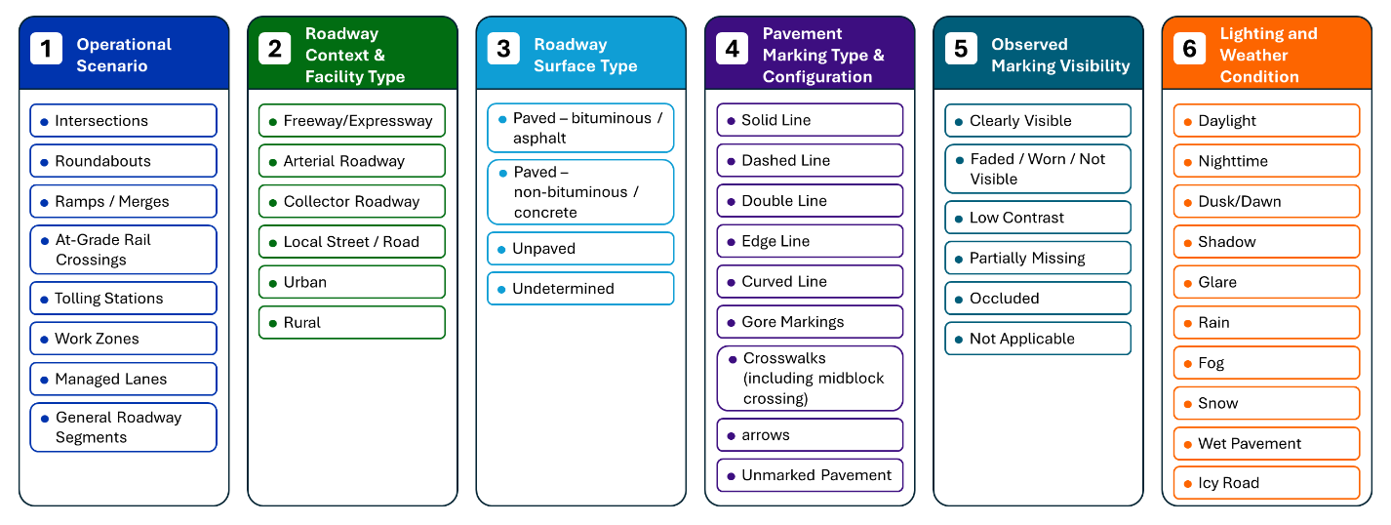
Source: FHWA.
Figure 2. Illustration. Scenario- and condition-based image screening groups for pavement marking analysis.

The five screening groups used in the image review are described as follows:
- Operational scenario includes roadway situations in which infrastructure conditions may be especially relevant to ADS operation. For this study, the operational scenarios considered were intersections, roundabouts, ramps and merges, at-grade rail crossings, tolling stations, work zones, managed lanes, and general roadway segments. General roadway segments capture conditions between intersections or outside the other identified operational scenarios.
- Roadway context and facility type describe the general roadway setting and facility type represented in an image. The categories used in the screening were freeway or expressway, arterial roadway, collector roadway, local street or road, urban, and rural. More than one tag may be assigned to an image; for example, an image may be tagged as both freeway or expressway and urban.
- Roadway surface type identifies the apparent surface type visible in the image or documented in available metadata. The categories used in this group were paved–bituminous or asphalt, paved–nonbituminous or concrete, unpaved, and undetermined.
- Pavement marking type and configuration identifies the types of markings visible in the image and whether they are relevant to lane guidance or path definition. The screening categories used in this group were solid line, dashed line, double line, edge line, curved line, gore markings, crosswalks (including midblock crossings), arrows, and unmarked pavement.
- Observed marking visibility describes how pavement markings appear in the image based on visual review. The categories used in this group were clearly visible, faded/worn/not visible, low contrast, partially missing, occluded, and not applicable. The combined faded/worn/not visible category was used when the available image did not support a reliable distinction among those conditions. Not applicable was used when the image was tagged as unmarked pavement. These categories were intended to capture visible image-based conditions only and were not intended to represent measured engineering condition.
- Lighting and weather condition identifies image-level factors that may affect how pavement markings appear in roadway-facing imagery. The categories used in this group were daylight, nighttime, dusk or dawn, shadow, glare, rain, fog, snow, wet pavement, and icy road.
Table 6 summarizes the six screening groups, the conditions reviewed within each group, and the purpose of each group in the pilot image screening process. These categories were not intended to create a complete roadway inventory or confirm engineering condition measures such as retroreflectivity. Instead, they provided a practical structure for documenting the types of scenarios and conditions represented in the imagery and for identifying where additional image sampling might be needed to support the pilot analysis.
Table 6. Scenario- and condition-based image screening categories for pavement marking analysis.
Screening Group | Categories and Conditions Reviewed | Use in Pilot Image Screening
Operational scenario | Intersections, roundabouts, ramps/merges, at-grade rail crossings, tolling stations, work zones, managed lanes, general roadway segments | Used to align the pilot image set with the operational scenario framework carried forward from the previous phase of the research and to identify general roadway segments outside the identified specialized scenarios.
Roadway context and facility type | Freeway or expressway, arterial roadway, collector roadway, local street/road, urban, rural | Used to document the roadway setting and facility type represented in each image. More than one tag may apply.
Roadway surface type | Paved–bituminous or asphalt, paved–nonbituminous or concrete, unpaved, undetermined | Used to document apparent roadway surface type where it can be identified from imagery or available metadata.
Pavement marking type and configuration | Solid line, dashed line, double line, edge line, curved line, gore markings, crosswalks (including midblock crossings), arrows, unmarked pavement | Used to identify the types of pavement markings visible in the image, their configurations, and images in which pavement markings are absent.
Observed marking visibility | Clearly visible; faded, worn, or not visible; low contrast; partially missing; occluded; not applicable | Used to group images by the visible appearance of pavement markings. Not applicable is used when unmarked pavement is identified.
Lighting and weather condition | Daylight, nighttime, dusk or dawn, shadow, glare, rain, fog, snow, wet pavement, icy road | Used to identify conditions that may affect image quality and pavement marking visibility.
With these screening groups defined, the next subsection summarizes the results of the image review and describes how the downselected datasets support coverage across the relevant roadway, pavement marking, and visual conditions.

Candidate Dataset Coverage by Screening Group
Sampled images from each candidate image source were reviewed using the six screening groups defined in the previous section. The purpose of this review was to document which datasets provide useful coverage of roadway scenarios and conditions. The review was based on available dataset documentation, dataset descriptions, and manual screening of sampled images by the research team.
Table 7 summarizes the observed or expected coverage of each candidate dataset across the screening groups. The table is intended to support pilot image selection and identify where certain scenarios or conditions may be underrepresented in the available public imagery.
[Placeholder: Summarize the screening results after Table 4 is completed, including which datasets provide the strongest coverage for specific scenarios, roadway contexts, pavement marking configurations, visibility conditions, and lighting/weather conditions.]

Table 7. Candidate dataset coverage by screening group.
Candidate Image Source | Reviewed Sample Size | Operational Scenario | Roadway Context & Facility Type | Roadway Surface Type | Pavement Marking Type & Configuration | Observed Marking Visibility | Lighting & Weather Condition
TuSimple
CULane
CurveLane
BDD100K
Waymo Open Dataset
XXXX.

Pilot Image Set Assembly and Image-Level Tracking
Following the scenario- and condition-based screening, the research team created an image-level screening spreadsheet to support pilot image selection and documentation. The spreadsheet was used to track sampled images from each candidate dataset and document the roadway settings, pavement marking characteristics, roadway surface types, and visual conditions represented in each image.
For each sampled image, the spreadsheet included the following identification and tracking fields:
- Source dataset: the dataset from which the image was obtained.
- Original image or frame ID: the identifier, filename, frame number, or path assigned by the original dataset, if available.
- Pilot image ID: a unique identifier assigned by the research team to images selected for the pilot analysis.
- Retained or not retained flag: an indicator of whether the image was selected for inclusion in the pilot analysis.
- Notes or uncertainty comments: reviewer notes documenting unclear conditions, image quality issues, missing metadata, or reasons for excluding an image.
Each screening group listed in table 6 was represented in the spreadsheet using separate columns for the corresponding categories or conditions. An “X” was added when a sampled image included a specific category or condition. This format allowed one image to be associated with multiple conditions. For example, one image could be marked as an urban freeway/expressway with a paved bituminous/asphalt surface, dashed lane lines, low-contrast markings, shadows, and wet pavement. When an image was tagged as unmarked pavement, observed marking visibility was recorded as not applicable.
This image-level tracking approach provides a transparent basis for assembling the pilot image set and summarizing dataset coverage. It also helps identify gaps where the candidate datasets may not provide sufficient coverage for certain scenarios or conditions, such as tolling stations, at-grade rail crossings, or adverse weather. Roadway surface type was recorded as undetermined when it could not be identified from the image, metadata, or dataset documentation. Other conditions that could not be confirmed were left unmarked and documented in the notes field as needed.
[Placeholder: Add final summary of the image-level screening results, including the number and percentage of retained images by source dataset and major coverage gaps identified during screening.]

Summary of Dataset Suitability and Limitations
The public and publicly accessible image sources reviewed in this chapter provide a practical basis for developing and demonstrating a pavement marking analysis framework. The downselected candidate sources include roadway-facing imagery, annotations related to pavement marking, or labeled roadway infrastructure elements that can support assessment of marking presence, visibility, continuity, and lane-line detectability across different roadway, surface, and visual conditions.
The scenario- and condition-based image screening described in the prior section provides a structured basis for determining which datasets may support the pilot analysis and where coverage gaps remain. Some datasets are better suited for baseline highway lane detection, while others provide broader roadway context, challenging lighting or visibility conditions, curved roadway geometry, work zone conditions, or richly labeled AV perception scenes. These differences should be considered when assembling the pilot image set and interpreting the results.
Table 8 summarizes the types of pavement marking information that public imagery can reasonably support and the limitations that should be considered when interpreting the pilot analysis results.
Table 8. Suitability and limitations of public imagery for pavement marking analysis.
Public Imagery Can Directly Support | Public Imagery Cannot Directly Support | Implication for the Pilot Analysis
Visual review of pavement marking presence, visibility, continuity, and lane-line detectability. | Direct measurement of retroreflectivity, marking material, marking age, or verified maintenance condition. | The analysis should focus on indicators based on visibility and image processing, not engineering-condition measurements.
Comparison of pavement markings across selected roadway contexts, apparent roadway surface types, lighting and weather conditions, and visibility conditions. | Complete representation of all roadway scenarios, surface types, or national roadway conditions. | Coverage across the screening groups should be documented, and gaps should be clearly identified.
Assessment of how available imagery and annotations can support image-based pavement marking analysis. | Replication of proprietary ADS or ADAS perception, classification, or decision-making processes. | Results should be framed as infrastructure-focused image analysis, not direct ADS or ADAS performance evaluation.
Identification of images or conditions where pavement markings appear difficult to distinguish or interpret. | Confirmation of causal impacts on ADS or ADAS performance without vehicle or system data. | Findings can help identify areas where additional field data, sensor data, or controlled testing may be needed.
ADAS = advanced driver assistance systems; ADS = automated driving systems;
Overall, the downselected public image sources are suitable for developing and testing a practical pilot workflow for pavement marking analysis. However, the results should be interpreted within the limits of the available imagery, annotations, and coverage across the screening groups.
[Placeholder: Once the image-level tracking spreadsheet is completed, update this section to summarize final coverage across the screening groups and any major gaps identified during screening.]

Chapter 3. Reference Image Processor Identification and Assessment
This chapter describes the approach used to identify and assess candidate image processing models for analyzing the results of the pavement-marking pilot. The goal is to select one or more practical reference-image processors that can generate consistent and interpretable lane-line or pavement marking–related outputs from public roadway imagery.
The chapter first summarizes the image processing approaches relevant to pavement marking analysis, including lane detection and segmentation-based methods. It then describes the candidate models carried forward for initial comparison, defines the core evaluation metrics used for model assessment, and presents the comparison approach using a common subset of images from the selected datasets. The assessment informs selection of the reference processor or processors used in the pilot analysis.

Overview of Lane Detection and Segmentation Approaches
The reference image processor used in this study is intended to support an infrastructure-focused assessment of pavement markings in roadway-facing imagery. Lane detection approaches can help identify whether lane markings are visible, continuous, geometrically coherent, and detectable under different roadway and visual conditions. The processor is used as an analytical tool for evaluating what pavement marking information can be extracted from public imagery, not as a representation of a specific ADS or ADAS perception stack.
Lane detection and pavement marking analysis methods can generally be grouped into two categories: classical computer vision methods and deep learning–based methods.
Classical computer vision–based lane-detection methods typically rely on hand-crafted pipelines that combine region-of-interest selection, image preprocessing, edge extraction such as Canny edge detection, and subsequent line or curve fitting using methods such as the Hough transform (Wei et al., 2021; Qin et al. 2024) . Although these approaches are transparent and computationally efficient, their performance can degrade under shadows, glare, faded lane markings, occlusions, roadway clutter, and complex roadway geometry (Canny, 1986; Duda & Hart, 1972).
On the other hand, deep learning–based lane-detection methods typically learn road-scene and lane-marking cues from annotated images. Within this broad category, models differ in how they represent and output lanes. Segmentation based approaches predict lanes marking pixels as a semantic class (Neven et al., 2018; Wu et al., 2022). In contrast, structed output approaches avoid pixel masks and predict compact lane representations, such as lane points, anchors, curves or polylines (Qin et al., 2020; Tabelini et al., 2021; Zheng et al., 2022). These structured predictions are often refined using learned image features (Zheng et al., 2022). Some driving-perception systems embed these lane predictors in a broader multi-task model that also estimates drivable areas and traffic objects (Wu et al., 2022).
For example, instance-segmentation-based methods identify lane pixels and lane instances (Neven et al., 2018), while the Spatial Convolutional Neural Network (SCNN) uses spatial message passing across feature maps to capture long, thin lane structures (Pan et al., 2018).. CLRNet and CLRerNet use lane-specific detection and refinement approaches to improve lane localization and, in the case of CLRerNet, the quality of confidence estimates associated with lane outputs (Zheng et al., 2022; Honda & Uchida, 2024). Multitask models such as YOLOP, HybridNets, and YOLOPX jointly support lane detection with related tasks such as drivable-area segmentation and traffic object detection (Wu et al., 2022; Vu et al., 2022; Zhan et al., 2024).
For this study, the distinction between deep learning-based lane representations is addressed through the processor outputs and output-standardization process rather than by treating segmentation, lane-line detection, and multitask perception as separate top-level approach categories. This is important because the candidate models may produce lane masks, lane boundaries, polylines, or other lane-level outputs that must be converted, where feasible, into a common evaluation representation.
Table 9 summarizes the two approach categories and their relevance to the pavement marking analysis.
Table 9. Overview of classical and deep learning-based approaches relevant to pavement marking analysis.
Approach Type | Typical Output | Potential Value for This Study | Key Limitation
Classical computer vision methods | Edges, line segments, fitted curves, or lane boundaries | Provides transparent baseline methods for identifying visible lane markings under relatively simple conditions | Sensitive to lighting, shadows, glare, worn markings, occlusions, and complex roadway geometry
Deep learning-based methods | Lane masks, lane instances, lane points, polylines, lane boundaries, and, for multitask models, related drivable area or traffic-object outputs | Supports evaluation of lane-line detectability, continuity, spatial agreement, and geometric consistency across varied roadway and visual conditions | Output formats and model specifications vary; results may be affected by domain mismatch, annotation differences, and the need for output standardization

For this study, the approaches summarized in table 9 are considered based on their practical usefulness for the pilot pavement marking analysis workflow. The model assessment emphasizes whether candidate processors can produce interpretable outputs from the selected public image datasets, whether those outputs can be standardized for evaluation, and whether the resulting outputs can support the later pilot analysis across the defined screening groups.

Candidate Image Processing Models
Building on the classical and deep learning–based approaches summarized in the previous section, four deep learning–based image processing models were carried forward for initial comparison in this study: SCNN, CLRerNet, YOLOPX, and HybridNets. These models were selected from a broader set of candidate processors because they provide a practical comparison between lane-focused detection models and multitask driving-perception models.
SCNN and CLRerNet were included because they are lane-focused deep-learning models. SCNN provides an established lane detection baseline that uses spatial message passing across feature maps to capture long, continuous lane structures in roadway images (Pan et al., 2018). This capability makes SCNN relevant for evaluating whether visible lane markings can be detected and represented as continuous lane-line outputs. CLRerNet is an anchor-based lane-detection approach. It scores how closely a predicted lane line overlaps with the true lane line. This overlap score is used to assign training targets and calculate loss, which improves the confidence scores attached to each detected lane (Honda & Uchida, 2024). This makes CLRerNet relevant for assessing whether a more recent lane-focused model can provide useful lane-line outputs for the selected public imagery.
YOLOPX and HybridNets were included because they are deep learning–based, multitasking, driving-perception models. YOLOPX jointly supports traffic-object detection, driven area segmentation, and lane detection through an anchor-free architecture (Zhan et al., 2024). HybridNets similarly supports traffic-object detection, drivable-area segmentation, and lane detection within a single framework (Vu et al., 2022). These models are relevant to this study because they provide lane-related outputs alongside other roadway-scene outputs. The primary comparison, however, focuses on the lane-related outputs that can be standardized for evaluation.
Table 10 summarizes the candidate image processing models considered for the initial comparison.
Table 10. Candidate image processing models considered for initial comparison.
Candidate Model | Approach Type | Reported Training Dataset(s) | Primary Output Relevant to This Study | Pilot Analysis Consideration
SCNN | Deep learning-based lane detection model | CULane / TuSimple | Lane-line or lane-boundary outputs that can be converted to a common evaluation format | Useful for evaluating lane-line detectability and continuity but may be less suitable for nonlane pavement marking types such as arrows, crosswalks, or gore markings.
CLRerNet | Deep learning-based anchor-based lane detection model | CULane / CurveLanes | Lane-line outputs with associated confidence information | Useful for comparing lane detection quality across selected datasets, but needs consistent handling of confidence thresholds and output conversion.
YOLOPX | Deep learning-based multitask driving-perception model | BDD100K | Lane detection outputs, with supporting drivable area and object-detection outputs | Useful for assessing lane-related outputs generated within a multitask perception framework, but the lane output must be isolated and standardized for fair comparison.
HybridNets | Deep learning-based multitask driving-perception model | BDD100K | Lane detection outputs, with supporting drivable-area and object-detection outputs | Useful for comparing lane-related outputs generated within a multitask perception framework, but results may be influenced by model training domain and need output standardization.
SCNN = Spatial Convolutional Neural Network.
For this study, candidate model outputs are standardized, where feasible, to support consistent comparison across datasets. The evaluation criteria used to compare these models are described in the following section.

Model Evaluation Approach
The candidate image processing models described previously are evaluated using a common evaluation subset and a consistent set of image-processing metrics. The purpose of this initial comparison is to select a practical reference image processor for the pilot analysis, not to conduct the full scenario- and condition-level pavement-marking assessment. The scenario- and condition-based pavement marking analysis is conducted later, after the reference processor is selected.

Evaluation Subset and Output Standardization
For the initial model comparison, each candidate model is applied to the same evaluation subset drawn from the four candidate datasets selected for model testing: TuSimple, CULane, BDD100K, and CurveLanes. These datasets were selected for model comparison because they provide roadway-facing imagery and reference information for lane markings or lane lines that can support quantitative evaluation.
For purposes of this model comparison, lane markings refer to pavement markings used to delineate or guide vehicles within travel lanes. Lane lines refer to the visible line features that form lane boundaries. The candidate models and reference annotations used in this comparison focus primarily on lane lines.
Because the datasets differ in image format, annotation structure, roadway context, and native benchmark definitions, model outputs are converted, where feasible, into a common evaluation format before metrics are calculated. This may include converting lane polylines, lane points, or lane segmentation outputs into standardized binary masks or another consistent lane-level representation. This standardization is needed to support a consistent comparison across models that produce different output types.

Core Evaluation Metrics
The comparison uses four core metrics: Intersection over Union (IoU), F1 Score, Precision, and Recall. These metrics are commonly used in evaluating image segmentation, object detection, and lane detection because they describe both spatial overlap and detection quality (Jaccard, 1912; Powers, 2011). For this study, the metrics are calculated by comparing each predicted lane-related output with its corresponding compatible reference annotation. When binary masks are used, true positives, false positives, and false negatives are defined at the pixel level. When polyline-based outputs are used, the outputs are first converted to a consistent evaluation representation before metric calculation.
Table 11 summarizes the four core metrics and their role in the model assessment process.
Table 11. Core metrics for initial model comparison.
Metric | Formula | Definition | Use in This Study
Intersection over Union | TP / (TP + FP + FN) | Ratio of overlap between the predicted marking output and the reference marking output to their combined area. | Primary metric for assessing spatial agreement between predicted and reference lane-related outputs.
F1 Score | 2TP / (2TP + FP + FN) | Harmonic mean of precision and recall. | Primary metric for assessing overall detection quality by balancing missed detections and false detections.
Precision | TP / (TP + FP) | Ratio of correctly detected marking pixels or lane outputs to all predicted marking pixels or lane outputs. | Diagnostic metric for identifying over-detection or false-positive behavior.
Recall | TP / (TP + FN) | Ratio of correctly detected marking pixels or lane outputs to all reference marking pixels or lane outputs. | Diagnostic metric for identifying missed-detection behavior
TP = true positives, FP = false positives, and FN = false negatives.
The initial model assessment is based primarily on the F1 Score and IoU. The F1 Score captures the balance between false detections and missed detections, while IoU measures spatial agreement between the predicted and reference outputs. When both metrics are calculated from the same binary masks, they are monotonically related (F1 = 2× IoU / (1 + IoU)) and therefore carry the same ranking information; they are reported together for comparability with prior work but are not independent confirmations of one another. Precision and recall provide the independent diagnostic axis used to interpret each model's error pattern. A model with strong F1 Score and IoU is expected to provide both reliable detection and good spatial alignment with reference markings.
Precision and recall are used to interpret the error pattern behind the F1 Score. A model with high precision and low recall may be too conservative, detecting only the clearest markings and missing, faded, partially visible, or complex lane markings. A model with high recall and low precision may detect many markings but may also over-detect shadows, pavement joints, curbs, or other non-marking features. For this study, the preferred reference processor should avoid both extremes and provide balanced precision and recall.

Aggregation and Selection Considerations
To avoid selecting a model that performs well only on one dataset, results are summarized at both the dataset level and overall level. First, image-level metrics are calculated for each model. Next, the metrics are summarized separately for each dataset. The overall comparison uses dataset-normalized results, so that one dataset does not dominate the assessment simply because it includes more images in the evaluation subset. This approach is important because the selected reference processor should be usable across different public imagery sources, not only on the dataset most similar to its original training or benchmark domain.
The model assessment process follows these steps:
- Apply each candidate model to the same evaluation subset from the four candidate datasets.
- Convert model outputs into a common evaluation format where feasible.
- Calculate IoU, F1 Score, precision, and recall for each image.
- Summarize the metrics by dataset and overall.
- Use F1 Score and IoU as the primary assessment metrics.
- Use precision and recall to identify over-detection or missed-detection tendencies.
- Review cross-dataset consistency to avoid selecting a model that performs well only on one dataset.
The preferred reference image processor should provide the strongest combination of spatial agreement, overall detection quality, balanced precision and recall, and consistent performance across the four candidate datasets. If two models produce similar quantitative results, the final selection may also consider practical factors such as output interpretability, ease of output standardization, implementation effort, and compatibility with the pilot analysis workflow. The preliminary comparison results and reference processor selection are presented in the following section.

Preliminary Model Comparison and Reference Processor Selection
The preliminary model comparison applies the four candidate image processing models, SCNN, CLRerNet, YOLOPX, and HybridNets, to the common evaluation subset described in the previous section. The purpose of this comparison is to support selection of the reference image processor, or processors, used in the pilot analysis. The comparison is not intended to evaluate pavement marking performance by scenario or condition; that analysis is conducted later using the pilot image set and the selected processor.
The preliminary comparison focuses on three questions:
- Which model provides the strongest overall agreement with available reference lane or marking annotations?
- Which model provides the best balance between missed detections and false detections?
- Which model performs consistently across the four candidate datasets, rather than only on one dataset or benchmark domain?
The four core metrics defined in the previous section, IoU, F1 Score, Precision, and Recall, were calculated for each candidate model. Image-level metrics were first calculated for each model and then summarized at the dataset level. The overall comparison used dataset-normalized results so that one dataset did not dominate the assessment because of a larger evaluation sample.
The completed evaluation subset included four public lane-line or lane-marking datasets: TuSimple, CULane, CurveLanes, and BDD100K-Lane. The evaluated splits included 2,782 TuSimple test images, 34,680 CULane test images, 20,000 CurveLanes validation images, and 10,000 BDD100K-Lane validation images, for a total of 67,462 images. Dataset-level results were calculated separately and then summarized using dataset-normalized averages so that the larger CULane subset did not dominate the overall comparison. Complete quantitative results for YOLOPX, HybridNets, CLRerNet and SCNN are shown in table 12.
Table 12. Segmentation core metrics (mask IoU / F1 / Precision / Recall) for YOLOPX, HybridNets, SCNN and CLRerNet across four benchmark datasets.
Model | Dataset | Split | Images | IoU | F1 | Precision | Recall
YOLOPX | TuSimple | test | 2,782 | 0.5042 | 0.6657 | 0.6464 | 0.7005
 | CULane | test | 34,680 | 0.2372 | 0.3553 | 0.4717 | 0.3293
 | CurveLanes | valid | 20,000 | 0.3748 | 0.5321 | 0.5457 | 0.5757
 | BDD100K-Lane | valid | 10,000 | 0.1887 | 0.3119 | 0.1941 | 0.8348
HybridNets | TuSimple | test | 2,782 | 0.4825 | 0.6453 | 0.7911 | 0.5524
 | CULane | test | 34,680 | 0.1718 | 0.2671 | 0.5428 | 0.1986
 | CurveLanes | valid | 20,000 | 0.3126 | 0.4595 | 0.6128 | 0.4159
 | BDD100K-Lane | valid | 10,000 | 0.2091 | 0.3380 | 0.2333 | 0.6747
CLRerNet | TuSimple | test | 2,782 | 0.4901* | 0.6457 | 0.8038 | 0.5520
 | CULane | test | 34,680 | 0.5778* | 0.6675 | 0.7149 | 0.6473
 | CurveLanes | valid | 20,000 | 0.4892* | 0.6321 | 0.7932 | 0.5459
 | BDD100K-Lane | valid | 10,000 | 0.1856* | 0.2803 | 0.2452 | 0.3919
SCNN | TuSimple | test | 2,782 | 0.5464 | 0.7019 | 0.6536 | 0.7649
 | CULane | test | 34,680 | 0.4223 | 0.5457 | 0.5179 | 0.5955
 | CurveLanes | valid | 20,000 | 0.1900 | 0.3011 | 0.3600 | 0.3266
 | BDD100K-Lane | valid | 10,000 | 0.0357 | 0.0652 | 0.0566 | 0.1581
* indicates IOU is generated from a rasterized mask from the polylines, since CLRerNet does not produce lane mask as other three models.
In addition to the four core metrics, the comparison includes cross-dataset consistency, output usability, and preliminary assessment fields to support interpretation of each model’s suitability for the pilot workflow.
Cross-dataset consistency is rated based on how stable the model’s primary metric results are across TuSimple, CULane, BDD100K, and CurveLanes. For this purpose, a dataset-level primary score may be calculated as the average of the dataset-level F1 Score and IoU. Cross-dataset consistency is reported as a numerical summary computed as one minus the coefficient of variation (standard deviation divided by mean) of the per-dataset primary score across TuSimple, CULane, CurveLanes, and BDD100K-Lane, where the per-dataset primary score is the average of that dataset's F1 Score and IoU. Higher values indicate more stable performance across datasets; lower values indicate greater variation. This avoids arbitrary categorical thresholds and supports direct comparison among candidate processors.
Output usability is rated based on whether the model outputs can be used reliably in the pilot workflow. A High rating indicates that the outputs are interpretable, stable, and can be converted to the common evaluation format with limited post-processing. A Moderate rating indicates that the outputs are usable but need additional conversion, threshold adjustment, or quality checks. A Low rating indicates that the outputs are difficult to interpret, inconsistent across datasets, or need substantial manual processing before they can be evaluated.
Preliminary assessment summarizes the overall suitability of each model based on the combined quantitative results and practical usability. A model may be identified as a strong candidate if it provides competitive F1 Score and IoU, balanced precision and recall, acceptable cross-dataset consistency, and usable outputs. A model may be identified as a supplemental candidate if it provides useful outputs for certain datasets or output types but is less consistent overall. A model may be identified as having limited suitability if it has lower quantitative performance, poor consistency, or outputs that are difficult to standardize.
Table 13 presents the summary of the preliminary quantitative comparison of the four candidate models with the average values across the four datasets.
Table 13. Cross-dataset summary statistics (mean IoU / F1 / Precision / Recall and cross-dataset consistency) for four models (YOLOPX, HybridNets, CLRerNet, SCNN).

Model | Mean IoU | Mean F1 | Mean Precision | Mean Recall | Cross-Dataset Consistency
YOLOPX | 0.3262 | 0.4663 | 0.4645 | 0.6101 | 0.6657
HybridNets | 0.2940 | 0.4275 | 0.5450 | 0.4604 | 0.6347
CLRerNet | 0.4357 | 0.5564 | 0.6393 | 0.5343 | 0.6900
SCNN | 0.2986 | 0.4035 | 0.3970 | 0.4613 | 0.3730

As shown in table 13, under the standardized stroke-width evaluation, CLRerNet achieved the highest dataset-normalized mean IoU (0.4357) and mean F1 Score (0.5564), followed by YOLOPX (IoU 0.3262, F1 0.4663), SCNN (IoU 0.2986, F1 0.4035), and HybridNets (IoU 0.2940, F1 0.4275). CLRerNet also achieved the highest mean precision (0.6393), while YOLOPX achieved the highest mean recall (0.6101). These results indicate two distinct error profiles among the strongest models: CLRerNet provides the most spatially precise lane-line agreement, whereas YOLOPX provides the broadest coverage. The CLRerNet results should be read alongside two caveats discussed below: CLRerNet is evaluated in-domain on CULane (its training dataset) and zero-shot elsewhere, and its mask-based scores depend on the rasterization width and tolerance defined in the evaluation methodology. Figure 3 summarizes these dataset-normalized metric profiles; CLRerNet encloses the largest area on the IoU, F1, and precision axes, while YOLOPX extends furthest on the recall axis.

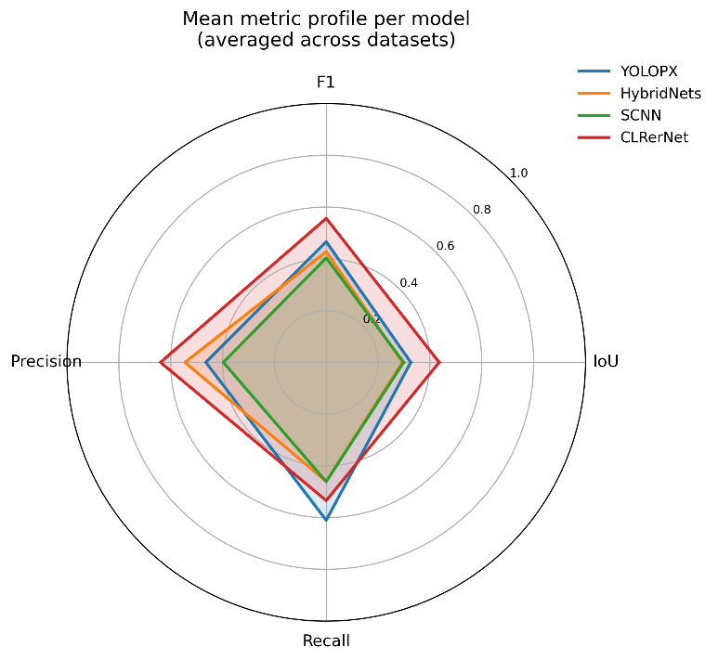
Source: FHWA.
Figure 3. Diagram. Mean metric profile (IoU, F1 Score, Precision, and Recall) for each candidate model, averaged across the four datasets (dataset-normalized). A larger enclosed area indicates stronger overall performance.
The model results should be interpreted together with the intended role of each processor in the pilot workflow. YOLOPX provides the strongest coverage- oriented reference processor because it has the highest mean recall among the evaluated models; CLRerNet, by contrast, achieves the highest mean IoU, F1 Score, and precision. CLRerNet shows a precision-oriented profile: it produced the highest precision on TuSimple (0.8038), CULane (0.7149), and CurveLanes (0.7932), with strong recall on the in-domain CULane split (0.6473) and moderate recall on TuSimple (0.5520) and CurveLanes (0.5459). Its recall drops only on BDD100K (0.3919), which is the furthest dataset from its CULane training domain. Earlier raw-mask scoring substantially understated CLRerNet because a thin predicted lane line compared to a thicker reference label produces low pixel overlap regardless of placement; once the rasterization width and tolerance are applied consistently (see methodology), CLRerNet's lane-level agreement is the strongest among the evaluated models. To confirm the detector itself is sound and not limited by the conversion, CLRerNet was also scored with its native lane-level F1 protocol on CULane, yielding results consistent with the published model. CLRerNet is therefore characterized as a high-precision lane-focused processor whose main limitation is reduced recall on out-of-domain imagery (BDD100K).
Figure 4 breaks these results down by dataset and metric. It shows that each model performs best on its training domain – SCNN and CLRerNet on CULane, CLRerNet on its in-domain split, and YOLOPX and HybridNets achieving their highest recall on BDD100K; and that CLRerNet's precision advantage is consistent across TuSimple, CULane, and CurveLanes.

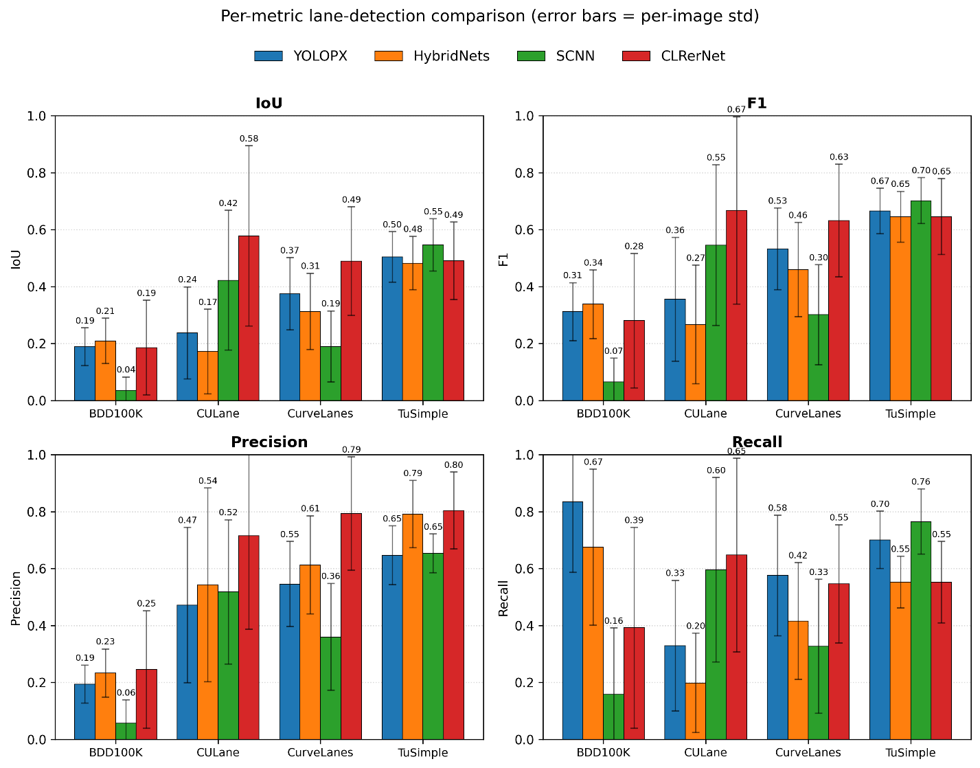
Source: FHWA.
Figure 4. Diagram. Per-dataset comparison of IoU, F1 Score, Precision, and Recall for each candidate model across BDD100K-Lane, CULane, CurveLanes, and TuSimple. Error bars denote per-image standard deviation.

HybridNets remains an informative quantitative comparator: it achieved higher mean precision than YOLOPX (0.5450 vs 0.4645) but the lowest mean IoU (0.2940) and a mean F1 Score (0.4275) below both CLRerNet and YOLOPX. It is also less distinct from YOLOPX in analytical role, since both are multitask driving-perception models with lane-related outputs.
The practical usability review considered whether each processor produced interpretable lane-related outputs that could be standardized for the pilot analysis and whether the outputs provided a useful analytical role beyond the aggregate metrics. YOLOPX was selected as the primary processor on the basis of coverage and practical fit rather than peak metric values: it achieved the highest mean recall (0.6101), produced lane-related outputs that convert readily to the common evaluation representation, and operates within a multitask perception framework whose drivable-area and object outputs support the pilot workflow. Although CLRerNet achieved higher mean IoU, F1, and precision, its advantage is concentrated on its in-domain CULane split and is sensitive to the mask rasterization settings; YOLOPX provides more uniform coverage across the four datasets for a coverage-oriented screening task. However, YOLOPX also showed a precision-recall imbalance, especially on BDD100K-Lane, where high recall was paired with low precision. Pilot analysis results based on YOLOPX should therefore include visual review of potential false-positive lane-line outputs.
Figure 5 shows the per-image F1 distributions and indicates that, beyond mean values, CLRerNet maintains higher median F1 with comparable spread on CULane and CurveLanes, whereas SCNN exhibits the widest variation across datasets, consistent with its lower cross-dataset consistency score.
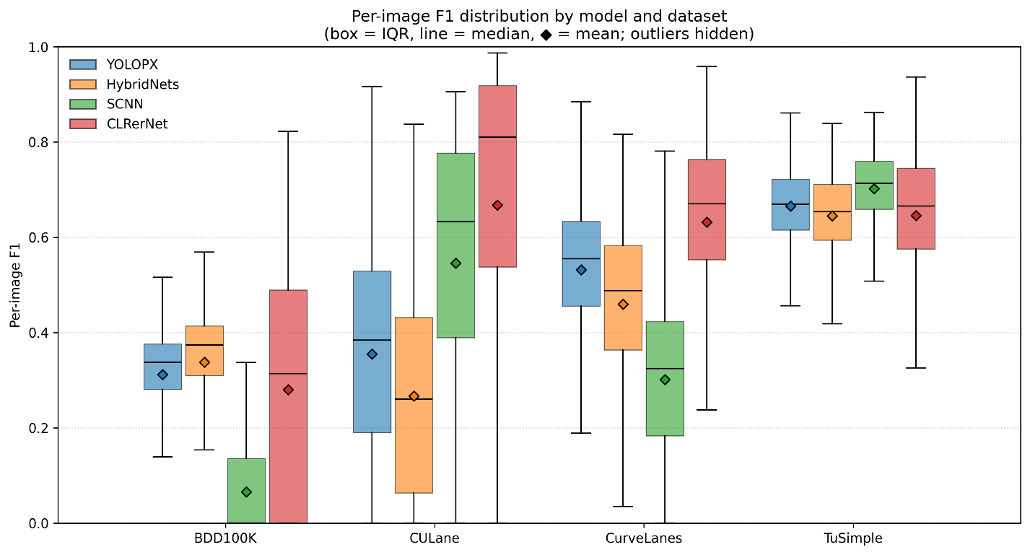
Source: FHWA.
Figure 5. Diagram. Distribution of per-image F1 scores by model and dataset (box = interquartile range, center line = median, diamond = mean; outliers hidden).

CLRerNet was retained as a supplemental lane-focused processor for the Chapter 5 pilot analysis. Although it achieved the highest mean IoU, F1 Score, and precision in the comparison, it was not selected as the primary processor because its advantage is concentrated on its in-domain CULane split, its recall falls on out-of-domain imagery (BDD100K), and its mask-based scores depend on the rasterization settings. Its high-precision, structured lane-line outputs nonetheless make CLRerNet valuable for testing whether pilot-analysis conclusions are sensitive to the choice of reference processor. In particular, comparison between YOLOPX and CLRerNet helps distinguish findings that are robust across processor types from those that depend on a broader-coverage versus a higher-precision lane-line detector.
These output-standardization settings were reviewed for CLRerNet, including image-coordinate scaling, the number of retained lane instances, and the line width and tolerance used when converting structured lane outputs to binary masks. This review confirmed that the initially low pixel-overlap scores were driven primarily by the mismatch between thin predicted lane lines and thicker reference labels rather than by the underlying detector; applying a consistent rasterization width and tolerance across all models resolved this mismatch. HybridNets was not selected for the main pilot workflow, but it remains a useful benchmark comparator. It achieved slightly lower IoU and F1 Score than YOLOPX but higher mean precision, indicating more conservative behavior. If resources allow, HybridNets may be retained for sensitivity analysis; however, the primary planned processor pair for the pilot analysis is YOLOPX and CLRerNet because they provide more complementary output modes: YOLOPX as a coverage-oriented multitask processor and CLRerNet as a lane-focused, high-precision structured detector. Figure 6 plots each model and dataset in precision-recall space against constant-F1 contours. CLRerNet's points sit toward the high-precision region, YOLOPX's BDD100K point sits at high recall but low precision, and points nearest the upper right (highest joint precision and recall) correspond to the in-domain splits.
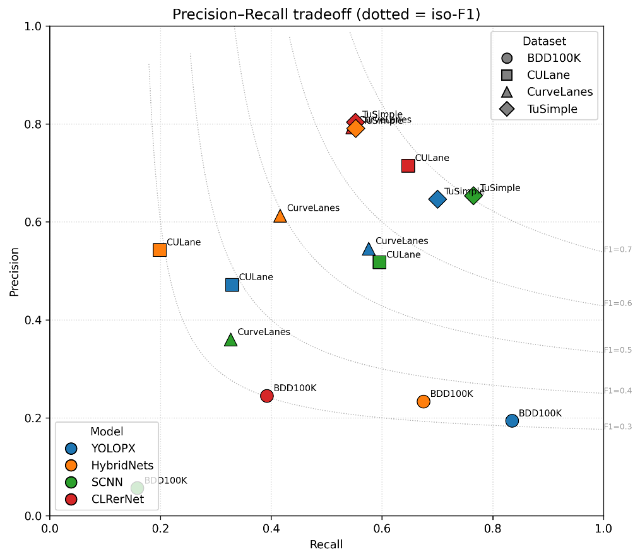
Source: FHWA.
Figure 6. Diagram. Precision-recall trade-off by model and dataset (dotted contours indicate constant-F1 (iso-F1) lines. Points toward the upper right indicate better joint precision and recall).

The final selection is based on the combination of quantitative performance and practical usability. A preferred reference processor provides strong IoU and F1 Score, balanced precision and recall, consistent performance across the candidate datasets, and outputs that can be standardized for the pilot analysis. If the results support carrying forward more than one processor, the selected processors should have complementary value, such as one model providing strong lane-line outputs and another providing useful segmentation-based outputs.

Summary and Implications for Pilot Analysis
This chapter identified and assessed candidate image processing models to support selection of a reference processor for the pavement marking pilot analysis. The candidate models included lane-focused detection models and segmentation or multitask driving perception models, allowing the study to compare different approaches for generating lane-line or pavement marking–related outputs from public roadway imagery.
The model assessment used a common evaluation subset and considered both quantitative performance and practical usability. This approach was intended to identify processors that can produce interpretable outputs, support consistent comparison across datasets, and be applied within the pilot analysis workflow.
Based on the preliminary comparison and the intended Chapter 5 pilot workflow, YOLOPX and CLRerNet were retained for the pilot analysis with complementary roles. YOLOPX was selected as the primary reference image processor for its coverage-oriented behavior (highest mean recall) and its multitask outputs that fit the pilot workflow, while CLRerNet was retained as a high-precision, lane-focused supplemental processor. CLRerNet achieved the highest mean IoU, F1 Score, and precision in the comparison; YOLOPX was preferred for the primary role on coverage and practical grounds, and the two processors are used together to test the robustness of pilot findings to processor choice. CLRerNet contributes structured, high-precision lane-line outputs that complement YOLOPX's broader-coverage behavior; its reduced recall is confined to out-of-domain imagery (BDD100K) and does not affect its suitability for supplemental analysis. The selected processors are used only as reference image processors for infrastructure-focused analysis of public roadway imagery and do not represent ADS or ADAS perception-stack performance.
The selected processors provide the basis for the pilot analysis described in the next chapter. While the model assessment in this chapter focuses on selecting a practical analytical tool, the pilot analysis applies the selected processors to evaluate how pavement marking detectability varies across roadway scenarios, marking characteristics, and visual conditions.

Chapter 4. Pavement Marking Evaluation Methodology
This chapter describes the methodology used to conduct the pavement marking pilot analysis. It presents the pilot analysis scope, end-to-end workflow, pavement-marking assessment metrics and analytical measures, and the approach used to group, compare, and interpret the results. The methodology is built on the image-source screening and pilot image set preparation described in chapter 2 and the reference processor assessment described in chapter 3.

Purpose and Scope of the Pilot Analysis
The pilot analysis applies the selected reference image processor or processors to a set of public roadway images to evaluate how pavement markings can be observed, processed, and compared across roadway, surface, and visual conditions. The purpose is to demonstrate a practical image-based approach for assessing pavement marking visibility and detectability using existing public imagery, rather than to conduct a comprehensive roadway inventory or directly evaluate the performance of a specific ADS or ADAS technology.
The pilot analysis builds on the dataset screening process described in chapter 2 and the reference processor selection process described in chapter 3. Chapter 2 identifies the candidate public image sources and screening groups used to assemble the pilot image set, including operational scenario, roadway context and facility type, roadway surface type, pavement marking type or configuration, observed marking visibility, and lighting and weather condition. Chapter 3 identifies the reference processor or processors used to generate lane-line or pavement marking–related outputs from the selected imagery.
Within this scope, the pilot analysis focuses on two related questions. First, what pavement marking information can be observed from public roadway imagery? Second, how consistently can a reference image processor detect or represent those markings under different roadway and visual conditions? These questions are used to evaluate the practical value and limitations of public imagery for infrastructure-focused ADS readiness assessment.
The analysis is limited to image-based and processor-output-based indicators. It does not measure pavement marking retroreflectivity, material type, marking age, or verified maintenance condition. It also does not determine whether a roadway is ready for ADS deployment or whether a specific ADS-equipped vehicle would perform safely in the observed conditions. Instead, the pilot analysis provides a structured method for identifying where pavement markings appear more or less detectable in public imagery and where additional data collection, field measurements, or controlled testing may be needed.

End-to-End Pilot Analysis Workflow
The pilot analysis follows an end-to-end workflow that connects the prepared pilot image set, selected reference processor outputs, and pavement marking evaluation. The workflow is designed to support a consistent assessment of pavement marking visibility and detectability across selected roadways, surface, and visual conditions.
Figure 7 illustrates the overall pilot analysis workflow. The workflow is organized into three main stages: pilot image set preparation, selected reference processor application, and evaluation and reporting.
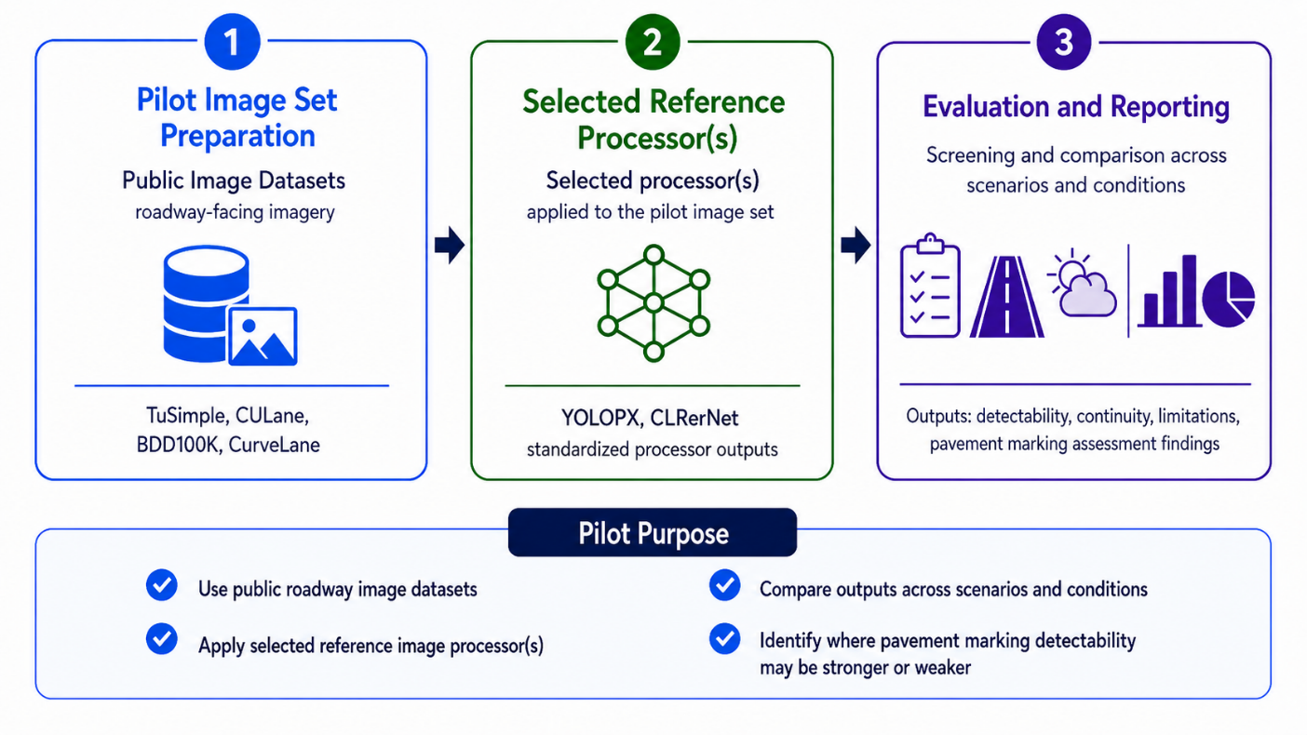
Source: Image generated by ChatGPT 5.5, OpenAI, June 2026, in response to “[ENTER PROMPT USED].”
Figure 7. Diagram. End-to-end pilot analysis workflow.
The first stage, pilot image set preparation, uses the public roadway-facing image datasets identified and screened in chapter 2. In this stage, the selected images are organized using the image-level tracking fields and screening groups defined earlier, including operational scenario, roadway context and facility type, roadway surface type, pavement marking type or configuration, observed marking visibility, and lighting and weather condition. This organization allows the pilot analysis to compare pavement marking detectability across different image conditions without repeating the full dataset screening process.
The second stage applies the selected reference processor, or processors, to the pilot image set. The processor generates lane-line or pavement marking–related outputs, which are converted, where feasible, into standardized processor outputs for comparison. This stage builds on the reference processor identification and assessment described in chapter 3 and focuses on applying the selected processor to the pilot image set rather than comparing all candidate models again.
The third stage evaluates and reports pavement marking detectability, continuity, limitations, and related assessment findings. Results are summarized across datasets, operational scenarios, roadway contexts and facility types, roadway surface types, marking configurations, visibility conditions, and lighting or weather conditions. The evaluation is intended to identify where pavement markings appear more or less detectable in public imagery and where processor outputs may be incomplete, inconsistent, or affected by roadway or visual conditions.
This workflow provides a structured method for evaluating what can reasonably be learned from public imagery and reference image processor outputs. The results are intended to support infrastructure-focused interpretation of pavement marking detectability, not to represent the performance of a proprietary ADS or ADAS perception system.

Pilot Image Set Preparation
The first stage of the pilot workflow prepares the selected public roadway images for consistent processing and comparison. As described in chapter 2, the pilot image set is assembled from public roadway-facing image datasets that were screened based on operational scenario, roadway context and facility type, roadway surface type, pavement marking type or configuration, observed marking visibility, and lighting or weather condition. This screening process provides the basis for selecting images that represent a range of roadways and visual conditions relevant to pavement marking analysis.
Figure 8 illustrates the pilot image set preparation workflow. Dataset-specific information from each source is organized through dataset adapters and converted into a unified pilot image manifest. This manifest provides a standardized structure for tracking selected images, reference annotations, metadata, and screening group tags across datasets.
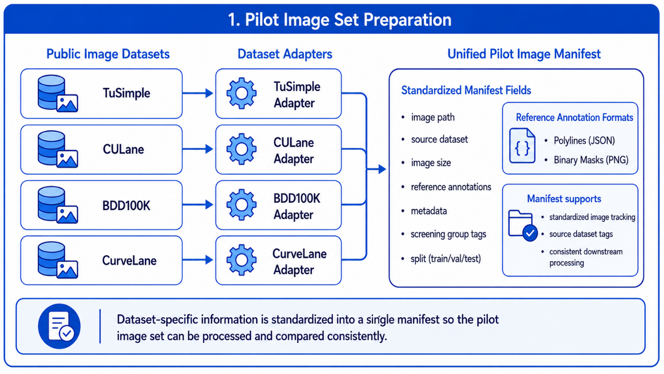
Source: Image generated by ChatGPT 5.5, OpenAI, June 2026, in response to “[ENTER PROMPT USED].”
Figure 8. Diagram. Pilot image set preparation workflow.
The unified pilot image manifest serves as the internal tracking structure for the pilot analysis. At a minimum, the manifest records the image path, source dataset, image size, available reference annotations, metadata, screening group tags, and data split information where applicable. Reference annotations may be represented in different formats depending on the original dataset, including polylines or binary masks. Organizing these fields in a common structure allows images from different datasets to be processed by the selected reference processor and compared using a consistent downstream workflow.
This preparation step does not replace the dataset screening and image-level tracking described in chapter 2. Instead, it operationalizes that information for the pilot analysis by converting dataset-specific records into a common structure that can support processor input preparation, output comparison, and evaluation across scenarios and conditions.

Reference Processor Application and Output Standardization
The second stage of the pilot workflow applies the selected reference processors to the prepared pilot image set. As illustrated in figure 9, the unified pilot image manifest developed during the preparation stage serves as the common input structure for model processing. The manifest links each selected image to its source dataset, available reference annotations, metadata, and screening group tags, allowing processor outputs to remain associated with the corresponding image-level records throughout the workflow.
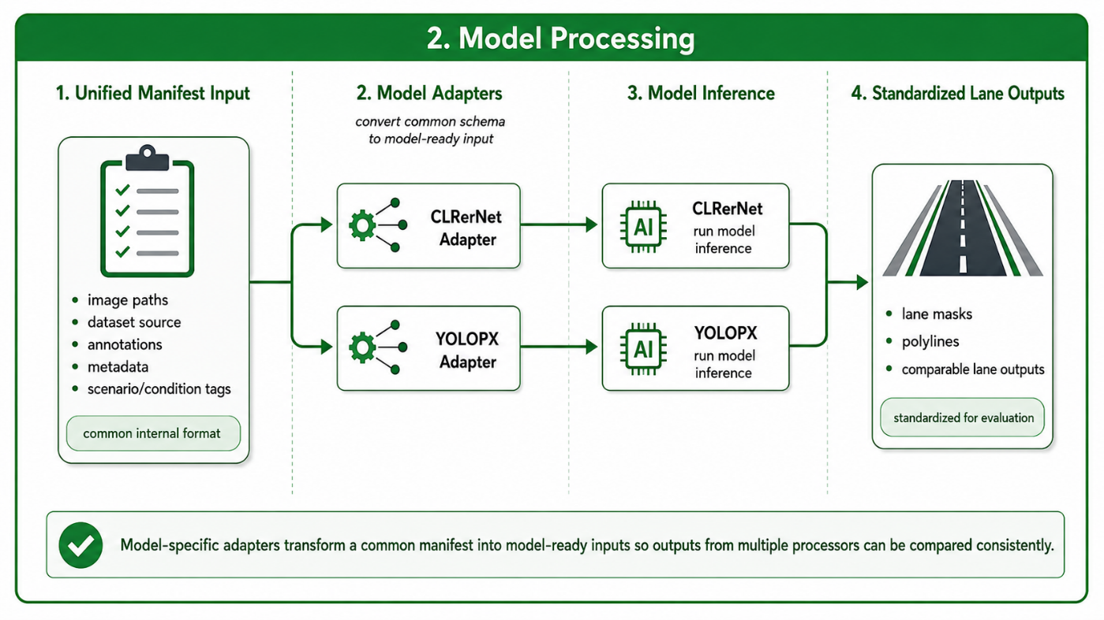
Source: Image generated by ChatGPT 5.5, OpenAI, June 2026, in response to “[ENTER PROMPT USED].”
Figure 9. Diagram. Reference processor application and output standardization workflow.
The pilot configuration shown in figure 9 applies CLRerNet and YOLOPX through separate model-specific adapters. Each adapter converts records from the common manifest into the input format specified by the corresponding processor, including any needed image preprocessing, file-path handling, and model-specific input formatting. This approach allows processors with different implementation specifications to be applied to the same pilot image set without altering the underlying image records or screening information.
The reference annotations retained in the manifest are not used as processor inputs. Instead, they are preserved for later evaluation, where available, and may be converted into a consistent representation for comparison with processor outputs. Depending on the source dataset, reference annotations may be available as lane polylines, lane points, or binary masks.
Each reference processor produces its native lane-related output through model inference. These outputs may include lane masks, polylines, lane boundaries, or other lane-level representations. Where feasible, the outputs are converted into standardized lane-level formats that can be compared consistently across processors and datasets. The standardized outputs are then used in the evaluation and reporting stage to assess pavement marking detectability, continuity, and other image-based indicators across the screening groups defined in chapter 2.
This processing design preserves dataset-specific and model-specific information while establishing a common downstream structure for comparison. It also supports documentation of outputs that need additional conversion, threshold adjustment, or quality review before they are included in the pilot evaluation.

Evaluation and Reporting Framework
The third stage of the pilot workflow evaluates the standardized processor outputs and summarizes the findings in a form that supports comparison across the selected image sources and screening groups. As shown in figure 10, the evaluation and reporting framework accommodates lane-related outputs represented as either polylines or binary masks. Where compatible reference annotations are available, processor outputs are compared with the corresponding annotations using a consistent evaluation representation.
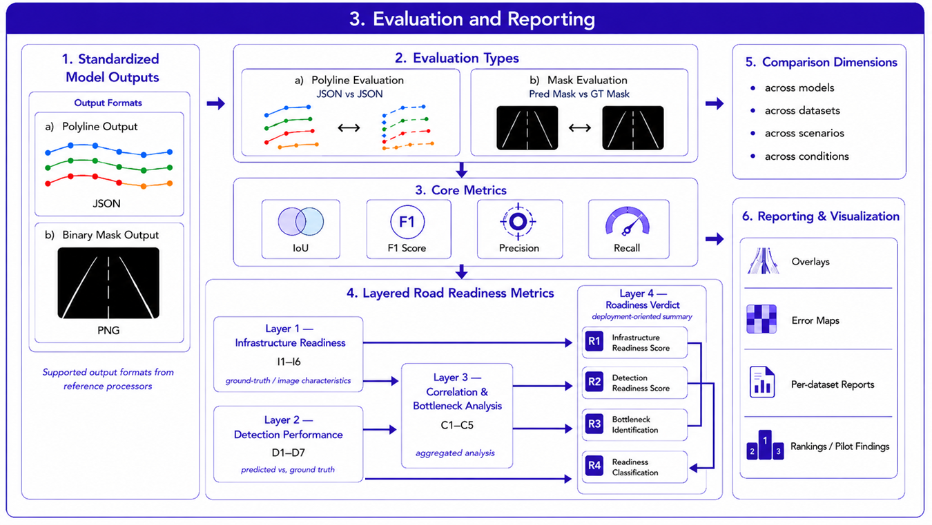
Source: Image generated by ChatGPT 5.5, OpenAI, June 2026, in response to “[ENTER PROMPT USED].”
Figure 10. Diagram. Evaluation and reporting framework for the pavement marking pilot analysis.
The evaluation approach includes both quantitative and descriptive components. Quantitative evaluation is conducted where processor outputs and reference annotations can be converted into compatible polyline- or mask-based representations. The core detection measures introduced in the chapter 3 discussion of the model evaluation approach, including IoU, F1 Score, Precision, and Recall, are used to characterize agreement between processor outputs and available reference information. Images without compatible reference annotations may still support visual review, qualitative comparison, and documentation of processor behavior, but they are not used for annotation-based quantitative scoring.
Results are examined across the comparison dimensions established in earlier chapters, including reference processors, source datasets, operational scenarios, roadway contexts and facility types, roadway surface types, pavement marking types or configurations, observed marking visibility, and lighting or weather conditions. This allows the pilot analysis to identify patterns in pavement marking detectability and processor performance without treating any individual dataset or image condition as representative of all roadway environments.
The reporting component includes visual overlays, error maps where applicable, dataset-level summaries, comparison charts, and documented examples of successful detections, missed detections, false detections, and other notable output patterns. These materials are intended to support interpretation of the quantitative results and to identify conditions in which pavement markings appear more or less distinguishable in public roadway imagery.
The framework also supports additional image-based pavement marking indicators, detection performance indicators, and exploratory cross-factor analyses. These measures are described in the following section and are used to examine how visible pavement marking characteristics and roadway conditions may be associated with processor output quality.

Metrics for Pavement-Marking Assessment and Analytical Measures
The pilot analysis uses a set of image- and annotation-based, processor-output-based, and cross-factor measures to examine pavement marking characteristics and detection performance. These measures extend the core evaluation metrics introduced in the chapter 3 discussion of the model evaluation approach by providing a structured approach for examining visible pavement marking features, processor output quality, potential relationships between image characteristics and detection performance, and selected exploratory synthesis measures.
Unless otherwise noted, the annotation-based indicators and processor-performance measures in this section apply primarily to lane lines, which are the pavement marking features represented in the compatible reference annotations and processor outputs used for the pilot analysis.
The measures are organized into four groups:
- Image- and annotation-based pavement marking indicators.
- Detection performance indicators.
- Cross-factor and condition-based analysis measures.
- Exploratory integrated assessment outputs.
The measures are applied only where the needed imagery, compatible reference annotations, processor outputs, metadata, and screening information are available and can be represented in a compatible format. Therefore, not every measure is expected to apply to every image or dataset.
Table 14 summarizes the four metric groups and their intended role in the pilot analysis.
Table 14. Summary of metric groups for pavement-marking assessment and their intended use.
Metric Group | Metric IDs | Primary Inputs | Intended Use in the Pilot Analysis
Image- and annotation-based pavement marking indicators | I1–I6 | Roadway images and available compatible reference lane-line or pavement marking annotations | Characterize visible pavement marking features and roadway-image characteristics, such as continuity, contrast, edge clarity, apparent lane-width variation, curvature complexity, and compatible reference annotation availability.
Detection performance indicators | D1–D7 | Standardized processor outputs and compatible reference annotations; model-confidence information where available | Characterize processor detection quality, including output availability, lane-boundary count agreement, spatial overlap, missed detections, condition-specific performance differences, and confidence-related information.
Cross-factor and condition-based analysis measures | C1–C5 | Per-image image- and annotation-based results and detection-performance results, together with applicable operational scenario, roadway context and facility type, roadway surface type, and visual-condition tags | Explore whether visible marking characteristics, roadway-image geometry, or image conditions are associated with changes in processor output quality.
Exploratory integrated assessment outputs | R1–R4 | Aggregated image- and annotation-based, detection-performance, and cross-factor results, together with data-availability or evidence-sufficiency information | Synthesize selected findings, identify potential bottlenecks, and support exploratory comparison across image sets or conditions.
XXX.
The metric groups are intended to support infrastructure-focused interpretation of pavement marking detectability in public roadway imagery. They do not represent validated measures of ADS deployment readiness, roadway safety, or the performance of a specific ADS- or ADAS-equipped vehicle. In particular, the exploratory integrated assessment outputs are intended to summarize pilot findings and identify potential areas for further investigation; they are not intended to support deployment decisions or roadway certification.
The following subsections define the metrics included in each group, their needed inputs, expected range or output, intended interpretation, and key limitations.

Image- and Annotation-Based Pavement Marking Indicators
The first metric group characterizes visible lane-line features and roadway-image characteristics that may affect the visibility and interpretation of pavement markings. The indicators are derived from roadway-facing images and, where available, compatible reference lane-line or pavement marking annotations. Reference annotations may be provided as polylines, lane boundaries, lane instances, or binary masks and are converted to a common representation where necessary.
These indicators are intended to describe image-based characteristics relevant to the pilot analysis. They do not measure pavement marking retroreflectivity, material type, installation age, compliance with design standards, or verified maintenance condition. In addition, an indicator is calculated only when the specified image information and compatible reference annotations are available. Missing or incompatible annotations are documented as unavailable rather than interpreted as a zero-value result.
Table 15 summarizes the image- and annotation-based pavement marking indicators used in the pilot analysis.

Table 15. Image- and annotation-based pavement marking indicators.
ID | Indicator | Primary Inputs | Calculation or Application | Expected Range or Output | Interpretation and Key Limitations
I1 | Lane Continuity Score | Compatible binary lane-line mask derived from reference annotations and pavement marking configuration tag | A lane-boundary representation is derived from the compatible reference mask using a documented edge-detection method. Connected boundary segments are identified, and the score is calculated as the share of boundary pixels contained in segments meeting a pre-specified minimum length. | 0–1 | A lower value indicates a more fragmented lane-boundary representation. This may reflect occlusion, low visibility, incomplete annotation, or image-processing limitations. Dashed or otherwise intentionally discontinuous markings should be excluded or reported separately because lower continuity may reflect the intended marking design.
I2 | Boundary Contrast Ratio | Roadway image and compatible lane-line or pavement marking annotation | The absolute difference between the mean grayscale luminance of annotated marking pixels and adjacent pavement pixels is calculated and normalized by the image luminance range. | 0–1 | A lower value indicates lower apparent contrast between the marking and surrounding pavement in the image. The measure may be affected by lighting, shadow, glare, camera exposure, wet pavement, and image compression; it is not a measurement of retroreflectivity or paint quality.
I3 | Boundary Sharpness Score | Roadway image and compatible binary lane-line or pavement marking mask | A boundary band is created by dilating the edge of the compatible reference mask using a documented buffer size. The score is calculated as the proportion of pixels within that band identified as image edges using a documented edge-detection method. | 0–1 | A lower value indicates that the marking boundary is less visually distinct in the image. Results may be influenced by image resolution, motion blur, focus, compression, lighting, and pavement texture, in addition to marking condition.
I4 | Lane Width Stability | Compatible lane-line mask or paired left and right lane-boundary annotations | At each image row with a valid lane span, apparent lane width is calculated as the horizontal distance between the leftmost and rightmost lane pixels or paired lane boundaries. The standard deviation of apparent width across valid rows is then calculated. | Integer ≥ 0 pixels | A higher value indicates greater variation in apparent lane width within the image. This may reflect roadway geometry, perspective, merges, lane transitions, or annotation uncertainty. It is not a direct measure of physical lane width, pavement condition, or marking quality.
I5 | Road Curvature Complexity | Compatible lane-line mask or lane-centerline annotation | At each image row with valid lane pixels, the horizontal lane-center position is calculated. The standard deviation of these center positions is normalized by image width. | 0–1 | A higher value indicates greater lateral variation in the visible lane path and, therefore, greater apparent curvature or geometric complexity. The measure is affected by camera viewpoint and perspective and should be interpreted as an image-space proxy rather than a direct roadway-design curvature measure.
I6 | Lane Count (GT) | Compatible reference lane-boundary annotations and image-level metadata | Counts the distinct annotated lane-boundary instances represented in the ground-truth annotation for each image. For this metric, “lane count” refers to annotated lane-boundary instances, not the number of travel lanes. Connected-component counts from a merged binary mask are not used as a substitute. | Integer ≥ 0 | Provides descriptive context on the amount of lane-boundary reference information available for image-level evaluation. The metric is calculated only when distinct lane-boundary instances can be identified reliably from the source annotation. When annotations are missing, incompatible, or represented only as a merged mask without separable instances, the value is reported as unavailable rather than zero.
XXX.

The implementation parameters for these indicators, including edge-detection settings, boundary-buffer size, minimum segment length, and image-row sampling rules, should be documented with the pilot analysis results. Where appropriate, sensitivity checks should be used to determine whether the selected parameters materially affect the observed patterns.
Together, these indicators provide a structured basis for examining how visible pavement marking characteristics and roadway-image geometry may be associated with processor output quality. The indicators are interpreted in combination with the detection performance measures described in the following section and the cross-factor analyses described in the section after that.

Detection Performance Indicators
The second metric group evaluates the quality and usability of the standardized processor outputs. D1 is calculated across the applicable processed images, while D2 through D6 are calculated only where compatible reference annotations and processor outputs are available. Images without compatible annotations may still be retained for visual review and qualitative reporting, but they are not included in annotation-based quantitative measures.
The core measures of IoU, F1 Score, Precision, and Recall were defined in chapter 3 discussion of the model evaluation approach. In this subsection, Segmentation IoU is used as the primary spatial-agreement measure for D3 and related cross-factor analyses. F1 Score, Precision, and Recall may be reported alongside IoU to provide additional context on overall detection quality, false detections, and missed detections. The additional indicators describe detection success, lane-count agreement, near-field agreement, occlusion-related performance differences, missed marking information, and model confidence where available.
Table 16 summarizes the detection performance indicators used in the pilot analysis.

Table 16. Detection performance indicators.
ID | Indicator | Primary Inputs | Calculation or Application | Expected Range or Output | Interpretation and Key Limitations
D1 | Detection Success Rate | Standardized processor outputs and image-level records | Calculates the percentage of applicable processed images for which the standardized processor output contains at least one predicted lane-related pixel or lane-boundary instance. | 0–1 | A lower value indicates that the processor generated no lane-related output for a greater share of processed images. Detection success does not indicate whether the output is accurate, complete, or correctly aligned with a reference annotation.
D2 | Lane Count Accuracy | Predicted lane-boundary instances and compatible ground-truth lane-boundary instances | Calculates the percentage of eligible images for which the number of predicted lane-boundary instances equals the number of distinct ground-truth lane-boundary instances. | 0–1 | A lower value may indicate missed boundaries, merged boundaries, or false boundaries. For this metric, lane count refers to identifiable lane-boundary instances, not the number of travel lanes. Connected-component counts from merged masks should not be used as a substitute when lane-boundary instances cannot be distinguished reliably.
D3 | Segmentation Intersection over Union (IoU) | Standardized processor outputs and compatible reference annotations | For each eligible image, calculates IoU as TP / (TP + FP + FN) using the common evaluation representation described in chapter 3. Image-level IoU values are then summarized across the applicable image group. | 0–1 | Higher values indicate stronger spatial overlap between predicted and reference lane-related outputs. Results depend on the compatibility and quality of the reference annotations and the selected evaluation representation.
D4 | Near-Field IoU | Standardized processor outputs and compatible reference annotations | Applies the D3 IoU calculation only within a documented lower image region, such as the lower half of the image. | 0–1 | Provides a focused view of agreement in the roadway area closest to the camera within the image. Without camera calibration, the lower image region should not be interpreted as a fixed physical distance from the vehicle.
D5 | Occlusion Robustness Gap | D3 image-level IoU results and observed marking visibility tags | Calculates the difference between mean IoU for images with nonoccluded markings and mean IoU for images tagged as occluded: mean IoU_nonoccluded − mean IoU_occluded. | −1 to +1 | A positive value indicates lower spatial agreement for images with occluded markings. The measure is reported only where both groups contain a sufficient number of eligible images. Occlusion is identified using documented image-level screening tags or review criteria; dark-pixel thresholds alone should not be used to define occlusion.
D6 | Detection Gap Ratio | Standardized processor outputs and compatible reference masks or equivalent representations | Calculates the proportion of available reference marking pixels missed by the processor: sum of false-negative pixels divided by the sum of ground-truth marking pixels across the applicable image group. | 0–1 | A higher value indicates that a larger share of available reference marking information was missed. The measure is applicable only when compatible mask-based or equivalent reference representations are available.
D7 | Confidence Mean | Model-generated confidence information, where available | Calculates the mean confidence associated with the processor’s lane-related outputs across the applicable images or image group. | 0–1 | Lower confidence may indicate greater model uncertainty. Confidence definitions, scales, and calibration may differ across processors; therefore, confidence values should not be compared directly across models unless their comparability has been established. Where meaningful lane-output confidence is not available, the metric is reported as unavailable.
XXX.

The indicators in table 16 are intended to provide complementary information. For example, a processor may produce lane-related outputs for most images but still show low spatial agreement or a high detection gap ratio. Similarly, a processor may show strong overall IoU but a substantial occlusion robustness gap, indicating lower agreement for images with occluded markings.
The indicators are interpreted together with the image- and annotation-based pavement marking indicators described in the previous section. The following subsection describes the cross-factor and condition-based measures used to explore potential relationships between visible pavement marking characteristics, roadway-image conditions, and processor output quality.

Cross-Factor and Condition-Based Analysis
The third metric group examines potential associations among visible pavement marking characteristics, roadway-image geometry, image conditions, and processor output quality. These measures combine image- and annotation-based indicators with the detection performance indicators, as described in the previous two sections.
The arrows used in the metric names identify the relationship examined by each analysis. They do not indicate that a pavement marking characteristic, roadway condition, or image condition causes a change in processor performance.
The analyses are exploratory and are intended to identify patterns for further interpretation. Observed patterns may also reflect differences in dataset composition, camera configuration, image quality, annotation practices, processor training data, or other factors not represented in the pilot image set. Where sufficient eligible images are available, analyses are conducted separately by processor and, where appropriate, by source dataset or other relevant image group. Each reported comparison identifies the sample size, grouping approach, selected performance measure, and any exclusions applied during analysis.
Table 17 summarizes the cross-factor and condition-based measures used in the pilot analysis.

Table 17. Cross-factor and condition-based analytical measures.
ID | Measure | Primary Inputs | Calculation or Application | Expected Range or Output | Interpretation and Key Limitations
C1 | Continuity → Detection | Image-level I1 results and image-level D1 outcomes | Calculates the Pearson point-biserial correlation between the Lane Continuity Score and the binary Detection Success Rate across eligible images. For this analysis, D1 equals 1 when the processor produces a nonempty lane-related output and 0 otherwise. | −1 to +1 | A positive value indicates that higher lane continuity scores are associated with greater detection success. The result does not establish that improving lane continuity would directly improve processor performance.
C2 | Contrast → IoU | Image-level I2 and D3 results | Calculates the Pearson correlation between the Boundary Contrast Ratio and Segmentation IoU across eligible images. | −1 to +1 | A positive value indicates that higher apparent marking-to-pavement contrast is associated with stronger spatial agreement. The relationship may also reflect lighting, camera exposure, shadow, wet pavement, image quality, and dataset-specific characteristics.
C3 | Sharpness → IoU | Image-level I3 and D3 results | Calculates the Pearson correlation between the Boundary Sharpness Score and Segmentation IoU across eligible images. | −1 to +1 | A positive value indicates that greater boundary sharpness is associated with stronger spatial agreement. Boundary sharpness is an image-based measure and should not be interpreted as a direct measure of pavement marking material condition.
C4 | Curvature → Performance Gap | Image-level I5 and D3 results | Divides eligible images into lower- and higher-curvature groups using the median I5 value. Calculates the difference between the mean IoU of the lower-curvature group and the mean IoU of the higher-curvature group. | −1 to +1 | A positive value indicates that the higher-curvature group had lower mean spatial agreement. The metric reflects image-space lane-path variation and camera perspective; it does not directly measure roadway design curvature or establish that curvature caused the observed performance difference.
C5 | Condition Degradation Ranking | I1, I2, I3, D1, D3, D4, and applicable screening group tags | For each selected condition group, calculates the mean value of each component metric and compares it with a documented reference condition, such as a clear, daylight, dry, or nonoccluded condition. Before combining the component differences, all measures are converted to a common 0–1 scale and oriented so that higher values indicate more favorable results. The mean difference across the selected components is calculated as the condition degradation score, and condition groups are ranked from largest to smallest score. | Ranked list of condition groups with a standardized degradation score from −1 to +1 | A larger positive score indicates less favorable observed results relative to the reference condition. The ranking is exploratory and depends on the selected reference condition, component measures, normalization method, and sample size. It is not an infrastructure investment priority ranking or a readiness score. Results are not reported for groups with insufficient eligible images.
XXX.

Figure 11 illustrates the analytical inputs to the cross-factor and condition-based measures. Each measure combines selected image- and annotation-based indicators and detection performance indicators to examine whether pavement marking characteristics, roadway-image geometry, or relevant conditions are associated with differences in processor output quality.
The arrows in figure 11 identify the indicators used in each analysis. They do not represent a confirmed causal relationship between an image characteristic or condition and processor performance.
Together, the measures in table 17 support a structured examination of processor-output patterns across pavement marking characteristics and image conditions. These findings provide context for the exploratory integrated assessment outputs described in the following section.
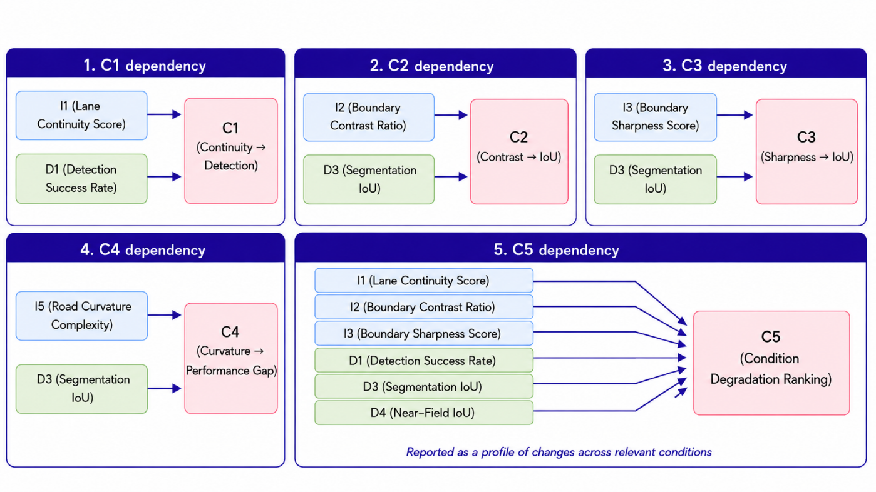
Source: Image generated by ChatGPT 5.5, OpenAI, June 2026, in response to “enter prompt used.”
Figure 11. Diagram. Relationships among image- and annotation-based pavement marking indicators, detection performance indicators, and cross-factor and condition-based
Exploratory Integrated Assessment Outputs
The fourth metric group integrates selected results from the preceding analyses to support structured reporting and interpretation of the pilot findings. These outputs combine image- and annotation-based pavement marking indicators, processor performance measures, and cross-factor results at an image-group, dataset, or condition-group level, as appropriate.
R1 and R2 are exploratory composite scores intended to provide concise summaries of selected image-based and processor-performance measures. They are not validated measures of roadway readiness for ADS deployment, do not represent the performance of a specific ADS- or ADAS-equipped vehicle, and should not be used for roadway certification, maintenance prioritization, or deployment decisions. The component weights are analytical choices for this pilot and do not represent validated safety or risk weights.
Where an integrated score or summary is prepared, the applicable component measures, normalization approach, weighting approach, sample size, exclusions, and data limitations are documented with the results. Individual indicators remain available for review and are reported alongside any integrated result.
Table 18 summarizes the exploratory integrated assessment outputs used in the pilot analysis.
For R1, the normalized terms N(I4) and N(I5) are calculated using documented reference bounds established before final analysis. The reference bounds should be selected based on the pilot data structure and tested through sensitivity analysis to determine whether alternative bounds materially affect the resulting score.

Table 18. Exploratory integrated assessment outputs.
ID | Output | Primary Inputs | Calculation or Application | Expected Range or Output | Interpretation and Key Limitations
R1 | Exploratory Infrastructure Indicator Score | I1–I5, with I6 reported separately as descriptive context | Calculates a weighted summary of applicable image- and annotation-based indicators: R1 = 100/0.95 × [0.30(I1/100) + 0.30(I2) + 0.20(I3) + 0.10N(I4) + 0.05N(I5)]. N(I4) and N(I5) are normalized 0–1 terms, oriented so that higher values represent more favorable apparent lane-width stability and lower apparent curvature complexity. The normalization bounds and sensitivity checks are documented with the pilot results. I6 is reported separately because it describes ground-truth lane-boundary availability rather than an image-based pavement marking characteristic. | 0–100, where higher values indicate more favorable results under the documented exploratory scoring approach | Provides a concise summary of selected visible pavement marking and roadway-image characteristics. It does not measure physical marking condition, retroreflectivity, material quality, compliance with design standards, or verified maintenance need. The score is calculated only when the needed component measures are available.
R2 | Exploratory Detection Performance Score | D1–D6 and D7 where meaningful model-confidence information is available | Calculates a weighted summary of processor-performance measures: R2 = 100 × [0.25(D1/100) + 0.20(D2/100) + 0.20(D3) + 0.15(D4) + 0.08R(D5) + 0.08(1 − D6) + 0.04(D7)]. R(D5) is an occlusion-robustness term calculated as 1 − |D5|, where values closer to 1 indicate a smaller observed difference between occluded and nonoccluded image groups. D7 is included only where meaningful confidence information is available; otherwise, the remaining component weights are re-normalized and the treatment is documented. | 0–100, where higher values indicate more favorable results under the documented exploratory scoring approach | Provides a concise summary of processor output quality for the selected pilot configuration. The score does not represent the performance of a complete ADS or ADAS perception system. Results should be interpreted with the underlying D-series measures, particularly when component measures show conflicting patterns.
R3 | Bottleneck Identification | C1–C5, supported by relevant I- and D-series results | Identifies the pavement marking characteristic, roadway-image factor, or condition associated with the largest adequately supported adverse association, performance difference, or condition-related degradation result. The determination considers effect magnitude, direction, sample size, consistency across applicable groups, and data-quality limitations. | Identified factor or condition, supporting measure or measures, direction of observed pattern, and evidence-sufficiency information | Identifies a potential area for further investigation rather than a confirmed cause of processor behavior. A reported bottleneck may reflect confounding factors, dataset composition, limited sample size, or other characteristics not isolated in the pilot analysis.
R4 | Exploratory Pilot Findings Profile | R1, R2, R3, and evidence-sufficiency information | Organizes the integrated pilot findings into a descriptive profile using documented criteria. The profile may distinguish among more favorable observed results, mixed or variable results, less favorable observed results, and findings with limited or insufficient evidence. R1 and R2 support the profile but do not determine it alone. | Descriptive findings profile | Supports communication of pilot findings, uncertainty, and evidence limitations. It is not a roadway readiness classification and must not use labels such as “ready,” “marginal,” or “not ready.”
XXX.

Figure 12 illustrates the relationship between the preceding metric groups and the exploratory integrated assessment outputs. The figure shows how I1–I5 support the R1 score, while I6 provides descriptive context on available ground-truth lane-boundary information. The D-series indicators support the R2 score, and the C-series measures support identification of potential bottlenecks through R3. R1 and R2, together with R3 and evidence-sufficiency information, support the descriptive pilot findings profile represented by R4.
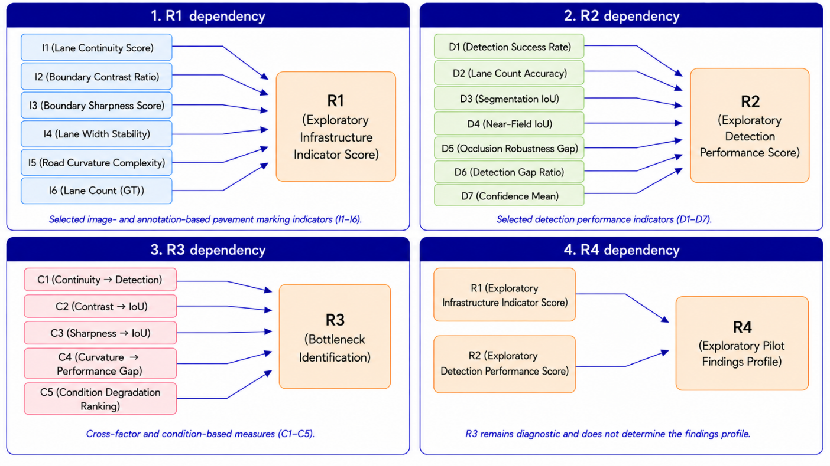
Source: Image generated by ChatGPT 5.5, OpenAI, June 2026, in response to “enter prompt used.”
Figure 12. Diagram. Relationships among pavement marking indicators, detection performance indicators, cross-factor measures, and exploratory integrated assessment outputs.
The arrows in figure 12 identify the information used to develop each output. They do not establish causal relationships or imply that an integrated score can replace the underlying measures. In particular, R3 is intended as a diagnostic output that helps identify potential areas for further examination and does not directly determine the R4 pilot findings profile.
Together, the R-series outputs provide an organized way to summarize the pilot findings while preserving the supporting evidence, limitations, and uncertainty associated with the underlying measures.

Analysis Grouping, Comparison, and Interpretation Approach
The pilot analysis will use the individual image as the primary unit of analysis. For each eligible image, the pilot workflow will retain the applicable source dataset, processor, standardized output, available reference annotation, and screening group tags described in Chapter 2. This structure allows results to be traced to the underlying image and supports review of individual cases when aggregated findings indicate an unexpected pattern.
Quantitative comparisons will be conducted only for images with compatible reference annotations and processor outputs that can be represented in the common evaluation format described in the chapter 3 discussion of the model evaluation approach and the chapter 4 discussion of the pilot analysis workflow. Images that do not meet these specifications may still be included in the pilot image set for visual review, qualitative documentation, and examples of processor behavior, but they will not be included in annotation-based performance calculations. The number of eligible images and excluded images, along with the reasons for exclusion, will be documented for each reported analysis.
Results will first be summarized separately by reference processor and source dataset. Where sufficient eligible images are available, results will then be examined across the screening groups established in Chapter 2, including operational scenario, roadway context and facility type, roadway surface type, pavement marking type or configuration, observed marking visibility, and lighting or weather condition. Comparisons will be limited to groups with enough eligible images to support meaningful interpretation. Groups with small sample sizes, incomplete annotation coverage, or limited variation in the relevant condition will be identified as preliminary or not reported quantitatively.
When results are pooled across datasets, the analysis will retain dataset-level summaries and use dataset-normalized aggregation, where appropriate, so that a dataset with a larger number of eligible images does not disproportionately influence the overall findings. This approach is particularly important because the candidate datasets differ in image content, camera perspective, annotation format, roadway coverage, and original development purpose.
The I-, D-, C-, and R-series measures will be interpreted together rather than in isolation. Image- and annotation-based indicators provide context on visible pavement marking characteristics; detection performance indicators describe processor output quality; cross-factor measures identify potential associations; and the R-series outputs provide exploratory composite scores and structured summaries of the pilot findings. Any integrated score or summary will be accompanied by the underlying component measures so that the factors contributing to the result remain visible.
The findings will be interpreted as evidence of how pavement markings are represented and processed within the selected public imagery and reference processor configuration. They will not be used to infer the performance of a specific ADS or ADAS-equipped vehicle, establish a causal relationship between roadway characteristics and processor outcomes, or determine roadway readiness for deployment. Reported results will identify key limitations, including annotation availability, image quality, dataset coverage, sample size, and differences among source datasets and processor outputs.

Chapter Summary
This chapter presents the pilot analysis approach for examining pavement markings in selected public roadway imagery. The approach begins with preparation of a standardized pilot image set, applies the selected reference processor or processors through model-specific processing workflows, and evaluates the resulting outputs using compatible reference annotations where available.
The chapter also defines a structured set of image- and annotation-based indicators, detection performance indicators, cross-factor analyses, and exploratory integrated assessment outputs. These measures are intended to support consistent comparison of pavement marking detectability and processor behavior across source datasets and relevant roadway, surface, and visual conditions.
The analysis framework retains image-level traceability, documents exclusions and data limitations, and distinguishes annotation-based quantitative evaluation from qualitative visual review. The findings are interpreted within the limits of the selected imagery and reference processor configuration. The following chapter applies this framework to the pilot image set and presents the resulting observations and findings.

Chapter 5. Pilot Analysis Execution and Results

Pilot Analysis Design
Describes the scope and design of the pilot analysis, including the datasets used, the number of images analyzed, and the roadway environments represented.

Implementation of the Analysis Pipeline
Explains how the selected imagery datasets and reference image processor were used to conduct the pilot analysis.

Detection Outputs and Analysis Results
Presents the outputs generated by the image processor and summarizes observations related to pavement marking detection.

Observed Patterns and Failure Cases
Highlights situations where pavement markings were successfully detected and identifies conditions that resulted in missed detections or reduced performance.

Chapter 6. Insights, Limitations, and Implications for Future Work

Key Findings from the Pilot Analysis
Summarizes the main observations and insights obtained from the pilot analysis of pavement markings.

Limitations of the Analysis
Discusses limitations associated with the datasets, image processor, and the scope of the pilot study.

Lessons Learned
Highlights practical insights gained during the implementation of the pilot analysis.

Implications for Future Data Collection and Analysis
Discusses how the findings may inform future research efforts and potential real-world data collection activities planned for subsequent phases of the ROAD Readiness project.

References

Chen, H., X. Wang, and W. Xian. (2020). BDD100K: A diverse driving dataset for heterogeneous multitask learning. (2020). In Proceedings of the IEEE/CVF Conference on Computer Vision and Pattern Recognition (CVPR). https://doi.org/10.1109/CVPR42600.2020.00271.

Canny, J. (1986). A computational approach to edge detection. IEEE Transactions on Pattern Analysis and Machine Intelligence, 8(6), 679–698. https://doi.org/10.1109/TPAMI.1986.4767851.
Chen, L.-C., Papandreou, G., Kokkinos, I., Murphy, K., & Yuille, A. L. (2018). DeepLab: Semantic image segmentation with deep convolutional nets, atrous convolution, and fully connected CRFs. IEEE Transactions on Pattern Analysis and Machine Intelligence, 40(4), 834–848. https://doi.org/10.1109/TPAMI.2017.2699184.
comma.ai. (2019). Comma2k19: A large-scale dataset for end-to-end driving. GitHub. https://github.com/commaai/comma2k19.
Duda, R. O., & Hart, P. E. (1972). Use of the Hough transformation to detect lines and curves in pictures. Communications of the ACM, 15(1), 11–15. https://doi.org/10.1145/361237.361242.
Ghosh, A., Zheng, S., Tamburo, R., Vuong, K., Alvarez-Padilla, J. R., Zhu, H., Cardei, M., Dunn, N., Mertz, C., & Narasimhan, S. G. (2024). ROADWork dataset. Carnegie Mellon University. https://doi.org/10.1184/R1/26093197.
Honda, H., & Uchida, Y. (2024). CLRerNet: Improving confidence of lane detection with LaneIoU. In Proceedings of the IEEE/CVF Winter Conference on Applications of Computer Vision (WACV) (pp. 1165–1174). https://doi.org/10.1109/WACV57701.2024.00121.
Liu, H., Wang, K., Yang, N., & Deng, L. (2021). CondLaneNet: A top-to-down lane detection framework based on conditional convolution. In Proceedings of the IEEE/CVF International Conference on Computer Vision (pp. 3773–3782). https://doi.org/10.48550/arXiv.2105.05003.
Mihalj, T., Li, H., Babić, D., Lex, C., Jeudy, M., Zovak, G., Babić, D., & Eichberger, A. (2022). Road infrastructure challenges faced by automated driving: A review. Applied Sciences, 12(7), Article 3477. https://doi.org/10.3390/app12073477.
Neven, D., De Brabandere, B., Georgoulis, S., Proesmans, M., & Van Gool, L. (2018). Towards end-to-end lane detection: An instance segmentation approach. 2018 IEEE Intelligent Vehicles Symposium (IV), 286–291. https://doi.org/10.1109/IVS.2018.8500547.
Novat, N., Calvo, J., Soleimaniamiri, S., Leslie, E., & During, W. (forthcoming). Understanding the availability and gaps of real-world operational assessment data of physical road elements for automated driving systems.
Pan, X., Shi, J., Luo, P., Wang, X., & Tang, X. (2018). Spatial as deep: Spatial CNN for traffic scene understanding. In Proceedings of the AAAI Conference on Artificial Intelligence, 32(1), 7276–7283. https://arxiv.org/abs/1712.06080.
Qin, L., Wang, S., & Xu, X. (2025). HSV-enhanced Canny-Hough algorithm for robust lane line recognition. International Conference on Mechatronic Engineering and Artificial Intelligence (MEAI 2024), 90. https://doi.org/10.1117/12.3064448
Ronneberger, O., Fischer, P., & Brox, T. (2015). U-Net: Convolutional networks for biomedical image segmentation. In N. Navab, J. Hornegger, W. M. Wells, & A. F. Frangi (Eds.), Medical image computing and computer-assisted intervention—MICCAI 2015 (pp. 234–241). Springer. https://doi.org/10.1007/978-3-319-24574-4_28.
Soleimaniamiri, S., Novat Baraba, N. K., Monteiro, H. L., & During, W. (forthcoming). Road features for automated driving systems readiness: Framework, inventory, and condition assessment development order – Final report.
Tabelini, L., Berriel, R., Paixão, T. M., Badue, C., De Souza, A. F., & Oliveira-Santos, T. (2021). Keep your eyes on the lane: Real-time attention-guided lane detection. In Proceedings of the IEEE/CVF Conference on Computer Vision and Pattern Recognition (CVPR) (pp. 294–302).
TuSimple Inc. (n.d.). TuSimple Lane Detection Benchmark. GitHub. https://github.com/TuSimple/tusimple-benchmark.
Vu, D., Ngo, B., & Phan, H. (2022). HybridNets: End-to-end perception network. arXiv preprint arXiv:2203.09035. https://arxiv.org/abs/2203.09035.
Waymo. (n.d.). Waymo Open Dataset. https://waymo.com/open/.
Wei, Y., & Xu, M. (2021). Detection of lane line based on Robert operator. Journal of Measurements in Engineering, 9(3), 156-166.
Wu, D., Liao, M.-W., Zhang, W.-T., Wang, X.-G., Bai, X., Cheng, W.-Q., & Liu, W.-Y. (2022). YOLOP: You only look once for panoptic driving perception. Machine Intelligence Research, 19(6), 550–562. https://doi.org/10.1007/s11633-022-1339-y.
Zhan, J., Luo, Y., Guo, C., Wu, Y., Meng, J., & Liu, J. (2024). YOLOPX: Anchor-free multi-task learning network for panoptic driving perception. Pattern Recognition, 148, 110152. https://doi.org/10.1016/j.patcog.2023.110152.
Zheng, T., Huang, Y., Liu, Y., Tang, W., Yang, Z., Cai, D., & He, X. (2022). CLRNet: Cross layer refinement network for lane detection. In Proceedings of the IEEE/CVF Conference on Computer Vision and Pattern Recognition (CVPR) (pp. 898–907). https://doi.org/10.1109/CVPR52688.2022.00097.

