


VLAN-Vortex-Odyssey

To Eng : EL Hosein Ahmed

By Teammates

Yossef Elsharqawy - Mohab Essam - Fares Ahmed
Menna Mohamed -Nourhan Al Sharkawy

Network Topology:

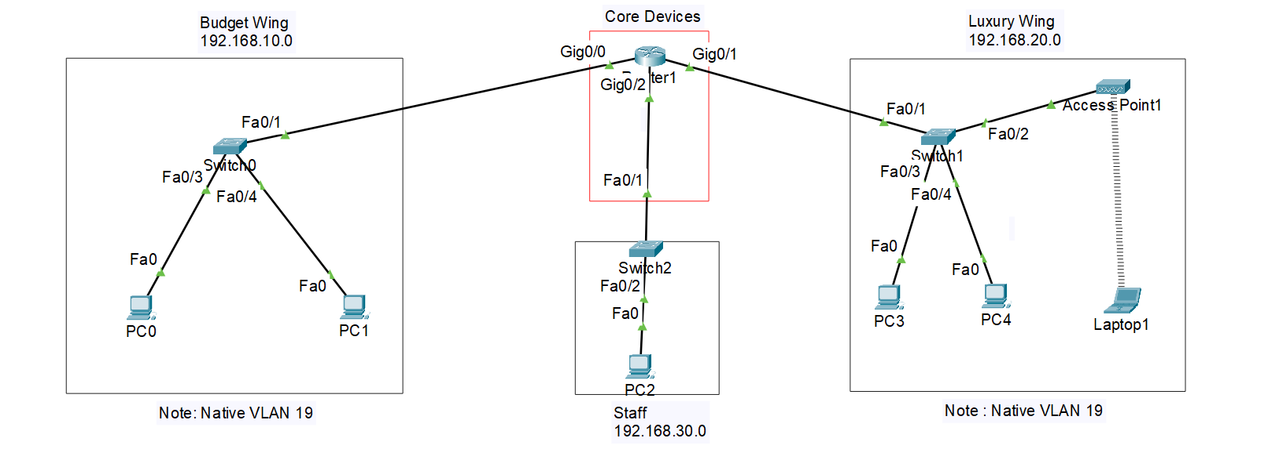

Topology Description:

- Budget Wing (192.168.10.0/24):

  - Hosts basic accommodations with two PCs (PC0 and PC1) for guest use.
  - Connected via Switch0, which is linked to the core router using a FastEthernet interface.
  - Uses VLAN 19 as the native VLAN for secure communication.

- Luxury Wing (192.168.20.0/24):

  - Caters to premium guests with two PCs (PC3 and PC4) and a laptop connected to an Access Point for wireless connectivity.
  - All devices connect through Switch1, which links back to the core router.
  - VLAN 19 is also designated as the native VLAN for consistency.

- Staff Section (192.168.30.0/24):

  - Provides connectivity for staff operations with one PC (PC2).
  - Connected through Switch2, which communicates with the core router via FastEthernet.

- Core Devices:

  - The central point of the network, featuring Router1 and interconnecting switches via Gigabit Ethernet for high-speed and reliable data transfer.
  - Ensures routing between the different VLANs and subnetworks for effective communication across all sections of the hotel.

Features of the Hotel Network Topology:

- Efficient Segmentation: The network is divided into three subnets: Budget Wing (192.168.10.0/24), Luxury Wing (192.168.20.0/24), and Staff (192.168.30.0/24), ensuring proper separation of traffic and optimized bandwidth utilization.

- Native VLAN Utilization: VLAN 19 is configured as the native VLAN, providing an additional layer of security by using an uncommon VLAN number to deter potential attackers.
- Wireless Connectivity: The Luxury Wing includes an Access Point for seamless wireless access, catering to premium guests who require mobility.

- Centralized Management: The core router acts as the central hub, enabling routing and communication between all subnets while maintaining high-speed connections using Gigabit Ethernet links.

- Scalability: The design supports future expansion, allowing additional devices or subnets to be integrated with minimal changes to the existing architecture.

- Traffic Isolation: Separate VLANs ensure that broadcast traffic is contained within its designated subnet, improving performance and network security.

- Redundancy and Reliability: By connecting all sections to the core through dedicated switches, the network ensures consistent and reliable connectivity across all wings.

