An Exploration into Three Closely Related Varieties of Iris

Jordan Schupbach

March 16, 2017

Introduction
This famous iris data set, collected by Anderson (Anderson 1936) and used by Fisher (Fisher 1936), gives the measurements in centimeters of the variables sepal length and width and petal length and width, respectively, for 50 flowers from each of 3 species of iris. The species are Iris setosa, versicolor, and virginica. They are extremely similar species of iris, but do have some blank differences. In Plot 1 we give images of the three iris species.
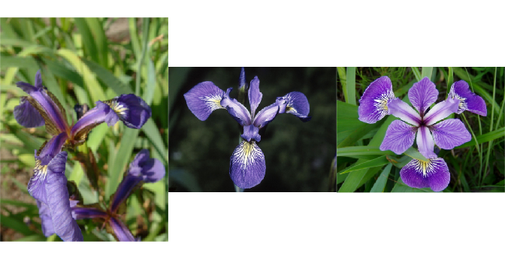
Figure 1: Three species of iris; versicolor, virginica and setosa

Description of Data
This dataset has 1 categorical variable and 4 quantitative variables. Whether a variable is the explanatory variable or the dependent variable may depend on the model being considered motivated by some question of interest. Before looking at any models, we want to get familiar with the data. In the very least, we will want to summarize the data either with plots or with summary statistics. The first few lines of the dataset are given below:
Sepal.Length | Sepal.Width | Petal.Length | Petal.Width | Species
5.1 | 3.5 | 1.4 | 0.2 | setosa
4.9 | 3 | 1.4 | 0.2 | setosa
4.7 | 3.2 | 1.3 | 0.2 | setosa
4.6 | 3.1 | 1.5 | 0.2 | setosa
5 | 3.6 | 1.4 | 0.2 | setosa
5.4 | 3.9 | 1.7 | 0.4 | setosa
4.6 | 3.4 | 1.4 | 0.3 | setosa
A table of the first 7 lines of the dataset
First, let's explore the whole dataset. We can print summary tables by each variable using the pander function out of a package by the same name. This is the output:
Sepal.Length | Sepal.Width | Petal.Length | Petal.Width | Species
Min. :4.300 | Min. :2.000 | Min. :1.000 | Min. :0.100 | setosa :50
1st Qu.:5.100 | 1st Qu.:2.800 | 1st Qu.:1.600 | 1st Qu.:0.300 | versicolor:50
Median :5.800 | Median :3.000 | Median :4.350 | Median :1.300 | virginica :50
Mean :5.843 | Mean :3.057 | Mean :3.758 | Mean :1.199 | NA
3rd Qu.:6.400 | 3rd Qu.:3.300 | 3rd Qu.:5.100 | 3rd Qu.:1.800 | NA
Max. :7.900 | Max. :4.400 | Max. :6.900 | Max. :2.500 | NA
In Table 2, we see the summary output of each variable. We also may want to subset our data by species and look at summary statistics. Consider the beanplot's below.
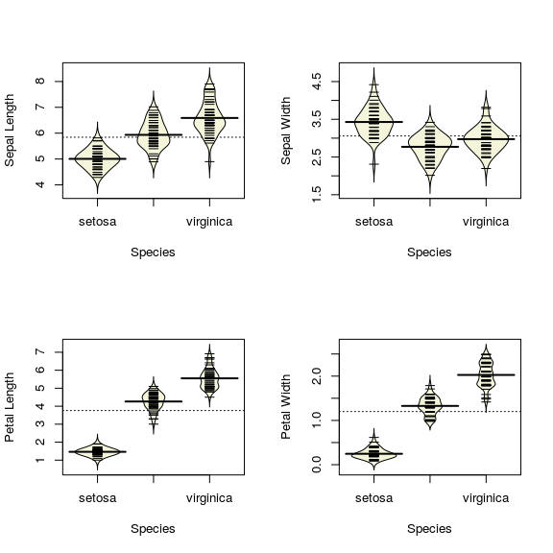
Figure 2: Beanplots of variables by species
We can also visualize these summary statistics with a box-plot. The box-plot given in Figure blank
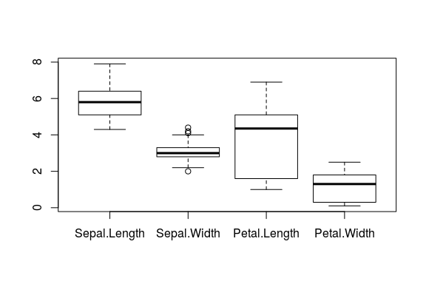
Figure 3: A boxplot of the variables
Though this marginal information may be useful in an analysis, when exploring multivariate data such as this we may want to consider some pair-wise relationships
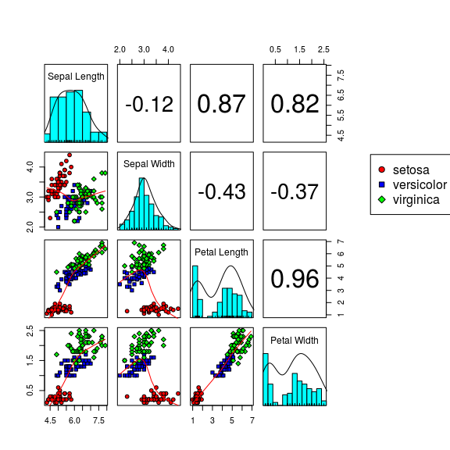
Figure 4: A pairs plot of the data
We first make a simple plot of sepal width and sepal length.
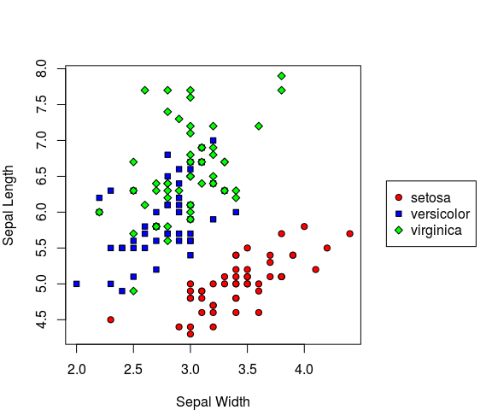
Figure 6: Scatterplot of Sepal Width by Sepal Length
We can see in Figure blank that a clear relationship between sepal width and sepal length. We also see that this relationship may differ by species of iris.

A Simple Regression
To explore the relationship we observed in figure blank, we will build a regression model. We can write out the relationship as:

We get the following model summary output.
 | Estimate | Std. Error | t value | Pr(>|t|)
Sepal.Width | 0.6905 | 0.1657 | 4.166 | 5.311e-05
Speciesversicolor | 0.9007 | 0.7988 | 1.128 | 0.2613
Speciesvirginica | 1.268 | 0.8162 | 1.553 | 0.1225
Sepal.Width:Speciesversicolor | 0.1746 | 0.2599 | 0.6718 | 0.5028
Sepal.Width:Speciesvirginica | 0.211 | 0.2558 | 0.8252 | 0.4106
(Intercept) | 2.639 | 0.5715 | 4.618 | 8.526e-06
Observations | Residual Std. Error |  | Adjusted
150 | 0.4397 | 0.7274 | 0.718
Fitting linear model: Sepal.Length ~ Sepal.Width * Species
In Table blank, we see that
We can also conduct an Analysis of Variance (ANOVA) to test
We might wonder if we need to model the interaction term
 | Df | Sum Sq | Mean Sq | F value | Pr(>F)
Sepal.Width | 1 | 1.412 | 1.412 | 7.303 | 0.007712
Species | 2 | 72.75 | 36.38 | 188.1 | 6.867e-41
Sepal.Width:Species | 2 | 0.1572 | 0.0786 | 0.4064 | 0.6668
Residuals | 144 | 27.85 | 0.1934 | NA | NA
Analysis of Variance Table
We can see from the ANOVA output that there isn't much evidence that the slope of the relationship between Sepal Width and Sepal Length differs by species. We might then test the additive effects. We give type II sums of squares in the additive model to get two tests we are interested in.
 | Sum Sq | Df | F value | Pr(>F)
Sepal.Width | 10.95 | 1 | 57.1 | 4.187e-12
Species | 72.75 | 2 | 189.7 | 2.558e-41
Residuals | 28 | 146 | NA | NA
Anova Table (Type II tests)
We see that the additive model seems appropriate. The diagnostic plots for this model are given in table

Appendix

R-code
pander(iris[1:7,])

Document Creation Info
- platform:
  - version: R version 3.3.2 (2016-10-31)
  - system: x86_64, linux-gnu
  - ui: X11
  - language: en_US
  - collate: en_US.UTF-8
  - tz: Navajo
  - date: 2017-03-16
- packages:

References
Anderson, Edgar. 1936. “The Species Problem in Iris.” Annals of the Missouri Botanical Garden 23 (3). Missouri Botanical Garden Press: 457–509. http://www.jstor.org/stable/2394164.
Fisher, R. A. 1936. “The Use of Multiple Measurements in Taxonomic Problems.” Annals of Eugenics 7 (2). Blackwell Publishing Ltd: 179–88. doi:10.1111/j.1469-1809.1936.tb02137.x.

