
Vidyavardhini’s College of Engineering & Technology
Department of Computer Science & Engineering (Data Science)

NAME : Samar Santosh Sawant
Div : SE3-B2
Roll No: 35
Branch : CSE-DS
Experiment No : 6
DOP (Date of Performance) : 09/03/26
DOC (Date of Completion):09/03/26
Experiment Title : Create a webpage that retrieves, displays, and updates user data from a MySQL database. Implement CRUD operations (Create, Read, Update, Delete) using PHP &amp; MySQL. Ensure user input is validated and securely stored in the database. Add Session &amp; Cookies.
CODE :
- db.php
<?php
$conn = mysqli_connect("localhost", "root", "", "userdb");
if (!$conn) {
die("Connection failed: " . mysqli_connect_error());
}
?>
2.) delete.php
<?php
include __DIR__ . "/db.php";
$id = $_GET['id'];
mysqli_query($conn, "DELETE FROM users WHERE id=$id");
header("Location: index.php");
?>

- edit.php
<?php
include __DIR__ . "/db.php";
$id = $_GET['id'];

if (isset($_POST['update'])) {
$name = $_POST['name'];
$email = $_POST['email'];

mysqli_query($conn, "UPDATE users SET name='$name', email='$email' WHERE id=$id");
header("Location: index.php");
}

$data = mysqli_fetch_assoc(mysqli_query($conn, "SELECT * FROM users WHERE id=$id"));
?>

<!DOCTYPE html>
<html>
<head>
<title>Edit User</title>

<style>
body {
font-family: Arial;
background: #f4f6f8;
text-align: center;
}

form {
background: white;
padding: 25px;
width: 300px;
margin: 50px auto;
border-radius: 10px;
box-shadow: 0 0 10px rgba(0,0,0,0.1);
}

input {
width: 90%;
padding: 10px;
margin: 10px 0;
border-radius: 5px;
border: 1px solid #ccc;
}

button {
background: #007bff;
color: white;
padding: 10px;
border: none;
width: 100%;
border-radius: 5px;
}

button:hover {
background: #0056b3;
}
</style>
</head>
<body>
<h2>Edit User</h2>
<form method="post">
<input type="text" name="name" value="<?= $data['name']; ?>" required>
<input type="email" name="email" value="<?= $data['email']; ?>" required>
<button name="update">Update</button>
</form>
</body>
</html>
- index.php
<?php
session_start(); // ✅ start session

$_SESSION['user'] = "Admin"; // store session data
// ✅ Last Visit Cookie Logic
if(isset($_COOKIE['last_visit'])){
$last = $_COOKIE['last_visit'];
} else {
$last = "This is your first visit";
}
// set new last visit time
setcookie("last_visit", date("Y-m-d H:i:s"), time() + 3600);

// existing cookie
setcookie("username", "Student", time() + 3600);

include __DIR__ . "/db.php";
?>
<!DOCTYPE html>
<html>
<head>
<title>User List</title>

<style>
body {
font-family: Arial;
background-color: #f4f6f8;
text-align: center;
}

h2 {
color: #333;
}

h3 {
color: #555;
}

a {
text-decoration: none;
padding: 6px 10px;
background-color: #007bff;
color: white;
border-radius: 5px;
}

a:hover {
background-color: #0056b3;
}

table {
margin: 20px auto;
border-collapse: collapse;
width: 70%;
background: white;
}

th, td {
padding: 10px;
border: 1px solid #ddd;
}

th {
background-color: #007bff;
color: white;
}

tr:hover {
background-color: #f1f1f1;
}
</style>

</head>

<body>

<h3>
<?php
// ✅ Cookie display
if(isset($_COOKIE['username'])) {
echo "👋 Welcome " . $_COOKIE['username'];
}

echo "<br>";

// ✅ Session display
if(isset($_SESSION['user'])) {
echo "🔐 Session User: " . $_SESSION['user'];
}
echo "<br>";

// ✅ Last Visit display
echo "🕒 Last Visit: " . $last;
?>
</h3>

<br>
<a href="insert.php" style="background: green;">+ Add New User</a>

<h2>User List</h2>

<table>
<tr>
<th>ID</th>
<th>Name</th>
<th>Email</th>
<th>Action</th>
</tr>

<?php
$result = mysqli_query($conn, "SELECT * FROM users");

while ($row = mysqli_fetch_assoc($result)) {
?>
<tr>
<td><?= $row['id']; ?></td>
<td><?= $row['name']; ?></td>
<td><?= $row['email']; ?></td>
<td>
<a href="edit.php?id=<?= $row['id']; ?>">Edit</a> |
<a href="delete.php?id=<?= $row['id']; ?>"
onclick="return confirm('Are you sure you want to delete this user?')"
style="background:red;">
Delete
</a>
</td>
</tr>
<?php } ?>

</table>

</body>
</html>
- insert.php
<?php
include "db.php";

if (isset($_POST['submit'])) {
$name = $_POST['name'];
$email = $_POST['email'];
$password = password_hash($_POST['password'], PASSWORD_DEFAULT);

if (!empty($name) && !empty($email)) {
mysqli_query($conn, "INSERT INTO users(name,email,password) VALUES('$name','$email','$password')");
header("Location: index.php");
}
}
?>

<form method="POST">
Name: <input type="text" name="name"><br><br>
Email: <input type="email" name="email"><br><br>
Password: <input type="password" name="password"><br><br>
<button name="submit">Add User</button>
</form>
- session.php
<?php
session_start();
$_SESSION['user'] = "Admin";
echo "Session User: " . $_SESSION['user'];
?>
OUTPUT :
MAIN PAGE
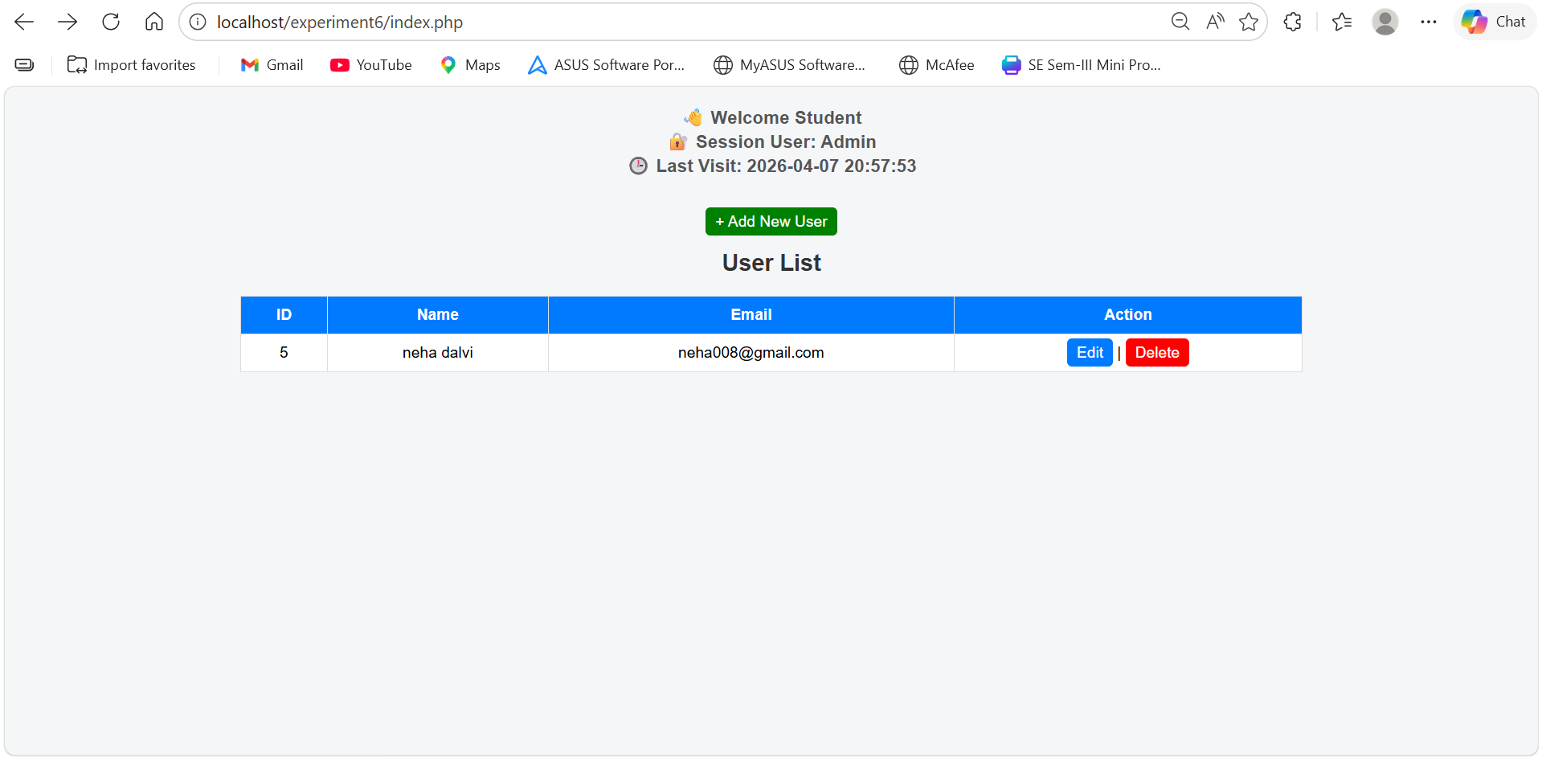
ADD USERS :
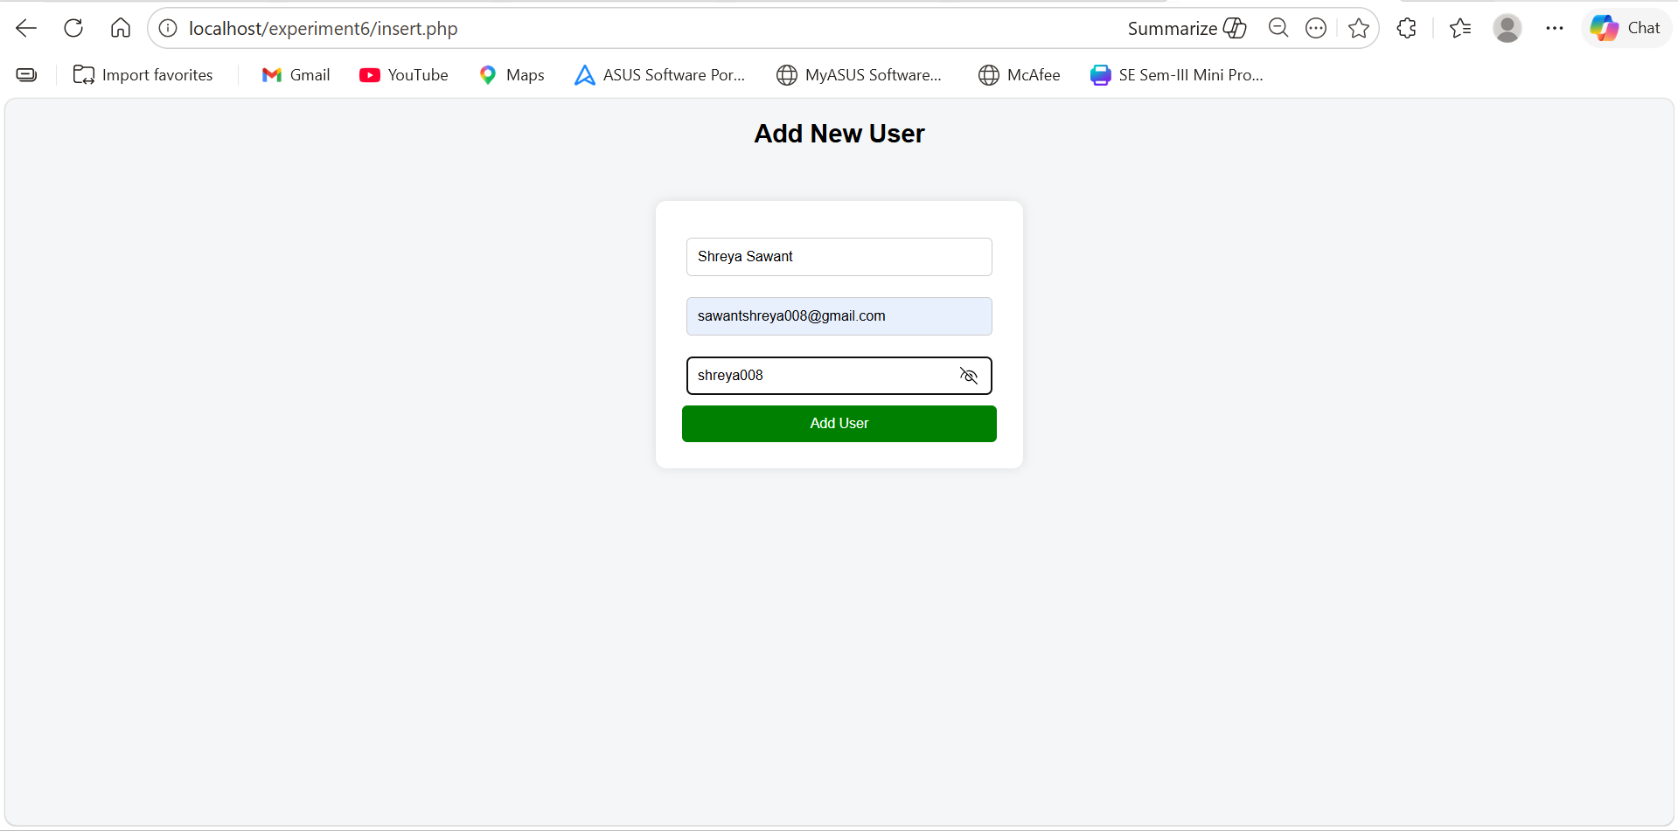
Delete user 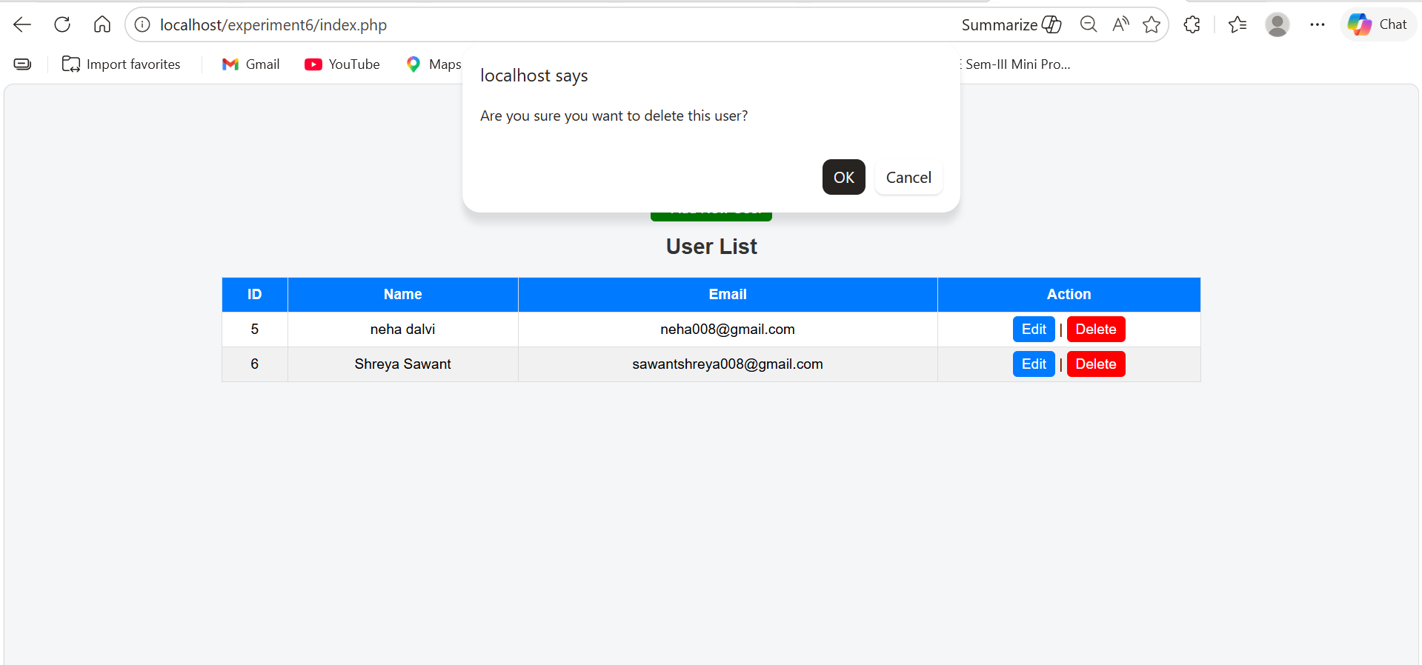
Edit user :
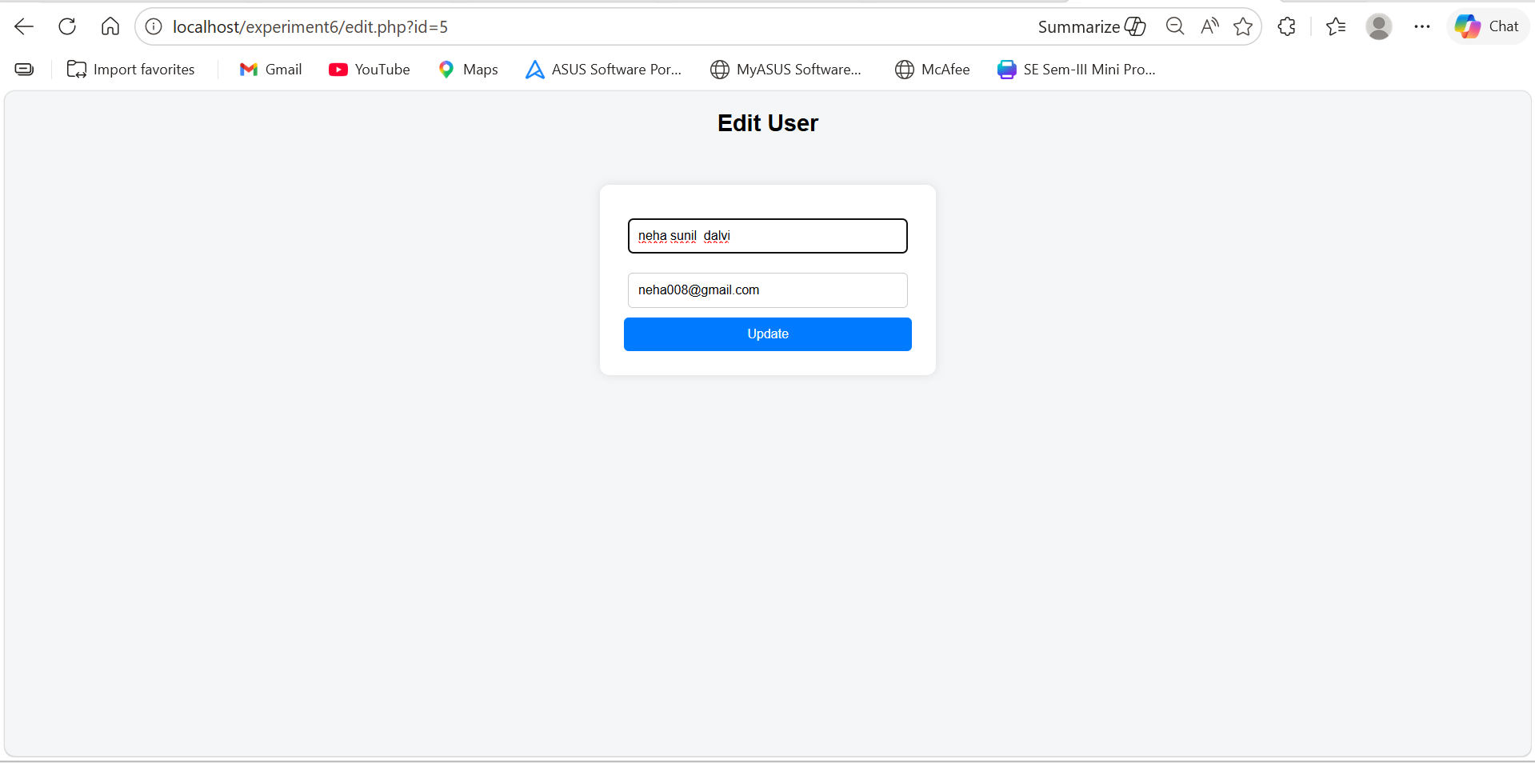
Updated
