Experiment 9

Name:Samar Santosh Sawant

Rollno:SE3-35

DOP:09/03/26

DOC:09/03/26

Title:
Implement search functionality to filter API results dynamically.

Theory:
Modern web applications often handle large amounts of data retrieved from external APIs. Displaying all fetched data at once can reduce usability. To improve user experience, search and filtering functionality is implemented to dynamically narrow down results based on user input.
An API (Application Programming Interface) provides structured data in formats such as JSON. JavaScript fetches this data asynchronously and stores it in memory. A search input field allows users to enter keywords, which are used to filter the API results in real time.

- Dynamic Search Filtering
Dynamic search filtering allows data to be filtered without refreshing the page. As the user types in the search box, JavaScript compares the input text with the fetched data and displays only matching records.

- AJAX and Fetch API
The Fetch API is used to retrieve data asynchronously from the server. It returns a promise that resolves with the API response, which is then converted into JSON format. This ensures smooth and fast data retrieval.

- JavaScript Array Methods
JavaScript provides built-in array methods such as filter() and includes() to efficiently search through data. These methods help compare user input with data fields like name, title, or description.

- DOM Manipulation
The filtered data is displayed dynamically using DOM manipulation, ensuring instant updates to the user interface whenever the search input changes.

Algorithm / Procedure

- Start the experiment.

- Create an HTML file with a search input field.

- Use JavaScript to fetch data from a public API.

- Store the API response in an array.

- Display all API results on the webpage.

- Capture user input from the search field.

- Filter the stored data based on the search keyword.

- Update the displayed results dynamically.

- Repeat filtering as the user types.

- Stop the experiment.

Program / Code:
<!DOCTYPE html>
<html>
<head>
<title>API Search Filter</title>
<style>
body {
font-family: Arial; background: #f4f4f4;
}
input {
width: 300px; padding: 10px; margin: 20px;

}
.card {
background: white; padding: 15px; margin: 10px; border-radius: 5px;
}
</style>
</head>
<body>

<h2 align="center">Search API Data</h2>
<center>
<input type="text" id="search" placeholder="Search by title...">
</center>

<div id="results"></div>

<script>
let apiData = [];

fetch("https://jsonplaceholder.typicode.com/posts")
.then(response => response.json())
.then(data => { apiData = data;
displayData(apiData);

});

function displayData(data) {
const resultDiv = document.getElementById("results"); resultDiv.innerHTML = "";

data.forEach(item => { resultDiv.innerHTML += `
<div class="card">
<h4>${item.title}</h4>
<p>${item.body}</p>
</div>
`;
});
}

document.getElementById("search").addEventListener("keyup", function() { const keyword = this.value.toLowerCase();
const filteredData = apiData.filter(item => item.title.toLowerCase().includes(keyword)
);
displayData(filteredData);
});
</script>

</body>

</html>

Scenario based questions:
Create a web page that fetches data from an API and allows users to search and filter the displayed results dynamically using a search input box.

Code:

<!DOCTYPE html>
<html lang="en">
<head>
<meta charset="UTF-8">
<title>Search Users</title>

<style> body { margin: 0;
font-family: Arial, sans-serif; background: #d3d3d3; display: flex;
flex-direction: column; align-items: center;
}

h1 {
margin-top: 30px; font-size: 40px;

font-weight: bold;
}

#searchBox { width: 60%;
max-width: 500px; padding: 15px; font-size: 18px; margin: 20px 0;
border: 2px solid black; border-radius: 5px; outline: none;
}

#container { width: 80%;
max-width: 600px;
}

.card {
background: #eaeaea; padding: 30px; border-radius: 12px; margin-top: 20px; text-align: center;
box-shadow: 0 2px 6px rgba(0,0,0,0.2);

}

.card h2 {
margin-bottom: 15px; font-size: 28px;
}

.card p { margin: 8px 0;
font-size: 18px;
}
</style>
</head>
<body>

<h1>Search Users</h1>

<input type="text" id="searchBox"
placeholder="Search users..."
>

<div id="container"></div>

<script>

const API_URL = "https://jsonplaceholder.typicode.com/users"; let users = [];

async function fetchUsers() {
const res = await fetch(API_URL); users = await res.json(); displayUsers(users);
}

function displayUsers(data) {
const container = document.getElementById("container"); container.innerHTML = "";

data.forEach(user => {
const card = document.createElement("div"); card.classList.add("card");

card.innerHTML = `
<h2>${user.name}</h2>
<p>${user.email}</p>
<p>${user.address.city}</p>
`;

container.appendChild(card);
});
}

function filterUsers(value) {
const filtered = users.filter(user => user.name.toLowerCase().includes(value.toLowerCase())
);
displayUsers(filtered);

}
document.getElementById("searchBox")
.addEventListener("input", (e) => { filterUsers(e.target.value);
});

fetchUsers();
</script>

</body>
</html>

Output:

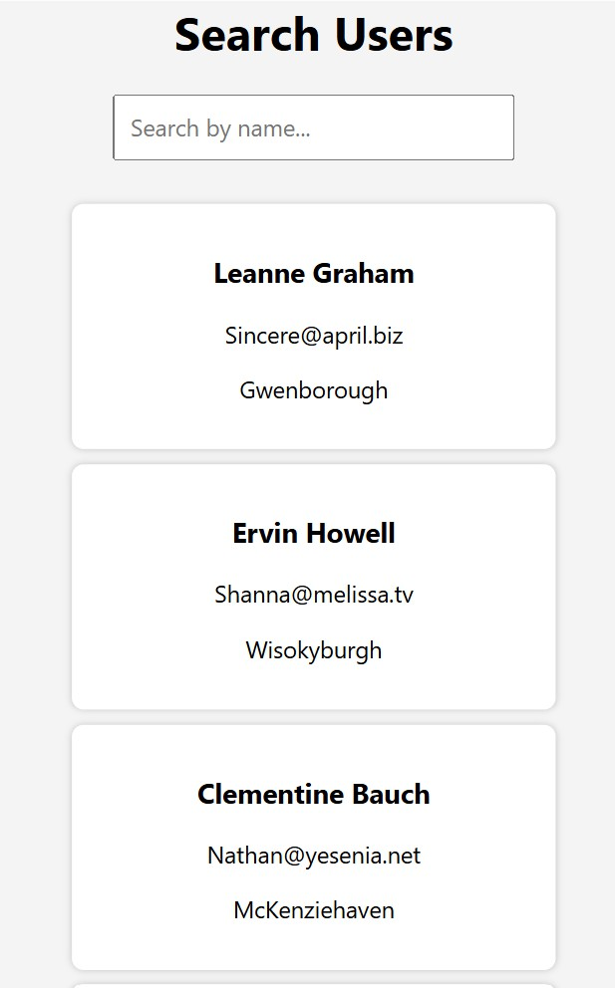


Conclusion
Thus, dynamic search functionality was successfully implemented to filter API results using JavaScript. This experiment demonstrates the use of Fetch API, array filtering methods, and DOM manipulation to create responsive and interactive web applications.

Question:
- To filter results dynamically when a user types in a search box, which event is most appropriate?Ans………………………
  - onclick
  - onmouseover
  - oninput
  - onscroll
Ans: C) oninput

- If API results are not updating after search input changes, what is most likely missing? Ans………………………………….
  - DOM update logic
  - CSS styling
  - HTML title
  - Bootstrap link
Ans: A) DOM update logic

- Why should API data be stored in a separate variable before filtering?

Answer:
API data should be stored in a separate variable so you can preserve the original dataset and apply filtering multiple times without losing data.

