

**User Needs**

01/06/1400

1 از 3

UN_01

**تاریخ**

**شماره**

**برگ**

**عنوان پروژه :** طراحی و ساخت دستگاه دماسنج **" ELMAN "**

ط

1.Type K/J/T/E/R/S, Pt 100 ohm , Pt1000 ohm  
2. Show 4 channels display on the LCD at the same time   
3. Type K : -100 to 1300 . ℃  
4. Type J : -100 to 1200 . ℃  
5. Pt 100 ohm : -199.9 to 850.0   
6. Pt 1000 ohm : -199.9 to 850.0   
7. ℃ / F , 0.1 degree/1 degree.  
8. 4 channels ( T1, T2, T3, T4 ), T1-T2.  
9. Offset adjustment for the Type K/J/T/E/R/S , Pt 100 ohm , Pt1000 ohm measurement.  
10. Measuring unit can select to ℃ or F  
11. Real time uSD memory card Datalogger, it Built-in Clock and Calendar, real time data recorder, sampling time set from 1 second to 3600 seconds.  
12. Manual datalogger is available ( set the sampling time to 0 second ), during execute the manual datalogger function, it can set the different position ( location ) No. ( position 1 to position 99 ).  
13. Innovation and easy operation, computer is not need to setup extra software, after execute datalogger, just take away the uSD card from the meter and plug in the uSD card into the computer, it can down load the all the measured value with the time information ( year/month/date/ Included hour/minute/second ) to the Excel directly, thenuser can make the further data or graphic analysis by themselves.  
14. uSD card capacity : 1 GB to 16 GB.  
15. LCD with green light backlight, easy reading.  
16. Can default auto power off or manual power off.  
17. Data hold, record max. and min. reading  
18. Power by UM3/AA ( 1.5 V ) x 2 batteries or DC 3.3V adapter  
19. RS232/USB PC COMPUTER interface  
20. Auto shut off saves battery life or manual off by push button.  
21. Operating Temperature : 0 to 50 . ℃  
22. Operating Humidit : Less than 85% R.H  
23. Power Supply : AAlkaline or heavy duty DC 1.5 V battery ( UM3, AA ) x 2 PCs, or equivalent.  
24. Power Supply : DC 3.3V adapter input. ( AC/DC power adapter is optional ).  
25. Pt 100 ohm and . Pt 1000 ohm ( 2 wire , 3 wire , 4 wire )

مدیر پروژه :

مهندس ناظر :

**شرکت ابزار دقیق دورآت**

**تاریخ :**

**User Needs : 1 of 3**

مدیریت :



**User Needs**

01/06/1400

2 از 3

UN_01

**تاریخ**

**شماره**

**برگ**

**عنوان پروژه :** طراحی و ساخت دستگاه دماسنج **" ELMAN "**

ط

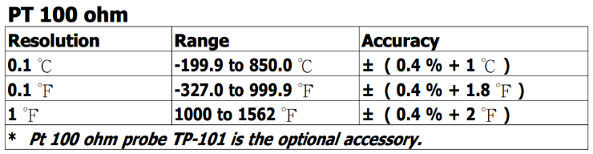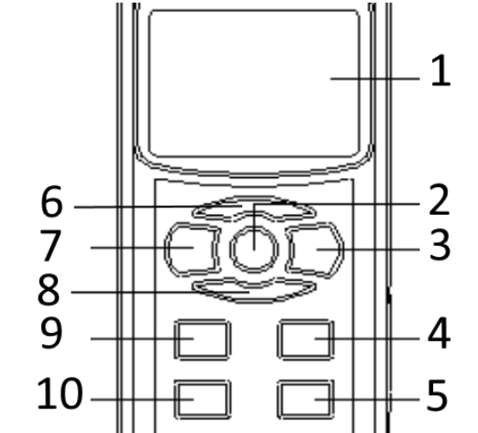 **Accuracy Pt100 and Pt1000**

مدیر پروژه :

مهندس ناظر :

**شرکت ابزار دقیق دورآت**

**تاریخ :**

**User Needs : 2 of 3**

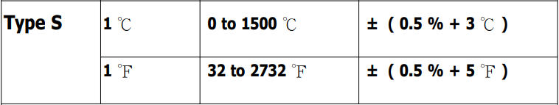

**1. Display  
2. Hold Button ( Next Button )  
3. REC Button ( Enter Button )  
4. T1-T2 Button (Down Button, R Button )  
5. Logger Button ( OFFSET, Sampling time check Button)  
7. Power Button ( ESC, Backlight Button )  
9. Type Button ( Up Button, L Button )  
10. SET Button ( Time check Button )**

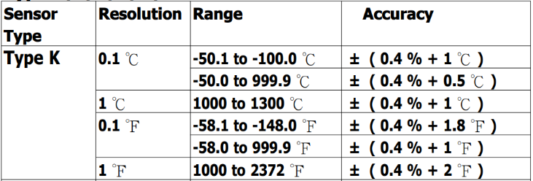

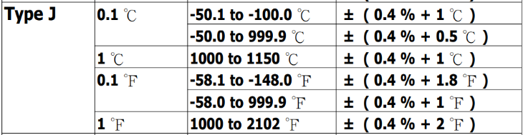

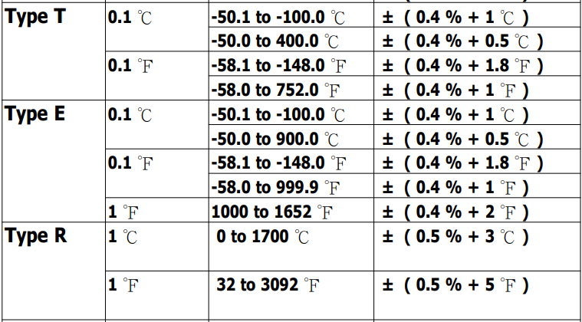

مدیریت :



**User Needs**

01/06/1400

3 از 3

UN_01

**تاریخ**

**شماره**

**برگ**

**عنوان پروژه :** طراحی و ساخت دستگاه دماسنج **" ELMAN "**

ط

LCD

مدیر پروژه :

مهندس ناظر :

**شرکت ابزار دقیق دورآت**

**تاریخ :**

**User Needs : 3 of 3**

مدیریت :