|  |  |  |  |
| --- | --- | --- | --- |
|  | Assignment3  Chapter Nine |  |  |

Part one:

1. Determine whether the relation R on the set of all people is reflexive, symmetric, antisymmetric, and/or transitive, where (a, b) ∈ R if and only if
   1. a is taller than b.
   2. a and b were born on the same day.
   3. a has the same first name as b.
   4. a and b have a common grandparent.
2. List the ordered pairs in the relation R from A = {0,1, 2, 3, 4} to B = {0, 1, 2, 3}, where (a, b) ∈ R if and only if
   1. a = -b.
   2. a - b = 4.
   3. a < b.
   4. b | a.
3. List the ordered pairs in the relations represented with the following graphs:
   1. 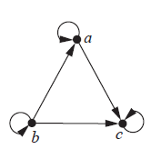
   2. 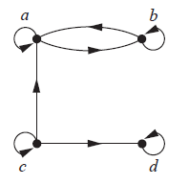
4. Which of these relations on the set of all people are equivalence relations? Determine the properties of an equivalence relation that the others lack.
   1. {(a, b) | a and b are the same age}
   2. {(a, b) | a and b have the same parents}
   3. {(a, b) | a and b share a common parent}
   4. {(a, b) | a and b have met}
   5. {(a, b) | a and b speak a common language}
5. Let R be the relation on the set of ordered pairs of positive integers such that ((a, b), (c, d)) ∈ R if and only if ad = bc. Show that R is an equivalence relation.
6. Determine whether the relation with the directed graph shown is an equivalence relation.  
   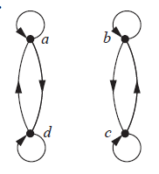
7. What is the congruence class [4]m when m is
   1. 2?
   2. 3?
   3. 6?
   4. 8?
8. Which of these collections of subsets are partitions of {−3,−2,−1, 0, 1, 2, 3}?
   1. {−3,−1, 1, 3}, {−2, 0, 2}
   2. {−3,−2,−1, 0}, {0, 1, 2, 3}
   3. {−3, 3}, {−2, 2}, {−1, 1}, {0}
   4. {−3,−2, 2, 3}, {−1, 1}
9. Which of these collections of subsets are partitions of the set of integers?
   1. the set of even integers and the set of odd integers
   2. the set of positive integers and the set of negative integers
   3. the set of integers divisible by 3, the set of integers leaving a remainder of 1 when divided by 3, and the set of integers leaving a remainder of 2 when divided by 3
   4. the set of integers less than −100, the set of integers with absolute value not exceeding 100, and the set of integers greater than 100
   5. the set of integers not divisible by 3, the set of even integers, and the set of integers that leave a remainder of 3 when divided by 6

***Best of luck!***