**John Mark Lagarto BSCS 4B**

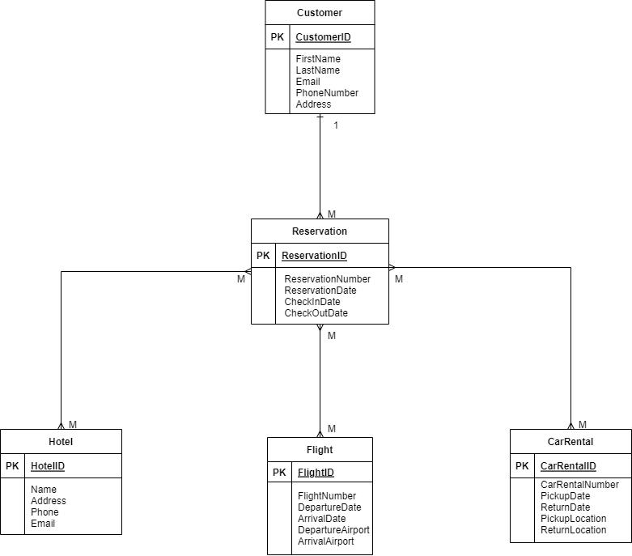**Travel Reservation System ERD**